KEEPING THE CITY MOVING
Project Management Plan for a Temporary Multimodal Transport Solution
Part A: project portfolio poster
Part B: Critical Reflection on Tutor and Peer Feedback
Part C: Detailed Project Management Plan
Student Name: Janeks Cimme
Student ID: 2529721
Module: LCLM5003 Project Management
Institution: Buckinghamshire New University

Table of Contents
Part A: Project Portfolio Poster 2
Part B – Critical Reflection on Tutor and Peer Feedback 3
Part C – Project Management Plan 4
1. Introduction 4
2. Project Description 5
3. Scope 6
4. Work Breakdown Structure 7
5. Quad Chart 8
6. Gantt Chart 9
7. Stakeholder Involvement 10
8. Allocation of Resources 12
9. Risk Analysis 13
10. Conclusion 15
References 16

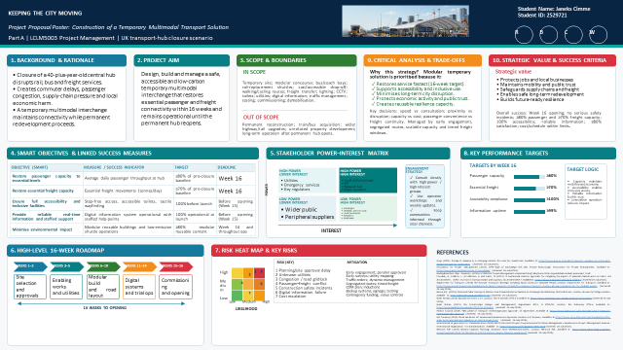
Part A: Project Portfolio Poster

Part B – Critical Reflection on Tutor and Peer Feedback
The tutor and peer feedback on the poster has shown that the poster is a good foundation to the final project management plan. The strong design, the clear and logical progression of the events and the connection between the necessity to take some immediate action and the cause are its main strengths. The proposal gives the purpose of the project, the scope and the stakeholders, the risks, the trade-offs and strategic value in a simplified manner and easy to read. The quantifiable goals of the passenger capacity, continuity of freight, accessibility and reliability of information also shows that the proposal is result oriented, and not activity based on the operations of the organization. Use of transport policy and project management advice also contributes to the credibility and sensitivity to the reality of the public-sector environment.
The feedback however, indicates three areas which should be improved. Firstly, the objectives ought to be more specific. The latter scheme, therefore, links all the goals with any particular indicator, target, deadline and owner and check-up process. The throughput of passengers should be 80 per cent. of pre-closure base Week 16 and the essential freight capacity should be 70 per cent. Accessibility as a state is mandatory and the digital information has to be shown to be ready prior to launching it. These transformations enable performance to be measurable, and aid in responsible decision-making.
Second, more practical usage of project management tools should be used in the poster. The resulting plan would then be a work breakdown structure, quad chart, sixteen weeks Gantt chart, stakeholder power-interest matrix, responsibility arrangements, resource allocation table, risk heat map and scored risk register. The interdependences of the tools make the connections evident, ownership, milestones, and escalation paths and acceptance evidence obligatory.
Third, the feedback is more critically assessed and has less text. It is the latter which explains why a constructed exchange with a modular structure is desirable to the restricted action of the dangerous hub, intermittent momentary pauses or impending reconstruction. The modular solution provides the optimal trade-off between the speed, the safety, the accessibility, the coordination and reversibility, but the temporary cost and the local impacts are also considered. These limitations are overcome with the help of re-usable modules with the help of isolated paths, planned freight intervals and consultations in advance. No repetition, short paragraphs, tables and figures do not sacrifice decision relevant detail. Generally, the feedback converts the work into a graphically sound proposal into a risk-managed, measurable and controlled delivery plan.
The reflection realises also that not everything that is suggested is so important. Success, approval gates, risk ownership measures take precedence since the vulnerabilities can impact on the safety, readiness and confidence of the stakeholders to open. Perfection of the images but as a second to government and regulation. This prioritisation shows critical reviewing of the feedback instead of mechanically accepting all the comments.

Part C – Project Management Plan

1. Introduction
Closure of the old central transport centre in the city isolates rail, bus and freight transport, overloads, supply chains, damages economies and leaves citizens dissatisfied. This plan offers a temporary multimodal exchange with long term redevelopment going on. The suggested facility is supposed to be launched within less than sixteen weeks and restore required connectivity and safety, accessibility and environmental assurances.
Success goes beyond the conventional cost, time and quality measurement. Other criteria that can be used in evaluating projects include stakeholder impact and longer term value according to Atkinson (1999) and Shenhar et al. (2001) benefits. As such, the success entails safe opening by Week 16, 80 per cent or more of the previous passenger throughput, 70 per cent or more of the required freight capacity, complete step-free access, reliable information and performance with acceptable deviations.
A combined approach is taken. Approval, design, construction and commissioning is controlled by predictive stage gates and digital information is optimised by short iterative cycles with wayfinding and operational trials. This individualisation aids in cultivating a sense of urgency without watering down confidence (Association for Project Management, 2025).
The plan is prepared to the local authority, transport operators, regulators, suppliers and affected communities. It establishes a single level of decision making and defines the escalation level before work is started. Three restrictions are applied to affect delivery: the statutory approvals have to be avoided, passenger and freight services must not be mixed, and temporary facility must not interfere with the permanent redevelopment. The assumptions concerning the land availability, accessibility and participation of the operator of utilities are tested at the mobilisation phase and converted into the risks in the situations when the evidence remains to be taken.

2. Project Description
The project designs, builds, commissions and prepares operation of a temporary interchange close to the closed hub. Deliverables include objects like a modular concourse; bus, coach and rail-replacement bays; availability of taxi and drop-off points; secure walking and bicycle paths; a critical freight-transfer area; utilities; toilets; CCTV; lighting; help points; staffed help points; real time passenger information; traffic controls; testing; training and subsequent demobilisation.
The local authority acts as sponsor. A Senior Responsible Owner, who heads transport, finance, safety, accessibility and operators, heads a Project Board. The Project Director leads a small project management office along with the design, construction, operations, digital systems, commercial control and engagement workstream managers. Well-defined authority is required since the governance has to tie the decisions on delivery to the social good and responsibility (Too and Weaver, 2014; Müller, Pemsel and Shao, 2014).
There are four options that are taken into account. The continued use of the unsafe hub is denied due to the weight of safety exposure as compared to continuity. Open temporary stops can be easily opened, but results in increased transfers, accessibility problems, and congestion. A permanent rebuilding will not cause any costs in the short term but will prolong the disruption. A modular integrated exchange is desirable as it integrates rapidity, coordinated activities, inclusive access and reversibility. Modular construction can cut the delivery time and reuse in situations where logistics and interfaces are controlled (Kamali and Hewage, 2016). Table 1 will be the desired benefits converted into SMART goals.
Benefits management process does not start when it opens but rather at the design stage. Each operational target has a baseline, owner and evidence source and the Project Board evaluates whether the evolving solution is offering mobility, economic continuity and the confidence of the public. The temporary asset gets dismantled and modules, digital equipment and barriers can be transferred to resilience needs in the future. This will ensure that a short-term intervention is not an expendable activity and an improvement in the strategic argument of investment.
Table 1. SMART objectives and linked success measures
Objective | Measure and target | Deadline / evidence
Restore passenger service | Daily throughput ≥80% of pre-closure baseline | Week 16; automated counts and operator records
Restore essential freight | Daily essential movements ≥70% of baseline | Week 16; logistics records
Assure accessibility | 100% step-free routes, accessible toilets and tactile wayfinding | Week 15; independent audit and user trial
Provide reliable information | All systems launch-ready; ≥99% operational uptime | Week 15 onward; test and uptime reports
Limit environmental impact | ≥80% reusable modular content and approved low-emission plan | Week 16; supplier certificates and operations audit

3. Scope
Scope control safeguards the programme of urgency against becoming permanent reconstruction. Covered work includes work on the temporary site, the surveys, approvals, the modular buildings, transport and freight layout, utilities, and safety systems, accessible facilities, digital information, testing, training, commissioning and demobilization. They are permanent reconstruction, purchase of a new vehicle, off-site network upgrades, and unrelated property development and operation following re-opening the permanent hub.
The scope statement, WBS, schedule, cost plan and acceptance criteria are included in the baseline. The changes are considered based on their benefit, cost, time, safety and operating effects. Minor changes that are within tolerance are approved by the Project Director; any changes that are to do with opening, compliance, capacity or budget need approval by the Project Board. Examples of open evidence are the safety files, emergency arrangements, accessibility audit, traffic orders, system tests, training records and operator sign-off. Capacity, inclusive access and construction assurance is informed by Network Rail (2022), the Department of Transport (2018) and the CDM Regulations (Great Britain, 2015).
Approved drawings, interfaces and specifications are controlled by a configuration register. Only the permitted revision can get the work underway. Scope verification is done at every gate and final validation is done to ensure that users and operators can carry out necessary journeys and tasks without any danger. Defects are categorized based on the severity and any defect that is safety, accessibility or operation important is not accepted until it is closed or officially resolved by the concerned authority.
Table 2. Scope boundaries and acceptance evidence
Area | Boundary | Acceptance evidence
Temporary facilities | Included: modular concourse, bays, routes, toilets and help points | Approved design, inspections and capacity trial
Freight continuity | Included: transfer area, segregation and timed windows | Operator sign-off and route test
Systems | Included: utilities, CCTV, lighting, signage and real-time information | Certificates, manuals and resilience test
Permanent assets | Excluded: hub rebuild, vehicles and major network upgrades | Change register confirms exclusion
Close-out | Included: demobilisation, reuse and reinstatement | Approved handover and reuse records

4. Work Breakdown Structure
Figure 1 presents a deliverable-based WBS containing eight control accounts: governance; approvals and design; enabling works; modular facilities; transport and freight infrastructure; digital and security systems; testing and operational readiness; and opening and demobilisation. Each work package receives an owner, budget, duration, dependency and acceptance condition. Weekly reporting compares planned completion, actual progress, forecast finish, cost and risks. This structure supports procurement and accountability because deliverables are accepted only when drawings, inspection records, certificates or operational evidence are complete.
Control accounts align with the cost plan and schedule, allowing variance to be traced to a specific deliverable rather than reported only at project level. Interface packages receive named coordinators because delays commonly arise between utilities, civil works, modules and systems. The WBS dictionary records inclusions, exclusions, quality standards and handover evidence, reducing ambiguity between contractors and operators.
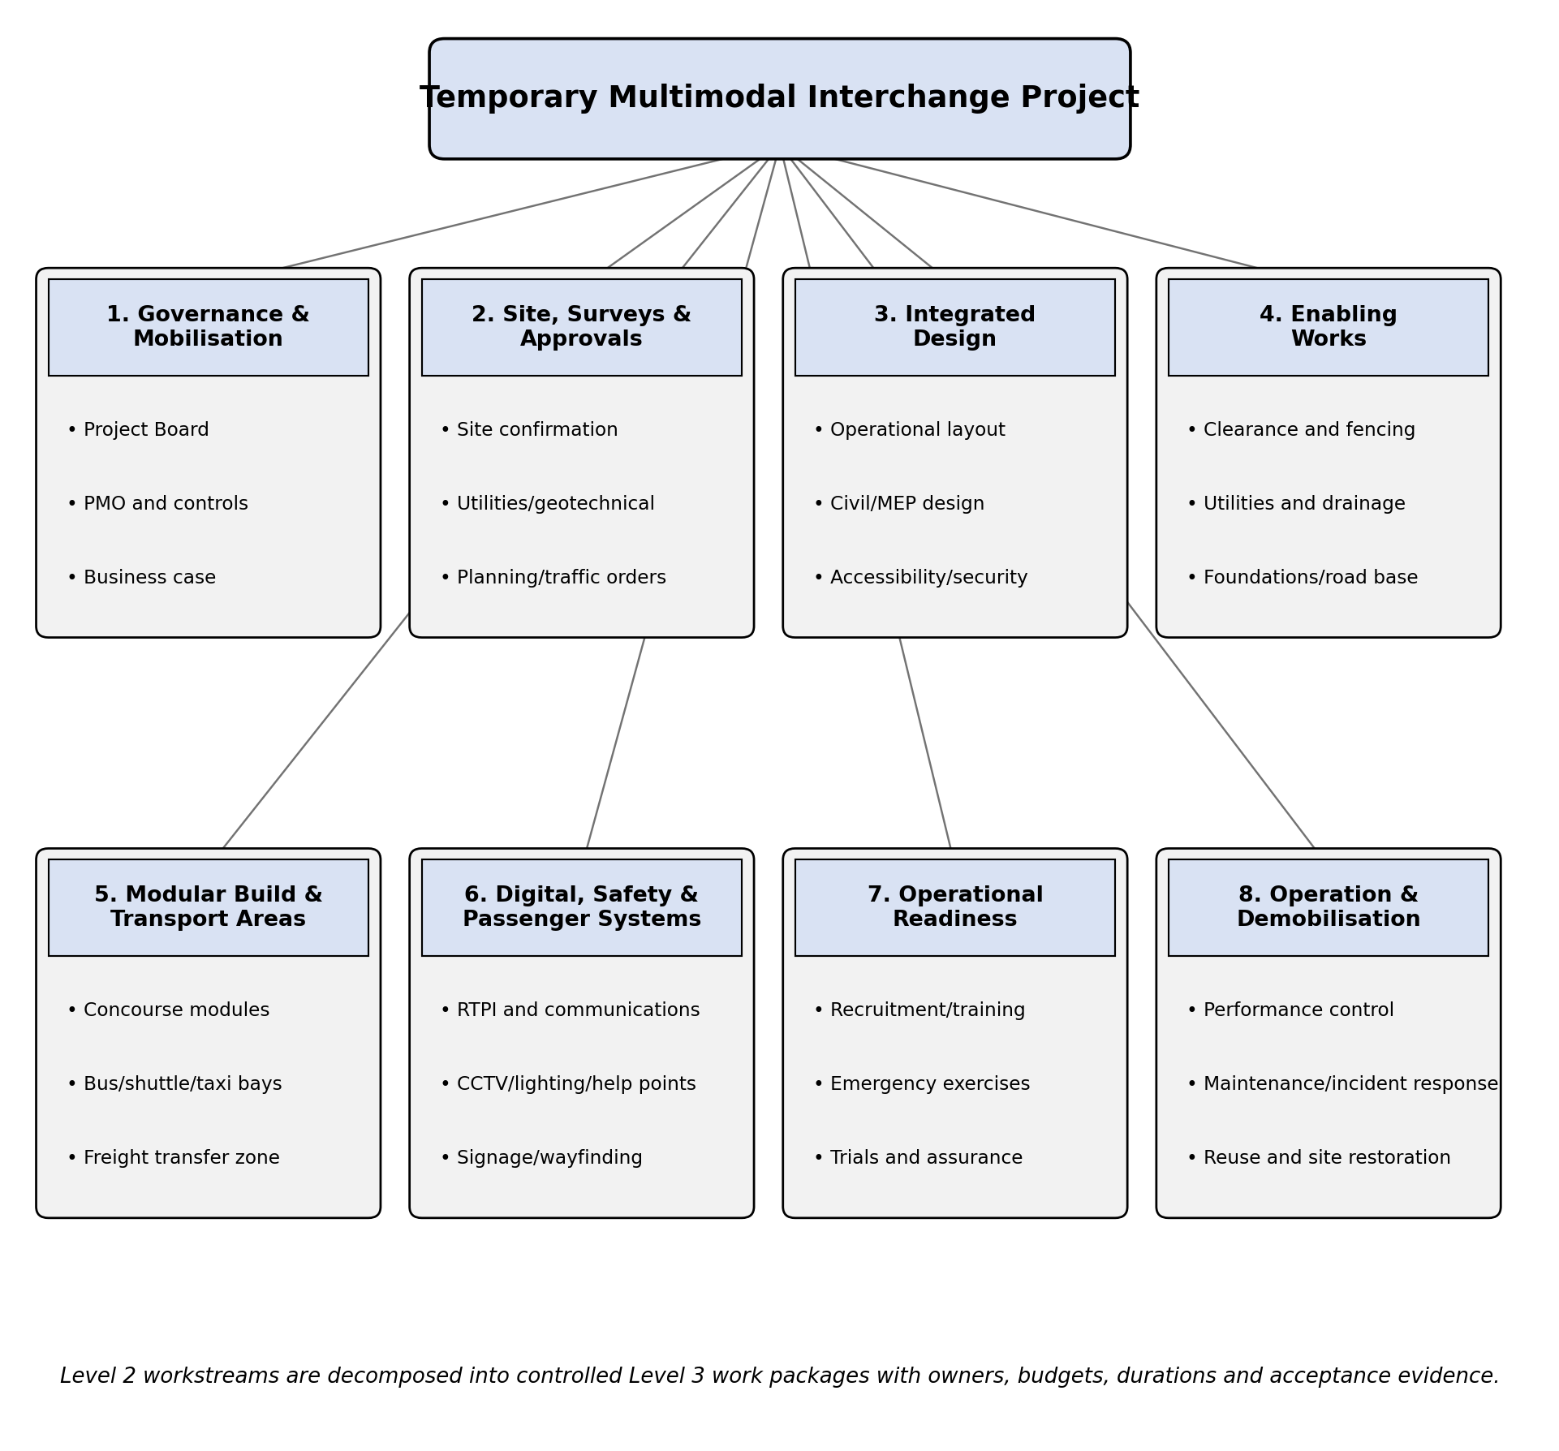
Figure 1. Work breakdown structure for the temporary interchange

5. Quad Chart
Figure 2 summarises the problem, objective, major deliverables, benefits, measures, constraints and decisions for senior stakeholders. The quad chart is reviewed at Project Board meetings to maintain a shared strategic view through concise, evidence-based executive reporting. It does not replace detailed controls; it highlights exceptions requiring sponsor action, including approval delay, forecast overspend, unresolved accessibility issues or threats to the Week 16 opening.
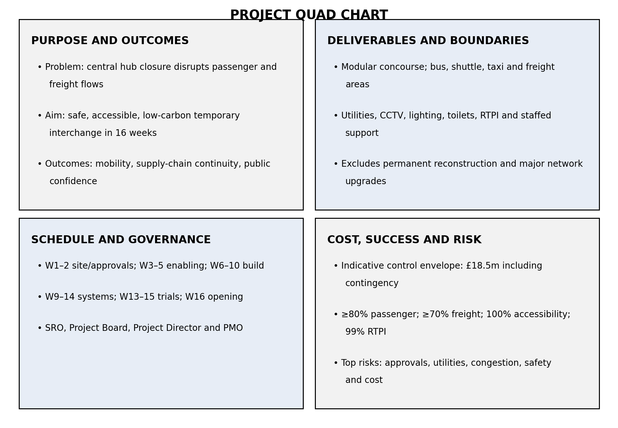
Figure 2. Project quad chart

6. Gantt Chart
Figure 3 shows the sixteen-week schedule. Weeks 1–2 confirm the site, surveys, concept and parallel approvals. Weeks 3–5 complete detailed design, procurement and enabling works. Weeks 6–10 deliver foundations, modular installation and transport layouts. Weeks 11–14 integrate utilities, digital systems, staffing and trials. Weeks 15–16 complete assurance, commissioning and opening.
The critical path runs through site approval, utility confirmation, enabling works, modular installation, systems integration, trials and certification. Key gates are site approval at Week 2, design and procurement release at Week 5, weather-tight completion at Week 10, operational readiness at Week 15 and public opening at Week 16. Modular delivery is prioritised over a bespoke build because it offers faster service restoration; multimodal coordination also reduces disruption during major transport interruptions (Consilvio et al., 2021). Recovery actions include off-site assembly, additional shifts and resequencing non-critical finishes, but safety and accessibility cannot be traded for speed.
Schedule control uses a two-week look-ahead, dependency checks and milestone trend analysis. Contractors update actual starts, finishes and remaining durations each week. The PMO tests whether slippage affects the critical path or available float before recommending recovery. Temporary acceleration is approved only after reviewing fatigue, safety, quality, cost and community impacts. Operational trials include normal service, peak demand, equipment failure, evacuation and severe-weather scenarios.
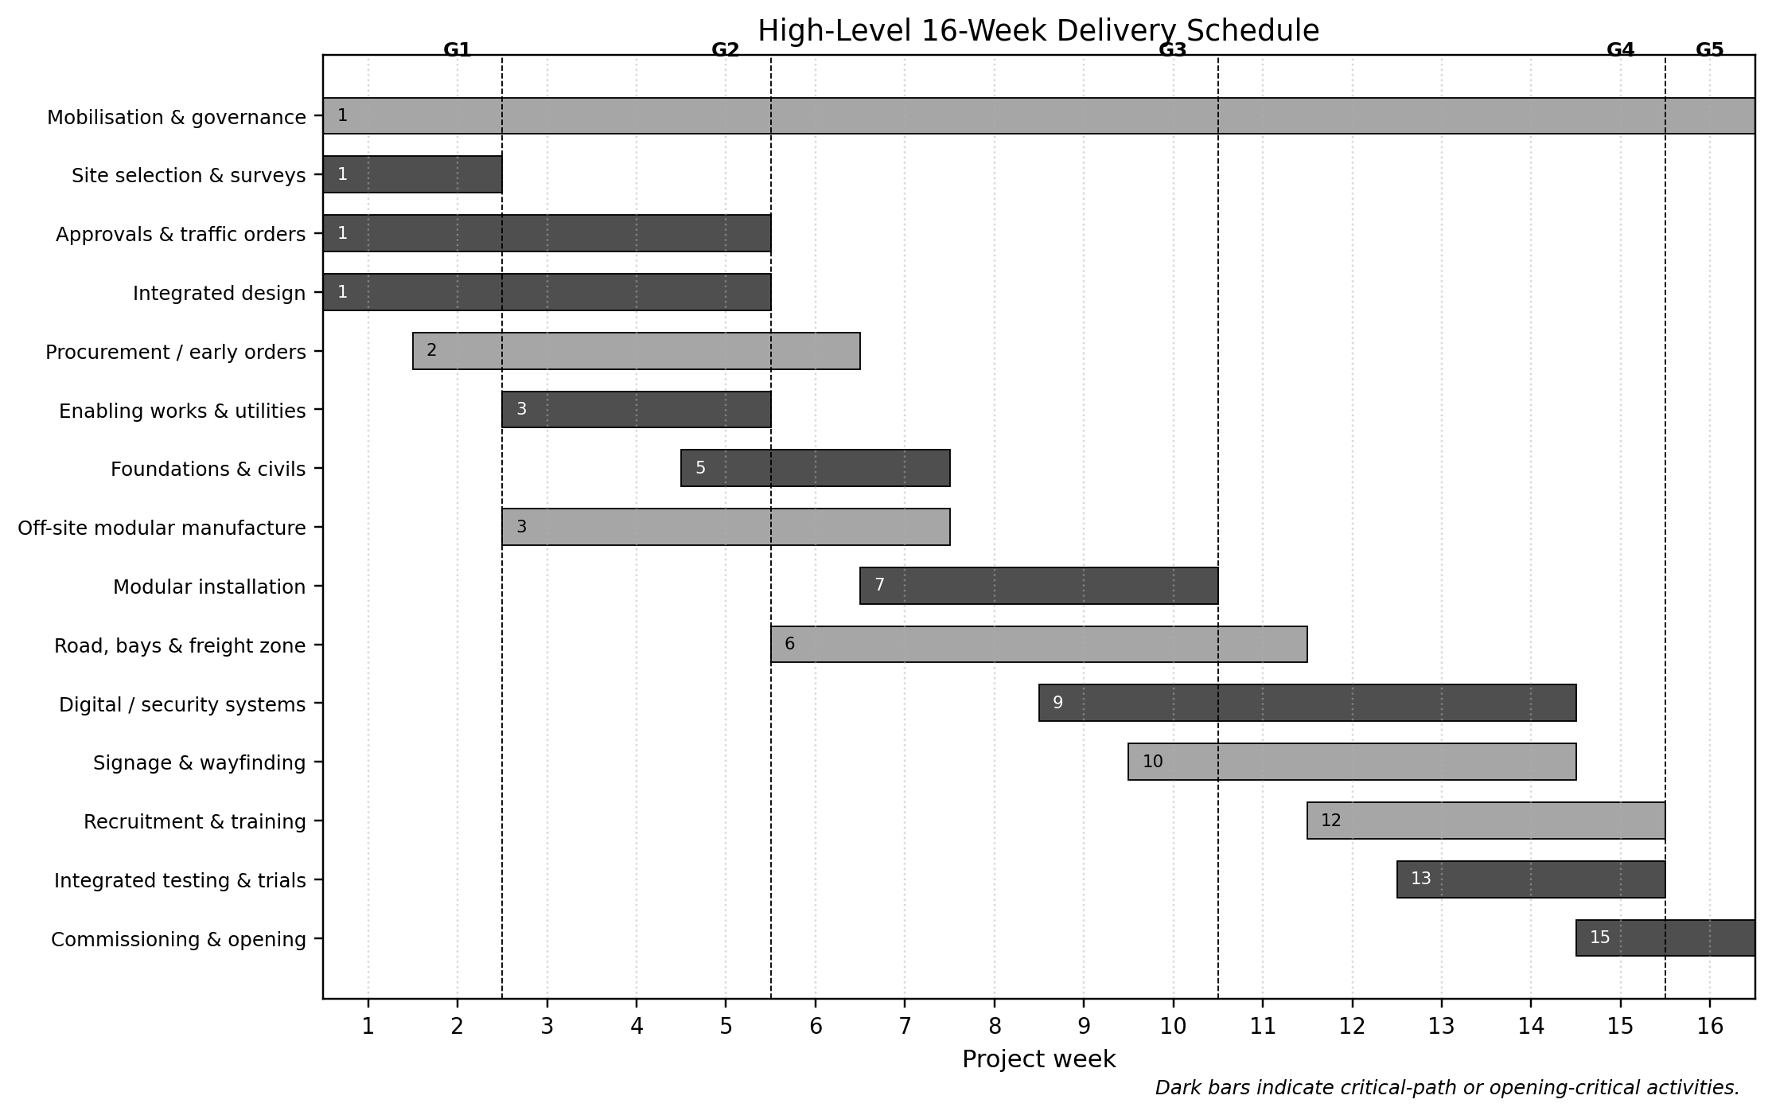
Figure 3. High-level 16-week Gantt chart

7. Stakeholder Involvement
Stakeholders are assessed by power, interest, impact and attitude. Freeman (1984), Bryson (2004) and Olander and Landin (2005) show that systematic analysis improves decision quality and helps anticipate influence. Figure 4 places the sponsor, Department for Transport, Network Rail, operators and regulators in the high-power/high-interest group. Utilities and emergency services receive focused technical management. Passengers, disabled persons’ organisations, residents, businesses and employees have high interest and require meaningful consultation.
Engagement is tied to decisions. Accessibility groups review routes, gradients, toilets, signage, assistance and evacuation before design freeze and during trials. Operators validate capacity, timetables, staffing and incident procedures. Freight firms agree segregated routes and timed windows. Residents and businesses receive traffic, noise and access information, with commitments recorded and closed. A RACI approach makes the Senior Responsible Owner accountable for the business case and opening, the Project Director responsible for delivery, workstream leads responsible for packages and assurance specialists consulted on compliance. Table 3 defines practical involvement.
A communication plan specifies audience, message, channel, frequency, owner and accessibility format. Consultation responses are logged with the decision taken and reason, preventing engagement from becoming symbolic. Complaints receive target response times and recurring themes are analysed for design or operating changes. Where interests conflict, the Project Director records the trade-off and escalates decisions that exceed agreed tolerances.
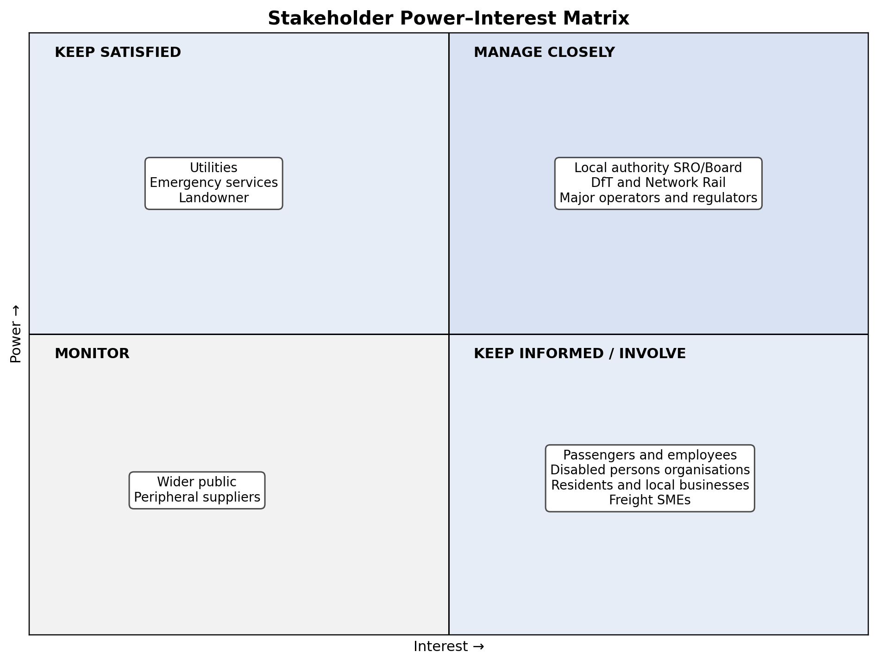
Figure 4. Stakeholder power–interest matrix
Table 3. Stakeholder involvement and decision arrangements
Stakeholder | Involvement | Governance / cadence
SRO and Project Board | Approve business case, tolerances, major changes and opening | Accountable; fortnightly decisions
DfT, Network Rail and operators | Validate capacity, integration, standards and readiness | Consulted/accountable for interfaces; weekly
Regulators, utilities and emergency services | Provide approvals, utility coordination and emergency assurance | Technical workshops and trackers
Passengers and accessibility groups | Co-design routes, information and assistance | Walk-throughs and user trials
Residents, businesses and freight firms | Review traffic, noise, access and delivery windows | Briefings, liaison and issue close-out

8. Allocation of Resources
Resources follow WBS priorities and the critical path. The core team includes the Senior Responsible Owner, Project Director, controls and commercial managers, design and construction managers, operations and digital leads, safety and accessibility specialists, communications staff and administration. Specialist suppliers provide surveys, traffic modelling, utilities, modular structures, civil works, systems integration, testing and training.
As the poster provides no budget, an indicative £18.5 million control envelope is used solely for planning and requires validation through surveys, market testing and business-case approval. Table 4 allocates funding by control account and retains Board-held contingency. Early supplier involvement supports modular and digital packages, while competitive procurement is used where schedule permits. Evaluation considers whole-life value, capability, safety and delivery certainty. Sustainable control also considers reuse, low-emission operation, waste and disruption (Kivilä, Martinsuo and Vuorinen, 2017). Labour peaks during construction in Weeks 6–10 and shifts towards operators, trainers and testers in Weeks 13–16. Forecast cost and completion are reviewed weekly, with safety-critical and critical-path work prioritised when capacity is constrained.
Resource planning distinguishes committed, forecast and contingency capacity. Long-lead modules, switchgear and information equipment receive early procurement decisions, while framework suppliers provide alternatives if lead times deteriorate. Earned-value indicators are used proportionately at control-account level, supported by physical progress evidence. Commercial reviews examine forecast final cost, claims, contingency use and upcoming commitments rather than relying only on expenditure already incurred.
Table 4. Indicative resource and budget allocation
Control account | Share | Indicative £m | Primary control
Design, surveys and approvals | 8% | 1.48 | Design freeze and approval tracker
Enabling works and utilities | 17% | 3.15 | Surveys, permits and productivity
Modular structures | 30% | 5.55 | Factory inspection and installation milestones
Transport and freight layouts | 13% | 2.41 | Traffic tests and operator acceptance
Digital, security and accessibility | 12% | 2.22 | Acceptance tests and audits
Testing, management and communications | 7% | 1.30 | Readiness evidence and forecasts
Board-held contingency | 13% | 2.39 | Released only through formal change control

9. Risk Analysis
Risk management continues from mobilisation to demobilisation. Ward and Chapman (2003) recommend addressing uncertainty, assumptions and interfaces rather than recording isolated threats only. Risks are scored from one to five for likelihood and impact, assigned to owners and reviewed weekly. Figure 5 displays initial exposure and Table 5 records controls, triggers and residual ratings.
The most serious threats are approval delay, unknown utilities, congestion, passenger–freight conflict, safety incidents, digital failure, supply delay, cost escalation and accessibility failure. Controls include parallel approvals, utility mapping and trial holes, traffic modelling, segregated routes, timed freight windows, CDM planning, backup information, early ordering, change control and independent accessibility testing. Accessibility failure blocks opening. High-impact contingencies are rehearsed rather than assumed.
Risk transfer through insurance or contract does not remove the authority’s accountability for public outcomes. Avoidance is used where safety cannot be assured; mitigation is used where essential work must continue. Opportunities include reusing modules for future emergencies and retaining shared digital infrastructure. Flyvbjerg (2014) warns that infrastructure projects are vulnerable to optimism bias. The plan therefore uses explicit assumptions, independent assurance, comparable-project data and forecast-at-completion reporting. Progress reports show residual risk beside cost and schedule so unresolved problems are not hidden by apparent milestone achievement.
The risk register is linked to the schedule, cost forecast and decision log. Triggers are observable conditions, not vague warnings, enabling action before consequences occur. The Safety Manager and Accessibility Lead have authority to stop work or withhold readiness approval. A pre-opening risk workshop tests combined scenarios, because individually manageable events may create serious consequences when they occur together. Residual risks accepted at opening are documented with monitoring arrangements and accountable approval.
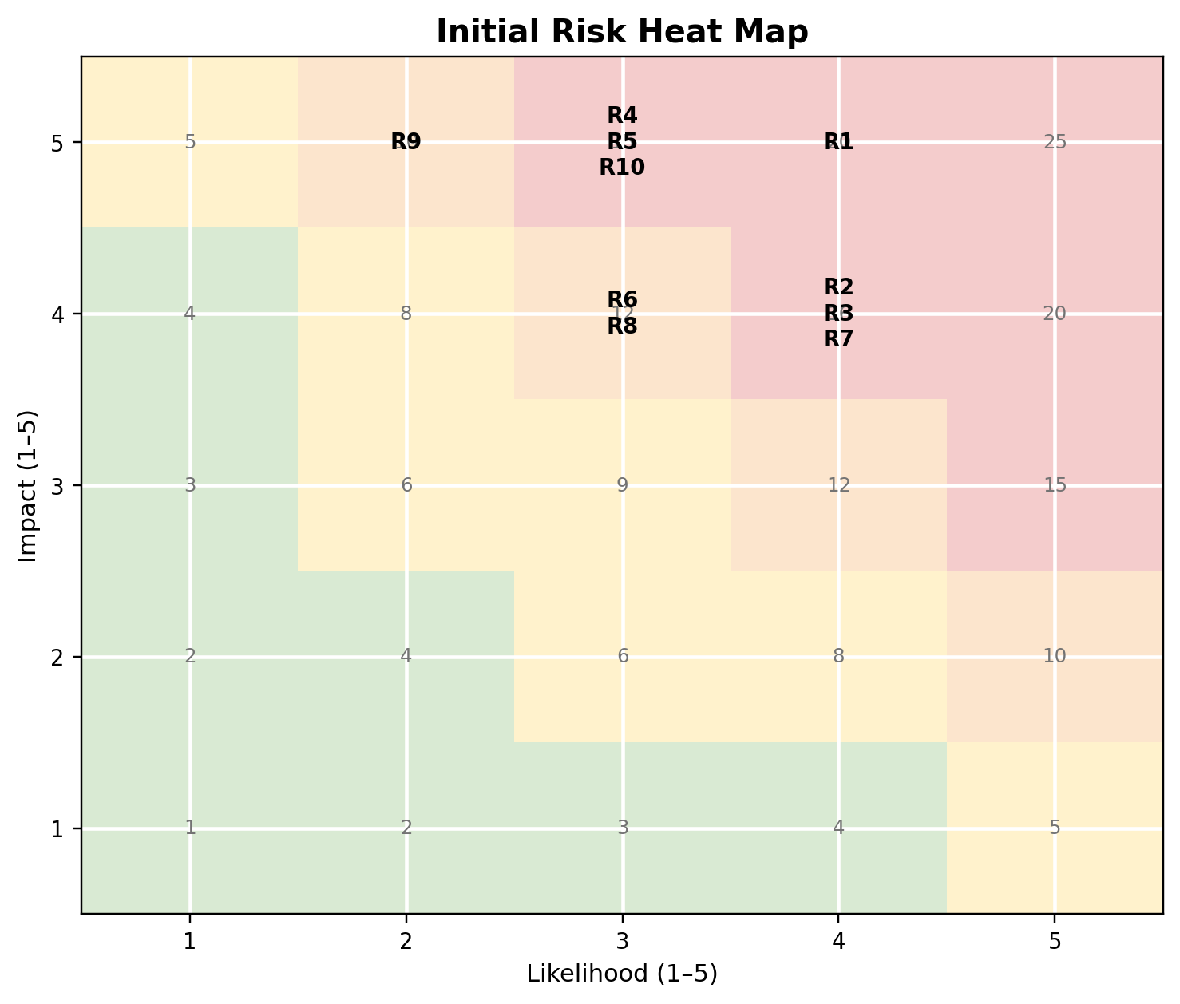
Figure 5. Initial risk heat map
Table 5. Principal project risk register
Risk | Initial | Main response and trigger | Owner / residual
Approval or site delay | 4×5=20 | Parallel submissions; escalate after three-day slippage | SRO / 2×4=8
Unknown utilities | 4×4=16 | Records, scanning and trial holes; redesign on discovery | Design Manager / 2×3=6
Traffic gridlock | 4×4=16 | Modelling, orders, marshals and dynamic routing | Operations Lead / 3×3=9
Passenger–freight conflict | 3×5=15 | Segregation and timed windows; stop on route breach | Freight Lead / 2×4=8
Construction safety incident | 3×5=15 | CDM plan, permits, inspections and near-miss learning | Safety Manager / 2×5=10
Digital information failure | 3×4=12 | Backup channels, printed signs and staffed help points | Digital Lead / 2×3=6
Cost or supply escalation | 4×4=16 | Early orders, alternatives, package allowances and contingency | Commercial Manager / 3×3=9
Accessibility non-compliance | 3×5=15 | Independent audit and user trial; opening blocked | Accessibility Lead / 1×5=5

10. Conclusion
The plan converts the poster into a controlled temporary transport programme. A modular multimodal interchange provides the strongest balance of rapid delivery, safety, accessibility, coordinated passenger and freight operations, environmental responsibility and reversibility. SMART objectives, the WBS, quad chart, Gantt chart, stakeholder matrix, resource plan and risk register create traceable controls for the sixteen-week target. Success depends on early approvals, disciplined scope, clear accountability, meaningful consultation and evidence-based opening gates. With active assurance and transparent reporting, the project can keep the city moving while permanent redevelopment is completed.

References
Association for Project Management (2025) APM Body of Knowledge. 8th edn. Princes Risborough: Association for Project Management. Available at: https://www.apm.org.uk/apm-body-of-knowledge/ [Accessed 26 July 2026].
Atkinson, R. (1999) ‘Project management: cost, time and quality, two best guesses and a phenomenon, it is time to accept other success criteria’, International Journal of Project Management, 17(6), pp. 337–342. Available at: https://doi.org/10.1016/S0263-7863(98)00069-6 [Accessed 26 July 2026].
Bryson, J.M. (2004) ‘What to do when stakeholders matter: stakeholder identification and analysis techniques’, Public Management Review, 6(1), pp. 21–53. Available at: https://doi.org/10.1080/14719030410001675722 [Accessed 26 July 2026].
Consilvio, A., Calabrò, L., Di Febbraro, A. and Sacco, N. (2021) ‘A multimodal solution approach for mitigating the impact of planned maintenance on metro rail attractiveness’, EURO Journal on Transportation and Logistics, 10, article 100047. Available at: https://doi.org/10.1016/j.ejtl.2021.100047 [Accessed 26 July 2026].
Department for Transport (2018) The Inclusive Transport Strategy: Achieving Equal Access for Disabled People. London: Department for Transport. Available at: https://www.gov.uk/government/publications/inclusive-transport-strategy/the-inclusive-transport-strategy-achieving-equal-access-for-disabled-people [Accessed 26 July 2026].
Flyvbjerg, B. (2014) ‘What you should know about megaprojects and why: an overview’, Project Management Journal, 45(2), pp. 6–19. Available at: https://doi.org/10.1002/pmj.21409 [Accessed 26 July 2026].
Freeman, R.E. (1984) Strategic Management: A Stakeholder Approach. Boston, MA: Pitman.
Great Britain (2015) The Construction (Design and Management) Regulations 2015, SI 2015/51. London: The Stationery Office. Available at: https://www.legislation.gov.uk/uksi/2015/51/contents [Accessed 26 July 2026].
Kamali, M. and Hewage, K. (2016) ‘Life cycle performance of modular buildings: a critical review’, Renewable and Sustainable Energy Reviews, 62, pp. 1171–1183. Available at: https://doi.org/10.1016/j.rser.2016.05.031 [Accessed 26 July 2026].
Kivilä, J., Martinsuo, M. and Vuorinen, L. (2017) ‘Sustainable project management through project control in infrastructure projects’, International Journal of Project Management, 35(6), pp. 1167–1183. Available at: https://doi.org/10.1016/j.ijproman.2017.02.009 [Accessed 26 July 2026].
Müller, R., Pemsel, S. and Shao, J. (2014) ‘Organizational enablers for governance and governmentality of projects: a literature review’, International Journal of Project Management, 32(8), pp. 1309–1320. Available at: https://doi.org/10.1016/j.ijproman.2014.03.007 [Accessed 26 July 2026].
Network Rail (2022) Station Capacity Planning Design Manual NR/GN/CIV/100/03. London: Network Rail. Available at: https://www.networkrail.co.uk/wp-content/uploads/2022/02/Station-Capacity-Planning-Design-Manual.pdf [Accessed 26 July 2026].
Olander, S. and Landin, A. (2005) ‘Evaluation of stakeholder influence in the implementation of construction projects’, International Journal of Project Management, 23(4), pp. 321–328. Available at: https://doi.org/10.1016/j.ijproman.2005.02.002 [Accessed 26 July 2026].
Shenhar, A.J., Dvir, D., Levy, O. and Maltz, A.C. (2001) ‘Project success: a multidimensional strategic concept’, Long Range Planning, 34(6), pp. 699–725. Available at: https://doi.org/10.1016/S0024-6301(01)00097-8 [Accessed 26 July 2026].
Too, E.G. and Weaver, P. (2014) ‘The management of project management: a conceptual framework for project governance’, International Journal of Project Management, 32(8), pp. 1382–1394. Available at: https://doi.org/10.1016/j.ijproman.2013.07.006 [Accessed 26 July 2026].
Ward, S. and Chapman, C. (2003) ‘Transforming project risk management into project uncertainty management’, International Journal of Project Management, 21(2), pp. 97–105. Available at: https://doi.org/10.1016/S0263-7863(01)00080-1 [Accessed 26 July 2026].

