Module Code: LCBB5000
Module Name: Data Handling & Business Intelligence
Assessment 2
Data Analysis & Visualisation

Student Name: Maria Hagiu
Student ID: 2024157
Table of Contents
Part 01 3
Determination of the profit or sales decline over the years using given superstore data 3
What if analysis of the sales and profit data of superstore 10
The use of Excel in prepossessing, analysing and visualising the data 13
Part 2 14
2.1 14
2.2 14
2.3 15
2.4 17
2.5 19
2.6 21
Advantages and disadvantages of the SPSS and Excel with relevant practical examples 21
References 23

Part 01

Determination of the profit or sales decline over the years using given superstore data
The given data includes more than 8000 sales-related data of a superstore. A pivot table has been used to show the trends of the profits or sales from the given data over the year. The trends of the profits or sales have been represented based on the different key items such as product categories, consumer categories, and regions.
Sum of Profit
Years | Quarters | Order Date | Total Profit
2009 | Qtr1 | Jan | 62326.4
 |  | Feb | 30368.64
 |  | Mar | 22802.96
 | Qtr2 | Apr | 39132.73
 |  | May | 18035.35
 |  | Jun | 34640.55
 | Qtr3 | Jul | 41582.58
 |  | Aug | 14469.59
 |  | Sep | 46657.81
 | Qtr4 | Oct | 55213.68
 |  | Nov | 16128.42
 |  | Dec | 52737.31
2010 | Qtr1 | Jan | 48177.27
 |  | Feb | 26225.49
 |  | Mar | 1095.53
 | Qtr2 | Apr | 17133.63
 |  | May | 42632.3
 |  | Jun | 36130.26
 | Qtr3 | Jul | 15918.45
 |  | Aug | 21279.8
 |  | Sep | 50474.77
 | Qtr4 | Oct | 48810
 |  | Nov | 23605.33
 |  | Dec | 33434.5
2011 | Qtr1 | Jan | 17750.59
 |  | Feb | 20848.88
 |  | Mar | 44260.68
 | Qtr2 | Apr | 36106.24
 |  | May | 24828.37
 |  | Jun | 17718.39
 | Qtr3 | Jul | 35212.15
 |  | Aug | 24378.93
 |  | Sep | 33098.01
 | Qtr4 | Oct | 49054.12
 |  | Nov | 39560.02
 |  | Dec | 37494.12
2012 | Qtr1 | Jan | 44339.89
 |  | Feb | 26392.27
 |  | Mar | 37641.03
 | Qtr2 | Apr | 31059.14
 |  | May | 29371.44
 |  | Jun | 30205.1
 | Qtr3 | Jul | 26834.31
 |  | Aug | 13515.36
 |  | Sep | 34579.9
 | Qtr4 | Oct | 20591.32
 |  | Nov | 26621.43
 |  | Dec | 21292.94
Grand Total |  |  | 1521767.98

Table 01: The total profits from 2009 to 2012 on a month and quarter basis
The given pivot table shows the profits of the superstore per month and quarter form over the years from 2009 to 2012. The total grand profit of the company was 1521767.98 over 4 years.
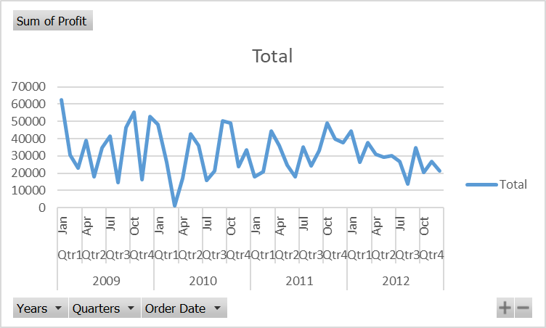
Figure: The trends of the total profits from 2009 to 2012.
From the line chart, it can be observed that the profit of the superstore has fluctuated over the years. It did not sharply decline or increase. The superstore faced the lowest profit in the first quarter of 2010. It generated the highest profit in 2009.

Sum of Profit |  | Years
Region | Province | 2009 | 2010 | 2011 | 2012 | Grand Total Profit
Atlantic | New Brunswick | 64,824 | 16,561 | 4,714 | 29,252 | 115,352
 | Newfoundland | 2,119 | - 887 | 3,403 | 2,250 | 6,885
 | Nova Scotia | 16,354 | 29,051 | 28,691 | 11,266 | 85,362
 | Prince Edward Island | - 1,348 | 10,509 | 10,203 | 11,998 | 31,362
Atlantic Total |  | 81,949 | 55,233 | 47,012 | 54,767 | 238,961
North Carolina | Elon | - 1,282 | 3,189 | 347 | 587 | 2,841
North Carolina Total |  | - 1,282 | 3,189 | 347 | 587 | 2,841
Northwest Territories | Northwest Territories | 4,510 | 1,616 | 3,625 | - 1,445 | 8,307
Northwest Territories Total |  | 4,510 | 1,616 | 3,625 | - 1,445 | 8,307
Ontario | Georgina | 7,818 | 14,615 | - 150 | 4,711 | 26,994
 | Hanover | 33,126 | 54,569 | 14,887 | 18,143 | 120,725
 | Ontario | 60,670 | 15,435 | 13,907 | 34,871 | 124,883
 | Orangeville | 22,285 | 12,214 | 21,065 | 18,703 | 74,267
 | Waterloo | 16,869 | 24,601 | 31,763 | 19,113 | 92,346
Ontario Total |  | 140,767 | 121,435 | 81,471 | 95,541 | 439,215
Prarie | Manitoba | 18,442 | 15,422 | 51,985 | 50,578 | 136,427
 | Saskachewan | 69,243 | 33,428 | 46,177 | 35,885 | 184,733
Prarie Total |  | 87,685 | 48,849 | 98,162 | 86,464 | 321,160
Quebec | Quebec | 47,563 | 29,332 | 17,383 | 46,149 | 140,427
Quebec Total |  | 47,563 | 29,332 | 17,383 | 46,149 | 140,427
West | Alberta | 30,823 | 32,086 | 63,314 | 25,725 | 151,946
 | British Columbia | 28,366 | 46,834 | 40,025 | 29,837 | 145,062
West Total |  | 59,189 | 78,920 | 103,338 | 55,561 | 297,009
Yukon | Dawson | 10,604 | 18,936 | 20,595 | 8,646 | 58,781
 | Whitehorse | 3,112 | 7,407 | 8,376 | - 3,826 | 15,068
Yukon Total |  | 13,716 | 26,343 | 28,971 | 4,819 | 73,849
Grand Total |  | 434,096 | 364,917 | 380,311 | 342,444 | 1,521,768

Table 02: The profit of the superstore from different regions and provinces over the years from 2009 to 2012
From the table, it can be seen that the company generated the highest total profit from Ontario in the 4 years from 2009 to 2012.
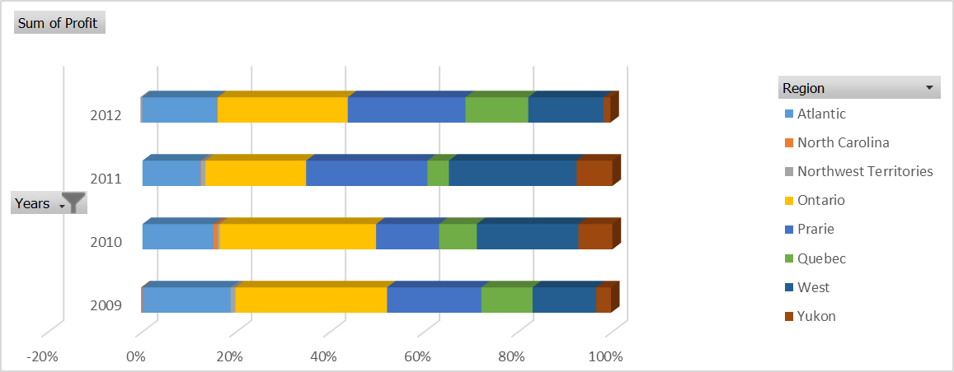
Figure 02: The profit of the superstore generated over the years from a different region
By using the pivot table, it can be seen which customer segment contribute most to the profit generated by the superstore from 2009 to 2012.
Sum of Profit |  | Years
Customer Segment | Quarters | 2009 | 2010 | 2011 | 2012 | Grand Total Profit
Consumer | Qtr1 | 32823.71 | 12454.04 | 20549.48 | 14250.06 | 80077.29
 | Qtr2 | 26656.52 | 28431.99 | 10231.46 | 16209.18 | 81529.15
 | Qtr3 | 25970.57 | -2652.47 | 13663.34 | 8851.46 | 45832.9
 | Qtr4 | 21754.34 | 23418.16 | 25488.33 | 9859.77 | 80520.6
Consumer Total |  | 107205.14 | 61651.72 | 69932.61 | 49170.47 | 287959.94
Corporate | Qtr1 | 51034.86 | 37901.22 | 11431.96 | 42232.17 | 142600.21
 | Qtr2 | 27699.18 | 24248.34 | 15849.17 | 50671.4 | 118468.09
 | Qtr3 | 28782.61 | 54141 | 41864.51 | 46815.12 | 171603.24
 | Qtr4 | 41405.46 | 49123.34 | 62346.59 | 14199.07 | 167074.46
Corporate Total |  | 148922.11 | 165413.9 | 131492.23 | 153917.76 | 599746
Home Office | Qtr1 | 13408.59 | 9777.62 | 26828.8 | 37735.58 | 87750.59
 | Qtr2 | 20422.89 | 21089.72 | 28091.77 | 7312.33 | 76916.71
 | Qtr3 | 33079.72 | 25501.2 | 14244.24 | 13008.04 | 85833.2
 | Qtr4 | 15216.51 | 27660.3 | 11087.17 | 13889.55 | 67853.53
Home Office Total |  | 82127.71 | 84028.84 | 80251.98 | 71945.5 | 318354.03
Small Business | Qtr1 | 18230.84 | 15365.41 | 24049.91 | 14155.38 | 71801.54
 | Qtr2 | 17030.04 | 22126.14 | 24480.6 | 16442.77 | 80079.55
 | Qtr3 | 14877.08 | 10683.29 | 22917 | 6254.95 | 54732.32
 | Qtr4 | 45703.1 | 5648.03 | 27186.17 | 30557.3 | 109094.6
Small Business Total |  | 95841.06 | 53822.87 | 98633.68 | 67410.4 | 315708.01
Grand Total |  | 434096.02 | 364917.33 | 380310.5 | 342444.13 | 1521767.98
Table 03: Profit generated from different customer segments over the years from 2009 to 2012.
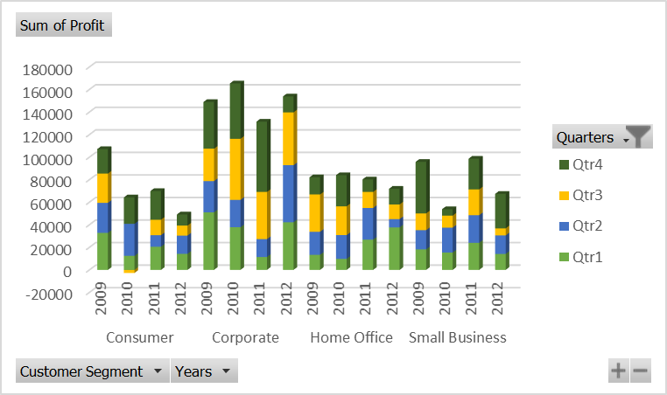
Figure 03: The profit generated from the different customer segment
The bar chart shows the profit generated from the different customer segments on a quarterly basis. It can be seen that the superstore generated the highest profit from the corporate customer segment. On the other hand, the home office segment provided a steady profit over the years compared to the consumer, corporate and small business segments.

Along with that, it is possible to see how much different product categories and sub-categories contribute to the profit generation of the company by using the Pivot table.
Sum of Profit |  | Years
Product Category | Product Sub-Category | 2009 | 2010 | 2011 | 2012 | Grand Total profit
Furniture | Bookcases | -3737.69 | -732.77 | -5164.59 | -23947.08 | -33582.13
 | Chairs & Chairmats | 54375.94 | 20433.28 | 40215.4 | 34625.11 | 149649.73
 | Office Furnishings | 27455.59 | 29418.19 | 25389.12 | 18165.03 | 100427.93
 | Tables | -16289.31 | -39721.3 | -10017.48 | -33034.41 | -99062.5
Furniture Total |  | 61804.53 | 9397.4 | 50422.45 | -4191.35 | 117433.03
Office Supplies | Appliances | 19849.29 | 32646.78 | 21918.29 | 22743.7 | 97158.06
 | Binders and Binder Accessories | 123917.08 | 44151.03 | 45016.67 | 94328.61 | 307413.39
 | Envelopes | 7450.6 | 16324.61 | 9727.04 | 14680.35 | 48182.6
 | Labels | 2623.09 | 2361.01 | 5702.02 | 2991.05 | 13677.17
 | Paper | 16968.01 | 12405.84 | 4460.37 | 11428.98 | 45263.2
 | Pens & Art Supplies | 2116.79 | 2504.73 | 1980.6 | 962.66 | 7564.78
 | Rubber Bands | -18.23 | -203.12 | -144.42 | 263.1 | -102.67
 | Scissors, Rulers and Trimmers | -2906.06 | -1340.33 | -1821.91 | -1730.95 | -7799.25
 | Storage & Organization | 7645.7 | 9292.69 | 121.35 | -10395.59 | 6664.15
Office Supplies Total |  | 177646.27 | 118143.24 | 86960.01 | 135271.91 | 518021.43
Technology | Computer Peripherals | 21279.68 | 15639.9 | 29195.9 | 28172 | 94287.48
 | Copiers and Fax | 33389.3 | 50521.2 | 58896.48 | 24554.51 | 167361.49
 | Office Machines | 60494.52 | 104221.57 | 76732.38 | 66264.46 | 307712.93
 | Telephones and Communication | 79481.72 | 66994.02 | 78103.28 | 92372.6 | 316951.62
Technology Total |  | 194645.22 | 237376.69 | 242928.04 | 211363.57 | 886313.52
Grand Total |  | 434096.02 | 364917.33 | 380310.5 | 342444.13 | 1521767.98

Table 04: Profit of the superstore from different product categories

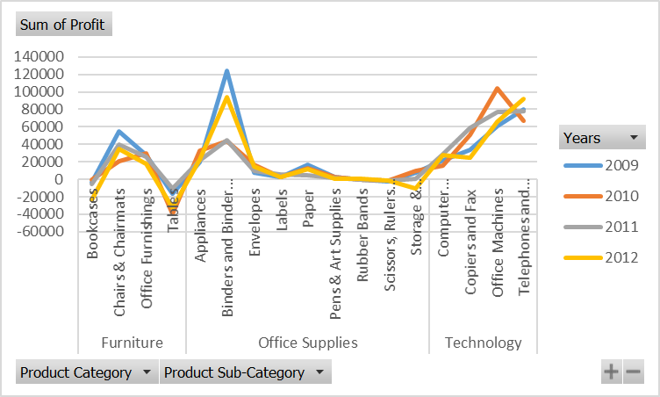
Figure 04: Different product categories’ contribution to profit generation
The line graph shows that the superstore generated a loss in table categories product in every from 2009 to 2012. Binders and Binder Accessories is the product segment which generated the highest profit in 2009. And after that, from 2010 to 2012, office machines generated the maximum amount of profit for the superstore.

What if analysis of the sales and profit data of superstore
The given table below shows the sales of the superstore along with its cost and profit over the years from 2019 to 2012 on a quarterly basis.
Years | Quarters | Sum of Sales | Cost | Sum of Profit
2009 | Qtr1 | 1260505.865 | 1145007.87 | 115498
 | Qtr2 | 886878.088 | 795069.458 | 91808.63
 | Qtr3 | 1036090.29 | 933380.31 | 102709.98
 | Qtr4 | 1026422.603 | 902343.193 | 124079.41
2010 | Qtr1 | 825530.275 | 750031.985 | 75498.29
 | Qtr2 | 844439.909 | 748543.719 | 95896.19
 | Qtr3 | 877873.556 | 790200.536 | 87673.02
 | Qtr4 | 1012243.305 | 906393.475 | 105849.83
2011 | Qtr1 | 843994.75 | 761134.6 | 82860.15
 | Qtr2 | 748576.579 | 669923.579 | 78653
 | Qtr3 | 835066.3905 | 742377.3 | 92689.09
 | Qtr4 | 1002307.262 | 876199.002 | 126108.26
2012 | Qtr1 | 969332.0665 | 860958.877 | 108373.19
 | Qtr2 | 923686.9725 | 833051.293 | 90635.68
 | Qtr3 | 868312.0995 | 793382.53 | 74929.57
 | Qtr4 | 954340.8145 | 885835.125 | 68505.69
Grand Total |  | 14915600.82 | 13393832.8 | 1521767.98
Table 05: Sum of the total profit of the superstore
Further, what if the analysis has been conducted to see how much the profit moves if the sales increase or decrease by 10 per cent? The result is given below
 |  | Current Values: | 10% increase in sales | 10% decrease in sales
Changing Cells:
 | $D$7 | 1260505.865 | 1386556 | 1145914
 | $D$8 | 886878.088 | 975565.9 | 806252.8
 | $D$9 | 1036090.29 | 1139699 | 941900.3
 | $D$10 | 1026422.603 | 1129065 | 933111.5
 | $D$11 | 825530.275 | 908083.3 | 750482.1
 | $D$12 | 844439.909 | 844439.909 | 844439.909
 | $D$13 | 877873.556 | 877873.556 | 877873.556
 | $D$14 | 1012243.305 | 1012243.305 | 1012243.305
 | $D$15 | 843994.75 | 843994.75 | 843994.75
 | $D$16 | 748576.579 | 748576.579 | 748576.579
 | $D$17 | 835066.3905 | 835066.3905 | 835066.3905
 | $D$18 | 1002307.262 | 1002307.262 | 1002307.262
 | $D$19 | 969332.0665 | 969332.0665 | 969332.0665
 | $D$20 | 923686.9725 | 923686.9725 | 923686.9725
 | $D$21 | 868312.0995 | 868312.0995 | 868312.0995
 | $D$22 | 954340.8145 | 954340.8145 | 954340.8145
Result Cells:
 | $F$7 | 115498 | 241548.135 | 906.135
 | $F$8 | 91808.63 | 180496.442 | 11183.342
 | $F$9 | 102709.98 | 206318.6905 | 8519.9905
 | $F$10 | 124079.41 | 226721.807 | 30768.307
 | $F$11 | 75498.29 | 158051.315 | 450.115
 | $F$12 | 95896.19 | 95896.19 | 95896.19
 | $F$13 | 87673.02 | 87673.02 | 87673.02
 | $F$14 | 105849.83 | 105849.83 | 105849.83
 | $F$15 | 82860.15 | 82860.15 | 82860.15
 | $F$16 | 78653 | 78653 | 78653
 | $F$17 | 92689.09 | 92689.09 | 92689.09
 | $F$18 | 126108.26 | 126108.26 | 126108.26
 | $F$19 | 108373.19 | 108373.19 | 108373.19
 | $F$20 | 90635.68 | 90635.68 | 90635.68
 | $F$21 | 74929.57 | 74929.57 | 74929.57
 | $F$22 | 68505.69 | 68505.69 | 68505.69
 | $F$23 | 1521767.98 | 2025310.06 | 1064001.56
Notes: Current Values column represents values of changing cells at
time Scenario Summary Report was created. Changing cells for each
the scenario is highlighted in grey.
Table 06: Scenario Summary
In the scenario summary, it can be seen that if the total sale increased by 10 per cent the total profit increased to 2025310. On the other hand, if the sales of the superstore decreased by 10 per cent, the total profit of the superstore would be decreased to 1064001.

The use of Excel in prepossessing, analysing and visualising the data
Excel has complex analytical and computing features. It helps users to organise and sort the data in a meaningful way and to identify the trends of the data. This process helps users in decision-making in a significant way. Excel has features for shorting the data in any meaningful order desired by the user. A huge amount of data can be categorised and subcategorised based on the different basis (D. McCullough and Wilson, 2018). All those options help users to form a large amount of raw data into an easily usable format in an efficient way. A productive Excel spreadsheet will structure original data in a manner that is easy to read, which will make it much simpler to derive insights that can be put into practice. Excel users are able to change the fields and functions that generate calculations when working with data that is more sophisticated (Nash, 2008).
Excel provides a variety of options for displaying the analysis reports generated from the data. The information can be represented visually using a variety of charts, including bar charts, line charts, pie charts, and histograms, in either a two-dimensional or three-dimensional manner. Excel users have access to a wide selection of chart kinds, and they are able to choose the sort of chart that functions most well with their data (Randi, Nicholson and Bettio, 2018). On the other side, one can utilize the Excel Recommended Charts feature to display charts that have been customized to work with specific data, and then one can choose one of those charts to use. The usage of charts and graphs makes it simpler for the audience and the readers to comprehend the information being presented. In addition to this, it has a great influence on the style of presentation (Zimmermann, 2019).

Part 2

2.1
From the Pie chart generated through SPSS, it can be seen that 95 students like vanilla flavour ice cream. This portion is shown by the blue part of the chart given below.
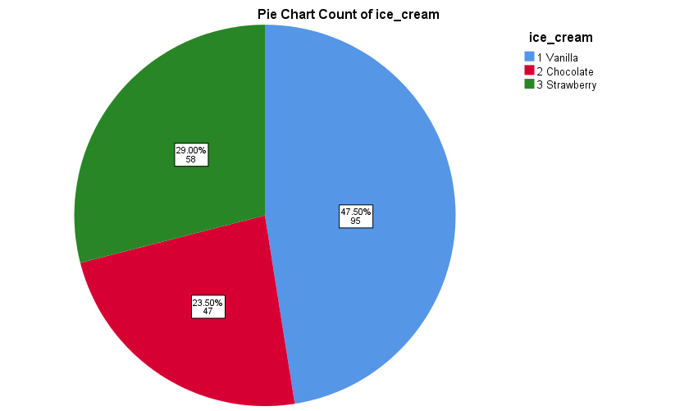
Figure 05: The pie chart of the count of ice cream flavours liked by the students

2.2
From the pie chart generated by the SPSS, it can be seen that there are the number of female students indicated by 1 is 109 in the number shown by the red part of the graph. On the other hand, it also can be seen there are 91 male students indicated by the 1 and shown by the blue part of the chart.

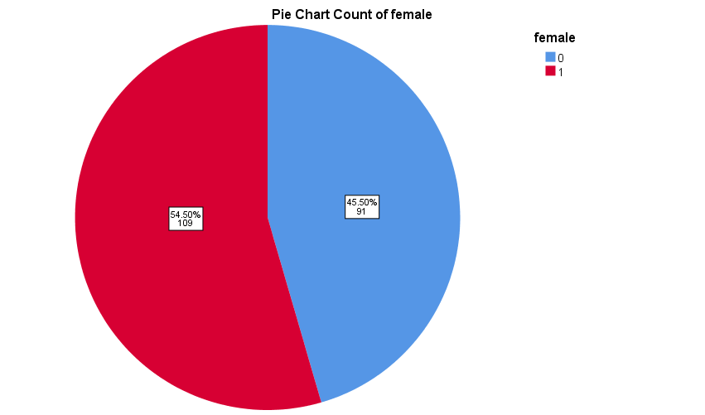
Figure 06: The count of male and female students participating in the survey

2.3
The mean and median of the student who likes vanilla and chocolate ice cream are based on the video and puzzle test.

Descriptive
 | ice-cream |  |  | Statistic | Std. Error
puzzle | Vanilla | Mean |  | 52.03 | 1.023
puzzle | Vanilla | 95% Confidence Interval for Mean | Lower Bound | 50.00
puzzle | Vanilla | 95% Confidence Interval for Mean | Upper Bound | 54.06
puzzle | Vanilla | 5% Trimmed Mean |  | 52.31
puzzle | Vanilla | Median |  | 51.00
puzzle | Chocolate | Mean |  | 47.32 | 1.581
puzzle | Chocolate | 95% Confidence Interval for Mean | Lower Bound | 44.14
puzzle | Chocolate | 95% Confidence Interval for Mean | Upper Bound | 50.50
puzzle | Chocolate | 5% Trimmed Mean |  | 47.31
puzzle | Chocolate | Median |  | 46.00
puzzle | Strawberry | Mean |  | 57.14 | 1.308
puzzle | Strawberry | 95% Confidence Interval for Mean | Lower Bound | 54.52
puzzle | Strawberry | 95% Confidence Interval for Mean | Upper Bound | 59.76
puzzle | Strawberry | 5% Trimmed Mean |  | 57.73
puzzle | Strawberry | Median |  | 61.00
video | Vanilla | Mean |  | 51.71 | .916
video | Vanilla | 95% Confidence Interval for Mean | Lower Bound | 49.89
video | Vanilla | 95% Confidence Interval for Mean | Upper Bound | 53.52
video | Vanilla | 5% Trimmed Mean |  | 51.48
video | Vanilla | Median |  | 53.00
video | Chocolate | Mean |  | 47.70 | 1.519
video | Chocolate | 95% Confidence Interval for Mean | Lower Bound | 44.64
video | Chocolate | 95% Confidence Interval for Mean | Upper Bound | 50.76
video | Chocolate | 5% Trimmed Mean |  | 47.58
video | Chocolate | Median |  | 47.00
video | Strawberry | Mean |  | 55.45 | 1.286
video | Strawberry | 95% Confidence Interval for Mean | Lower Bound | 52.87
video | Strawberry | 95% Confidence Interval for Mean | Upper Bound | 58.02
video | Strawberry | 5% Trimmed Mean |  | 56.10
video | Strawberry | Median |  | 58.00

The mean of the students who like the vanilla is 52.03 in Puzzle and 51.71 in video and the median is 51.00 and 53.00 respectively. And the mean of the student who likes chocolate is 47.32 in puzzles and 47.70 in video and the median is 46.00 and 47.00 respectively.

2.4
Interpretation:
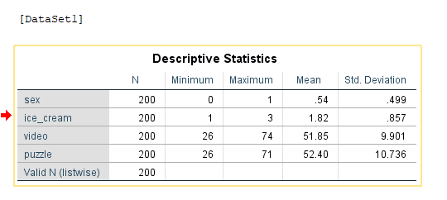
As it can be seen from the descriptive statistics, the number of people participating here or the same taken is 200 people and the mean is 54 for sex and the standard deviation is .499 and the rest are presented similarly.
K-mean clustered graph:
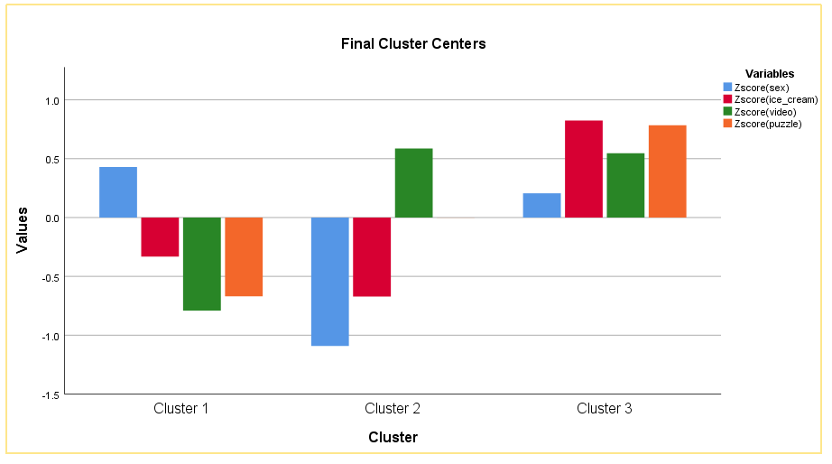
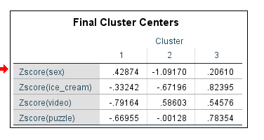
As can be visible from the graph, there have been three clusters that have been derived from the data given and in cluster 1, only the Z-score for sex (male/female) is positive and the rest z-score values are negative. In the second cluster, the z-score for the puzzle is so minimal that, it can’t be visible in the graph and only the z-score for video is positive. The third cluster shows every value is positive.
ANOVA Table:
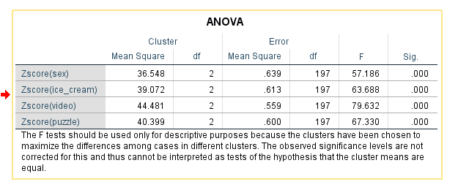
The ANOVA table shows the mean square for each variable sex, ice cream, video, and puzzle which are 36.548, 39.072, 44.481, and 40.399 respectively. The significance column shows that all the values in the cluster are significant so, the derivation is successful of the k-mean of all the values here. The cluster mean for the three clustered classes are significant in this way. The cluster number of data taken in cluster 1 was 83, in cluster 2 the number of data taken was 46 and in the last cluster, the number of data taken was 71.

2.5
Data mining methods
Data mining refers to the processes that are used to transform unprocessed data into information that can be used. The ability of a corporation to recognize patterns is necessary for the development of more fruitful marketing campaigns, the acceleration of sales, and the reduction of operating costs. Data mining is the process of applying software to search for patterns in large amounts of data to assist in obtaining the desired result (Adriaans and Zantinge, 2020).
Clustering is one of the most famous techniques for data mining. Clustering indicates the method of putting together different data points into different groups based on what they have in common. Through cluster data mining, data miners can easily divide the data into subsets, which lets them make better decisions about consumers or users as well as regarding their acts and behaviour (D. McCullough and Wilson, 2018).
The individual can use different cluster mining methods for data mining. The methods include partitioning methods, density-based methods, Grid-based methods, model-based methods, and hierarchical methods. In the partitioning method, data is clustered according to shared characteristics and then individually assessed. In the density-based method data, individual data points are considered to be "noise" and thrown out, but data plotted together is examined further. Grid-based method indicates dividing the embedding space into cells rather than considering how the input items are scattered. It takes less time to data (HAN, 2022).
Retail companies such as Walmart use the clustering method to identify customer buying behaviour such as which product an individual customer purchased and how often he purchases this product. This helps the company in catering specific products or services to a specific group of people or geographical area (Last and Kandel, 2018).
Text mining
Text mining refers to the practice of sifting through and analysing huge amounts of unstructured text data with the help of software that can isolate and categorise significant concepts, patterns, subjects, keywords, and other qualities. Text mining and analysis help companies identify business insights in company papers, consumer emails, call centre logs, survey comments, social media posts, and medical information (Soriano, Au and Banks, 2013).
Text mining is similar to normal data. The very initial step of the text mining process involves organising and structuring the data so that it can be used in quantitative as well as qualitative analysis.
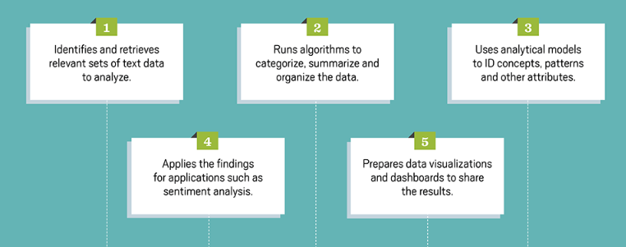
Figure 08: The steps of text mining (ZONG, 2022)
In the initial point the text data mining, a company requires to identify the relevant set and text data and retrieve those for further analysis. In the next step, the company requires to run algorithms to categorise the data and summaries and organised them based on a different basis. The company can use a different model to identify the pattern and concept of the text data. When the company can get the pattern or concept, the firm can apply the finding through sentiment analysis. In the last stage, the company can visualise the data to easily communicate the data. The results can be used to develop a new product or develop a marketing or distribution strategy (ZONG, 2022).
The most famous use of text mining is in SEO (Search Engine Optimisation). Google and Bing use a text mining process for identifying the spam and filler in content marketing websites. The search engine can identify misspellings, context, and intent to classify an email as spam, or it can penalize a firm website that has attempted to raise its search ranking by keyword stuffing and other techniques (Last and Kandel, 2018).

2.6

Advantages and disadvantages of the SPSS and Excel with relevant practical examples
The advantages and disadvantages of SPSS
SPSS is a famous statistical tool which is used for advanced analytics, data management, business intelligence, multivariable analysis and even in criminal investigations (Gilmour, 2016).
Advantages | Disadvantages
SPSS has flexible input capabilities. For example, it can take any file to process them and generate the chart, tabulated report, descriptive statistics, etc. | For using the SPSS, the users need to be trained.
SPSS offers in-depth statistical capabilities to its users. | SPSS requires an annual license.
Better reporting and presentation features are also included in SPSS | It fails to deal with long question text well.
The output generated from the SPSS can be used easily on other statistical tools | Error logs are difficult to interpret

The advantages and disadvantages of Excel
Advantages | Disadvantages
In excel it is easy to store the data | Data entry in excel is very time-consuming. It takes significant time to enter the data before processing or analysing the data.
A large amount of data such as sales data, survey data, etc. can be analysed | Users require to be trained before using Excel.
All mathematical and logical functions such as addition, average, etc. help to deal with complex calculations. | Consolidation of data is very hard in excel
The data can be visualised graphically using different features of Excel such as line graphs, pie charts, bar charts, etc. | Excel is prone to human error.
Users can lock their data by using the password in Excel. | In making a quick decision, excel is not a suitable tool for the decision-makers. Because, processing, analysing, and summarising the data in Excel required significant time.

References
Adriaans, P. and Zantinge, D., 2020. Data mining. New Delhi: Pearson Education.
D. McCullough, B. and Wilson, B., 2018. On the accuracy of statistical procedures in Microsoft Excel 2000 and Excel XP. Computational Statistics &amp; Data Analysis, 40(4), pp.713-721.
Gilmour, H., 2016. Doing data analysis with SPSS 10.0Title: Doing data analysis with SPSS. MSOR Connections, 3(2), pp.49-50.
HAN, J., 2022. DATA MINING. [S.l.]: MORGAN KAUFMANN.
Last, M. and Kandel, A., 2018. Data mining in time series databases. New Jersey: World Scientific.
Nash, J., 2008. Teaching statistics with Excel 2007 and other spreadsheets. Computational Statistics &amp; Data Analysis, 52(10), pp.4602-4606.
Randi, G., Nicholson, N. and Bettio, M., 2018. Information System web application (Excel): analysing and visualising data. European Journal of Statistic, 28(suppl_4).
Soriano, J., Au, T. and Banks, D., 2013. Text mining in computational advertising. Statistical Analysis and Data Mining: The ASA Data Science Journal, 6(4), pp.273-285.
Zimmermann, A., 2019. Method evaluation, parameterization, and result validation in unsupervised data mining: A critical survey. WIREs Data Mining and Knowledge Discovery, 10(2).
ZONG, C., 2022. TEXT DATA MINING. [S.l.]: SPRINGER VERLAG, SINGAPOR.

