Integrated Project Report
(ACHA4008)
Daniel Jones

Contents
1. Introduction 3
2. Background Research 4
3. Project Plan 5
4. Design Process 7
4.1 Physical Design 7
4.2 Program Design 7
5. Evaluation & Conclusion 12

1. Introduction
The goal of this report is to construct and program a Lego spike robot that can follow a set route with three different stages that the robot must pass to successfully complete the course.
The first stage of the course consists of a coloured line the robot would need to follow towards the maze. The second stage consists of an obstacle the robot will have to avoid continuing its path along the coloured line. Finally, the last stage is a maze structure that will test the robot’s ability to detect dead ends and bring it to the red finish line where the program would finally terminate.
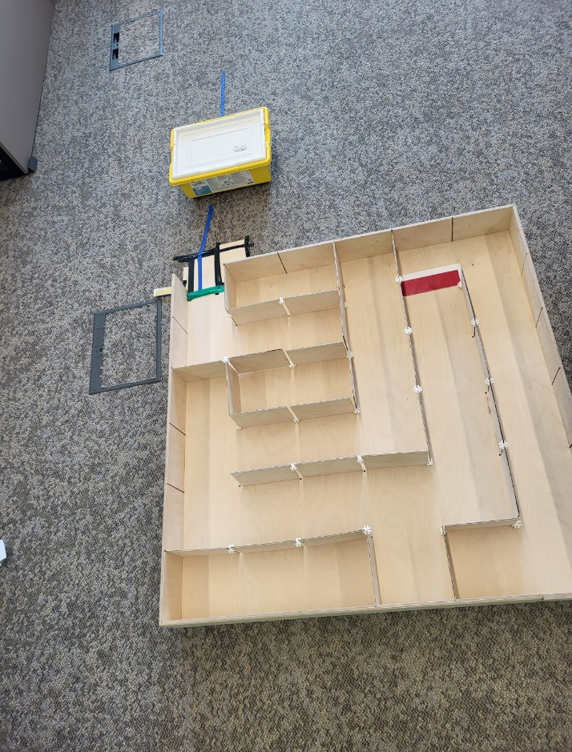
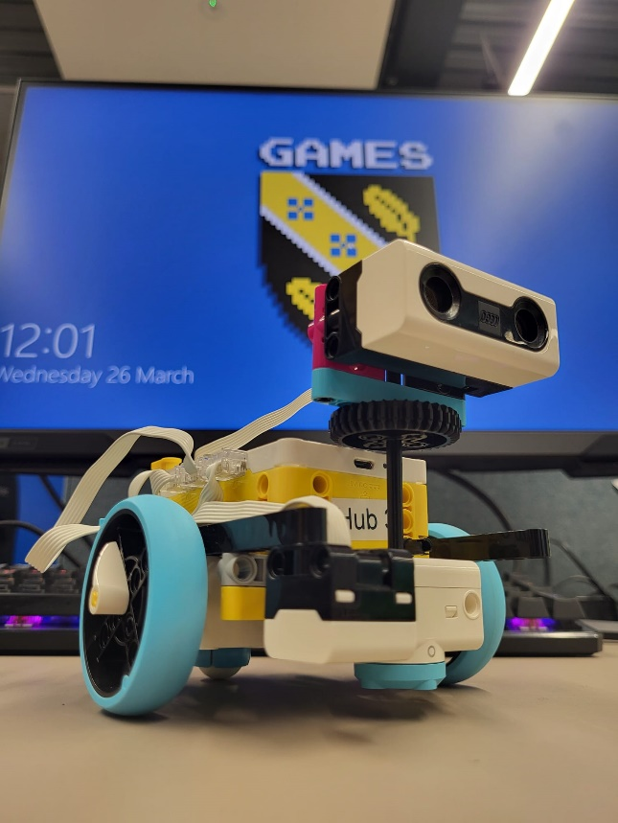
This project promotes teamwork, critical thinking, and the development of practical programming and problem-solving abilities. The project's ultimate objective is to create a working robot that can navigate the maze structure, solve each obstacle, and cross the red finish line.

2. Background Research
Throughout this project me and my team have done quite a deal of study into the Lego Spike Prime robot, to find appropriate strategies for our robot to meet each obstacle within this project. We found plenty of construction examples online which surely offered us numerous ideas of how to build the robot as well a few samples of the Lego spike block code that would aid us with the programming of our robot.
Since our first classes in this module, we have learnt a great deal about the construction and coding of the Lego Spike robot using the Lego Spike Education app. Our group gained some valuable insight into our primary project by being able to grasp the various Lego components and programming blocks and why they would be important.
Unfortunately, because this project is practical, the majority of the research we were able to locate and utilise consisted of straightforward YouTube video examples, which were not usually very beneficial because they lacked shared code or even instructions.
Jeremy Wuitschick's YouTube channel was one of the most beneficial to us; it gave us information on how the gyro, colour, and ultrasonic sensors functioned and how to use them correctly when creating the actual robot and the block code that naturally goes with it.
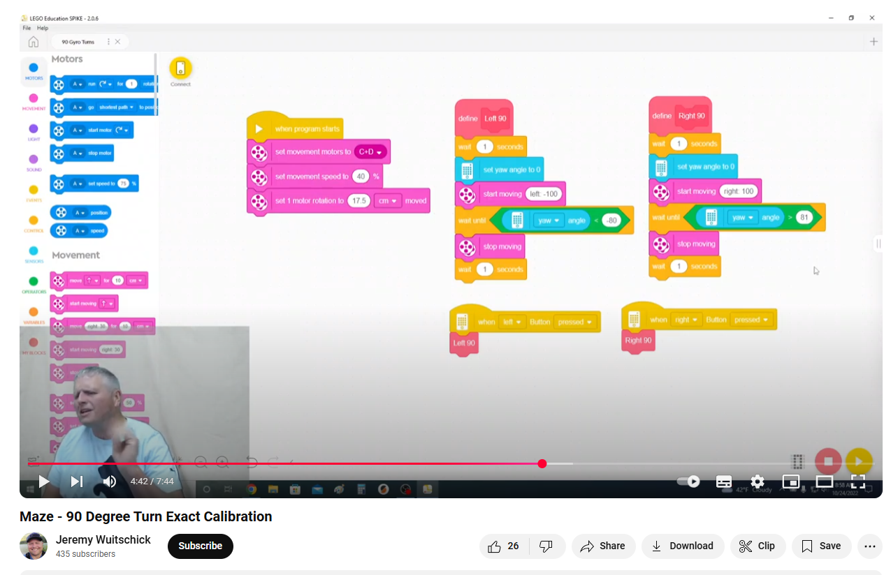
https://www.youtube.com/watch?v=GP6kGewvjb4&t=281s&ab_channel=JeremyWuitschick

3. Project Plan
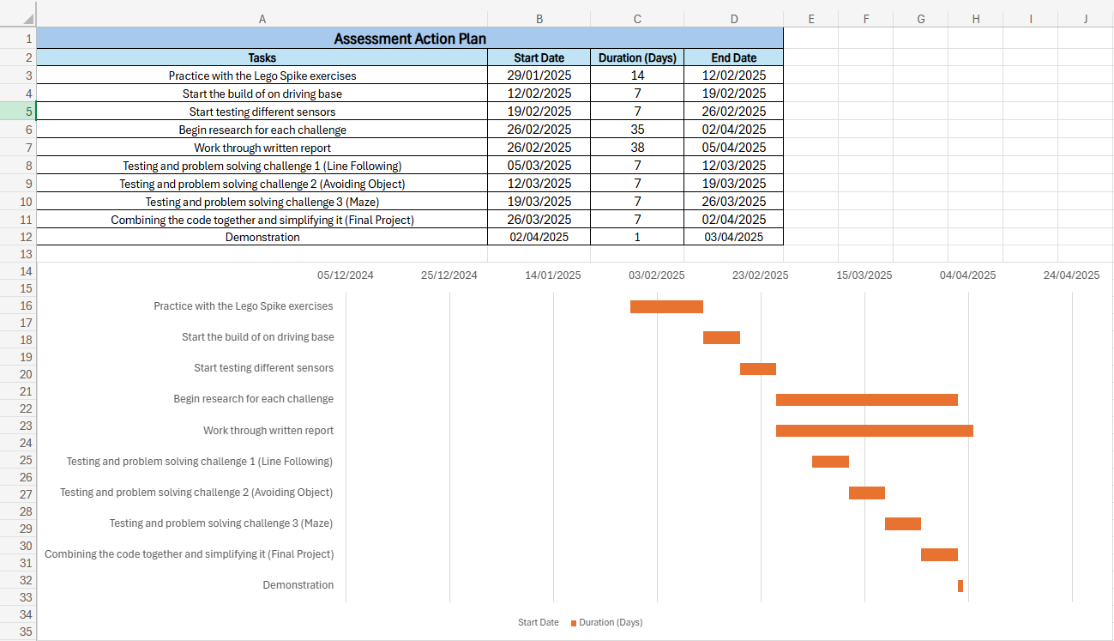
Throughout this project I have made an action plan to help organize my time and ensure I cover all my requirements for this project. Starting on the 29th of January we began practicing the Lego spike robot and the many practical exercises the website/app provides to get us used to the block programming and building aspect of the Lego Spike.
Later, we began working on the robot's first driving base, experimenting with various designs to determine which one best suited our future requirements. We started thoroughly testing the many sensors that the Lego spike comes with around February 19 and were beginning to comprehend their functions.
I began conducting more thorough internet study around February 26th in order to identify several strategies for overcoming the stages we would need to go through during our demonstration. Additionally, this is also the time I started to work on this report so I could work on it throughout the course of this module piece by piece.
We started working on resolving the many phases and difficulties of this project in March. We designated each team member to be a lead on each of the stages in accordance with this module. I was in charge of overseeing the line-following stage, which we worked on first. At this point, we practiced and tested the colour sensor and motor commands to enable the robot to follow the line using coloured paper.
We then started developing the robot's ability to avoid obstacles. Under Alex's direction, we detected the obstruction using a distance sensor, and then we used motor control and loop conditions to manoeuvre the robot around it.
Finally, we worked on the maze challenge where we had to make sure the robot can navigate a maze of wooden panels and get to the end of the maze with the red finish line. Lead by Beth we managed to build the robot and program it to detect walls with our rotatable distance sensor and have it rotated with supposedly 90 degree turns to help it navigate the maze structure and eventually find the finish line.
Once the above was completed, we as a team worked together to compile the code into a single program that should work from start to finish. In this time, we also cleaned up and simplified the code to ensure it visually made sense and even created a flowchart to help visually demonstrate the process. Lastly was the demonstration day whereas a group we recorded and presented our final practical project and discussed a bit about how it operated.

4. Design Process
In this part of the report, we’ll present and discuss both the physical design of the robot, and the programming blocks used with the respective flowchart to demonstrate how the robot works and how it solves each challenge step by step.

4.1 Physical Design
Below are some images of the final physical design of our Lego Spike robot used in the final demonstration. The robot's initial design was inspired by the Driving Base 3 construct seen in the Lego Spike educational program. This was because, in our first testing of the bases, we found the base design to be quite dependable. After that, we built up the distance sensor by attaching it to the third motor, which was initially employed for its additional weight, so that it could spin.
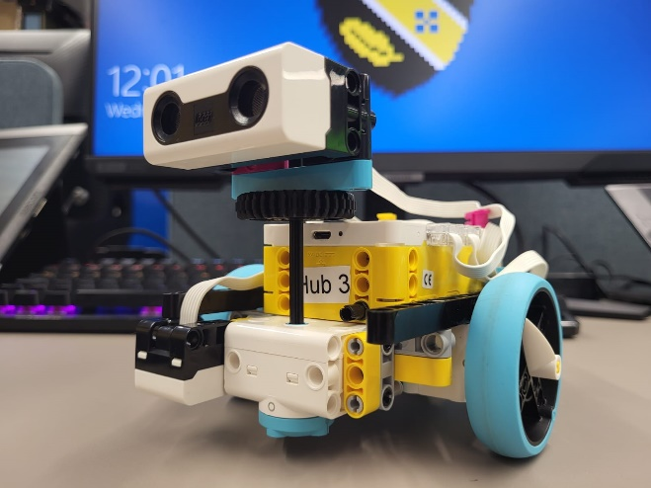

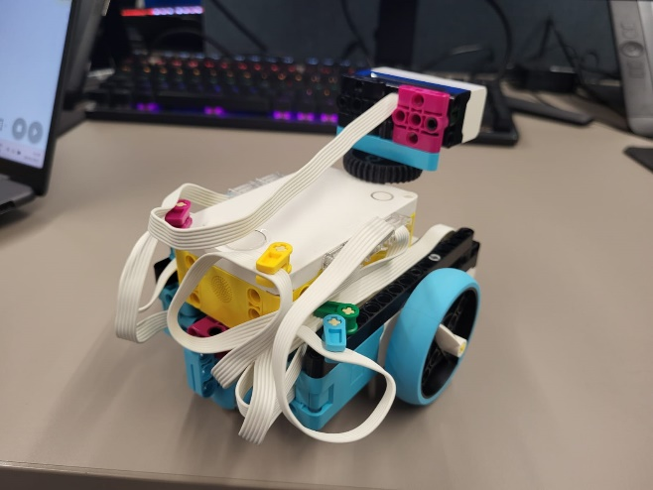
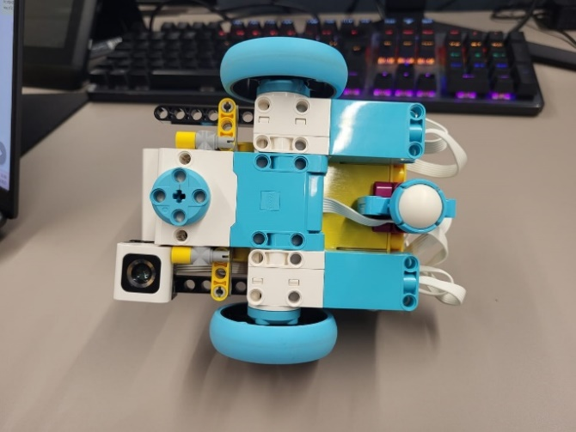
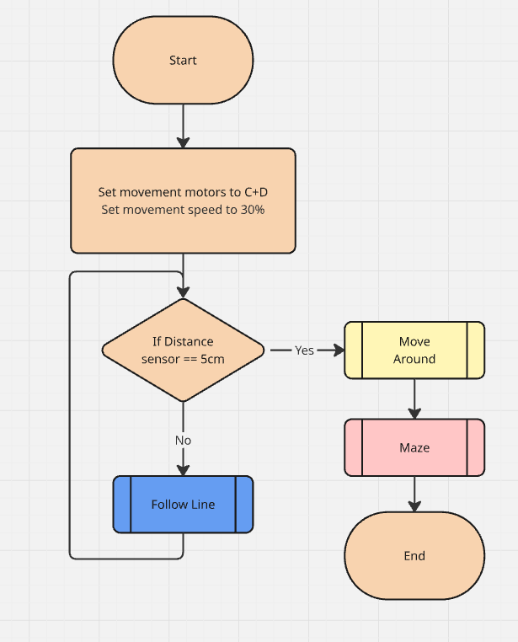
4.2 Program Design
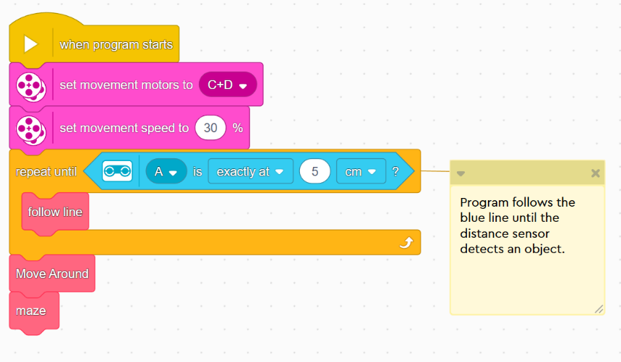

When it comes to programming the Lego spike robot, we as group worked on overcoming the different phases and challenges of the project and once that step was completed, we worked on combining the code into one seamless program using the block code provided with the Lego spike education app.
The images above present both the block code and the flowchart of the main program when the robot starts. Within this segment of the program the movement motors are set to the appropriate ports, the movement speed is set to 30% and a loop condition is set to have robot use the custom follow line functioned until an obstacle is detected in which point it will stop and continue on to the “Move Around” function that should allow the robot to avoid the object.
After the robot has successfully avoided the obstacle, the robot will then proceed with the Maze function where it will continue until it finds the red coloured finish line in which it will stop the program.

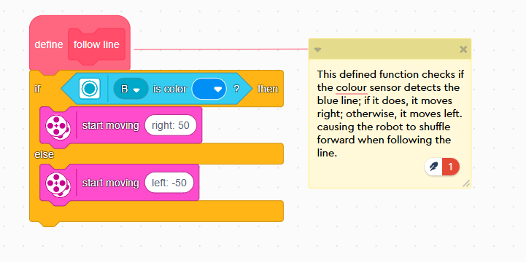
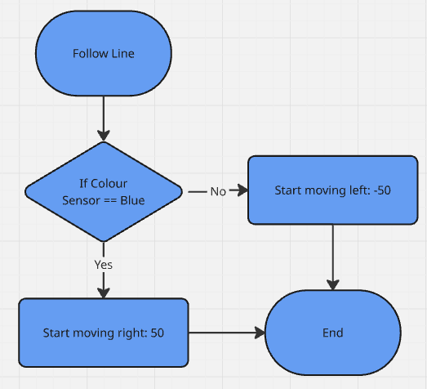
This part of the program demonstrates the follow line function that allows the Spike robot to follow the coloured line. With a simple if statement we were able to have the robot move either right when it detects a blue line or left when it doesn’t which allows the robot to follow the line no matter how the line is laid out.

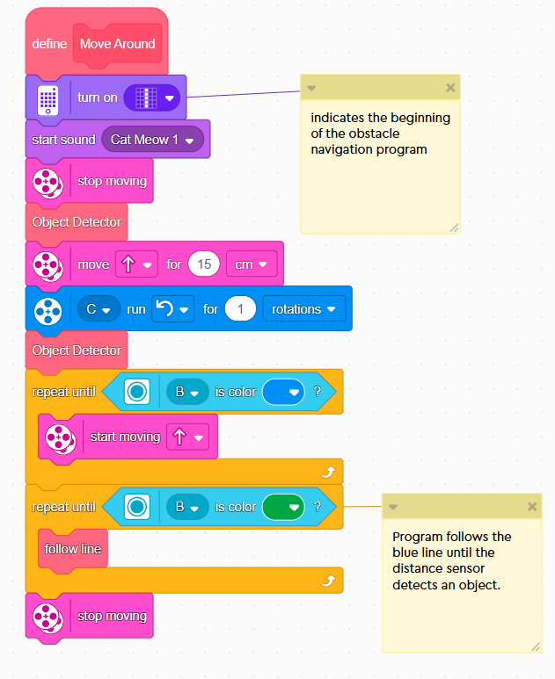
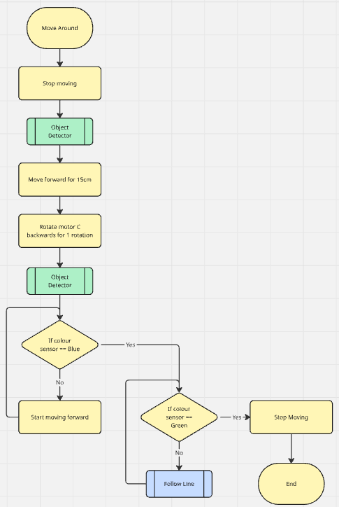
This part of the program allows the Spike robot to avoid the obstacle between it and the maze structure. It works by using the object detector function to detect for an object and if so rotate and move the robot slowly around the obstacle. This is setup to happen twice so that theoretically it should not matter the length or the width of the obstacle it is required to move around which in the case of the demonstration was the Lego Spike box.
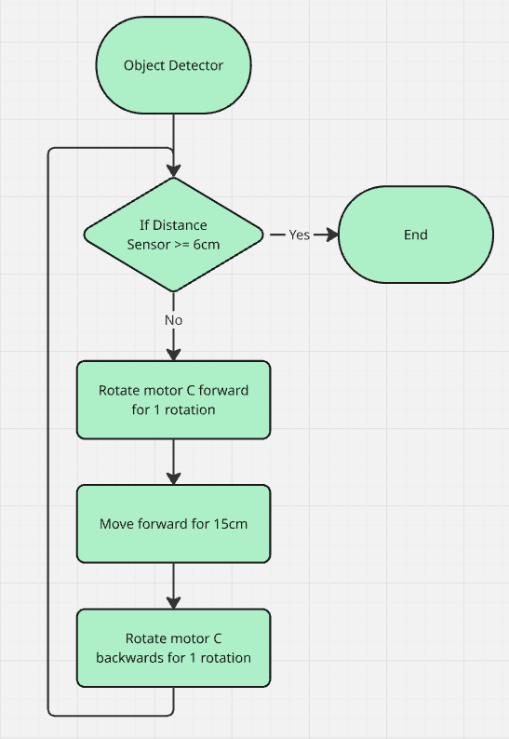
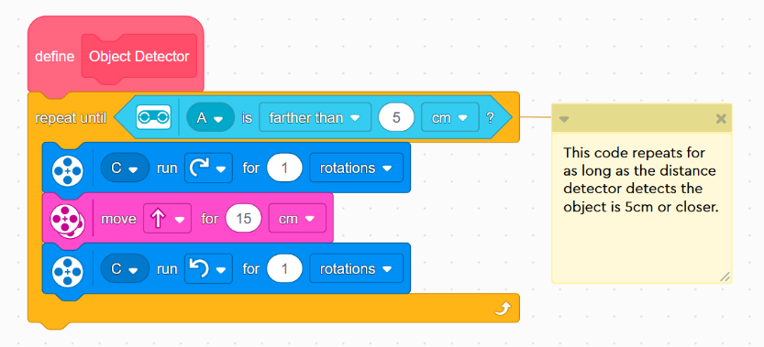
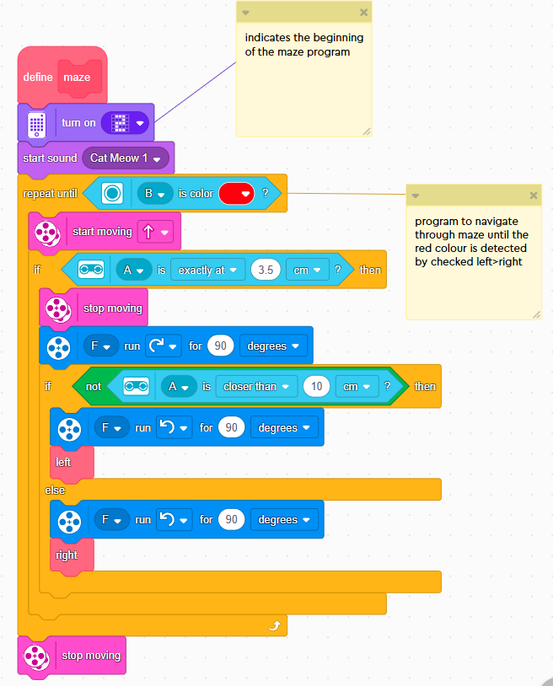
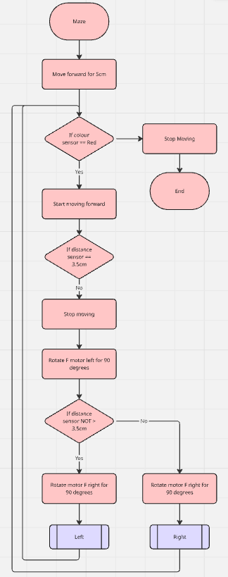
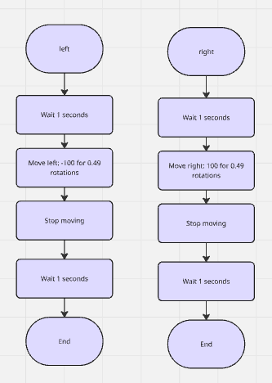
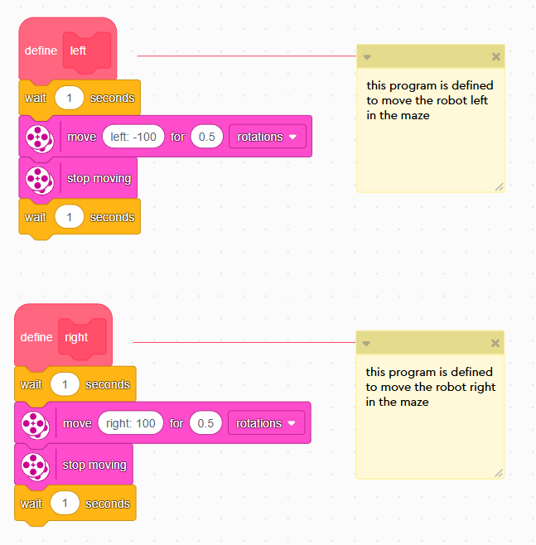
Finally, the program above is what we used for to navigate the maze structure of the course. By using a loop, we would be able to set a condition that the robot would look out for while exploring the maze structure which in this case would be the red line that symbolises the end of the course. Within this loop we set the spike robot to start moving forward and with if statements detect if any walls are within 3.5cm in front of it. If so, the robot would stop look left and determine there was also a wall to the left of it. By checking the left side for a wall, we can determine which direction we want the robot to rotate and continue to move in.

5. Evaluation & Conclusion
On the day of the demonstration our group did encounter a few technical challenges that did affect the overall performance. The main issues that arose was during the maze navigation phase, specifically when the robot needed to make 90-degree turns. Although the programming logic was untended to produce accurate right-angle turns, the robot would frequently fail to execute them as intended and due to this it would often clip the walls of the maze getting stuck and requiring physical assistance.
Additionally, there was also a minor inconsistency with the obstacle phase that would cause the robot to not detect the object properly and cause it to be stuck when attempting to get around said object. Despite the above issues, the remainer of the program did indeed run as intended and it was reassuring to see the robot still completed the core movements and respond appropriately with the sensors used.
In conclusion, while the project did complete all three challenges, it required more manual assistance than initially anticipated due to the inaccurate in its turning. If this project were to be replicated, it would require further research, refinement and extensive testing to reduce errors faced.

