DEVELOPING relationships and WORKPLACE achievement
Enakshi Chowdhury (1713199)

Table of Contents
1.0. Procedure 3
2.0 Introduction 4
3.0. Critically evaluation of employee engagement developing individual needs in the workplace. 4
4
3.1 Critically assessments the potential benefits of the organisation of personal development in the workplace 7
3.1.1 Training benefit to individual advantage and disadvantage 12
3.1.2 Training benefit to Organisation advantage and disadvantage 12
3.3 Performance management and details plan of individual development plan . 13
3.3.1 personal development plan 13
4. 0. Conclusion 15
5.0. Reference /Bibliography 15

1.0. Procedure

- Procedure adopted to prepare the report
- Included sources of information
- Website, Article’s, Books and News reports in online.

2.0 Introduction
For the development of the employees, nowadays employers try to attract them by acquiring a number of tips but unfortunately, the majority of them is yet to understand the value of the key statement, what the employee really needs to be successful (kholl,2020).McCarthy stated that employers seem to be overlooking the fact that employee is the key to the success behind the stiff rise of an organisation (mcarthy,2020).
According to the researches, it has been noticed that there is a number of ways to develop the employee’s skills by different technical skills, understanding the route or the vehicle through which the skills can be improved also differ from person to person.
This report will find out how individual success will eventually help the growth of the organisation. To come out with a plan lots of mediums will be researched like appraisal, training, motivation, personal development plan, performance management, etc.

3.0. Critically evaluation of employee engagement developing individual needs in the workplace.



Engagement is recognized as an individual manifestation of own’s in a role, it can be seen as when the individual is deeply engrossed in a work and take the eagerness or involvement in that work, expressing the critical intent to amalgamate with the particular job (Truss et al., 2014)
employee engagement means how personal involvement, can enhance the needs in the particular workplace.
As cited by Bakker, stated by (Schaufeli & Bakker, 2010; Schaufeli, Salanova, Gonz lez-R om, & Bakker, 2002, p. 74) work engagement is quite randomly mentioned as accomplished, constructive, a positive structure of thinking identified as Vigour, dedication and absorption.

In terms of talking about the workplace it can be categorised into 3 components.

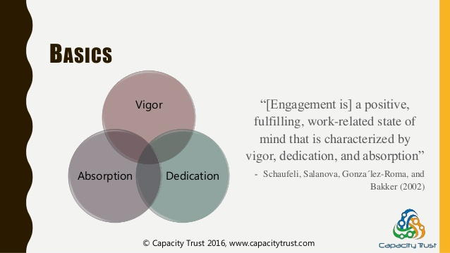

Vigor- It can be described as an attempt by an individual who is not only proactive but has that extra bit of enthusiasm or energy to reach an extra distance. At a time when the individual gets it, it is noticed that the individual is giving that extra effort to go beyond the potential limit, this state is recognising as the Vigor engine. (Robinson, 2020).

Dedication – This is the stage when the individual put commitment, the enthusiasm reflects positive vibes where the individual takes it to that level when the contribution becomes enormous, the passion of the individual goes to the level of ultimate commitment. Even in the toughest of the challenges the employee keeps ongoing with more commitment (Robinson, 2020).

Absorption –is well explained as engrossed! this is the special ability of the individual to engrossed in the work. The individual engagement is so much that it takes the commitment to another level where it is. In this work engine, the level of commitment goes in a such a level that is not only the work has to be done at the stipulated time, but it could be done at the best possible way (Robinson, 2020)
While describing the 3 engine of work engagement it could understand that when the employee goes through the 3 engine the work is done, level rise to a certain level that simultaneously the requirement level of the individual also increases.
There is 3 dimension which can be discussed in these circumstances, they are intellectual, affective and social engagement.
Intellectual work engagement –The commitment level is high in the effective ways as the individual thinks in the circumstances that they think about the job and how it could be done more better way .The creative mind of the individual start to work here more aggressively, it starts to develop the ideas which in turns develop the personal needs. This dimension not only develops the individual needs but also helps the organisation developing the power to grow simultaneously. (insight,2020)

Effective work engagement – At this dimension the individual is confident, ultimately brings a total sense of positivity to do the job, in this work engagement dimension the work is done with total fluency without any type of hindrance. This dimension also creates a development of skill. positivity which helps both the employee and the organisation.

Social engagement – In this dimension of the work engagement, the individual takes many opportunities actively to discuss what can be done to improve the work, to the other Concern workers or employee of the organisation this dimension is vital if seen critically it not only improve the individual needs but collectively develop the entire organisation as a whole.
While discussing the work engagement it is quite vital to discuss the drivers or the forces that instigate the engagement which has been nicely discussed by Macleod and Clarke in 2009.

It’s a debatable question that weather physical abilities increase work ethic and satisfaction so that the works will fill engrossed in the job where they personally fill are involved with, they think that their work is most fastidious and the most profitable one which does help the organisation in return(research gate,2020) in the demonstration they mention 4 drivers for engagement as, leadership, engaging line managers, employee voice & integrity, this are the fact that drives the commitment level to go on as they are the key elements for the employee commitment which helps them to develop their personal needs.

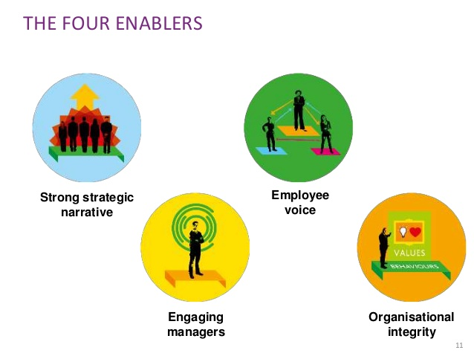

Discussing leadership according to John Adair a leader who can make a critical strategy is a key to the development of an organisation. The leader is invariably vital in determining the strategy which is needed in times of changes in the organisation (Adair, J., 2010). Taking to his leadership model three circle overlays each other.

- TO ACHIVE THE TASK
- TO MANAGE THE ENTIRE GROUP OR TEAM
- TO MANAGE THE SINGLE OR THE INDIVIDUAL

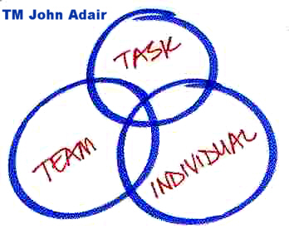
Source (Adair ,2020)
As for instant in this discussion an example of how Taxco’s create some opportunity to enhance employee work engagement can be narrated in Bangalore Tesco they came up with Three business challenges to consolidate the fact that the employee takes pride in their job and they are engaged in the work.
The challenges are -
1 The staff has a lack of ideas on how they are helping the border business by engaging in the work. 2. Lack of vigorous verbal contact between management and employee 3. Lack of inspiration for an employee to take part in all the activities, functions, social events, etc.
After the challenge, they came up with the result as follows
Ascertain Tesco Bangalore as an employee’s choice, build the much more pride sense as working in the branch and to connect in all possible way with each of the employees So, the above research clarifies employee engagement developing individual needs in the workplace (Sengupta, 2017)

3.1 Critically assessments the potential benefits of the organisation of personal development in the workplace

Potential benefits of the organisation will be critically assessed in this part of the research. How the individual will be developed in the workplace and in turn help the organisation to be benefited.

Development tools, Motivation, Training, Performance Management.

MOTIVATION
According to the discussion while researching it is found that Jayson DeMers find keeping employee motivated is the biggest challenges, process like bringing personal attention, future growth opportunity, setting example like leadership, commitment, and progressive communication, mixing with the employee socially and communicating with the staff transparently is the key to motivate them (DeMers,2015).
The management golden strategies need to grow with the staff motivational level so that the number of loyal staff for the organisation can be grown by keeping them motivated towards the organisational value, ethics, and belief.

According to Maslow motivation should be the ultimate target based instead promptly driven, or the behaviour and it should be human cantered not be focused on animal-centred (Maslow ,2017).



Mullins while describing motivation pyramid have described how Maslow has described its factor-like according to Maslow the moment the lower needs in his pyramid has been met or satisfied it does not mean that the individual will be motivated, it simultaneously goes to the need of next level of the pyramid cycle and become the motivator at that point (Mullins ,2007). This point is exactly been researched by Kirmanen and Salanova when they stated quoting Maslow
who describe also that if the needs are not satisfied at the particular level its automatically goes to the next level of motivation in his theory. (Kirmanen, Salanova ,2010).While Herzberg came up with two different kinds of instant in his theory about motivation, as – the individual can be motivated quite hard to work in the organisation but some factors are also present in the process and in turn, can demotivate the employee which could in turn damage the development for both the employee and the organisation (Turtor2u,2005).
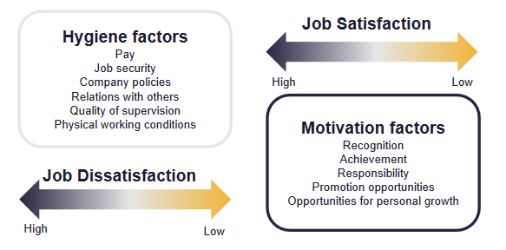

present at all, when Hygiene is thoroughly practice the disappointment of the worker can be avoided (Bogardus, 2007)
Realistic examples of motivation in an organisation are “Tesco’s” can be highlighted, Tesco employee rewards system- to encourage the team -a number of brilliant rewards are there as for example,
- The Employee can have shared after a year of service
- Equal payment on the pension scheme
- Healthcare in private, free or in much lower value
- Payslip voucher /festival vouchers
- Fitness free memberships in gyms
- O2 contract-free phones
- Discount in the holiday package
(Motivational-theory-in-practice-at-Tesco - Business Case Studies, 2019)
So in each and every alternative way, a good organisation like Tesco tries to motivate the employee so that they keep loyal to the organisation.
After motivation the research will concentrate into how training and development one of the major development tools can play a vital role and what is the advantage /disadvantage, the research will also try to find out to understand the basic difference of Training and development

TRAINING

Training is the considered to be the basic factor in the human
resource As stated by Parker, Michael Crichton’s in his new novel “Rising Sun” It’s the new modern time which the entire world is going to be where the old technology, thinking, training and development do not stands (Parker, 1952).
As correctly forecasted by out by Parker that in modern days people started to recognize that the changes are changes is taking place quite quickly, so comparing that it to the olden days training and development will be the key need to everybody to adopt and things are changing too fast, so the changes have to be adopted.
Staff nowadays recruited by the company judging on attitude, talent, and interest towards the particular subject, as because the investments of time, finance of the employer are also accountable at that moment. Author R.K.Sahu studied the fine understanding of Training and development.
Training can be illustrated as obtaining particular ability for depiction specific aim whereas development can be defined as the alteration transported in the pursuit of the staff as a result of smart education and training. (Sahu,2006)

Training and Development can be understood as –

Development | Training
Development is a followed process which goes on and have to be monitored | Totally planned earlier, a structure which is designed to give knowledge
The level of skill, education development can grow to the next stage if monitored properly | Can be brought in effect immediately
Gives an immense opportunity the learning to improve and grow | Training helps to increase abilities
Gives major confidence in both to grow responsibility and take the leading part | Can be very affective in small term goal, can be planned to get a effective quick success
It is a totally monitored process | Performance level can grow a mile with proper smart training

While describing some of the types of training intervention which can be formal or informal, for example in respect to the job - instruction, shadowing,coaching, rotation .mentoring, etc or in terms of learning could be in class or distance learning which can be treated as a training. In other terms right training makes employees flexible, easy filling the gaps can be possible to cover the job, training is also not only initial investments but cost effective, can be a vital factor for retention and promotion within the organisation. According to the current market evaluation, it is much easy to train the right staff and nourish them with proper training and motivation internally rather than to find a new employee and then to train them and start the process again. (Wescott, F. 2011).

The systematic training cycles

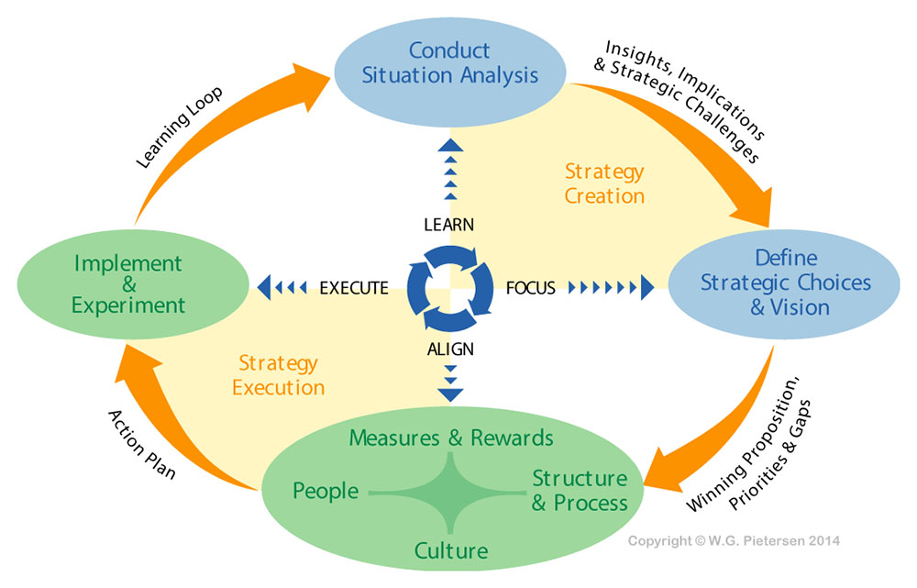
The basic needs for the development of the specific training systematic cycle are to find out the gap that stays between the skill and knowledge the individual virtually possesses and the need of developing competency level of the particular employee. (Pieterson ,2020The basic needs for the development of the specific training systematic cycle is to find out the gap that stays between the skill and knowledge the individual virtually possesses and the need of developing competency level of the particular employee. (Pieterson ,2020
Critical evaluation of both of the development vehicle's advantages and disadvantages of benefits in an organisation and personally to the employee.
Karen Lawson describes training is the key for the new employee to develop in a structured, planned way so that the individual skill and education level rich to the highest level” (Lawson,2002).

3.1.1 Training benefit to individual advantage and disadvantage

ADVANTAGE / BENEFIT
Researching the advantage in training, by modern development, not only stands for the economic success it had massive fruition of mutually hold on, politic, physiology, medical sociology and many other disciplines (Goldin,2016).
- an increase in the moral satisfaction level of the staff.
- Organisation starts to gain financially as the motivation grows up of the staff.
- Adaptation of new technology by the staff grows and, in a way, increase in the personal way of the organisation
DISADVANTAGE
The disadvantage of employee, some of the key factors as found by research.
- The expenses done by the organisation can go into vain
- Learning should be the main concern, qualification does not matter a lot
- During the daily training process, it might take up some vital time for the work.
- Training is good as far as competitiveness is a concern but sometimes it can be a great disadvantage as it can easily bring collusion between the staff internally which in turn harms the organisation itself

3.1.2 Training benefit to Organisation advantage and disadvantage

ADVANTAGE
- Individual performance improves with proper training in the organisation . Satisfaction and moral keep high in the team which is good for the organisation.
- Proper systematically Training helps to reduce the Weakness, consistency of the work increases.
- Help in Staff retention with innovative new ideas and strategies.
- Have a huge effect on the organisation profile as the production level rises up

DISADVANTAGE
- If an employee having no interest in training, a waste of time, money, strategy result in a huge loss for the organisation.
- Sometimes practical training is good than the theoretical one as it grows the attention of the staff more and they stay focused on the job and not rise the stress level.
- If it takes a long time for the training process, then it could hinder the production level.
- A Control system about how the training should be conducted should be in place.

3.3 Performance management and details plan of individual development plan .

According to Cardy and Leonard Performance management is a vital element for both personal as well as organisational effectiveness and progress, correct pinpoint evolution is needed to measure the growth of personal and organisational progress (Cardy and Leonard ,2004). As stated by Becker in 2013 cited by Brunnert, Vögele, Danciu, Pfaff, M., Mayer, & Krcmar, H. in 2014 in their article of performance work performance is measured by the metric of time to reply, consumption of rescores and through output. Performance development can be well understood by drawing up a detailed personal development plan.

3.3.1 personal development plan

A personal development plan is directly related to personal enlargement of benefit and of individual growth in each and every angle which helps in abundance to motivate and in the process benefit the organisation. (Robert, J.2014)

Objectives | measure | priority | support  Internal | development  External | Reviews | Comments
To grow full confidence as a leader.  To acquire knowledge how to lead by example  To develop personal communication skills to improve communication in the entire level.  Grow the confidence on decision taking and strategy making. | Making self-appraisal, appraisal from higher management.  Taking knowledge from learning measuring them through work implementation.  various ways, communication to grow the knowledge.  Getting feedback from the team and customers  Following the self believe or keeping faith by himself and in the team. | Keeping a top priority to follow up the performance.  Each day track record obtains trough individual feedback.  Wining confidence of the team through improvement of the communication.  Sharpen more knowledge digitally and enrolling in some course of communication and motivation as it is hard to self-motivate when going gets tough. | Ask suggestion from senior managers or getting feedback from one to one report.  Automatic reaction of the staff, by observation learn from the staff reaction, hoe they take it.  Implementation on the daily work, getting positive result will be a big plus point towards further growth towards higher management. | Happy smiley face of the customers can grow the confidence a lot as it generates more revenue.  Getting refresh course from external source is vital as it recapitulate or refresh the knowledge.  Original and honest feedback is key to know how the team is doing as it also improve. | On going process  Daily track record of observation.  Daily day to day ongoing process.  Should be reviewed within 3 months at the completion of the course. | Have to be focused on improvement  Daily checks on the development plan have to be followed.  Self-motivation has to gained trying different method of studies, may be concerning meditation books.  Self-belief is the key to grow faster with the entire team.

4. 0. Conclusion
It has been observed throughout this report that the tools or the engines are available to develop personal skills that help to develop the organisation also. Studies show that employee engagement can be critically assessed how it helps in personal development, shows how training, motivation and performance management can help an individual to grow the required skills to develop to the upward level it also helps the organisation to grow, in return, the organisation can get loyal staff, who could, in the long run, can pay huge bonus by way of increase in the profit margin of the particular organisation.
One of the vital points to mention in the last but not the least is every successful induvial in every form of life follow some personal development path or plan. The plan is the key to the individual onwards movements towards success. PDP is the vital organism for an individual to grow, it supplies the moral boosting the motivation required for the particular individual to gain success in life.

5.0. Reference /Bibliography

Adair, J., 2020. John Adair's Action-Centred Leadership Model - Businessballs.Com. (online)Businessballs.com. Available at: <https://www.businessballs.com/leadership-models/action-centred-leadership-john-adair/> (Accessed 28 March 2020)

Adair, J., 2010. Strategic Leadership. Philadelphia, Pa.: Kogan Page, p.3.

Bakker, A., 2020. Arnold Bakker. (online) Arnoldbakker.com. Available at: <http://www.arnoldbakker.com/workengagement.php> (Accessed 27 March 2020).

Bogardus, A. (2007). PHR®/SPHR® Professional in Human Resources Certification Study Guide, Third Edition. p.26.

Business Case Studies. 2019. Motivational-Theory-In-Practice-At-Tesco - Business Case Studies. (online) Available at: <https://businesscasestudies.co.uk/motivational-theory-in-practice-at-tesco/> (Accessed 1 April 2020).

Brunnert, A., Vögele, C., Danciu, A., Pfaff, M., Mayer, M., & Krcmar, H. (2014). Performance Management Work. Business & Information Systems Engineering, 6(3), 177-179.

Cardy, R.and Leonard (2004), Performance management. P.8

DeMers, J. (2015). 6 Motivation Secrets to Inspire Your Employees. (online) www.inc.com. Available at: https://www.inc.com › jayson-demers › 6-motivation-secrets-to-inspire-your-... (Accessed 12 March. 2020).

Goldin, I. (2016). The pursuit of development. Oxford: Oxford University Press.P.6

Insights.com. 2020. Employee Engagement. (online) Available at: <https://www.insights.com/media/1102/employee-engagement-whitepaper.pdf> (Accessed 27 March 2020).

Kohll, A., 2020. What Employees Really Want at Work. (online) Forbes. Available at: <https://www.forbes.com/sites/alankohll/2018/07/10/what-employees-really-want-at-work/#2cf8c1cb5ad3> (Accessed 11 March 2020).

Kirmanen, Salanova. (2010). Employee satisfaction and work motivation. Lap Lambert Academic Publishing GmbH, p.78

Lawson, K. (2002). New employee orientation training. ASTD, p.8

McCarthy, d. (2019). (online) Available at: https://www.thebalancecareers.com › ... › Careers Development (Accessed 11 March ,2020).

Maslow, A. (2017). A Theory of Human Motivation. Lanham: Dancing Unicorn Books, p.8

Mullins, l. (2007). Management and organisation behaviour. 8th ed. England: Pearson education ltd, p.288.

Pieterson, w., 2020. Strategic Learning | Willie Pietersen. (online) Williepietersen.com. Available at: <https://williepietersen.com/strategic-learning/> (Accessed 27 March 2020)

Parker, J. (1952). (online)Available at: https://www.latimes.com › archives › la-xpm-1992-07-05-op-2469-story (Accessed 27 March. 2020)

Robinson, J., 2020. The 3 Engines of Employee Engagement. (online) Worktolive.info. Available at: <https://www.worktolive.info/blog/bid/354012/The-3-Engines-of-Employee-Engagement> (Accessed 27 March 2020)

Research gate. 2020. (online) Available at: <http://www.researchgate.net/publication/242468702_Engaging_for_success_enhancing_performance_through_employee_engagement> (Accessed 27 March 2020).

Roberts, J. (2014). Landing the job: A guide to successful transition. Nursing Management (2014), 21(5), 18-21.

Sengupta, S., 2017. How Tesco Creates Opportunities to Boost Employee Engagement. (online) Peoplematters.in. Available at: <https://www.peoplematters.in/article/employee-engagement/how-tesco-creates-opportunities-to-boost-employee-engagement-16538> (Accessed 28 March 2020)

Sahu, R. (2006). Training for Development all you need to know. New Delhi: Excel Books, pp.1-2.

Tutor2u, (2005). (online) Available at: https://www.tutor2u.net › business › reference › motivation-Herzberg-two-... (Accessed 28 March. 2020).

Truss, c., Delbridge, R., Alfes, K., Shantz, A. and Soane, E., 2014. Employee Engagement in Theory and Practice. New York: Routledge, p.24.

Wescott, F. (2011). The Importance of Training. Journal of Housing and Community Development, 68(3), 1

