Madison Jay Willow Oats
DATE: APRIL 07 2023

HND APPLIED COMPUTING – LEVEL 5 – DATABASES & APPLICATION DEVELOPMENT
DATABASE DRIVEN WEBSITE APPLICATION

Contents
DATA DRIVEN WEBSITE APPLICATION 2
Website Images 2
Running Demo 9

DATA DRIVEN WEBSITE APPLICATION

Website Images
Login Page
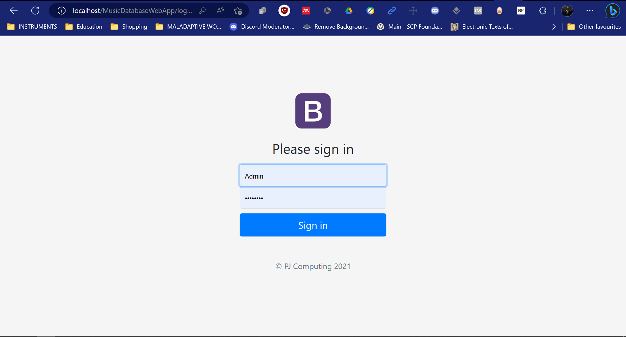
Artist Page
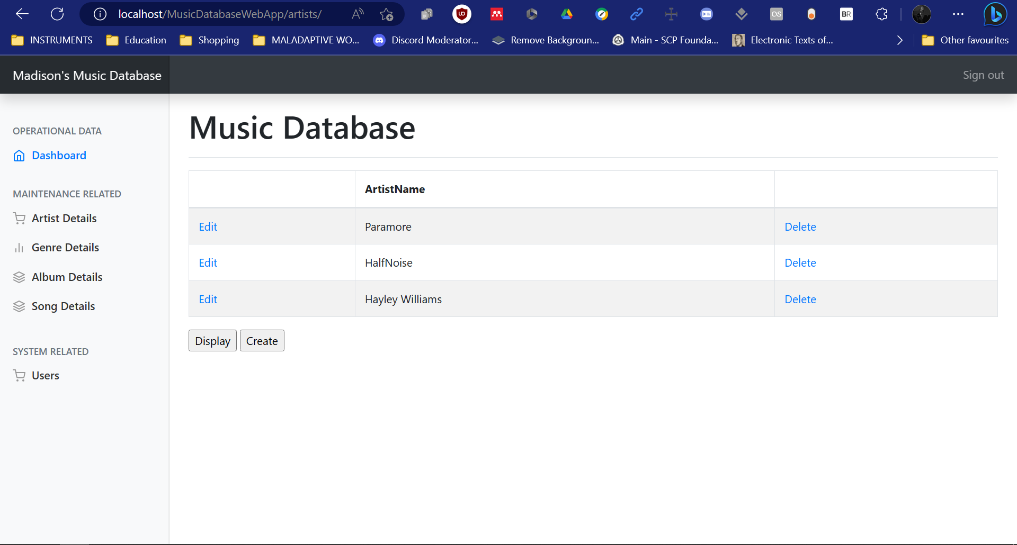
Artist Edit Page
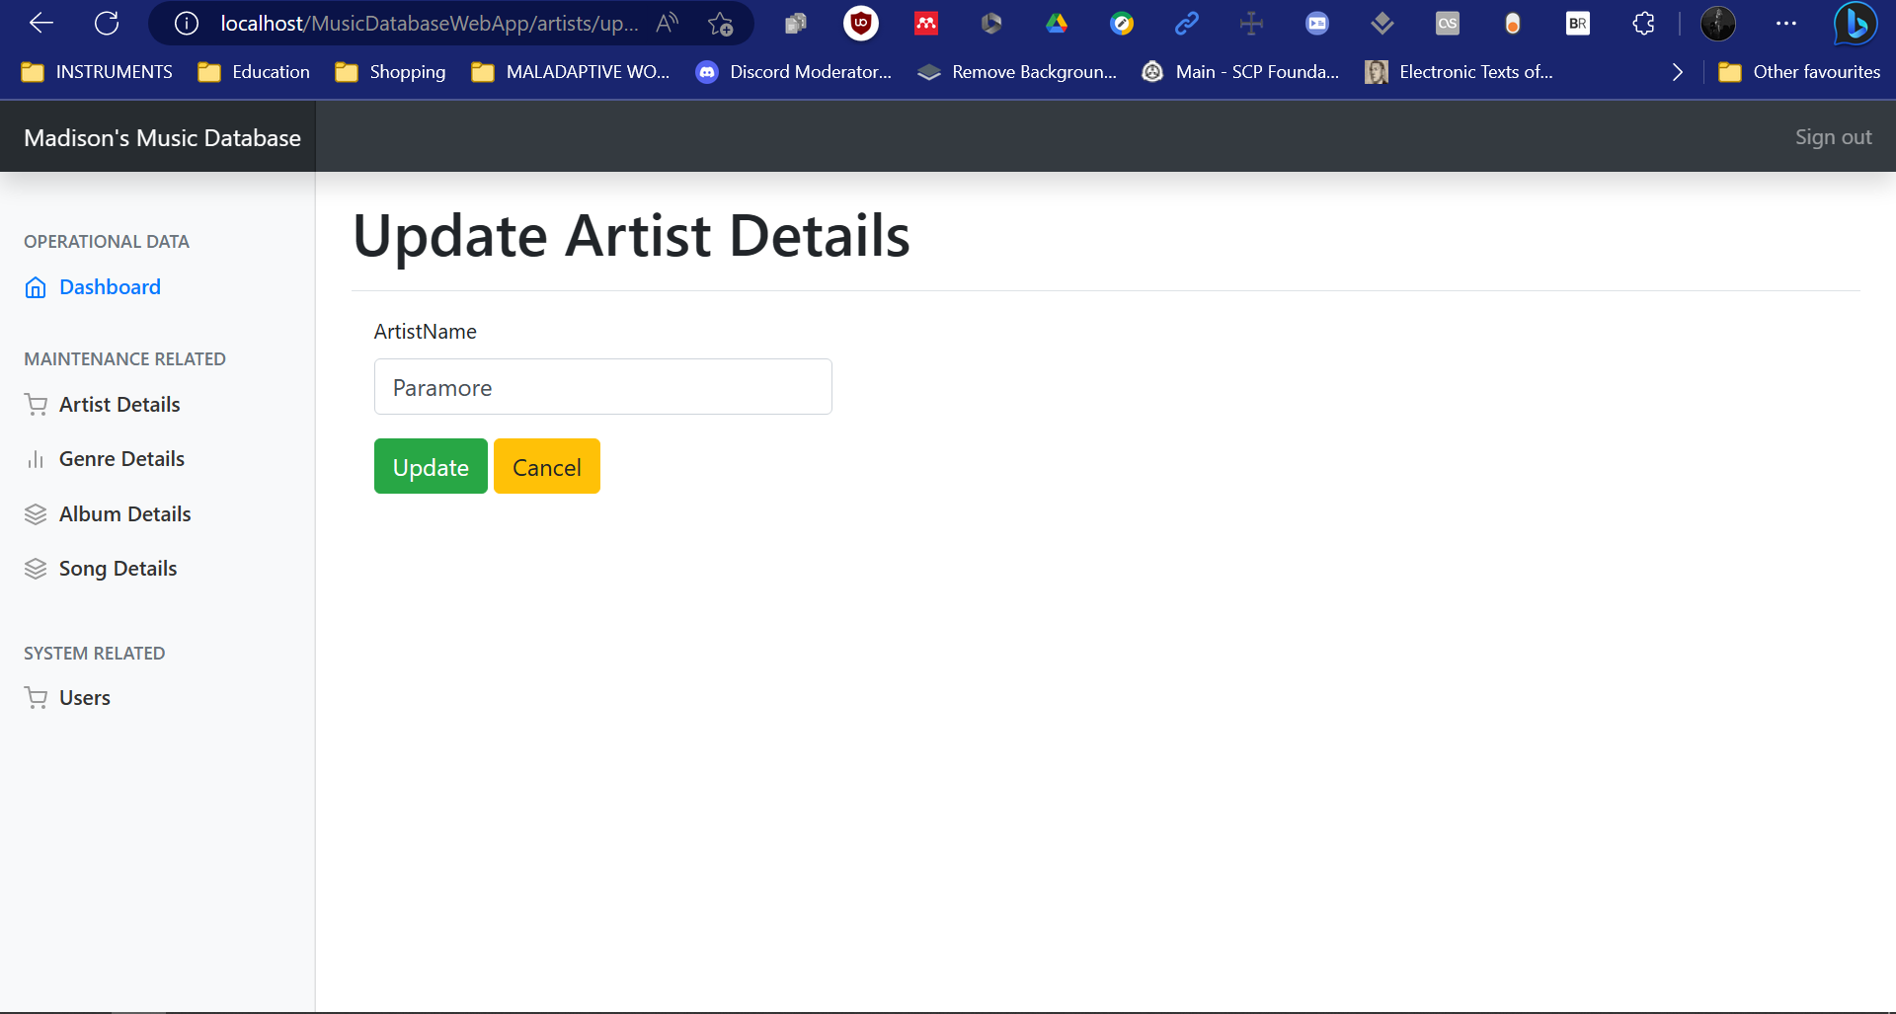

Artist Delete Page
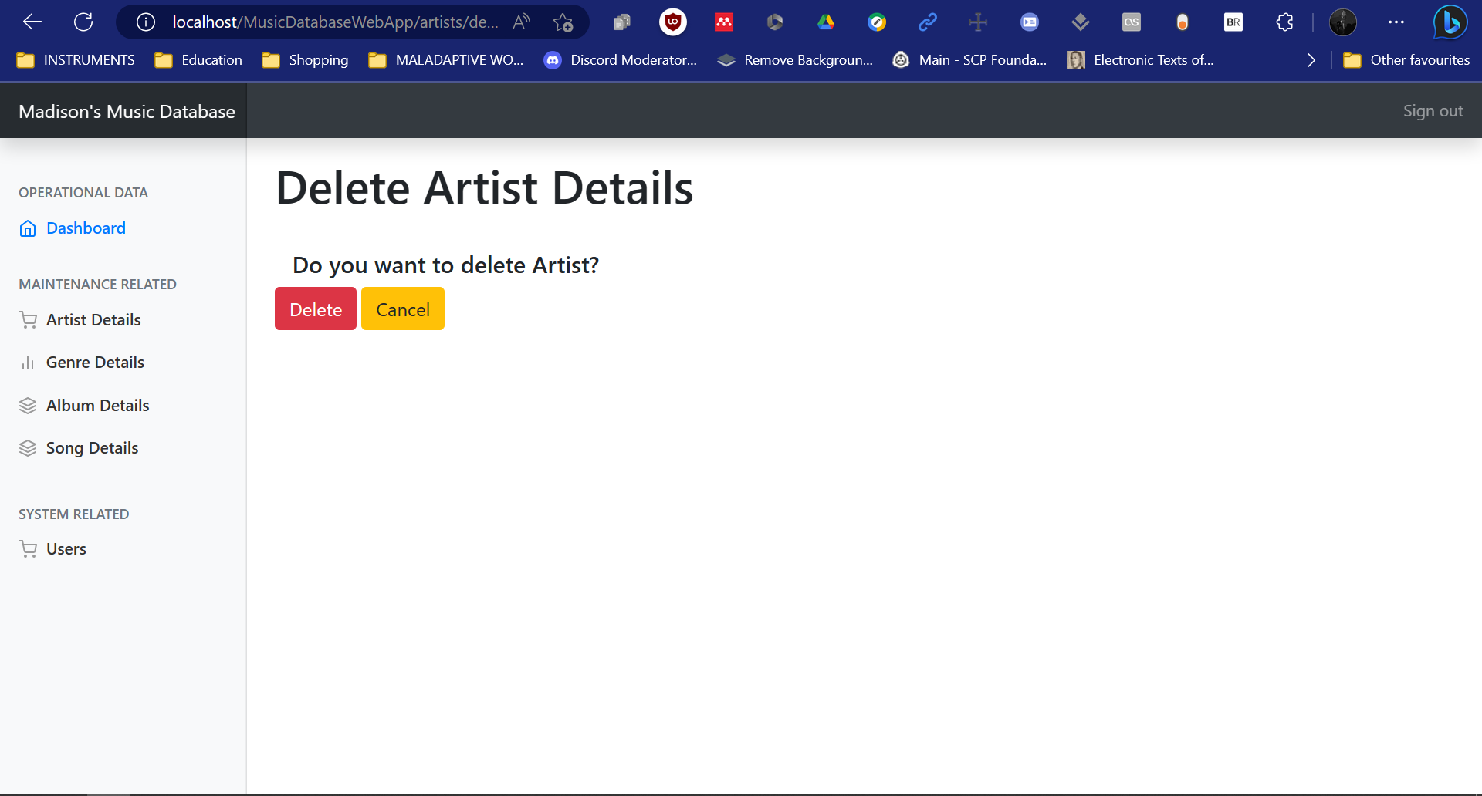
Artist Create Page
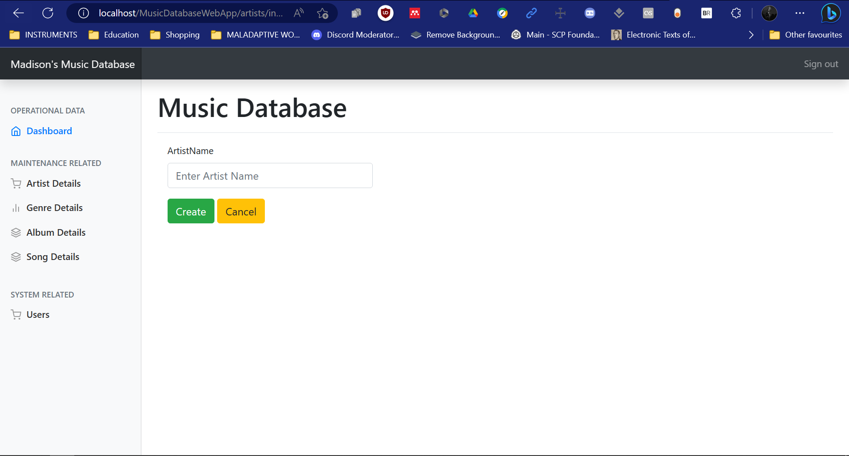
Album Page
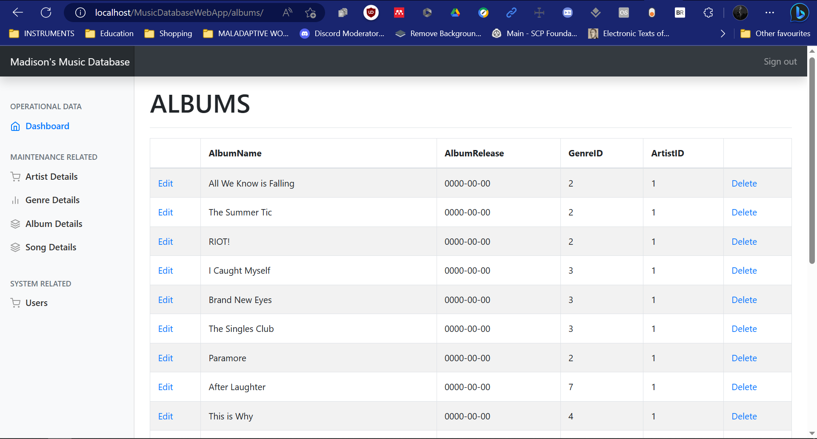

Album Edit Page
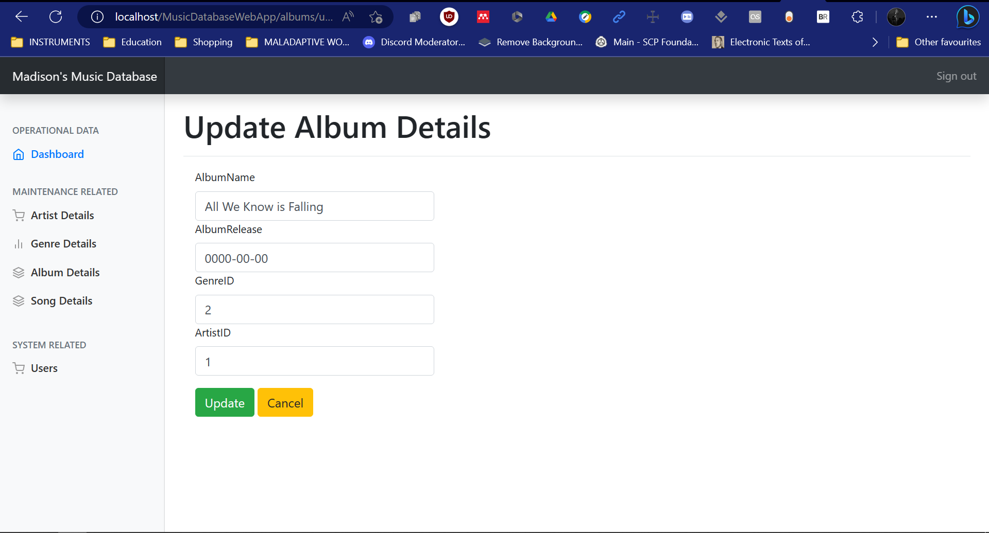
Album Delete Page
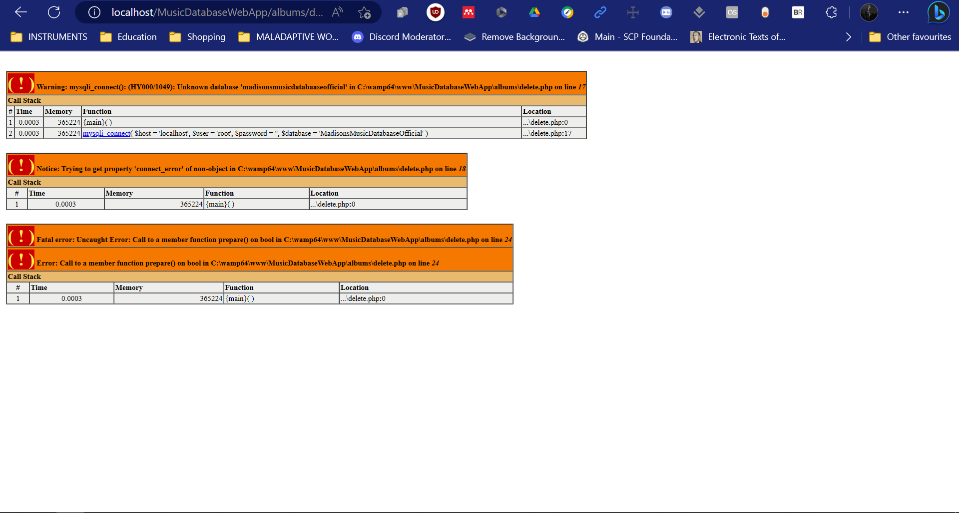
Album Create Page
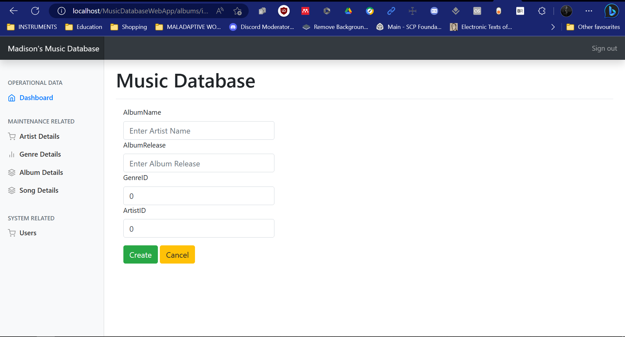

Genre Page
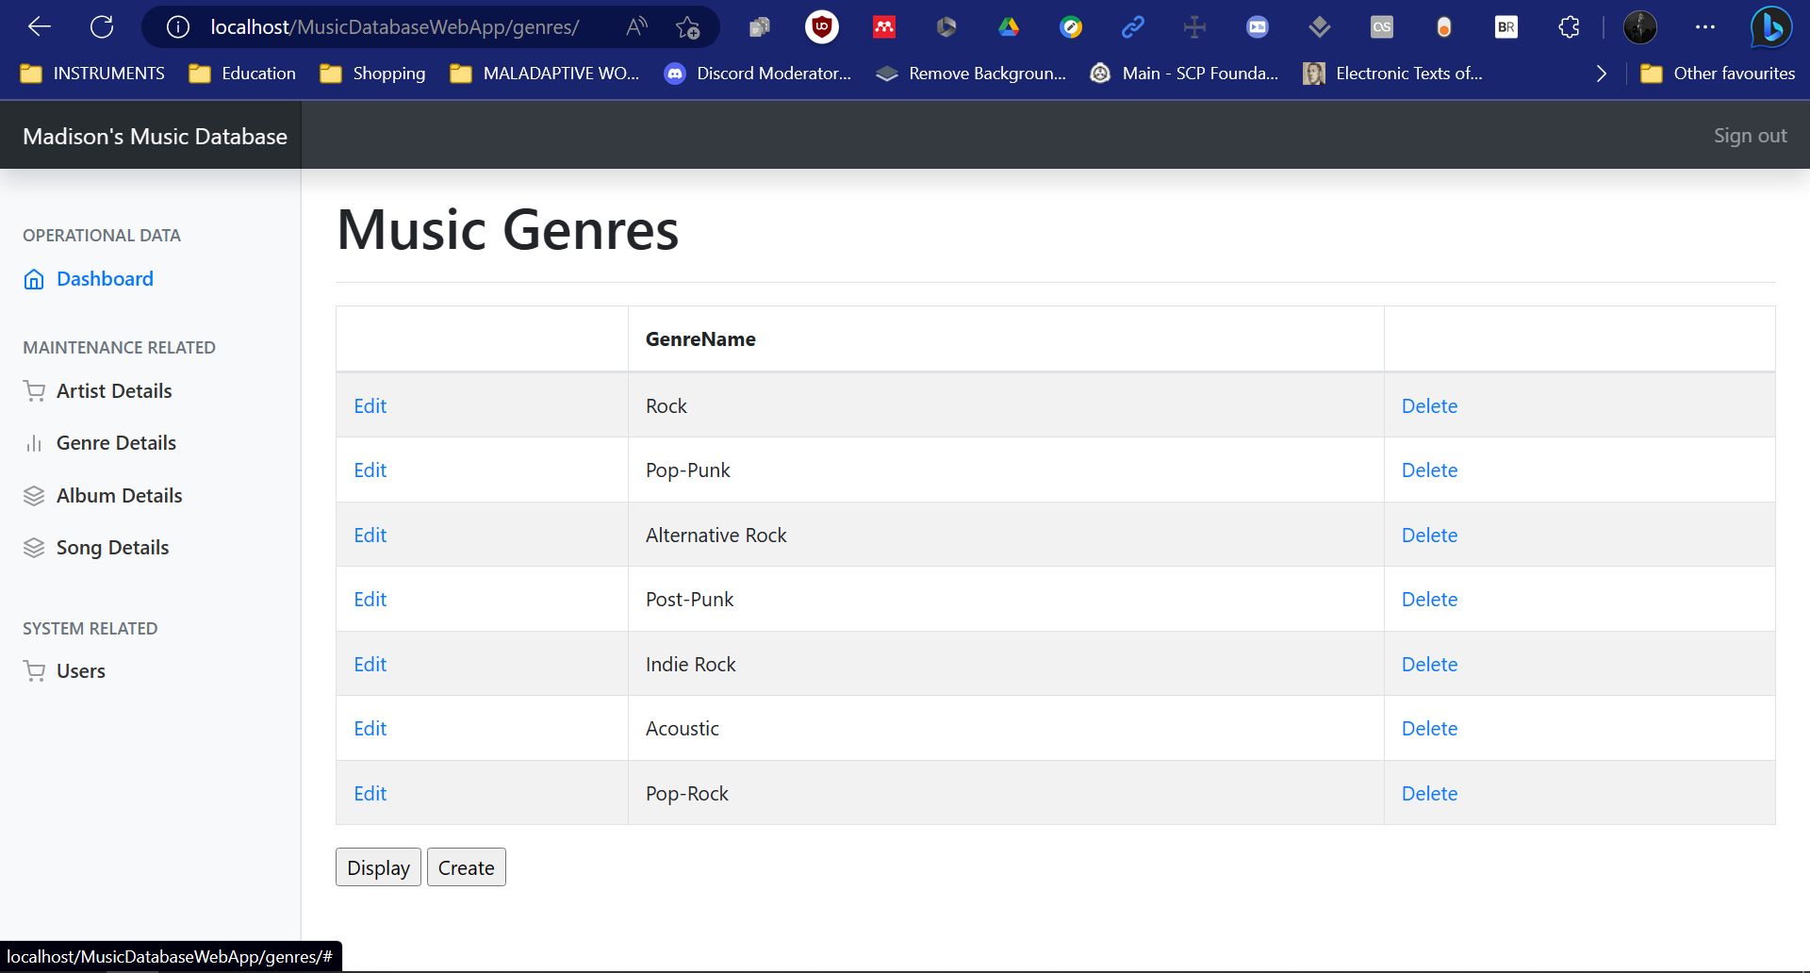
Genre Edit Page
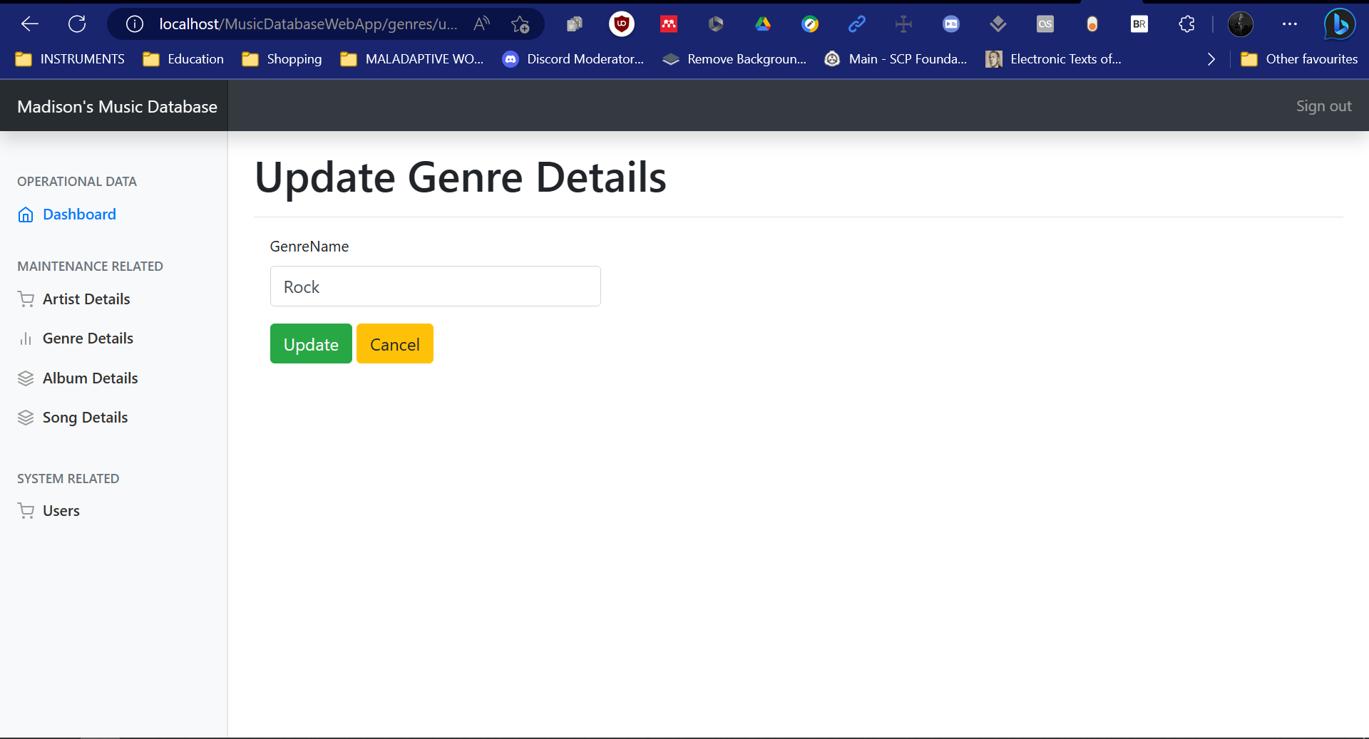
Genre Delete Page
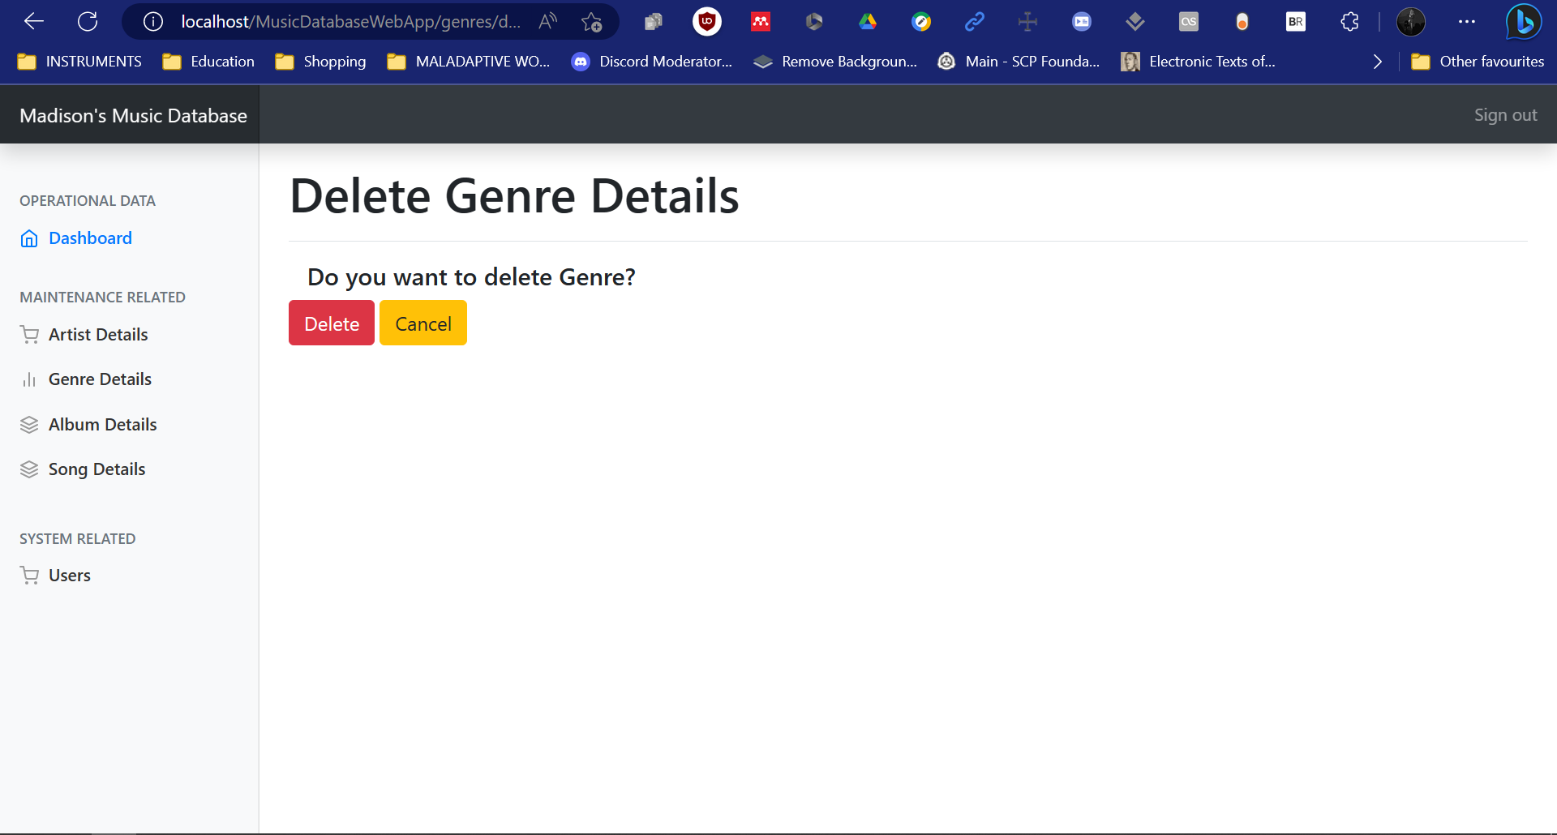

Genre Create Page
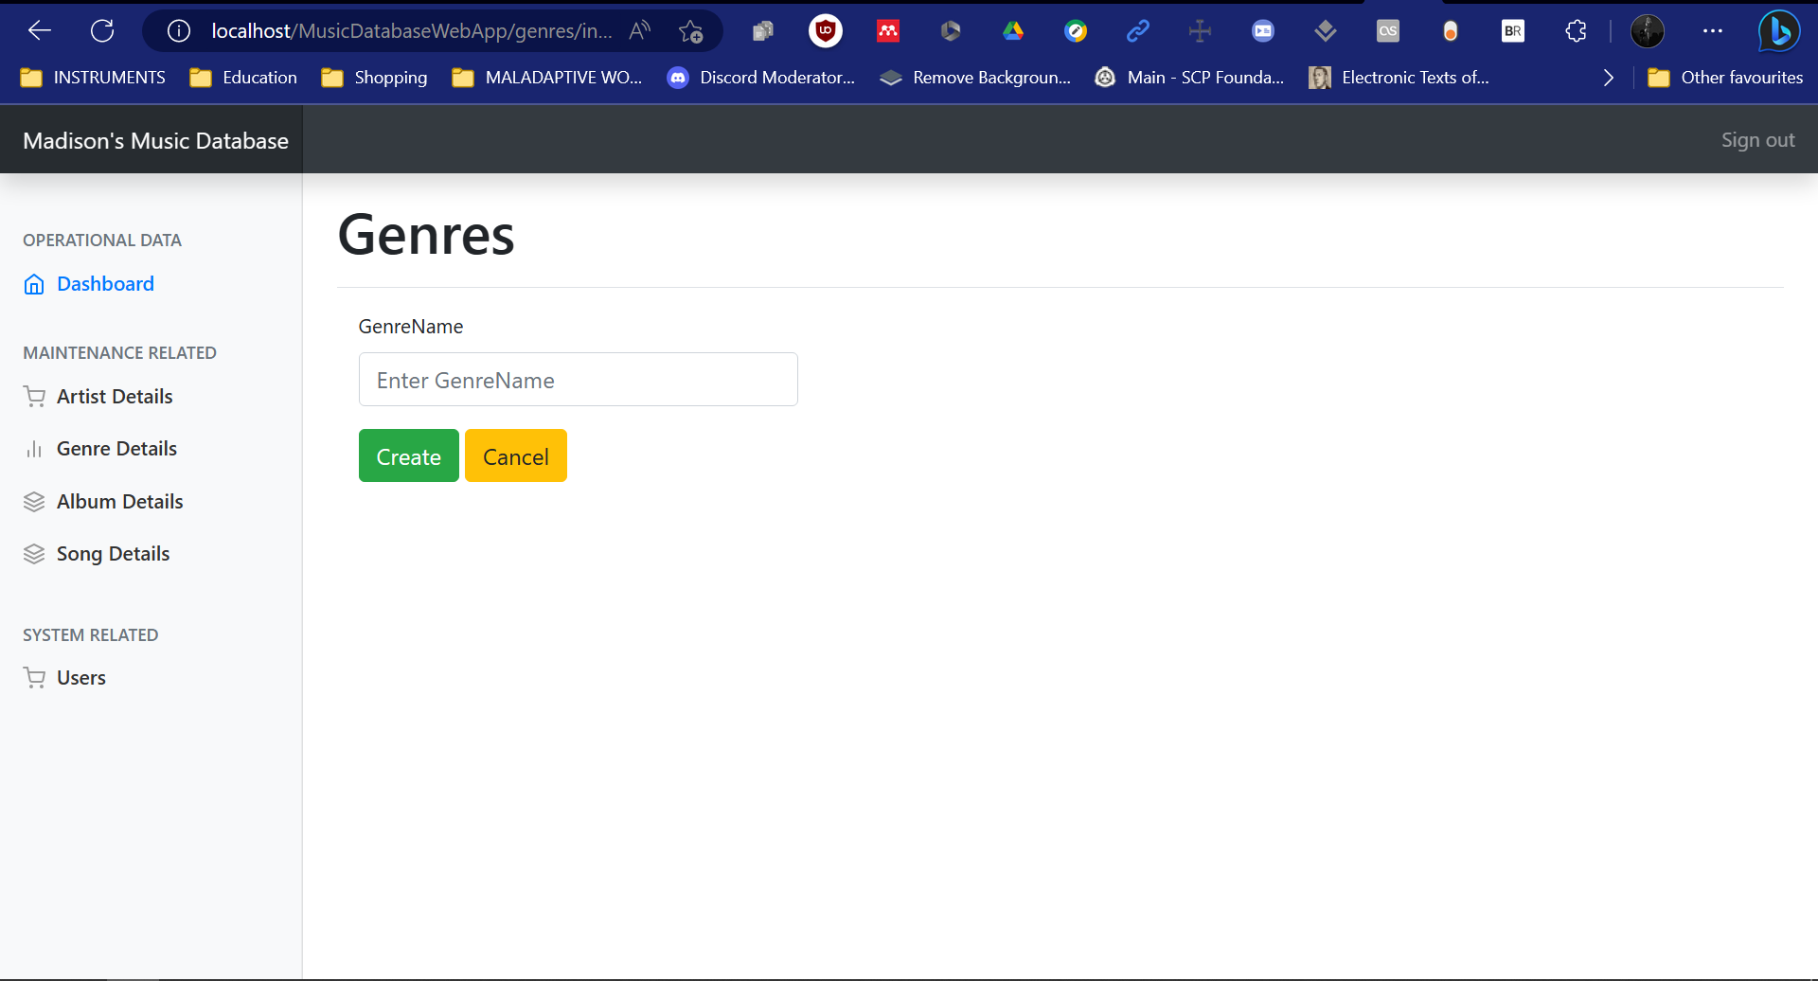
Songs Page
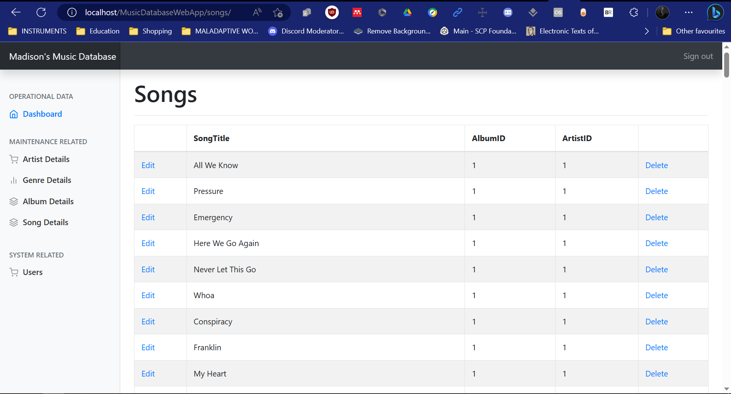
Songs Edit Page
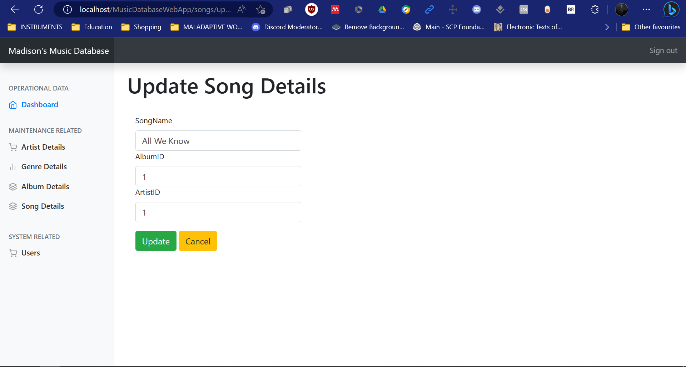

Songs Delete Page
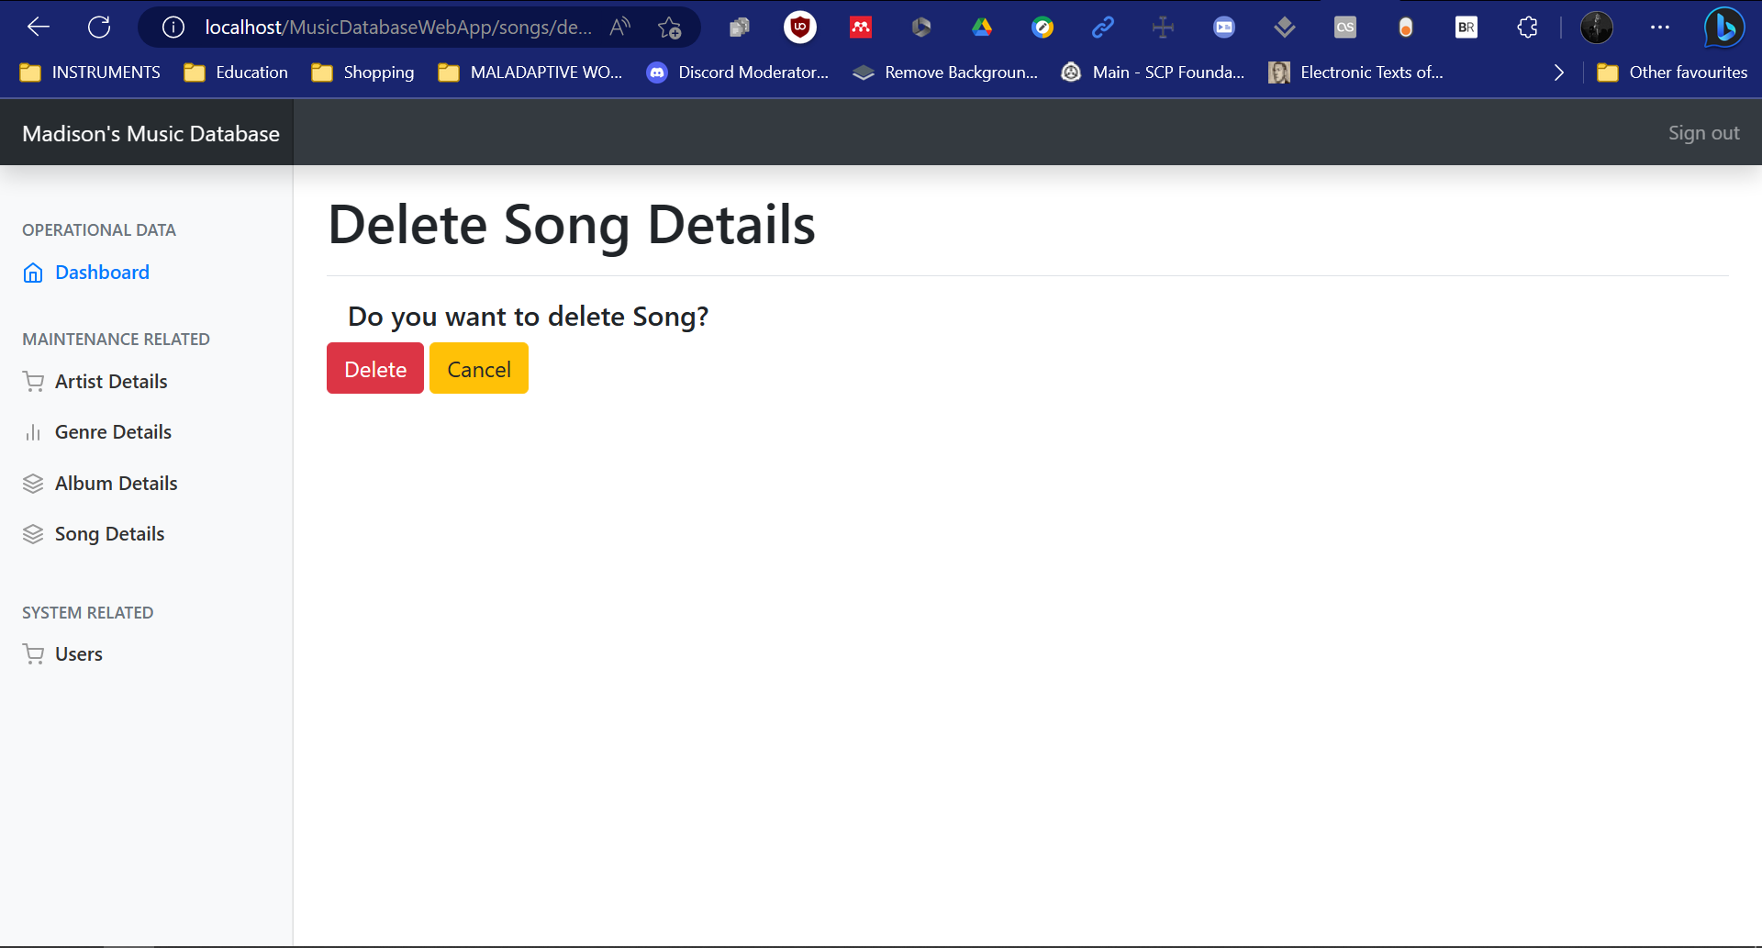
Songs Create Page
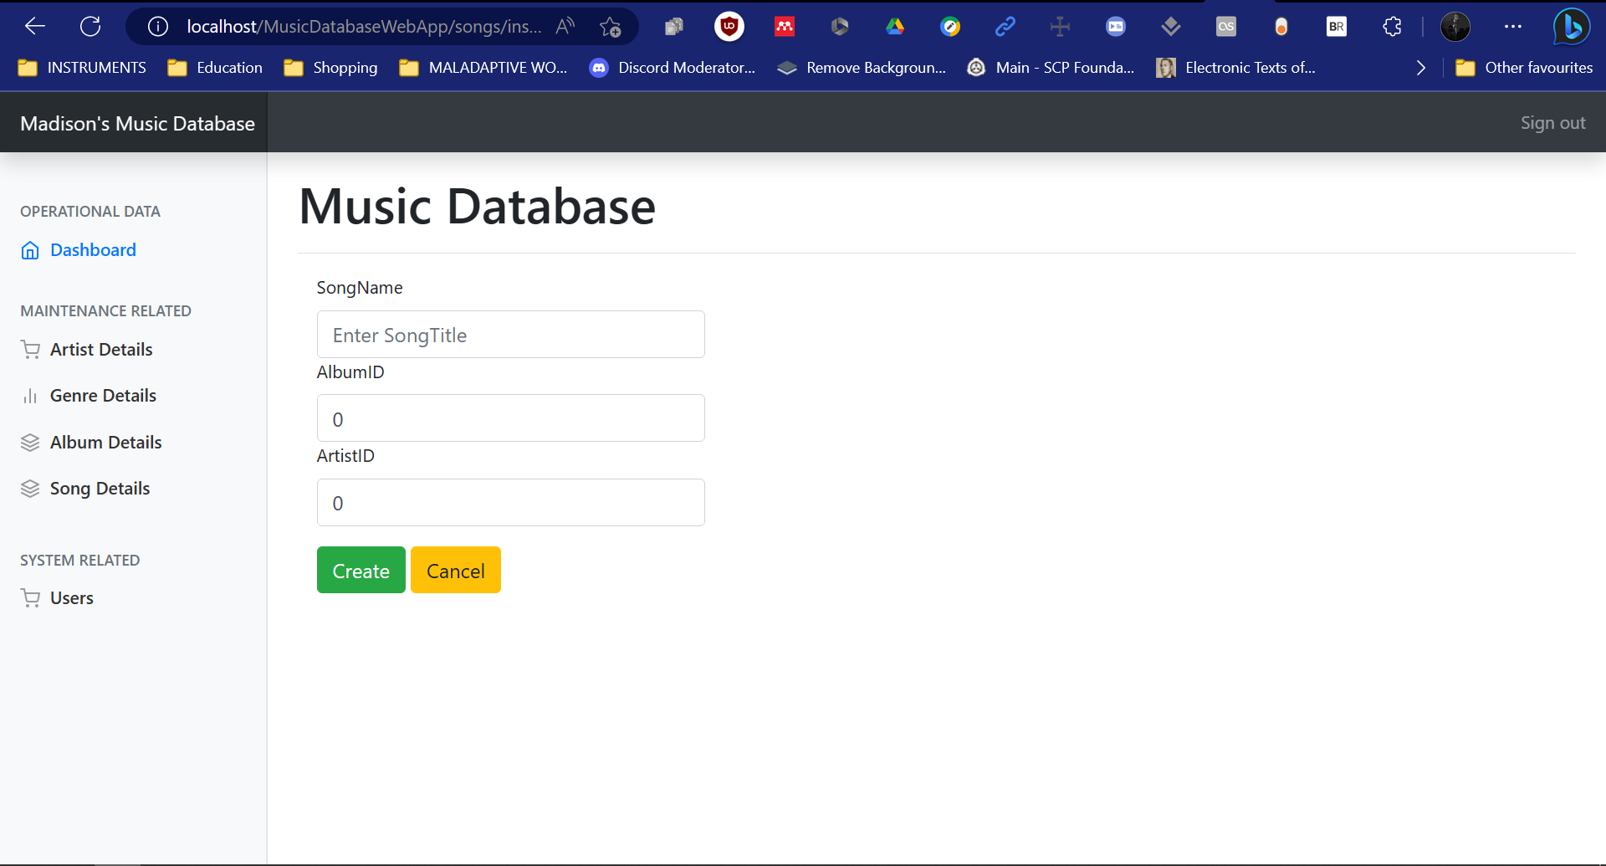
Users Page
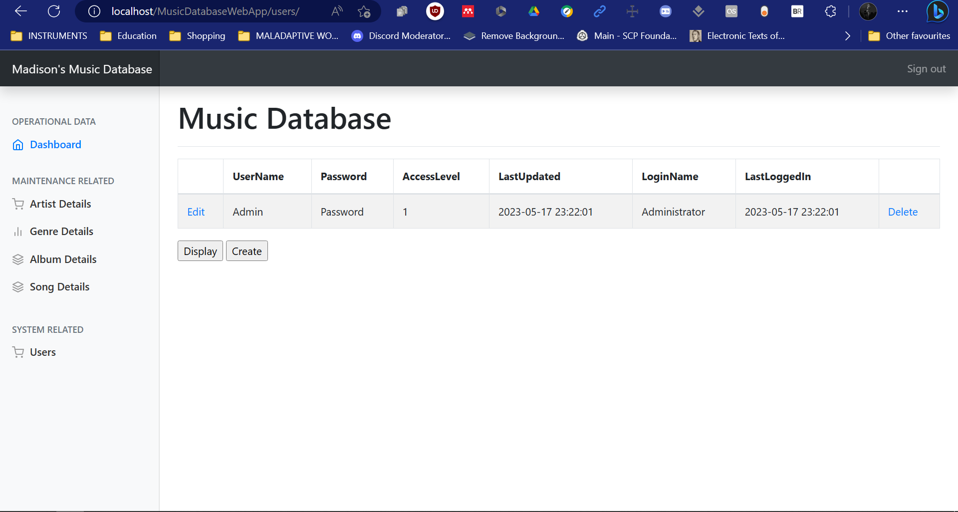

Users Create Page
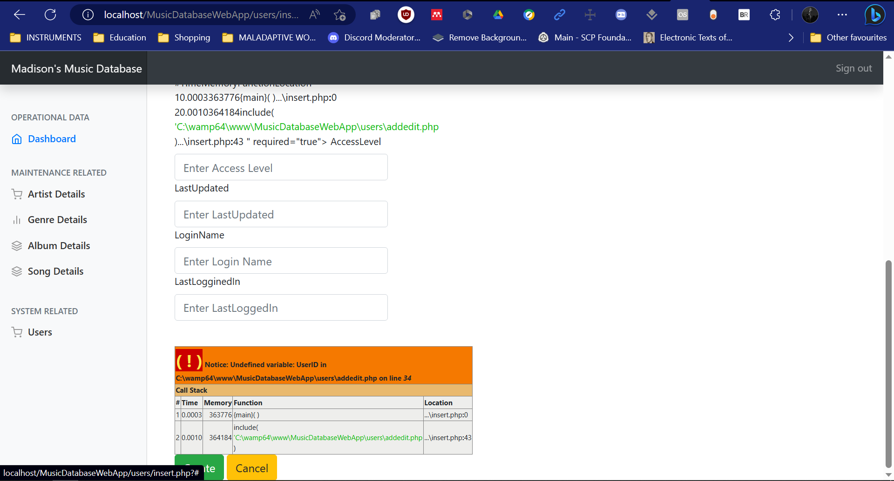
Users Edit Page
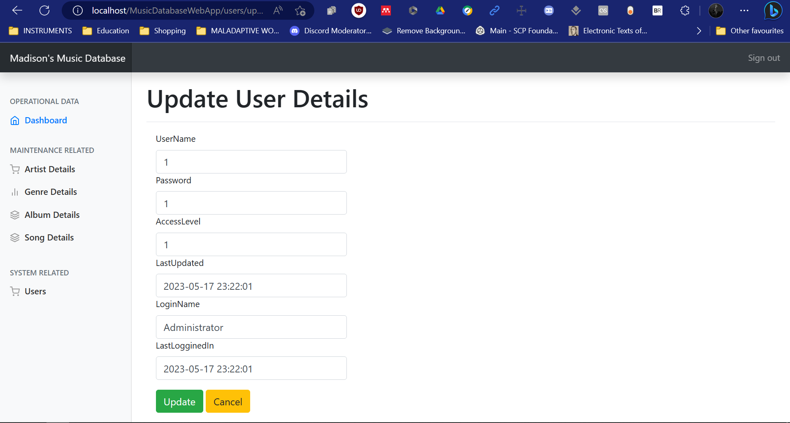
Users Delete Page
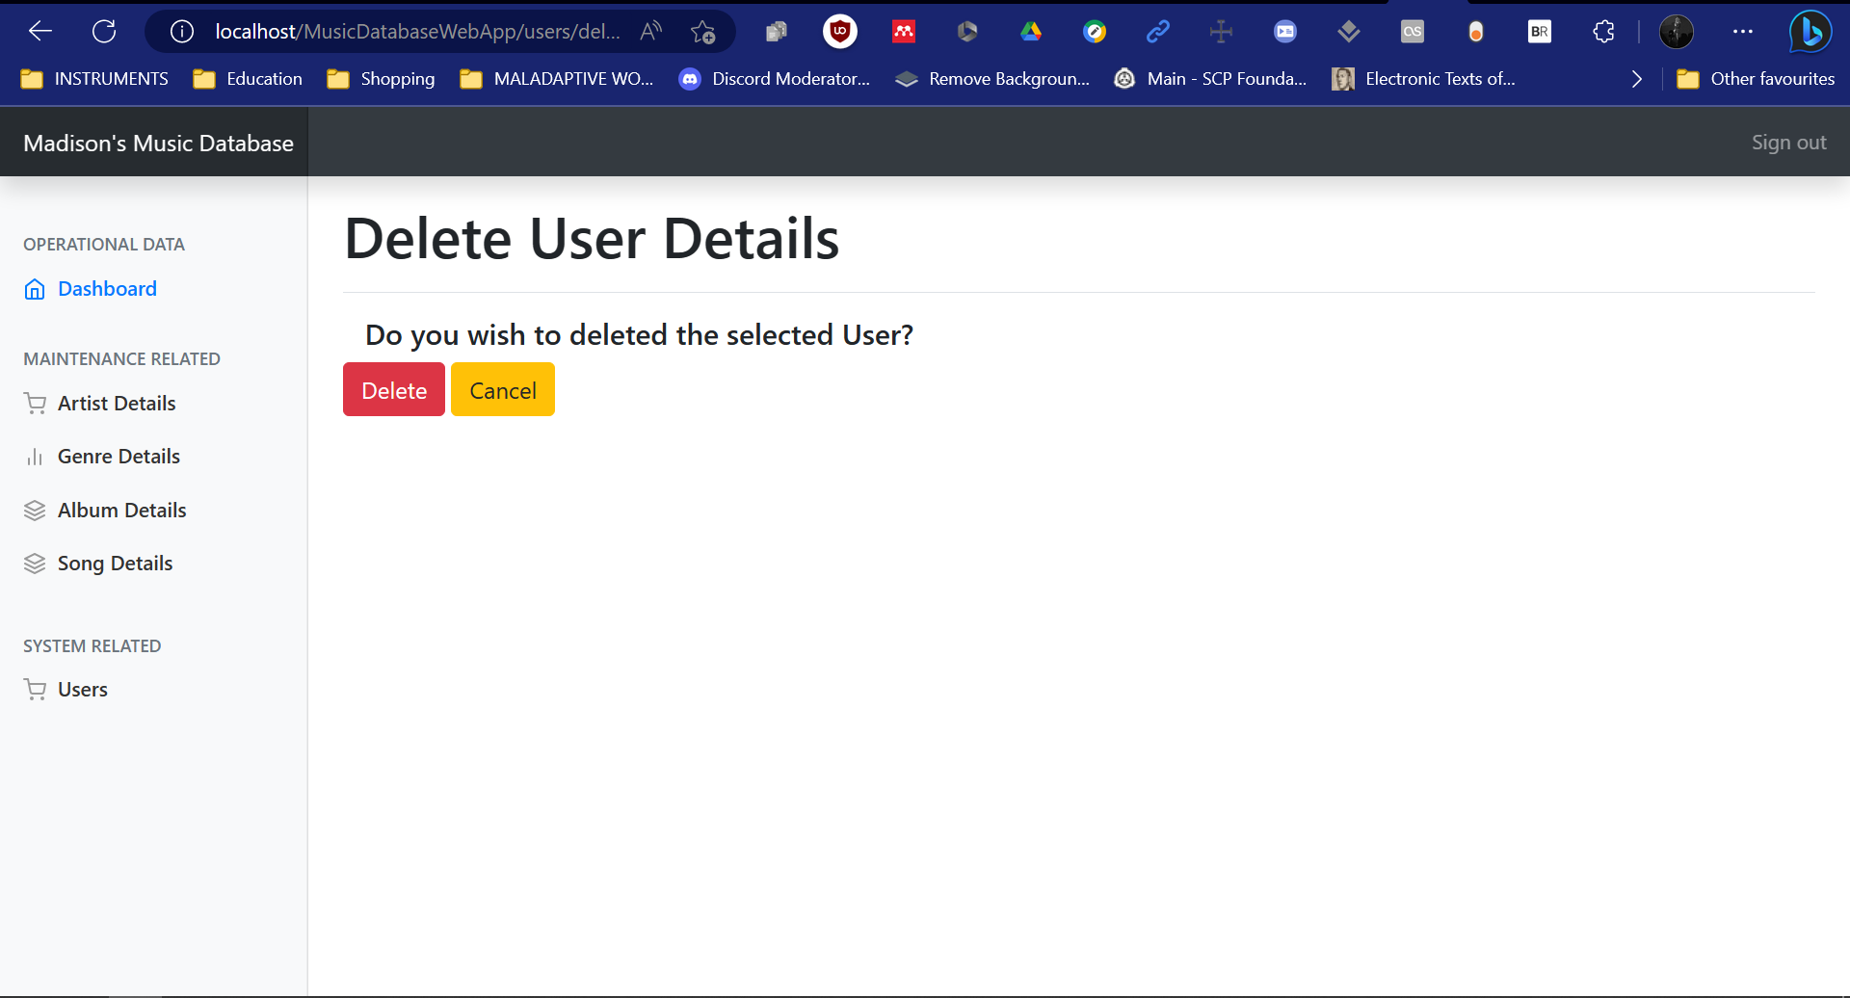

Running Demo
Below is an embedded YouTube video of a running demo of my database website application. If there are any issues with watching the embedded video, there will also be a direct YouTube link to the video, below.
DIRECT YOUTUBE VIDEO LINK


