
developing relationships and workplace achievement
Nazrin Karim - 1710333

April 17, 2019
University of Wales Trinity Saint David

Executive Summary

The purpose of this report is to critically evaluate development vehicles and their importance in developing an individual. the researcher has looked at how Eton Mayo and Fredrick Taylors theories help in motivated employees and the benefits of using them. As training helps motivate employees, the researcher has evaluated different forms on training and how useful they can be. Performance management is also vital in developing skills so the researcher has looked at different ways that an individual’s performance can be measured formally and informally. Also, in the report is case study evaluation on how Tesco have applied some of these methods and how it has helped them develop skills in their employees.
The researcher has also critically assed the potential benefits of using development vehicles in the workplace for both the organisation and an individual. Using case study’s, the researcher has looked at how Kellogg’s have applied Abraham Maslow and Frederick Herzberg’s theory and give examples of the results for both individual’s and the organisation.
As the researcher is looking to pursue a career as a teacher, they have created a personal development plan. Here they have set objectives and actions to work towards improving on their weaknesses to be able to succeed.

Table of Contents
Executive Summary 1
Introduction 3
Main Findings 4
1.1 Motivation………………………………………………………………………………………………………………………………4
1.2 Training……………………………………………………………………………………………..……………………………………5
1.3 Performance Management…………………………………………………………………………………………………….6
1.4 Methods Used by Tesco………………………………………………………………………………………………………….7
2. Benefits of Using Development Vehicles……………………………………………………………………..…………8
2.1 Organisation………………………………………………………………………………………………………………………….8
2.2 Individual………………………………………………………………………………………………………………………………8
3. Personal Development Plan………………………………………………………………………………………………….9
conclusion…………………………………………………………………………………………………………………………………….…13
Bibliography…………………………………………………………………………………………………………………………………….14
Appendices……………………………………………………………………………………………………………………………………...19

Introduction

Developing work place relationships are a vital part of development in our jobs (Skills for Justice, 2017). Having good relationships at work can benefit in different ways as they learn and develop new skills. For example, with new and improved skills people are more likely to enjoy work and implement changes to make an individual more creative and innovative (Industrial Personal LTD, 2017). It can also help develop careers and open opportunities for new positions to work one’s way up to better pay and other initiatives.
For employers it is important to plan out goals and how to achieve them (Barry, at el, 2015) this can be done through different development vehicles and theories. These methods can give the employer ideas on how to train staff and motivate them while manging their performance to ensure maintenance of knowledge and skills (Skills for Justice, 2017). For employers this can be very beneficial as staff who are well trained and motivated will perform better leading to more productivity and profits for the organisation.

Main Findings

- Different Develop vehicles

  - Motivation
Motivation is one of the key factors which helps to get the most out of employees. It is when an organisation feels important to make them perform better (MSG, 2019). Employee motivation can be done through keeping employees updated, rewards, feedback, and training (Squareup International, 2019).
According to Fredrick Taylors motivation theory, workers were motivated through pay. He argued that workers do not really enjoy work so managers should break down production into small tasks (Caramela, 2019). Workers should be given the appropriate training and tools and should be paid according to the number of items produced on a piece rate pay. This would motivate employees to produce more. Taylors methods were used by many organisations (Tutor2u, 2018), the most notable user was Henry Ford who used his method to design the first ever production line to make Ford cars. However, workers started feeling like they were being treated like machines as they were given repetitive tasks which were becoming boring (Tutor2u, 2018). Organisations were also starting to reduce workers as productivity was increasing which lead to more strikes and other actions from dissatisfied workers.
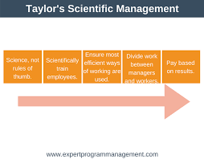(EPM, 2018)
On the other hand, Elton Mayo who was inspired by Taylors theory, believed that even though pay was important workers satisfaction were linked more to social needs (toolshero, 2019) and. Mayo carried out a set of tests known as the Hawthorne experiment (Dininni, 2017). From them he found that along with physical variables such as pay, workers would be more motivated through social factors like better communication, greater management involvement, more team work and more care in employee interests. Some critics did however argue that Mayo’s Theory was extremely manipulative as it makes people think that they are interested in workers when really, they were just interested in productivity by motivating them (Simplify, 2017).
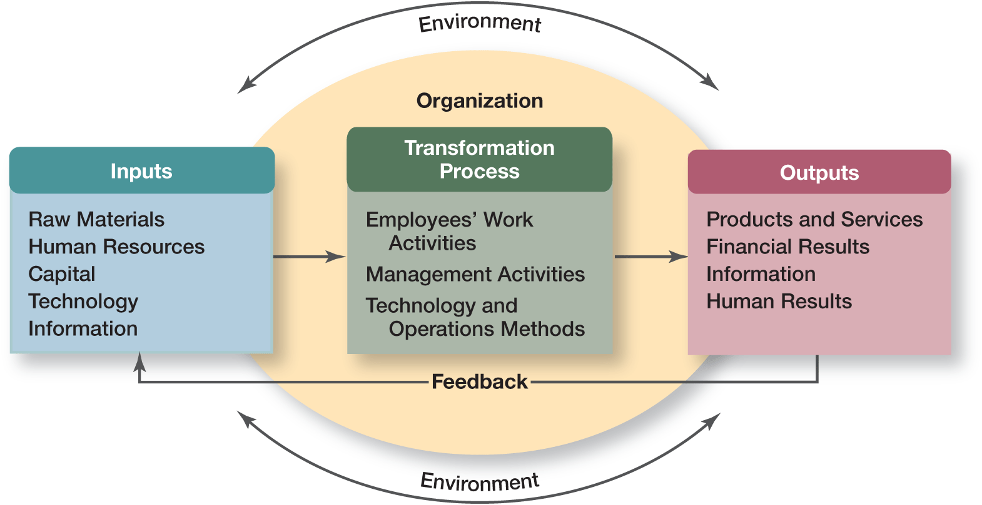
(Air Freshener, 2019).

The only similarity between these two theories’ is that they both are looking to increase productivity through motivation but the two differ in aspects where one is scientific and the other is more social (Grin, 2011). Taylor has approached motivation from a technical level and was more concerned on how the workers were doing rather than the managers or supervisors where Mayo looked at how the managers and supervisors were treating their workers.

  - Training
Training is when employees are led by more experienced or someone qualified. It is when they are given instructions from which they improve on skills or behaviour (CIPD, 2019). Training helps expand and develop the knowledge of employees. The systematic training cycle is a training model commonly used by organisations as its four stages helps to act in a structured and controlled manor (UK essays, 2016). It offers a systematic approach to training and identify weaknesses which need working on. Through training employees can benefit from improved job satisfaction, better performance, more confidence in workers and consistency at work (2020 Business Insight, 2019). The training method used depends on the needs of the task or job role. Training methods include on the job training and off the job training.
(Sultana, A. 2019) 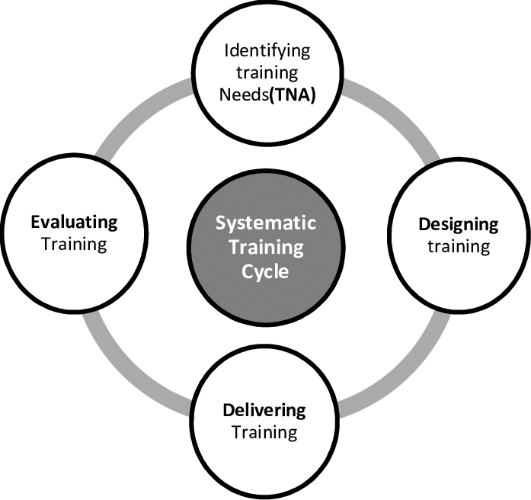

On the job training is methods of learning a job while doing it. A person will do the task or job and at the same time learn and develop skills (Tutor2u, 2018). On the job training can include, understudy, this is when an employee is trained by their supervisor and called understudy or assistant. Coaching were the employee is given guidance and instructions from a superior or supervisor. As stated in CMOE (2019), it may involve demonstrations and critical evaluation. Mentoring, in this the trainee is supported and given advice from someone with more experience. Secondment, here employees are sent to a different place where they can learn different and useful skills (business Case Studies, 2019). Some companies also offer apprenticeships where an apprentice will do a mixture of formal training, practical work and even informal training along with studying to gain a qualification.
Off the job training is when a person trains and learns while being away from the job (Tutor2u, 2018). Trainees are required to learn skills and get fully equipped with techniques that are needed on their actual job. According to CIPD (2019), off the job training may include doing internal or external courses and attending classes. This will give individuals the opportunity to focus on specific issues relating to the organisation or gain a fresh prospective and develop new and different skills to bring to the workplace. Other methods may include case studies and role playing.
Though both methods are useful, on the job training disadvantage are that quality will depend on the ability of the trainer and bad habits may be passed on but on the other hand is known to be most effective were off the job training can be expensive and once trainees have learnt new skills they may decide to leave and go for a better job but on the positive side employees may can be more confident when starting the job (Tutor2u, 2018).

  - Performance Management
Performance management is the process of improving individual’s performance and ensuring goals are met in the most effective and efficient way (Barry et al 2015). It is done through reviewing and assessing progress and developing skills, knowledge and the ability to perform better.
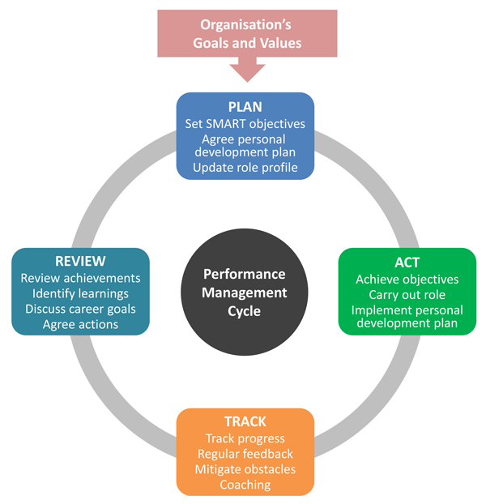

(Hearn, 2017)

Armstrong’s performance management cycle starts from planning. Planning should involve a SMART objective, a personal development plan or an action depending on job requirement. According to Hearn (2017), the ‘Act’ and ‘Track’ stages are the most important as these are the stages were the performance is produced and results are achieved. Staff need be encouraged to work on achieving their goal and in the same way managers need to give individuals regular feedback and coaching to be able to improve on their performance. The last stage is ‘Review’, this was deigned to allow both the employee and manager to look at how they have towards achieving their goal and results gained. Here they can also look at what places to put more effort into before returning to the ‘Plan’ stage. The stages on this cycle do not follow each other as ‘Act’ and ‘Track’ should always be continuing, and reviews can be taken at any point and planning can take place more than once.
However, as stated by Hearn, (2017), since 2015 more organisations are using the ‘Continues Performance Management Cycle’. This cycle is defined as performance management cycle that is ongoing throughout the year. This process includes regular objective goals, feedback and one to ones. People now believe that regular feedback and reviews work better than having a review once a year.
Regular reviews give employees the chance to see what has gone well and how they can continue to succeed in achieving their goals. It gives the opportunity to see where improvements can be made to further develop and improve performance. This process works better as found in a research fifty percent of companies where they have monthly reviews are at the top on financial performance where only twenty four percent of companies who have reviews once a year made it to the same bracket (Hearn, 2016).
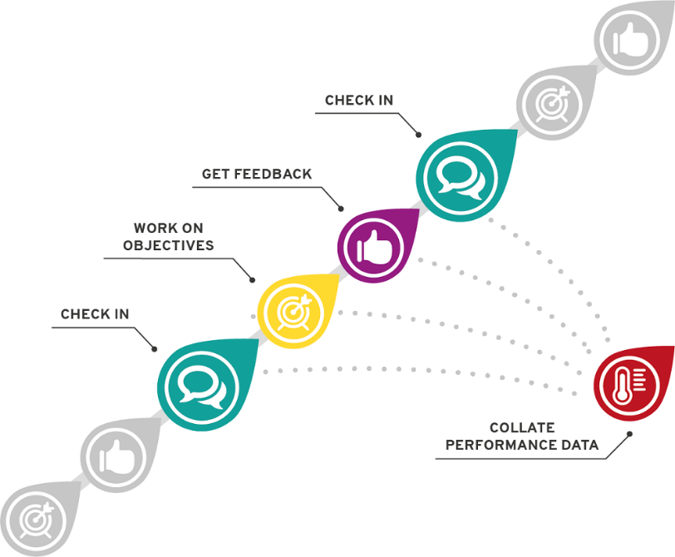

(Hearn, 2017)

  - Methods Used by Tesco
Tesco’s rewards system is like Taylor’s theory as their financial reward is one of the many motivating factors. However, they believe that there are more to employee motivation then money which is why Tesco go past pay increases and more onto personal and individual benefits. According to Business case study (2019), Mayo’s theory is seen used throughout the company as they say communication is one of the most important factors of motivating employees. Tesco may do this through one to one discussion, newsletters or more formally such as appraisals. Tesco recognises that by maintaining employee motivation by increasing their job satisfaction through training, development and timely rewards it will increase their company growth.
Tesco’s offer both on the job training and off the job training and both are equally important. On the job training is directly relevant to their work where they get to meet the people and become part of the team quicker (Business Case Studies, 2019). Off the job training is more for developing an individual and their skills to work their way up. Providing these training methods helps Tesco build a team of employees who are committed and flexible delivering high standards of customer service increasing customer growth.
Tesco continually manage their staff performance through different methods. To ensure that goals are met, and the factors used to insure this are using annual goal settings, involving staff, high commitment and support from managers, appropriate training, appraisals and have strong leaders to focus on the path (My Assignment Help, 2019). From this Tesco are clearly following the performance management cycle but as it is continuing through the year, they believe more on the modern continues management cycle as it helps their employees provide high level of performance leading to high productivity.
- Benefits of Using Development Vehicles

  - Organisation
Organisations that engaged employee development, benefited from sales increases and double profits (Getsmarter, 2019). It helps develop organisation employer brand making it more attractive to potential new and top employees working for competitor companies especially those looking to improve their skill (CFI, 2019). Training programmes are used as a competitive benefit. Motivating employees is very important for an organisation as it helps improve business performance (Napolitano, 2017). Staff turnover will reduce leading to reduction in recruitment costs. Number of absences will reduce which will benefit to higher productivity (NIBusiisnessinfo.co.uk, 2019). According to Getsmarter, (2019), investing in staff development is important for team retention and ninety four percent employee would stay with a company if it invested in their development. Herzberg who developed the two-factor theory which states that hygiene factors would satisfy employees who would become more productive (Business Case Studies, 2019). He believes that organisations need to ensure that hygiene factors reduced to motivate staff to have their full effect. According to another Case study on Linked In, Kellogg’s was recently placed in the top hundred best companies to work for in The Sunday Times. Kellogg’s using Herzberg’s theory has built a business that delivers consistent strong results. According to Business case studies, 2019, Kellogg’s makes work an exciting experience resulting in more productive, profitable and competitive business. However, this can come across as being a bit exaggerated as using Herzberg theory alone, money becomes secondary and if a competitor company is paying more money for the same job employees will not be satisfied resulting in problems for the company for example more staff may leave the organisation for a better paid job (Parikh, 2018), which is why Kellogg’s implement other theories as well as Herzberg.
  - Individual
Employees are benefited in numerous ways through using development vehicles. These include learning new skills and knowledge, or existing skills can be enhanced leading to further improvement (The Happy Manager, 2019). Training will help employees become more confident and positive which will result in better performance and pay rises. Ongoing performance management help employees improve their engagement at work whilst giving them a clear picture of their performance. It can also open opportunities to work their way up through promotions (Jones, 2016). Employees feel more at power and valued and will keep them motivated to do better if they are given the right attention (Getsmarter, 2019).
Maslow’s Theory is about motivation and the hierarchy of employee needs. He believes that when an individual is satisfies on one level of need (Linked in, 2016), they will move on to the next level which benefits the organisation but for employees Maslow’s theory is also highly beneficial as organisations who apply the Maslow theory will not only take care of staff pay but also their personal needs. For example, according to a case study on Business Case Studies, (2019), Kellogg’s employees are all motivated through all these levels and this has positive effects on each employee as the are offered completive salaries. They also have benefit programmes where employees can choose the benefits that suit their needs (Business Case Studies, 2019). Theses include child care vouchers, company cars, cash rewards and even discounted life assurance schemes. Employees at Kellogg’s also can choose work patterns that suit them and even take career breaks allowing employees to benefit from choosing a healthy work-life balance. Kellogg’ s also gives employees to take on ownership of projects which give them development opportunity.
For example, Laura Bryant who wanted to move into marketing joined Kellogg’s in 2002 in the sales team (Business Case Studies). Two years later she was rewarded and promoted to customer marketing manager which helped build her profile. Laura made the transition from marketing manager to assistant brand manager with her managers support. In 2009 she was again promoted to manage the marketing plan for Special K and now she is the brand manager of Kellogg’s Cornflakes. Through this Laura was helped by the organisation through motivation, training and performance management to help climb the hierarchy of needs and achieve her career goal.

- Person Development Plan
Personal development plan, also known as a PDP is a tool used to set goals and manage an individual’s or an organisation’s learning and growth (Brian, 2019) from which they work on every day to make progress on their development leading to success. Objectives in the PDP should be SMART or else it will, or it will leave everyone unsure of what to do (Parker and Crosby, 2012).
The researcher is looking to build a career in education and become a teacher and created a PDP identifying objectives.

Personal Development Plan

Name: Nazrin Karim Date: 17th April 2019

Objectives  What do I want to be able to do  or do better? | Success criteria  How will I recognise success?  How will I review and measure my improvement? | Actions  What methods will I use to achieve my learning objectives? | Implementation  How will I practise and apply what I learn?
Improve on numeracy skills as it is an essential part of teaching (Future Learn, 2019). | - Level three award qualification.  - Lecturer feedback  (City and Guilds, 2018) | Do the level three award in mathematics for numeracy as this will help develop skills needed for teaching (City and Guilds, 2018). | Take the National Numeracy  Challenge. This will help see help see progress (National Numeracy,2019).  Apply mathematical solutions without using calculators or computers (City University of London, 2019).
Improve on leadership skills as it is vital for a teacher to have leadership quality.They will need to be able  to provide guidance instructions,  direction and motivation (Lynch,  2019). | - Researcher will receive a  Certificate of completion at the end of the course (UCL, 2019).  - Researcher will receive a QTS  Certificate (UCAS, 2019). | The researcher should do the Early  Leadership level one course as this will  them understand themselves,  understand others and develop good  leadership skills (UCL, 2019). | To practice skills which they have learnt  researcher should go on to do a Postgraduate  Teaching Apprenticeship where they will be  able to put their leadership skills to practice  while working in a school with children  (UCAS, 2019).  The researcher should also find themselves  a mentor whom they can get constructive  feedback from (Randstad, 2019).
Develop better verbal communication skills as teaching is all about communicating through listening, speaking, reading, writing and presenting (Silver, 2018). | Success can be recognised when the  researcher can communicate in a  novel way and engage audience  enough where content of conversation  sticks with them (Patel, 2017). | Researcher should listen to what others  have to say and think about who the  audience are before they speak (Patel,  2017).  Researcher should also do more  networking through social media and  other networking sites (Darmody,  2018). | Attend local society debate meetings.  This will help see how the researcher has  developed communication skills and  confidence and put them to practice (Bright  Network, 2019).
Improve on being more patient. As a  teacher it is important to have  patience as they will come across  different characteristics in children,  some who will put in minimal effort  or some who will express anxiety.  (School of Educators, 2011), so | Once the researcher feels less stressed  and feels happier in what they are  doing this can be marked as success in  being more patient (Power, 2018). | The researcher will be more mindful of  the things that make them impatient by  writing them down and focusing on one  task at a time (Power, 2018). | The researcher can practice patience levels  with their own children at home by pausing  and reflecting on situations before reacting  (Korpalski, 2019).
Develop their creative ICT skills.  Nowadays to be a teacher an  individual will need knowledge in  modern technology. Researcher  (Fort, 2017). | Researcher will gain a level two on Information and Creative Technology (Coleg Gwent, 2019). | Do BTEC in Information and Creative  Technology level two as it will  Help gain broad knowledge on  information technology and develop  creative aspects of ICT  (Coleg Gwent, 2019). | Researcher can practice their ICT skills by  using the computer more often whether it’s for  course work or assignment or personal use  such as booking holidays and shopping  online. Researcher should also find a part  time job which involves using computer  programmes in which they can apply them  skills (Doyle, 2018).
Develop better teamworking skills  and work better with different  personalities. (Teacher Certification,  2019). | Success can be seen when the researcher is respected by members of a team where they can rely on them and a positive attitude is kept whether the results are good or bad (Riggio, 2013). | The researcher will work with different  groups of people while doing them  courses take part in decision making  (Founders Grid, 2014). | Prioritise my weaknesses identified whilst  working in different groups and work on  improving them. Take feedback from other  members. Try using teamwork theories like  the Belbin theory which can help identify  strengths and weaknesses of different  members of the team which can help  communicate and work together better  (Belbin, 2019).

Conclusion

To conclude, the researcher has found that developing workplace relationships and achieving skills plays a big part for both the employer and employee. Learning new skills or developing on weak skills can help work towards building an individual’s career and help increase organisation profits and status.
The researcher has found that using different theories in the organisation is important as they help plan goals and how to achieve them. Motivating employees through social factors is just as important as pay to satisfy employees (toolshero, 2019).
On the job training allows workers to learn while working and was found the most effective. Off the job training gives the opportunity to learn new and different skills but can be expensive for the employer. The systematic training cycle gives a systematic approach to training and identifying weaknesses which need to be improved (2020 Business Insight, 2019).
According to Hearn, (2017), performance management helps review progress of staff formally and informally. The researcher found that regular reviews help both the employer and employee see weaknesses and set goals to improve them as well as recognising achievements which can help motivate them. Using a PDP to set goals for those objectives can help plan towards improving them in a SMART way (Brian, 2019).

Bibliography

MSG. (2019), ‘Motivating and Employee Development’, [Online]. Available: https://www.managementstudyguide.com/motivation-and-employee-development.htm. [Accessed: 29th March 2019].
Squareup. (2019), ’10 Scientifically Ways to Motivate Employees’, [Online]. Available: https://squareup.com/gb/townsquare/how-to-motivate-your-employees. [Accessed: 29th March 2019].
Caramela, S. (2019), ‘Management Theory of Fredrick Taylor’, [Online]. Available: https://www.business.com/articles/management-theory-of-frederick-taylor/. [Accessed: 30th March 2019].
Tutor2u. (2018), ‘Theories of Motivation (GCSE)’, [Online]. Available: https://www.tutor2u.net/business/reference/theories-of-motivation-gcse. [Accessed: 30th March 2019].
Dininni, J. (2017), Management Theory of Elton Mayo, [Online]. Available: https://www.business.com/articles/management-theory-of-elton-mayo/. [Accessed: 26th March 2019].
Tools Hero. (2019), Elton Mayo, [Online]. Available: https://www.toolshero.com/toolsheroes/elton-mayo/. [Accessed: 26th March 2019].
Mister Simplify. (2017), Mayo’s Hawthorne Effect (Employee Motivation) - Simplest Explanation Ever, [Video]. Available: https://www.youtube.com/watch?v=UUMYVN-4wFw&t=12s. [Accessed: 30th March 2019].
Grin. (2011), ‘Compare and Contrast Scientific Management and Human Relations Theory’, [Online]. Available: https://www.grin.com/document/205705. [Accessed: 30th March 2019].
Business Case Studies. (2019), Developing People Through Training, A Forestry Commission Case Study, [Online]. Available at: http://businesscasestudies.co.uk/forestry-commission/developing-people-through-training/training-in-action.html. [9th March 2019].

CMOE. (2019), ‘Three Methods of Employee Development for Professional Growth’, [Online]. Available: https://cmoe.com/blog/three-methods-of-employee-development-training-coaching-and-mentoring/. [Accessed: 31st March 2019].
CIPD. (2019), ‘Learning Methods’, [Online]. Available: https://www.cipd.co.uk/knowledge/fundamentals/people/development/learning-methods-factsheet#6679. [Accessed: 31st March 2019].
Tutor2u. (2018), ‘Training - On-The-Job Training’, [Online]. Available: https://www.tutor2u.net/business/reference/training-on-the-job-training. [Accessed: 31st March 2018].
Tutor2u. (2018), ‘Training – Off-The-Job Training’, [Online]. Available: https://www.tutor2u.net/business/reference/training-off-the-job-training. [Accessed: 31st March].
UK Essays. (2016), ‘Forgotten Element of the Systematic Training Cycle Management Essay’, [Online]. Available: https://www.ukessays.com/essays/management/forgotten-element-of-the-systematic-training-cycle-management-essay.php. [Accessed: 31st March 2019].
Air Freshener. (2019), ‘Elton Mayo Human Relations Theory’, [Online]. Available: https://airfreshener.club/quotes/elton-mayo-human-relations-theory.html. [Accessed: 30th March 2019].
EPM. (2018), ‘Taylors Motivation Theory – Scientific Management’, [Online]. Available: https://expertprogrammanagement.com/2018/05/taylors-scientific-management/. [Accessed: 30th March 2019].
Sultana, A. (2019), ‘Systematic Training’, [Online]. Available: https://www.researchgate.net/figure/Systematic-Training-the-basic-cycle-Cole-Employee-development-and-Training-pp-351_fig1_268382111. [Accessed: 31st March 2019].
Hearne, S. (2017), ‘What is an Effective Performance Management System (Explained)’, (Online). Available: https://www.clearreview.com/resources/guides/what-is-effective-performance-management/. [Accessed: 31st March 2019].
Hearne, S. (2016), ‘What is Continues Performance Management?’, [Online]. Available: https://www.clearreview.com/resources/guides/continuous-performance-management/. [Accessed: 4th April 2019].
Business Case Studies. (2019), ‘Motivational Theory in Practice at Tesco, A Tesco Case Study’, [Online]. Available: http://businesscasestudies.co.uk/tesco/motivational-theory-in-practice-at-tesco/conclusion.html. [Accessed: 4th April 2019].
Business Case Studies. (2019), ‘How Training and Development Supports Business Growth, A Tesco Case Study’, [Online]. Available: http://businesscasestudies.co.uk/tesco/how-training-and-development-supports-business-growth/conclusion.html. [Accessed: 4th April 2019].
My Assignment Help. (2019), ‘Tesco Performance Management: Performance and Productivity’, [Online]. Available: https://myassignmenthelp.com/free-samples/tesco-performance-management-performance-and-productivity. [Accessed: 4th April 2019].
Parikh, V. (2018), ‘Advantages and Disadvanteges of Herzberg Theory’, [Online]. Available: http://www.letslearnfinance.com/advantages-and-disadvantages-of-herzberg-theory.html. [Accessed: 4th April 2019].
Getsmarter. (2019), ‘Employee Training and Developing: The Benefits and Why it’s Important’, [Online]. Available: https://www.getsmarter.com/blog/employee-development/employee-training-and-development-the-benefits-and-why-its-important. [Accessed: 4th April 2019].
NIBusiness info.co.uk. (2019), ‘Lead and Motivate your Staff’, [Online]. Available: https://www.nibusinessinfo.co.uk/content/advantages-leading-and-motivating-your-employees. [Accessed: 4th April 2019].
Napolitano, A. (2017), ‘Beyond the Clock: The Benefits of Highly Motivated Employees’, [Online]. Available: https://www.business.com/articles/the-benefits-of-highly-motivated-employees/. [Accessed: 4th April 2019].
Jones, D. (2016), ‘How Ongoing Performance Management Benefits the Employee and the Business’, [Online]. Available: https://blog.shrm.org/blog/how-ongoing-performance-management-benefits-the-employee-and-the-business. [Accessed: 5th April 2019].
The Happy Manager. (2019), ‘Employee Training Development’, [Online]. Available: https://the-happy-manager.com/articles/employee-training-development/. [Accessed: 5th April 2019].
Business Case Studies. (2019), (Building an Better Workplace Through Motivation’, [Online]. Available: http://businesscasestudies.co.uk/kelloggs/building-a-better-workplace-through-motivation/maslow.html. [Accessed: 5th April 2019].
Linked in. (2014), ‘Kellogg’s Strategy (K-Values) of Motivating Employees’, [Online]. Available: https://www.linkedin.com/pulse/20140722081552-40947926-kellogg-s-strategy-k-values-of-motivation-of-employees/. [Accessed: 5th April 2019].
Barry, N, Cumberland, N, Kamp, D, and Manser. (2015), ‘The Ultimate Management Book’. Great Britain: Hodder & Stoughton.
Linked in. (2016), ‘Maslow’s Hierarchy of Needs: The Benefits of Self – Actualised Employees’, [Online]. Available: https://www.linkedin.com/pulse/maslows-hierarchy-needs-benefits-self-actualized-employees-scott-king/. [Accessed: 5th April 2019].
CFI. (2019), ‘Employee Training and Development’, [Online]. Available: https://corporatefinanceinstitute.com/resources/careers/soft-skills/employee-training-and-development/. [Accessed: 5th April 2019].
Future Learn. (2019), ‘Numeracy Skills for Employability and Workplace’, [Online]. Available: https://www.futurelearn.com/courses/numeracy-skills. [Accessed: 5th April 2019]. Ity
National Numeracy. (2019), ‘How to Improve Your Maths’, [Online]. Available: https://www.nationalnumeracy.org.uk/improve-your-maths. [Accessed: 6th April 2019].
City and Guilds. (2018), ‘English for Literacy and Mathematics for Numeracy Teaching’, [Online]. Available: https://www.cityandguilds.com/qualifications-and-apprenticeships/learning/teaching/6255-english-for-literacy-and-mathematics-for-numeracy-teaching#tab=information. [Accessed: 5th April 2019].
City University of London. (2019), ‘Application of Numeracy’, [Online]. Available: https://experience.city.ac.uk/develop-skills/application-numeracy. [Accessed: 7Th April 2019].
Lynch, M. (2016), ‘Why More Teachers Need a Leadership Mindset’, [Online]. Available: https://www.theedadvocate.org/teachers-need-leadership-mindset/. [Accessed: 7th April 2019].
Randstad. (2019), ‘Developing Leadership Skills in Teaching’, [Online]. Available: https://www.randstad.co.uk/career-advice/skills/developing-leadership-skills-in-teaching/. [Accessed: 7th April 2019].
UCL. (2019), ‘Early Leadership (Level 1): Leadership Development Programme (For New and Aspiring Leaders in Education), [Online]. Available: https://www.ucl.ac.uk/lifelearning/courses/early-leadership-level-1-new-aspiring-leaders-education. [Accessed: 7th April 2019].
UCAS. (2019), ‘Post Graduate Teaching Apprenticeship’, [Online]. Available: https://www.ucas.com/teaching-option/postgraduate-teaching-apprenticeship. [Accessed: 7th April 2019].
Patel, D. (2017), ’14 Ways to Improve Your Communication Skills’, [Online]. Available: https://www.entrepreneur.com/article/300466. [Accessed: 7th April 2019].
Darmody, J. (2018), ‘How to Improve Your Communication Skills in 7 Easy(ish) Steps’, [Online]. Available: https://www.siliconrepublic.com/advice/grief-in-the-workplace-hr. [Accessed: 7th April 2019].
Silver, F. (2018), ‘Why is it Important for Teachers to Have Good Communication Skills?’, [Online]. Available: https://work.chron.com/important-teachers-good-communication-skills-10512.html. [Accessed: 7th April 2019].
School of Educators. (2011), ‘Patience Maybe the Most Important’, [Online]. Available: http://schoolofeducators.com/2011/06/patience-may-be-the-most-important/. [Accessed: 7th April 2019].
Power, R. (2018), ‘4 Tips to Help You be More Patient, Science Says You Will Be Happier’, [Online]. Available: https://www.inc.com/rhett-power/4-tips-to-help-you-be-a-more-patient-person-science-says-you-will-be-happier.html. [Accessed: 7th April 2019].
Korpalski, B. (2019), ‘Five Easy-To-Implement Strategies for Exercising Patience’, [Online]. Available: https://www.doyouyoga.com/5-easy-to-implement-strategies-for-exercising-patience/. [Accessed: 7th April 2019].
Fort, A. (2017), ‘Eight Computer Skills for Every Teacher to Master’, [Online]. Available: https://elearningindustry.com/8-computer-skills-every-teacher-to-master. [Accessed: 7th April 2019].
Coleg Gwent. (2019), ‘BTEC Fist Diploma in Information and Creative Technology Level 2’, [Online]. Available: https://www.coleggwent.ac.uk/courses/BTEC_First_Diploma_in_Information_and_Creative_Technology_Level_2%20(BD0028). [Accessed: 7th April 2019].
Doyle, A. (2018), ‘Five Fee and Easy Ways to Improve Your Computer Skills’, [Online]. Available: https://www.careertoolbelt.com/5-free-and-easy-ways-to-improve-your-computer-skills/. [Accessed: 7th April 2019].
Teacher Certification. (2019), '9 Useful Skills for Teachers’, [Online]. Available: http://www.teachercertification.org/a/9-useful-skills-for-teachers.html. [Accessed: 7th April 2019].
Founders Grid. (2014), ‘20Stratergies Start Ups Can Implement Today to Improve Teamwork’, [Online]. Available: https://foundersgrid.com/teamwork/. [Accessed: 7th April 2019].
Riggio, R, E. (2013), ‘Characteristics of Good Team Members’, [Online]. Available: https://www.psychologytoday.com/us/blog/cutting-edge-leadership/201301/characteristics-good-work-team-members. [Accessed: 7th April 2019].
Belbin. (2019), ‘Why Use Belbin?’, [Online]. Available: https://www.belbin.com/about/why-use-belbin/. [Accessed: 7th April 2019].
Tracy, B. (2019), ‘Turn All Your Dreams Into Reality With a Personal Development Plan’, [Online]. Available: https://www.briantracy.com/blog/personal-success/personal-development-plan/. [Accessed: 7th April 2019].
Industrial Personal LTD. (2016), ‘Why is it Important to Have Effective Working Relationships with Colleagues?’, [Online]. Available: http://www.industrialpersonnel.co.uk/important-effective-working-relationships-colleagues/. [Accessed: 8th April 2019].
Skills For Justice. (2017), ‘Five Reasons Why Staff Development in the Workplace is Important, [Online]. Available: https://www.sfjuk.com/blog/215-five-reasons-why-staff-development-in-the-workplace-is-important. [Accessed: 8th April 2019].
Crosby, E and Parker, J.A. (2012), ‘Certificate in Team Leading’. Italy: Hodder Education.

Appendix

Forestry commission training presentation notes

Introduction

Hi everyone, my name is Naz and this is our team, Aleha, Shahida, Thanuma, and Akbar. As a team we have chosen to talk about the forestry commission. The forestry commission are Britain’s largest land managers. As stated in the forestry commission, they harvest almost four million tonnes of wood every year. They also plant millions of trees a year to create new woodland and to replace trees we harvest. The forestry commissions mission is to protect and expand forests and woodlands and increase their value to society and the environment.
Today we will discuss what types of training the forestry commission use on their staff and the importance of training their employees. We have also looked at a case study and will talk about how training has helped in this case study.
On the job training
I will start by looking at on-the-job training. On-the-job training basically means training while at work. It is considered to be the best way to learn practical skills as trainees will learn by following instructions given by a manager, trainer or colleague while doing a real task (Business Case Studies, 2019). Training may include things like how to plant new seedings and how to protect them from the cold and heat.
Different types of on the job training methods include, coaching and mentoring. This is where trainees will be guided and instructed by a coach. A senior member or someone with more experience will provide advice and give trainees support.
Another on the job training type is secondment. Here employees are sent to a different place for a short time so they can learn different useful skills.
They also offer an apprenticeship where the apprentice will combine a mixture of formal training, practical work experience, informal on the job training as well as studying towards their qualification (Forestry Commission, 2018).
I will now pass it on to Aleha who will define off the job training.

Motivation presentation notes
Hi everyone, my name is Naz and I will briefly explain how a business can improve through applying these motivational theory’s.
So how does motivation of employees help a company or organisation to achieve competitive achievements?
There are several reasons why employee motivation in a business is important. As a group we think motivating the staff is one of the most important strategy’s in a business as it helps allow the management team to meet the company goals.
Motivation affects nearly all aspects of a business. If an employee is motivated to do well this automatically shows that they are happy and satisfied at what they are doing and the right motivation will make them feel responsible for their part of the job and will make them work harder and perform better (Reference for Business, 2019).
Working harder will lead to more work done is less time and if one employee is able to do the same amount of work as two or even three workers than this will reduce labour costs for the business which show higher productivity for the company, (NDA).
Motivation can also help build a good team of people who are all aiming for the best and will provide an outstanding service, people who will not waste time, call in sick unless needed or clock out before its time to leave (Chron, 2019).
So as an example, if we look at the NDA who say they have applied different motivation theories to increase motivation in their employees, we can see that it has helped their company as they hold the ‘Investors in People’ status. So, they are a great example of how motivation can help a business.
So basically, if your staff are motivated results will be better and management teams will be happier.

