PROGRAMME: MSC PUBLIC HEALTH AND SOCIAL CARE IN
PRACTICE

ASSIGNMENT TITLE: CASE STUDY ANALYSIS REPORT

MODULE CODE: LCHS7002
LECTURER: SHAILA HUSSAIN

MODULE: HEALTH CARE SYSTEM ORGANISATION AND LEADERSHIP

STUDENT NAME: Nilesh Ambalal Patil
STUDENT ID: 2523930

Institution: University of Wales trinity saint David London Campus
City, Country: London UK

Executive summary
The overall report has reflected the case evidence of Public Health and social care in practice by taking the reference of the NHS considering the case information about over limit dose of morphine to a 4-year old child. The report has provided a brief understanding of the background along with the problem and leadership context associated with the case study. Valuable lessons learnt from this problem have clearly reflected the necessity of integrating situational leadership along with decentralized decision making. Recently, the NHS is also suggested to consider the duty of quality along with autonomy and digital medication management software to avoid medication errors in future.

Table of Content
1. Introduction 4
2. Main Body and Analysis 5
2.1 Identifying the Problem and Setting the System Context- Applying Systems Thinking and the Rich Picture 5
2.2 Centralisation or Decentralisation within the Case Study 11
2.3 Leadership Theories and Application to the Case Study 13
2.4 Improvement, and Lessons Learned 17
3. Recommendation 20
4. Conclusion 22
Reference List 24

1. Introduction
1.1 Background and purpose of the study
The present study denotes the evidence of infant morphine overdose in the NHS for a child. A 4-year old child in the North East and Yorkshire received the overdose of morphine sulphate oral solution by 20 times higher as compared to the intended dosage (NHS, 2023). In this case, the GP stated morphine sulphate solution at a measure of 200 mcg in every 4 hours that was wrongly interpreted by the pharmacists as well as support staff to the child’s parents. This incident resulted in excessive overdose of ‘Red Drug’ with 3.8 mg instead of having 190 micrograms and also forced the necessity of providing medical emergency care (NHS, 2023). In this regard, the purpose of the current study is to define the problem with an Insight into the Case Context and Evidence Highlighting Leadership Implications.
1.2 Leadership
Leadership is defined as a perceptual ability for influencing, inspiring and guiding people for obtaining common goals. In the health and social care environment, leadership is clearly reflected as the core element to drive compassion and person-centred care by maintaining collaborative and ethical practices (Schaub et al. 2022). Prospective skills of leadership considerably include adaptability and emotional intelligence, accountability and smooth communication. (West et al. 2015).

1.3 Centralisation, decentralisation and key leadership styles
The concept of centralisation in health and social care is associated with concentrated decision making and planning for improving efficiency and standardised care quality (Shishkinz et al. 2025).For example Improved patient outcomes and efficiency are coherently signifying centralisation along with the attributes of resource allocation. Decentralization clearly reveals shifting decision-making and management in health and social care with re-distributed decision authority (Kwachou, 2025). As compared to centralisation, decentralised results in increasing community participation and regional decision-making that leads to faster decisions.
Different leadership theories and styles are recognised for The purpose of Centralisation and Decentralisation including transformational, transactional and situational leadership. Transformational leadership theory highlights the perceived ability of leaders to guide and inspire the followers (Khan et al. 2025). The aspect of staff motivation is required for the NHS to eliminate medication errors through transformational leadership. Similarly, transactional leadership theory reveals the process of motivating staff through exchange of rewards or punishments. This theory also defines staff motivation as a topmost factor that aligns with the case study of the NHS to prevent medication errors. Situational leadership theory also denotes the alignment of leadership styles according to different situational needs (Xuecheng et al. 2022). Application of proper leadership style was missing in the NHS that raised the mentioned case study issue of medication error. Hence, different leadership styles are recognising the role of leadership as an influential parameter to comprehend the extension of health and social care quality.
1.4 Importance of leadership
Leadership is signified as the stair to succeed in change or crisis situations through appropriate strategic planning and direction. Restivo et al. (2022) reflected the evidence of lacking leadership efficiency and effectiveness on healthcare outcomes that also requires improvement. The current case of the NHS defines the necessity of modifying existing leadership style in order to prevent the occurrence of serious issues like medication errors. Hence, leadership is maintaining a transverse relationship in health and social care with patient experience and satisfaction.
The present report would cover problem identification for the mentioned incident of the NHS along with providing real evidence and statistical information about wrong treatment. Apparently, the sequences of centralisation and decentralization would also be comprehended with the case study along with defining leadership theories and application. A small recommendation is also added in this case to denote the future plan of operations in the NHS along with suggesting effective leadership styles for sustaining improvement.

2. Main Body and Analysis

2.1 Identifying the Problem and Setting the System Context- Applying Systems Thinking and the Rich Picture
2.1.1 Describe the central problem
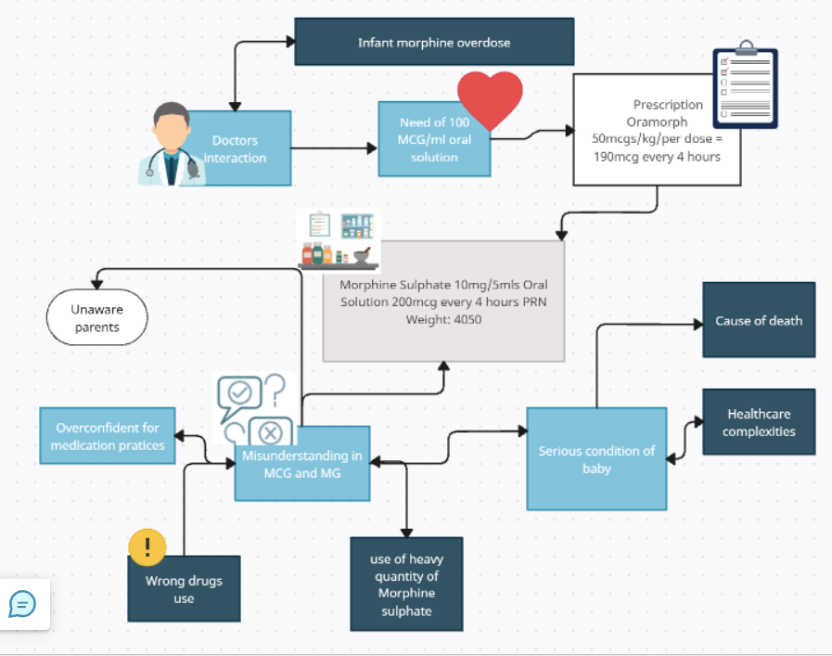
Figure 1: Rich Picture to define the central problem
(Source: Self-developed)
The above figure demonstrates the faults and complexities in supplying proper medicines within hospital sectors. In this regard, morphine sulphate oral solution has been provided with overdose due to which a four-week-old baby reported with a more serious condition (NHS, 2023). The above rich picture also presents mistakes that are often considered in hospitals while providing a dose of medicines regarding patient care. Referring to this case, there are other examples and data based on national and global data that also supports this argument. According to a report of GOV.UK, approximately 2.2 million medical errors have been reported in England due to which patient safety as well as medication threat has been affected (GOV.UK, 2025). This information highlights major problems in the UK hospital where multiple drug issues and medical errors are affecting living standards. Henceforth, major causes such as medication errors and wrong practices in the healthcare field reflect on poor governance as well as decision-making in dealing with operational efficiency.
2.1.2 Global Statistical Overview of the Problem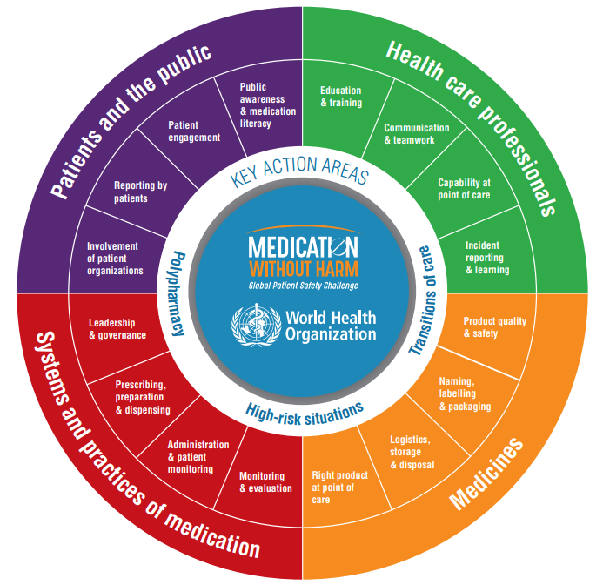
Figure 2: Global patient safety challenges
(Source: WHO, 2025)
The world health organisation (WHO) reveals the major issues within hospital sectors due to which numbers of injuries, excessive overdose of medicine and operational risk has been increased. The cost estimated regarding global medical errors has been considered as 42 billion dollars annually that reveals unsafe medication practices, errors and staff shortages (WHO, 2025). The above figure highlights key areas regarding health care systems identifying major activities as administration, monitoring, prescribing and transcribing during health-related practices. Henceforth, WHO also justified that patient safety has been recognised as common challenges due to unsafe medication practices that caused excessive red drug use during the case of a 4-week-old baby.
2.1.3 National Statistical Overview of the Problem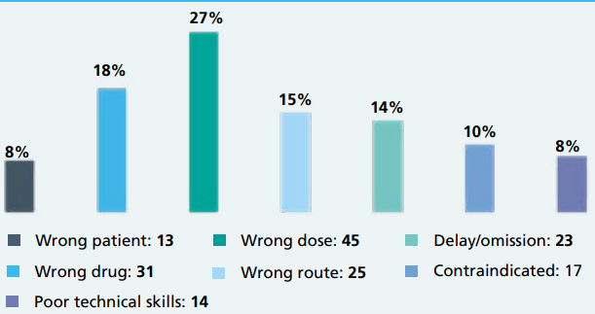
Figure 3: NHS’s report on patient safety challenges
(Source: NHS, 2022)
Patient safety is considered as common challenges around the world including the UK where NHS reviews their perspectives in analysing the major factors for causing the problems. In this case, wrong dose has been accounted for as 45 out of 100 that reveals serious concerns while treating patients with proper medication (NHS, 2022). This information also signifies the present case information in examining that wrong dose causes major challenges where a 4-week-old baby got affected from heavy red drugs dose. According to a report, prescription errors and drug doses along with unsafe practices have been examined where 6000 people were harmed by prescription errors within 2021 (Goodier, 2022). A pregnant woman also died at that time due to providing wrong usage of dosages and 29 people killed by following the wrong prescription during medication practices. This information also reveals internal as well as external case summary of 4-week-old baby cases where excessive doses of red drugs have been provided due to mistakes of doctors in mentioning 10mg/5ml. (Sutherland et al., 2020)

2.1.4 National Figures in a Global Context
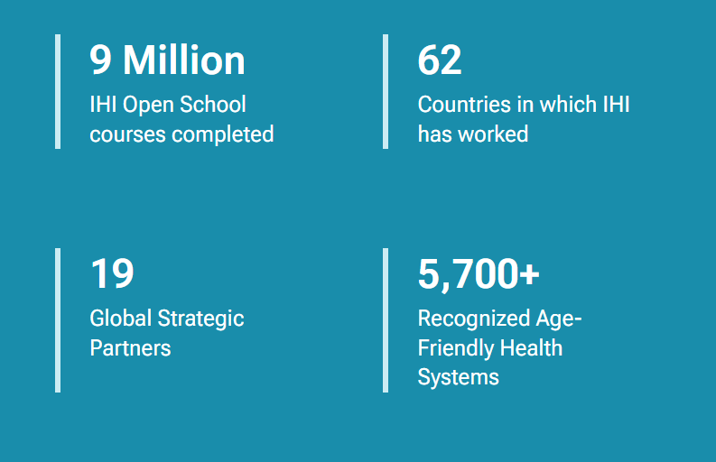
Figure 4: Measurable statistics of IHI
(Source: IHI.ORG, 2022)
The red drug case regarding a 4-week-old baby is explored by understanding different perspectives including the existing information from Institute for Healthcare Improvement. For example, IHI (Institute of Health Improvement) has developed 10 global strategic partnership in business process for developing connection with other nations (IHI.ORG, 2022). Furthermore, in case of developing strong connection with international aspects, IHI might reduce on the problem in connection to worldwide presentation. Furthermore, according to a report of IHI, several issues in healthcare refers to wrong use of abbreviation and providing wrong drugs due to which many people are killed by poor hospital management. This significantly aligns information with the current case where mistakes are considered from the doctor's side while writing prescriptions. (IHI.ORG, 2022).
2.1.5 Systemic Weaknesses Contributing to the Problem
The case of a 4-week baby in the context of excessive doses of red drugs reflects communication as well as an understanding gap along with poor leadership activities. In this case, the general practitioner issued a prescription for the review of the baby's health where the GP was unaware that about 100 micrograms/ml serving was already available (NHS, 2023). The baby is given an oral morphine solution containing 10 mg/5 ml as a result of this poor accountability in determining which composition with the appropriate quantity of medications will be appropriate. Therefore, it is evident from this data that general practitioners failed to manage pharmaceutical practices in accordance with regulations due to a communication breakdown and a lack of leadership. (World Health Organization, 2017)
2.1.6 Role of Local, Regional, and National Governance
At the local, regional, and national levels, governance for drug safety works to promote safe prescription practices and lower medication errors. These governance mechanisms in this instance draw attention to deficiencies in medicine administration and leadership. These levels are described in Table 1 along with how they relate to the stated problem.
Local | Regional | National
Northeast and Yorkshire promote “The controlled drugs regulations 2013” in addressing drug control and emphasizes right ways to treat patients along with proper use of drugs (Legislation, 2026). For example, the present cases show the failure of general practitioners in providing drug doses to 4-week-old babies that need a proper coordination with previous and current prescription for getting better results. | Medication safety management is considered within different areas in the UK (NHS, 2025). Medication safety management influences this problem and promotes medication error policy in dealing with such challenges. | The NHS has promoted NHS patient safety strategy 2 that mainly focuses on medication errors in dealing with complexities (NHS, 2022). Referring to this, all information and documents can be reviewed during this case that can help health care professionals to provide right doses of drugs.
Table 1: Level of governance
(Source: Self-developed)
2.1.7 Underlying Challenges Supported by Data
The current problem related to this case highlights risk of patient safety outcomes that caused use of morphine oral solution with 10mg/5ml. For example, general practitioners followed the EPS prescriptions where 200 micrograms medicine was needed based on the baby’s weight and current conditions (NHS, 2023). However, it was not mentioned in the discharge letter that per serving of drugs will be measured under 10mg/5ml. It also shows the staff shortages where general practitioners did not understand and provide wrong doses. The action in terms of prevention reflects on communication between surgery and pharmacists that can provide a clinical conversation to address the patient safety issues (NHS, 2023). Henceforth, staff shortages also raised this challenge in providing wrong doses of medicines due to which healthcare professionals did not interact with the right way to review the medical documents and medicines.

2.2 Centralisation or Decentralisation within the Case Study
2.2.1 Centralised systems:
a) Concentration of Decision-Making and Example
The case of 4-week-old babies who received an overdose of morphine oral solution needs a well-structured healthcare system to address these issues. As per the view of Marzok et al. (2023), centralized decision-making systems refers to those organizations where decisions are granted from top management. This helps organisations to consider paths for dealing with complexities and plan for further improvements. Referring to this, NHS England can introduce a structured body in preventing wrong medical diseases and allow doctors to review the patient history for refilling reliable medicines. For example, the US government describes root cause analysis and computerised physician order entry along with clinical decision support systems that can help healthcare professionals to reduce impacts of medication errors (Scherbak et al. 2024). Moreover, electronic identification such as Barcode can be used for patient identification and providing right medications that can contribute in continuous improvement towards patient safety. Similarly, the NHS needs to focus on the electric systems along with patient identification that can help in managing medication dosages based on patient information. Therefore, investing in root cause analysis as well as computerised systems for the medication process would be beneficial for the NHS that can review drugs, patient’s history and better practices.
b) Strengths and Limitations of the Case Study
Decision-making factors | Advantage | Disadvantage
Centralised decision systems | - Creates uniformity  - Clear signals to employees (Goel and Rahulamathavan, 2024)  - Provide clear path | - Negative effects on nurses (Bigestans et al. 2023)  - Lack of creativity for further change
Table 2: Advantage and disadvantage of centralised decision-making systems
(Source: Self-developed)
The above table presents a comprehensive view in understanding the advantage of centralised decision systems that effects on motivating factors to enhance nurse engagement within healthcare sectors. However, there are also disadvantages in centralised decision systems where lack of creative tasks refers to complexities in managing medication practices for better health outcomes (Maine et al. 2022). The NHS can manage the order of cases in the context of wrong prescription, heavy drug usage and medical errors by introducing staff engagement for better care plans. Following the centralised decision system, the NHS has introduced medication error policies that are often considered to promote patient safety outcomes by supporting the number of staffs in dealing with situations (NHS, 2025). The purpose of medication error policy reflects on better decision support within the NHS that can be able to reduce medication errors. Henceforth, considering a centralized decision process can be beneficial for 4-week baby cases where medication error policy can play an important role to promote right drug usages. (NHS, 2025).

2.2.2 Decentralised systems:
a) Distribution of Authority and Example
Decentralised decision systems are recognised within the organisation where decisions are processed at various labels to do the prior changes. In this context, decentralized decisions are categorised into smaller groups and segments in order to drive easier processes for better results (Tavares et al. 2024). The application of decentralisation can be adopted during this case where multiple activities like doctor meetings, prescription detailing and infant of drugs can be considered at different stages. For example, the NHS significantly applies decentralised decision-making systems regarding its supply chain networks that are able to demonstrate technical, commercial and financial capability in meeting requirements (NHS, 2025). Using the application of decentralised decisions, the NHS can be rewarded for introducing a planned healthcare system that will be able to manage multiple work complexities. Thus, incorporation of decentralisation would ensure transparent treatment for 4-week-old baby cases where screening, reviewing and documentation can be considered to address use of wrong drugs.

b) Critical Evaluation of the Case Study: Strengths and Limitations
Decision-making factors | Advantage | Disadvantage
Decentralised decision systems | - Quick decision  - Response time  - Better ability to expand brand value (Monastyrskyi et al. 2024) | - Coordination challenges (Hanisch et al. 2025)  - Incongruity in operations
Table 3: Advantage and disadvantage of decentralisation
(Source: Self-developed)
The concepts of decentralisation can be considered in relation to the present case that will be able to transform the health care operations. In this case, application of decentralisation can be adopted by healthcare professionals in managing health practices along with proper usage of drugs. However, applying decentralisation decision systems is more challenging in dealing with coordination that can negatively impact the patient outcomes (Dougherty et al. 2022). Application of decentralisation decisions will allow health managers to maintain proper staffing within the hospital that can review prescriptions in reducing impacts of overdose during clinical practices. Henceforth, decentralisation might promote diverse teamwork during clinical practices that can re-check use of drugs and quantity in reducing the medication errors.

2.3 Leadership Theories and Application to the Case Study
2.3.1 Application of Transactional Leadership Theory
Figure 5: Application of transactional leadership theory
(Source: Self-developed)
The case of morphine overdose shows major gaps of compilation, rules and procedures regarding medication practices that outline adoption of transactional leadership theory to address the issues. According to Selvarajh and Arif (2025), transactional leadership theory is often considered within healthcare for promoting rules and establishing compliance systems for dealing with complexities. Transactional leadership can help leaders to follow red drug policy during medication practices that will be able to monitor dosage. Transactional leadership mainly focuses on structured performance within healthcare organizations that establish protocols and execute short-term tasks in dealing with complexities (Al-Rjoub et al. 2024). Referring to this, considering application of transactional leadership theory will be beneficial for following protocols and rules regarding medication practices that can reduce the number of wrong drug usage.
Transformational leadership theory
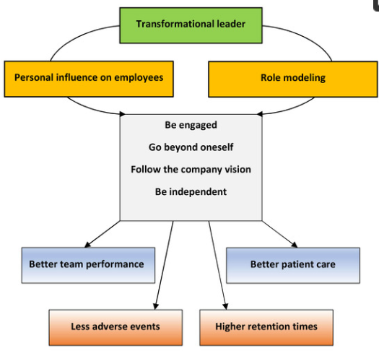
Figure 6: Transformational leadership theory
(Source: Fischer et al. 2022)
The present case highlights lack of clinical support because of poor governance due to which medication errors have been observed. Following the principles of transformational leadership in healthcare, leaders are encouraged by visions and promoting a safe culture for clinical practices (Fischer et al. 2022). Health professionals during this case can apply transformational leadership theory that will prioritize better medication by using proper medicines and dosages to enhance patient safety outcomes. As an example, the NHS promotes transformational leadership that will foster innovative ideas in building healthcare infrastructure for dealing with uncertainties and complexities (NHS, 2024). Hence, application of transformational leadership can be adopted that could allow general practitioners to focus on patient record in understanding the right report of prescriptions.
2.3.2 Evaluation of Leadership Style Effectiveness
The above discussion highlights the application of transformational as well as transactional leadership in the context of command-driven and purpose-driven that were not followed during the case of overdose medicine. The case reveals that general practitioners were unaware about patient information and medicines which were already being given (NHS, 2026). This information highlights lack of vision towards patient safety and entertained the principles of Red Drug usage. Hence, leadership styles such as transformational as well as transactional can be considered for dealing with these types of issues while treating patients in enhancing patient outcomes.
2.3.3 Leadership Orientation: Reactive or Proactive
During the case of infant morphine overdose, leaders were not proactive and reactive in reviewing the prescriptions on priority basis because of excessive dosage of red drugs to 4-week-old babies. It has found that pharmacies received prescriptions via EPS (Electric Prescription Systems) where dosages were already mentioned with reliable quantities (NHS, 2023). However, discussion with general practitioners confused pharmacy professionals due to the medicine dosage set with 10mg/5ml. Hence, this information shows how hospital management entertained this kind of cases and provided dosage of red drugs without examining the prescriptions.
2.3.4 Data Insights on Leadership Effectiveness
The present case reveals lack of leadership interference while dealing with medication practices towards better health for a 4-week-old baby. It has been examined that the pharmacy dispensing label mentioned medical abbreviation as “PRN” that was not clearly interpreted with the medicine description (NHS, 2023). This created challenges for pharmacists and general practitioners and also for parents without prior knowledge the process of measuring dosage has been discussed. Thus, safety outcomes have been affected due to lack of prior information regarding red drug usage where leaders such as general practitioners and pharmacists provided wrong medicine to harm health.
2.3.5 Alternative Leadership Approaches for Improvement
Distributed leadership:
The application of transactional leadership can be aligned with distributed leadership context in dealing with this challenge of infant overdose. The above discussion reveals lack of clarity and misunderstanding due to which mistakes have been repeated. Application of transactional leadership, information distribution can be prioritized in order to promote equal responsibility to doctors, pharmacists and prescribers (Ali and Khan, 2023). It can reduce errors by promoting screening of information multiple times. Hence, distributed leadership functions can be adopted along with transactional functions that can establish a new system in dealing with infant morphine overdose cases.
Emotionally intelligent leadership:
The case reflects on key leadership as transformational leadership can be applied for emotionally intelligent people that show empathic behaviours in dealing with complex situations. According to Arghode et al. (2022), transformational leadership is often considered along with empathic approach along with safe culture. Referring to this, general practitioners can create a safe environment for medication practices that will promote the right term to use Red Drugs based on patient conditions.

2.4 Improvement, and Lessons Learned
2.4.1 Interaction between Leadership and Governance in Shaping Outcomes
The defined problem context in the NHS has clearly demonstrated the failure of leadership and governance that resulted in such levels of medical negligence or error. The case study completely disclosed the negligence from pharmacists on duty alongside the inability to understand the dose limits in the prescription (NHS, 2023). Hence, comparatively weak accountability of leadership and governance can be signified within the NHS that eventually result in such medication errors. The NHS is already reported to operate with a centralised hierarchy system at the national and regional level (NHS, 2022). The case study also revealed the consideration of systematic steps including calculation of the dose by the GP and sending the instructions to the pharmacist with prescription. In this case, the outcomes are clearly indicating a distinct farsighted vision of the leadership and management in the NHS by considering the need for maintaining effective communication during dealing with complex medication issues. Mulyana et al. (2022) has stated the implications of communication as a relevant leadership skill that also influences organisational commitment. In this context, the actions taken for preventing the incidents has denoted proper indication of the dose quantities alongside maintaining communication between the surgery and pharmacy for treating complex medical issues.
The leadership and management of the NHS can be accused of emerging negligence in care standard and quality despite reflecting the preventative actions as denoted in the case study. The NHS leadership is already identified to emphasize on collaborating with the Care Quality Commission for improving patient health outcomes in compliance with the Health and Social Care Act 2012 (NHS, 2026). Referring to this quality standard, concrete failure of leadership and management can be signified within the NHS that created such medication error despite having comprehensive commitment towards improving patient outcomes. Hence, the failure of leadership and management is highlighted in the NHS that created such toxic evidence of medication errors.
2.4.2 Missed opportunities and evidence-based solutions and present a discussion highlighting the problems, solutions and relevant data
a) Problem
Referring to the case study evidence, the raised problem clearly denotes the mistake of the pharmacist on duty to understand proper dose quality for morphine sulphate oral solution. The GP practice is also accused of not clearly indicating the dose quantities that raised confusion with the quantity units (NHS, 2023). Referring to this aspect, the current case study problem is comprehended as weak accountability of the leaders to consider care quality as a supportive stair to improve brand recognition in the health and social care environment. The overall evidence also defines violation of the care quality standard in the NHS that reveals the inefficiency of leadership and management alongside governance.
b) Data
Referring to the evidence of medication error, the NHS staff and GP practice are accused of violating the care quality standard. As of global statistics, medication error has taken place as a comprehensive point of concern that is questioning the integrity and commitment of healthcare service providers. For example, WHO reports have clearly stated around USD 42 billion annual cost to be associated with medication errors (WHO, 2026). This rising evidence of medication error expenses is pointing serious questions to the integrity and commitment of healthcare service providers to ensure improved patient outcomes.

c) Improvement
Comprehending improvement for the mentioned case study issue, the preference of decentralization is largely signified. Oliveira et al. (2023) mentioned the benefits of decentralization in health and social care to enable a shift in the decision-making mechanisms by transforming from central authorities to the regional levels for improving efficiency. Hence, the NHS would be able to contextualize medication decisions with situational judgement by evaluating the right and wrong. The situational leadership theory can be evaluated for this purpose that reflects the application of appropriate leadership styles and vision as per the situational demands (Sikalgar et al. 2025). Hence, the NHS should align decentralization with situational leadership for empowering local teams with medication decision-making ability based on delegation style. The delegation style would enable decentralised decision-making with combined power of authority to the regional or departmental staff in the NHS. Based on this delegation, medication errors can be avoided through a contextual and decentralised decision framework for preventing overdose of ‘Red Drug’ as reflected in the case study.
Apparently, concentration of digital reporting can be beneficial for improving the current situation by eliminating the medication error due to lack of proper understanding. The NHS has already implemented digital technologies like AI in order to transform the health and social care operations through a data driven approach by collecting data from GP practices (NHS, 2026). In this case, digital reporting is clearly certified as an improvement mechanism for the NHS that would enable clear information of patients' medical reports and medication details to the staff and GP practice for avoiding overdose.
d) Interaction of system structure with leadership and feedback
The system structure within the NHS has considerably reflected the preference of a hierarchical structure supported with centralised decision-making and transformational leadership. In this case, the centralised system has clearly interacted with the existing leadership style in the NHS as replicated through the vision of the pharmacist on duty. For instance, the GP practice was inquired about the discharge summary by the community pharmacist in the NHS (NHS, 2023). Despite having this discussion, the morphine sulphate solution dose became over limit due to lack of understanding of the quantity units. In this regard, the existing transformational leadership of the NHS is also questioned due to the occurred medication error. Apparently, the system feedback has eventually denoted the necessity of conducting face-to-face medicinal reconciliation that could have helped in identifying the unavailability of 100 mcg/ml dose for the child (NHS, 2023). In this case, effective interaction of the system feedback with leadership style and system structure is contextualized to open up wider necessity of decentralisation along with delegation based situational leadership to prevent medication errors.
e) Lessons for other health organisations
Other respective healthcare organisations can consider the mentioned case evidence as a prior symptom of medical negligence. In this case, digital reporting of patient medication status can be comprehended by the healthcare organisations as an integral part of avoiding medication errors and negligence. For instance, the evidence of Mayo Clinic can be reflected precisely on digital information and communication technologies with virtual visits for empowering remote healthcare access (Mayo Clinic, 2024). In this case, the healthcare organisations can also learn about the necessity of referring to standard care quality by maintaining active communication to avoid misunderstanding and medication errors.
f) Continuous improvement and accountability based on data and evidence
The recognition of continuous improvement and accountability largely depends on the continuation of care quality standards under the defined guidelines in the UK. For example, the UK has actively included the NICE (National Institute for Health and Care Excellence) framework with contextual emphasis on ensuring safe medication management and handling of errors to provide person-centred care (NICE, 2026). This evidence details the platform to integrate continuous improvement with enhanced accountability to secure accurate medication management without any error. As evidence, more than 237 million medication errors are reported in the UK per year (BMJ, 2026). Hence, the NHS can integrate continuous improvement through enabling strict application of the NICE guidelines for eliminating medication errors.

3. Recommendation
3.1 Summarisation of what should be done
The NHS should profoundly introduce strict guidelines with zero tolerance regarding any error or issue in patient medication. In this case, the NHS should look forward to entitle precise Health and Care Quality Standard as a pathway to apply the duty of quality in practice across entire services (NHS, 2023). This duty of quality should be comprehended by the NHS as a complimentary measure for empowering service quality and standards by erasing medication errors. Apparently, the NHS must ensure digitisation of patient health and medical records in order to enable accurate measurement and injection about the dosage. This action would enable the NHS with digital disclosure of patient medical conditions to ensure appropriate dosage as prescribed.

3.2 Recommending most effective leadership style
The NHS should consider the delegation style of leading through the situational leadership concept. Under situational leadership theory, delegation style enables less engagement of the hierarchy or leaders in the decision-making process (Mulyana et al. 2023). Hence, the formulation of this decentralised decision-making would enable the NHS with situational judgement of the patient's medical conditions and medication details. Apparently, the delegation style of leading would also empower internal staff motivation within the NHS that may also add a greater value to signify continuous improvement attributes by empowering situational judgement ability.
Suggestion for empowering governance, communication and system integration
The extension of communication and governance within the NHS must be deployed through entitling decision-making autonomy. As opined by Botes (2023), autonomy in decision-making extends individual capability of considering self-determined choices aligned with individual values by fostering responsibility. The case study of the NHS has considerably reflected potential areas of improvements particularly in-patient medication details reporting and communication. In this regard, the extension of digital communication is suggested for the NHS through advanced communication platforms (NHS, 2026). Apparently, the contextualisation of digital reporting of medication details would also enable explicit governance efficiency for the NHS based on clear and timely information to ensure improved care quality standards. The clause of continuous improvement is already entitled within the visionary focus of the NHS for improving service quality and safeguarding with high care standards (NHS, 2023). In this case, the NHS is suggested to integrate zero tolerance policy as a substantial and supportive parameter to empower strict prohibition to care negligence and medication errors for enhancing patient satisfaction and experience.
3.3 Actions to enhance technical and allocative efficiency
The NHS is clearly recommended to comprehend technical efficiency by including advanced medication management software and digital tools. For example, the NHS should be attentive to integrate Well Sky, a digital medication management software integrated with automation and streamlined clinical workflow (Wellsky, 2026). This mentioned facility of the medication management software is highly beneficial for reducing the chances of errors. Referring to this understanding, the inception of this data driven approach is clearly suggested for the NHS as an integral part of eliminating the mentioned sequence of medication error and misunderstanding of the quantity units as prescribed. Alongside this, digital resource allocation management is also suggested for the NHS in order to ensure extended efficiency in operations and medication management (NHS, 2023). Application of advanced scheduling software can be highly beneficial for the NHS to comprehend enhanced allocative efficiency.

4. Conclusion
4.1 Summarise the main findings of your case study and analysis
On a summarisation note, the case study analysis revealed real examples of infant morphine overdose cases that affected a 4-week-old baby. In this case, lack of leadership has reflected on unawareness about the medication doses that caused a serious reason of excessive overdose. Application of leadership styles such as transformational, transactional and situational has been considered and aligned with this case to understand its relevance in managing significant clinical practices. The study summarised drug policy, medication policy and better medication management that can help healthcare professionals to deal with complexities.
4.2 The Role of Leadership, Governance, and Systems Thinking in Driving Change
The importance of leadership is essential regarding this case that can establish a significant and safe culture for clinical practices. Regarding this, the role of transformational as well as transactional leadership that can be often considered during this case in applying vision towards patient centric culture and following rules regarding medications. Driving change has also reflected on policies such as medication error policy, red drug policy and zero tolerance policy that referred to system thinking in dealing with infant morphine cases.

Reference List
- Ali, A.A. and Khan, K., (2023). Utilizing Transactional Leadership In Nursing World: Fostering Accountability, Efficiency, And Innovation. i-Manager's Journal on Nursing, 13(2). Available at: https://www.researchgate.net/profile/Anny-Ali/publication/373919584_Utilizing_transactional_leadership_in_nursing_world_Fostering_accountability_efficiency_and_innovation/links/651d3057d717ef1293ca2f30/Utilizing-transactional-leadership-in-nursing-world-Fostering-accountability-efficiency-and-innovation.pdf?utm_medium=email&utm_source=transaction (Accessed: 16 March 2026).
- Al-Rjoub, S., Alsharawneh, A., Alhawajreh, M.J. and Othman, E.H., (2024). Exploring the impact of transformational and transactional style of leadership on nursing care performance and patient outcomes. Journal of Healthcare Leadership, pp.557-568. Available at: https://www.tandfonline.com/doi/pdf/10.2147/jhl.s496266 (Accessed: 17 March 2026).
- Arghode, V., Lathan, A., Alagaraja, M., Rajaram, K. and McLean, G.N., (2022). Empathic organizational culture and leadership: conceptualizing the framework. European Journal of Training and Development, 46(1-2), pp.239-256. Available at: https://www.emerald.com/ejtd/article-pdf/46/1-2/239/2427963/ejtd-09-2020-0139.pdf (Accessed: 16 March 2026).
- Bigestans, D., Cardin, M.A. and Kazantzis, N., (2023). Economic performance evaluation of flexible centralised and decentralised blue hydrogen production systems design under uncertainty. Applied Energy, 352, p.121944. Available at: https://www.sciencedirect.com/science/article/pii/S0306261923013089 (Accessed: 17 March 2026).
- BMJ, (2026). 237+ million medication errors made every year in England. Available at: https://www.bmj.com/company/%20newsroom/237-million-medication-errors-made-every-year-in-england/ (Accessed: 17 March 2026).
- Botes, M., (2023). Autonomy and the social dilemma of online manipulative behavior. AI and Ethics, 3(1), pp.315-323. Available at: https://link.springer.com/content/pdf/10.1007/s43681-022-00157-5.pdf (Accessed: 17 March 2026).
- Dougherty, S., Lorenzoni, L., Marino, A. and Murtin, F., (2022). The impact of decentralisation on the performance of health care systems: a non-linear relationship. The European Journal of Health Economics, 23(4), pp.705-715. Available at: https://pmc.ncbi.nlm.nih.gov/articles/PMC8520686/pdf/10198_2021_Article_1390.pdf (Accessed: 17 March 2026).
- Fischer, H., Heidler, P., Coco, L. and Albanese, V., (2022). Leadership theories and the veterinary health care system. Veterinary Sciences, 9(10), p.538. Available at: https://www.mdpi.com/2306-7381/9/10/538 (Accessed: 17 March 2026).
- Goel, A. and Rahulamathavan, Y., (2024). A comparative survey of centralised and decentralised identity management systems: Analysing scalability, security, and feasibility. Future Internet, 17(1), p.1. Available at: https://www.mdpi.com/1999-5903/17/1/1 (Accessed: 17 March 2026).
- Goodier, M., (2022). Almost 6,000 people harmed by prescription errors in NHS last year. Available at: https://www.theguardian.com/society/2022/sep/26/almost-6000-people-harmed-by-prescription-errors-in-nhs-last-year (Accessed: 16 March 2026).
- GOV.UK (2025). Review of patient safety across the health and care landscape. Available at: https://www.gov.uk/government/publications/review-of-patient-safety-across-the-health-and-care-landscape/review-of-patient-safety-across-the-health-and-care-landscape?utm (Accessed: 16 March 2026).
- Hanisch, M., Goldsby, C., Fortin, M. and Rogerson, M., (2025). Governing Within Semirigid Limits: Navigating the Centralization–Decentralization Paradox in Blockchain‐Based Platforms. Journal of Operations Management, 71(7), pp.917-938. Available at: https://onlinelibrary.wiley.com/doi/pdf/10.1002/joom.70001 (Accessed: 17 March 2026).
- IHI.ORG (2022). Statement from IHI and LLI About the Risks to Patient Safety When Medical Errors Are Criminalized. Available at: https://www.ihi.org/about/news/statement-ihi-and-lli-about-risks-patient-safety-when-medical-errors-are-criminalized?utm_source=chatgpt.com (Accessed: 16 March 2026).
- Khan, I.U., Amin, R.U. and Saif, N., (2025). Individualized consideration and idealized influence of transformational leadership: Mediating role of inspirational motivation and intellectual stimulation. International Journal of Leadership in Education, 28(6), pp.1322-1332. Available at: https://www.researchgate.net/profile/Saif-Naveed/publication/361080539_The_contributions_of_inspirational_motivation_and_intellectual_stimulation_in_connecting_individualized_consideration_and_idealized_influence/links/63b3ba57a03100368a4b4346/The-contributions-of-inspirational-motivation-and-intellectual-stimulation-in-connecting-individualized-consideration-and-idealized-influence.pdf?origin=journalDetail&_tp=eyJwYWdlIjoiam91cm5hbERldGFpbCJ9(Accessed: 16 March 2026).
- Kwachou, M., (2025). Pathways for pragmatic decolonisation in research. Open Research Europe, 5, p.112. Available at: https://pmc.ncbi.nlm.nih.gov/articles/PMC12149805/v (Accessed: 16 March 2026).
- Legislation (2026). The Controlled Drugs (Supervision of Management and Use) Regulations 2013. Available at: https://www.legislation.gov.uk/uksi/2013/373/contents/made (Accessed: 16 March 2026).
- Maine, J., Florin Samuelsson, E. and Uman, T., (2022). Ambidextrous sustainability, organisational structure and performance in hybrid organisations. Accounting, Auditing & Accountability Journal, 35(3), pp.734-769. Available at: https://www.emerald.com/insight/content/doi/10.1108/AAAJ-12-2019-4338/full/pdf (Accessed: 16 March 2026).
- Marzok, S.R., Abd Elrhmaan, S.M., Ali, R.M.N. and Ali El-said, H.D., (2023). Centralization and Decentralization of Decision Making in Relation to the Well-being of Nursing Staff at their Work Setting. Minia Scientific Nursing Journal, 14(2), pp.77-84. Available at: https://www.researchgate.net/profile/Heba-Ali-55/publication/377100409_Centralization_and_Decentralization_of_Decision_Making_in_Relation_to_the_Well-being_of_Nursing_Staff_at_their_Work_Setting/links/65c4a1781e1ec12eff7bf8ff/Centralization-and-Decentralization-of-Decision-Making-in-Relation-to-the-Well-being-of-Nursing-Staff-at-their-Work-Setting.pdf (Accessed: 16 March 2026).
- Mayo Clinic, (2026). Telehealth: Technology meets health care. Available at: https://www.mayoclinic.org/healthy-lifestyle/consumer-health/in-depth/telehealth/art-20044878 (Accessed: 17 March 2026).
- Monastyrskyi, G., Khudyk, D., Pilat, R., Fedenchuk, S. and Kisilevych, V., (2024). Decentralisation: Exploring Challenges, Opportunities, and Its Role in Strengthening Local Governance. Journal of Information Systems Engineering and Management, 10, pp.514-523. Available at: https://www.researchgate.net/profile/Grygorii-Monastyrskyi/publication/389258654_Decentralisation_Exploring_Challenges_Opportunities_and_Its_Role_in_Strengthening_Local_Governance/links/67eaa0a176d4923a1ae8e7c7/Decentralisation-Exploring-Challenges-Opportunities-and-Its-Role-in-Strengthening-Local-Governance.pdf (Accessed: 16 March 2026).
- Mulyana, A., Ridaryanthi, M., Faridah, S., Umarella, F.H. and Endri, E., (2022). Socio-emotional leadership style as implementation of situational leadership communication in the face of radical change. management, 11(3), pp.150-161. Available at: https://www.researchgate.net/profile/Endri-Endri/publication/360404776_Socio-Emotional_Leadership_Style_as_Implementation_of_Situational_Leadership_Communication_in_the_Face_of_Radical_Change/links/63437c252752e45ef6a78a9b/Socio-Emotional-Leadership-Style-as-Implementation-of-Situational-Leadership-Communication-in-the-Face-of-Radical-Change.pdf(Accessed: 16 March 2026).
- Mulyana, A., Ridaryanthi, M., Faridah, S., Umarella, F.H. and Endri, E., (2022). Socio-emotional leadership style as implementation of situational leadership communication in the face of radical change. management, 11(3), pp.150-161. Available at: https://www.researchgate.net/profile/Endri-Endri/publication/360404776_Socio-Emotional_Leadership_Style_as_Implementation_of_Situational_Leadership_Communication_in_the_Face_of_Radical_Change/links/63437c252752e45ef6a78a9b/Socio-Emotional-Leadership-Style-as-Implementation-of-Situational-Leadership-Communication-in-the-Face-of-Radical-Change.pdf (Accessed: 17 March 2026).
- NHS (2022). Did you know? Insights into medication errors. Available at: https://resolution.nhs.uk/wp-content/uploads/2022/03/Did-You-Know-High-Level-Medication-Errors.pdf (Accessed: 16 March 2026).
- NHS (2022). General Practice Medication Errors. Available at: https://resolution.nhs.uk/wp-content/uploads/2022/04/Did-You-Know-General-Practice-Medication-Errors.pdf (Accessed: 16 March 2026).
- NHS (2023). Serious Incident Case Study: Infant Morphine Overdose Investigation Summary & Learning. Available at: https://northyorkshireccg.nhs.uk/wp-content/uploads/2023/09/11.07.23-NHS-NEY-INFANT-MORPHINE-OVERDOSE-CASE-STUDY.pdf?utm (Accessed: 16 March 2026).
- NHS (2024). Navigating Transformational Leadership. Available at: https://nw.leadershipacademy.nhs.uk/navigating-transformational-leadership/ (Accessed: 16 March 2026).
- NHS (2025). Medication Error Policy. Available at: https://www.leicspart.nhs.uk/wp-content/uploads/2025/03/Medication-Error-Policy-exp-July-26.pdf (Accessed: 16 March 2026).
- NHS (2025). Medication safety management. Available at: https://www.england.nhs.uk/long-read/medication-safety-management/ (Accessed: 16 March 2026).
- NHS (2025). Supplying to the NHS. Available at: https://www.england.nhs.uk/nhs-commercial/supplying-to-the-nhs/ (Accessed: 16 March 2026).
- NHS (2026). Controlled Drug Reporting. Available at: https://www.cdreporting.co.uk/nhs/resources/articles?category=Guidelines (Accessed: 16 March 2026).
- NHS, (2022). Structure of the NHS. Available at: https://www.england.nhs.uk/long-read/structure-of-the-nhs/ (Accessed: 17 March 2026)
- NHS, (2023). Health and Care Quality Standards 2023. Available at: https://nwssp.nhs.wales/a-wp/governance-e-manual/putting-the-citizen-first/health-and-care-quality-standards-2023/ (Accessed: 17 March 2026).
- NHS, (2023). Supporting clinical decisions with health information technology. Available at: https://www.england.nhs.uk/long-read/supporting-clinical-decisions-with-health-information-technology/ (Accessed: 17 March 2026).
- NHS, (2026). Care Quality Commission. Available at: https://www.england.nhs.uk/ourwork/part-rel/cqc/ (Accessed: 17 March 2026)
- NHS, (2026). Data and technology that improves lives. Available at: https://digital.nhs.uk/ (Accessed: 17 March 2026).
- NHS, (2026). Governance, patient safety and quality. Available at: https://www.england.nhs.uk/mat-transformation/matrons-handbook/governance-patient-safety-and-quality/ (Accessed: 17 March 2026).
- NHS, (2026). Our digital-first approach to patient communications. Available at: https://digital.nhs.uk/about-nhs-digital/digital-first-messaging (Accessed: 17 March 2026).
- NICE, (2026). NICE guidance. Available at: https://www.nice.org.uk/guidance (Accessed: 17 March 2026).
- Oliveira, R., Santinha, G. and Sá Marques, T., (2023). The Impacts of health decentralization on equity, efficiency, and effectiveness: a scoping review. Sustainability, 16(1), p.386. Available at: https://www.mdpi.com/2071-1050/16/1/386(Accessed: 16 March 2026).
- Restivo, V., Minutolo, G., Battaglini, A., Carli, A., Capraro, M., Gaeta, M., Odone, A., Trucchi, C., Favaretti, C., Vitale, F. and Casuccio, A., (2022). Leadership effectiveness in healthcare settings: a systematic review and meta-analysis of cross-sectional and before–after studies. International journal of environmental research and public health, 19(17), p.10995. Available at: https://www.mdpi.com/1660-4601/19/17/10995 (Accessed: 16 March 2026).
- Schaub, J., Hewison, A., Haworth, S. and Miller, R., (2022). A leadership model for social work: Drawing on health care to inform social work leadership. The British Journal of Social Work, 52(5), pp.2911-2930. Available at: https://academic.oup.com/bjsw/article-pdf/52/5/2911/45046657/bcab185.pdf (Accessed: 16 March 2026).
- Scherbak, Y., Sinha, A., Vashisht, R., and Tariq, A., R., (2024). Medication Dispensing Errors and Prevention. Available at: https://www.ncbi.nlm.nih.gov/books/NBK519065/ (Accessed: 16 March 2026).
- Selvarajh, G. and Arif, M.A.M., (2025). Examining the Role of Transformational and Transactional Leadership in Driving Digital Transformation in Saudi Healthcare. International Journal of Research and Innovation in Social Science (IJRISS), 9(11). Available at: https://rsisinternational.org/journals/ijriss/uploads/vol9-iss11-pg5068-5074-202512_pdf.pdf (Accessed: 16 March 2026).
- Shishkin, S., Sheiman, I., Potapchik, E., Vlassov, V. and Sazhina, S., (2025). The impact of centralization on structural changes in healthcare: when it works. Frontiers in Health Services, 5, p.1484225. Available at: https://www.frontiersin.org/journals/health-services/articles/10.3389/frhs.2025.1484225/pdf (Accessed: 16 March 2026).
- Sikalgar, F.R., Bangera, D., Kumar, M.P., Paul, Y. and Muralidharan, S., (2025). A review of leadership theories in healthcare. Journal of Pharmacy and Bioallied Sciences, 17(Suppl 1), pp.S163-S165. Available at: https://journals.lww.com/jpbs/_layouts/15/oaks.journals/downloadpdf.aspx?an=01438291-202505001-00046(Accessed: 16 March 2026).
- Tavares, M.C., Vale, J. and Costa, A., (2024). The role of decentralised managers in decision-making in a large industrial company. Administrative Sciences, 14(9), p.202. Available at: https://www.mdpi.com/2076-3387/14/9/202 (Accessed: 16 March 2026).
- Wellsky, (2026). Ensure patient safety and enhance profitability with WellSky® Medication Management. Available at: https://wellsky.com/medication-management/ (Accessed: 17 March 2026).
- WHO (2025). Medication Without Harm. Available at: https://www.who.int/initiatives/medication-without-harm/medication-safety-in-high-risk-situations#:~:text=high%2Drisk%20situations-,Medication%20Without%20Harm,the%20safety%20of%20medication%20practices. (Accessed: 16 March 2026).
- WHO, (2026). Medication Without Harm. Available at: https://www.who.int/initiatives/medication-without-harm (Accessed: 17 March 2026)
- Xuecheng, W., Iqbal, Q. and Saina, B., (2022). Factors affecting employee’s retention: Integration of situational leadership with social exchange theory. Frontiers in psychology, 13, p.872105. Available at: https://www.frontiersin.org/journals/psychology/articles/10.3389/fpsyg.2022.872105/full(Accessed: 16 March 2026).

