Introducing a modern workplace
Code: LCBB4003
Student Name: Radu Neata
Student id:1905633

Table of Contents
Introduction: 2
Relationship between culture, structure, people and organizational performance: 3
Nature of managerial work and the role of leadership: 6
Evaluation of behavioral approach of management: 8
Conclusion 9
References 10

Introduction:
Structure and culture are indispensable for any organization. Every company has valued culture and structure for creating a modern workplace in the global business environment. To create a modern workplace and culture it is necessary to implement dynamic organizational culture and structure for sustaining long term growth. Modern workplace refers to the practices where skilled workforce, standard values, modern equipment, strong knowledgeable management body, practice proper human resource management as well as the development of infrastructures are available within the business environment(Boddy, 2018). This report tells about the practice of modern culture and structure which has a significant impact on creating a modern workplace. However, various scholars and authors told about the modern workplace have several dimensions like the practice of modern management theories, leadership theories, retaining the employee with valuing them with the respective manner, and so on. Thus, to create a modern workplace, a combination of effective culture, structure, and people is required.

Adidas is a renewed company in the UK. It is one of the best companies in the UK as well as around the world. The company has perhaps 59,000 employees around the world. Employees from 100 nations are working at their head-quarter. In 2019, they produce 1.1 billion sports and sports-related lifestyle products. By implementing modern and dynamic structure and culture it has created a modern workplace that will excel in its productivity and profitability (Certo, 2018). They have developed a dynamic relationship by providing flexible culture for their valuable employees.

Relationship between culture, structure, people, and organizational performance:
The authority of Adidas has numerous ideas regarding their business as well as gradually implemented management structure for implementing a modern workplace within a business environment. They are open for profit sharing, employee participation, and employee engagement. It will help them to ensure better work within the global business environment. In terms of the profit-sharing plan, employees get one-quarter profit each year for gaining a competitive advantage over a competitor. Employees can easily discuss with their working hours that is why they are benefited from the workplace as well as it will enhance the productivity and profitability for the organization. Employees are committed to providing innovation and invention for the development of the organization. They are committed to providing the best service to the organization that is why next is growing day by day with maintaining high-quality products to the valued customer as well as their suppliers. Dynamic product and company culture have ensured a lot of unique activities and ideas which are helpful to create a contemporary workforce (Daft, 2018). They are competing for a various company which is operating around the country by providing quality products and services with maintaining quality workplace.
Culture and structure are related to each other. To become a successful business organization effective culture and structure are required to establish a modern working environment for coping with the change intuition in the global business environment. To cope with the mission every company needs to operate in the structure for practicing best policies within the workplace (Grey, 2017). Normally large business operates in the functional areas for making their effective decision. Adidasis focusing on modern human resource management, Industrial engineering, sales and marketing, quality assurance, production, accounts, and information technology for creating a modern workplace. The company has some layers of authority for managing workforce diversity. They have followed a hierarchical structure for expanding their business opportunities. It includes a chain of command as well as the unity of direction of enhancing a couple of rules and policies. The company practices democratic leadership rather than autocratic leadership for making their business more reliable. They ensure tight control for ensuring their modern workplace which will impact employee performance.
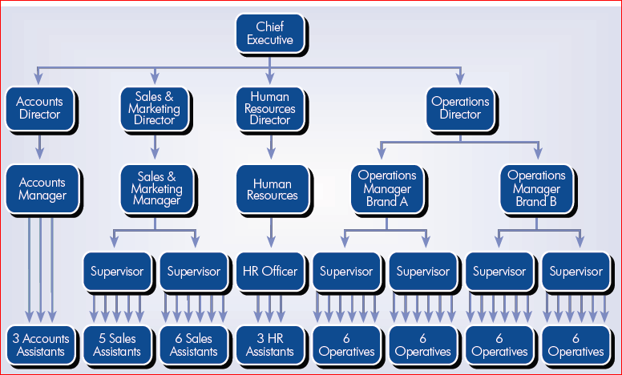
Source: (Grint, 2019)
Adidas is focusing on valuing its employees and they do not follow hierarchical functions for implementing their innovative styles. Study shows that to implement modern workplace they focus on matrix structure so that employee engagement and retention is maintained for conducting their operation. In this approach, the team leader conducts all specific tasks and responsibilities. They create a team from the different departments with maintaining the expertise of knowledge and skills which will essential for making a modern workplace. It also helps the company to complete the project within a short period. Apart from this, it has a relationship between company culture and employee performance.
In addition to structure, the company has a dynamic culture for insuring a better workplace for a couple of workers as well as employees. Culture consists of values, beliefs, and behaviors of employees for making the business profitable (Huczynski, 2018).
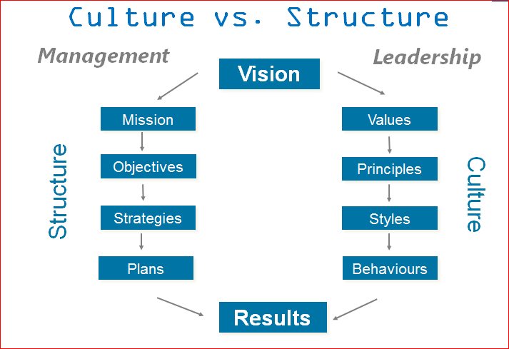
Source :(Kelly, 2019).
The company is valuing its employees and set a principle-based management system that helps make a dynamic and unique workplace. Cultures create a leadership approach within the business environment. The prime aspect of culture in terms of Adidas is teamwork and employee engagement. The company believes that its employee is their best asset as well as a profit maker. They motivated their employees which will enhance the company’sgrowth. They organize their people as a team that is why an employee of that organization feels valued by the top management. The team member encourages to share their ideas and innovate new opportunities so that company can gain a competitive advantage over a competitor. By creating an innovative and friendly culture they depend on a high-quality workplace which will impact their management and employees' mind as well. The modern workplace is mandatory for ensuring better diversity management. Trust is considered as the most essential element of business culture. By providing quality products and services the company can maintain suppliers and consumer trust in an effective way (Knights, 2017).
Hofstede’s cultural dimensions: There are four aspects of national culture which influence the thinking of the organization.
Low/high power distance:
Low power distance | High power distance
The company employee faces a minimum of inequality as it can exploit another employee of the organization. | In terms of high power distance, inequality is unavoidable and all employees have the value they deserve.
Since the company has a hierarchy, it is the only convenience for the higher-level employees | Hierarchy reflects the natural differences
The supervisor and subordinates are all the same | They are treating different types of people.

Collectivism/individual dimension:
Collectivist | Individualist
The company make their decisions in terms of the betterment of the group | Decisions are made for the betterment of the individual.
The value varies according to the group | Values are differed according to the individual.

Masculine/feminine dimension:
Masculine | Feminine
It focuses on the think that men are assertive and women are nurturing | Both are nurturing roles in implementing modern workplace
They are trying to the acquisition of wealth | They are trying to maintain quality of life

Low and high uncertainty avoidance:
Low uncertainty avoidance | High uncertainty avoidance
There are fewer rules for the betterment of the organization. | Formal roles are necessary for terms of this dimension
Competition and conflict may be valued in this dimension | The consensus is essential for making conflict less organization.

Nature of managerial work and the role of leadership:
Management is the process of planning, organizing, leading, and controlling people of the organization and other resources (Levinthal, 2018).

Source: (Martin, 2018)
It is also the four functions of management. The company also has these four functions for creating a dynamic workplace. According to the studies they have a management layer that helps create a modern workplace.
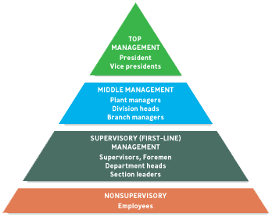
Source: (Mullins, 2017)
The company management consists of top management, middle management, and first-line manager. Top management is responsible for making a unique policy for their valued co-workers. Apart from this, they have arranged different seminars, workshops, and training programs with the other agencies for getting some dynamic ideas. According to Martin (2018), top management has played dynamic roles and responsibilities for making the organization with modern equipment. They are the prime decision-maker for gaining a competitive advantage over a competitor. After that middle manager executes, the top management plans regularly. The middle manager plays a vital role in ensuring better management and modern equipment within the workplace. Besides, the first line manager has a significant role within the business environment. They are the lifeblood of any organization. Adidas has a huge number of the first-line employee and they are the prime resource for making a modern workplace. The company manages supervisory employees so that they can directly supervise the workers and evaluate daily performance.

In the meantime, the management has some managerial skills which help make a modern workplace within the business environment. Human relations skills are one kind of skill which is essential for gaining competitive advantage (Stippler, 2018). The top management of that company has human relations skills so that they can manage their employees for managing their performance. They enable managers to work with people. Apart from this, they have conceptual skills where they can capture the company as a whole and maintain good relationships among them. Besides, they have technical skills so that they can work in a specific part or department. Thus it can be said that the company management is decorated with sufficient skills which help make the dynamic and modern organization.
However, leadership can play a vital role in creating a modern workplace. The company has significant leadership capability with maintaining high quality. Leadership is a matter of practice, not a position. According to Senge (2018) people expand their capacity to improve the results. The leaders of Adidas create new ideas for their team members so that they can achieve a competitive advantage over their competitors. They can achieve continuous learning programs to achieve different kinds of knowledge. As a result, a good and viable working environment is created by doing these activities. They are responsible for creating a learning organization. The leaders of that company design the learning session for creating a sound workplace in nature. Later, they create a vision and manage a shared mission for their business as well as valued employees. They also help people to learn about change so that they can accept the change management effort which is essential. The company follows a transformational leadership process by maintaining its core values and beliefs. It helps them to create confidence, commitment, and loyal to the organization.

Evaluation of behavioral approach of management:
Management by objective is personnel strategies where managers and staffs work collectively to record, set, and monitor goals for a certain period. To create a better working environment the employees of the organization align their personal goals with organizational goals. Without aligning the goal the company does not achieve its goal within a specific period. By understanding individual behavior the company has applied MBO for aligning the individual goal with organizational goal. Peter Drucker thought that applying MBO companies can achieve their desired goals and success with maintaining a quality workforce for the employees. The employees and managers get some benefits from the application of MBO. It helps them to attain their goal by implementing organizational goals and personal goals.
Behavioral management theories are the process of better understanding the human aspects by the manager to treat them well manner by focusing on the modern workplace within the business environment (Grey, 2017). The company has followed behavioral management with its business environment so that company can gain a competitive advantage over its competitor. The management of Adidas has taken a special interest in workers which are making them feel like part of a special group. If the employees of the organization feel good about their co-workers and organization then they will focus on workplace development so that it helps to improve their productivity and profitability. Elton Mayo's Hawthorne's studies give a good example of this. For example, company management is thinking shifted and management started looking at employee satisfaction and working conditions as a process of increasing productivity. As a result, the employee will more engage with their co-workers and peers. It helps them to create an environment where they enjoy work together. By applying these behavioral approaches the company can get more advantages of the modern workplace. The company can find out the real scenario of modern workplace development. It also helps them to understand the individual difference within the organization. They value the difference which arrives among the individual. By valuing the differences among them they will able to find out the shortcomings from the workplace. It will assist them to manage workforce diversity and the modern work environment.

Conclusion
Culture and structures have a massive relationship to build a modern workplace. It has practiced dynamic culture and flexible organization within the business organization. Every organization should follow this strategy for making the modern workplace (Knights, 2017). In thisreport there are various theories and models are applied for creating work around the world. By making this environment creative and dynamic next has practiced behavioral management approach, management by objective approach. These approaches are truly helpful for the organization as well as their valued employees. After all, it can be said that effective leadership and managerial skills are prime determinants to create a modern workplace in the 21st century.

References
Boddy, D., (2018) Management: An Introduction (5th edition) Harlow: Pearson
Certo, S., and Certo, S., 2018. Modern Management. Harlow, United Kingdom: Pearson Education Canada.
Daft, R., and Lane, P., 2018. Leadership. [Florence, KY]: South-Western, Cengage Learning.
Grey, C (2017) A Very Short, Fairly Interesting and Reasonably Cheap Book about Studying Organisations (4th edition) London: Sage
Grint, K., 2019. Leadership. London/Basingstoke: Palgrave Macmillan.
Huczynski, A., Buchanan, D (2018) Organisational Behaviour (8th edition) Harlow: Pearson
Kelly, W., 2019. The Sportsworld Of The Hanshin Tigers. Oakland (CA): University of California Press.
Knights, D., 2017. Introducing Organizational Behaviour And Management. Cengage Learning.
Levinthal, C., 2018. Drugs, Behavior, And Modern Society. Boston: Allyn & Bacon.
Martin, J., 2018. Profiting From Multiple Intelligences In The Workplace. Carmarthen, Wales: Crown House Pub.
Mullins, L, (2017) Management and Organisational Behaviour 11th Edition, Pearson.
Stippler, M. and Dörffer, T., 2018. Leadership - Approaches, Developments, Trends. Gütersloh: Verl. Bertelsmann-Stiftung.

