
Master of Business Administration

INTERNATIONAL MARKETING: PRINCIPLES AND PRACTICES

LCMB7026

ASSESSMENT COMPONENT 1: INDIVIDUAL REPORT

- Lecturer names: Tushara Balendran Dian Mayasari
- Student name: Shubh Banshibhai Modi
- Student ID: 2509172
- Date of submission: 24th April 2026

Table of Contents
Introduction of Zara : 5
Background History of ZARA : 5
Mission and vision 6
Macro environment analysis (PESTLE) 6
Political Aspects 7
Favourable For Both Country 7
Unfavourable For Both Country 8
Economical 8
Favourable For Both Country 9
Unfavourable For Both Country 9
Social Aspects 9
Favourable For Both Country 9
Hofstede Cultural Dimensions – Zara (UK vs USA) 9
Advantages of Hofstede dimensions 11
Disadvantages of Hofstede model 12
Technology 12
Favourable For Both Country 12
Legal 13
Favourable for UK 13
Environmental Factors 13
Favourable For UK 14
Unfavourable USA 14
STP For ZARA In UK and USA 15
Segmentation UK: 15
Market Segmentation USA 15
Targeting UK: 16
Targeting usa 16
Positioning UK: 16
Positioning USA: 16
7P Marketing Mix 18
Product (UK) 18
Width in uk 19
Depth in UK 19
Width in USA 19
Depth in USA 19
Example : 20
Price (UK) 20
Pricing (USA) 21
Place (UK) 21
Place (USA) 21
IMC (Integrated Marketing Communications) Definition 22
Promotion (UK) 22
Promotion (USA) 22
Process (UK) 22
Process (USA) 23
Physical Evidence (UK) 23
Physical Evidence (USA) 23
Zara Directional Development Strategy in the UK 25
Ansoff Matrix 25
Ethical issues related to this brand’s marketing mix in UK 26
Ethical marketing Sustainability Messaging (“Join Life”) 27
Unethical Marketing Example – Greenwashing and Misleading Sustainability Claims 27
Recommendation: 28
Section 2 29
Gibbs reflective cycle : 29
Description 29
Feelings 29
Evaluation 30
Analysis 30
Conclusion 30
Action Plan 31
References 31

Introduction of Zara :
This assignment presents an international business analysis of Zara, one of the world’s leading fashion retailers, which has achieved strong success in both the United Kingdom and the United States. As the flagship brand of Inditex, Zara is widely recognised for its efficient supply chain and ability to respond quickly to changing fashion trends in global markets (Inditex, 2023). The UK and the USA are two of the most influential fashion markets globally, each shaped by different political, economic, social, technological, environmental, and legal conditions, making them suitable for comparative international business analysis.
The analysis applies the PESTEL framework to evaluate the macro-environmental factors affecting Zara’s operations in both countries. It also examines cultural differences using Hofstede’s Cultural Dimensions Theory to understand how culture influences consumer behaviour. Zara’s marketing strategy is analysed using the STP model and the 7Ps marketing mix, followed by an evaluation of growth strategies using the Ansoff Matrix. Ethical and unethical issues are considered, and recommendations are provided. Finally, Gibbs’s Reflective Cycle is used to reflect on the learning process gained from conducting this international business analysis.
Overall, the purpose of this assignment is to develop a clear understanding of Zara’s competitive advantages and strategic positioning in the UK and US markets.

Background History of ZARA :
Zara was founded in 1975 by Amancio Ortega and Rosalía Mera in the Spanish city of A Coruña. The company was initially started as a small retail store selling fashion clothing that was inspired by the designs of high-end clothing brands, but at relatively lower price points. The initial business model of Zara was based on the analysis of consumer behavior, which helped the company achieve rapid success in the domestic Spanish market (Tokatli, 2008).

In 1985, Zara was incorporated as the main brand of Inditex (Industria de Diseño Textil S.A.), an organizational structure that was established for the management of the expanding operations of the firm, including its overseas expansion. Inditex helped Zara develop a vertically integrated structure that enabled the firm to manage all aspects of the supply chain, thus allowing Zara to bring fresh designs into its stores within two to three weeks, thus giving the firm a competitive advantage in the fast-fashion industry (Cavusgil, Knight, and Riesenberger, 2020).

Zara started its overseas expansion drive by opening its first store outside Spain in 1988 in Portugal, while the firm expanded its presence across Europe, the United States, Asia, etc., during the 1990s and 2000s. Zara entered the United States in 1989, while the firm entered the United Kingdom in 1998 by opening stores in the prominent fashion capitals of the world, such as New York and London. Today, the firm operates thousands of stores across the world, while the firm has also managed to develop an effective online presence, adapting the firm’s business model as per the macro-environmental factors while ensuring the consistency of the Zara brand across the world (Inditex, 2023; Ortega, 2015).

Mission and vision
For Zara, the mission and vision are aligned globally in both the UK and USA markets, although the actual implementation is modified based on consumer preference in each market. Zara's mission statement includes providing good quality, fashionable clothing at reasonable price points. This is accomplished by having fast and flexible supply chain processes to quickly generate new designs from creation to stores so that customers in both markets have access to current trend items in an efficient manner. Zara aims to be the worldwide leader in providing innovative and sustainable fashion at retail through decreasing their impact on the environment, improving the circularity of their product offerings, and creating superior customer experiences through ongoing innovation and digital transformation. The execution of Zara's fast-fashion model is evidenced by both the UK and USA markets, however there are differing emphases on each model: in the UK market, there are greater efforts placed on sustainability and responsible consumption while in the USA market, there are greater efforts placed on being quick to deliver product trends and provide convenience to the consumer in a competitive retail environment (Inditex, 2024; Zara, 2024).

Macro environment analysis (PESTLE)
PESTLE analysis refers to a strategic model that is applied in the assessment of macro environmental factors that affect operations of a business and the long-term management decisions. Zahan et al. (2025) opined that to do strategic planning, it is imperative to analyse the external environments, especially in sensitive sectors like the automotive sector, which are dynamic. Similarities and diff
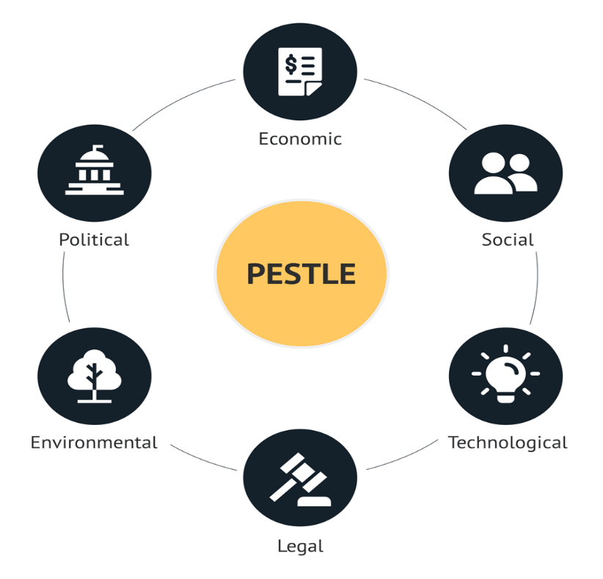
Fig. 1 PESTLE Analysis,Sorce : Martin Heubel 2024

Political Aspects
Zara's foreign activities in the UK and the USA are significantly influenced by political concerns. Large-scale retail activities and foreign direct investment are supported by the generally stable political climate in both nations. But with Brexit, which drastically changed its commercial links with Europe, the UK now faces particular difficulties. Zara has to deal with more border delays, customs inspections, extra paperwork, and greater import-related administrative expenses. Product availability and competitiveness are directly impacted by any disruption in speed because Zara depends on a quick supply chain strategy. Zara, on the other hand, is still impacted by import taxes on clothing and textiles because the majority of its production is located outside, despite the USA providing a more stable trading environment. Furthermore, Zara's long-term sourcing and distribution methods may be impacted by legislative decisions on trade agreements, taxes, and international relations (UK Government, 2024; US International Trade Administration, 2023).

Favourable For Both Country
The UK’s political landscape supports retail investments, allowing for a safe and secure place for retailers to invest. The UK government is focused on creating ethical supply chains, which will help Zara meet its sustainability goals (Johnson et al., 2020).

Unfavourable For Both Country
Brexit has altered the manner in which retailers can conduct business in Europe. Increased customs checks for goods imported from the EU have resulted in greater amounts of paperwork and delays for fashion retailers sourcing from Europe (UK Government, 2023).

Economical
Both the United Kingdom and the United States have a highly developed economy with strong urban centres, and they present Zara with attractive, stable consumer markets where spending on goods and services is high. The United States is important to Zara because it is the world’s largest consumer market (by a large margin), it has a large proportion of consumers with disposable income and is also a leading consumer of fast fashion. The UK is also still a leading global fashion centre. However, both of these markets are facing economic challenges. Inflation has put upward pressure on the cost of living, which has reduced discretionary income for consumers and has caused consumers to be extremely price sensitive (especially in non-essential industries, such as fashion retail). Rising interest rates will also reduce consumers’ capacity to spend by increasing households’ borrowing costs. In addition, the volatility of the euro (the currency in which Zara’s parent company is based), the British pound and the US dollar (which can affect the price Zara has to pay for importing goods into those countries and the price it must offer its goods in those countries) all affect Zara’s profitability and its pricing strategies. These economic conditions require Zara to carefully balance its need to price competitively against its goal of profitability while maintaining its competitive position in the fast fashion segment of the global apparel market (OECD, 2023).
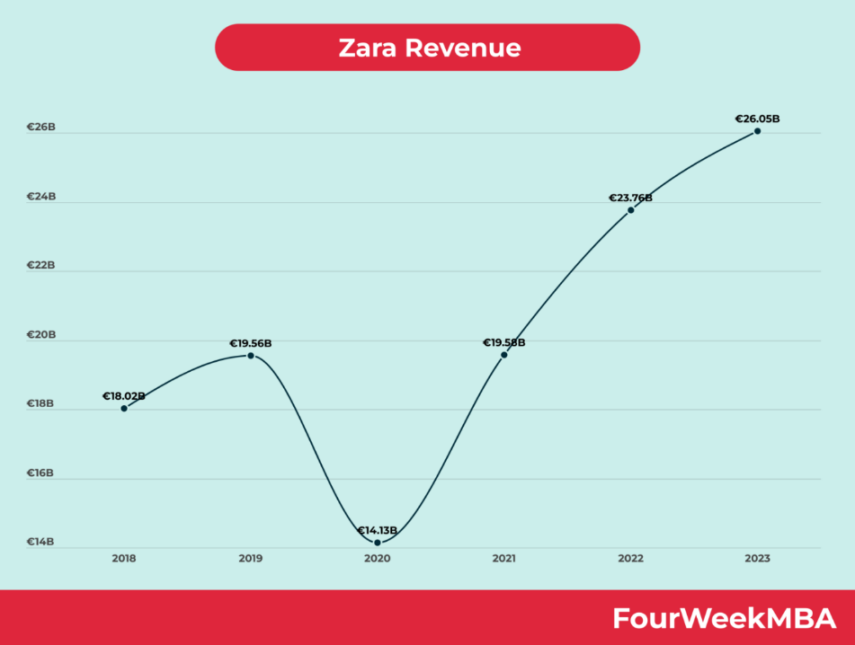
Fig.2 (Business, By Gennaro Cuofano , March 18, 2024)

Favourable For Both Country
The UK is a well-developed fashion marketplace with high consumer demand for affordable, fashionable clothing and this supports Zara’s fast-fashion model (Inditex, 2023).

Unfavourable For Both Country
Inflation, combined with the rising cost of living, impacts UK consumers’ disposable income and this class of consumers is not spending as much as they were previously on non-essential clothing (ONS, 2023).

Social Aspects
One of the key influences on Zara's performance in both the UK and USA markets related to social factors. In both regions, consumers are greatly affected by fashion trends, celebrities, and social media platforms (e.g., Instagram and TikTok). Because these influences help support Zara's fast-fashion business model of quickly replicating trends and frequently introducing new products into its stores, Zara is able to take advantage of these social behaviors in relation to its quick-response design and production systems. Social attitudes towards both sustainable and ethical consumption have also changed. Public awareness of environmental impact, waste reduction, and ethically sourced products is very strong in the UK; therefore, fast fashion brands must prove themselves to be transparent with how their products are produced. In the USA, although fast fashion is still popular, the demand for diversity, body inclusivity, and corporate social responsibility continues to grow, and consumers are using social media to be vocal about their concerns. Because of the ease with which information travels on social media, if Zara has an ethical issue, its reputation could suffer from the negative publicity. Therefore, Zara must continue to adapt its marketing strategies and product development processes to meet the needs of consumers as they evolve and to meet their expectations as a social factor continues to change (Kotler and Keller, 2022).

Favourable For Both Country
Consumers in the UK are savvy shoppers who use the Internet to shop, and are often shopping for fashion items; therefore, Zara is able to successfully test consumers by introducing new merchandise frequently to market (McKinsey, 2023).

Hofstede Cultural Dimensions – Zara (UK vs USA)
Hofstede's Cultural Dimensions Theory explains the importance of national culture in guiding how to behave as a consumer, work with co-workers, and implement different strategies for marketing your products. Zara’s product management, consumption, and marketing strategies are heavily influenced by cultural differences between the UK and US in relation to the Power Distance Index (PDI) as a society. In the UK, while there is still a degree of class structure, both employees and customers tend to expect managers to be approachable and to communicate in a way that involves consulting them (Hofstede Insights, 2024). On the other hand, in the US, both employees and customers highly regard independence and equality as demonstrated by their strong expectation for both independence and autonomy at work (Hofstede Insights, 2024). Thus, while both countries allow Zara to operate flexibly as stores, the stores in the US are required to make decisions quicker and for employees to have more authority than they have in the UK due to the greater degree of autonomy that employees and customers both expect in the US.
Both the United States and the United Kingdom rank high on the Individualism vs. Collectivism (IDV) scale, with the U.S. roughly 2 percent higher (U.S.: ~91; U.K.: ~89). The U.K. emphasises personal identity and subtle individualism through self-expression. However, the U.S. is more concentrated on self-branding, distinctiveness and individual success via tailored style and customised fashion (Hofstede Insights, 2024). Thus, the U.K.'s branding strategy places a greater emphasis on curated style and minimalistic expression of fashion, while the U.S. marketing strategy is decidedly more aspirational — both as a lifestyle statement and a reflection of social status.
Although competition is important to the UK as well, it is equally important to balance this with quality of life and comfort, which makes UK retailers more likely than US retailers to offer consumers practical and sustainable fashion options. Additionally, because many American consumers view fashion as an extension of their success and personal brand, they have higher expectations than their UK counterparts when it comes to finding visually stunning and trendy clothing (Hofstede Insights, 2024).
Long-Term Orientation (LTO) is generally seen as having a more balanced approach between traditional values versus the development of increasing sustainable awareness for the UK, and shorter-term orientation for the USA, with a focus on immediate consumption gratification; however, UK consumers are more strongly influenced by ethical and sustainable fashion trends, such as those from brands like Zara and their new eco-friendly collections, or the growth of circular fashion behaviour, while American consumers tend to emphasise immediate gratification and high frequency of purchase, thereby supporting Zara's rapid product turnover approach (Hofstede Insights, 2024).

Dimension | UK 🇬🇧 | USA 🇺🇸 | Difference | Impact on Zara
Power Distance (PDI) | 35 | 40 | USA slightly higher | Both support flat retail structure
Individualism (IDV) | 89 | 91 | USA higher | Strong demand for personal fashion
Masculinity (MAS) | 66 | 62–70 | USA slightly higher | USA more status-driven
Uncertainty Avoidance (UAI) | 35 | 46 | USA higher | USA expects more service reliability
Long-Term Orientation (LTO) | 51 | 26 | UK higher | UK more sustainability-focused
Indulgence (IVR) | 69 | 68 | Similar | Both support fashion consumption
Table 1 Hofstede culture dimension (Source: Hofstede Insights, 2024)

Advantages of Hofstede dimensions
The primary benefit of the Hofstede Model is that it offers an established and systematic way for understanding cultural differences between countries, providing a means by which to make complicated cultural values more comparable (Hofstede, 1980). The Hofstede Model can be incredibly valuable in International Business & Management since it allows organisations to understand the variances in leadership styles, communication methods and employee behaviour within multi-cultural work environments (Hofstede, Hofstede & Minkov, 2010). Furthermore, this model has been recognised extensively in academia as an effective, useful & credible theoretical basis for doing research on cross cultural issues (Beugelsdijk, Maseland & Van Hoorn, 2015). By identifying the individual cultural dimensions, the Hofstede model can reduce instances of misunderstanding across different cultures and provide support in developing improved decision making processes for global marketing & human resource management (Tung & Verbeke, 2010).

Disadvantages of Hofstede model
There are various criticisms of the Hofstede Model as it has many limitations regarding its applicability and therefore less utility. One limit is that it has been labelled overgeneralising with regard to national cultures. The assumption that all people from a given country share similar values actually does not take into account individual, regional or ethnic differences (McSweeney 2002: 142-143). Further, the original data used to construct the model were collected from a single multinational company (IBM), undermining its ability to be used to represent the national population as a whole (Hofstede 1980). A further criticism is that the Hofstede Model has not taken into consideration the cultural changes that have occurred during the past several decades due to globalisation (Beugelsdijk, Maseland and Van Hoorn 2015). All of these factors combined mean that it is possible to use Hofstede's dimensions of culture to stereotype or oversimplify complex behaviour within cultures (Tung and Verbeke 2010).

Technology
Technology plays such a pivotal role in Zara's success across all areas of its business operations. Zara's ability to successfully implement its omnichannel retail strategy, integrating both its physical store locations with online platforms, is primarily attributed to the highly developed digital ecosystems (high internet usage) and receptiveness to ecommerce in both the UK and USA. Zara can rapidly adjust its manufacturing and inventory levels based on advanced analytics that provide real-time data about sales activity and customers' preferences. Additionally, this use of technology is a significant contributor to Zara's competitive advantage and its ability to respond quickly in the fast fashion industry. However, Zara's reliance on technology also comes with some disadvantages. Zara must continue to invest heavily in automation, digital supply chains, AI, and mobile commerce platforms in order to remain competitive among its main competitors (H&M; Shein). Furthermore, Zara's increasing reliance on these digital platforms heightens the risk associated with cybersecurity and data privacy issues. Specifically, due to the varying data privacy laws that are established in the UK (GDPR) and USA (different state-specific laws) there are considerable concerns associated with these two issues.

Favourable For Both Country
The U.S. is at the forefront of adopting retail technology used to enhance the customer experience lines, including those which enhance the customer experience are’s through technology, providing software/apps that enhance consumer experience (Statista, 2024).

Legal
The legal environment provides both opportunities and challenges to Zara’s operations in both the United Kingdom and the United States. Strong laws in both jurisdictions protect Zara’s intellectual property from imitation, including design, brand, and their retail identity. Consumer protection laws also promote fair trading conditions, creating trust among consumers in the retail markets. On the contrary, Zara faces an increasing number of complicated and expensive compliance requirements. Zara must comply with strict laws regarding employment in the UK, including health and safety regulations and post-Brexit trade rules in the UK, creating an increasingly complex and administratively burdensome environment. Zara also faces complex employment regulations in the United States. The United States, as a federal government, has multiple layers of authority, and as a result, there is no uniformity in laws such as employment, taxation, minimum wage, etc., for legal compliance purposes throughout the United States. As a result of the regulatory environment in both the UK and the US, Zara will be subject to increasing legal costs and the risk of punitive penalties associated with non-compliance as they are required to modify their business practices based on where they operate; for example, due to local differences in legal compliance requirements. Therefore, Zara must implement strong corporate governance practices and ensure that they have access to legal counsel to facilitate the proper execution of their business. (UK Government, 2023; U.S. International Trade Administration, 2023).

Favourable for UK
Strong laws regarding consumer rights and intellectual property rights help protect a brand's value and business as well as its retail operations (Johnson et al., 2020).

Environmental Factors
The environmental elements are one element of many that will impact Zara's global corporate strategy (including (UK) and (USA). Globally, governments, regulators, and consumers are increasing their demand for apparel retailers to minimize the negative effects their production has on our planet. Issues such as carbon emissions, water usage and waste management related to textile waste are an increasing focus of attention for these stakeholders. Zara is reacting to growing awareness surrounding these issues by investing in sustainable fabrics, investing in programs to recycle and reuse textiles, and has developed a circular fashion program designed to minimize harmful environmental impacts caused by textile production. These three initiatives will enhance Zara's brand and meet consumer demands for sustainability with an emphasis on Gen Z consumers. That being said, the environmentally sustainable options Zara has explored have increased the cost associated with producing goods. Sustainably sourced fabrics and produced fabrics may be more expensive than conventionally used fabrics. Long-term climate change will negatively impact Zara's global supply chain through potential disruptions to the transportation of textiles, extreme weather events affecting textile production, and shortages of raw materials used to produce textiles. Zara will be required to balance its sustainability initiatives with a focus on minimizing costs and creating a reliable supply chain when developing strategies to mitigate the environmental challenges they (Zara) will face moving forward (The European Commission, 2023; Inditex, 2024).
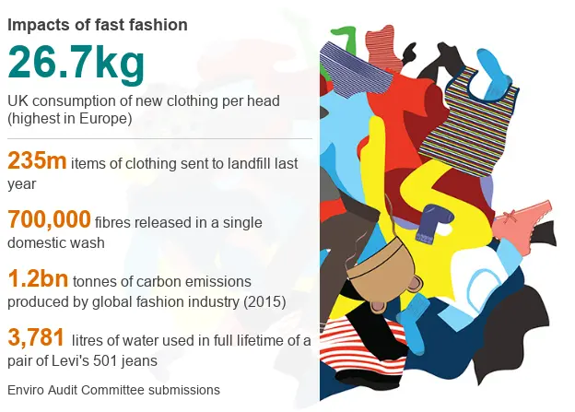
Fig.3 source ( https://www.bbc.com/news/newsbeat-49022453 )

Favourable For UK
As the demand for sustainable fashion continues to grow, Zara will increase its environmental efforts (Inditex, 2023).

Unfavourable USA
Environmental regulations (and compliance with these regulations) vary from state to state; therefore, compliance requirements differ depending on the industry across the nation.
PESTLE Factor | Similarities (UK & USA) | Differences (UK vs USA)
Political | Politically stable environments; global trade policies and ethical sourcing requirements affect Zara in both countries. | UK: Post-Brexit trade rules increase customs checks and delays. USA: State-level trade and labour policies create higher regulatory complexity.
Economic | High purchasing power; inflation and currency fluctuations influence pricing and consumer demand. | UK: Cost-of-living pressures reduce discretionary spending. USA: Larger market size offers higher sales potential but higher wage costs.
Social | Fashion-conscious consumers; rising demand for sustainable and ethically produced clothing; strong online shopping culture. | UK: Preference for minimalist, European-inspired styles. USA: Demand for size inclusivity and casual, comfort-focused fashion.
Technological | Advanced supply chain systems, RFID, data analytics, and strong e-commerce presence in both markets. | UK: Greater focus on energy-efficient stores and sustainable retail technology. USA: Faster adoption of AI personalization and logistics automation.
Legal | Strong labour laws, consumer protection, and product safety regulations apply in both countries. | UK: GDPR enforces stricter data protection laws. USA: Employment and privacy laws vary by state, increasing legal complexity.
Environmental | Pressure to reduce carbon footprint; growing consumer demand for sustainable materials and recycling initiatives. | UK: Stricter environmental regulations and higher eco-awareness. USA: Environmental laws vary by state, leading to uneven enforcement.

Table 2, similarities and differences of PESTLE analysis

STP For ZARA In UK and USA

Segmentation UK:
Zara identifies and finds key customer groups in the UK through age (18 to 40), living a city lifestyle, and how they approach fashion. Sustainability is also beginning to segment the UK consumer.
Example: For instance, students or young professionals in the city of London who like the look of trendy clothing that is also ethically made (Kotler et al, 2022).

Market Segmentation USA
Zara segments its US apparel market by demographics, lifestyles, and regional fashion preferences because of the wide range of consumers living in the US.
For example, in well-established fashion hubs like NYC and Los Angeles, there are consumers who shop to stay trendy (Kotler and others, 2022).

Targeting UK:
Zara utilizes a concentrated targeting strategy within the UK by focusing on providing fashion-savvy young adults in addition to urban professionals who are sensitive to the rapid changes in European fashion. Zara introduces style-forward product lines on a regular basis with a focus on trend-based collections which allows the company to offer fast fashion in the UK market (Inditex, 2023; Kotler and Keller, 2016).

Targeting usa
Zara employs a differentiated targeting strategy within the USA due to the large number of markets and diversity amongst its customers. To accommodate this diversity, Zara has provided casual styles and basics along with an expansive variety of sizes in order to appeal to more customers throughout the entire country (Inditex, 2023; Hofstede, Hofstede and Minkov, 2010).

Positioning UK:
Zara has positioned itself as a fast-fashion retailer, with the objective of creating an outlet for high-fashion runway ready to wear lines at moderate prices, while building towards an environmentally sustainable base.
Example: Marketed eco-friendly collections that use recycled materials to a growing awareness of sustainability (Moore and Fernie 2021).

Positioning USA:
Zara is positioned in the US as a global fashion brand that can quickly adopt new trends and has multiple new items coming to its stores regularly.
For example, Zara has displays in its stores that get updated often to encourage shoppers to return to the store (Moore and Fernie, 2021).
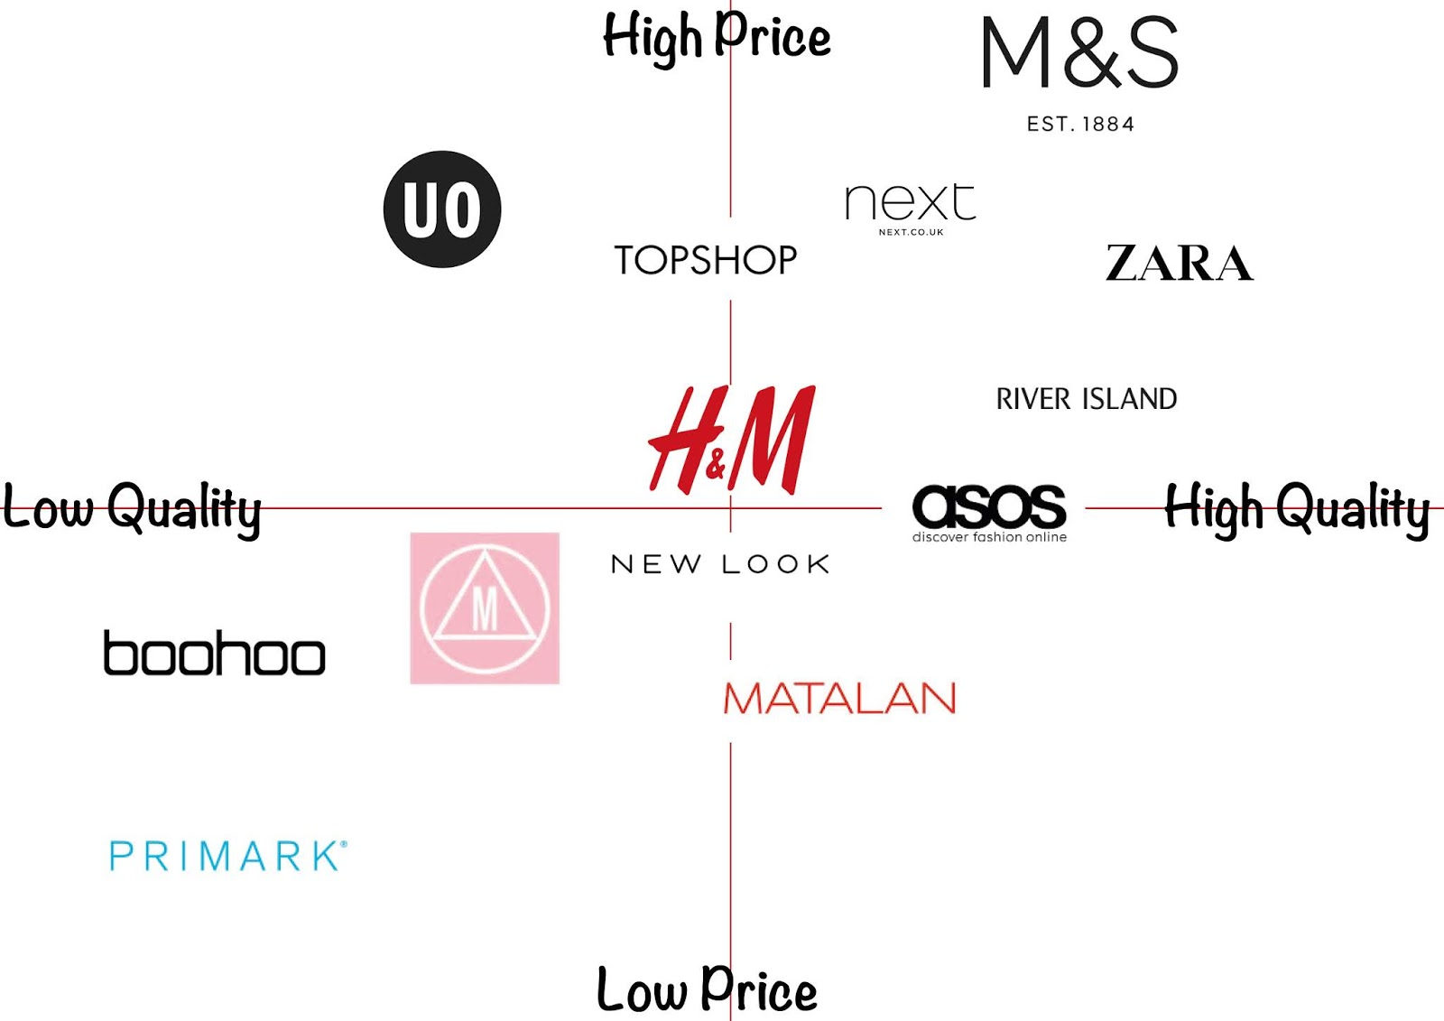
Fig.4 PERCEPTUAL MAP for ZARA Source:( Fashion Management and Marketing 1)

Element | UK | USA
Segmentation Focus | Value + sustainability + style | Trend + status + lifestyle
Target Group | Students, young professionals | Wider youth + middle-upper class
Targeting Strategy | Differentiated + ethical focus | Mass + digital + influencer-driven
Positioning | Affordable, stylish, increasingly sustainable | Trendy, aspirational, status-driven

7P Marketing Mix
For Zara, the 7P marketing mix in the UK and USA is broadly similar but adapted to cultural differences. In both markets, Zara offers fast-fashion, trend-driven products with a mid-range pricing strategy and strong physical and online presence in major cities. In the UK, the product focus is more on sustainable and practical fashion, promotion is relatively minimal and brand-led, and stores are designed with a clean, premium aesthetic, while consumers are more value-conscious and expect more personalised service. In the USA, Zara places greater emphasis on bold, trend-led and status-driven fashion, uses stronger influencer and social media-based promotion, and operates larger, more experience-focused stores with faster, more self-service-oriented processes to match high consumer demand and impulse buying behaviour (Hofstede Insights, 2024; Inditex, 2024).
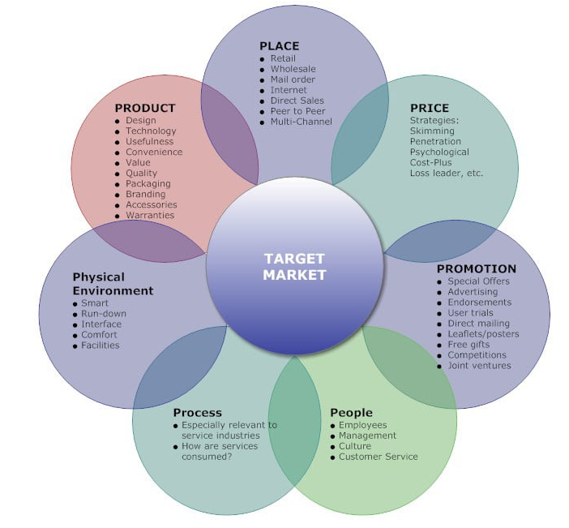
Fig.5 7P Source: Lukasz Sramkowski. March 3, 2021 .

Product (UK)
A strong impact from European fashion trends and climate can be seen in the product range available at Zara UK.

Width in uk
In the UK, Zara's brand extension (width of product) is relatively limited but covers all the main fashion product categories: women, men, children, and some home items. Zara's brand extension is mostly an extension of the retail brand from one part of the fashion lifestyle to another part of the fashion lifestyle and not from one fashion to a different fashion. Zara maintains a strong fashion identity and will not over-extend into too many different categories of products so that it maintains its premium fast fashion positioning.

Depth in UK
Zara frequently fills its line (depth of product), such as releasing new styles, colours, fabrics, and seasonally new styles (different styles from previous seasons), all within a short time period. For example, a basic blazer or dress will typically be released in multiple colours, different cuts, and multiple textures in a short period of time. This type of extensive use of line filling is consistent with the UK market's expectation of fast changing fashion based on current trends. Consumers in the UK generally expect to see new limited quantity products and styles all the time.

Width in USA
The United States has a very different product (or brand) extension strategy than the United Kingdom. Zara has significantly greater breadth in the extension of product offerings, with much greater emphasis placed on casual and lifestyle-oriented products such as denim garments, hooded sweatshirts, and everyday essential items. Zara's product extensions will continue to grow, as the US market is larger, more diverse, and more focused on comfort in terms of how consumers wear clothing than the UK.

Depth in USA
Zara (in the USA) also continues to fill lines and expand product (or brand) offerings across categories by providing a greater variety of functional options and allowing for larger ranges of (size inclusive) options, especially amongst basic and casual wear. For example, t-shirts, jeans, and loungewear will include a much wider range of fits (e.g., slim, relaxed, and oversized) and sizes to meet the expectations of US consumers. Thus, there is a clear emphasis on practical use and inclusive sizing within the US market.

Example :
As outlined by Inditex (2023), there are multiple brands in their multi-brand portfolio, with multiple separate retail channels used to sell the products for each brand. For example, the Zara brand operates through US and UK websites for both their online retail stores, and through separate, individual stores for retail sales. In contrast to Zara's retail and marketing independent of other brands in Inditex's portfolio, each ownership brand independently maintains their own brand name and operates independently of each other; therefore, Massimo Dutti has its own website and is not sold via Zara's two websites because it is not part of Inditex's overall multi-brand strategy (Zara, 2024). This is confirmed by Kotler et al. (2021), who assert that to avoid confusion between brands, a company using a multi-brand strategy must have a separate identity for each brand and must not sell its brands through the retail channels of each other. This explains why Massimo Dutti is a separate brand to the Zara by not being sold through Zara's UK websites.
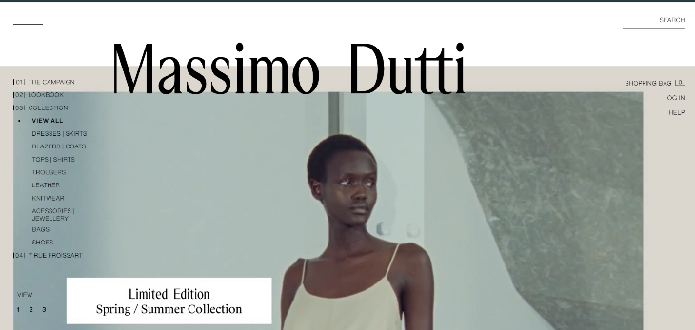
Fig 6. Massimo Dutti source : https://www.zara.com/us/

Price (UK)
Zara employs charm pricing (e.g., £29.99 as opposed to the full price of £30, or £49.99 as opposed to £50) in the UK in order to give consumers the impression that they are spending less money via their purchases, thus increasing their likelihood to make impulsive purchases on ideas that they may not have otherwise purchased. For example, if an individual purchases a blazer for £79.99 they may find that the cost does not appear as steep in comparison to £80, though the price difference is minimal, making Zara appear affordable yet fashionable as a fast fashion retailer throughout the UK.

Pricing (USA)
Similarly, in the United States, Zara uses very similar strategies, though they have adapted them slightly to better suit the US market such as charging $49.90 or $59.90 as opposed to rounding up their prices to $50 or $60. For example, if you were to purchase a dress at $59.90 you might feel that you are spending less money in comparison to spending $60. This ultimately positions Zara to compete in the price sensitive and diverse US Marketplace while still being positioned as a mid-tier/upper tier fashion retailer.

Place (UK)
Zara’s stores are located generally in prime city centre locations and there is a high volume of online orders; therefore, clicking and collecting or utilising fast delivery has become commonplace.
Example: London has both large flagship stores that serve as brand experience focal points of the brand (Inditex, 2023).
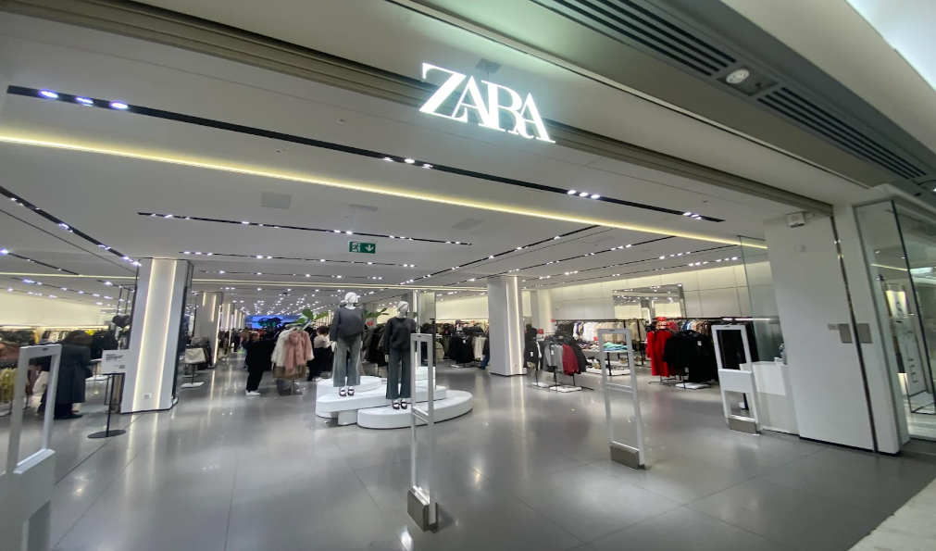
Fig. 7 Store In United Kingdom, source ( https://www.zara.com/uk/en/stores-locator/zara-london-brent-cross-s3210 )

Place (USA)
Zara has large format locations located within metropolitan cities such as New York and Los Angeles; however, they provide substantial support via their online and app-based systems.
For example, customers can order online and pick up from stores on the same day (Inditex, 2023).
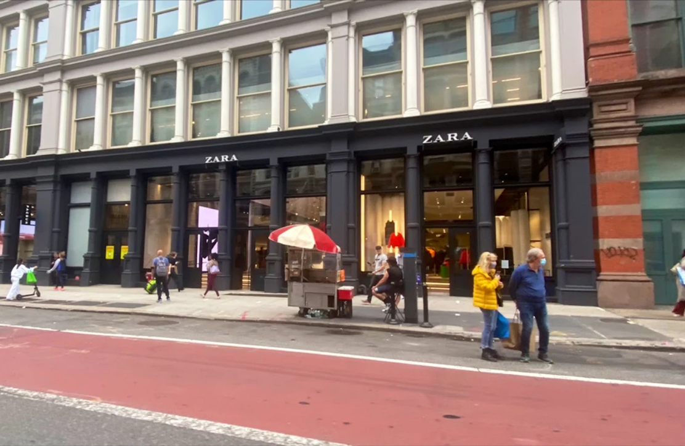
Fig. 8 Store in United state of America, Source:( https://www.zara.com/us/en/stores-locator/zara-new-york-ny_ny_d_ny_soho-s3862 )

IMC (Integrated Marketing Communications) Definition
According to Kotler and Keller (2016) in Marketing Management, IMC is described as a concept that ensures a company “integrates and coordinates its many communication channels to deliver a clear, consistent, and compelling message about the organization and its brands.”

Promotion (UK)
Zara uses little to no paid media advertising in the United Kingdom, however their promotions mainly use either store displays or social media to promote their collections.
Example: Zara uses eye-catching window displays on Oxford St rather than TV ads to attract consumers (Moore and Fernie, 2021).

Promotion (USA)
Zara employs very little traditional advertising but highly employs digital and mobile platforms for advertising within the USA.
For example, new products can be viewed on the Zara app and via social media (Moore and Fernie, 2021).

Process (UK)
The Zara stores use a fast inventory replenishment system, where stores receive new inventory several times weekly, and returns and exchanges are easy and customer-friendly. A perfect example of this is that Zara UK stores receive their newest collection approximately 2-3 weeks after the item designs have been completed (Cavusgil, Knight & Riesenberger, 2020).

Process (USA)
Zara employs cutting-edge technology combined with highly efficient coordination between the online and physical stores for quick turnaround times from order to delivery and efficiency of operations.
Example 1: Online orders are processed and delivered very quickly (Cavusgil, Knightama and Riesenberg, 2020).

Physical Evidence (UK)
In the UK, Zara's stores adopt a clean-lined, modern European approach to design emphasising a fashionable reputation and brand cohesion. The clean lines, neutral colour palette, and well-chosen materials used by Zara all contribute to the perceived value of the brand.
The physical store suggests that the brand is fashionable but still affordable; it is an alternative source of up-to-date yet stylish clothing for consumers.

Physical Evidence (USA)
Zara stores in the USA are large, contemporary and digital in design and incorporate many modern design features such as self-checkout and clearly designed aisles and layout.
Example 1: Tech enabled fitting rooms and automated payment options. consumers are driven by convenience, product availability, and digital experience.

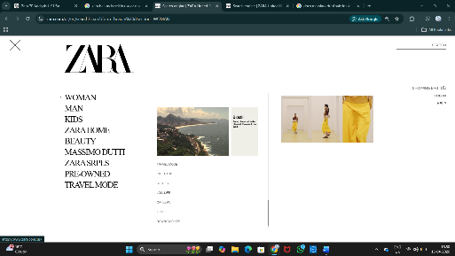
Fig. 9 USA Zara store website ( https://www.zara.com/us/)

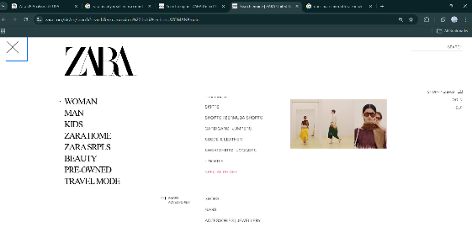
Fig 10 UK ZARA store website (https://www.zara.com/uk/)

7P Element | UK | USA | Similarity / Difference
Product | Trend-led fashion, strong focus on European styles | More casual wear, basics, and wider size range | Difference (UK more fashion-focused, USA more diverse)
Price | Mid-range value-based pricing | Mid-range value-based pricing with slight cost adjustments | Similar (both use value-based pricing)
Place | Strong high-street presence + online | Flagship stores in major cities + online | Similar (omnichannel strategy)
Promotion | Minimal advertising, strong store image | Slightly more digital engagement | Difference (USA more digital focus)
People | Fashion-focused customer service | Efficiency and high-volume service | Difference (UK style advisory vs USA service scale)
Process | Fast stock rotation based on trends | Fast supply chain adapted to large market | Similar (fast fashion model)
Physical Evidence | Minimalist, premium store design | Larger stores with segmented layout | Difference (UK minimalist vs USA spacious stores)
Table 3 similarities and differences of 7P

Zara Directional Development Strategy in the UK
Zara is pursuing a directional development strategy in the UK by building on its already strong position within the marketplace, while adapting to changing consumer demands. Part of its strategy is focused on product development through the continual launch of new collections that reflect rapidly changing fashion trends in order to encourage customers to buy again and visit stores frequently. Sustainability is also important to Zara; they are increasing the use of organically grown, recycled and biodegradable materials, as well as developing supply chain efficiencies to reduce waste in line with the increasing ethical awareness among consumers in the UK. Additionally, Zara continues to invest heavily in digital/omni-channel retailing, enhancing integration between its physical stores and digital platforms through services like click & collect and faster delivery times. Over the long term, Zara's strategy in the UK will allow it to remain competitive by combining speed, innovation, sustainability and digital accessibility as part of its fast fashion business model (Inditex, 2024; Zara, 2024).

Ansoff Matrix
Using the Ansoff Matrix, Zara’s growth strategy in the USA and UK can be summarized in one cohesive paragraph. For example, World Market share increases for both geographies through the ongoing updating of collection offerings, competitive pricing, and enhanced omni-channel services (i.e., online shopping/click-and-collect) to build repeat purchases from their existing customer base. In Product Development, Zara develops new products which include design, seasonal collections, and sustainable clothing lines to fit local tastes with the UK being the strongest market for eco-friendly apparel and the USA concentrating on product trend speed and size inclusivity. For Market Development, Zara is enhancing e-commerce capabilities, improving delivery networks, and/or opening/upgrading Flagship store locations in key cities to attract new customer segments, particularly in the USA where there is significant geographic variance. Finally, through Diversification, Zara is investing heavily in digital innovation, advanced retail technology, and sustainability initiatives (e.g., recycling program/circular fashion projects) which will support future growth and brand positioning within the UK and USA (Inditex, 2024; Zara, 2024).
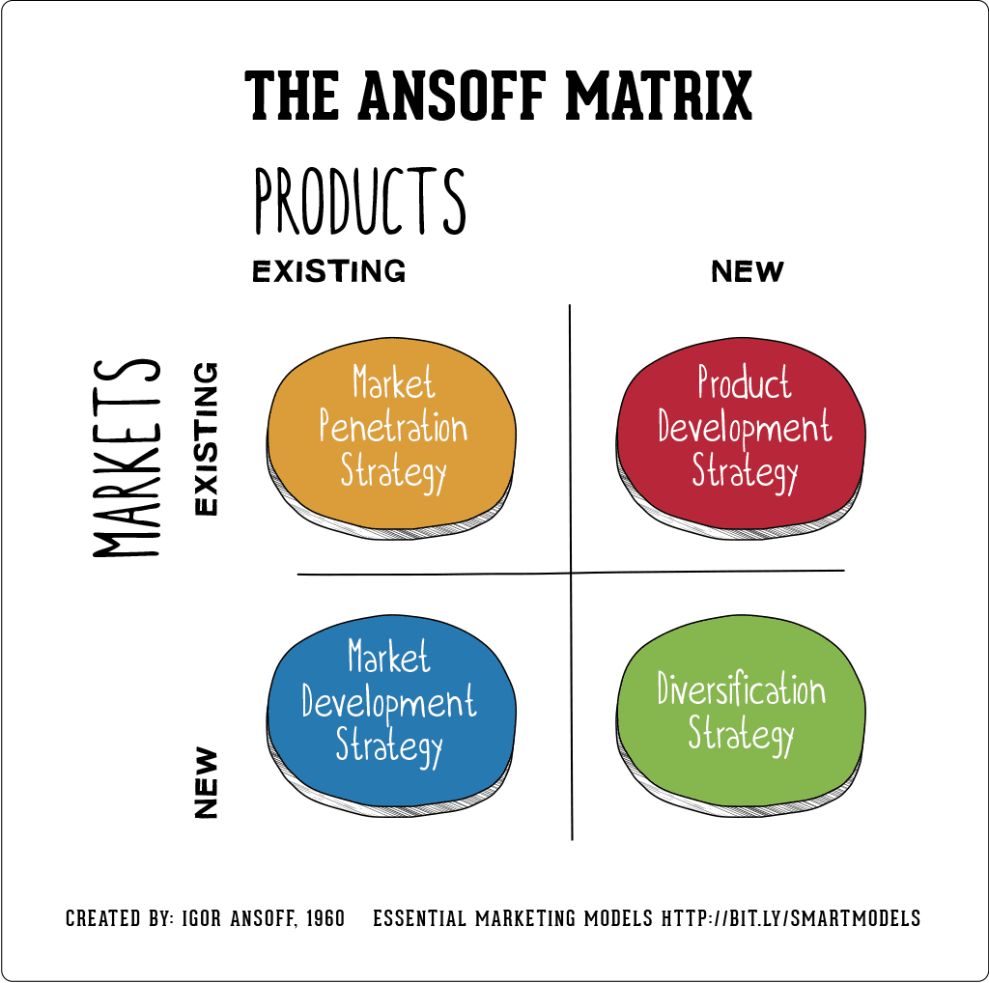
Fig. 10 The Ansoff Matrix Source : Annmarie Hanlon 12 Aug, 2021

Ethical issues related to this brand’s marketing mix in UK
Numerous ethical issues with Zara's marketing mix (4Ps) that are subject to scrutiny by the UK public, NGOs, and governmental authorities from an ethical perspective. First of all, the over-consumption will be a result of Zara's fast-fashion product development process, which is defined by short-term trend development cycles, combined with rapid garment destruction rate and excessive waste on textiles - an area of concern for many in the UK due to the push for sustainable consumption in that country. Additionally, despite Zara's commitment to using sustainable textile materials and achieving climate neutrality as part of its operational goals, many believe that the architecture of the fast-fashion business model is not conducive to achieving those objectives. In terms of price, Zara's low price point produces an array of ethical issues surrounding its global supply chain, including the question of fair compensation, the number of hours of work required from workers, and overall factory conditions in manufacturing countries. These concerns are compounded by the fact that Zara and its parent company, Inditex, are reliant on maintaining competitive prices in a fast-fashion environment. With respect to place, the global nature of Zara's distribution model, along with its ability to create new fashion trends quickly, necessitates the constant shipment of inventory to stores in the UK.

Ethical marketing Sustainability Messaging (“Join Life”)
Zara has committed to sustainable development in many of its public undertakings (e.g., “Join Life” Collection), placing focus on using a greater proportion of sustainable raw materials while simultaneously working to minimize the environmental impact created by the manufacture and distribution of their products. Zara demonstrates the importance of ethical marketing to their entire operation through their communication of sustainability goals to the public via press interviews and/or newspaper articles. Zara has also done an outstanding job of communicating their sustainability goals through press interviews and/or newspaper articles, explicitly indicating there intent to use materials that are environmentally friendly in the production process (e.g., include representation for consumers in Europe and North America who are considered eco-conscious) (Frost, Euronews, 2019). Additionally, by providing educational opportunities regarding environmentally preferred practices for consumers and by being transparent about the types of environmentally preferred practices that may be utilized in the use of products will allow consumers to make more informed choices that align with their values and beliefs regarding the environmental impact that products may have. As part of Zara's comprehensive mission statement, its commitment to Create Social Responsibility (CSR) will place emphasis on defining CSR as a core component of the Zara identity rather than simply as being price or trend driven. Given that CSR is becoming an increasingly more prevalent aspect of consumer behavior, this trend is seen as one element of the overarching trend toward environmentally responsible purchases among consumers in general (Frost, Euronews, 2019).

Unethical Marketing Example – Greenwashing and Misleading Sustainability Claims
Although Zara has received many positive responses for their communication, they have also received negative responses due to unethical methods of marketing, such as greenwashing; therefore, Zara’s sustainability messaging is frequently accused of overstating their true environmental impact. For example, reports concerning Zara’s limited edition "sustainable" line of clothing, made from polyester derived from captured carbon emissions, indicated that even though the campaign seemed like a departure from what the company typically produces (a fast-fashion model), the campaign did very little to resolve the root of the problem: overproduction and excessive consumption. According to critics, these types of campaigns have the potential to mislead consumers into thinking that the brand’s overall impact on the environment has dramatically decreased, when in reality the company continues to produce consumer goods using a high-volume fast-fashion model, which is a leading contributor to both waste and pollution (Leach, Euronews, 2022). This style of marketing can be classified as unethical because it is focused on providing consumers with an image of sustainability at the expense of providing them with products that are truly sustainable.

Recommendation:
Zara can improve its marketing mix from an ethical standpoint by making changes to its product design, price, place, and promotion in the UK. Specifically, Zara can reduce its number of clothing collections offered per year and create more durable and repairable garments to help mitigate overconsumption and textile waste through sustainable product design. Additionally, from a price perspective, Zara can demonstrate to ethically minded UK consumers that its prices reflect the ethical sourcing of materials, fair wages, and responsible production practices to help create trust in its brand. In terms of place, Zara can further improve its supply chain by 1) using low-carbon transportation to reduce its overall environmental impact, 2) producing goods local to or near-shore to the UK market, and 3) utilizing energy-efficient distribution centres. Finally, Zara can create more transparent and informative marketing communications to the UK market by giving monthly updates about its sustainability accomplishments, barriers, and progress so as to avoid greenwashing. These recommendations will allow Zara to better align its fast-fashion business model with the ethical needs of UK consumers, the ethical framework of government regulation, and the growing consumer preference for using responsible marketing practices, and ultimately will support long-term credibility and competitiveness for the brand (Inditex, 2024; Zara, 2024; Fashion Revolution, 2023).

Section 2

Gibbs reflective cycle :
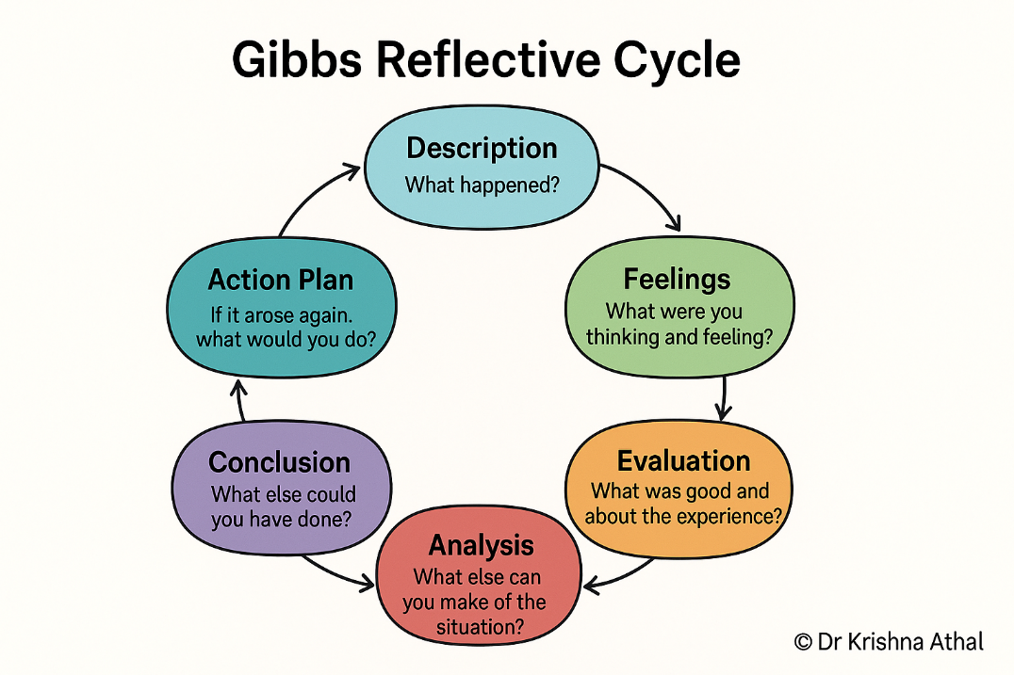
Fig 11 Gibbs Reflective Cycle Source By Dr. Krishna Athal - global index 2026

Description
This reflection will consider an in-depth business analysis of Zara’s actual operations in the UK and USA, focusing on its marketing strategies, adaptation to culture, and ethical considerations. The analysis used key business frameworks, including Hofstede’s Cultural Dimensions, STP (Segmentation, Targeting, Positioning), 7Ps Marketing Mix, Ansoff Matrix, and a review of ethical marketing considerations. This business analysis will examine how Zara's fast-fashion business model adapts to different cultural environments, as well as comparing the UK’s growing focus on sustainability compared to the USA’s high level of consumerism and impulse-driven fashion marketplace. Additionally, this study will also look at ethical issues such as environmental impact, overproduction, labour practices, and transparency in marketing.

Feelings
At first, I had difficulty comprehending the complexities surrounding the integration of multiple global business theories and methodologies into two different international markets. But as I continued studying these topics, I became confident in linking marketing theory to practice through an understanding of how cultural dimensions impact product positioning. I learned about the ethical issues surrounding fast fashion, such as sustainability, environmental degradation, and supply chain accountability, which has made me more aware of the global fashion companies’ social responsibility.

Evaluation
The analysis sufficiently highlighted the differences between the UK Market and the US Market. The UK has much higher expectations of sustainability, a moderate indulgence culture, and a high level of awareness of ethical consumerism whereas the USA is more indulgent, has a strong emphasis on individualism and has a faster rate of consumption, which supports Zara's rapid product turnover. The use of the Hofstede Insights (2024) and McKinsey (2023) frameworks assisted in the logical structure of the analysis. The use of secondary data presents limitations in that secondary data may not capture the current or real-time behaviour of consumers or the internal operational strategy of Zara. Additionally, the research is limited in that there was no primary research, such as customer or employee surveys or interviews.

Analysis
Zara's global success is largely due to cultural adaptation and ethical tensions (Hofstede Insights, 2024). While both the UK and USA are both individualistic cultures, impulse purchasing is greater in the USA as a result of their high level of indulgence, which results in greater levels of fashion consumption. This aligns with Zara's fast-fashion business model of creating a high volume of products quickly to respond to trends and rapidly replenish stock. On the other hand, increasing economic and environmental sustainability awareness in the UK has led to consumer expectations that Zara will become more responsible and adopt circular business models.

From an ethical perspective, there are many criticisms against fast-fashion due to its contribution to environmental degradation, excessive textile waste, and exploitation of workers in the global production supply chain (Fashion Revolution, 2023; Ellen MacArthur Foundation, 2022). As part of Inditex, Zara has launched sustainability initiatives such as its ecologically-friendly stores, recycling programs and using sustainable materials in its products. However, some researchers argue the benefits realised through these initiatives would not mitigate the overall environmental effects of the excess inventory produced and the short lifespan of the products produced (Inditex, 2024; McKinsey & Company, 2023).

Conclusion
In conclusion, Zara's business model in both the UK and USA relies heavily on its capabilities to maintain balance between the ethical implications of fast fashion, rapid supply chain production methods, and adaptations to local cultures. The USA will provide Zara with a greater opportunity for profitability because of the emphasis on consumerism, high levels of indulgence, and fashion as part of an American's identity. In contrast, the UK market shows a greater emphasis on sustainability issues, as well as being careful about the regulations that surround the sustainability of the retail sector. Despite these differences there still exist many ethical challenges for Zara, as the fast fashion model is inherently not compatible with environmental sustainability goals. I have enhanced my understanding of how international brands function based on differing codes of cultural and ethical conduct.

Action Plan
To help in evaluating Zara’s operations, an action plan will consist of primary research to gather first hand data for both the UK and USA markets. Consumer surveys will provide information on customers’ shopping behaviour, perception of price and their preferred products, which will provide insight into differences in both UK and US locations based on how effectively primary research can be used to measure actual consumer behaviours, instead of only relying on secondary data (Saunders et al., 2019). In-store observation will be conducted to examine the volume of customer traffic, store layout and consumer purchasing behaviours to assess the findings obtained from each UK and USA site and obtain a broader understanding of the differing types of behaviours encountered at each retail environment (Kotler & Keller, 2016). Qualitative data will be collected from customers via short interviews to learn about their perceptions of the Zara brand and reasoning behind shopping at Zara compared to competitive retailers.. In addition, Zara’s UK and USA websites will be compared to assess product range, pricing and availability in order to provide a more complete comparison of the digital consumer purchasing behaviours (Inditex).

References
BBC (2023) Brexit: What are the new UK trade rules? Available at: https://www.bbc.com/news (Accessed: 12 April 2026).
Cavusgil, S.T., Knight, G. and Riesenberger, J.R. (2020) International Business: The New Realities. 5th edn. Harlow: Pearson.
Dicken, P. (2020) Global Shift: Mapping the Changing Contours of the World Economy. 8th edn. London: Sage Publications.
Fashion Revolution (2023) What Fuels Fast Fashion? Available at: https://www.fashionrevolution.org
Frost, R. (2019) ‘Vogue features Zara’s sustainability pledge, but is it greenwashing?’, Euronews, 17 July. Available at: https://www.euronews.com/2019/07/17/vogue-feature-zara-s-sustainability-pledge-but-is-it-greenwashing
Hill, C.W.L. (2021) International Business: Competing in the Global Marketplace. 13th edn. New York: McGraw-Hill Education.
Hofstede, G. (2011) Cultures and Organizations: Software of the Mind. New York: McGraw-Hill.
Hofstede, G., Hofstede, G.J. and Minkov, M. (2010) Cultures and Organizations: Software of the Mind. 3rd edn. New York: McGraw-Hill.
Hofstede Insights (2024) Country Comparison Tool: United Kingdom and United States. Available at: https://www.hofstede-insights.com
Inditex (2023) Annual Report 2023. Arteixo: Industria de Diseño Textil S.A. (Inditex). Available at: https://www.inditex.com
Inditex (2024) Annual Report and Sustainability Strategy. Available at: https://www.inditex.com
Inditex (2024) Corporate Responsibility and Sustainability Overview. Available at: https://www.inditex.com
Johnson, G., Scholes, K. and Whittington, R. (2020) Exploring Strategy. 12th edn. Harlow: Pearson Education.
Johnson, G., Scholes, K. and Whittington, R. (2020) Exploring Strategy: Text and Cases. 12th edn. Harlow: Pearson Education.
Kotler, P., Keller, K.L. and Chernev, A. (2022) Marketing Management. 16th edn. Harlow: Pearson Education.
Leach, F. (2022) ‘Clothes made from “carbon emissions”: Why Zara’s new line is just more greenwashing’, Euronews, 21 June. Available at: https://www.euronews.com/2022/06/26/clothes-made-from-carbon-emissions-why-zaras-new-line-is-just-more-greenwashing (Accessed: 15 April 2026).
Moore, C.M. and Fernie, J. (2019) Fashion Marketing and Retailing. London: Bloomsbury Publishing.
OECD (2023) Economic Outlook for the United Kingdom and United States. Available at: https://www.oecd.org (Accessed: 12 April 2026).
Ortega, A. (2015) Zara and Her Sisters. Barcelona: Conecta.
Ortega, A. (2015) Zara and Her Sisters: The Story of the World’s Largest Clothing Retailer. Barcelona: Conecta.
Tokatli, N. (2008) ‘Global sourcing and fast fashion: the case of Zara’, Journal of Economic Geography, 8(1), pp. 21–38.
Zara (2024) About Zara. Available at: https://www.zara.com
Zara (2023) About Zara / Brand Philosophy. Available at: https://www.zara.com
Zara (2022) About Zara / Company Information. Available at: https://www.zara.com
Zara (2024) Sustainability and Brand Information. Available at: https://www.zara.com

