
Assignment 1: A SWOT analysis of Starbucks in the UK

Problem Solving and Innovation (BMSW4014)

Student Name: Andrei Silviu Popina

Student number: 2332738

Lecturer Name: Rebecca Francis-Davies

Submission Deadline: 08.11.2024

Word Count: 520

Table of Contents

A SWOT Analysis of Starbucks in the UK- Summary of Starbucks 3
Background of Starbucks 3
Current Situation of Starbucks 4
Speaker Notes 4
References 6

A SWOT Analysis of Starbucks in the UK- Summary of Starbucks
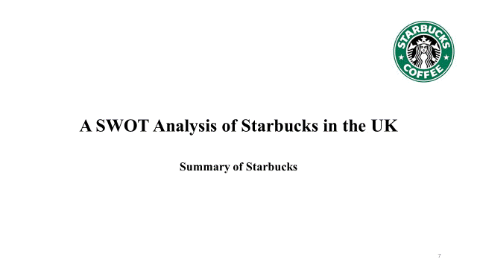

Background of Starbucks
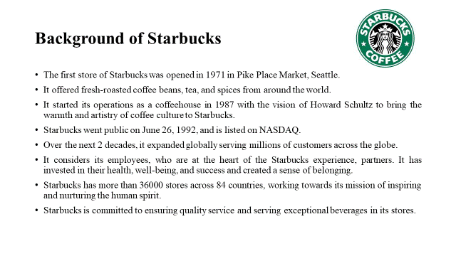

Current Situation of Starbucks
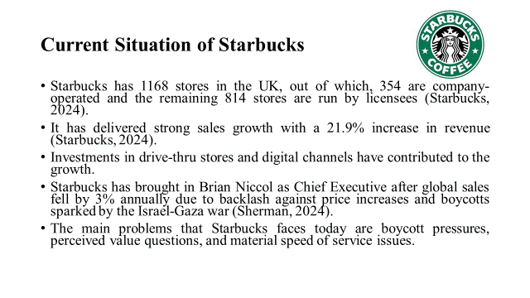

Speaker Notes
According to Starbucks (2023), it started its operations in 1971 as a roaster and retailer of whole bean and ground coffee, tea, and spices in Pike Place Market, Seattle. The name was inspired by the classic tale Moby-Dick evoking coffee traders’ sea-faring tradition and the logo is inspired by the sea, featuring a twin-tailed siren from Greek mythology. It embarked on a new chapter as a coffee shop in 1987 based on Howard Schultz’s idea. Over the next two decades, it continued to expand globally with over 36000 stores in 84 countries.
The mission of Starbucks is to nurture the limitless possibilities of human connection with every cup, every conversation, and every community (Starbucks, 2024). Starbucks is committed to the highest standards of quality and service embracing its heritage and innovating to create new experiences for its customers.
Starbucks is undergoing a company-wide transformation initiative to identify pain points and gain innovation and wisdom from employees at all levels (Ko, 2022). Starbucks support teams collaborate with employees and customers to improve the in-store customer experience. The transformation initiative tends to refocus on key initiatives that will help in providing clarity on roles and priorities, store modernisation, and improve the experience of customers and partners.
Starbucks has embraced a work culture that embraces differences and provides equal opportunities thereby fostering a sense of belonging. According to Starbucks (2022), it is making attempts to reinvent for the future by modernizing and transforming the store experience and recreating a welcoming and safe environment.
Starbucks' global store sales fell by 7% and net revenue declined by 3% in the fourth quarter of 2024 ( (Starbucks, 2024). Although the company has invested in an expanded range of product offerings and increased the frequency of in-app promotions and integrated marketing, changes in customer attitudes led to lower-than-expected performance.
According to Sherman (2024), Brian Niccol has taken charge as the new Head as Starbucks is struggling with a decline in sales due to price increases and boycotts initiated due to the Israel- Gaza war. The firm is facing fights with staff in the US, who want to join a union, tarnishing its progressive reputation. According to Hooker & Silva (2024), as Starbucks is embarking on simplifying its menu and price reviews globally to overcome staff shortages and customer bottlenecks, it has not been confirmed whether these reforms would apply to the UK.
According to Starbucks (2024), Starbucks UK has registered strong revenue growth of 21.9% for the financial year ending October 2023 despite the challenging economic conditions. Investments in drive-thru stores and digital channels such as mobile order and pay systems, delivery services, and improvements to loyalty programs have assisted in its growth. It has invested in growth opening more than 100 stores. It has continued to invest in its employees offering performance-linked bonuses for employees contributing to sustainable success and providing incentives and benefits with salary increases and green apron discounts. There was an increase in operational costs due to inflationary pressures and wage increases resulting in strategic price increases.

References

Hooker, L. & Silva, J. d., 2024. Starbucks boss shakes up menu to win back customers. BBC, 24 October .
Ko, M., 2022. Collaboration sessions highlight opportunities for Starbucks to grow stronger bond between stores and Support Center. [Online]
Available at: https://stories.starbucks.com/stories/2022
[Accessed 28 October 2024].
Sherman, N., 2024. Starbucks replaces boss after sales slump. BBC, 13 August.
Starbucks, 2022. Reinventing Starbucks, Together, Seattle: Starbucks.
Starbucks, 2023. Company Profile, Seattle: Starbucks.
Starbucks, 2024. About Us. [Online]
Available at: https://www.starbucks.com/about-us
[Accessed 28 October 2024].
Starbucks, 2024. Starbucks files UK and EMEA accounts for the fiscal year ended October 2023. [Online]
Available at: https://stories.starbucks.com/emea/stories/2024
[Accessed 28 October 2024].
Starbucks, 2024. Starbucks Reports Preliminary Q4 and Full Fiscal Year 2024 Results. Financial Times, 22 October.

