DS 1 Template

My Screenshots/Photos
- Please add 4–6 screenshots or photos of your digital life.
- You can use your phone or laptop.
- For each screenshot, write one or two sentences explaining what it shows.

Screenshot/Photo 1
[Insert Photo/Screenshot below]
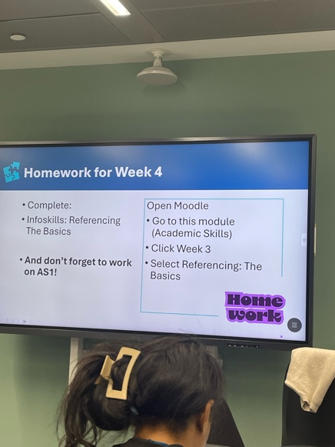
In class we use a digital board and is more interactive.

Screenshot/Photo 2
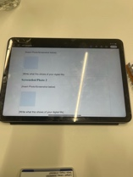
I feel more comfortable using my iPad for do the homework, is fast and easy.

Screenshot/Photo 3
[Insert Photo/Screenshot below]
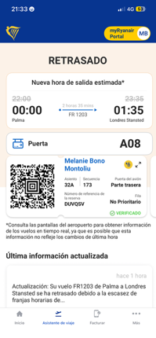
This is boarding pass and make my life more easier because I don’t need use the printer and carry with a lot of documents, I can scan my phone and all done.]

Screenshot/Photo 4
[Insert Photo/Screenshot below]
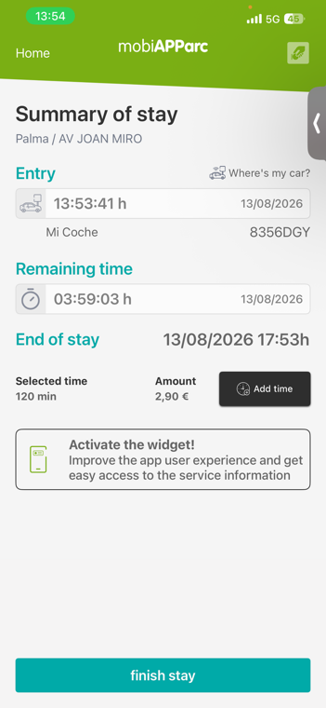
This is an app for pay the parking online. And if do you think your time ends, you don’t need to rush, from your phone you can pay extra time.

Screenshot/Photo 5
[Insert Photo/Screenshot below]
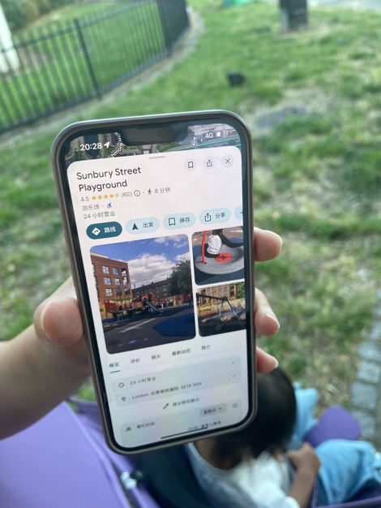
I use the phone for found new places and locations.

Screenshot/Photo 6
[Insert Photo/Screenshot below]
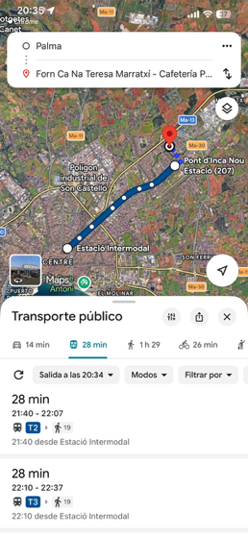
I often use this tools for planing my journeys and prepare in advance with enough time for don’t get lost or late.

My Short Reflection
- Write 5–8 simple sentences about your digital life.
- You can use the sentence starters below if helpful.
• In my personal life I use very frequently digital skills even for simple things.
• I feel more comfortable when I have everything under control and the digital life make me the life more easily and accessible.
•I hope this modul help me to improve my skills and be more faster and take more benefits with the digital life
• I use digital tool to do almost everything in my life, take aeroplanes, trains, found a simple address, pay a coffe with my phone, open the door with a card pass…
• I sometimes feel nervous about the new technology’s because I need time for learn how it’s works.

Sentence starters
- I use digital tools to …
- I feel confident when I …
- I want to improve …
- I often use these tools: …
- I sometimes feel nervous about …
- I hope this module will help me …
- Digital skills are important for me because …
You can write more if you want.

Submission Checklist
Before you submit, please check:
​​​ ☐ I added 4–6 screenshots
☐ I wrote short sentences for each screenshot
☐ I wrote my short reflection
☐ My work is my own
☐ My file opens correctly
​​☐ My file opens correctly

