Background of the School:
Sunshine Primary School is situated close to Carmarthen town centre. It is a small to medium size facility with over 230 children enrolled. Latest figures show 16% of its pupils are in receipt of Free School Meals (FSM) and 10% of its pupils are registered with Special Educational Needs (SEN). This would indicate that the school supports a diversity of needs, cultures and background. Diversity is highly valued and embraced within the school’s rich culture as it’s ethos believes that every individual has something of importance and consequence to offer. The school, therefore embeds a firm significance on inclusiveness, where all children feel valued, important and able to take risks and make mistakes, which is one of the foundation needs according to Maslow (1943) as well as being central to the new curriculum, Donaldson (2015). The school also relies heavily on and encourages parental and community involvement, recognising the many benefits to be realised by including different expertise, life skills and experiences and ensuring everyone has a common understanding, in order for the child to have the best possible learning experience. For more information on Sunshine Primary School, refer to the newsletter in appendices.
Within the context of this assignment, I will be acting as the School’s Head of Language along with taking on the Reception Teacher role. My passion for improving communication comes from a deep-rooted interest in connecting with people through face to face contact both in my working role and personal life and an interest in both the English and Welsh languages.


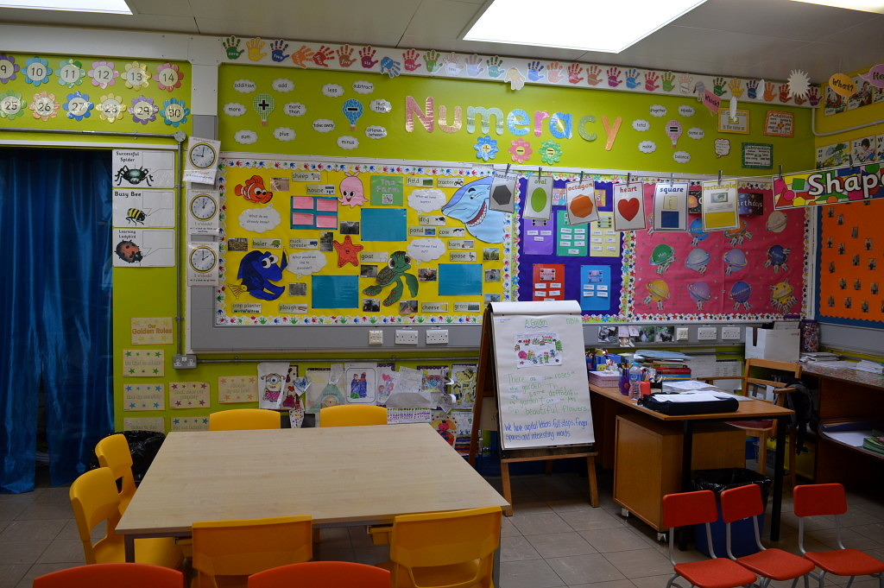
Sunshine Primary School
Classroom example

Background

Core Values
November 2018
Sunshine Primary School is only a short walk away from Carmarthen town centre, a town that is rich in heritage. There are currently 232 children enrolled in the school, with little capacity to expand. The predominant language of our school is English. However, we recognise the importance of our national language and have a strong ethos to embed Welsh into our everyday lessons and transitions.
Our school is very inclusive. Every single learner is a great asset to us. We aim to work together to aid them in achieving their full potential and foster their interests.
Pupil voice is key to our pedagogies, to create independent, critical and creative thinkers.
Community involvement allows our learners to gain a sense of belonging and pride of our locality.
We value parents as much as their children, as they play a vital role in developing the cross curricular skills within our children. Therefore, parents are invited into school every half term for an informal meeting to discuss the medium term plan and see how they could aid their children’s learning at home.
There is an open door policy which allows parents to alleviate any anxieties they may have.

“Teaching Future Generations to Shine Bright”
We aim to develop every individual’s skills in Literacy, Numeracy and Digital Competency, as not only are they vital life skills, but they have been highlighted as cross-curricular responsibilities in the new curriculum. We also endeavor to create learners who are resilient, creative, open to challenges and most importantly confident.

Key Aims
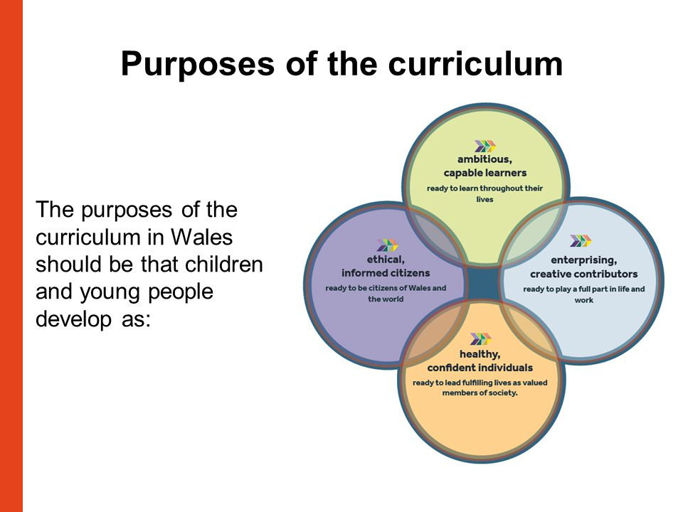





Putting the Child First!
Carmarthenshire has one of the highest percentages of children across the Welsh counties. As of 2017, there were roughly 32,000 children living here. Therefore, its number for Free School Meals (FSM) is also higher than many other areas in Wales. The FSM rate for Sunshine is roughly 16%. Our school embraces the diversity of the children and families that enter our education system. Therefore, we have a breakfast club to ensure that all children irrespective of their backgrounds have the correct start to the learning day. Ethnic minorities are welcomed, valued and are a vital part of our school community.
The Pupil Development Grant has enabled us to provide additional support to the 10% of pupils who have Special Educational Needs (SEN), as well as the 16% who have FSM. It has been used for a variety of resources, including staff training and a nurture room.
We encourage parental/guardian involvement and if you have any
concerns, ideas, suggestions or queries for us please contact us using one of the following options, or simply visit our office:-

Address - Sunshine Primary School, Any Road, Somewhere Town, XXX XXX
Phone - 01883 667580
Email - sunshineprimary@outlook.com
Text Service - 08990 776543

Keep checking our website and Facebook pages for regular updates
www.sunshineprimary.ac.uk

There are many extra-curricular activities including; sport, mindfulness and choir, as well as our school council, which emphasises the importance of pupil voice. The children have ownership of their agenda and a responsibility to value everyone’s needs. They have previously tackled tasks such as organising fundraisers, creating a healthy, balanced lunch menu and enterprise challenges.
Extra Activities
We are very proud of our staff here at Sunshine Primary School. They are at the centre of our success and embody innovative experiences for our learners. It is important to us that our children see the value of the staff, and have strong role models for professional collaboration. Every month the children have the opportunity to nominate a teacher for an award and have to reason why they believe they deserve it.
Our Staff
Every need of the child, whether it be social, emotional, physical or educational, is important to us. We aim to embody Donaldson’s four purposes, to create the best global citizens.
SPLAT Write Up:
The intervention presented as a proposal to the Governing Body is ‘Speech and Language Action Transformers’ (SPLAT). It is a new interactive Speech, Language and Communication Needs (SLCN) intervention that ultimately aims to develop children and families who require extra support to have a good understanding of appropriate communication, giving them the tools to cope with differing scenarios within life. Language is an essential life skill, it is a crucial building block in the child’s intellect, which will allow an individual to thrive in and explore multiple opportunities in life. This is reinforced by Woolley, who believes ‘it is fundamental to a basic education for all, and as such is essential for the eradication of poverty,’ (2014: xi). Poverty is the main reason for the emergence of this intervention, as for the purposes of this assignment; there has been a surge in linguistic difficulties in Carmarthenshire, which is directly correlated to poverty levels. Poverty often demands people to place prominence on surviving rather than thriving, thus children often receive limited educational reinforcement at home. Sunshine Primary School endeavour to create children who are ambitious, creative and in due course prosperous, in order to fulfil and exceed their daily requirements. As a result, raising the standards of literacy has been highlighted as a priority within the School Development Plan (SDP), which is in line with the Welsh Governments priorities (2012). An element of this is the priority is to support those children with SLCN, which is where SPLAT becomes active. It has been developed in accordance with educational theorists’ findings, Estyn recommendations, Welsh Government priorities and Donaldson’s (2015) new curriculum.
Initially all children within the school will be assessed utilising a screening implement, Carmarthenshire Speech Language and Communication Screen, which will be utilised twice a term. This will require mutual observations by the teacher and the Teaching Assistant (TA), with the intention of collective agreement regarding the attainment of children. Each descriptor within the screen entertains three ranks; red, amber or green, RAG ratings, corresponding to their proficiencies. Conditionally the children are considered for their membership in SPLAT if they have persisted within the red and amber sections consecutively. Parental consent is imperative, therefore a letter will be sent home asking for their involvement in the new project, and inviting them into the school to discuss their expectations for the sessions, and how they can be educators within the home context. Once they are on board, an in depth screen will take place, which covers all the SLCN skills, which will create a springboard for SPLAT and the type of activities needed.
This intervention encompasses elements of the CHATT intervention that is commonly applied in the region. Conversely, it has an innovative, active, child-led stance, which formerly has not been applied within interventions, in Sunshine Primary School. SPLAT promotes interactive, hands – on and multisensory experiences, as this holistic nature of learning allows learners to make sense of their world. Pestalozzi believed that children need experiences to engage with concrete materials within social interactions in order to allow development, Pound (2014). Froebel again accentuated the importance of play as a benefit for the child’s well-being and mentioned the importance of teaching to stage not age. This is topical within education at the moment, as Donaldson’s (2015), suggested the removal of key stages in order to allow educators to focus on skills appropriate for individual children. However, careful consideration must be taken when allowing children to ‘play’ as they could lose focus on the purpose of the activity, as suggested by Montessori.
There will be three twenty-minute sessions a week. It is an intervention that requires a whole school approach. The ethos of effective communication will need to seamlessly be incorporated in day-to-day activities, in order for the skills to be practiced fluidly. Consequently, there will be a need for the creation of a highly collaborative school, with staff working inter- professionally. This should ensure that there is continuity within the provision for children, as they mature through their education. Provision also needs to be tailored for individual needs, which Donaldson (2015) believes will better learning and higher standards. Inclusion is central to this intervention. It allows all learners to have equal opportunities to achieve in life. Belonging in a learning environment is vital in order for them to develop confidence and engage in-group activities.
SPLAT will embed a cross-curricular approach, because skills need to be practiced in a variety of contexts, to be able to make formidable connections between and within curricular areas. ‘A curriculum defined largely in terms of discrete subjects can become directly translated into a timetable within which important cross-curricular learning is marginalised,’ Donaldson (2015: 35). Language is often a subject, which is taught discretely, however SLCN skills are the utmost applied skills across all curriculum areas, thus we should not compartmentalise their skills development to one subject area. There is a risk of making too many tenuous links between subjects, and consequently learning becomes tokenistic, Barnes (2015), subsequently attention must be taken whilst formulating activities.
Learning within SPLAT will not be restrained to one environment, children will explore diverse surroundings and communicate with several people, which will operate as a catalyst for speech. ‘Working outside the classroom expands and enriches this learning environment,’ Cremin et al. (2018: 216). Children’s interests will also be incorporated into the planning, which highlights elements of Donaldson’s four purposes, and expectantly obtains the engagement of learners, thus cultivating wealthier learning. The United Nations Convention on the Rights of the Child (UNCRC) has an Article dedicated to ‘freedom of expression,’ showing the importance of valuing children’s views, Unicef (unknown).
Questioning will be well-thought-out, as this allows learners to develop their thinking skills. It is important in SPLAT that enough time is given to every participant before asking for an answer. Strategies such as Blooms’ taxonomy can be used to help learners learn.
Teaching Assistants will be responsible for the delivery of SPLAT. It has been proven that when given responsibility, TA’s show a great rate of progression with children. TAs will be given INSET training by a speech therapist on how best to engage with poor language skills and how to utilise strategies effectively, the estimated cost for this is £1000. An observation book will be prepared with the skill and activity for each session. Once they have completed a session, progression should be planned within the observation book. Ofsted expect teachers to demonstrate that they have had an understanding of the impact of the intervention on progress, Nasen (2014), therefore there will be a brief weekly meeting with the teacher to view general progression. This in turn will influence the progression map, Nasen (2014), to ensure that progression is visible to any external authorities. There will be a half termly pupil progress review meeting with the SENCO to reflect on the effectiveness of the intervention itself. Reflection is key within education. ‘Reflecting on our own thinking and practices helps us to understand the complexity of the classroom choices and decisions that are faced routinely every day,’ Pollard (2014: 23).
It is hoped that by partaking in this intervention, children will be able to advance six months with their understanding of language skills, allowing them to achieve their full potential.
However, there will be challenges to effectively implementing this intervention, which teachers need to be open to and aware of. There is a significant change in pedagogies to the standard classroom in Wales, therefore the teaching cohort (TAs) may be reluctant to adopt
and partake in a different style of delivery. Nevertheless, as it is a whole school approach, staff should support each other and share best practice. Funding is a constant pressure within schools, and training will deplete these sources. It is important to weigh the benefits against limitations, in terms of what teaching staff will take out of the training. Time is also a constraint. There is little time to cover the current curriculum, and teachers are under constrained pressure to deliver for 5 hours a day for 5 days, thus leaving little time for them to allow such activities. However, Donaldson’s new curriculum is promoting value of teaching activity over amount of teaching activity, allowing such activities to develop these children with SLCN.

Provision Map Explanation:
This is an example of a provision map in a Reception class, which has been made in accordance with the recommendations from Nasen (2014). It is a working table that will need to be continually reviewed by each class teacher, alongside the appropriate staff who are delivering the interventions. The table should include any learning opportunity that is not part of the daily curriculum, e.g. catch up sessions, positive play, etc. This is an effective tool which allows you to quickly and visually access information on the needs of children within a class, and how they are being met. Within each intervention there will be an observation book that provides information such as; a child’s name, the skill they are developing during that time and comments relating to engagement and progression, whether they are transitioning from different skills or not. These comments will then inform the provision map’s outcomes (concisely). It is important that SMART (specific, measurable, achievement, relevant, time-bound) targets are used, in order to convey clear understanding of what a child needs to do to progress, how they will be assessed and the period of time needed to reach this. The purpose of any intervention is progression. Therefore, the exit data acts as the value added on any skills and understanding they have gained during the sessions.


“Teaching Future Generations to Shine Bright”
Sunshine Primary School

Information Pack



This information pack aims to outline the components of SPLAT (Speech and Language Action Transformers) and includes some examples of activities that can be used within the intervention. It is adaptable to meet the needs of individual students, and suit the learning environment. In addition to the SPLAT activities, there are suggestions on how to gain student engagement through good communication within every learning context.

- This is a Teaching Assistant (TA) led intervention, which takes place for three twenty minute sessions a week.
- The children are identified through a screening process, and participate if parental consent is given.
- The sessions are prepared for and reflected on in an observation book, which then informs the progression map.
- The sessions will include small groups, of around four students, and aim to increase their confidence and development of social skills.
- The activities will vary in style, location, context and complexity. They are meticulously designed to meet the stage of each learner and aim to use everyone’s strengths to enhance each other’s understanding.
- SPLAT has been developed in line with the School Development Plan, to raise the standards of literacy across the whole school. If successful, it is hoped that children will advance their skills by six months, in order to have the understanding and confidence to participate within day to day lessons.
- Funding for this proposed intervention will come from the Pupil Development Grant, and will be used for TA training and resources.

- Praising children is powerful. It is a component that raises their confidence and value within the class. Every child should have strong self-efficacy within their language skills, as social interaction allows leaners to make sense of their world. Therefore, SPLAT promotes positive praise in order to encourage the children to develop whilst not being afraid to take risks.

TIP: Overpraising children can be detrimental, as it gives a false perception of their progression, perhaps inhibiting their future efforts.
- Multisensory experiences will be provided. Children need opportunities to embed their skills, including language, by using them in different contexts, and by manipulating a variety of concrete materials. This in turn will build more meaningful neurological connections, and will intrinsically stimulate the mind and body.

TIP: There is a fine line between stimulating the brain and having sensory overload. Be mindful of how the child will benefit from the experience.
- In developing this intervention, activities will have been created that promote cross-curricular learning. Language is continually used and developed in a multitude of social situations, meaning it should not be confined to pure classroom experience. It should be used as an opportunity to link other curricular areas, whilst adopting learner’s personal interests. Allowing learners to have ownership over their learning, endeavours for rich involvement and engagement. Rigid division of learning into specific subjects marginalises children’s thought processes and hinders their capabilities to develop interests.
TIP: care and confidence needs to be taken when using cross-curricular skills, that activities have been made authentic and meaningful, in terms of the output of the experience.
- Differing environments will be used as a stimulus for speech and communication. Children need to develop an understanding of how to interact within different contexts, and by removing physical walls, children will not perceive it as learning. This will allow them to apply their thinking in a real-world context.

TIP: children need regular experiences outside of the classroom, or the novelty of leaving the classroom may outweigh the experience itself.

Activities for Developing Speech Skills
The aim of these activities is to have children develop their use of sounds in language. The activities won’t be prescriptive to each stage; it will be about appropriateness for each child. Speech is the first stepping stone to literacy; if a child cannot produce sounds it will be difficult for them to blend words in the later stages of reading or writing.
There are three main areas that will be supporting in speech;
- Oromotor development – ability to move the muscles that control speech
- Facial charades – use of charade cards e.g. smiley face – to prompt children to use their facial muscles to create a shape/emotion – can be played in teams therefore interactive and stimulating.
- Paint blowing (to create a shape) – use of straws to blow paint into different shapes – encourages creativity and artistic skills
- Making own musical instrument - utilising vegetables and empty plastic bottles e.g. a carrot recorder – to create sound patterns with their speech muscles.
- Journey stick - schedule a walk outdoors and identify shapes within nature to recreate in the classroom (in front of a mirror)using their mouth and facial muscles.

NB: Children to exercise their facial muscles and breathing by singing well known songs every day

- Phonological awareness – awareness that sounds make words
- Sound games - mimic sounds using games such as I Spy for children to recognise and associate the initial sounds of words
- Syllable games – recognising the rhythm and sequence of sounds through clapping, instruments etc.
- Conversation box - children pick out an item and think of a rhyming word
NB: These games could be used as a plenary activity.
- Sound awareness- ability to tell the difference in sounds
- Environment sounds - children to walk around different environments and notice different sounds and recognise the variations in these sounds e.g. loud, repetitive etc.
- Simon Says – children to copy or suggest different sounds for their peers to follow
- Bean bag – children throw a bean bag onto different pictures and name the picture and identify the sound
NB: Calming strategy for the whole class and ask them to be silent and count how many different noises they can hear.

Activities for Developing Social Skills
These activities aim to develop both verbal and non-verbal communication skills. These skills are essential in life; otherwise there is a risk of poor academic achievement, as well as behavioral difficulties.
- Pie Corbett stories – the use of actions to portray words in order to help understanding and memory of a story
- Pass the parcel - unwrap and each layer holds a different emotion which the holder needs to vocally express and show empathy
- Puppet stories – class puppet to read out a familiar story and children to stop puppet when a mistake or changes have been made
- Tea party – set up a tea party and give children the brief of introducing themselves to peers as if they were strangers
- Challenges – team building activities that requires collaboration to achieve an end product e.g. building a den
NB: After every lunch break children should converse with a peer about what they had for lunch and what they did in their spare time

Activities for Developing Receptive Language Skills
These activities should give the children the ability to understand words and language. In order for communication to occur, children need to understand spoken language. Difficulty in understanding spoken language will lead to difficulty in understanding written language.
- Role play – children to be given scenarios and have to portray understanding
- Sequencing stories – children will be given a mixed up jumble of cards and be asked to create storyboards in the correct sequence
- Conversation starters – TA to model sentence starters and challenge children to use these in different situations and with different people.
- Visual timetables- children to work collaboratively to create a timetable of their daily schooling using pictures in order to create smooth transitions
- Baking – children to choose a recipe and follow the instructions to assemble their bake
- Obstacle course – children to design and build their own obstacle course and direct their peers around it
- Mindfulness colouring – children to listen carefully to guidance and complete a picture of their choice
NB: Questioning – teachers to carefully consider the complexity and style of their questions to meet the needs of their learners

Activities for Developing Expressive Language Skills
These activities will give the children the ability to use language to communicate. Through talking, children are able to think and learn, which will later affect their reading and writing.
- Acting – children to adopt the role and personality of a character and portray this through their expression of language
- Story maps – children to draw pictures to represent how a story flows
- News time – children to create short news broadcasts and share them appropriately
- Scrap book of the week – children to use IPads to take pictures of their learning throughout the week and create a digital scrapbook which they will feedback on
- Children as teachers – children research and deliver information to their peers
- Guess who – children can use yes or no questions to guess who they are playing
- Marshmallow/candle challenge – children to take part in creative activities which require them to work together and challenge their perception of the use of different materials
NB: the use of the AFL strategy – Think Pair Share – can be used within lessons

Script:
Good morning and many thanks to you all for coming. I value the opportunity to share my proposal with you, which if successful will raise the profile of language and literacy teaching here within Sunshine Primary School. I hope you all had the opportunity to familiarise yourself with the information pack that I distributed last week, I will happily answer any questions you may have at the end of my presentation.
My proposal is to introduce a Speech Language and Communication Needs intervention, named Speech and Language Action Transformers, abbreviated as SPLAT. SPLAT has been developed due to a surge in linguistic difficulties within our region, which have primarily but not exclusively risen due to the level of poverty within our catchment area. As you are all aware, it was agreed that the first priority within our School Development Plan, was to raise the standard of literacy across the whole school, and as one of the targets we felt there was need for an intervention to help those children with Speech, Language and Communication Needs, as reiterated by our Local Authority Challenge Advisor. This is in line with Welsh Government priorities, which highlight the inconsistencies within our schools pertaining to literacy skills. Over the summer, I have carried out extensive research with reference to these needs and have amalgamated a wealth of good practice and recommendations, which enabled me to develop the ‘prototype’ of SPLAT.
SPLAT as a tool is highly interactive in nature and requires active participation from all relevant stakeholders adult and child alike guiding us all to work inter-professionally with all relevant agencies to ensure that the best opportunities are given to each individual. The principle body of professionals that support this intervention are speech therapists, to whom we will be closely liasing for both training and support and advice purposes. The Local Authority also have subject matter experts (SMEs) in this field who will prove valuable in providing advice and good practice. The relevance of this has been highlighted as a core aim in the ALN and Educational Tribunal Act, which states that increased collaboration is needed for the best interests of the learner.
Our Education Secretary, Kirsty Williams, emphasises the need to close the attainment gap between deprived children and their peers, as one of our national priorities. Thus, this early identification and intervention should help break the poverty cycle and equip our next generation with vital communication skills that will underpin their employability prospects.
SPLAT can and should be utilised across the whole school. Necessitating that all teachers and Teaching Assistants will need to show commitment and enthusiasm, to ensure that there is continuity for the children. Donaldson’s new curriculum emphasises that learning should be a continuous experience, and sees the removal of key stages, which have previously fragmented teachers understanding of children’s transitions within or across key stages. By ensuring that the principles of SPLAT remain firm across the school, children’s confidence throughout their transition should grow.
Children will be identified for SPLAT through a screening process via a RAG rating system (Red, Amber, Green). All children will be screened twice within a term, which should show the value added to their skillset over a period of time. They will be put forward for SPLAT if they remain on red or amber consecutively. As soon as Additional Learning Provision is provided, the children are then identified as having Special Educational Needs, which is the new term that replaces Additional Learning Needs. This new term is hoped to reduce the stigma around these individuals and create a more inclusive atmosphere. SPLAT formally starts in the New Year for Reception children and continues across the board for older children. Section 64 of the ALN and Educational Tribunal Act requires schools to notify parents where they think their child has SEN. Therefore, we must have parental consent to remove children from their existing learning provision, but the benefits of partaking in SPLAT will be clearly explained, to ensure that parents are aware of the best progression for their child. Parents will also be given support and guidance on how to provide continuity for their child’s development at home and will be given regular updates on their child. Estyn recognised fantastic good practice within a school in Pontypool, which encouraged parental involvement to raise literacy standards, by enrolling on learning programmes. This is an aspect that we could develop in the future if SPLAT is as successful as has been predicted, but for the present it is important that we involve parents in the quickest and most beneficial way. The trick to use the EAST principles when applying new practices – make it Easy, Accessible, Social and Timely. (Easy to use, Accessible for all who need it, Social - participants feel they are missing out (FOMO) if they don’t get involved as it is fun and useful to take part and Timely - action the intervention as soon possible)
Once they have permission to partake in SPLAT, they will be assessed against all the Speech Language and Communication Needs skills, which will provide a starting point for activities. SPLAT provides interactive, hands – on and multisensory experiences, in a range of
environments, which aim to develop speech, social, receptive and expressive language skills. It has been proven that by using collaborative and innovative activities, children are more likely to engage with the activity and are able to show understanding of the skills learnt in different, real-world contexts. By being involved within these activities, it is hoped that children are able to become ambitious, capable learners, as they will be involved in challenge, applying skills in different context, questioning and problem solving, as well as communicating effectively. They will also be developing elements of the other three purposes that Donaldson has suggested. Examples of the types of suitable activities can be found within the information pack and are meant to be flexible and adaptive to meet the needs of all individuals. There are no restrictions to either teaching staff or children suggesting or inventing their own activities, as long as they aid progression. The aim is for these activities to be engaging, memorable and effective. I think we would all agree that a child would gain more from going on an outdoor treasure hunt and following a pirate’s instructions than they would following a teacher’s instructions to draw a simple house, sat in rows in a class – imagination and creativity will be actively encouraged. Thus, Donaldson recommends that teachers should ‘promote coherence and encourage children to make connections across different aspects of their learning,’ (2015:35). It is also within the child’s rights, according to Article 12 of the United Nations Convention on the Rights of the Child to give them opportunities to express their views, feelings and wishes on matters that affect them. This is reinstated in core aim 10 of the ALN document that states children and their parents should be involved in the decision-making process. It is therefore planned that children will be given regular opportunities to take ownership of their learning, and it will be down to the TA to ensure that Speech Language and Communication Needs skills are embedded into the chosen activities or learning experiences. Parental concerns or wishes will also be considered, provided they are of benefit to the children.
There will be three twenty-minute sessions a week, which are to be led by the Teaching Assistants within each class. The TAs will have INSET training from a speech therapist, which will cost roughly £1,000, and will be covered by the Pupil Development Grant. Estyn shared positive feedback from a school in Cardiff that allowed TAs to develop professionally by leading an intervention programme, they saw high levels of motivation and achievement within both staff and children. TAs will have the responsibility to reflectively feedback to the teacher and plan accordingly, with the aim of progression in mind. They will be provided with an observation book, which will clearly display the current level of the child’s
understanding, activities used to develop these and the next steps for progression. This way, for inspection or audit purposes the information is clear and concise. The progression will then inform the provision map, which will include all interventions within that class. The example seen is for a Reception setting. It is important that these activities do not just benefit those children for an hour a week, but that they continue to develop within the classroom context also. Ofsted state that teachers should be clear on how an intervention helps progression within the classrooms. Through weekly meetings between the class teacher and TA, both professionals can openly discuss and reflect on effective strategies for that child and how it can be incorporated into lessons. It’s also important to add that good communication skills should be developed within every learner. Questioning strategies such as Bloom’s Taxonomy can be used within general lessons, and differentiated to develop everyone’s thinking skills, whether they be higher or lower order thinking skills. There will also be a pupil progress review meeting every half term with the SENCO, to discuss every individual within the intervention, focus on high quality teaching, address arising issues and make any decisions to change provision to best tailor the support to each individual. Reflection is key to continual professional development, and the only thing it costs is a small amount of time.
In line with what’s been seen, I envisage that children will make six months progress against their original screen assessment, and should all leave our school with good Speech Language and Communication skills.
As with all aspects of education there are challenges that could potentially inhibit the effectiveness of its delivery. However, it is down to our dedicated and experienced teaching staff to foresee these and overcome them. First of all, funding is tight. I am aware that this is not the only priority within the school and that other key areas also need resourcing. However, this project only requires an initial outlay for the cost of training, with some small incidental resource needs throughout the process. SPLAT will also heavily involve the support and engagement of the teaching cohort, holistically across the school. The teachers have all been sent the same information pack and there will be a meeting to address any concerns they may have within the next fortnight. Time is also a limiting element. However, Donaldson has stated that teachers are to view learning not as a matter of quantity, but of quality, therefore it is important they allow interventions such as SPLAT to enhance other curricular learning.
Thank you for your attention and participation. I look forward to reviewing this innovative intervention in the New Year.
Do you have any questions?

Critical Reflection:
I have enjoyed having the responsibility of developing an intervention that explored progression, in a field that I have a passion within. It has been an informative task, as I have discovered many new perspectives to effective teaching and have had to reason with different viewpoints to create a logical, valuable intervention. Throughout the lectures, different aspects have been introduced and suggested, which have been embedded within this assignment, along with wider reading and research, to create a well-versed concept. The intervention has been made with the intention for it to be accessible for all primary schools. Therefore, educational challenges have been considered and possible solutions have been suggested. I am aware that not all aspects have been covered, as I did not want to create a presentation that lost the interest of the stakeholders and I also did not have the means to elaborate further within the time constraints.
I believe that I have been able to demonstrate an understanding of the importance of working inter-professionally, in order to benefit the learning experiences of the children, this develops QTS standard S1.6, working with others, S2.6, Special Educational Needs and S3.1.4, working in teams. However, I have not gone into great detail about how these may arise or how frequent they are required, meaning instructions do rely on a professional’s inhibition. I have created an intervention with children’s rights firmly in mind, as their participation and voice are both used and valued throughout the experience, this develops QTS standard S3.2.4, meeting learners’ needs, and S3.2.6, reporting to parents. The extent this may be able to be used within a classroom may vary within the work constraints of the teaching staff. I have purposefully used the role of Teaching Assistants to lead this new intervention, as it gives them ownership within the environment and allows professional development that goes beyond the class teacher, this develops QTS standard S1.7, commitment to professional development. I do understand that this would depend on the competence of staff within and between schools. Extensive research has been undertaken in order to create these pedagogies, and they have been presented in two different formats, which I believe best suit the audience. I feel that through the researching material covered within lectures, my understanding and perception of transition and progression has been taken to a new level, where I feel comfortable suggesting areas that may enhance or inhibit them.
Overall, I believe that a great deal of commitment on my part has been paid to this particular assignment, as many hours have been spent on research, reading, idea formulating, resource making and the presentation of the file and PowerPoint. This has allowed for critical reasoning on areas that may conflict with each other, and possible solutions for these. In the future, I should be mindful of overcomplicating the whole process, as at times the ideas have been cluttered, which at times is evident in the file. Within presentations I should take care with the pace of my speech, as I tend to rush and stutter the words, this I am sure will improve over time with practice and increased confidence.

Bibliography and Reference List:
Afasic. (2018) What are Speech Language and Communication Needs, Available at: https://www.afasic.org.uk/about-talking/what-are-speech-language-and-communication-needs-slcn/ [Accessed: 07/10/2018].
Arshad, R. et al. (2012) Social Justice re-examined, UCL IOE Press: London.
Babcock. (2017) Use of the Blank language levels for pupils with Autism, Available at:
https://www.babcockeducation.co.uk/ldp/dcs_images/uploads/Nicki%20Perry%20(User%20ID%2059949)//SLCN.pdf [Accessed: 10/10/2018].
Barnes, J. (2015) Cross-Curricular Learning 3-14, (3rd edition) London: SAGE Publications Ltd.
Bercow, J. (2018) Bercow: Ten Years On, Available at:
https://www.bercow10yearson.com/wp-content/uploads/2018/03/337644-ICAN-Bercow-Report-WEB.pdf [Accessed: 07/10/2018].
Best Start. (2018) Factors Affecting Child Development, Available at: https://www.beststart.org/OnTrack_English/2-factors.html [Accessed: 20/07/2018].
Bloom, B. (1956) A Definition for Teachers, Available at:
https://www.teachthought.com/learning/what-is-blooms-taxonomy-a-definition-for-teachers/ [Accessed 05/11/2018].
Carmarthenshire County Council. (Unknown) Speech Language & Communication Screen, Unknown.
Clark, C. (2013) Speech and Language Kids, Available at:
https://www.speechandlanguagekids.com/about-us/ [Accessed: 07/10/2018].
Cremin et al. (2018) Learning to Teach in The Primary School, Oxon: Routledge.
Dauncey, M. (2018) Research Briefing Act Summary: Additional Learning Needs and Education Tribunal Act, Available at: http://www.assembly.wales/research%20documents/18-023/18-23-web-english.pdf [Accessed: 10/10/2018].
Donaldson, G. (2015) Successful Futures Independent Review of Curriculum and Assessment Arrangements in Wales, Unknown: Crown copyright.
Education Endowment Foundation. (2018) Wellcomm: The complete speech language tool kit, Available at: https://educationendowmentfoundation.org.uk/projects-and-evaluation/evaluating-projects/early-years-measure-database/early-years-measures-database/wellcomm-the-complete-speech-language-tool-kit/#closeSignup [Accessed: 28/10/2018].
ERW. (Unknown) Pyramid of Teaching: Suggested Order and Approaches, Unknown.
Estyn. (2013) Effective transition from primary to secondary school, Available at: https://www.estyn.gov.wales/effective-practice/effective-transition-primary-secondary-school [Accessed: 05/10/2018].
Estyn. (2017) Innovative interventions that lead to improvement in attainment, Available at:
https://www.estyn.gov.wales/effective-practice/innovative-interventions-lead-improvement-attainment [Accessed: 19/10/2018].
Estyn. (2014) Learning Support Assistants lead on intervention programmes, Available at:
https://www.estyn.gov.wales/effective-practice/learning-support-assistants-lead-intervention-programmes [Accessed: 19/10/2018].
Estyn. (2018) Placing the rights of the child at the heart of curriculum development, Available at:
https://www.estyn.gov.wales/effective-practice/placing-rights-child-heart-curriculum-development [Accessed: 20/07/2018].
Estyn. (2018) Rapid development of pupils’ oracy skills, Available at: https://www.estyn.gov.wales/effective-practice/rapid-development-pupils%E2%80%99-oracy-skills [Accessed: 19/10/2018].
Estyn. (2015) Working in partnership with parents to raise learner literacy and numeracy, Available at:
https://www.estyn.gov.wales/effective-practice/working-partnership-parents-raise-learner-literacy-and-numeracy [Accessed: 29/10/2018].
Holland, S. (2018) Children’s Commissioner for Wales, Available at: https://www.childcomwales.org.uk/ [Accessed: 01/10/2018].
Leicestershire County Council. (2018) Every Child a Talker, Available at: https://resources.leicestershire.gov.uk/education-and-children/early-learning-and-childcare/childcare-practice/teaching-learning-and-assessment/every-child-a-talker-ecat/strategies-and-resources [Accessed: 07/10/2018].
Massey, A. (2013) Provision Mapping: Improving outcomes in primary school, Routledge: London.
Melbourne Graduate School of Education. (2011) Practice Principle 2: Partnerships with principles, Department of Education and Early Childhood Development: Australia.
McLeod, S. (2018) Maslow’s Hierarchy of Needs, Available at: https://www.simplypsychology.org/maslow.html Accessed [05/11/2018].
Nasen. (2014) Tracking Progress and Managing Provision. Unknown: Staffordshire
Pollard, A. (2014) Reflective Teaching in Schools, (4th edition). London: Bloomsbury Academic
Pound, L. (2014) How children learn. London: Practical Pre-School Books.
Psychology Notes. (2013) What is Bronfenbrenner’s Ecological Systems Theory, Available at:
https://www.psychologynoteshq.com/bronfenbrenner-ecological-theory/ [Accessed: 05/11/2018].
Symonds, J. (2015) Understanding School Transition, Routledge: Oxon.
Teaching Talking. (2018) Speech Therapy Activities, Available at: https://teachingtalking.com/ [Accessed: 07/10/2018].
Thompson, F. & Smith, P. (Unknown) Anti-bullying strategies in schools, Available at:
http://www.bullyingandcyber.net/media/cms_page_media/55/Thompson-Smith2.pdf [Accessed: 07/10/2018].
Trodd, L. & Chivers, L. (2011) Interprofessional Working in Practice, Open University Press: England.
Unicef. (Unknown) A Summary Of The UN Convention Of The Rights Of The Child, Available at:
https://www.unicef.org.uk/child-rights-partners/wp-content/uploads/sites/3/2016/08/CRC_summary_leaflet_Child_Rights_Partners_web_final.pdf [Accessed: 05/11/2018].
Watkins, L. & Williams, E. (2012) Creating a Communication Friendly Classroom, Carmarthenshire County Council: Unknown.
Webster, R. (2017) Six steps to ensure effective TA-led interventions, Available at:
https://www.tes.com/news/six-steps-ensure-effective-ta-led-interventions [Accessed: 19/10/2018].
Welsh Government. (2016) A Guide to the Wellbeing of Future Generations Act, Available at:
https://gov.wales/docs/dsjlg/publications/160401-wfg-easy-read-en.pdf [Accessed: 01/11/2018].
Welsh Government. (2017) Children received care and support per 10,000 population by local authority and year, Available at: https://statswales.gov.wales/Catalogue/Health-and-Social-Care/Social-Services/Childrens-Services/children-receiving-care-and-support/childrenreceivingcareandsupportpopulation-by-localauthority-year [Accessed: 28/10/2018].
Welsh Government. (2018). Delegated School Budgets per pupil, by authority, Available at:
https://statswales.gov.wales/Catalogue/Local-Government/Finance/Revenue/Delegated-School-Budgets/delegatedschoolbudgetsperpupil-by-authority [Accessed: 28/10/2018].
Welsh Government. (2017) Education in Wales – Our national mission, Available at: https://beta.gov.wales/sites/default/files/publications/2018-03/171218-education-in-wales-key-dates-calendar-cyen.pdf [Accessed: 05/11/2018].
Welsh Government. (2017) Foundation Phase Profile Handbook, Available at: https://beta.gov.wales/sites/default/files/publications/2018-03/foundation-phase-profile-handbook-revised-september-2017.pdf [Accessed: 19/10/2018].
Welsh Government. (2012) Improving Schools, Available at:
http://learning.gov.wales/docs/learningwales/news/121025improvingschoolsen.pdf [Accessed: 05/11/2018].
Welsh Government. (2006) Inclusion and Pupil Support, Available at: http://learning.gov.wales/docs/learningwales/publications/121128inclusionen.pdf [Accessed: 10/10/2018].
Welsh Government. (2017) Population estimates by local authority and age, Available at:
https://statswales.gov.wales/Catalogue/Population-and-Migration/Population/Estimates/Local-Authority/populationestimates-by-localauthority-age [Accessed: 28/10/2018].
Welsh Government. (2017) Literacy and Numeracy: Your questions answered, Available at:
http://learning.gov.wales/docs/learningwales/publications/170425-your-questions-answered-en.pdf [Accessed: 19/10/2018].
Welsh Government. (2018) Number of pupils eligible free school meals on census by local authority, region and year, Available at: https://statswales.gov.wales/Catalogue/Education-and-Skills/Schools-and-Teachers/Educated-Other-Than-At-School/Pupil-Referral-Units-2005-to-2009/NumberOfPupilsEligibleForFreeSchoolMeals-by-LocalAuthority-Year [Accessed: 28/10/2018].
Welsh Government. (2018) Number of pupils taking free school meals on census by local authority, region and year, Available at: https://statswales.gov.wales/Catalogue/Education-and-Skills/Schools-and-Teachers/Schools-Census/Pupil-Level-Annual-School-Census/Provision-of-Meals-and-Milk/pupilstakingfreeschoolmealsoncensusday-by-localauthorityregion-year [Accessed: 28/10/2018].
Welsh Government (Unknown) Strengthening confidence in teacher assessment, Available at:
http://learning.gov.wales/docs/learningwales/publications/141211-teacher-assessment-poster-en-v2.pdf [Accessed: 19/10/2018].
Welsh Government. (2016) Study to map the current educational provision of speech, language and communication support in Wales, Available at: http://learning.gov.wales/resources/browse-all/educational-provision-of-speech-language-and-communication-supportin-wales/?lang=en [Accessed: 19/10/2018].
Welsh Government. (2009) The Qualified Teacher Status Standards Wales, Available at: https://gov.wales/legislation/subordinate/nonsi/educationwales/2009/3220099/?lang=en [Accessed: 09/11/2018].
Woolley, G. (2014) Developing Literacy in the Primary Classroom. SAGE Publications: London.
Worcestershire Health and Care NHS Trust. (2018) Children’s Speech and Language Therapy, Available at: https://www.hacw.nhs.uk/our-services/speech-language-therapy/childrens/ [Accessed: 28/10/2018].

