BMSW 5103 Understanding and Engaging in the Customer Experience

Lecturer: Obinna Nkwocha

Student Name: Jahura Begum
Student Number: 1807431

Contents
Introduction 2
Examine the Ethical policies of Asda and how it impacts on customer experience 2
What is Ethics? 2
Investigate the Sustainability policies of retail supermarket and how it impacts on their customer experience. 4
A critical discussion of two quality models / theories that may assist in improving the customer relationship management (CRM) of an organisation. 6
Ishikawa’s Quality diagram 6
Taguchi’s Loss Function model 8
Conclusion 9
Recommendations 10
References 10

Introduction
This article will be about arguing the ethical policies of the supermarket Asda and how they understand and gauge with their customers. The definition of ethics and sustainability will be analysed, including a study into the quality models of Ishikawa’s Quality model and Taguchi Quality Loss model. Additional study will look into understanding the impact of ethical and sustainability at Asda.

Examine the Ethical policies of Asda and how it influences customer experience.

What is Ethics?
Ethics is defined by the BBC as ’a system of moral principles’ (BBC, 2014). The term is derived from the Greek word ethos which can mean ‘a custom, habit, character or disposition (BBC, 2014). Ethics is usually associated with confronting issues of moral and controversial dilemmas, and makes individuals decide what is right or wrong. Ethics can then instill a ‘moral map’ of understanding, a compass that can direct individuals to the beliefs and practices they consider right or wrong. With the element of faith being used in anything associated with ethics, it can be considered a dangerous term when weaponised to control and instil fear in those who do not follow the same moral map. This concept of wrongness can be enough justification to attack those who practise activities that certain individuals consider unethical. Unethical is synonymous with immorality, and anyone defined as an immoral being are usually treated in a working environment with little to no respect.
Asda ensures that all goods they trade are created without exploitation and are created in acceptable working conditions (Powerbase, 2021). Asda asserts how ethics and compliance lies at the heart of their business, where everyone in the business is committed to championing treating colleagues, customers and staff with respect and conforming to the rules and regulations required to maintain integrity and deference with all who work within and alongside the business (ASDA, 2021). They assert boldly on their website that “As a business, we are committed to complying with all relevant laws and regulations while upholding the highest standards of ethics.” (ASDA, 2021). With anti-corruption policies put in place, and zero tolerance policies installed into the business, Asda is a business that prides itself on carrying out training to prevent corruption from taking place from within the business. In addition, anti-trust policies are monitored to ensure that all suppliers connected to the Asda business are all treated fairly (ASDA, 2021). Asda asserts how it complies with the rules and regulations inhibiting money laundering and practises financial control to prevent Asda from being targeted by launderers. Another area that Asda ethically excels in, in terms of ‘environmental compliance’ are their interactions with the local environment is recorded as positive and rewarding. From managing significantly reduced waste and sustainability is nurtured. Knowing that Asda complies with policies that prevent threats to the environment only reassures the importance of their ethos and moral code in all that they do. However, in December 2019 Asda has been accused of tax avoidance strategies (ethicalconsumer, 2021). Here it reveals how Asda is identified as the worst in the treatment of their suppliers.

On the Ethical Consumer, both Asda and its owner Walmart have been accused of slavery and accused of heavy discrimination (Ethicalconsumer, 2018). Compared to other stores, Asda has been marked lower on the rating system and have been reported for incidents of employee discrimination where women get paid less than men. It was defined as UK’s biggest equal pay case who are represented by law firm Leigh Day. “In 2017, 9,500 women had lodged claims alleging that their roles were seen as ‘women’s work’ and therefore paid considerably less than the work carried out by their male counterparts in the warehouse (Ethicalconsumer, 2018). This blatant gender discrimination will impact customers and suppliers who are triggered by such sensitive unfairness and may inspire female boycotting of the business, which will have a severe impact on financial results. The Court of Appeal has intervened and recognised how shop floor workers and their duties can be compared for the roles of those in distribution in terms of offering equal pay (ethicalconsumer, 2021).
Another ethical issue that has arisen is how Asda have been trading products which are anti- animal rights. For example, Asda has been rendered guilty of selling fresh dairy products and fresh and frozen meat that ‘not labelled as organic nor free-range’, and even continuing to sell products that are known to test on animals. (ASDA, 2021). The impact of Asda being connected with unethical behaviour impacts the business negatively, as it makes people believe that it is immoral and has the potential to be discussed and described in an extremely negative light. Anything that is considered negative in terms of business means that suppliers may be reluctant to work with Asda and customers are more likely to shop elsewhere. That is why ethics are integral in governing any business, for without clear, honourable practises, theft, exploitation and laundering can happen upon unprotected business parties collaborating with Asda leading to negative consequences for all parties involved. With Asda collaborating with Walmart, it reveals how Asda becomes jointly responsible for any negative actions of Walmart as the customers who shop at Asda are by extension adding to Walmart capital. (Investigations, 2009).

To conclude, ethical policies exist to create and maintain ethical practises and reduce potential corruption in a business. All businesses have a right to protect themselves against unlawful behaviour and Asda attempts to follow ethical procedures, however there is room for much improvement.

Investigate the Sustainability policies of retail supermarket and how it impacts on their customer experience.
Kotler defines ethical promotion as the foundation of sustainable publicity (Kotler, et al., 2017). The definition of Sustainability by the Oxford dictionary as an enduring quality ‘that is able to be maintained at a certain rate or level’. Sustainability is also concerned with making sure the ecological balance is upheld, defended, conserved and not significantly depleted. (Pryor, et al., 1998). Asda’s approach to sustainability is fashioned on the idea that defending and conserving their environment and saving their consumers money is advantageous for all. Their clear aims to significantly reduce any negative environmental impact in their operations and to provide good selling products and services from respected suppliers make them a supermarket that inspires its competitors to act on improving their sustainability strategies.

The ERP environment published an article highlighting sustainability policies practised within Asda. Created in the 1960s, Asda is recognised as one of Britain’s main primary retailers. It hires over 80 000 workers and helps serve customers from 600 stores, including 32 Supercentres, 409 Superstores, 27 Asda Living stores, 148 Supermarkets, three Home Shopping Centres and 14 Petrol Filling Stations (ASDA, 2021). In addition, Asda serves over 18 million shoppers a week. Regarding sustainability, Asda takes the lead from its parent company, Walmart. Their three goals are as follows: to be supplied by 100% renewable energy, to generate zero waste and trade goods that sustain both the needs of the environment and the needs of the consumer.

The ERP in addition tested communication channels of Asda in 2015 through six national surveys using an internet panel. Their goal was to check the efficiency of food waste communication campaigns in a supermarket environment. Their goal is to confront efficiency of Asda’s message stations regarding ‘food reduction messaging’ and ‘reported food waste of customers’. (ASDA, 2021) Asda is part of the Courtauld Commitment. The Courtald Commitment is a ‘series of voluntary agreements such as reducing the carbon and wider environmental impact of the UK food and drink sector’ from 2005. (WRAP, 2021) With their support, Asda has created a collection of sustainability goals under the ‘Sustainability 2.0’ strategy. These strategies are as follows: focusing on the sustainability of property and energy, transport and waste. In addition, Asda collaborates with suppliers with their ‘Sustain and Save Exchange. The purpose of this website is to encourage suppliers to share the best ways of increasing resource efficiency so they can become their own experts with energy efficiency.
Asda has other methods of connecting, educating their customers on their sustainability aims. The Asda magazine is distributed to 3 million readers each month and is available online and in paper format. One of the published articles that has grown increasingly popular is the tips page on cutting down food waste such as ‘making the most of bread products’, ‘using up fruit’, ‘storing salad’ and ‘reviving veg past its best before date’ (ASDA, 2021). In addition of the magazine, Asda provides an online newsletter that is circulated every couple weeks and has an average online readership of 1.4 million consumers. Asda in addition interacts with their customers by asking them to submit their favourite leftover food recipes labelled ‘love food and hate waste’ page.
Another additional key that Asda provides in building stronger bonds with the community and the business is through the role of the Community Champion. During one event that stretched out across 600 stores, Community Champions educated customers on top food waste tips and asked customers to pledge that they would attempt to reduce their food waste at home. Asda also provides opportunities for customers to reuse their own bags in store New 100% sustainability stores have been created where customers are invited and encouraged to use their own bags and packaging when they collect products in store foreshadowing the future generation of sustainable shopping that Asda and Walmart aspire towards.

A critical discussion of two quality models / theories that may assist in improving the customer relationship management (CRM) of an organisation.
The dictionary defines the term ‘quality’ as an essential or distinctive characteristic that is highly valued. It is associated with positive and valued property, and is commonly attributed with respect to finesse, a marketable grade of excellence, an uncommon superiority; or a high quality or merit. Setting the standard, to be better than their competitors and providing better quality products and services then becomes a challenge that Asda aims to achieve in order to create an edge with their competitors. The two models that will be discussed are Ishikawa’s Quality diagram and Taguchi’s loss model.

Ishikawa’s Quality diagram
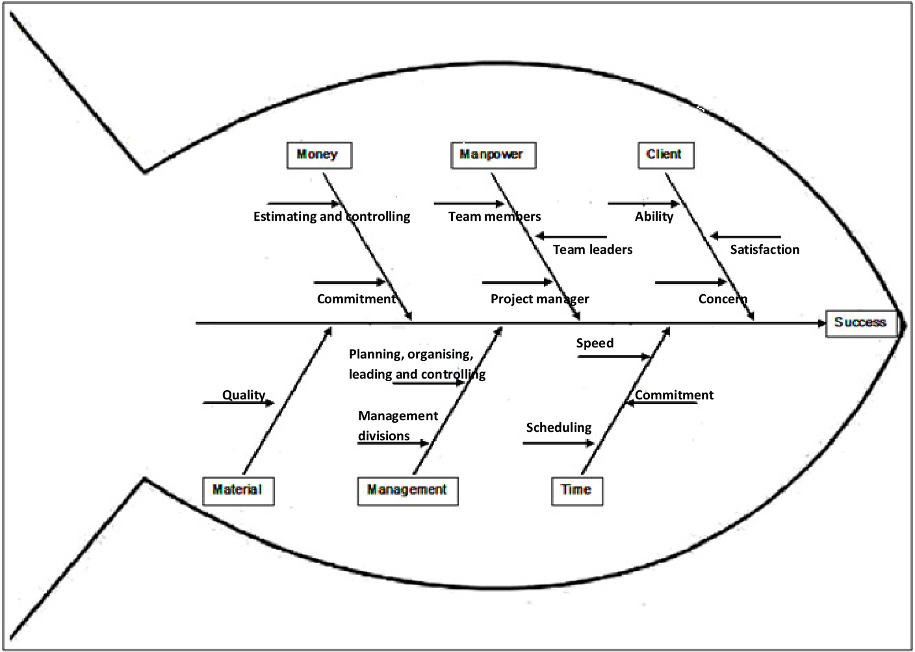
The diagram of Ishikawa’s Quality diagram is commonly compared to a fish for the way the backbone mimics the spine. The horizontal arrow at the centre of the diagram points to the cause of the issue and the arrows which bombard it are the spines that lead to revealing areas of weaknesses that impact the structure of the diagram. It is commonly compared with brainstorming ideas. The reason why this diagram is affective is that it is visual. It is clear to see what is presented as the main problem (i.e. the head of the fish), and the major factors contributing to the problem with performance (i.e. the main bones fixed to the spine) and potential causes (i.e. the additional smaller bones). Ishikawa’s diagram is effective in constructing an argument of cause and effect. It can address a problem and solve a problem. A key pro of using the fishbone diagram is that it organises the problem in a simplified structured way. The drawbacks of applying the fishbone diagram is how it is concerned with ‘root cause analysis’ of cause and effect (Taproot, 2020).
The main problem of the fishbone diagram is how it provides potential hypothesises for cause and effect but draws no concrete answers that can be implemented right away. In addition, there is no guidance in creating the structure of the fish and it depends on what individual is investigating to set up what will be implemented into the diagram. As most managers at are not trained to the capacity to perceive the entire cause of human errors in their business, Ishikawa’s diagram become more a fish based on hunches than anything that is cemented as fact. Any Asda employee using the fishbone diagram to investigate issues concerning in the store often jump to conclusions without properly fact finding and there is no official proof why the bones that are put on the fish are addressed in the first place. The most important negative issues are how Ishikawa’s diagram does not provide definite guidance for how an investigator can fix a problem, instead it falls back to simplified corrective actions of training procedures and discipline.

Taguchi’s Loss Function model

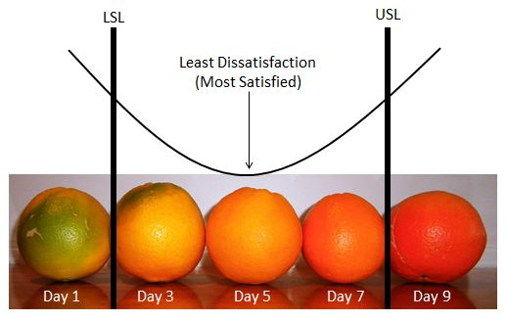
Taguchi’s Loss Function is another quality model that controls success and failure/loss rate. Taguchi’s Loss Function diagram concerns itself with what generates least dissatisfaction and most satisfaction for customers with the goal of satisfying them and keeping them happy. For example, in a Asda store, an example of effectively using the Taguchi Loss Function could be presented as a core customer centric strategy as it aims to win and keep customers by giving them exactly what they want. (Armstrong, et al., 2017) High quality products whose quality and shelf life are marked appropriately. Taguchi provides a Quality model that serves the satisfaction needs of a customer. For example, with a packaged loaf of Asda sliced loaf, there is a target date. This date set limits when the bread can be eaten before it becomes stale, i.e. keeping bread 3 to 7 days sat room temperature. Altering the temperature can stretch the shelf life for a few more days, but any time after that, the bread becomes stale and goes off. Having sell by dates on products is therefore crucial for customers to know what is safe to eat, reduce potential waste and asserts when is the best time to purchase quality based products. After all, there is a time when a product should and shouldn’t be eaten and a preferred time when it is at its best to buy and consume. For example, purchasing and consuming an unripen piece of fruit on Day 1 would bring a customer dissatisfaction. If they were to buy and consume the produce on day 3, there would still be dissatisfaction, as the fruit is not being eaten on it’s ideal date for consumption. Wait too long and the customer will be dissatisfied as the food will be too far past its ideal sell by date for consumption. Although Asda is a supermarket that encourages customers to keep an eye on sell by dates, their sustainability magazine offers monthly tips in freezing products to prolong shelf life, and how to use stale bread for bread crumbs and croutons, and turn unripe green bananas into banana bread.
The concept of Taguchi’s Loss Function model then is an appropriate supermarket aid in gauging how the improvement of quality, and the reduced variation in performance of a product can transfer into reduced cost outcome. Taguchi highlighted in a Manufacturing Processes publication “that no amount of inspection can improve a product; quality must be designed into a product from the start.” (Simpson, et al., 2000). Here, It then reasserts the importance of quality and why it is crucial for Asda to work with suppliers that manufacture high quality products that meet all the needs of their consumers. Another pro of Taguchi’s model is how it can be used to assess and predict economic loss from a deviation in quality.
To conclude, Taguchi’s loss function clearly conveys the fact that quality is not something that declines suddenly nor do private and social costs rise. It can then be assessed that losses to the manufacturer, are ‘a function of the deviance or variability from the target best quality level’ In order for supermarkets like Asda to remain competitive, they will need to trade with high quality products. To accomplish this, Asda has to focus on reducing the variability of their product’s characteristic, keeping what suppliers create for them controlled, managed and fitting the requirements of their consumer’s needs. It then seems appropriate to assert that in order to compete in this competitive business world, all companies should consider applying Taguchi’s Quality Loss Function model in their business strategy.

Conclusion
To close this assignment, quality control exists in all business strategies as to prevent difficulties and problems growing in the business. Quality control serves as a way that can address, reduce, control and contain problems from getting worse from within your business. By employing Taguchi’s Quality Loss Function and Ishikawa’s Quality strategy in a supermarket like Asda, it means cause and effect anomalies and deviations can be reduced, and resolved in a short time frame. The ethical and sustainability polices that Asda employs and asserts into managing their business are crucial for reducing negative environmental impacts in their operations and to provide good selling products and services from respected suppliers.

Recommendations
All throughout the world, large supermarkets like Asda are looking for different ways to enhance their relationship with their consumers regarding asserting their sustainability and maintaining ethical goals. Asda is very well aware that meeting the customer’s needs are extremely important and that dissatisfied customers are unlikely to return. After all, without customers there is no business. Establishing relationships with customers through arranged community champion events, and educating the public how to be more energy efficient and green is key in meeting both the business needs and sustainability objectives. As customers have a high demand for high quality products and services, Ishikawa and Taguchi’s Quality Models are a fantastic for producing products and maintaining services that serve customer needs. Having a positive reputation for asserting sustainability means Asda will always be recognised by customers and investors as caring for the environment, the future for the planet and not just profits.

References
Adams, L., 2017. Three components of business ethics. [Online]
Available at: https://www.succeedinginsmallbusiness.com/three-components-of-business-ethics/
Armstrong, G., Kotler, , P. & Opresnik , M. O., 2017. Marketing: An Introduction. 13th ed. Harlow: Pearson.
ASDA, 2021. Ethics and Compliance Programme. [Online]
Available at: https://www.asda.com/creating-change-for-better/better-business/ethics-and-compliance
[Accessed 24 June 2021].
BBC, 2014. Ethics - introduction to ethics. [Online]
Available at: http://www.bbc.co.uk/ethics/introduction/intro_1.shtml
[Accessed 23 07 2021].
Ethicalconsumer, 2018. Ethical Consumer. [Online]
Available at: https://www.ethicalconsumer.org/company-profile/asda-group-ltd
[Accessed 11 July 2021].
ethicalconsumer, 2021. ethicalconsumer. [Online]
Available at: https://www.ethicalconsumer.org/company-profile/asda-group-ltd
[Accessed 8 July 2021].
Guardian, T., 2017. The Guardian. [Online]
Available at: https://www.theguardian.com/business/2017/jun/26/asda-supermarket-suppliers-walmart-morrisons
[Accessed 25 July 2021].
Investigations, P. I., 2009. Public Interest Investigations. [Online]
Available at: https://powerbase.info/index.php/ASDA_Wal-Mart:_Corporate_Crimes
[Accessed 25 July 2021].
Kotler, P., Armstrong., G., Harris, L. C. & Piercy, N., 2017. Principles of. s.l.:s.n.
Powerbase, 2021. Public interest investigations- Powerbase - Asda. [Online]
Available at: https://powerbase.info/index.php/ASDA_Wal-Mart:_Corporate_Crimes
[Accessed 25 July 2021].
Pryor, M. G. A., White, J. C. J. C. & Toombs, L. A., 1998. Strategic Quality Management. 1 ed. Albany: New York: Thomson Learning.
Simpson, T. W., Wysk, R. A., Niebel, B. W. & Cohen, P. H., 2000. Manufacturing Processes: Integrated Product and Process Design. New York: McGraw Hill.
Taproot, 2020. Taproot. [Online]
Available at: https://www.taproot.com/a-look-at-3-popular-quick-idea-based-root-cause-analysis-techniques-5-whys-fishbone-diagrams-and-brainstorming/
[Accessed 1 July 2021].
WRAP, 2021. The Waste and Resources Action Programme. [Online]
Available at: https://wrap.org.uk/taking-action/food-drink/initiatives/courtauld-commitment
[Accessed 3 July 2021].

