

LCLM4004 Problem Solving and Decision Making
Component 2: Individual Report

Student Name: Sinde Franklin Woppiwo
Student ID: 2414246
Module Leader: Anita Nan

Table of Contents
Introduction 3
Business Problem Overview 4
Proposed Alternative Strategic Solutions 4
Solution A: Developing a Fully Integrated E-Commerce Platform with Digital Marketing 4
Solution B: Strategic Partnership with Local Sustainable Businesses and Event Collaborations 4
Evaluation of the Alternative Solutions Using a PMI Framework 5
Solution A: Integrated E-Commerce and Digital Marketing Strategy 5
Solution B: Strategic Partnerships and Event Collaboration Strategy 6
Critical Comparison and Selection of the Most Appropriate Solution 6
Risk Analysis of the Selected Solution 7
Implementation Plan 8
Monitoring and Measuring Effectiveness 8
Conclusion 10
References 11

Introduction
Green Haven Florists is a small independent retail company based in Norwich, UK, which has seen its performance seriously drop over the last year (Mehta, 2024). The business issue is why the in-store sales have reduced drastically by almost 30 per cent, even on the tail of a slight online growth. Such decline can be explained by changing buying habits, increasing digital rivalry, the escalating price of sustainable materials and a decline in the high-street presence. Even though, sustainability was previously the sole company value proposition, the higher cost of ethical sourcing has adversely affected the profitability. Customer demands are also changing very fast where the need to experience fluidity in online interactions, subscriptions and adaptable delivery systems have become the norm in the floral retail market. This report critically examines the business issue and comes up with two alternative strategic options to deal with the decline. The solutions can be assessed based on a PMI (Plus–Minus–Implication) scale to assess feasibility, risks, and scalability over the long term. After assessment is provided, an implementation plan and monitoring strategy is outlined to facilitate business change that is sustainable.

Business Problem Overview
The losses of Green Haven are based on both external and internal issues. On the outside, there are the consumer shifts towards online platforms that have increased competition. Younger tech-savvy clients adore bouquets that are cheaper, have more options, and can be delivered quickly, so national floral chains offer a better fit. The high street location which was previously a benefit due to its visibility is currently hindering visibility in its limited foot traffic as well as some of the accompanying complementary businesses being closed down. Moreover, the company does not have a strong digital infrastructure, as it has old web features and few delivery services. The marketing is a traditional one, where the word-of-mouth is used and there is no long-term social media strategy (Trusov and Bucklin, 2024). The increasing price of procurement and packaging associated with sustainability ethos cause additional pressure and decrease the price competitiveness. All these interconnected problems are evidence that the business model has not been developed in tandem with the market conditions. Thus, the only way to be competitive and financially viable is strategic repositioning.

Proposed Alternative Strategic Solutions

Solution A: Developing a Fully Integrated E-Commerce Platform with Digital Marketing
The solution includes the redesign of the online presence of Green Haven to include a sophisticated e-commerce platform with the online payment option, built-in bouquet creators, subscription service, live chat support, and online delivery tracking. The improved digital version would be facilitated by a refined social media marketing plan on all channels (Instagram, Facebook, and TikTok) with the emphasis on the visibility of attractive organic and sponsored content to appeal to younger audiences (Felix and Rauschnabel, 2023).

Solution B: Strategic Partnership with Local Sustainable Businesses and Event Collaborations
This solution aims at enhancing the local presence and income by collaborating with the wedding planners, caterers, and hotels, schools, and funeral directors as well as corporate offices. The collaboration model will entail events contracts of supplies, co-branded campaigns, pop-up stores at venues with allies, and cross-promotional advertising (Whipple and Russell, 2023). This is to take advantage of the reputation of the community as it develops streams of recurring revenue that do not rely on the foot traffic every day.

Evaluation of the Alternative Solutions Using a PMI Framework
The PMI (Plus, Minus, Interesting) Framework is a thinking tool created by Edward de Bono to aid people in making ideas or decisions more impartially and creatively (Hemant and Priyamvada, 2024). The application of the PMI framework for solutions 1 and 2 is as follows:
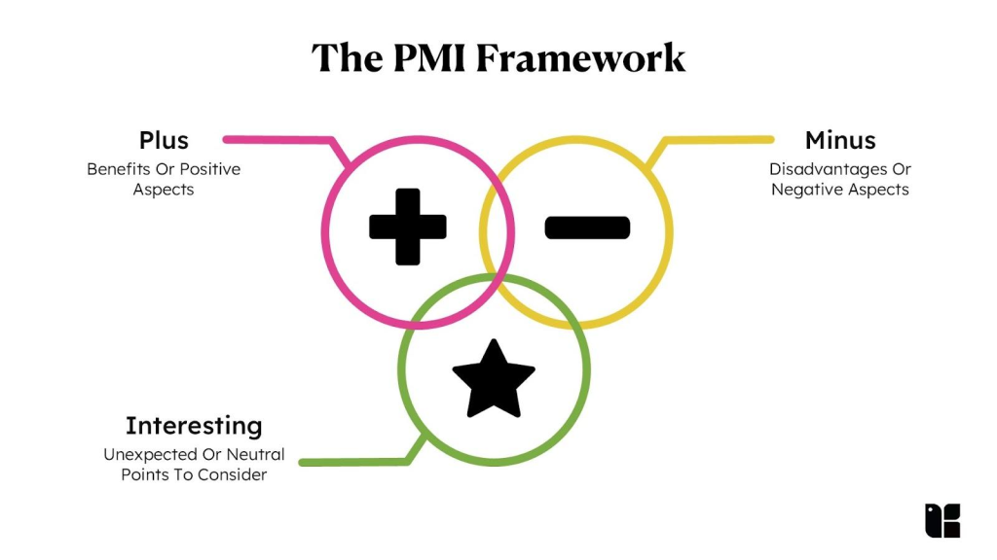
Figure 1: The PMI Framework
Source: (Sahni, 2023)

Solution A: Integrated E-Commerce and Digital Marketing Strategy
Plus | Minus | Interesting
Increases customer convenience and expands market beyond Norwich. | Early costs in web development, delivery logistics and system. | Ability to compete at the industry level and consumer expectations.
The subscription services create a recurrent revenue stream. | The owners need training and more personnel to fill orders. | An increased brand interaction and scalability.
Data analytics can improve consumer-based decision-making. | High dependence on digital may impact the business with cybersecurity and maintenance risks (Saeed and Altamimi, 2023). | The development of digital capability becomes critical in the long term.

Solution B: Strategic Partnerships and Event Collaboration Strategy
Plus | Minus | Interesting
Creates recurrent revenue on corporate/event contracts. | The negotiation concessions involved in partnerships can lower profit margins (Mackintosh, 2022). | Enhances community presence at the expense of scalability.
Enforce sustainability USP using local networks. | The revenue that is based on events is seasonal and may vary. | Helps re-awaken the brand identity without heavy costs of technology.
The common marketing costs and audience. | Risk of dependency in case a significant partner plays out or goes bankrupt. | Increases company loyalty but low popularity with younger online shoppers.

Critical Comparison and Selection of the Most Appropriate Solution
Although both solutions have their chances, the integrated e-commerce and digital marketing change (Solution A) offers more long-term sustainability opportunities. The floral business has been moving towards digital-first concepts where clients anticipate quick browsing and direct price comparison and convenience-based delivery (Faltan, 2023). The solution also fulfils the need of younger demographics and puts Green Haven in line with national competition and creates a wider reach than the local geography. By comparison, the partnership approach solely depends on local networks and seasonal events, which restricts scalability and does not respond to the fundamental cause of sales decline online migration. Besides, Solution A offers practical information in terms of consumer analytics and optimises personalisation of services. Thus, the most suitable solution is the digital transformation strategy.

Risk Analysis of the Selected Solution
The following section will analyse the various risk associated with solution A.

Figure 2: Risks Related with Solution A
Source: (Self-Made)
Operational Risk: The deployment of a sophisticated e-commerce system involves technical skills and can interfere with the current operations (Marri and McGaughey, 2023). In order to overcome this phased implementation and training of the staff will be necessary.
Financial Risk: Short-term financial pressure is subjected to investments in the development of websites, paid digital campaigns, and the infrastructure of delivery. Mitigation includes the phased investment, applying to grant to small digital businesses, and applying to the subscription prepayment model to enhance cash flow.
Cybersecurity and Data Privacy Risk: E-commerce systems are prone to breach of data. The vulnerability will be minimised by ensuring consent to GDPR and the introduction of secure payment gateways.
Reputational Risk: Customers would lose confidence in the company that failed to fulfil promises on same-day delivery (Deokar and Summerfield, 2023). This means that delivery capabilities should not be sold unless they are confirmed to be operational.

Implementation Plan
Phase One: Infrastructure and System Development (Months 1–3)
The project will start by contracting a web development firm to design a responsive site with subscription platform, live tracking, and online catalogue database. Chatbots will be implemented on the customer support to address order questions and troubleshooting (Peters, 2023). The training of the system will be done to staff. The use of existing loyal customers will be as a soft launch exercise.
Phase Two: Introduction of Delivery and Subscription Services (Months 3–6)
It will be a pilot radius-based delivery service service operating in Norwich with gradual expansion. Office flower subscriptions, home flower subscriptions and event subscriptions will be introduced with early adopters getting promotional discounts.
Phase Three: Digital Marketing Execution and Brand Positioning (Months 6–12)
The calendar of the social media marketing will be created in detail. Engagement will be enhanced by user-created content, collaboration with influencers, seasonal promotion, and tutorials (Mehta, 2024). Google and Meta advertisement will focus on the local population, and SEO will increase organic traffic. The new sustainability communications will be repositioned as a value proposition of considered gifting with less impact on the environment.

Monitoring and Measuring Effectiveness
Measures of the effectiveness of the solution will be done based on quantitative and qualitative Key Performance Indicators:
- Sales and Online Metrics: The online volume, rate of sales, average order value, frequency of repeat orders, and subscription will be monitored monthly (Pauwels and Weiss, 2022). The analytics of the web sites will give the insights on the traffic, the bounces, and the trends of the consumer behaviour.
- Customer Engagement: Digital visibility and interest will be reported by the increase in followers, the rate of interaction with customers, and the rate at which a campaign is clicked through (Mehta, 2024). Further enhancement will be informed by customer satisfaction surveys and post purchase feedback.
- Financial Performance: Quarterly review of gross profit margins, cost of acquisition, and the digital ads spending will be reviewed to assess financial operation sustainability.
- Operational Efficiency: The accuracy of delivery, the delivery times and the uptime of the system will be evaluated to be reliable.

Conclusion
Green Haven Florists is operating in a complicated business environment that has been influenced by shifting consumer behaviour, rising overhead expenses and aggression in digital rivalry. A strategic change is needed in order to be viable. Having considered the two possible solutions, a fully integrated e-commerce solution together with a planned digital marketing would represent the most feasible step to reverse falling sales and rebrand the brand towards sustainable growth. This solution is in line with the changing market demands, scalability and the good sustainability ethos in Green Haven. Risk reduction and effective performance tracking via staged implementation will help the business to become resilient and regain competitive edge in the floral retail market.

References
Deokar, A. and Summerfield, N. (2023). The role of commitment in online reputation systems: An empirical study of express delivery promise in an E-commerce platform. Decision Support Systems, [online] 176(5), p.114061. doi:https://doi.org/10.1016/j.dss.2023.114061.
Faltan, B. (2023). Marketing Tactics to Increase Millennial Floral Purchases. [online] Available at: https://floralmarketingfund.org/wp-content/uploads/2017/01/FMRF_MarketingMillennialsReport.pdf [Accessed 10 Dec. 2025].
Felix, R. and Rauschnabel, P.A. (2023). Elements of Strategic Social Media marketing: a Holistic Framework. Journal of Business Research, [online] 70(1), pp.118–126. doi:https://doi.org/10.1016/j.jbusres.2016.05.001.
Hemant, L. and Priyamvada, S. (2024). PMI (Plus-Minus-Interesting): An Attention- Directed Strategy for Enhancing Creative Thinking Among Elementary School Students. SSRN Electronic Journal, [online] 5(4). Available at: https://pdfs.semanticscholar.org/2ec5/b9a7533142ab6b3224f5e5119d921ea0705b.pdf [Accessed 10 Dec. 2025].
Mackintosh, M. (2022). Partnership: Issues of policy and negotiation. Local Economy: The Journal of the Local Economy Policy Unit, 7(3), pp.210–224. doi:https://doi.org/10.1080/02690949208726149.
Marri, H.B. and McGaughey, R.E. (2023). E-commerce and its impact on operations management. International Journal of Production Economics, 75(1-2), pp.185–197. doi:https://doi.org/10.1016/s0925-5273(01)00191-8.
Mehta, T. (2024). Revitalizing Green Haven Florists: Strategies for Survival and Growth. [online] prezi.com. Available at: https://prezi.com/p/cid94g7ccp8b/revitalizing-green-haven-florists-strategies-for-survival-and-growth/ [Accessed 10 Dec. 2025].
Pauwels, K. and Weiss, A. (2022). Moving from Free to Fee: How Online Firms Market to Change Their Business Model Successfully. Journal of Marketing, 72(3), pp.14–31. doi:https://doi.org/10.1509/jmkg.72.3.014.
Peters, F. (2023). Design and implementation of a chatbot in the context of customer support. MatheO - Master Thesis Online, [online] 3(2). doi:http://hdl.handle.net/2268.2/4625.
Saeed, S. and Altamimi, S.A. (2023). Digital Transformation and Cybersecurity Challenges for Businesses Resilience: Issues and Recommendations. Sensors, 23(15). doi:https://doi.org/10.3390/s23156666.
Sahni, A. (2023). Critical Thinking Skills Examples | Real-World Applications & Scenarios. [online] Kapable Blog. Available at: https://kapable.club/blog/critical-thinking/critical-thinking-skills-examples/ [Accessed 1 Dec. 2025].
Trusov, M. and Bucklin, R.E. (2024). Effects of Word-of-Mouth versus Traditional Marketing: Findings from an Internet Social Networking Site. Journal of Marketing, 73(5), pp.90–102. doi:https://doi.org/10.1509/jmkg.73.5.90.
Whipple, J.M. and Russell, D. (2023). Building supply chain collaboration: a typology of collaborative approaches. The International Journal of Logistics Management, 18(2), pp.174–196. doi:https://doi.org/10.1108/09574090710816922.

