

Student Name: Asfiyabanu Muntasibahemad Malek
Student ID: 2521746

Module Name: Marketing Management
Module Code: LCMB7024

Lecturer’s Name: Laila Maazouz

Word Count: 2586

Term 1

Table of Contents
1. Introduction 3
2. Industry Overview – Social Media Industry 4
3. Pioneer Company – Facebook (Meta) 5
4. Follower Company – TikTok 6
5. Macro Environment Analysis – Technological and Legal Factors 8
5.1 Technological Factors 8
5.2 Legal and Regulatory Factors 9
6. Impact on Competitive Position 10
7. Strategic Responses of Facebook (Meta) and TikTok 11
8. Porter’s Generic Strategies 11
9. Ansoff Growth Matrix 12
10. Conclusion 13
11. References 14

List of Figures
Figure 1: Social Media Market Report 2026 4
Figure 2: Annual revenue generated by Meta Platforms from 2009 to 2025 6
Figure 3: Social app active users 2024 (bn) 7

1. Introduction
Marketing environment refers to the internal and external factors that affect the marketing decisions, marketing strategies, and performance of an organisation (Erdi and Bambang, 2021). The macro marketing environment is more important since it includes broader forces like technological, legal, economic, social, political and environmental forces that organisations have no power to control, but are forced to respond to the environment in a strategically meaningful way. The macro environment is significant in understanding the opportunities available to organisations, the threats, and maintaining a competitive advantage in the market.
According to Salam et al. (2025), the social media business has turned out to be very competitive and technologically oriented in the modern digital market, and as a result, companies should constantly update their marketing methods. In this industry, organisations may be pioneers or followers, with the pioneer organisations launching innovative platforms and innovations and the followers advancing the existing ones and competing with new functions and approaches. For example, Facebook (Meta Platforms) can be viewed as a leading organisation in terms of social networking, and TikTok is one of those followers that achieved a swift growth with the help of short-form videos and advanced algorithms.

This report is a critical analysis of the macro marketing environment of the two companies and an evaluation of their strategic response based on models like the PESTLE Analysis, Porter's generic strategies, and the Ansoff Growth Matrix to appreciate how both companies retain a competitive advantage.

2. Industry Overview – Social Media Industry
Technological development, increased internet access, and the popularity of smartphones have led to a rapid increase in the social media industry (AL-Zoubi, 2023). The social media sites are no longer merely communication media but have now emerged as major digital marketing and advertising platforms where companies advertise their products, socialise with their customers, and create brand awareness. Digital advertising, user-generated content, artificial intelligence algorithms, and data analytics define the industry to a large extent.
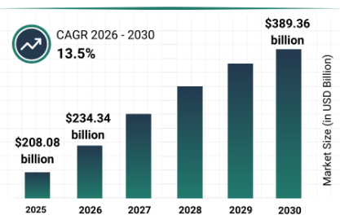
Figure 1: Social Media Market Report 2026
(Source: The Business Research Company, 2026)
Figure 1 shows the expected growth of the social media market from 2025 to 2030. The market size is projected to increase from approximately $208 billion in 2025 to about $389 billion by 2030, with a compound annual growth rate (CAGR) of 13.5%. This steady increase indicates that the social media industry is expanding rapidly due to digital transformation, online advertising growth, and increasing user engagement on social media platforms.

3. Pioneer Company – Facebook (Meta)
The former Facebook, under its current Meta Platforms label, is regarded as an innovative company in the social media sector (Meta, 2026). The company was established in 2004, and it became the first major social networking giant in the world that connected people worldwide through online profiles, messaging and sharing of content over the internet. The company continued to grow its platform ecosystem with the acquisition of Instagram and WhatsApp that enhanced its position in the market and its users worldwide. The business model of Meta mostly depends on the digital advertisement revenue, where companies pay to access displayed ads to the specific user by using data analytics and user behaviour insights.

Figure 2 above shows the revenue growth of Facebook (Meta) from 2009 to 2025, which demonstrates significant business expansion over time. The company’s revenue increased from less than $1 billion in 2009 to over $200 billion by 2025, showing continuous growth in digital advertising and social media usage (Thuy, 2026). This growth reflects the company’s strong market leadership, large user base, and effective advertising model.

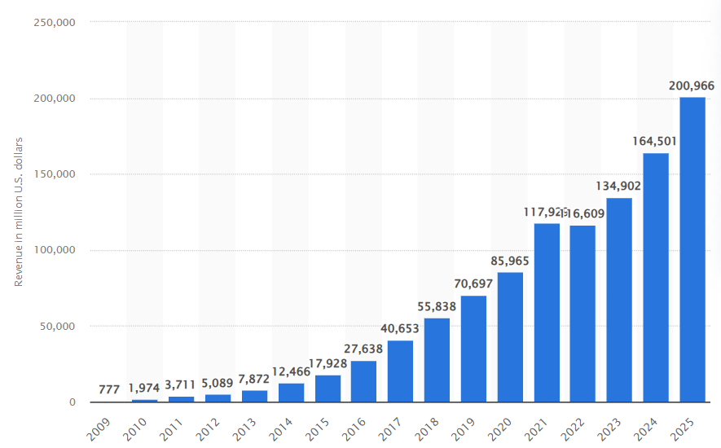
Figure 2: Annual revenue generated by Meta Platforms from 2009 to 2025
(Source: Thuy, 2026)
Meta is a pioneer due to its implementation of large-scale social networking, digital advertising platforms, and opportunities for social media marketing to businesses (Parada, 2022). The global user base, features of good data analytics, and platform-based ecosystem consisting of Facebook, Instagram, and WhatsApp are the means to grant the company its competitive advantage. These have contributed to Meta's continued leadership in the social media market as other new platforms like TikTok continue to gain traction.

4. Follower Company – TikTok
TikTok is arguably a follower organisation in the social media business, as it ventured into the market when the market had already been dominated by older platforms like Facebook and Instagram. The Tik Tok was created by the company ByteDance in 2016 and immediately became popular worldwide with its short-video content and very sophisticated content-recommendation algorithm system (Xing, 2023). TikTok focuses on entertainment, creativity, and personalised content, which has helped the platform grow rapidly.

The data in the attached chart shows social media active users in 2024. Facebook has the highest number of users at around 3 billion users, followed by Instagram and WhatsApp with nearly 2.5 to 3 billion users (Curry, 2026). TikTok has approximately 1.7 billion active users, which shows that although it is a follower, it has grown very quickly and become one of the largest social media platforms in the world in a short time. This rapid growth shows TikTok’s strong competitive position in the market.
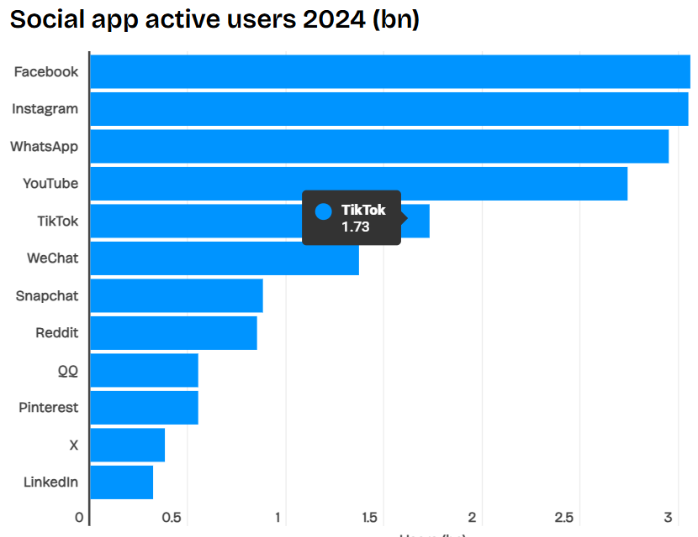
Figure 3: Social app active users 2024 (bn)
(Source: Curry, 2026)
The unfair competitive edge that TikTok has is its artificial intelligence algorithm, feed of personalised content, and the short video format that appeals to younger audiences and content creators. The strategy of the company is in the areas of innovation, user engagement, and global expansion. Thus, although TikTok is a follower in the social media industryit has disrupted the market and emerged as a strong competitor with the platforms of Facebook and Instagram owned by Meta.

5. Macro Environment Analysis – Technological and Legal Factors

5.1 Technological Factors
One of the macro-environmental forces that has the most significant impact on the social media industry is the technological factors. Artificial intelligence, data analytics, mobile technology, and video content technology change the functioning and competitiveness of social media platforms significantly because of their rapid evolution (Nasser El Erafy, 2023). Meta Platforms and TikTok are both applications that are based on highly advanced technology to enhance the user experience, advertisement targeting, and user engagement.
The technological factors that are of interest are artificial intelligence and content recommendation systems that are based on algorithms. The application of TikTok is based on an extremely developed AI algorithm, which suggests personalised short-length videos to users depending on their behavioural patterns, interests, and engagement (Amir Hamzah et al., 2025). This technology has contributed to TikTok expanding within a short period of time and gaining younger audiences. Meta responded by releasing similar functionalities like Instagram Reels and AI-based content suggestions to fight TikTok (Hou et al., 2025). This demonstrates that the social media companies are being presented with opportunities and threats by technological changes.
Another vital aspect is the mobile technology since the majority of users utilise social media via smartphones (Saprikis and Avlogiaris, 2021). Increasing the speed of mobile internet, video streaming technology, and mobile application have helped to grow the popularity of short-form video content. This trend was of great benefit to TikTok because its application can only be used to access mobile video content. Meta also changed its approach to pay more attention to mobile apps and video products on Facebook and Instagram.
Revenue generation is also significant because of data analytics and digital advertising technology (Haidar, 2025). Meta relies on the data and analytics of users to deliver targeted advertising as the primary revenue-generating activity. TikTok has also built its advertisement platform based on data analytics and AI technology. Thus, technological aspects have made both companies more competitive and compelled them to constantly innovate to retain their competitive status.

5.2 Legal and Regulatory Factors
The other significant aspect of the macro marketing environment that has an impact on social media companies is legal and regulatory. World governments are also enacting more laws regarding data privacy, user privacy, online advertising, and content rights on platforms (Celestin, 2024). These policies pose issues and threats to social media corporations.
The General Data Protection Regulation (GDPR) on data privacy in Europe has compelled businesses like Meta to alter their approach to collecting and utilising user information to facilitate advertising (Wodi, 2023). Meta has suffered a number of legal issues and penalties in data privacy and user information protection, and this has impacted its image and its operations. Conversely, TikTok has also not escaped legal cases, especially in states like the United States and India, where issues of data security and privacy of users have been raised. In certain nations, TikTok has even been banned and harshly regulated.
According to Galli et al. (2022), both companies are also impacted by the advertising laws and regulations on content moderation since they have to control the content, safeguard the user information and comply with the government laws. This makes the operation more expensive and puts more pressure on social media companies in terms of regulation. Organizations which can adapt to the law regulations more competently can sustain their market and competitive position.
It has been critically analysed that technological and legal factors have been identified as the most influential macro-environmental forces influencing Meta and TikTok. Technology brings innovation and growth opportunities, whereas legal regulations present challenges which companies have to cope with through strategic reactions and changes in policies.

6. Impact on Competitive Position
The competitive standing of Meta Platforms (Facebook) and Tik Tok at the social media industry have been greatly affected by the macro environmental factors, especially the technological and legal factors. These forces have transformed the way the two companies are competing based on the user, content, advertisement and market expansion.
Over the last few years, technological advances, particularly artificial intelligence and short-form video technology, have contributed to the rapid growth of TikTok in comparison to Facebook (Lynch, 2025). The content recommendation system on TikTok is a highly personalised algorithm, and it offers people highly personalised content, leading to high user engagement and time consumption on the platform. Such innovation propelled TikTok to gain a large user base among young people and content creators within a short period of time, enhancing its competitiveness. Meta launched Instagram Reels and enhanced its AI-based content recommendation systems to compete in the short video format in the same way as TikTok.
Both companies have also been influenced in their competitive position by legal and regulatory factors. Data privacy, advertising laws, and privacy of user data have presented more legal issues to Meta, particularly in Europe and the United States (Frichot, 2025). Such rules raised the operational expenses of Meta and restricted its data application in targeted advertising. Conversely, data security concerns have posed a threat to TikTok by exposing the Chinese-based company to regulatory pressure and even bans in certain countries, thus bringing uncertainty about growth in the global context.
The user engagement, market share and the advertising revenue also form competition between the two companies. TikTok is more of a platform for entertainment and short video content, whereas Meta is more of a social networking platform and digital advertisement that can be accessed on various platforms, including Facebook and Instagram (Dzreke, 2025). Macro environmental factors have augmented rivalry between Meta and TikTok, where both corporations have to keep innovating and altering their strategies to remain afloat in the social media market.

7. Strategic Responses of Facebook (Meta) and TikTok
Meta Platforms and TikTok have adopted numerous strategic reactions to cope with the changes in the macro environment in response to technological progress and legal provisions. These are strategic reactions to ensure the competitive advantage and growth are maintained in the social media industry, which is very competitive.
In response to technological shifts and growing competition with TikTok, Meta launched new features, including Instagram Reels, which directly compete with Tik Toks content, which is a short-form video (Hou et al., 2025). The firm has also invested a lot in artificial intelligence, data analytics, and the metaverse to develop new digital experiences and future growth opportunities. To ensure that its privacy policies and data protection practices were aligned with the legal requirements of its operations, including the data privacy laws and digital advertising regulations, Meta has changed its privacy policies and data protection practices. Another strategy that Meta changed was the advertising philosophy through enhancing targeted advertising and launching new advertising tools for the business.
Innovation, entering the global market and diversification of the platform helped TikTok to respond to the macro environmental changes. TikTok is constantly refining its algorithm to deliver personalised content and engage users. The firm moved to international market to grow its global users and competitiveness. New monetisation sources were created due to TikTok, including TikTok Ads, TikTok Shop and creator monetisation programmes, which enabled businesses and content creators to make money using the app (Zhou, 2025).
Comparatively, Meta is platform integration, advertising and technological innovation oriented, whereas TikTok is content innovation, user engagement, and platform expansion oriented. In their bid to retain their market position and competitive edge in the social media business, the two companies have adjusted their strategies to the technological and legal changes.

8. Porter’s Generic Strategies
The Generic Strategies of Porter define how firms gain a competitive advantage due to cost leadership, differentiation, or focus strategies. Differentiation is the primary competitive strategy applied by both Meta Platforms and TikTok in the social media industry. They vary slightly in the methods of differentiation depending on the models of business as well as the target markets.
Company | Porter Strategy | Explanation
Meta (Facebook) | Differentiation | Meta focuses on differentiation by offering multiple platforms such as Facebook, Instagram, and WhatsApp, advanced advertising tools, data analytics, and integrated social networking services (Sulkala, 2023).
TikTok | Differentiation Focus | TikTok uses a differentiation focus by specialising in short-form video content, AI-based personalised content, and targeting younger audiences and content creators.
Platform ecosystem, advertising technology and global user base help in differentiating between Meta and TikTok and innovations, short video content and user engagement help in differentiating between TikTok and Meta. These measures serve to enable the two companies to enjoy a competitive edge and good market positions in the social media market.

9. Ansoff Growth Matrix
Ansoff Growth Matrix describes the growth of companies by penetrating the market, developing products, developing the market and diversification. Meta Platforms and TikTok have different growth strategies to enhance their market share and competitive edge in the social media market.
Company | Ansoff Strategy | Explanation
Meta (Facebook) | Product Development | Meta introduced new features such as Instagram Reels, AI tools, and the Metaverse to attract existing users and compete with TikTok (Hou et al., 2025).
TikTok | Market Development & Product Development | TikTok expanded into new international markets and introduced new features such as TikTok Shop, Ads platform, and creator monetisation tools (Zaidi, 2024).
These strategies help both companies achieve growth, increase users, and strengthen their competitive position in the market.

10. Conclusion
The study above has concluded that the competitive position of Meta Platforms and TikTok in the social media industry is strongly influenced by the macro marketing environment, especially technological and legal factors. The technological innovations like artificial intelligence, mobile applications and short video content have heightened competition between the two companies. Their business operations and strategies are also affected by legal and regulatory aspects associated with data privacy and digital advertising. Product development, market expansion and platform innovation are some of the strategic responses that have been adopted by the two companies in order to sustain their competitive advantage. On the whole, innovation, adoption of technology, and strategic adaptation are necessary to maintain the growth and competitiveness in the social media industry.

11. References
AL-Zoubi, A., 2023, May. Digital technology and changes in media consumption: a case study of smartphone and app usage. In International Conference on Business and Technology (pp. 433-444). Cham: Springer Nature Switzerland.
Amir Hamzah, S.K., Abdul Aziz, A. and Mohamed, S., 2025. Behavioural influence of TikTok’s algorithm recommendations on users’ engagement and users’ self-persuasion. ESTEEM Journal of Social Sciences and Humanities, 9(1), pp.144-162.
Celestin, P., 2024. How Emerging Data Protection Laws Are Reshaping Digital Marketing and Consumer Privacy Policies.
Curry, D., 2026. Social App Revenue and Usage Statistics (2026). [online] available at https://www.businessofapps.com/data/social-app-market/
Dzreke, S.S., 2025. Beyond impressions: A multi-platform analysis of social media advertising effectiveness in driving sales and engagement. International Journal for Research in Applied Science and Engineering Technology.
Erdi, H. and Bambang, R., 2021. The influence of the external and internal business environment on the marketing strategy and their impact on the marketing performance. European Journal of Business and Management, 13(7), pp.54-61.
Frichot, E., 2025. Exploring the Ethical and Legal Dimensions of Data Collection: A Case Study of Meta Platform.
Galli, F., Loreggia, A. and Sartor, G., 2022, May. The regulation of content moderation. In International conference on the legal challenges of the fourth industrial revolution (pp. 63-87). Cham: Springer International Publishing.
Haidar, A., 2025. Digital Business Transformation in Advertising: Effects on E-services Revenue. FinTech and Sustainable Innovation, pp.1-10.
Hou, Y., Zhang, Y. and Zhu, Y., 2025. The TikTok miracle: cracking the code of TikTok’s platform strategy. Strategy & Leadership, 53(5), pp.557-566.
Huang, J., 2025. Optimization and Innovation of AI-Based E-Commerce Platform Recommendation System. Journal of Computer, Signal, and System Research, 2(6), pp.66-73.
Lynch, A.N., 2025. Decoding the Algorithm: The Mathematics Behind TikTok’s Short-Form Content Success.
Meta, 2026. Our mission. [online] available at https://www.meta.com/en-gb/about/company-info/?srsltid=AfmBOopSLUtt9kHFVhnbZgMwtkgmNCxLLc2WfLE7F2eEWD-OsOHaNO8x
Nasser El Erafy, A., 2023. Applications of Artificial Intelligence in the field of media. International Journal of Artificial Intelligence and Emerging Technology, 6(2), pp.19-41.
Parada, J.V., 2022. The importance of the present for future success: Analysis and strategic proposals for improving Meta's brand image.
Salam, K.N., Aslim, S., Palinggi, P.P.H., Marsela, I. and Megawaty, M., 2025. Analysis of Effective Marketing Strategies in Facing Tight Competition in the Marketplace Global. Paradoks: Jurnal Ilmu Ekonomi, 8(2), pp.525-539.
Saprikis, V. and Avlogiaris, G., 2021. Factors that determine the adoption intention of direct mobile purchases through social media apps. Information, 12(11), p.449.
Sulkala, K., 2023. Improving social media marketing in Meta platforms by developing an industry-independent tool: A research-based development study for a digital advertising agency.
The Business Research Company, 2026. Social Media Report 2026. [Online] available at https://www.thebusinessresearchcompany.com/report/social-media-global-market-report
Thuy, D., 2026. Annual revenue generated by Meta Platforms from 2009 to 2025. [Online] Available at https://www.statista.com/statistics/268604/annual-revenue-of-facebook/?srsltid=AfmBOoqsUEkNNAzNDDTa-vIjxeaX3D7wZG7BBwQc3bSGnrOO3VjAjv_s
Wodi, A., 2023. The EU General Data Protection Regulation (GDPR): Five years after and the future of data privacy protection in review. GDPR: Five Years After and the Future of Data Privacy Protection in Review (July-Oct. 2023).
XING, G., 2023. Study on the Marketing Strategy of ByteDance Company in the Internet Industry-Taking TikTok as an Example. Siam University.
Zaidi, U., 2024. Rise of Internet Platform Economy: Case Study of TikTok in the Metaverse. AIMS International Journal of Management, 18(3).
Zhou, Y., 2025, August. Research on the Strategy of Realizing Revenue Under the Business Model of Short Video Platform--Taking TikTok as an Example. In Proceedings of the 2025 5th International Conference on Enterprise Management and Economic Development (ICEMED 2025) (p. 373). Springer Nature.

