Is the external challenge a good or a bad?
Analyse the impacts of the external environment on employee recruitment and retention

Personnel Resourcing and Development
BMIH5005
Helen Lee

Dana Bagy - 2208667
Executive Summary
This report provides an in-depth analysis of the recruitment and retention difficulties encountered by Intercontinental Hotels Group (IHG), a prominent player in the worldwide hospitality sector. This study examines the impact of external and internal factors on IHG's workforce dynamics. These factors include political decisions such as Brexit, economic fluctuations, social trends, technological advancements, legal considerations, and environmental sustainability.
The PESTLE analysis illustrates the influence of these factors on IHG's recruitment and retention strategies. Political factors, notably Brexit, have influenced the talent pool in the UK, while economic changes, including those resulting from the COVID-19 pandemic, have impacted staffing needs and operational expenses. Social changes, such as the increasing number of retired people and changing expectations regarding work-life balance, require HR policies that can adapt to these shifts. Technological integration necessitates a proficient workforce and adherence to regulations and sustainability practices.
The SWOT analysis of IHG highlights strengths such as its strong global brand reputation and employee development programmes. However, it also identifies weaknesses such as dependence on a diverse, transient workforce and digital skills gaps. Opportunities arise from technology utilisation and flexible work arrangements, while threats stem from labour market competition and rapid technological advancements.
The report examines IHG's strategies regarding current industry trends, highlighting areas of agreement and required adjustments. The suggestion is for IHG to improve its competitive advantage through employee engagement, innovative recruitment strategies, technology integration, diversity and inclusion, and sustainable practices while taking inspiration from successful examples in the industry.
The report emphasises the importance of IHG's ongoing adjustment of recruitment and retention strategies in light of these changing factors. Recommendations encompass employee development expansion, innovative recruitment strategies adoption, advanced technology integration, diversity and inclusion policy enhancement, and increased commitment to sustainability.

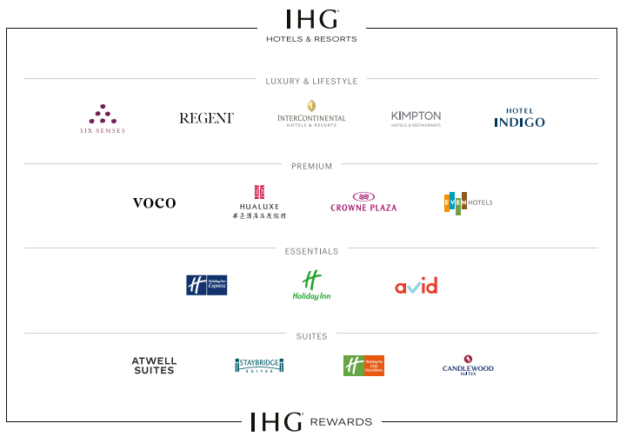

Table of Contents
- Introduction and Background…………………………………………….…4
- PESTLE Analysis: Impact on Recruitment and Retention…………….…5
- SWOT Analysis: Intercontinental Hotels Group………………………...…7
- Potential Solutions and Industry Examples………………………..………9
- Evaluation and Conclusion…………………………………………………12
- Recommendations……………………………………………………….….14
- References…………………………………………………………….……..15

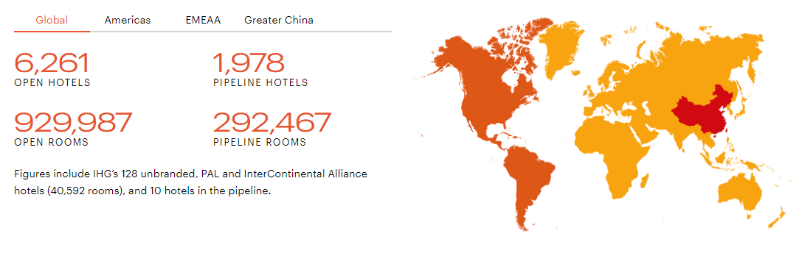Introduction and Background

Intercontinental Hotels Group (IHG) has become a model of luxury and service excellence in the fast-paced and competitive hotel industry. Intercontinental Hotels has a global presence on multiple continents, combining cultural respect and contemporary elegance to serve a diverse range of guests. IHG, along with other players in the hospitality industry, faces the complex problems of employee recruitment and retention despite its outward appearance of flawless service and luxury.
Moreover, the industry is on the verge of a technological revolution due to the emergence of Artificial Intelligence (AI) and digital innovations. The progress made in improving efficiency and customer experience poses a distinct challenge in integrating and adapting the workforce to these new technologies. The phenomenon known as the 'retirement tide' refers to the departure of experienced professionals from the workforce, which contributes to a shortage of skilled individuals.
Recruitment is complex due to the existing socio-economic conditions. Brexit's consequences have resulted in a constrained labour market, particularly in the UK, where a substantial portion of IHG's employees are located. The reduced number of available candidates has made the task of finding suitable employees increasingly difficult.
This report examines the impact of external challenges on employee recruitment and retention at IHG, including the pandemic aftermath, technological advancements, retirement tide, and socio-economic shifts. This study examines the potential strategies IHG could employ to effectively address these challenges, maintaining its reputation for excellence while adapting to evolving demands in the hospitality sector.
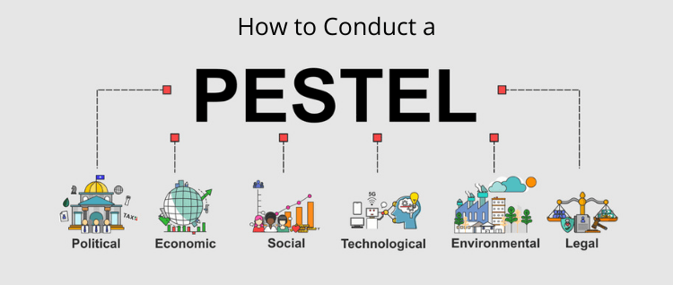PESTLE Analysis: Impact on Recruitment and Retention at
Intercontinental Hotels Group

Political Factors
According to López-Andreu, Papadopolous, and Jamalian (2019), Brexit has had a notable impact on the hospitality industry, specifically in the United Kingdom where a substantial number of Intercontinental Hotels Group's establishments are situated. The recent alterations in immigration policies have limited the influx of skilled individuals from the European Union, which has historically been a significant supplier of workforce for various industries. Boella and Goss-Turner (2019) argue that this has resulted in a shortage of skilled labour, making it more challenging to recruit employees and intensifying competition for local talent. International political climates impact cross-border travel, which in turn affects guest numbers and staffing requirements.

Economic Factors
The global economy significantly influences IHG's recruitment and retention strategies. Economic downturns, like the one caused by the COVID-19 pandemic, result in decreased travel and lower hotel occupancy rates, affecting revenue and subsequently, workforce management. Economic growth can increase the need for employees (Fernandes, 2021). Inflation impacts operational costs, such as wages, which affects the appeal of the hospitality industry to potential employees (Berhane, 2021).
Social Factors

Vetráková, Šimočková, and Pompurová (2019) state that the retirement of experienced professionals from the workforce has both positive and negative consequences. Although it creates job opportunities, it also leads to the departure of experienced professionals, requiring the hiring of younger and less experienced employees. IHG must adapt its HR policies to attract and retain talent, particularly among younger generations, in response to changing work-life balance expectations.
Technological Factors

According to Štilić, Nicić, and Puška (2023), the hospitality industry is being transformed by the incorporation of artificial intelligence (AI) and digital technologies. IHG must invest in technology and train staff to effectively utilise these tools, which will influence their recruitment and retention strategies. As stated by Kim et al. (2011), technological advancements can improve operational efficiency, but they also require a workforce that is proficient in using these technologies.
Legal factors refer to the various laws, regulations, and legal frameworks that impact businesses and organisations. These factors include legislation related to labour, and employment.
Legal Factors

Employment laws and regulations have a significant impact on IHG's recruitment and retention policies, as they differ across countries. Adhering to labour laws, health and safety regulations, and fair employment practises is crucial for upholding a lawful and ethical workplace, which in turn impacts the reputation and attractiveness of the brand to prospective employees (Boella & Goss-Turner, 2019).

Environmental Factors
Environmental sustainability is a growing concern in the hospitality sector, as stated by TULSI and JI (2020). IHG's dedication to sustainable practises influences operational choices and also appeals to environmentally aware employees, influencing recruitment and retention. Promoting green initiatives can improve a brand's attractiveness to a workforce that is increasingly focused on environmental responsibility.

SWOT Analysis: Intercontinental Hotels Group

Strengths: IHG's global brand reputation is a valuable asset in attracting top talent (Hospitality On, 2023). The group's dedication to employee development and training programmes strengthens its appeal as an employer. Nelissen, Forrier, and Verbruggen (2017) find that these programmes have a dual effect of improving skills and promoting loyalty while also decreasing turnover. IHG's wide range of properties provides employees with distinctive career growth and internal transfer prospects, contributing to effective recruitment and retention efforts. The group's focus on diversity and inclusion makes it more appealing as an employer, appealing to a wide range of potential employees (IGH, 2016).


Weaknesses: IHG encounters workforce management challenges despite its strengths. Codling et al. (2022) found that the hospitality industry's reliance on a diverse and transient workforce can result in service quality inconsistencies. Moreover, the hospitality industry's historically extensive working hours and challenging demands often lead to elevated rates of staff turnover. Another concern is the possibility of a skills gap in digital proficiency among employees, which might hinder the successful integration of new technologies and improvements in operational effectiveness (Kim, et al., 2011).


Opportunities: The dynamic technology landscape and changing guest expectations offer IHG substantial opportunities. According to Garavan et al. (2021), implementing digital training and development programmes can enhance operational efficiency and increase IHG's appeal as an employer for technologically skilled individuals. There is potential to benefit from the growing popularity of remote work and flexible scheduling, attracting a wider pool of candidates, including those desiring improved work-life equilibrium. Moreover, IHG can utilise its extensive global reach to provide international career prospects, attracting ambitious individuals who desire worldwide experience.

Threats: IHG faces external challenges in recruitment and retention due to heightened competition for skilled labour in the hospitality industry. The post-COVID-19 recovery of the industry has resulted in increased demand for experienced personnel, leading to increased competition (Fernandes, 2021). Political and economic uncertainties, like those caused by Brexit or global economic downturns, can affect the stability and availability of the workforce (López-Andreu, Papadopolous, and Jamalian, 2019). Rapid technological advancements have both benefits and risks, particularly if the workforce lacks sufficient training to adapt, which may result in a skills gap (Kim, et al., 2011).

Potential Solutions and Industry Examples
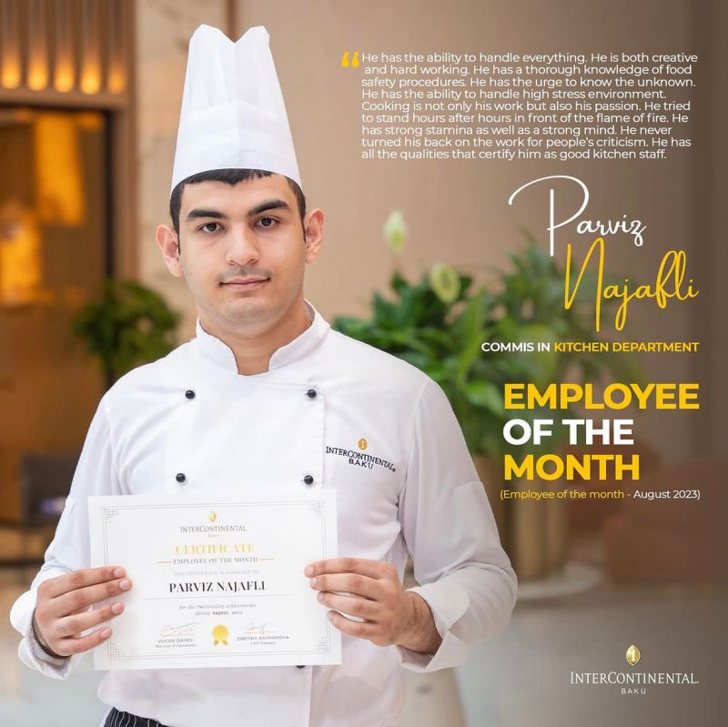
The challenges of recruitment and retention in the hospitality industry, particularly at Intercontinental Hotels Group (IHG), can be addressed through various potential solutions, which are supported by successful examples from other companies in the industry.
Enhanced Employee Engagement and Development: Investing in employee engagement and development programmes is crucial. Marriott International has effectively reduced turnover rates through its comprehensive training and development programmes (Boella & Goss-Turner, 2019). IHG could expand its training programmes to include both skill enhancement and personal and career development, leading to improved job satisfaction and employee retention.
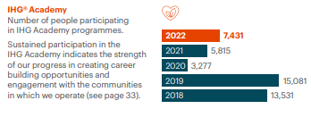
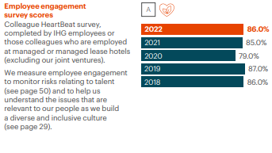
Innovative Recruitment Strategies: IHG could address recruitment challenges by implementing innovative strategies such as Hilton's "Work from Home" programme (Fachada, 2023). The program's inclusion of remote working options for specific positions broadened the pool of potential candidates, resulting in increased diversity among applicants. This inclusivity particularly appealed to individuals with caregiving responsibilities or residing in remote locations.
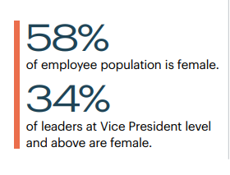
Leveraging Technology for Efficiency and Attraction: Technology has the potential to be both beneficial and detrimental. However, when employed judiciously, it can enhance efficiency and improve job satisfaction by reducing workload. AccorHotels has successfully incorporated artificial intelligence (AI) and digital tools in guest services and operational processes, resulting in decreased workload and increased appeal to technologically proficient individuals (Abass, 2023). IHG could adopt advanced technologies to enhance efficiency and appeal to a tech-savvy, younger workforce.
Focus on Diversity and Inclusion: IHG should enhance its diversity and inclusion efforts, taking guidance from Hyatt's esteemed policies in this domain. Hyatt's emphasis on fostering inclusivity has bolstered its employer brand, attracting a more diverse pool of job applicants (Kilson, 2022). IHG should improve its policies to promote inclusivity across all levels and locations.

Scandic Hotels in Scandinavia has effectively integrated sustainability into its operations, appealing to environmentally conscious employees and guests (Bohdanowicz, Simanic, & Martinac, 2005). IHG's enhanced dedication to sustainability can enhance its attractiveness as an employer.
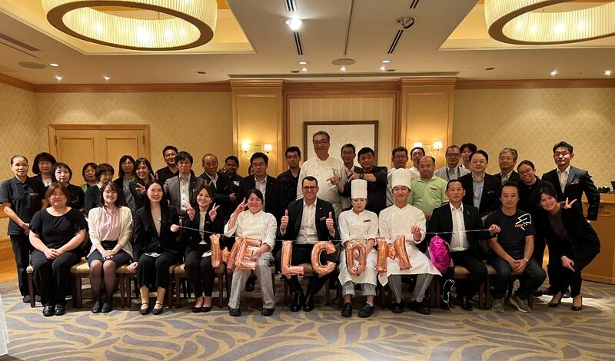
In summary, IHG can successfully address recruitment and retention challenges by implementing these strategies. By leveraging insights from prominent figures in the industry and adapting them to their specific context, IHG can sustain its prominent status as a frontrunner in the hospitality sector.

Evaluation and Conclusion
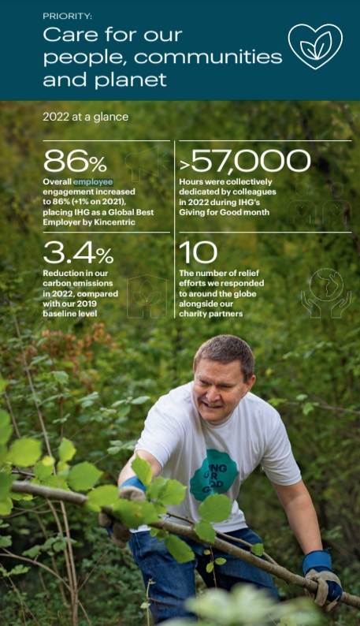
This report has provided a comprehensive analysis of the recruitment and retention challenges faced by Intercontinental Hotels Group (IHG), exploring the various external and internal factors that impact its workforce management. The PESTLE analysis revealed that political factors like Brexit, economic shifts including inflation, social trends like the retirement tide, technological advancements, legal changes, and environmental considerations significantly influence IHG's recruitment and retention strategies.
The SWOT analysis identified IHG's global brand reputation, employee development programs, and diversity initiatives as key strengths. However, the challenges of a transient workforce, potential digital skills gaps, and the demanding nature of hospitality work were noted as weaknesses. Opportunities for IHG include leveraging technology for recruitment and staff training, adapting to flexible work arrangements, and expanding its global career opportunities. Threats encompass the competitive labour market, political and economic uncertainties, and the need for technological adaptation.
From the industry trends and comparative analysis, it was evident that while IHG aligns well with some industry standards, such as employer branding and diversity initiatives, there is a need for further adaptation in areas like digital integration and flexible work policies.

Implications for the Hotel

The findings from this analysis have crucial implications for IHG's HR management. The changing political and economic landscape necessitates a more agile and adaptive recruitment approach. Embracing technology not just in operations but also in workforce management is essential to stay relevant and efficient. Additionally, the growing importance of work-life balance, diversity, and sustainability in the workforce's decision-making process cannot be overlooked.

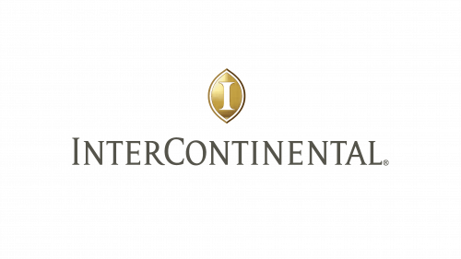

Recommendations

Based on this analysis, the following recommendations are proposed for IHG:
1. Expand Employee Development and Training: Invest in comprehensive training programs that cover not only operational skills but also personal and career development.
2. Adopt Innovative Recruitment Strategies: Explore flexible and remote work options for suitable roles, thereby widening the talent pool.
3. Integrate Advanced Technologies: Utilize AI and digital tools in recruitment and operational processes to attract a tech-savvy workforce and improve efficiency.
4. Enhance Diversity and Inclusion Policies: Ensure these policies are effectively implemented across all levels and locations to attract a broader range of talents.
5. Strengthen Commitment to Sustainability: Promote sustainable practices, appealing to environmentally conscious employees and guests.
By implementing these recommendations, IHG can enhance its recruitment and retention strategies, ensuring its continued success and leadership in the hospitality industry.

References

1. Abass, M.N., 2023. Artificial Intelligence Techniques in Egyptian Hotels: Current Status and Prospective. Egyptian Journal of Tourism and Hospitality, 30(1), pp.1-53. : https://journals.ekb.eg/article_303527_1cac202cead8ee8a66fc9549837a60c0.pdf
2. BERHANE, L., 2021. THE EFFECT OF INTERNAL MARKETING ON EMPLOYEE TURNOVER INTENTION, THE CASE OF INTERCONTINENTAL ADDIS HOTEL (Doctoral dissertation, ST. MARY’S UNIVERSITY). : https://run.unl.pt/bitstream/10362/122740/1/2020-21_fall_30458_francisca-fernandes_part-2.pdf
3. Boella, M.J. and Goss-Turner, S., 2019. Human resource management in the hospitality industry: A guide to best practice. Routledge.
4. Boella, M.J. and Goss-Turner, S., 2019. Human resource management in the hospitality industry: A guide to best practice. Routledge.
5. Boella, M.J. and Goss-Turner, S., 2019. Human resource management in the hospitality industry: A guide to best practice. Routledge.
6. Boella, M.J. and Goss-Turner, S., 2019. Human resource management in the hospitality industry: A guide to best practice. Routledge.: http://elibrary.gci.edu.np/bitstream/123456789/3050/1/BT-358%5BMichael_J_Boella%2C_Steven_Goss-Turner%5D_Human_Resou%29.pdf
7. Bohdanowicz, P., Simanic, B. and Martinac, I.V.O., 2005. Environmental training and measures at Scandic Hotels, Sweden. Tourism Review International, 9(1), pp.7-19.
8. Codling, S., Pinnock, C., Barrett, E., Gayle, S., Stephenson, N., Sibblies, N., and Sinclair-Maragh, G., 2022. Factors Contributing to Staff Turnover in the Hospitality Industry. https://www.intechopen.com/predownload/84110
9. Fachada, B.C., 2023. Business adaptive strategies in crisis: the case of Hilton Hotels Worldwide (Doctoral dissertation): https://repositorio.ucp.pt/bitstream/10400.14/41371/1/203278844.pdf
10. Fernandes, F.S.M.S., 2021. Intercontinental hotels group-time to check-in? analysis of one of the biggest hotel players in times of a global pandemic (Doctoral dissertation): https://run.unl.pt/bitstream/10362/122740/1/2020-21_fall_30458_francisca-fernandes_part-2.pdf
11. Garavan, T., Matthews-Smith, G., Gill, A.M. and O’Brien, F., 2021. Strategic talent management in the hospitality industry. In Talent management innovations in the international hospitality industry.
12. Gilch, P.M. and Sieweke, J., 2021. Recruiting digital talent: The strategic role of recruitment in organisations’ digital transformation. German Journal of Human Resource Management, 35(1), pp.53-82.: https://journals.sagepub.com/doi/abs/10.1177/2397002220952734
13. Hospitality On, 2023. Intercontinental Hotel Group. Campaign - Intercontinental Hotel Group - IHG Future Leaders Program.: https://hospitality-on.com/en/worldwide-hospitality-awards/intercontinental-hotel-group/intercontinental-hotel-group-ihg-future
14. Intercontinental Hotel Group, 2016. Annual Report and Form.: https://www.annualreports.com/HostedData/AnnualReportArchive/i/NYSE_IHG_2016.pdf
15. Kichuk, A., Brown, L. and Ladkin, A., 2019. Talent pool exclusion: the hotel employee perspective. International Journal of Contemporary Hospitality Management, 31(10), pp.3970-3991.
16. Kilson, G.A., 2022. The Use of Digital Media for the Employer Brand Management in Hotels (Doctoral dissertation).: https://comum.rcaap.pt/bitstream/10400.26/43989/1/2022.04.002.pdf
17. Kim, J., Erdem, M., Byun, J. and Jeong, H., 2011. Training soft skills via e‐learning: international chain hotels. International Journal of Contemporary Hospitality Management, 23(6), pp.739-763. :https://connect.liblynx.com/go/emerald?sachoose=1&target=https%3A%2F%2Fwww.emerald.com%2Finsight%2Fredirect%3Ftarget%3Dhttps%253A%252F%252Fwww.emerald.com%252Finsight%252Fcontent%252Fdoi%252F10.1108%252F09596111111153457%252Ffull%252Fhtml
18. López-Andreu, M., Papadopolous, O. and Jamalian, M., 2019. How has the UK hotels sector been affected by the fissuring of the worker–employer relationship in the last 10 years? : https://eprints.ncl.ac.uk/file_store/production/271645/4688CFBD-36A3-458E-971C-F1C5E207DDAC.pdf
19. Nelissen, J., Forrier, A. and Verbruggen, M., 2017. Employee development and voluntary turnover: Testing the employability paradox. Human Resource Management Journal, 27(1), pp.152-168.
20. Popely, D. and Uhlir, L., 2023. Advancing Health and Well-Being in Hospitality: Employers Respond to New Workforce Expectations.: https://digitalcommons.nl.edu/cgi/viewcontent.cgi?article=1002&context=kc
21. Stamolampros, P., Korfiatis, N., Chalvatzis, K. and Buhalis, D., 2019. Job satisfaction and employee turnover determinants in high contact services: Insights from Employees’ Online reviews. Tourism Management, 75, pp.130-147.: https://www.sciencedirect.com/science/article/pii/S0261517719300925
22. Štilić, A., Nicić, M. and Puška, A., 2023. Check-in to the future: Exploring the impact of contemporary information technologies and artificial intelligence on the hotel industry. Turističko poslovanje, (31).: https://www.aseestant.ceon.rs/index.php/turpos/article/view/43739/23061
23. TULSI, P. and JI, Y., 2020. A conceptual approach to green human resource management and corporate environmental responsibility in the hospitality industry. Journal of Asian Finance, Economics and Business, 7(1), pp.195-203.: https://doi.org/10.3390/su14052885
24. Vetráková, M., Šimočková, I. and Pompurová, K., 2019. Age and educational diversification of hotel employees and its impact on turnover. Sustainability, 11(19), p.5434.: https://doi.org/10.3390/su11195434

