AN INVESTIGATION INTO THE RISE OF PRIMARK
GEORGIANA HODOR/1812472
PRIMARK
12.07.2019

Executive Summary
The business and marketing strategies embraced by an organization tend to have a direct impact on its competitiveness and productivity. Primark Company has in the past two decades experienced significant growth, and this is because of its cheaper products compared to its rivals, and the strong relationship that it has built with its consumers. The company, however, struggles with an unethical issue that has not only negatively impacted its brand reputation, but also its sales. Some of the suppliers that provide garments to Primark have been linked to unethical practices such as child labor and poor working conditions for their employees. However, Primark is only concerned about maximizing on profits and had dismissed the issues as non-existent. The uncertainty that has been brought about by Brexit may also have a negative impact on the productivity for the company. Some of the options to be implemented for dealing with the current issues faced by Primark include implementation of ethical codes of conduct on sustainability that its suppliers have to abide by and to invest in e-commerce.

Table of Contents

1.0 Terms of References 4
2.0 Procedure 4
3.0 Findings 5
3.1 Brief Introduction of the Organization Based on the Timelines of Major Events 5
3.2 Overview of the Current Product Portfolio and Location 7
3.3 Planning, Communicating, and Reviewing Previous Attempts to Solve Problems with Suppliers. 7
3.4 Nature, Scope, and Impacts of the Current Problems 9
4.0 Conclusion 15
5.0 Options/Recommendations 15
6.0 Appendix 17
7.0 Acknowledgement 19
8.0 Reference List 20

1.0 Terms of References
Primark Company requested the report on the 5th of June 2019. The primary purpose of the report is to analyze the rise of the Primark Company. The researcher will submit the report. The problems highlighted in the report include a time of the significant developments that Primark has faced since its launch, description of the current products and the store location portfolio, investigation on how the company has communicated or solved problems with the suppliers in the past, and description of nature and scope of any issues facing Primark Company. Other tasks that will be analyzed in the paper include assessment of the causes of the problems at Primark by relying on the SWOT Analysis, PESTLE Analysis, and Stakeholders’ analysis. The date of submission for the research paper will be 12th of July 2019.

2.0 Procedure
The report will rely on various sources of information. The company’s website, for instance, will be critical for the provision of information on the history of the organization, its products and services, locations, and any challenges it faces. The internet will also provide information on the industry where Primark operates and the level of competition from the rival firms. Another source of information for the report will be books that primarily focus on business and marketing strategies that can be embraced by firms for the enhancement of their competitiveness and productivity. Finally, peer review articles will be used for the provision of detailed information for the report. Business, entrepreneurial, and marketing journals will be used as sources for information.

3.0 Findings

3.1 Brief Introduction of the Organization Based on the Timelines of Major Events
Primark is an Irish fast-rising fashion brand that has specialized in the sale of clothing, housewares, and cosmetics. The company has in the past decade experienced significant growth, and this is attributed to factors such as a strong relationship with the consumers, hiring skilled and qualified workers, and the dependence on aggressive marketing and advertisement strategies. Some of the areas served by the company include the U.S., UK, Austria, Germany, and the Netherlands among others. Paul Marchant is the CEO of the company and has been on the forefront in contributing to the enhancement in the productivity for the firm. Primark’s parent company is the Associated British Foods. Currently, the company has an estimated 70,000 employees. Below is a timeline table that outlines the key events describing significant developments faced by the Primark Company since its founding.
Timeline table for the company
Year | Major event
1969 | The company’s first store was founded in the streets of Dublin by Arthur Ryan. During its founding, the firm had a primary objective of improving lives of the people in Dublin.
1971 | The company experienced immense success in Ireland, and this motivated it to expand into the United Kingdom. Expansion into the UK was aimed at improving its revenue generation. The opening of a large store at the Belfast City Centre was a major step for the company.
1973 | Primark opened another store in Derby, England. The second store in the UK was an indication of the growth of the company.
2005 | By 2005, Primark was experiencing immense growth as evidenced by an improvement in revenue generation and the strengthening of its market share. The firm purchased the Littlewoods retail stores for £409m, and this was a strategy aimed at strengthening its competitiveness.
2006 | The company opened its first store in Spain, and this was also part of its expansionary process.
2018 | Fire destroyed Primark’s Belfast store, bringing it to a near collapse. The disaster had a negative impact on the brand image for the company. The store was reopened at the end of 2018.
2019 | Slovenia is the latest country that the company has expanded its operations into. In June 2019, the company expanded into Ljubljana, Slovenia.

3.2 Overview of the Current Product Portfolio and Location
Primark Company operates in the retail sector and has its headquarters in Dublin, Ireland. In the past three decades, the company has experienced significant growth and has since expanded into various countries across Europe. Some of these countries where the firm has its operational base include United Kingdom, Netherland, Belgium, Spain, Slovenia, Germany, and France, among others. The company also has nine stores in the U.S. with the first store having been opened in 2005. Primark has plans of expanding into Poland and the Czech Republic in 2020. Various operational bases have provided the company with the opportunity for capturing the attention of a large targeted audience, and this has, in return, contributed to an enhancement in its revenue generation. Diversification in production is a strategy that the company also applies for ensuring that it gains a competitive edge over the rivals in the industry. Some of the products sold by Primark Company include housewares, different types of cosmetics, and clothing. The products are of high quality and vary in prices. A combination of aggressive marketing, advertisement, and high-quality products is one of the reasons for the increase in the sales of the firm’s products (Eiteman, Stonehill and Moffett, 2015). The company offers unbeatable value to the clients while not losing its cutting and innovative edge.

3.3 Planning, Communicating, and Reviewing Previous Attempts to Solve Problems with Suppliers.
The suppliers are an integral aspect of success of an organization. Maintaining a strong relationship with the suppliers contributes to an enhancement in the operational efficiencies for a company as well as its ability to meet set goals and objectives. In the past, Primark has experienced challenges with the suppliers. Among fashion retailers in the UK, the company scored the lowest ethical index in 2005, and this was because of the poor working conditions in some of its stores and the deteriorating relationship with some of its suppliers (Kanter, 2009). In 2008, an undercover investigation revealed that the firm’s primary supplier in India promoted child labor and did nothing to address the deplorable working conditions. Primark was well-aware that the Indian supplier was involved in unethical practices but did little to resolve the issue.
Another problem that the company has experienced with some of its suppliers is lack of transparency. The firm has various independent suppliers, mostly from China. In the event of a lack of transparency, both the suppliers and Primark may be impacted negatively. Poor working conditions in the retailer’s Manchester-based vendor TNS Knitwear and a Bangladesh-based supplier in 2008 also revealed unethical standards in Primark’s supply chain (Jones, Temperley and Lima, 2009).
In the past, Primark has come under intense scrutiny due to ethical standards in the supply chain management, thus forcing it to take into account various measures for addressing the problems. In 2009, the company signed a deal for a web-based supply chain-auditing system. Introduction of the system was aimed at enhancing ethical auditing for the firm’s suppliers. Under the web-based supply chain auditing system, both internal and external auditor for Primark assess all the suppliers for the company and feed the results into the BSI Management System to be assessed by the organizational leadership. Across the last ten years, the BSI management system has since improved the relationship between Primark and its suppliers by ensuring that transparency is promoted and ethical standards are met.
Another strategy that the company has embraced to resolve its problems with the suppliers entails involving them in the decision-making process, while at the same time ensuring that high levels of transparency are maintained. Transparency index in the fashion industry remains as low as 40%, and this is an indication that most of the companies in the sector are not willing to share information on their CSR, suppliers, or working conditions (Wallwork and Begum, 2018). The company has implemented mechanisms whereby suppliers can either air their grievances or offer their suggestions directly to the company. Primark, other than allowing the suppliers to be involved in the decision-making process, has also implemented ethical standards that serve as guidelines for both the suppliers and the company. An enhancement in the level of transparency between the company and the suppliers has not only strengthened the relationship between the two parties, but also helped in ironing some of the problems such as poor working conditions and failure in adhering to some of the ethical standards that were regularly experienced in the past.

3.4 Nature, Scope, and Impacts of the Current Problems
In the modern day, most companies around the world are not only keen on strengthening their brands, but also ensuring that they adhere to set ethical standards (Fontana, 2017). However, issues such as aggressive competition, low employee morale, and poor relationship with the suppliers may have a negative impact on the firms’ ability to meet the needs of consumers. In as much as Primark has in the past decade experienced significant growth, various current challenges have a direct impact on its productivity.
One of the current problems that Primark Company faces in the retail industry is aggressive competition from the rival firms. Some of Primark’s main competitors include Marks & Spencers, Zara, and H&M. Aggressive competition limits Primark’s ability to expand its market share in most of the countries where it has an operational base. Consequently, this has a negative impact on the revenues generated by the firm. In the quest for dealing with the challenge of intense competition in the market, the company has reduced prices of its products slightly compared to the rivals in the industry. However, this has not been enough to deal with the problem effectively.
The company has occasionally been criticized heavily for engaging in unethical practices. Compared to most of the competitors in the market, the product prices for Primark are the lowest, and most critics argue that this is the avenue for the promotion of unethical practices. Undercover investigations by the BBC have in the recent past revealed that the company employs children in its sweatshops in South East Asia. The low prices for the firm’s products are made possible because of the low wages that are paid to the children employed in some of the suppliers in India and South East Asia (Parry, 2016). Failure by the company to implement measures aimed at addressing child labor in some of its stores and suppliers’ factories in parts of Asia has a negative impact on its brand reputation. Primark’s dented brand image has driven away some of the potential investors that would have injected funds aimed at bolstering its production capabilities (Maltwood, 2019). The company has denied reports of forced labor in some of its stores and factories in the past few years, but the issue will continue haunting the company.
Other than the issue of child labor, poor working conditions is another major current problem faced by Primark Company. The slave labor conditions that employees in the firm’s Bangladesh and Chinese factories are exposed to reveal the extent of the poor management practices and failure in meeting employee needs that the company condones. Employees in Bangladesh, Indian, and Chinese factories supplying garments to Primark Company have occasionally raised complaints of long working hours and meager wages (Parry, 2016). Most critics argue that Primark is only concerned about maximizing on its profits and not pursuing complaints raised by the workers in the South East Asia garment makers. Consequently, this has since had a negative impact on the firm’s brand reputation.
3.5 Analysis of the Causes of the Problems at Primark
SWOT Analysis
Strengths  - Primark Company has specialized in the diversification of its products, and this has a positive impact on its revenue generation.  - The company has a strong presence in Europe with estimated 300 stores in various countries across the continent.  - After the Rana Complex incident in Bangladesh, the company paid all the victims of the disaster long-term compensation (Hendriksz, 2019).  - The sales and net profits for the Primark Company have improved significantly in the past five years.  - Primark offers cheap clothing, and this gives it a competitive edge over the rivals in the market. | Weaknesses  - The company has specialized in the outsourcing of apparels, and this may contribute to the reduction in the quality of its products.  - The company faces a major weaknesses of consumer perception that it is unethical, and this has since had a negative impact on its brand reputation.  - The supply chain management has failed to advocate for measures that can effectively deal with issues of child labor and poor working conditions raised in its suppliers’ factories in China, Bangladesh and India (Hendriksz, 2019).  - Primark has limited e-commerce presence, and this negatively affects its market share.
Opportunities  - The company will continue focusing on Europe by opening more stores in the emerging markets.  - Expansion into the U.S. market has provided the company with the opportunity for improving its revenue generation and market stability.  - The company needs to start investing in plus-size clothing due to the rise in cases of obesity in the developed countries where it has operational bases. | Threats  - BREXIT has created uncertainty in the UK market, and this has since impacted Primark’s operations.  - The supply chain for the company is still vulnerable to disasters, even after the Rana Complex disaster (Maltwood, 2019).  - Primark faces aggressive competition from H&M, Marks & Spencer and Zara.

PESTLE analysis
- Political factors: The decision by the UK to exit the European Union, in what is commonly referred to as Brexit, has led to economic uncertainty across Europe. Primark has most of its stores across Europe, and the Brexit policy could have a direct impact on its operations once it is actualized. One of the challenges that is already evident is the fluctuation in the Euro and sterling pound currencies. Economic uncertainty, thanks to the Brexit policy, may give Primark’s competitors from China and the U.S. a competitive edge in the industry.
- Economic factors: Fluctuation in the sterling pound and the EURO due to the uncertainty that has been created by Brexit has exposed the company to various financial risks. Additionally, the market where Primark operates is characterized by intense competition, and with its ethical issues, the firm’s market share may reduce in the future if no suitable measures are put in place.
- Technological factors: Primark company has limited presence in the ecommerce, which has a negative impact on its sales. The company majorly relies on its brick and mortar form of business. Primark has implemented website and social media marketing that it uses for capturing the attention of large targeted audiences in the countries where it has operational bases.
Stakeholder analysis
Stakeholders’ name | Influence on the company | What is of importance to stakeholders | Strategy for engaging stakeholders | Significances of stakeholders
Employees | High | Ensuring that organizational goals are met | Internal communication | Maintains strong relationship with consumers.  Handle various job responsibilities
Consumers | High | Purchase products from the company | Word-of-mouth, social media marketing, website marketing | Product purchase and offering ideas on measures to improve the productivity for the company
Suppliers | High | Supply garments to Primark | Email and telephone communication | Have a significant importance on the supply chain
Shareholders | Medium | Offers advice to the company on strategies that can strengthen its productivity | Email and telephone communication | Inject funds that are used for running various operations

4.0 Conclusion
Primark has in the past decade experienced immense success thanks to its value proposition of low product prices, thus making it a low-cost leader in the fashion retail sector. Additionally, the firm’s strong presence in Europe and diversification in its products has also given it a competitive edge over most of its rivals in the market. Nevertheless, the company has across the years been faced with ethical issues that have negatively impacted its brand reputation and image. Cases of child labor and poor working conditions have exposed the firm’s failure in implementing ethical codes of conduct and measures that meet employee needs. The main area of concern, according to the information provided on its SWOT Analysis, is the ethical concern. Primark has been criticized for its failure in providing suitable solutions aimed at addressing some of the concerns such as child labor, poor management practices, long working hours, and low wages that have been raised by workers in some of its suppliers’ factories in South East Asia. Main areas of strengths include a strong presence in Europe, low prices for its products, and product diversification. Shareholders can offer the brand advice on measures to implement for effectively addressing the ethical concerns. Consumers, through their loyalty, can help in addressing the challenge of intense competition from the rival firms in the industry.

5.0 Options/Recommendations
In the quest for dealing with the issues faced by the company, there are various measures that Primark can implement. Firstly, the company needs to strengthen its relationship with the suppliers by encouraging them to “think sustainability” when sourcing materials. Primark needs to set ethical codes that require all the suppliers that provide it with materials to ensure that they create good working conditions for all workers (Missonier and Loufrani-Fedida, 2014). As a part of the ethical requirements, the suppliers have to increase wages for all their employees and introduce shifts that are at most eight-hours a day (Andreas, 2011). Primark also has to ensure that suppliers who engage in child labor stop unethical practices, failure to which it opts out of the contract that binds it with the supplier.
The company is also faced with the challenge of intense competition that limits its market share. One of the measures that can be implemented to address the problem of entails investing in e-commerce. By having its presence in e-commerce, Primark can benefit immensely from both an improvement in its revenue generation and competitive edge over most of the rival firms in the industry.

6.0 Appendix

Timeline for major events
2019-Expansion into Slovenia

1969-Launch of Primark
2018-Fire destroys Primark’s Belfast store

1971-Expansion into UK

2006-Opens first store in Spain

2005-Purchase of Littlewood Retail stores
1973-Opens another store in UK

Stakeholders for the Company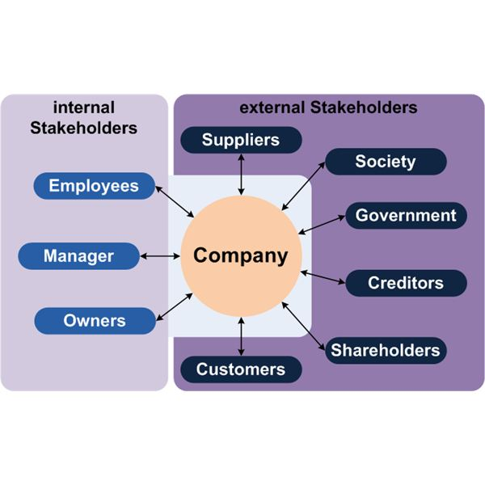

PESTLE Analysis Primark
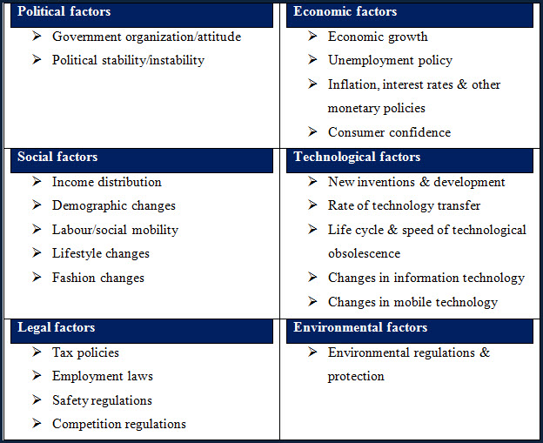

7.0Acknowledgement
I would like to express my special gratitude and appreciation to my instructor, classmates, and librarian who gave me the special opportunity and fruitful guidance to do this report. By doing this report, I have to say that I have been enriched with information that will help me in the future.

8.0 Reference List
Andreas, F., 2011. A simple path to sustainability. Santa Barbara, Calif.: Praeger.
Eiteman, D., Stonehill, A., and Moffett, M., 2015. Multinational business finance (14th ed.). Pearson.
Fontana, E., 2017. Corporate Social Responsibility as Stakeholder Engagement: Firm-NGO Collaboration in Sweden. Corporate Social Responsibility and Environmental Management, 25(4), pp. 327-338.
Hendriksz, V., 2019. Case study on Primark sustainability, ethics, supply chain. [online] Fashionunited.uk. Available at: https://fashionunited.uk/primark-sustainability [Accessed 19 Jun. 2019].
Jones, B., Temperley, J. and Lima, A., 2009. Corporate reputation in the era of Web 2.0: the case of Primark. Journal of Marketing Management, 25(9-10), pp. 927-939.
Kanter, J., 2009. Primark to improve ethical auditing of suppliers - Supply Management. [online] Supply Management. Available at: https://www.cips.org/en/supply-management/news/2009/march/primark-to-improve-ethical-auditing-of-suppliers/ [Accessed 18 Jun. 2019].
Maltwood, H., 2019. Concerns that Primark's cheap prices could be compromising its ethics. [online] cornwalllive. Available at: https://www.cornwalllive.com/news/cornwall-news/concerns-primarks-cheap-prices-could-753997 [Accessed 19 Jun. 2019].
Missonier, S. and Loufrani-Fedida, S., 2014. Stakeholder analysis and engagement in projects: From stakeholder relational perspective to stakeholder relational ontology. International Journal of Project Management, 32(7), pp. 1108-1122.
Parry, S., 2016. The true cost of your cheap clothes: slave wages for Bangladesh factory workers. [online] South China Morning Post. Available at: https://www.scmp.com/magazines/post-magazine/article/1970431/true-cost-your-cheap-clothes-slave-wages-bangladesh-factory [Accessed 19 Jun. 2019].
Wallwork, E. and Begum, T., 2018. Primark and Asos Are Becoming More Transparent About Who Makes Their Clothes. [online] Huffingtonpost.co.uk. Available at: https://www.huffingtonpost.co.uk/entry/fashion-transparency-index-2018_uk_5ad9c521e4b0e4d0715f65d5?guccounter=1&guce_referrer=aHR0cHM6Ly93d3cuZ29vZ2xlLmNvbS8&guce_referrer_sig=AQAAAAE_2cC_EL01CEWEbaO2nctt7sqf2vns2rFnr5YUcOTWdfYIlOKNnBbp-HDhK7Ft3v84G9Oj7dzF6sgprzngn1zSonfEUexENTYClBDErhDdA0TyQUbCRuE4ov5fZc-qd86F-6sp3Z9WOzKWYbuLsPIRDmu-QO99JQIg541KBvYP [Accessed 18 Jun. 2019].

