Field Report - Cors Caron – Tregaron Bog:
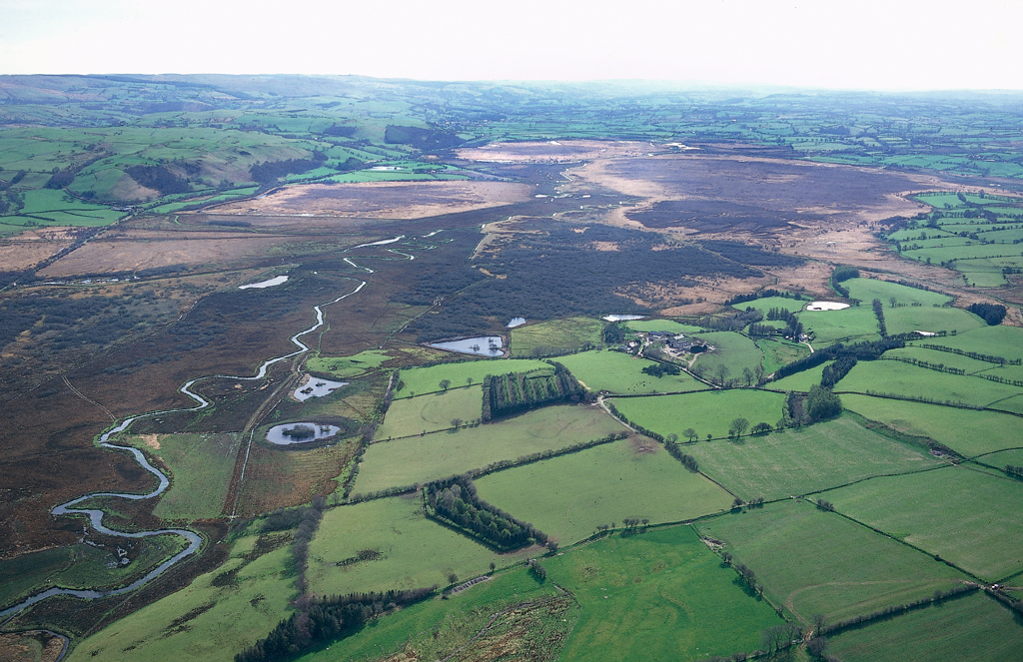Figure 1: Aerial photograph of Cors Caron, Toby Driver (2012)
About the site:
Cors Caron is currently a registered nature reserve managed by Natural Resources Wales situated approx. 2km from Tregaron, mid-west Wales. (OS grid reference: SN68536267)
The wetland area itself was formed from a late glacial period lake, creating three distinct bog domes across the fen. The site is managed currently by heritage bodies, but it has only been protected since 1992 when it was deemed a site of international importance. The lake measures 6km by 2km and has an extensive history of peat cutting.
Whilst on the trip, Dr. Coard explained to us the histories and importance of the bog itself, highlighting some of its key eras and the impact the area has had on the surrounding community. She explained what had been found at the site through excavation or accidental discovery, and the challenges archaeologists face in such adverse conditions. The bronze and iron ages brought to this site votive offerings found in the water and mud, with also a bog body. The bog body showed us as archaeologists how the community interact and value the site, as when it was uncovered it was reburied in the local churchyard, demonstrating their protective attitudes towards their people.
After the site was recognised for its peat harvesting potential, the locals began collecting it up until the 1960s. The first recorded references to peat cutting in this area come from the antiquarian John Leland, in the 1530s as he visited Strata Florida before its demise. This demonstrates that the site itself has been farmed for approximately 500 years. The harvesting of peat was popular and cheap, with it being used as fuel in a time where coal and wood was more expensive to acquire. Surprisingly however, with the addition of the railway and the ease of access to such materials, peat cutting remained popular.
I was particularly interested in the railway from a heritage perspective because of the way in which the tracks were laid, and the little effect it had on the locals. Being uniquely devised to work with the challenging landscape, the floatation of wool and sticks to provide a stable bedding for the track to be set is extraordinary. Yet the railway did not seem to add to the site or community. What remains of it now is simply the hollowed walkway where the sleepers would have been placed and a leaf covered information board. When observing the site as a whole, my mind was filled with images of what could’ve been a bronze age landscape, with the marshlands triggering memories of sites such as flag fen or the bog bodies of Ireland. I observed also the way humans have made the site accessible, walking on raised planks that led to before inaccessible areas of marsh, how drainage and water control gates make the environment seem natural, but still retaining an element of control. The site’s overall importance was explained to us too, highlighting the fact that few bogs are in such a good state in Europe, not only the UK and its international recognition.

Driver, T. ‘Cors Caron, Tregaron Bog’, 2012 <https://www.peoplescollection.wales/items/518281> [accessed 14 January 2019]
Caron Cors, Information Sheet on Ramsar Wetlands (RIS) <www.bto.org/survey/webs/webs-alerts-index.htm.> [accessed 14 January 2019]
Unknown, ‘Cors Caron: Peat and Peat Cutting’ <http://www.hanesybont.co.uk/corscaron/torrimawn.htm> [accessed 14 January 2019]
‘Cors Caron, Ceredigion Viewpoint’ <https://www.discoveringbritain.org/activities/wales/viewpoints/cors-caron.html> [accessed 15 January 2019]
‘Natural Resources Wales / Cors Caron National Nature Reserve, near Tregaron’ <https://naturalresources.wales/days-out/places-to-visit/mid-wales/cors-caron-national-nature-reserve/?lang=en> [accessed 15 January 2019]

