Module number: LCBB 5004
Module name: Managing People
Title of the assignment: Assessment 2
Name and student number: Mariana Cocos 2024061
Submission date:09.05.2022
Word count:1984

Assessment 2

Table of Contents

- Introduction…………………………………………………………………...3
- The review of the concept and drivers of employee engagement…………………………………………………………………...4
  - The Concept of engagement and asset analysis…….….5
  - Critical Review and measuring……………………………….6
- The diagnostic tools to measure employee engagement.…....….7
- The Employee value proposition…………………………………………8
4.1The concept and purpose of EVP……………………………9
4.2 The approaches to increase levels of Engagement ...10
- Conclusion……………………………………………………………………11
- References…………………………………………………………….…...13

Figure1. Engagement Index Model. Source: (Decision Wise, 2022) ………………………………………………………………….….…7
Figure 2. Employee Value Preposition: Source: (Chakraborty, 2021) ……………………………………………………………………...…9
1.Introduction

Engagement in the workplace has become very important because of various external factors and trends in society and businesses that drive change. Covid-19 has created many uncertainties and difficulties for employers and employees as well. Undoubtedly, engaging and supporting employees can help them in work-life balance and help support the organisation to improve performance. Employee engagement is a workplace mindset that secures all adherents of an organization to give their excellence every day (Chanana & Sangeeta, 2020). The workers show commitment to the firm's goals and values.
The report aims to analyse employee engagement in relation to organisation performance. First, it reviews the concept and drivers of employee engagement, including an asset analysis review on measuring performance. Second, the analysis is directed towards relevant instruments to measure productivity and performance, particularly the survey, productivity, and HR tools. The third part of the report analysis the employee value proposition and approaches to increase it.
To achieve the goals set, a literature review and various theories and methods are used to strengthen the argument and enhance understanding of employee engagement, such as the Engagement Index model (Decision Wise, 2022) and Employee value proposition (Chakraborty, 2021). However, it is important to acknowledge that the analysis does not address a particular group of employees, which may require direct interaction and additional research.

2.The review of the concept and drivers of employee engagement

Exploring various definitions of engagement, several differences have been observed. First, the concept can overlap with other concepts within HR activities, and the second is that
engagement is closely defined within human psychology. Robertson-Smith&Markwick (2009) defined employee engagement as an outcome of employee attachment, commitment, and loyalty to the company. Macey and Schneider (2008) suggested that engagement is sometimes defined based on what it is a psychological state. Harter et al. (2002) connected employee engagement with their satisfaction. Despite multiple definitions in the literature, many organisations still define based on company needs and their perception of engagement
2.1 The Concept of “engagement” and asset analysis

The concept of employee engagement has been more widely used within organisations, mainly being a concern for HR because of their responsibility to ensure employees recruited are demonstrating performance while ensuring their well-being at the workplace. Undoubtedly, employee engagement is a matter not only of HR but of management and leadership as well. Kruse (2012) believes that engagement could drive bottom-line profit, enable organisational agility, and increase efficiency in driving change initiatives.
Besides that, engagement reflects the individual’s behaviour within the organisation by showing how well they invest themselves into the work or projects, how effective they are, and what kind of outcome this behaviour provides for the organisation. It is believed that highly engaged employees will contribute to positive, healthy working culture. As Harter et al. (2002) suggested, employee engagement overlaps with employee satisfaction. In contrary with Harter’s assumptions, Kruse (2012) suggests that it doesn’t mean satisfaction motivating that a satisfied employee might show up for her daily working hours without complaining; however, the worker may not go an extra mile taking their own initiative; therefore, satisfaction may not be enough,
Employee engagement can be an essential indicator of whether employees become assets or losses. If employees are not effective and do not drive performance because of a low engagement, the company may have to lose. On the other hand, if the employees show a high level of engagement, they could be a great asset to the firm, driving profit Brunnetto et al. (2022) argue that “asset managers with insights to assist the movement from reactive to proactive organizational cultures can enhance asset management engagement and drive performance.” Possessing knowledge and suitable models to engage employees can benefit the organisation significantly.

2.2Critical Review and measuring

It cannot be very sensible to apply strategies to engage employees without first understanding the level of engagement in the company and what are the right tactics to apply. Individual characteristics and behaviour can provide great insights into that. Bridger (2018) outlined a model for success that relate to establishing an employee's voice. This refers to understanding employees better.
The elements in the model include the purpose of voice that boosts sustainability and the outcomes of voice that drives engagement commitment along with performance. Also, the culture and behaviour associated with the employee's voice and the structure and processes associated with voice. Another model to measure performance is Employee Engagement Index (Figure 1. Engagement Index Model. Source: (Decision Wise, 2022) Decision Wise, 2022); it measures engagement based on four indicators; fully disengaged, opportunity group, a key contributor, and fully engaged (Decision Wise, 2022).
This model can be beneficial for understanding employees, their attitudes, and the characteristics of employees in each of the groups. Furthermore, it provides an overview of workers' thoughts, feelings, and intentions in relation to their level of engagement.
However, it has its disadvantages; for example, it does not consider potential events or factors that trigger employee behaviour. It does not analyse it in terms of time. Human beings can be unpredictable and labelling an employee as a critical contributor may not be appropriate, especially when she/he has characteristics from various categories. When using the model, these aspects should be considered in order to avoid misunderstanding or generating an adverse effect.

Figure 1. Engagement Index Model. Source: (Decision Wise , 2022)

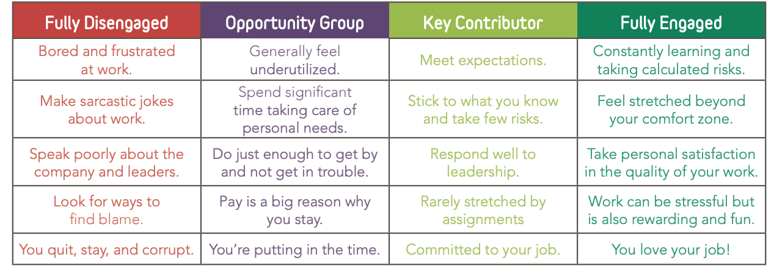

3.The diagnostic tools to measure employee engagement

As discussed previously, some strategies are very much needed to improve employee engagement. Starting from the basics, such as providing a platform for employees to be able to express their concerns, ensure they feel heard and appreciated, showing mutual respect, and encouraging effective communication across the teams (Reddy, 2022). It is important to acknowledge that a critical contributor may drive high performance but to the extent of burnout. Fletcher & Robinson (2014) stated that "Measures constructed from the Burnout-Antithesis Approach- a harmful psychological syndrome that comprises emotional exhaustion, cynicism, and reduced professional self-efficacy" is not a sustainable measure. Therefore, the measures derived from the approach appear to concentrate on activated forms of energy, stressed by the sorts of adjectives used such as bursting, vitality, inspiring resilience, and alertness.
During Covid-19 with hybrid working, measuring employee engagement could be challenging, and applying the necessary tactics to increase engagement is crucial. However, it is of high importance for the company's performance and well-being.
Technological advancement could be of real help to connect precisely when flexible work is a new normal. Using existing diagnostic tools or designing own based on company requirements may be among practical solutions to measure engagement.
Hook & Jenkins (2019) discussed that involving employees in decision-making or moving some responsibility from managers to junior workers known also as vertical job loading factor, can boost their motivation; the success of a business is determined by those who have a financial stake and by other people who have a direct interest in the organisation's growth. Every individual affected by the decisions and actions is a stakeholder. For example, employees who rely on their job for their livelihood and the contentment of their working life.

4.The Employee value proposition

The employee value proposition is about brand image or benefits employees have that may feel attracted to that and increase retentions. Barnes (2009) suggested that “Value propositions are the essence of a value-focused business approach, which is the only sustainable means to pursue proﬁtability and competitive edge.” It seems rather interesting as employees have the power to create value for the business, and businesses can, in return, employ workers via career opportunities, rewards, and others.

4.1 The concept and purpose of EVP

The purpose of EVP is to establish the meaning of the company and the values and bring these to its stakeholders. The aim of an EVP must be to make employees feel excited and proud to work for the organisation. EVP highlights the competitive strengths of a position within a company (Murdock, 2018); it helps differentiate the role or the company itself from competitors. According to (Hook & Jenkins, 2019), employer branding can attract suitable candidates and market their employment value proposition (EVP). It can comprise elements such as tangible rewards, wages, benefits, career, affiliation, and work content (Figure 2. Employee Value Preposition: Source: (Chakraborty, 2021) Chakraborty, 2021).
HR department is the main department that has the responsibility to deliver the information to potential candidates and ensure smooth onboarding and monitor employee engagement, performance, and wellbeing.

Figure 2. Employee Value Preposition: Source: (Chakraborty, 2021)
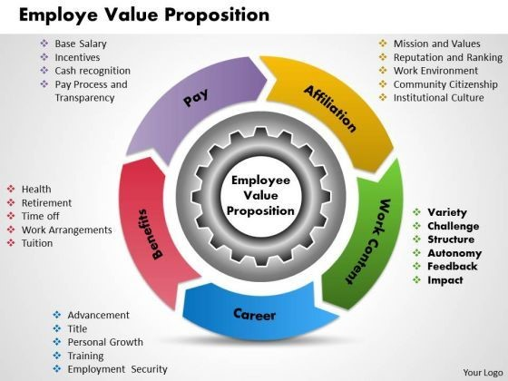
4.2 The approaches to increase levels of Engagement

During pandemics and after, the interest in flexible working has increased exponentially; therefore, it provides both advantages and limitations for the firm and employees as well. For example, engaging employees working remotely may be more complex than engaging employees in the office. Nevertheless, holistic approaches must be used to engage both groups without discriminating against them. Some of the approaches that can be taken to increase engagement in the workplace are measuring engagement, designing, and developing favourable policies, promoting a healthy working culture, developing learning and development opportunities, and providing regular constructive feedback.
Measuring individual engagement will provide an understanding of engaged employees and workers who are not engaged. The data can be effectively used to encourage and promote engagement based on the issues they face, whether it is special requirements, poor life balance, lack of motivation, stress, or any other difficulty they may face.
Individuals may engage easier if the firm makes efforts to improve their overall well-being. As Covid-19 has affected many lives, a wellness initiative could be a great way to enhance employee engagement and the same time, show support. Sponsoring exercise classes, yoga, or even group online meditation will encourage healthy lifestyles and help cope with challenges.
Sometime. Just listening to them and acknowledging their feeling may make a considerable change. Developing favourable policies such as equal opportunities, career development, effective communication among different hierarchical levels, and flexible working opportunities will provide a more productive and effective working environment. Promoting a healthy working culture is equally important; increasing awareness of inclusion and diversity will boost engagement. For example, employees may feel discriminated against race, gender, or religion, which may distance them from other colleagues and, at the same time, lose interest in their job.
Besides that, providing regular learning opportunities and various activities for personal and professional development may create a sense of connection that could increase employees' morale and make them feel a part of the company. These experiences could make them feel connected and highly appreciated, whether face-to-face or online meeting.

5.Conclusion

In conclusion, employee engagement has an important role when the request for flexible working has increased. Covid-19 has brought many uncertainties and difficulties for employers and employees; therefore, the need to adapt is more urgent than ever. Undoubtedly, there is a high connection between employee engagement and company performance, as highly engaged employees are more likely to show better progress than those disengaged.
Some of the significant drivers of employee engagement are inclusion, employee satisfaction, effective favourable policies, and healthy working culture. Employee engagement can be an excellent indicator of whether employees become assets or losses. Therefore, HR, leadership, and management could apply various strategies and approaches to increase engagement. Even basic actions providing a platform for employees to express their concerns, ensure they feel heard and appreciated, showing mutual respect could make a change for the organisation's performance and employees' wellbeing. Measuring individual engagement gives an understanding of engaged workers and those who are not engaged. The data can be effectively used to encourage and promote engagement based on their issues, whether special requirements, poor life balance, lack of motivation, and others. The employee value proposition is another vital tool that shows the company's image and how this impacts employee engagement. Employees may feel more engaged if the company provides various benefits, career opportunities such as advancement, work content such as constructive feedback, and a sense of belonging.

6.References

- Barnes, C. B. H. &. P. D., (2009)Creating and Delivering Your Value Proposition. Managing Customer Experience for Profit,. London: Kogan Page
- Bridger, E., (2018) Employee Engagement. 2nd ed. Great Britain: Kogan Page.
- Brunnetto, Y., Xerri, M. & Nelson, S., (2022) Journal of Management. Journal of Management, Volume 30.
- Chakraborty, M., (2021) Employee Value Proposition.
Available at: https://adamasuniversity.ac.in/people-first-an-emphasis-on-employee-value-proposition/
[Accessed 24 April 2022].
- Chanana , N. & Sangeeta (2020) Employee engagement practices during COVID‐19 lockdown. PMC PubMed Central .
- Decision Wise, (2022) Employee Engagement Survey.
Available at: https://qcg.co.uk/wp-content/uploads/2018/04/QCG-DecisionWise-Employee-Engagement-Survey-Brochure.pdf
[Accessed 24 April 2022]
- Fletcher , L. & Robinson, D., (2014) Measuring and Understanding Engagement. In: K. A. R. D. A. S. E. S. Catherine Truss, ed. Employee Engagement in Theory and Practice. Routledge, pp. 587-627
- Harter, J. K., Schmidt, F. L. & Hayes, T. L.,(2002) Business‐unit‐level relationship between employee satisfaction, employee engagement, and business outcomes: a meta‐ analysis. Journal of Applied Psychology, 87(2), p. 268–279.
- Hook, C. & Jenkins, A., (2019) Introducing Human Resource Management. 8th ed. Harlow: Pearson Education, Limited,.
- Kruse, K., 2012. What Is Employee Engagement.
Available at: https://www.forbes.com/sites/kevinkruse/2012/06/22/employee-engagement-what-and-why/?sh=3c51a6e17f37
[Accessed 24 April 2022].
- Macey, W. & Schneider, B., (2008) Engaged in engagement. In: Industrial and Organisational Psychology, p. 76–83.
- Murdock, P. K., 2018. The Importance Of An Employment Value Proposition For Recruiting In 2018 And Beyond.
Available at: https://www.forbes.com/sites/forbeshumanresourcescouncil/2018/01/09/the-importance-of-an-employment-value-proposition-for-recruiting-in-2018-and-beyond/?sh=698fa006690e
[Accessed 24 April 2022].

- Reddy, K., (2022) Employee Engagement: Top 22 Advantages & Disadvantages.
Available at: https://content.wisestep.com/top-advantages-disadvantages-employee-engagement/
[Accessed 24 April 2022].
- Robertson-Smith, G. & Markwick, C., (2009) Employee Engagement; A review of current thinking, UK: Institute for Employment Studie

