

Programme: MSc/PgDip/PgCert Cybersecurity and Digital Forensics
Module: Data Security, Governance and Compliance
Module code: ACCA7028
Lecturer: Dr. Ayman Al Hajjar

Assignment Title: Apply the principles and practices of Data security, Governance and Compliance based on a given scenario on FinSure Bank
Student name:
Student ID number:

Word Count: 3005

Table of Contents
1. Introduction 3
2. Literature Review 3
2.1 Security Governance and ITIL FrameworkThe 3
2.2 Information Security Management and ISO 27001 4
2.3 NIST and COBIT in Cybersecurity and Governance 4
2.4 Comparative Analysis and Critical Perspective 5
2.5 Integrated Theoretical Framework 5
2.6 Literature Gap 6
3. Proposed Design for FinSure Bank 6
3.1 Strategic Security Governance and Organisational Alignment 6
3.2 Risk Management Framework and ISO 27001-Based ISMS 7
3.3 Operational Cybersecurity and NIST-Based Control Mechanisms 8
3.4 Cloud, BYOD Security Architecture and Protection Mechanisms 10
3.5 Compliance, SLA Management and Continuous Improvement Strategy 11
4. Critical Discussion 12
5. Conclusion 13
Reference List 14

1. Introduction
Rapid growth digitalisation of the financial industry has a high level; of implication in the provision of banking services due to the embrace of cloud computing, mobile applications as well as data-driven technologies. Moreover, these developments are useful in enhancing efficiency and accessibility. It also has complicated cybersecurity risks as well as exposing sensitive financial information to threats. Cyberattacks may be considered as a frequent target of financial institutions, as the data they handle has a high value. Proper data security as well as governance are crucial (Alharbi et al., 2023).
Online banking is able to increase cybercrimes like data breaches, identification of theft as well as internet fraud, which may have devastating implications on organisational performance and customer confidence (Bouveret, 2025). Additionally , the increasing utilisation of new technologies which consist of artificial intelligence and cloud-based infrastructures. It has expanded the attack surface which needs to implement an integrated security framework as well as a governance model to handle these threats in an effective manner.
Data security may be treated as a very close factor with governance and regulatory compliance, more specifically organisations are required to follow the requirements and standards of confidentiality, integrity along with availability of information. It has been observed that a lack of well-organised governance systems, as well as risk management along with control measures which may lead to disjointed security practices along with heightened susceptibility to cybercrime.
This report provides a specific focus on the example of FinSure Bank, a digital-native financial institution which has experienced issues related to cloud-dependency, BYOD, a s well as the absence of unified security governance. This report aims to examine the applicable security structures along with recommending a holistic method of data security, governance as well as compliance to improve organisational resilience.

2. Literature Review

2.1 Security Governance and ITIL Framework
The Information Technology Infrastructure Library (ITIL) framework is generally credited with the contribution of streamlining the IT services in line with the organisational goals which used a systematic lifecycle methodology. Fajrillah, Lubis and Syam (2022) state that ITIL is useful in improving service delivery by the segmentation of the processes into phases. It consists of service strategy, service design, service related to transition, service operation along with service continual improvement. This lifecycle will be helpful for organisations to incorporate security considerations into every phase along with encouraging proactive risk management.
In addition, Sholekha et al., (2023), stated that ITIL enhances the aspect of governance by defining their roles, responsibilities along with standardized processes which is essential in ensuring accountability in complex IT environments. However, ITIL is less technically driven in terms of security control by ensuring service management, which makes it less effective in its application in highly sensitive industries like banking.
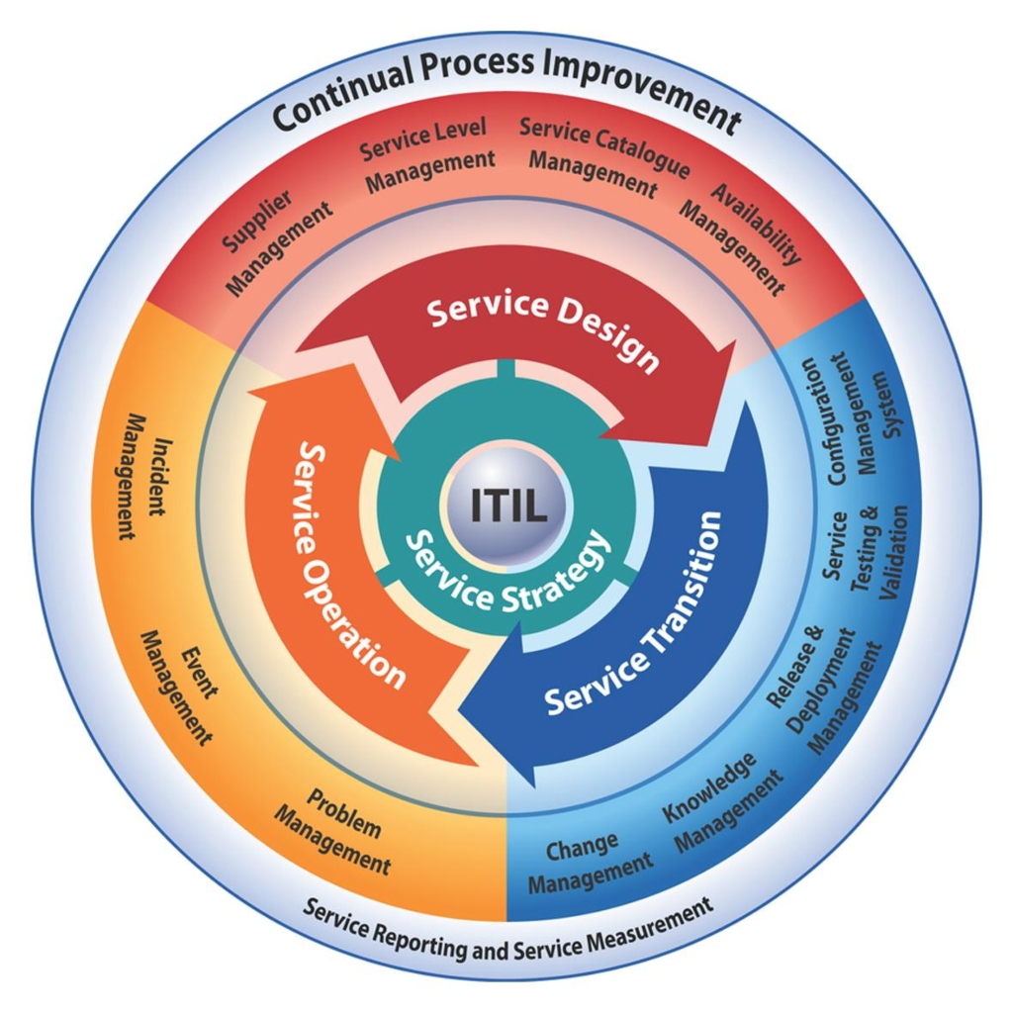
Figure 1: Information Technology Infrastructure Library (ITIL) framework
(Source: Milldesk, 2024)

2.2 Information Security Management and ISO 27001
The ISO 27001 standard offers an extensive model for the management of information security by adopting an Information Security Management System (ISMS). Legowo and Juhartoyo (2022) hold the view that the ISO 27001 is risk-based, meaning that it allows organisations to understand and manage the risks of information assets systematically.
Yin (2024) also emphasises that the framework is based on the Plan-Do-Check-Act (PDCA) cycle, which also guarantees the continuous monitoring and enhancement of security practices. It is believed that ISO 27001 helps in compliance with regulations provided through documentation, enforcement, auditing, and control measures. However, the structure may be intricate and resource-consuming, especially where organisations are not highly security mature.

2.3 NIST and COBIT in Cybersecurity and Governance
The NIST Cybersecurity Framework is useful to provide a flexible method of tackling cybersecurity risks. Aljumaiah et al. (2025) stated that it is based on five fundamental functions that consist of identify, protect, detect, respond, and recover and these are collectively used to increase the resilience of organisations against cyber threats. Its flexibility renders it very applicable in dynamic environments such as cloud-based systems. On a specific note, the COBIT is concerned with ensuring that IT governance is closely associated with business goals. Legowo and Juhartoyo (2022) stated that COBIT enhances decision-making and accountability in IT management. On the contrary, NIST as well as COBIT have requirements for a combination with other frameworks to cover compliance and risk management.
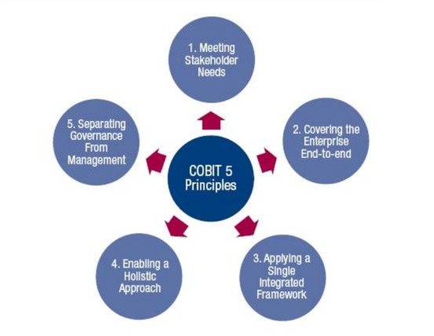
Figure 2: COBIT 5 Principles
(Source: CyberTalents, 2025)

2.4 Comparative Analysis and Critical Perspective
It becomes obvious that both of them deal with particular issues of data security, governance, and compliance when these frameworks are compared. Parida (2024) stated that ITIL is suitable for organising the processes of service management, ISO 27001 is based on risk management and compliance, more specifically, NIST offers operational capabilities of cybersecurity. It may be stated that the multifaceted security needs of contemporary digital organisations may not be covered in an effective manner by using a single framework. Nevertheless, Aljumaiah et al. (2025) point out that the integration of various frameworks may have a challenge to organisations due to complexity and lack of knowledge which may lead to disjointed security systems. This kind of fragmentation may expose vulnerabilities in cloud-based financial institutions, and these risks are complex.

2.5 Integrated Theoretical Framework
In order to overcome the limitations mentioned in the literature, this research paper implements an integrated theoretical framework that integrates ITIL, ISO 27001 and NIST principles into a layered model. ITIL in this context acts at the strategic level by offering governance frameworks, roles, and aligning IT services to the organisational goals. The ISO 27001 operates on the managerial level as it sets forth a risk-based information security framework and regulatory compliance achieved by applying an ISMS. NIST enhances the implementation of cybersecurity practices at the operational level by performing its core functions that enable organisations to deal with threats effectively. Haidar (2024) posits that the combination of various frameworks improves organisational capability in tackling the intricate security issues through the integration of governance, risk management, and operational controls. This multi-level approach is specifically applicable to FinSure Bank, where there is a combination of governance and compliance gaps, as well as operational risks related to cybersecurity. The combination of such frameworks allows the model to have an integrated and holistic approach to data security, governance, and compliance management.

2.6 Literature Gap
There is a limited number of studies regarding the way these can be applied to apex regulatory entities like digital financial institutions, which constitute a primary area of interest. While single frameworks have been well-explored in the literature Parida (2024), for example, identified that most studies studied frameworks individually instead of integrating them so that they can address complexities like the use of bring-your-own-device (BYOD), cloud dependency and third-party access. Additionally, adapting these frameworks to the fast-evolving regulatory landscape and the challenging new threat of cyber space is a need. The identified gap highlights the necessity of a standard framework that will be useful for making governance, risk management along with operational security interconnected to tackle the issues that modern financial institutions like FinSure Bank have to deal with.

3. Proposed Design for FinSure Bank

3.1 Strategic Security Governance and Organisational Alignment
The FinSure Bank design proposal starts with the creation of a solid strategic security governance framework that will ensure cohesion between organisational goals, regulatory demands, and cybersecurity needs. The establishment of a Security Governance Board (SGB) at the executive level and reporting straight to the top executive is the heart of this structure (Nodehi, Huygh and Bollen, 2024). This board will define the security vision and risk appetite of the bank and its compliance priorities and will make sure that cybersecurity is a part of the overall business strategy and not a strictly technical issue. Based on the principles of ITIL and especially on service strategy and continual service improvement, the governance framework will guarantee that security is incorporated into the lifecycle of digital banking services (Mahalle, Yong and Tao, 2020). This allows the FinSure Bank to be proactive in anticipating risks instead of responding to occurrences. Governance also entails the specification of roles and responsibilities within departments, the elimination of ambiguity and accountability, which is especially critical in complicated cloud-based settings. In addition, governance practices are integrated to make sure that key performance indicators (KPIs) and key risk indicators (KRIs) are checked on a regular basis in order to enable the leadership to measure the success of security initiatives. Strategic governance also becomes a vital part in making sure that there is adherence to financial rules and data protection legislation, and thus less legal and reputational risks (Sarwar et al., 2023). The governance layer in this manner constitutes the core of the suggested design, which connects business objectives to security concerns and makes sure that all decision-making processes are regular, clear, and goal-oriented by targeting the organisational resilience aims.
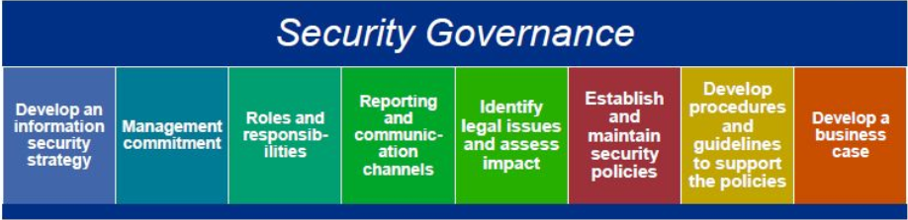
Figure 3: Security Governance Framework
(Source: Acte, 2024)

3.2 Risk Management Framework and ISO 27001-Based ISMS
The second aspect of the proposed design, which is formed based on the governance foundation, is the introduction of a detailed risk management framework on the basis of an Information Security Management System (ISMS) in accordance with ISO 27001 standards (Fonseca-Herrera, Rojas and Florez, 2021). This layer makes sure that any information security risks are systematically identified, analysed, treated, and monitored in a systematic and ongoing methodology. The first phase of the risk management process is the identification of the critical assets based on which the customer data, financial transaction systems, cloud infrastructure, and third-party integrations are among them and the potential risks are evaluated, including cyberattacks, insider threats, data breaches, as well as system vulnerabilities. With the ISO 27001 risk-based approach. On a further note, FinSure Bank may be able to prioritise risks according to their likelihood or potential effects and can effectively allocate the resources to the areas of greatest concern (Mirtsch, Kinne and Blind, 2020). It has to be stated that the risk treatment strategies are then put in place using a mix of technical, administrative, and physical controls such as access management, encryption protocols as well as secure system configurations. The Plan-Do-Check-Act cycle is essential to make sure that risk management is a continuous process that will adjust to the evolving threats and regulations. On an additional note, Internal audits, compliance checks as well as performance reviews are made frequent to maintain compliance with policies and areas to improve. On a broader note, it may be reviewed that the ISMS further fosters the culture of security awareness in the organisation as it encourages employees to train and engage in risk management activities. This comes into play especially when it comes to dealing with BYOD issues, where employee behaviour may play a key role in determining security outcomes (Culot et al., 2021). From a comprehensive perspective, the adoption of an ISO 27001-based ISMS can offer FinSure Bank a systematic and quantifiable method of dealing with information security risks and making sure that the company is in compliance with the standards as well as regulations provided by the industry.

3.3 Operational Cybersecurity and NIST-Based Control Mechanisms
The third element of the proposed design is operational cybersecurity that oversees the daily security of the digital assets and systems of the FinSure Bank. This layer is grounded on the NIST Cybersecurity Framework that offers a dynamic and pragmatic method of dealing with cybersecurity threats using five functionalities: identify, protect, detect, respond and recover (Amadi, 2025). The detection feature is concerned with the uninterrupted observation of systems by utilising tools like Security Information and Event Management systems that examine network traffic and recognise possible security events in real-time (Smith, 2026). Response function makes sure that FinSure Bank is ready to respond to cybersecurity incidents using clearly defined incident response plans, communication guidelines and escalation measures. Lastly, the recovery functionality underscores the significance of business continuity and disaster recovery planning, which is that critical services can be brought back online within a reasonable time in case of a failure. This layer of operation increases the resilience of the bank as it allows the bank to identify and effectively act on the threat without causing much harm to the customers and business activities (Reuben-Owoh and Haig, 2025). Applying the concepts of NIST, FinSure Bank is able to have a dynamic and adaptive cybersecurity posture that will keep up with the threats and technological advances.
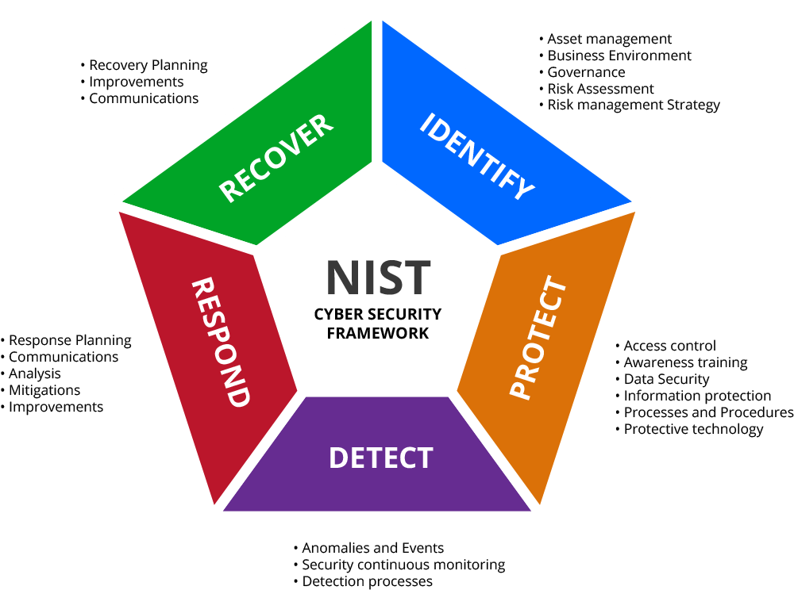
Figure 4: NIST-Based Control Mechanism
(Source: corcystems.com, 2025)

3.4 Cloud, BYOD Security Architecture and Protection Mechanisms
Considering that FinSure Bank uses cloud computing and brings your own device (BYOD) policies, the given design will include a specific security architecture that will resolve these particular challenges. The security of the clouds is also achieved by establishing a shared responsibility model, where the cloud service provider and the organisation have different roles to play in the security. FinSure Bank has to make sure that the cloud environments are well configured, access controls and encryption mechanisms, as well as continuous monitoring, are in place (Amadi, 2025). Cloud Access Security Brokers, automated compliance scanners, are some tools that can be used to increase visibility and control of cloud operations. Data security is also enhanced by using encryption of data at rest and data in transit, and effective key management. Under BYOD, the organisation should have stringent security measures to avert unauthorised access and leakage of data. This involves the application of Mobile Device Management solutions that impose security policies on personal devices of employees, and a containerisation approach that isolates corporate data and personal data (Fonseca-Herrera, Rojas and Florez, 2021). Also, there is the ability to remotely wipe and check device compliance, which means that only gadgets that their owners trust can access sensitive data.
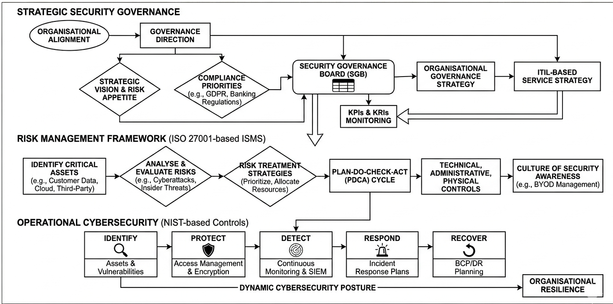
Figure 5: Proposed Integrated Security Framework
(Source: self-developed)

3.5 Compliance, SLA Management and Continuous Improvement Strategy
The last element of the suggested design is aimed at compliance, service level agreement (SLA) control, and continuous improvement, which are important to ensure the long-term security effectiveness and regulatory alignment. FinSure Bank needs to put in place a comprehensive policy framework defining security standards, data protection requirements and operational procedures throughout the organisation. The policies are also consistent and form a reference point to employees and other stakeholders and foster the culture of accountability and compliance. Moreover, the organisation needs to implement security requirements in SLAs with third-party vendors so that their external partners are subject to the same standards as internal business (Mirtsch, Kinne and Blind, 2020). Such things as the definition of data protection responsibilities, timelines of incident reporting, and audit privileges are involved and contribute to the reduction of risks of outsourcing and third-party interdependence. Vendor checks and performance reviews are done periodically to ensure continued compliance and detect potential weaknesses. The feedback mechanisms, performance measures, and periodic review of the security practices are all combined to improve continuously. This is in line with the continual service improvement of ITIL and the PDCA cycle of ISO 27001, which makes sure that the security measures are constantly updated to meet new threats and regulatory requirements (Mahalle, Yong and Tao, 2020). Moreover, the organisation should invest in training and awareness of the employees so that they can be kept updated regarding new risks and best practices.

4. Critical Discussion
The proposed integrated security, governance, and compliance architecture of FinSure Bank illustrates a thorough and theoretically-based design, but its practical application is fraught with numerous challenges and trade-offs that need to be scrutinised critically. Although ITIL, ISO 27001 and NIST frameworks can be integrated to offer a holistic framework, the integration may result in complexity, redundancy of processes, and inefficiencies. The organisations might have difficulties in matching the overlaps in controls and terminologies, which may cause confusion among employees and extra administrative load (Culot et al., 2021). This especially applies to FinSure Bank, because the absence of a single governing system might be a barrier to the successful implementation of such a comprehensive model. Moreover, the high cost of implementation of ISO 27001, such as documentation, auditing, and ongoing monitoring, can be financially and operationally limiting, particularly when the organisation is not advanced enough in cybersecurity. Likewise, the success of the NIST framework depends greatly on whether the organisation can implement more sophisticated technologies like real-time monitoring systems and threat intelligence tools, which can be costly to implement and can demand highly skilled personnel. The operational layer will not be able to provide the desired degree of cyber resilience without the necessary expertise.
One of the most important issues is the human factor, since employees are vital in ensuring security. Despite well-defined policies as well as controls, insider threats, lack of awareness, and resistance to change can undermine the effectiveness of the proposed design. On a broader note, the implementation of high security measures in BYOD without compromising on user convenience is a very delicate balancing act (Reuben-Owoh and Haig, 2025). More specifically, the use of third-party vendors also poses external risks that cannot be completely controlled, even with effective SLA agreements. It has to be stated that the imposed restrictions notwithstanding, the suggested design is a powerful strategic solution because it fosters integration, flexibility, as well as ongoing improvement. Its success is in the gradual implementation, organisational commitment along with the continuous review of the framework to keep the framework feasible in a proper manner.

5. Conclusion
It may be concluded that this study highlighted that one security framework cannot be used to tackle the numerous and intricate cybersecurity, governance, as well as compliance issues of digital financial institutions like FinSure Bank. Through the combination of ITIL to governance, ISO 27001 to risk management, as well as NIST to operational security, a multi-faceted and multi-layered strategy was created to aid in increasing organisational resilience. On an additional note, the proposed design was able to cover major problems such as dependency on the cloud, BYOD risks, as well as fractured governance structures. Furthermore, the integrated model offers a flexible and dynamic solution despite the challenges of implementation like cost, complexity and human factors. Finally, to support effective information security management, constant improvement, regulatory alignment, and organisational commitment are also required.

Reference List
Acte (2024). Information Security Governance: A Complete Hands-on How To Use Guide For Free, ACTE Technologies. Available at: https://www.acte.in/information-security-governance-tutorial (Accessed: 16 April 2026).
Alharbi, S.S., Al Mamun, M., Boubaker, S. and Rizvi, S.K.A. (2023). Green finance and renewable energy: A worldwide evidence. Energy Economics, 118, p.106499. https://www.sciencedirect.com/science/article/am/pii/S0140988322006284
Aljumaiah, O., Jiang, W., Addula, S.R. and Almaiah, M.A., (2025). Analysing cybersecurity risks and threats in IT infrastructure based on the NIST framework. J. Cyber Secur. Risk Audit, 2025(2), pp.12-26. https://jcsra.thestap.com/articles/v-2025-i-2-p-2.pdf
Amadi, C., (2025). From Compliance Audit to Continuous Control: Implementing AI-Based Security Posture Management to Ensure Real-Time Adherence to NIST Cybersecurity Frameworks in CI. Available at SSRN 5940974.https://papers.ssrn.com/sol3/Delivery.cfm?abstractid=5940974
Bouveret, A., Braouezec, Y., Kiani, K. and Wagalath, L., (2025). Coordination Problems in Money Market Funds and Macroprudential Constraints. Available at SSRN 5933235. https://papers.ssrn.com/sol3/Delivery.cfm?abstractid=5933235\
corcystems.com (2025). NIST Support - CorCystems. [online] CorCystems Managed IT Services. Available at: https://www.corcystems.com/services-solutions/cyber-security-compliance/nist/ [Accessed 16 Apr. 2026].
Culot, G., Nassimbeni, G., Podrecca, M. and Sartor, M., (2021). The ISO/IEC 27001 information security management standard: literature review and theory-based research agenda. The TQM Journal, 33(7), pp.76-105.https://www.emerald.com/tqm/article-pdf/33/7/76/2901367/tqm-09-2020-0202.pdf
CyberTalents (2025) Understanding COBIT Framework: Definition, Components, and Benefits, CyberTalents Blog. Available at: https://cybertalents.com/blog/understanding-cobit-framework-definition-components-and-benefits (Accessed: 16 April 2026).
Fajrillah, A.A.N., Lubis, M. and Syam, I., (2022). Organisational Architecture and Service Delivery Re-Alignment based on ITIL and TOGAF: Case Study of the Provincial Development Bank. International Journal of Advanced Computer Science and Applications, 13(4). https://www.researchgate.net/profile/Muharman-Lubis/publication/360381760_Organizational_Architecture_and_Service_Delivery_Re-Alignment_based_on_ITIL_and_TOGAF_Case_Study_of_the_Provincial_Development_Bank/links/63b1bc15a03100368a45d51c/Organizational-Architecture-and-Service-Delivery-Re-Alignment-based-on-ITIL-and-TOGAF-Case-Study-of-the-Provincial-Development-Bank.pdf
Fonseca-Herrera, O.A., Rojas, A.E. and Florez, H., 2021. A model of an information security management system based on NTC-ISO/IEC 27001 standard. IAENG Int. J. Comput. Sci, 48(2), pp.213-222.https://www.researchgate.net/profile/Alix-E-Rojas/publication/362062660_A_Model_of_an_Information_Security_Management_System_Based_on_NTC-ISOIEC_27001_Standard/links/62d485bcd351bd24f51fa7c5/A-Model-of-an-Information-Security-Management-System-Based-on-NTC-ISO-IEC-27001-Standard.pdf
Haidar, A., (2024). An integrative theoretical framework for responsible artificial intelligence. International Journal of Digital Strategy, Governance, and Business Transformation (IJDSGBT), 13(1), pp.1-23. https://www.igi-global.com/viewtitle.aspx?titleid=334844
Legowo, N. and Juhartoyo, Y., (2022). Risk management; risk assessment of information technology security system at bank using ISO 27001. Journal of System and Management Sciences, 12(3), pp.181-199. http://www.aasmr.org/jsms/Vol12/JSMS%20June%202022/Vol.12.No.03.10.pdf
Mahalle, A., Yong, J. and Tao, X., (2020), September. ITIL process management to mitigate operations risk in cloud architecture infrastructure for banking and financial services industry. In Web Intelligence (Vol. 18, No. 3, pp. 229-238). Sage UK: London, England: SAGE Publications.https://journals.sagepub.com/doi/pdf/10.3233/WEB-200444
Milldesk (2024). What is ITIL? [online] Milldesk. Available at: https://www.milldesk.com/what-is-itil-2/ [Accessed 16 Apr. 2026].
Mirtsch, M., Kinne, J. and Blind, K., (2020). Exploring the adoption of the international information security management system standard ISO/IEC 27001: a web mining-based analysis. IEEE Transactions on Engineering Management, 68(1), pp.87-100.https://ieeexplore.ieee.org/iel7/17/4429834/09082865.pdf
Nodehi, S., Huygh, T. and Bollen, L., (2024). Six Board Roles for Information Security Governance. In ICEIS (2) (pp. 713-720).https://www.scitepress.org/Papers/2024/126959/126959.pdf
Parida, P.R., (2024). Driving Business Value: ITSM and Vulnerability Management Mastery. Libertatem Media Private Limited. https://books.google.com/books?hl=en&lr=&id=WYo2EQAAQBAJ&oi=fnd&pg=PA1&dq=assert+that+ITIL+is+suitable+in+organizing+the+processes+of+service+management,+ISO+27001+is+oriented+on+&ots=FIOmvsS9vp&sig=OSyd-V2r0JwigwCw2aj2AHprOb0
Reuben-Owoh, B. and Haig, E., (2025). A Systematic Review of Voluntary Cybersecurity Standards and Frameworks: B. Reuben-Owoh, E. Haig. International Journal of Information Security, 24(5), p.206.https://link.springer.com/content/pdf/10.1007/s10207-025-01121-0.pdf
Sarwar, M.I., Abbas, Q., Alyas, T., Alzahrani, A., Alghamdi, T. and Alsaawy, Y., (2023). Digital transformation of public sector governance with IT service management–A pilot study. IEEE access, 11, pp.6490-6512.https://ieeexplore.ieee.org/iel7/6287639/6514899/10018341.pdf
Sholekha, K.P., Akhmarullah, N.D.Y., Tarwoto, T., Ramadhan, A.D., Setiawan, H., Prasetyo, I.C. and Hermawan, S.N.R., (2023). Optimising IT Service Strategies: A Performance Assessment through ITIL V3 in PT XYZ IT Operations Division. International Journal of Informatics and Information Systems, 6(4), pp.169-180. https://www.ijiis.org.bright-journal.org/index.php/IJIIS/article/download/176/128
Smith, H.K., (2026). Multi-Layered Intrusion Detection Systems Combining CNN-BiLSTM Models with NIST-Based Incident Response Strategies.https://www.researchgate.net/profile/Hussein-Smith/publication/402570829_Multi-Layered_Intrusion_Detection_Systems_Combining_CNN-_BiLSTM_Models_with_NIST-Based_Incident_Response_Strategies/links/69b9be9dc325e338e8eb5ff5/Multi-Layered-Intrusion-Detection-Systems-Combining-CNN-BiLSTM-Models-with-NIST-Based-Incident-Response-Strategies.pdf
Yin, Y., (2024). Information security and risk control model based on Plan-Do-Check-Action for digital libraries. Journal of Cyber Security and Mobility, 13(2), pp.305-326. https://ieeexplore.ieee.org/iel8/10934115/10963997/10963999.pdf

