

Assignment Title: Task 3 and 4 Reflective Journal
Module Name: Skills Development in the Workplace
Module Code: ACMA4031
Program of Study: Foundation Year (Computing and Electronics)
Student Name: Ambreen Kanwal
Student ID #: 2018998
Lecturer Name: Dr. Moutushi Tanha
Task 3
Topic: Collaboration not Competition
Reflective Journal Content
The topic collaboration not competition is aimed to create a strong network of people around who become helpful in activities related to personal and professional life. It is a fact that no organization or business can run without a support of people. Establishing network with people in the form of relatives, friends, customers and observers is required to survive in the society. The concept of stakeholders arises here who are part of the business or project as employees, customers, suppliers, and partners or shareholders.
The topic is divided into three sessions: establishing a supportive network, analysing stakeholders, and creating a stakeholder map. These sessions involve text, videos, and case studies to understand the topic of Mobilising Support, which involves involving people and authorities for methodical and durable solutions. Mobilizing support connects people, producing new ideas, creativity, and actions, reducing barriers and improving results. The conclusion reflects the lessons learned from this topic.
The session discusses establishing a supportive network through relatives, friends, and professional contacts. This network provides advice, new ideas, specialist skills, personal recommendations, business growth opportunities, and financial resources. The BBC video shown in the session where an economist and journalist, Evan Davis, discusses the benefits of contacts and networks in business and employee recruitment. The session highlights three types of networks: strong (family, friends), weak (indirect link), and latent (potential).
Furthermore, three qualities of good network are discussed in this session which are, open, diverse and deep. In the open network, it is not necessary that all known members are connected to each other, but structural diversity comes because new information and ideas are shared in network before others. Diversity is the second quality of a good network in which members belong to different demographics because it gives an understanding of different perspectives. The third quality is being deep into the network, its mean making strong relationships with others which helps in the exchange of useful information, resources and skills with people from different backgrounds. Observed my network's openness, diversity, and depth qualities, scoring 8 in openness, 6 in diversity, and 6 in depth. The first session also shows Patrick Boland's video discussing failure, mentorship, and improvement through self-awareness, finding mentors, and seeking improvement.
The next session focuses on stakeholder analysis, as defined by Freeman (1984). Stakeholders are individuals or groups affected by an organization's objectives. Professor Freeman discusses strategies for managing stakeholder relationships and demonstrates Employee Shareholder Customer Strategy, where companies prioritize employee care over providing excellent services for customers, resulting in greater value for shareholders.
The session further discusses, identifying stakeholders and identifying power Vs. interest. Identifying stakeholders refers to all the relevant bodies involved in the project as the example of Uber is given through mapping. Uber service involves the stakeholders which are, Service Drivers, Public, Regulatory authorities, Trade Unions, Phone Office Booking, and other services. Identifying power Vs. interest matrix is presented by Johnson et al. (2008) which expresses the interest of stakeholders and their expectations of the organisation also level of power stakeholders have to enforce their expectations.
A video from Mind Tools in the session discussed doing stakeholder analysis through these steps, brainstorming, using a power interest grid and finding out their motivations. The power interest grid can be explained as, those have high power and high interest manage closely the organisation or project. Stakeholders with high power and low interest need to be satisfied only. Low power and low interest people monitor the tasks and Low power and high interest stakeholders need to be informed only. A case study of Community Park is given in the session and asked about the identifying stakeholders, mapping them in the power interest matrix and posting to module forum (see Annexure A).
The third session focuses on creating a stakeholder map, involving brainstorming to identify stakeholders related to work. Students are presented with a table of various stakeholders, including family, co-workers, government, and public. Internal stakeholders include employees, managers, and owners, while external stakeholders include suppliers, society, customers, shareholders, and government. The discussion also explores the roles of supporters and critics, with those with high power or interest being considered critics due to their authority to appraise tasks.
In summary, these three sessions of collaboration and competition gave me a positive insight about developing a network, identifying the stakeholders and creating a map to manage stakeholders according to their power and interest. I can easily understand now how to utilize my contacts, work with stakeholders and consider their priorities in work. I have a plan to start my own business of clothing this topic gave me a reflection about collaboration which is actually working with people and identifying their priorities towards the task.

Task 4
Topic Measuring Success
The topic measuring success is trying to encourage students to evaluate success in its true meaning. The topic is divided in three sessions which are, what is success?, Pygmalion effect and success & wellbeing. The conclusion is drawn at the end to discuss how this subject is reflected me as a learner.
The first session explores the concept of success and its characteristics, encouraging students to discuss who they consider successful and what makes a person or organization successful. Success is often associated with an individual or group, but it is not necessarily essential for success. In my point of view, successful people are those influence and inspire society. Here the point comes do being famous is necessary for success? In today's information-driven world, fame can be easily obtained through social media to successful people. A healthy discussion with classmates on success emphasized the importance of achieving life goals and contributing positively to society.
In session two, Pygmalion effect is discussed which means how social and personal expectations of others can impact our feelings of success. An example of school of San Francisco America is discussed in this session where two scholars Robert Rosenthal and Lenor F. Jacobson made experiments on children. The IQ test is taken at the beginning of the academic year from five students of each class and their teachers were told that they are potential academic ‘spurters’ expected to provide better results. The IQ test is taken again at the end of the academic year and as per the expectations they scored better results. Hence, the experiment proved that a good expectation produces better results.
Furthermore, in the session two, various case studies are recommended for students. I have selected Chirayatah et al. (2009) case study for reading in which the study was conducted in the Kerala Minerals and Metals Limited (KMMML) to assess the positive signs given by the superiors to subordinates. The outcome of this case study came as non-verbal and verbal messages, opportunities for personal growth and feedback works as a positive attitudinal behaviour of employees (Chirayatah et al. 2009).
In session two, students were asked to discuss their experience that has ever been, they effected as a victim or perpetrator of Pygmalion effect. I like to share my own experience that I was expected to perform high and I have provided the positive results respectively. My superiors encouraged me at work which boosted my morale and they set targets for me which I have achieved success. I still feel encouraged and motivated which helps me taking new challenges in life. When I see around, I find many people who encourage me also some who discourages me. I find my father and my friends who always keep high expectations on me and I always try to fulfil their prospects.
In the session three, the relation between feelings of well-being and feelings of success is discussed. A video from the Civic Research Initiative discussed wellbeing and how it could be measured. The outcome of the video came as a personal experience of a person about their expectations in life, if someone likes to be happy with little facilities is different to the one with higher expectations. Furthermore, the recommended case study of Baptiste, (2008) states that employee wellbeing improves when management relationship behaviour provides them support and development of trust.
In the session three, the Wellbeing Map is defined which consists of five elements: career, social, financial, physical, and community. These elements determine a person's satisfaction in life. Career factors assess job satisfaction, social factors focus on personal relationships, financial management, physical fitness, and community factors determine a person's locality and relationships with society. The map is available for download and can be found in Annexure B.
In Summary, I can reflect my own understanding of the three lessons that success is achieving something not just personally but for the community as well. For example, Bill Gates is a successful person besides he earned billions but he has given the society concept of personal computers which opened many jobs for people and made their life easier with the use of computers. The Pygmalion effect really exists in my life, and I have given the results when the expectations were high from my mentors and seniors. Well-being is a state of satisfaction which is based on the five elements, career, social, financial, physical and community, I have also applied these to myself. I have found this topic very much useful because I truly understand why need to be successful and how influences the society with the success. It is now my aim to become successful in life with the intention to serve people in the community.
References
Baptiste, Nicole. (2008). ‘Tightening the link between employee wellbeing at work and performance: A new dimension for HRM’. Management Decision. 46. 284-309.
Chirayath, S., Lalgem, E. M., & George, S. B. (2009). ‘Expectations Come True: A Study of Pygmalion Effect on the Performance of Employees’. Management and Labour Studies, 34(1), 125–144.
Geneva: World Health Organization, (2008). Advocacy Step 4: Mobilizing Support. Cancer Control: Knowledge into Action: WHO Guide for Effective Programmes: Module 6: Policy and Advocacy. Available at: https://www.ncbi.nlm.nih.gov/books/NBK195419/ (Accessed: 30-Jun-2023)

Annexure A

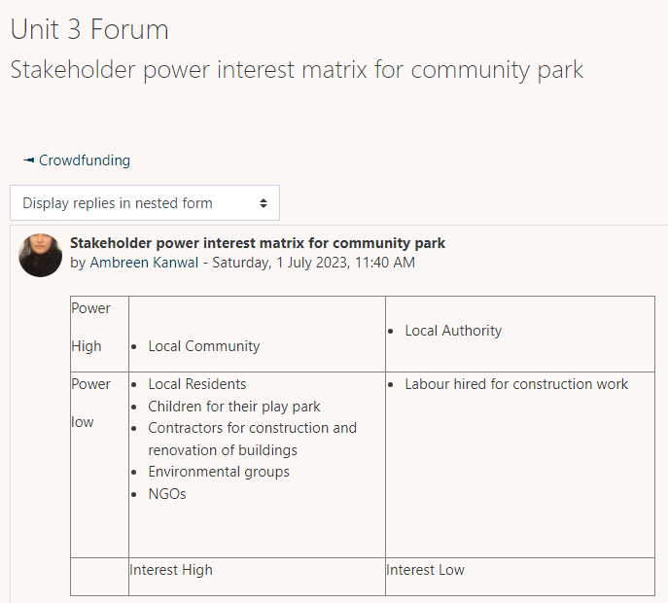

Annexure B
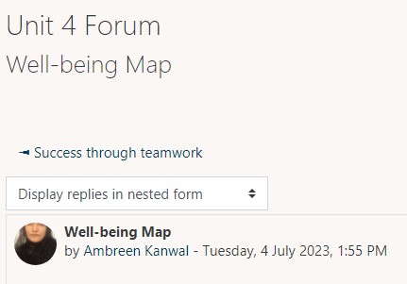

Well-being Map



