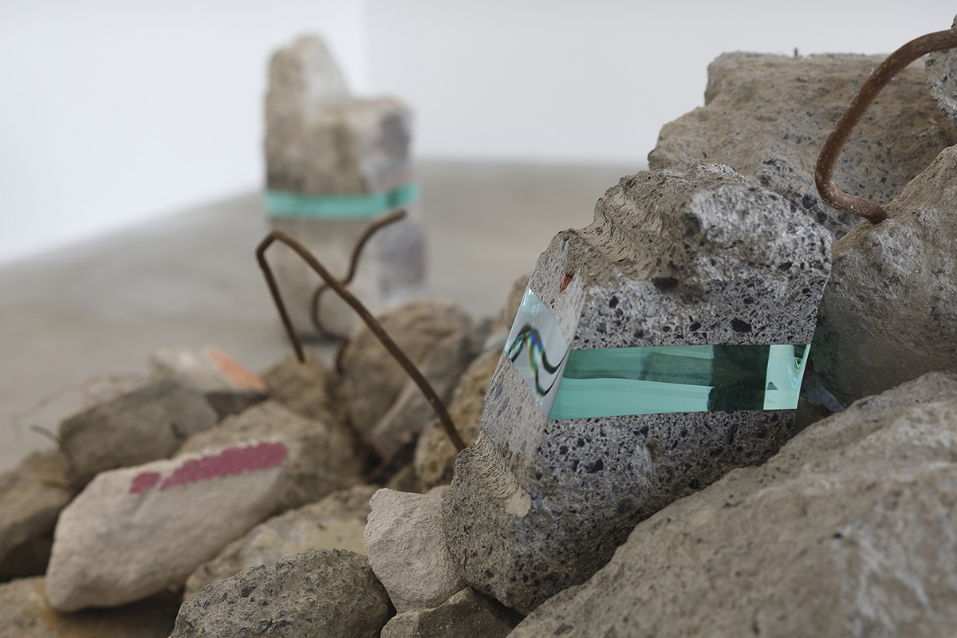

Student name: Antonio Joseph
Student ID number: 2113837
Module: Work Based Project
Module code: ACBA5009
Assignment Title: Learning contract
Lecturer: Dr Deborah Hughes

Table of content
Usage of waste glass in concrete………………………………………………………………………………………………………….1-2
Usage of demolished waste in concrete……………………………………………………………………………………………....3-4
Conclusion……………………………………………………………………………………………………………………………………………….5
References……………………………………………………………………………………………………………………………………………6-7

Usage of waste glass in concrete
Glass is a distinct inert material that can be produced repeatedly without altering its chemical composition. In other words, when bottles are pulverised into cullet, melted, and made into new bottles, the properties of the glass are not substantially changed. Vessels are made primarily of both freshly created glass and recycled glass that has been gathered.
The quantity of waste has been increasing every year in recent years as a consequence of population expansion and industrial development. Solid waste accumulation was anticipated to rise from an expected 2.01 billion tonnes in 2018 to 3.40 billion tonnes by 2050. Natural resources can be preserved and carbon dioxide pollution can be decreased by substituting recycled discarded glass for fine aggregate or cement. In this study I would provide a cost analysis of using waste glass in concrete in addition to information on how adding glass, affects the mechanical, long-term durability, and microstructural features of concrete. As a result, this study will act as a roadmap for subsequent studies in the field. This study will not only exhibit how recycling glass into concrete can lower production costs, but it will also show how it will lessen the amount of waste that would needs to be dumped in landfills.
One of the biggest environmental problems in the world right now is the daily disposal of waste glass. This problem keeps getting worse because there aren't many options for recycling and there isn't much room left in the valuable landfills before they're full. The production of different concrete products, including concrete blocks, self-compacting concrete, and architectural mortar, has been the subject of extensive research to find practical ways to recycle waste glass. Certain of these specialized glass-concrete products have been successfully commercialized and are becoming more popular. A waste management framework can be done to include recycling and waste reduction because they help to protect natural resources and lessen the need for priceless landfill space. The amount of glass waste being thrown out already strains waste facilities all over the world and most countries only use glass bottles once or twice before throwing them away. Wasted glass bottles make up a sizable portion of residues when waste is incinerated and, unlike paper or organic waste, they do not degrade when disposed of in landfills.
Research into the use of unusual materials in construction, such as recycled glass in Portland cement concrete, has been sparked by local recycling restrictions. It is well known that concrete can swell and fracture due to the strong reaction between glass silica and the alkalis in cement paste(alkali-silica reaction or ASR). I will examine the possibility for lowering ASR and creating durable, sturdy concrete by using discarded glass as the aggregate. Studies in the lab and in the field have been conducted on concrete mixes that are mainly used for paving or flat-work uses. Other studies have been done on the results of introducing various gradations of glass particle sizes at various percentages of the overall aggregate composition. Wet prism growth and tensile strength are two of the variables being monitored.
Concrete's tensile strength, endurance characteristics, longevity, shrinkage characteristics, impact, cavitation, erosion resistance, and serviceability are all improved by fibres like glass, carbon, polypropylene, and aramid. Research in glass fibre reinforced concrete led to the development of an alkali resistance fibres high dispersion that improved long-term durability. Fibres impart energy absorption, toughness, and impact resistance properties to fibre reinforced concrete material. These characteristics in turn improve the fracture and fatigue properties of fibre reinforced concrete. Alkali resistance glass fibre reinforced concrete is the term of this method.
Given that glass is susceptible to alkali, it stands to reason that glass strands or coarser glass could undergo ASR in concrete, potentially leading to negative effects. But it would be anticipated that fine ground glass, also referred to as glass powder or GLP, would have pozzolanic (Silicates and aluminates have little cementitious value, but they are siliceous or siliceous and aluminous) qualities similar to those of the substances listed above and would function as a strong ASR suppressant, preventing ASR damage to concrete when reactive aggregates are present. (Shayan & Xu, 2004,Abstract)
In laboratory experiments on concrete, it was discovered that glass particles with a size of about 1.5 mm caused significant expansion while particles with a size of 0.25 mm caused no expansion. Another study was conducted, and it was discovered that, in the particle size range of 0.15-4.75 mm, glass particles of about 1.2 mm produced the greatest mortar bar expansion. They discovered that the greatest expansion occurred when glass particles made up the entirety of the aggregate and that green glass with a chromium oxide content greater than 1.0% had a positive suppressive impact on ASR. Additionally, according to Carpenter and Cramer [9], powdered glass had impacts that were comparable to fly ash's in decreasing ASR growth in accelerated mortar bar tests (AMBT).
The information just mentioned suggests that there are three different ways that glass can be used in concrete: as coarse and fine aggregates, as well as in powder form. The GLP, like other cementitious materials, can inhibit the ability of the coarse and fine glass aggregates to cause ASR in concrete.

Usage of demolished waste in concrete
A major issue other than waste glass material today is the sizeable amount of construction and demolition waste produced. Sustainable growth should have a focus cantered on environmental protection and the conservation of the earth's natural quickly depleting natural resources. Continuous industrial development creates significant issues with the disposal of building and demolition waste. On the one hand, there is a severe lack of natural aggregates for the creation of new concrete, and on the other, the massive quantities of demolished concrete created from decayed and out-dated structures creates severe ecological and environmental problems.
The first nation to recycle construction waste was Germany following World War II. Since then, research initiatives carried out in several countries have indicated sufficient potential for advancing the use of building waste as a component in new concrete. Waste from construction and demolition projects includes things like cracked pavement, building blocks, and cracked concrete. Because of this, recycled aggregate might come from the demolition of buildings like bridge pylons, airport runways, and concrete roadbeds. Concrete made with such materials is referred to as recycled aggregate concrete.
The construction industry contributes significantly to the economies of many nations, but it also has a significant negative impact on the environment because it consumes a lot of resources and produces a lot of waste. Using recycled aggregate made from construction and demolition waste as opposed to traditional aggregates has two benefits for the environment: it uses fewer natural resources and requires less space for garbage removal and an addition benefit would be that it would reduce the cost of building to structures. Because of this, many studies have been conducted in recent years to investigate the viability of using recycled aggregate in a variety of civil engineering projects, which can significantly improve a country's financial and environmental sustainability.
Recycled aggregate may cause a slight decrease in the workability and compressive strength of concrete due to its higher water uptake and reduced density. Research has been conducted to discover how to limit adhered mortar or seal the pores of recycled concrete and demolition waste aggregates in order to improve the material quality.
A variety of materials, including concrete, timber, metals, and some hazardous substances, are produced during building and demolition activities. Given the intricacy and makeup of these materials, segregating building and demolition waste becomes a challenging job. While concrete has distinct properties that make it unique and challenging to manage, wood and metal can either be recycled directly or, in a select few cases, reused without further processing. Because so many natural resources are used to produce concrete, it is unavoidable to use leftover concrete. This will result in a substantial decrease in the amount of inert waste that goes into landfills, allowing for the conservation of natural resources. A large percentage of this waste will be retrieved as repurposed aggregate with mortar attached to their surface, which led to increased chloride penetration capability, reduced strength, and high water absorption.
According to studies, it is advantageous to use more recycled concrete in paving projects. However, there are some limitations when used in construction. In-depth analysis is being conducted to address these problems, and after establishing a few guidelines, it supports the safe and economical use of reclaimed concrete in the future. To examine the properties of recovered aggregate concrete, some trial work was carried out in the 1980s by the United states of America. According to the research, the United States of America used about 2.7 billion metric tonnes of aggregate, of which pavements accounted for 10-15%, other road works and maintenance activities consumed another 20-30%, and structural concrete accounted for the majority of the remaining 60-70%. Natural aggregate providers, contractors, and waste recycling facilities, which have relative market shares of 50%, 36%, and 14%, create recycled aggregate in the US.
It has been demonstrated that materials and parts recovered from demolished buildings are used for new construction and renovation projects, particularly by low-income populations in various countries. Additionally, it has been noted that after the current financial crisis, materials that were once thought unsuitable for reuse have returned to the market. As more material can be salvaged for new construction projects, demolition contractors are becoming more aware of this possibility. They therefore place a high value on the orderly organization, storage, and display of their products.
Rapid industrial development globally is a factor in difficult matters like the loss of natural aggregates and the vast quantity of refuse materials generated by building and demolition work. One method to mitigate these problems is to use recycled aggregate in the concrete components used in new building.

Conclusion
One of the sustainable answers to the increasing waste disposal problem and the depletion of natural aggregate sources brought on by the building industry is the recycling of glass and demolition waste, which can be used as recycled aggregate. Recycled aggregate has, however, primarily been utilised in low-value uses up until now, such as the foundation of pavement. Recycled aggregates have a more complicated microstructure and are more porous when compared to natural aggregate. By efficiently using the waste stream, the rapidly expanding construction industry can cut down on the use of natural resources and the amount of demolition and glass waste that is deposited in landfills, leading to a circular waste economy that will boost the economy of different countries and generate thousands of new jobs. By implementing effective management methods and integrating cutting-edge technology, building waste may be recycled according to its quality and usage, maximising the enormous potential associated with recycling. Because recovered coarse and fine aggregates absorb more water, they usually require more water than conventional concrete to achieve the same workability. This also affects the uniformity of the new concrete during casting, which lowers the mechanical strength of concrete. This research addresses the issue of waste produced by the building industry, including broken glass and demolished concrete. It has been proposed to reuse some of these waste materials to replace a portion of the main materials used in the common portland cement concrete in order to dispose of or at least decrease the build-up of these types of waste.

References
Akhtar, Ali, and Ajit K. Sarmah. “Construction and Demolition Waste Generation and Properties of Recycled Aggregate Concrete: A Global Perspective.” Journal of Cleaner Production, vol. 186, June 2018, pp. 262–281, www.sciencedirect.com/science/article/pii/S095965261830742X, https://doi.org/10.1016/j.jclepro.2018.03.085. Accessed 22 Feb. 2023.
Batayneh, Malek, et al. “Use of Selected Waste Materials in Concrete Mixes.” Waste Management, vol. 27, no. 12, Jan. 2007, pp. 1870–1876, www.sciencedirect.com/science/article/pii/S0956053X06002601, https://doi.org/10.1016/j.wasman.2006.07.026.
de Andrade Salgado, Fernanda, and Flávio de Andrade Silva. “Recycled Aggregates from Construction and Demolition Waste towards an Application on Structural Concrete: A Review.” Journal of Building Engineering, vol. 52, July 2022, p. 104452, www.sciencedirect.com/science/article/pii/S235271022200465X, https://doi.org/10.1016/j.jobe.2022.104452. Accessed 26 Mar. 2023.
Jorge De Brito, and Nabajyoti Saikia. Recycled Aggregate in Concrete : Use of Industrial, Construction and Demolition Waste. London, Springer, 2013. Accessed 9 Feb. 2023.
Ling, Tung-Chai, et al. “Management and Recycling of Waste Glass in Concrete Products: Current Situations in Hong Kong.” Resources, Conservation and Recycling, vol. 70, Jan. 2013, pp. 25–31, www.sciencedirect.com/science/article/pii/S0921344912001917, https://doi.org/10.1016/j.resconrec.2012.10.006. Accessed 8 May 2023.
Mallum, Isa, et al. “Sustainable Utilization of Waste Glass in Concrete: A Review.” Silicon, 17 May 2021, link.springer.com/article/10.1007/s12633-021-01152-x, https://doi.org/10.1007/s12633-021-01152-x. Accessed 12 Apr. 2023.
Pacheco-Torgal, Fernando. Handbook of Recycled Concrete and Demolition Waste. Woodhead Publishing Limited, 2017. Accessed 2 Feb. 2023.
Rao, Akash, et al. “Use of Aggregates from Recycled Construction and Demolition Waste in Concrete.” Resources, Conservation and Recycling, vol. 50, no. 1, Mar. 2007, pp. 71–81, www.sciencedirect.com/science/article/pii/S0921344906001315, https://doi.org/10.1016/j.resconrec.2006.05.010. Accessed 8 May 2023.
Shayan, Ahmad, and Aimin Xu. “Value-Added Utilisation of Waste Glass in Concrete.” Cement and Concrete Research, vol. 34, no. 1, Jan. 2004, pp. 81–89, www.sciencedirect.com/science/article/pii/S0008884603002515, https://doi.org/10.1016/s0008-8846(03)00251-5. Accessed 4 May 2023.
Chandramouli, K. et al. (2010) “Strength properties of glass fiber concrete,” ResearchGate [Preprint]. Available at: https://www.researchgate.net/publication/288971117_Strength_properties_of_glass_fiber_concrete.
Husain, A. and Assas, M.M. (2013) “Utilization of demolished concrete waste for new construction,” ResearchGate [Preprint]. Available at: https://www.researchgate.net/publication/292770154_Utilization_of_demolished_concrete_waste_for_new_construction.

