Course Title: BSc in Applied Computing

Interface Design Prototyping and Analysis

By Kyle Pixley

26th March 2021

Contents
Usability Engineering Assignment 1
Introduction 3
Interface Design Research 3
Interface Design Principles / Rules / Guidelines 3
User Requirements 4
Hierarchical Task Analysis 5
Human Factors 9
Prototype Design 10
Walkthrough 27
User & Self Design Evaluation 27
Software Prototype 28
Overall Evaluation 43
Conclusion 44
References 45
Appendix 46

Word Count (without the table of contents, references, and title page) – 3296 Words

Introduction
This report will look at interface design life cycles, interactions with interfaces, and various stages found in usability engineering lifecycles this will be done by looking at design rules and principles with references to Dix, Shneiderman, Nielsen, and Norman’s principles for design. Once research has been completed on interface design the requirements for the target user group will be defined using a task analysis which will aim to break down tasks into hierarchical levels so an understanding of how the system will progress when in use.

Interface Design Research
“Usability engineering is a professional discipline that focuses on improving the usability of interactive systems.” Usability engineering makes use of theories and principles to find, define and improve problems that occur when using systems. ^{[1]}
Requirements analysis within a usability engineering lifecycle is an analysis of user characteristics, and tasks in the system. The second stage within the usability engineering lifecycle is designing, testing, and developing the system, this stage typically takes a top-down approach to designing the system, testing completed within this stage provides feedback on issues allowing for improvements. The final stage within a usability engineering life cycle is installation, this is where the system is implemented, and feedback is gathered from end-users. ^{[2-5]}
Each stage mentioned will be used to ensure the interface is designed fit for purpose and usable, requirements analysis determines users so plans can be created before the designing phase, this identifies functionality necessary for the system to function. The designing, testing, and development phases enable the creation of an interface using information from the requirements analysis using drafts to ensure user interfaces are easy to use, the installation phase is beneficial to this project as it ensures issues are resolved before implementing the system into a live location, this reduces bugs and issues during the implementation phase.

Interface Design Principles / Rules / Guidelines
When looking at the usability of interfaces several principles should be considered, these principles come from Shneiderman, Gibson, Norman, Dix, and Nielsen, the listed people have their variation of rules for the usability of interfaces but there are a significant amount of similarities between each of the principles they state. This section will look at some principles while comparing various principles from each person. To begin, this report will look at Alan Dix’s principles for interface design and will compare them with other people while doing so.
Dix’s principles for interface design include learnability, flexibility, and robustness. Learnability refers to how easy an interface is for new users and whether they can interact with the interface and maximise the performance of the system. Principles under learnability are predictability, synthesizability, familiarity, generalisability, and consistency. Predictability looks at how interactions completed in the past impact future actions within systems, the benefit of an interface or system being predictable is users can determine how actions will affect the system. Synthesizability looks at the effects past actions have on the current state of the system, if an interface is synthesizable changes made by users through actions can be seen, if a user is unable to understand changes that have occurred it can lead to confusion, users may believe the system is broken. ^{[5]}
Familiarity is the ability to use prior knowledge of a system in newer systems, if a system is familiar a user will be able to finish tasks within a shorter time due to the knowledge they possess. Generalisability is the act of making functionality for specific sections of an interface general using knowledge from other situations. Consistency refers to inputs and outputs being similar in a wide range of scenarios by using the same features and functionality throughout the system, a consistent interface makes processes easier for users as they will not need to learn new layouts or functionality. Shneiderman, Nielsen, and Norman all have principles revolving around consistency and matching for designs which can be linked back to Dix’s principles for learnability. Norman’s principle for consistency discusses uses of affordances which suggests how to interact with something. Nielsen has a rule for recognition over recall, so users do not have to rely on memory so cognitive overload does not occur, this links to Shneiderman’s reduce short-term memory load principle. ^{[6-10]}
The principles of flexibility include dialogue initiative, multithreading, task migratability, substitutivity, and customisability, Dialogue initiative makes sure inputs from users do not have constraints from the system this is known as user pre-emptive and is more flexible than system pre-emptive because users can input any action towards the system. Multithreading is the ability of a system to support user’s interactions for more than a single task at a time, users can start a task and interact with other parts of a system for example “you are editing a program when a beep indicates that a new electronic mail message has arrived.” Task migratability refers to responsibilities for task execution between users and the system, an example of task migratability is spell checking a document because users can utilise the system to check for spelling errors but can also manually check, leaving this task to a single side can cause common mistakes including the system attempting to correct names. Substitutivity is the ability to use alternate values that are equivalent for both input and output, an example of substitutivity is using fractions or decimals for input. Customisability is the ability to modify an interface to fit user needs, modifying an interface changes the interface visually, this allows users to feel more comfortable using the interface. Shneiderman and Nielsen have principles like Dix’s principles for flexibility, Shneiderman’s principle for keeping users in control, and universal usability can be linked-to dialogue initiative and customisability. Nielsen’s flexibility and efficiency of use principle can be linked as this allows users to tailor actions for easier use. This principle discusses features for novices, experts, and people with disabilities. ^{[6-10]}
The principle of robustness refers to the observability, recoverability, responsiveness, and task conformance of a system. When discussing observability, it refers to the understanding of a systems state from visible representations. Recoverability is the ability to correct mistakes when found by users like returning to a previous screen due to incorrect information, this is beneficial to a system as users will be less worried about making mistakes. Responsiveness is the speed that changes are made visible for users within a system, if a system is unable to provide instant response it should be made visible to users. Task conformance is whether the system can support tasks users want to perform and how users understand them, systems should allow users to complete tasks from the task analysis, if the system cannot do this it does not meet requirements. Shneiderman, Nielsen, and Norman have principles for error prevention, aesthetic minimalist design, visibility, and offering informative feedback and dialogs to yield closure which links to Dix’s recoverability and observability because feedback and help and documentation would provide information for fixing errors when they occur. Aesthetic minimalist design is like observability as it is used to remove unnecessary information so cognitive overload is minimised. ^{[6-10]}

User Requirements
I have been asked to produce an interface design for a blood test kiosk. The system should allow users to register within the system, users should be able to select test types based on their gender, the available tests include pregnancy, STD, and blood chemical. The system should ask users for payment, prices will vary for each test, and users should be able to pay via credit card or cash. The kiosk should provide instructions for users completing blood tests, once the test has been completed users should be allowed to select a method of collection for their results – either printed or emailed, and users should receive recommendations after results have been collected.

Hierarchical Task Analysis
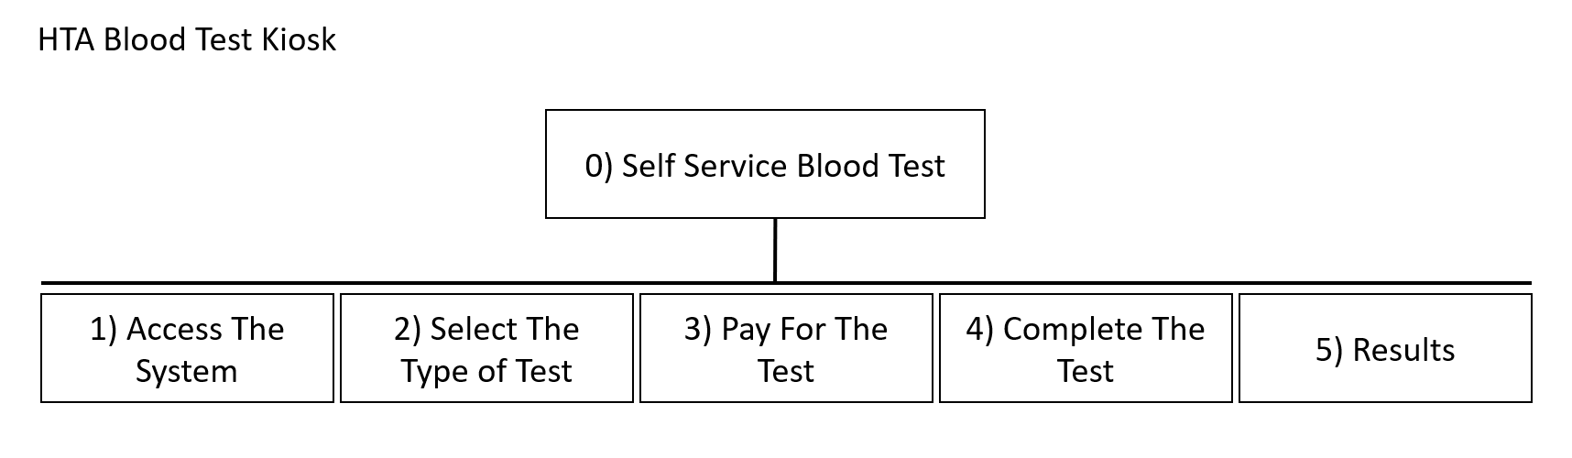
Accessing the System
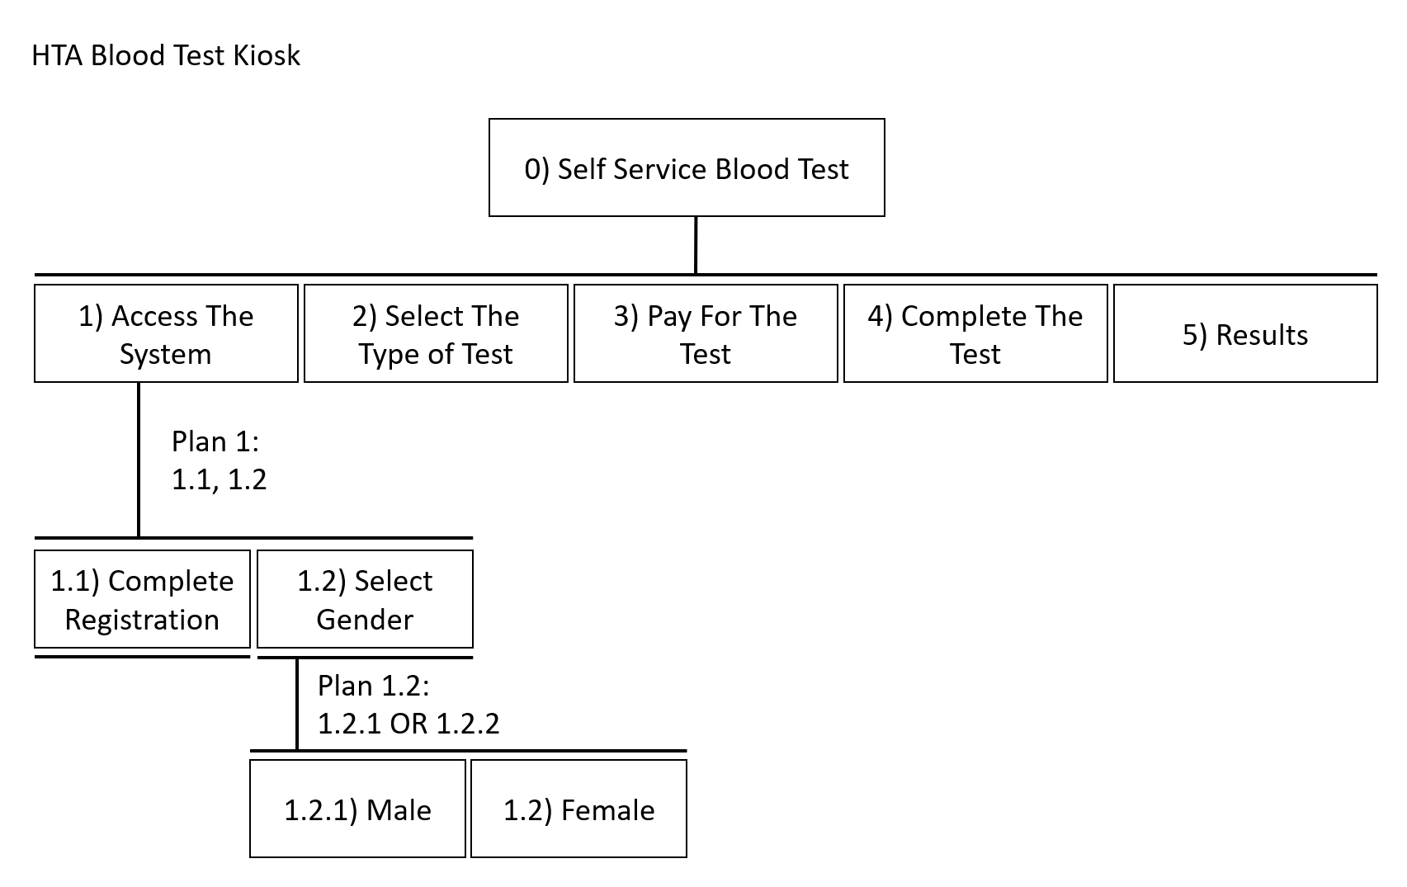

Selecting the test
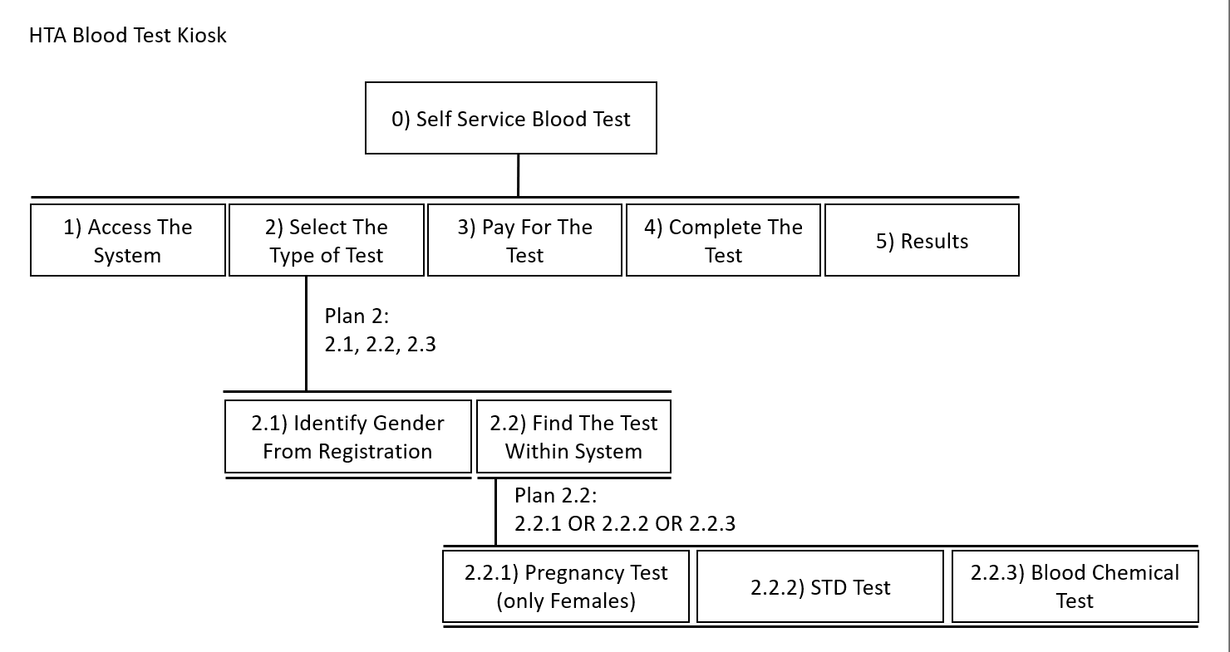
Payment for the test
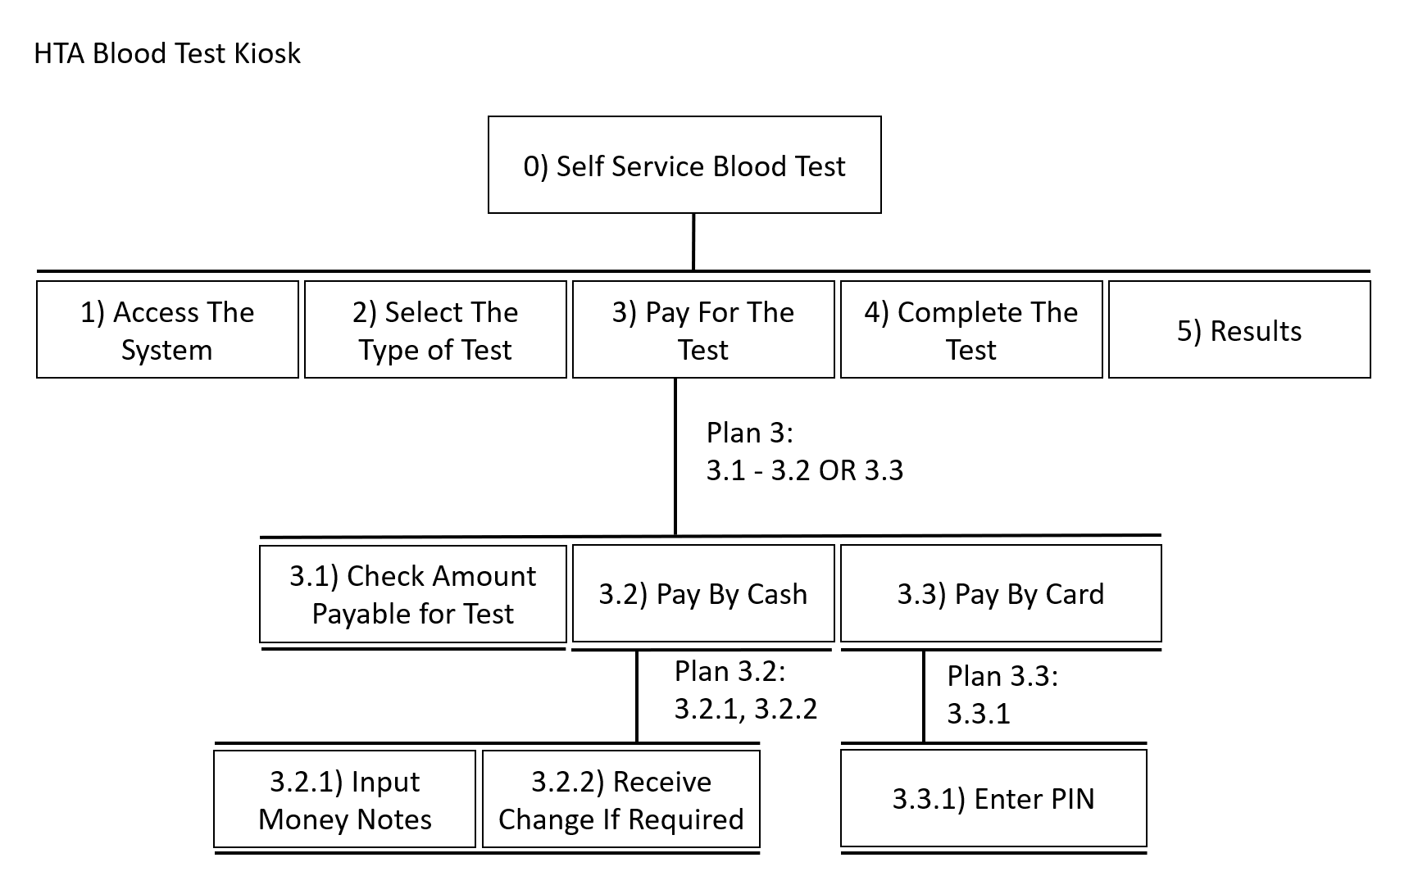

Completing the test
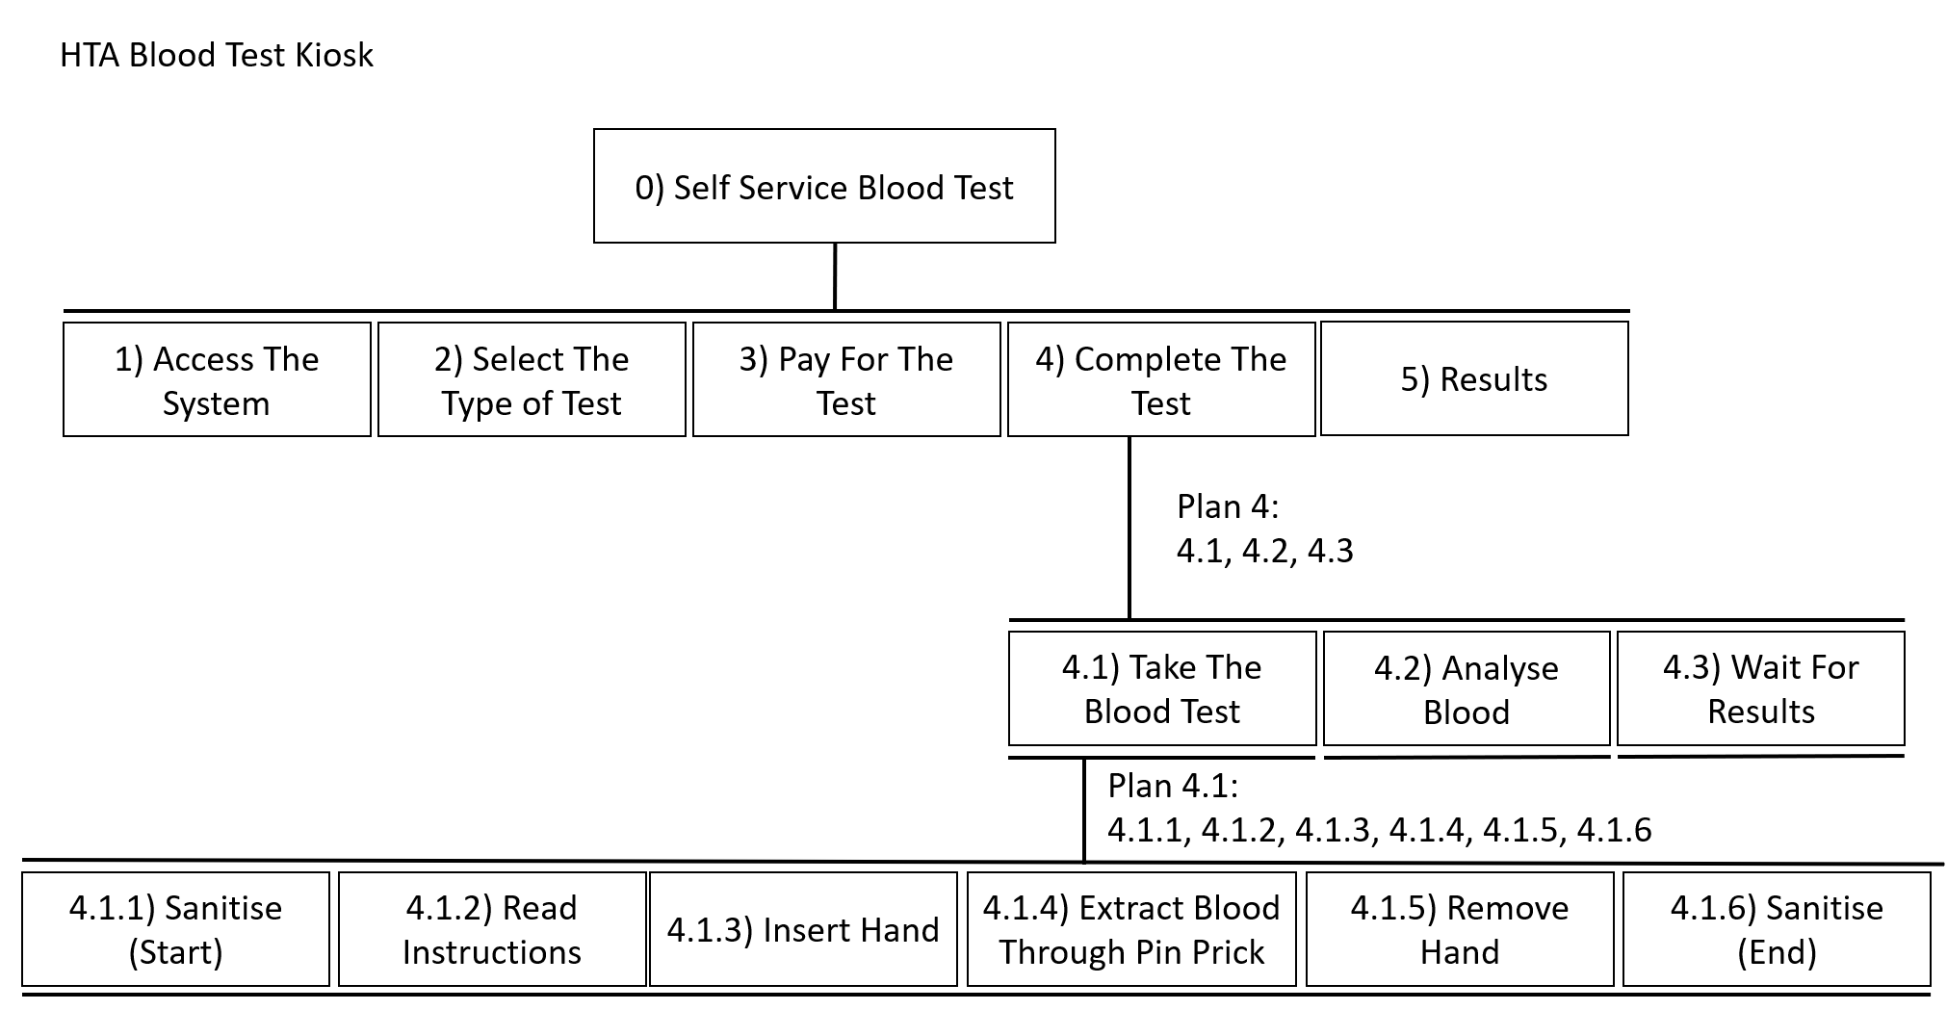

Results Collection
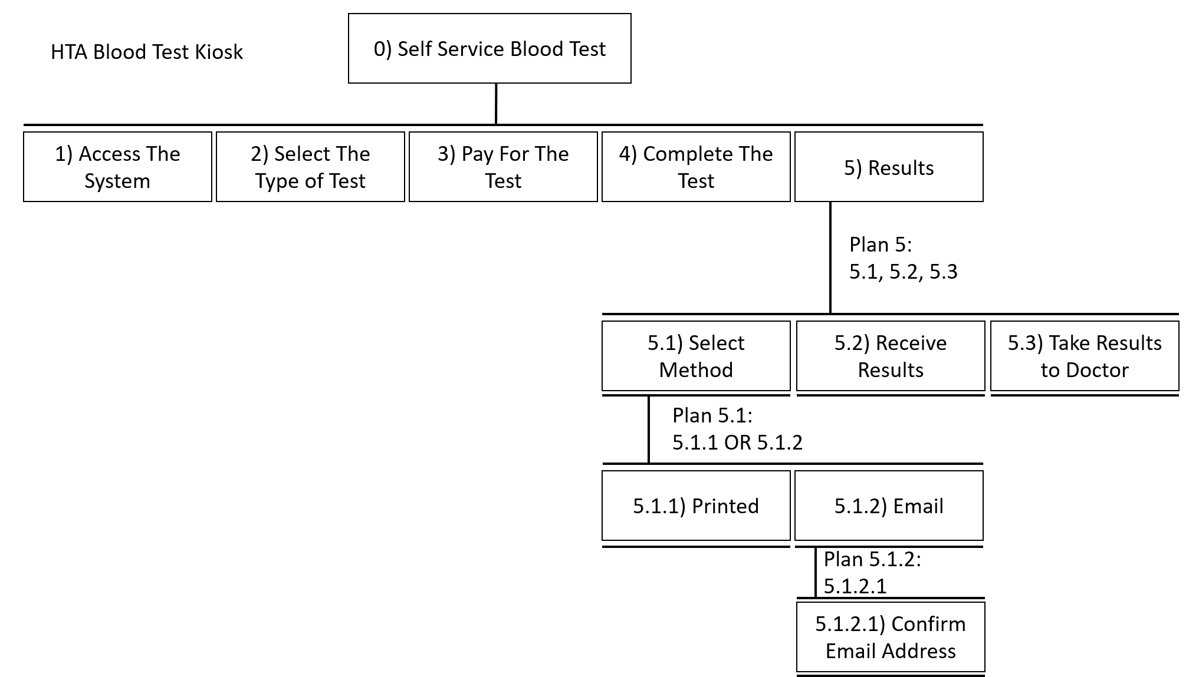
The screenshots above provide the breakdown of tasks within the required system, this shows base tasks and breaks them down further, this task analysis will be used in the designing of the system to ensure users can complete all tasks and meet task requirements. Registration will need to be completed, depending on gender later sections of the system will either be available or unavailable.
The second task to select a test type, to achieve this, users will be given a list of tests based on their gender, only if they chose female a pregnancy test will be shown.
Once a test has been selected users will need to pay for the test, they will be taken to a screen where the amount owed is displayed with choices between card and cash payment, they will be taken to a screen for the method they chose, card payments require users to input their PIN to pay by card, payment is then processed.
When users have paid for the test they are taken to a screen where instructions on how to complete the test will be presented. Once the test is completed, results from the analysis will be provided to users.
When users have finished reading the analysis, they can choose how to receive their results, they can choose either a printed copy or an emailed copy. After the results have been collected users are provided some recommendations like visiting their doctor.

Human Factors
Cognition is the functions users complete mentally for acquiring, retaining, and using knowledge. An example of cognition would be thinking as it is done consciously or unconsciously and fast or slow. Being able to do something without a need for effort and doing so intuitively is experiential according to Donald Norman while having to pay attention and use decision making is a reflective state of cognition. Creating an interface that requires a minor amount of thinking means users can complete processes without needing much effort. ^{[11]}
Memory is a person’s ability to recall information after storing and retaining the same information, essentially memory is the ability to use past experiences to have an impact on current behaviour. There are three types of memory which include sensory memory, short-term memory, and long-term memory. Short-term memory is used for temporary recall of information, this memory is typically quick but stored information rapidly decays. Long-term memory is slower as it contains more information which has a slower decay if any. When storing information in long-term memory use of rehearsal may be required so information can move from short-term memory to long-term memory. Typically, you are more likely to recognise something than recall information regarding the same thing. The use of images enables our ability to activate memories. The use of memory in designs is done using labelling like images. ^{[12-13]}
Visual perception is the ability of the brain to make sense of what is being seen. Context allows people to understand what they are viewing and helps resolve any ambiguity and provides users with options as to what they are viewing. Changing the shape of a word like the location of a capital letter can make the speed and accuracy of reading lower. ^{[13]}

Prototype Design
Start Screen
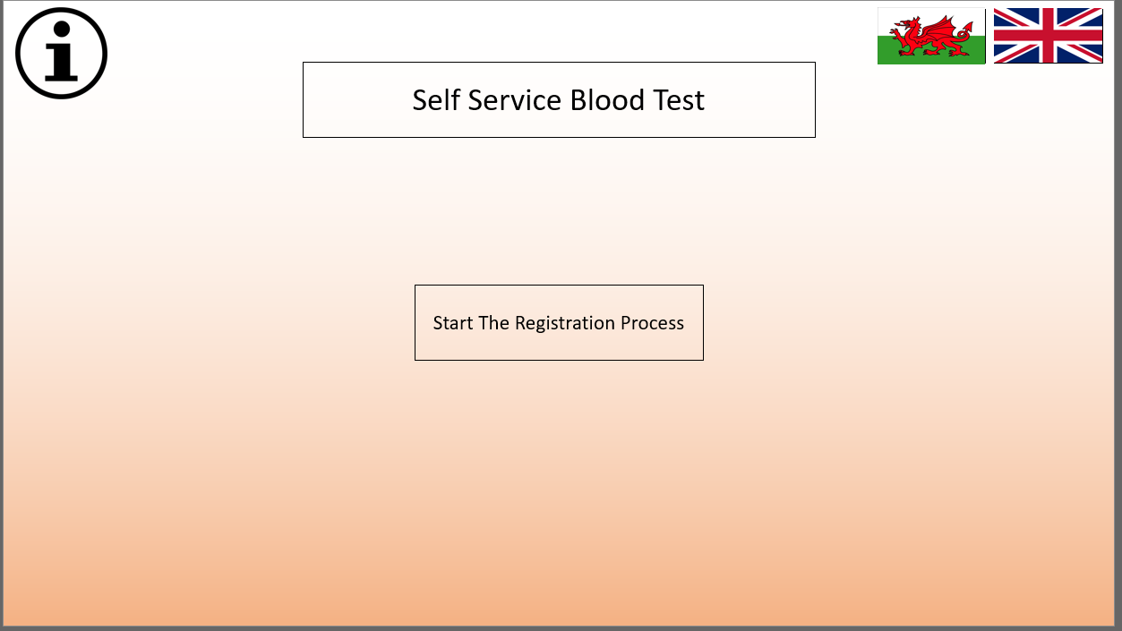
Registration Screen
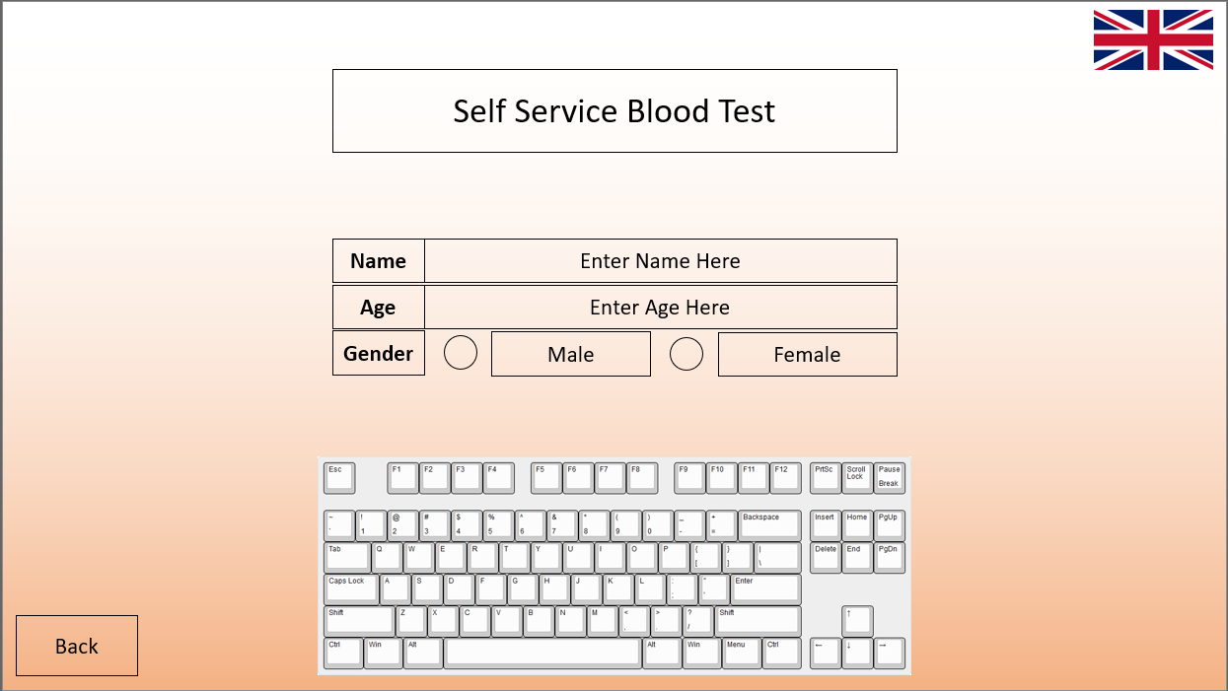

Test Selection Screen (first is female and second is male)
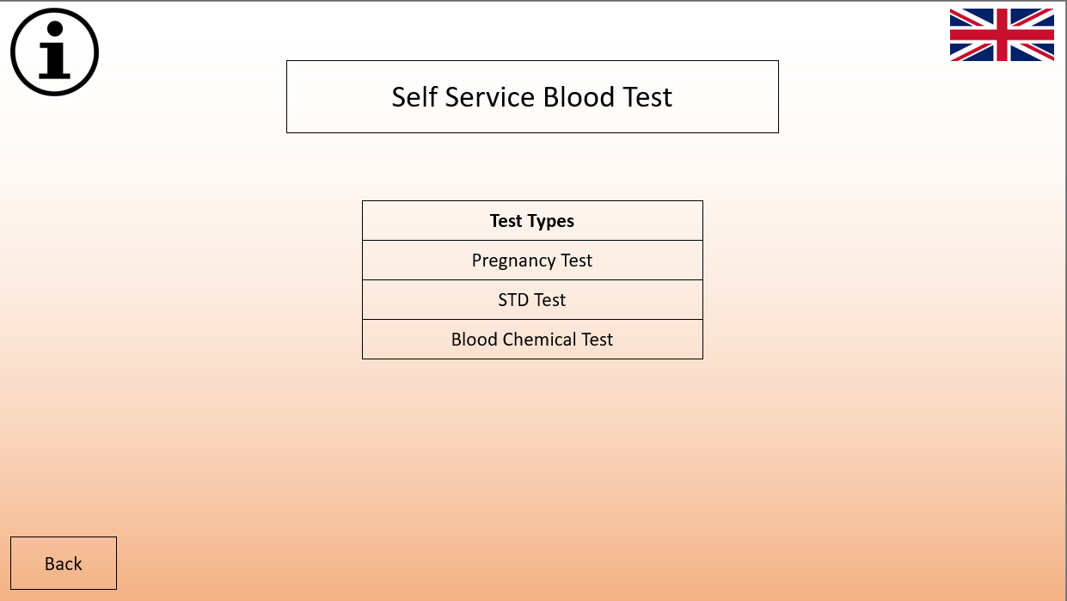
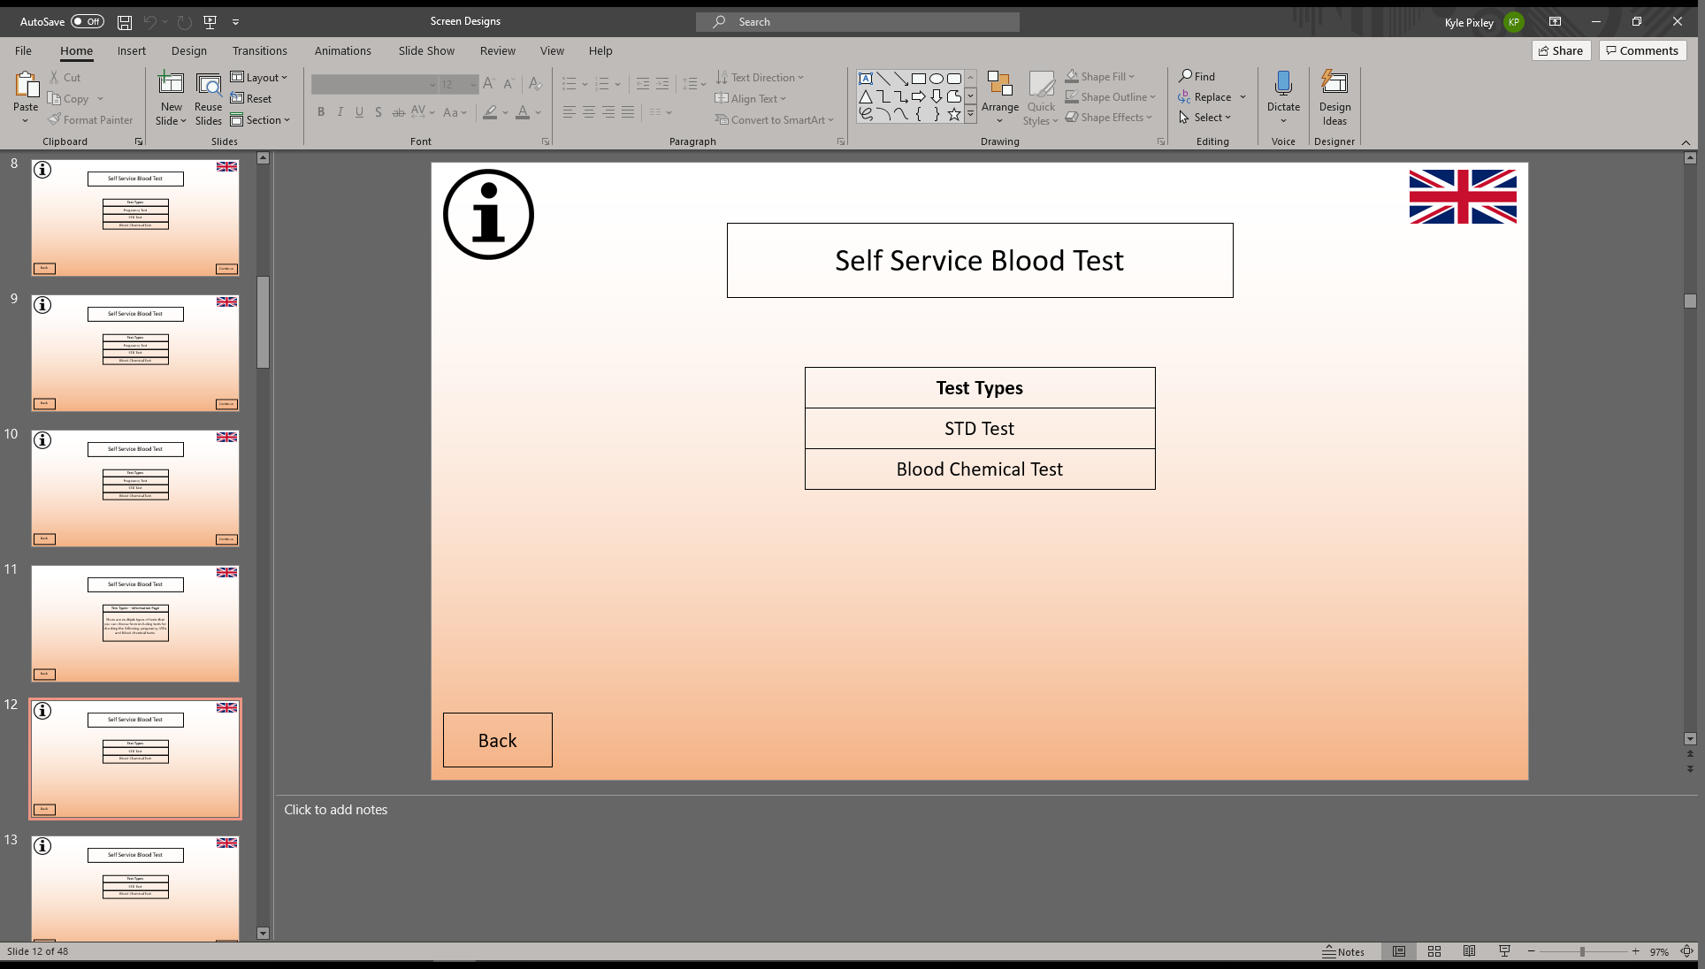

Payment Screens (Selection, Cash Payment Screen, Card Payment Screen)
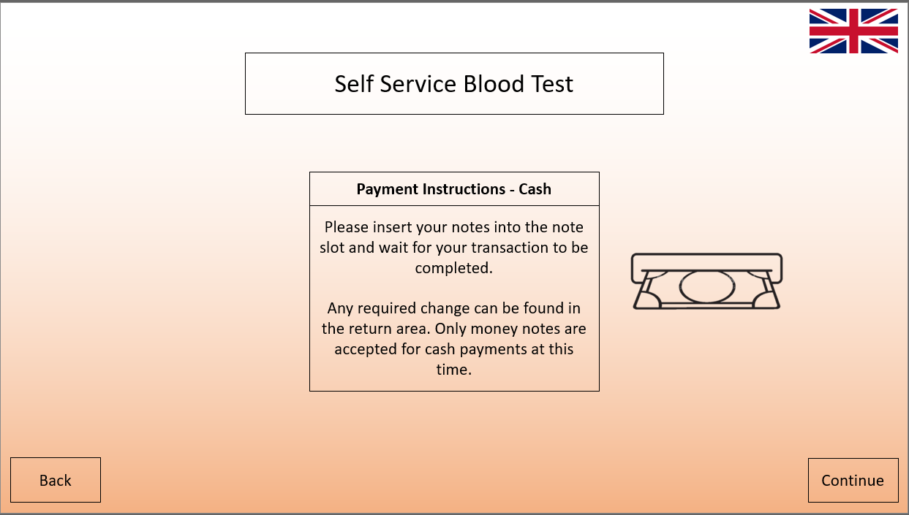
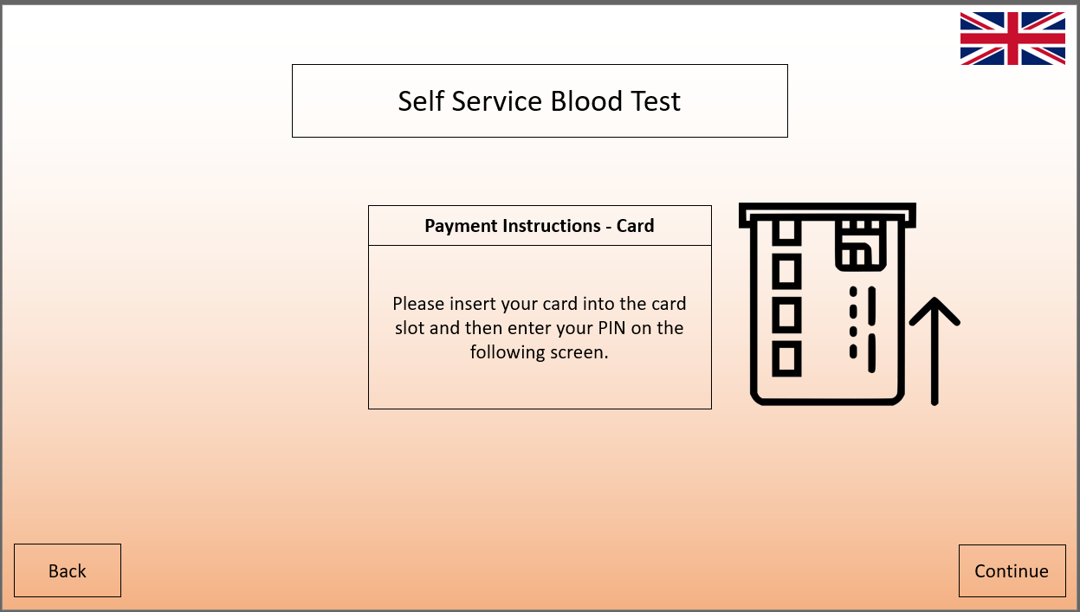
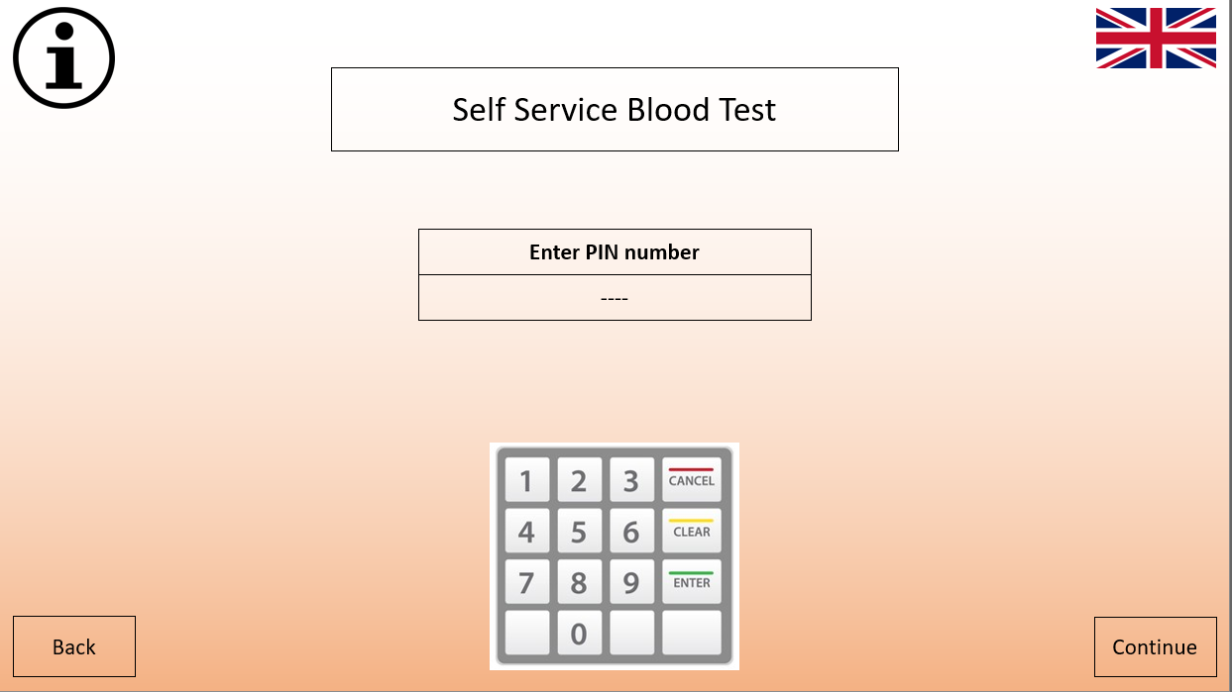
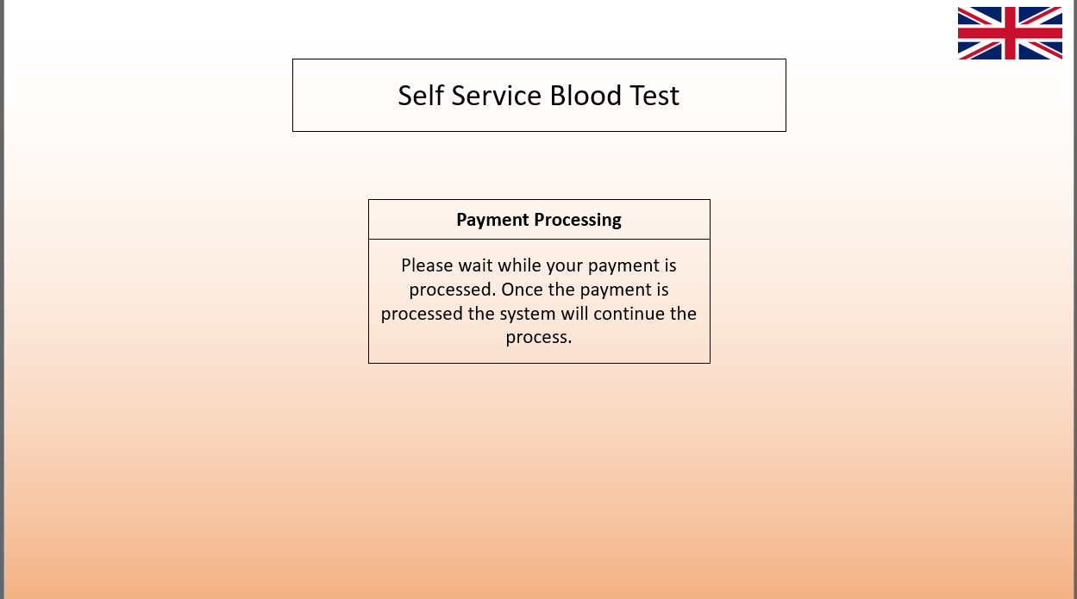
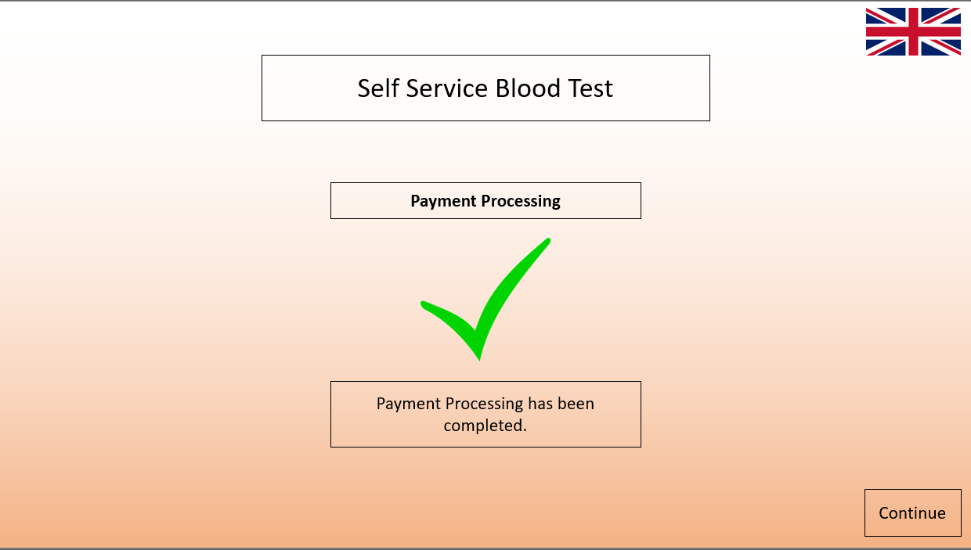

Test Screens (Instructions, Waiting for Test Screens)
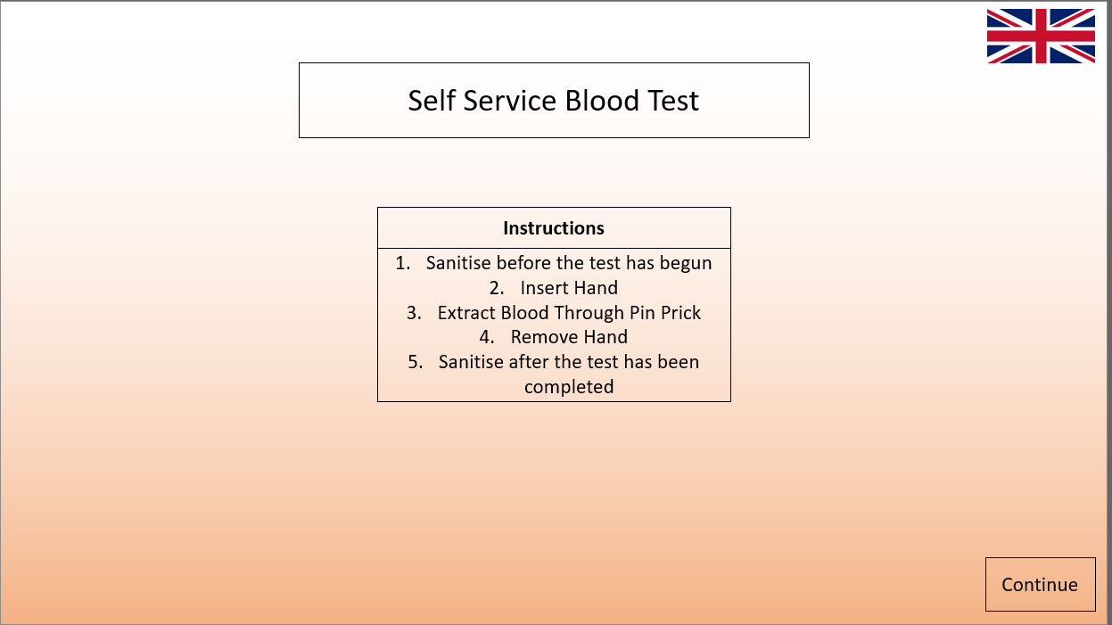
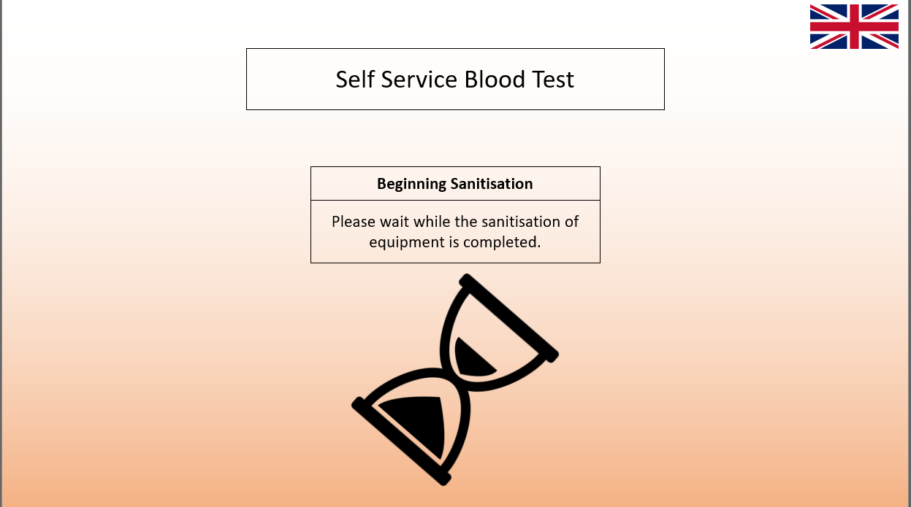
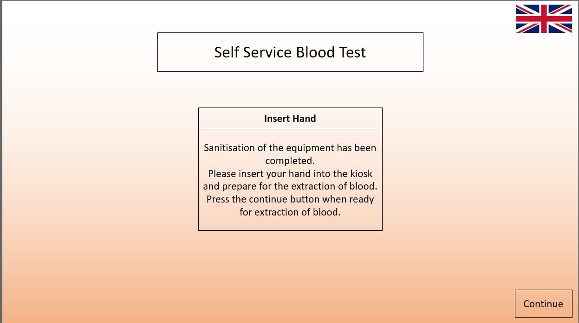
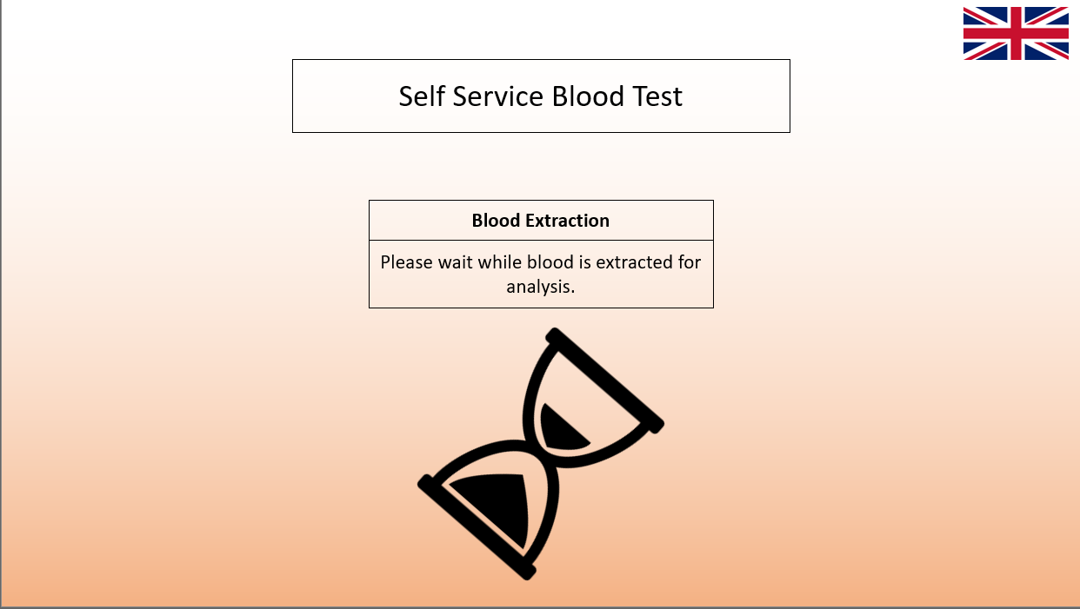
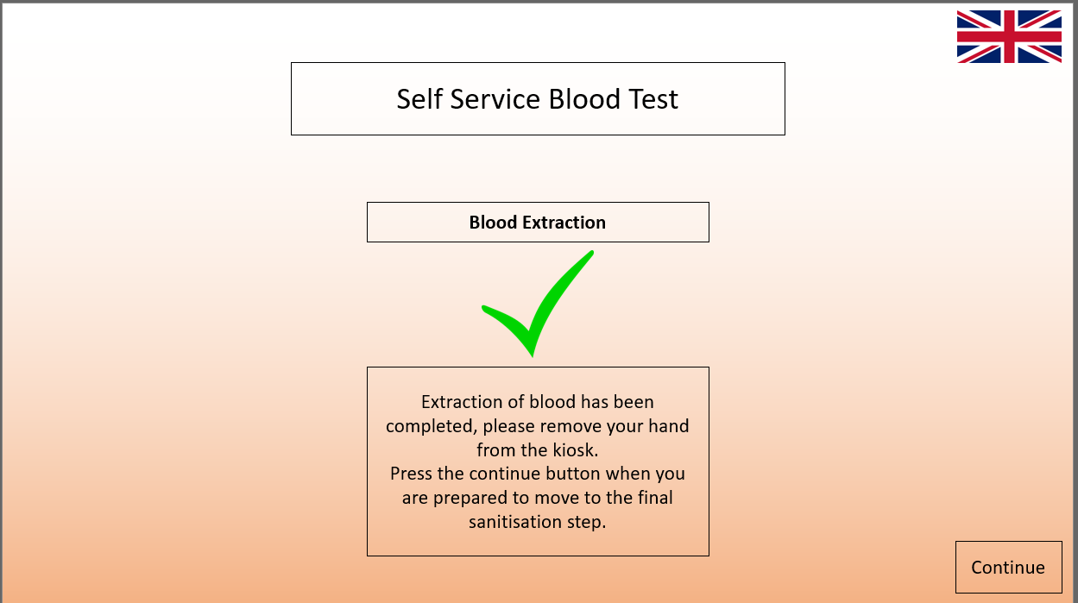

Blood Analysis Screen
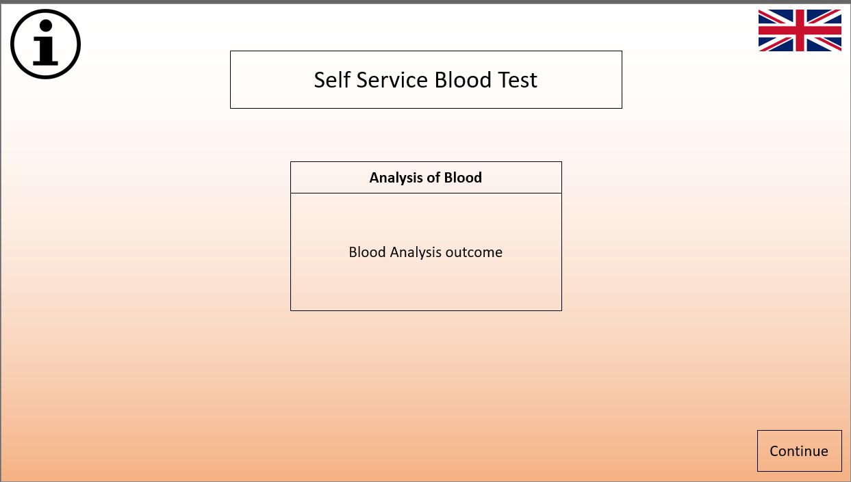
Results Screens (Collection Method, Printed Results, Emailed Results)
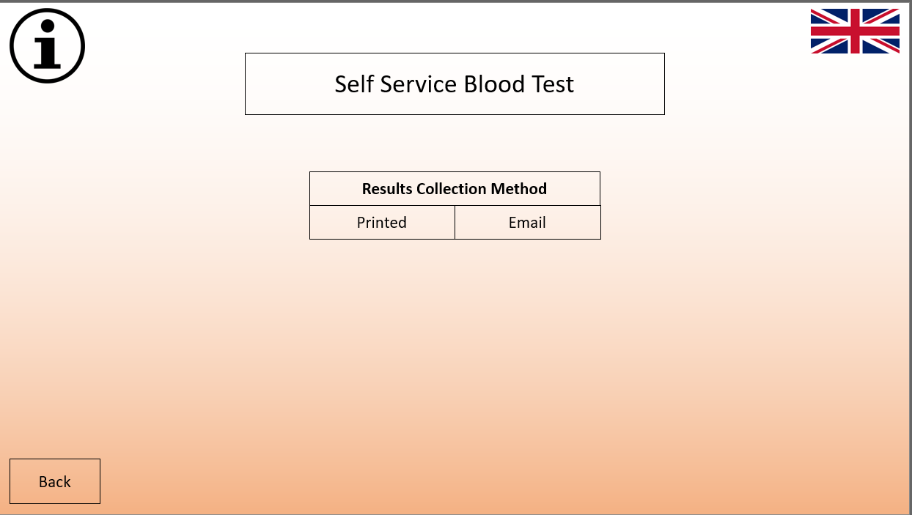
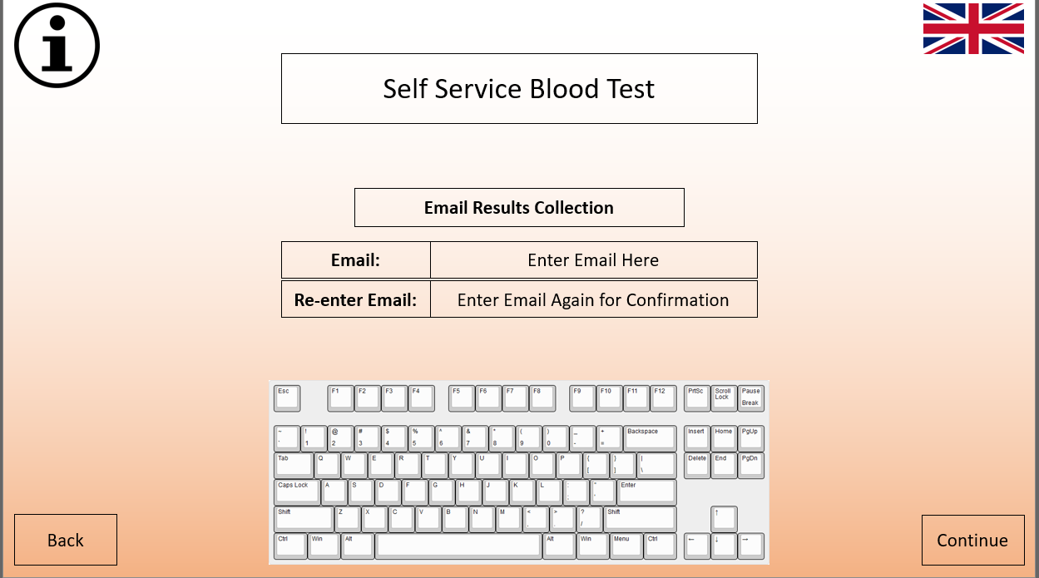
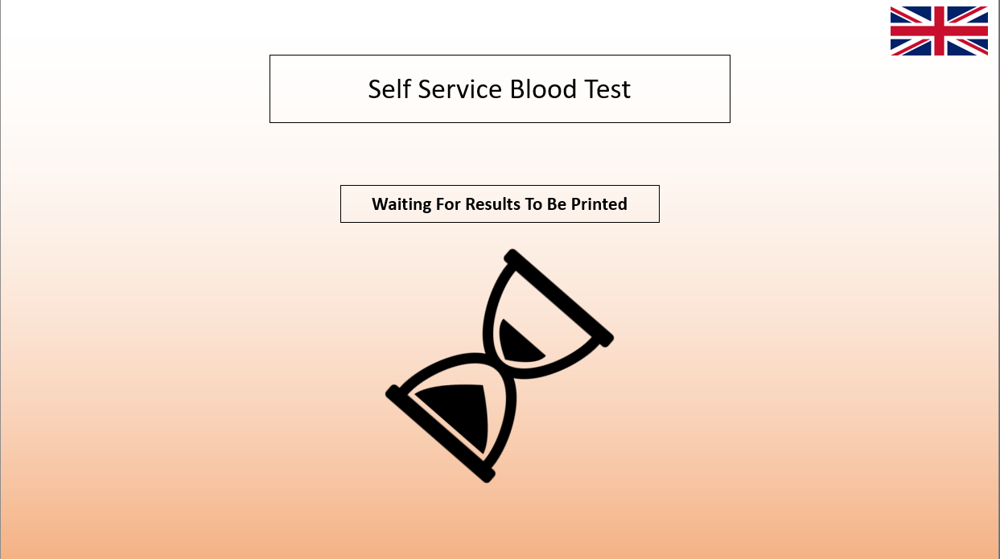
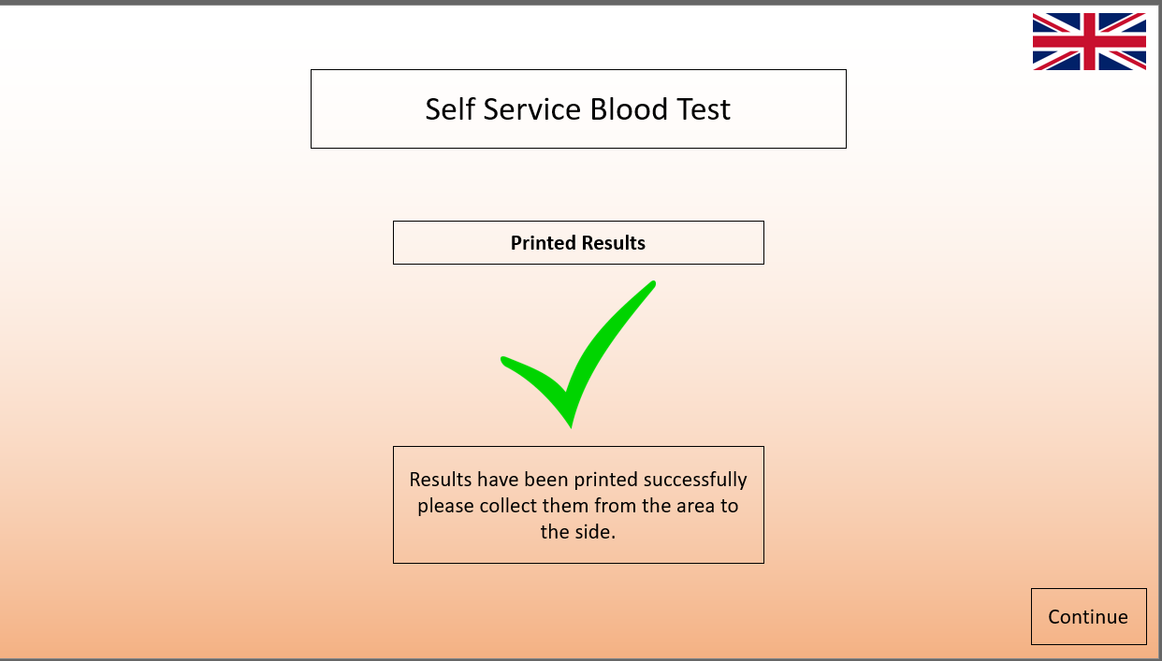

Recommendations Screen
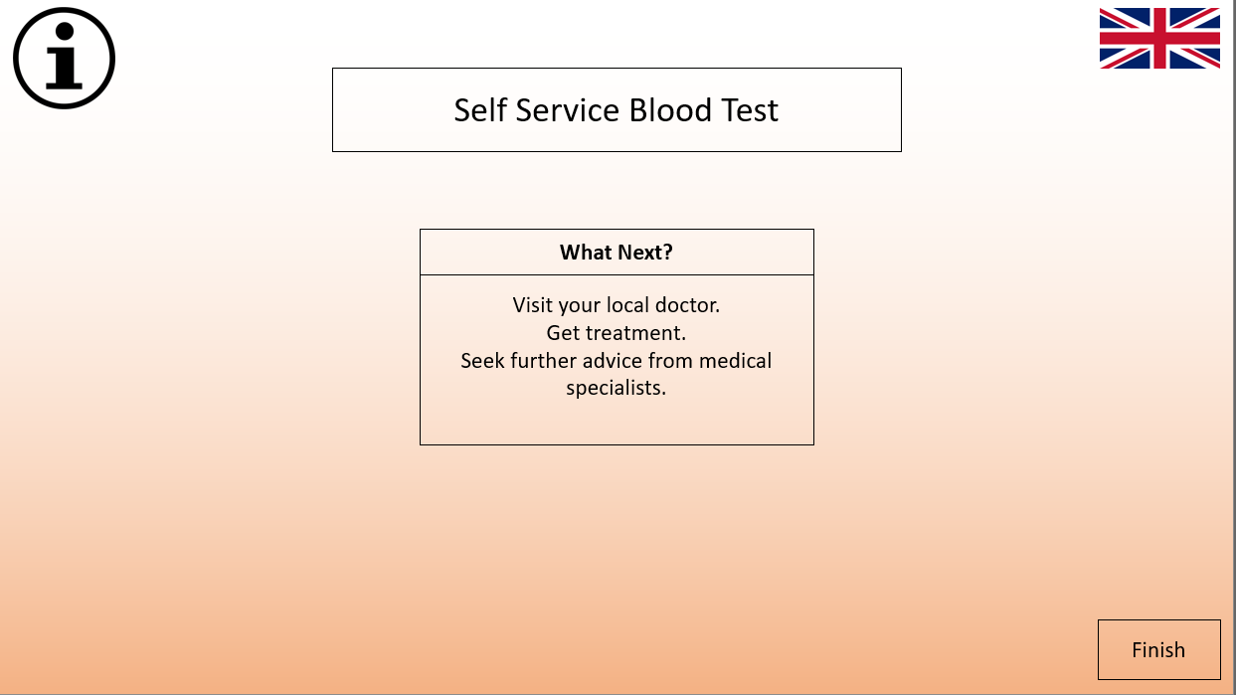
Information Screens (Information Screens for all Screens with the information icon)
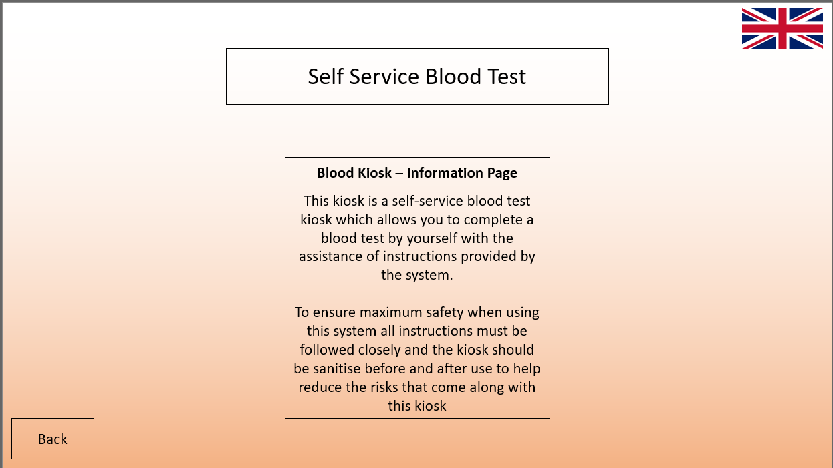
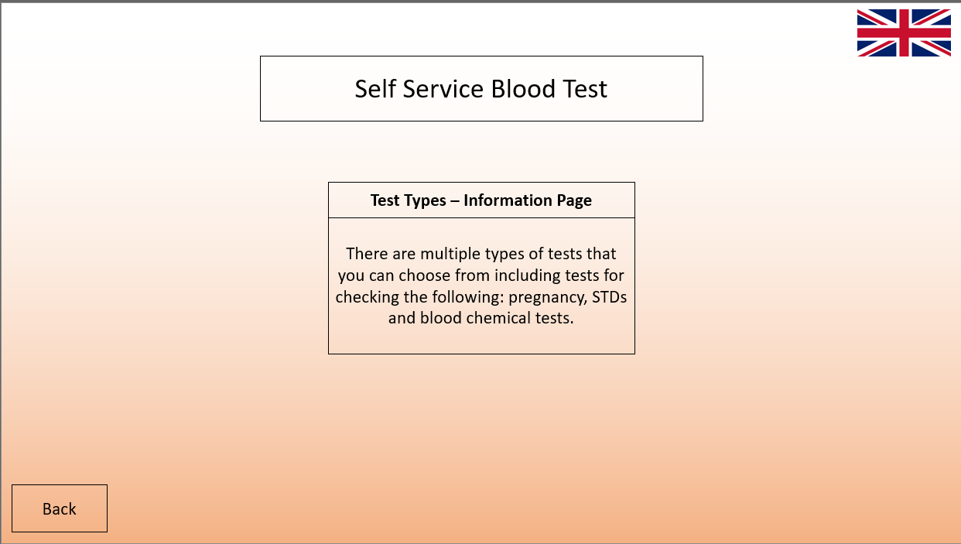
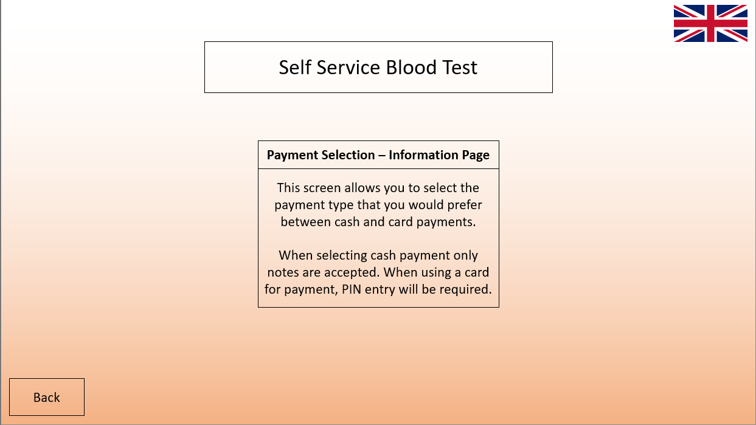
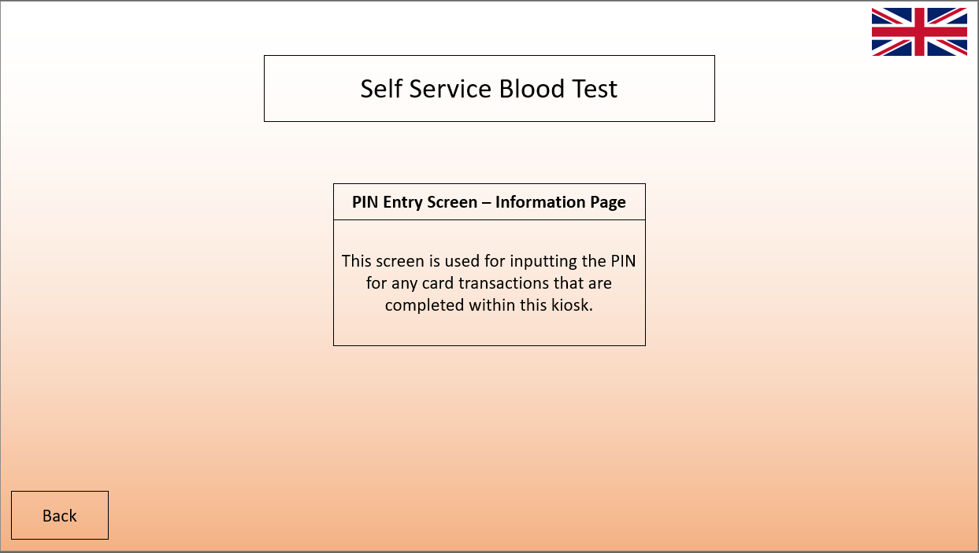
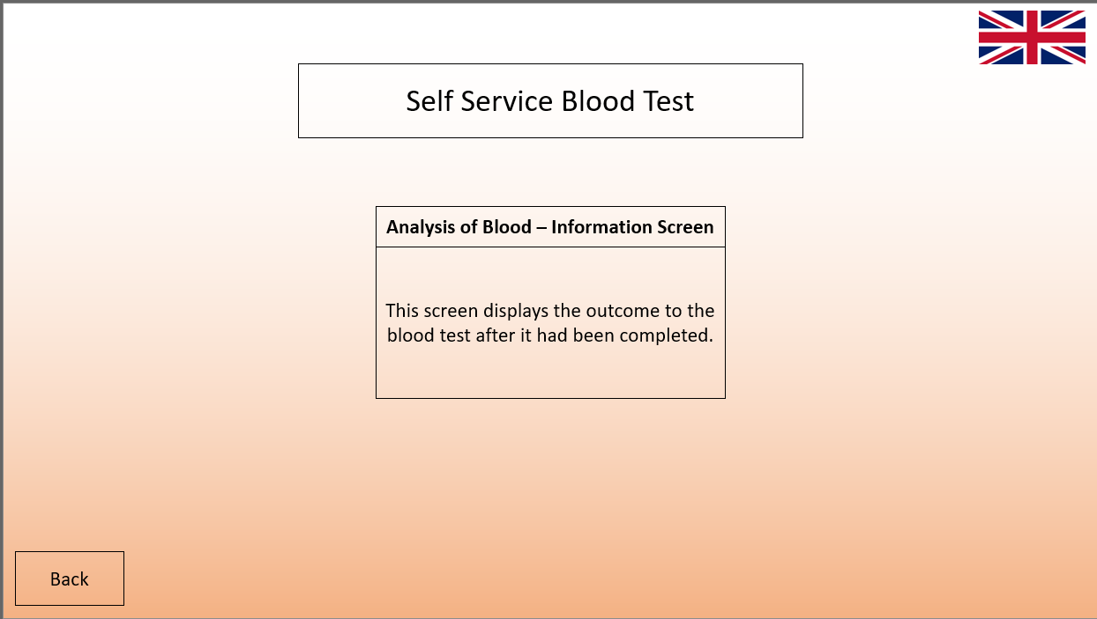
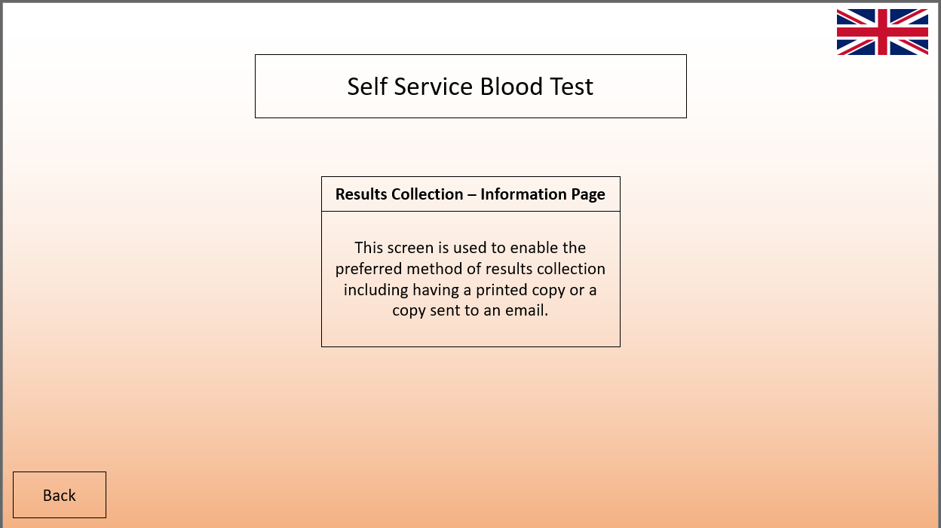
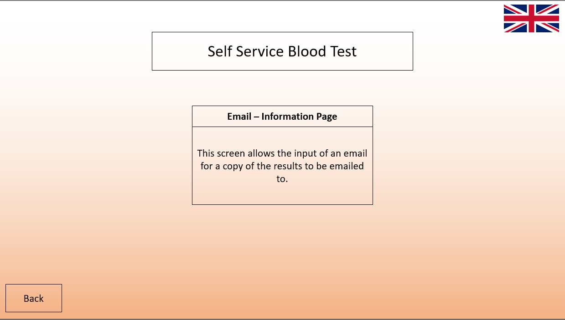
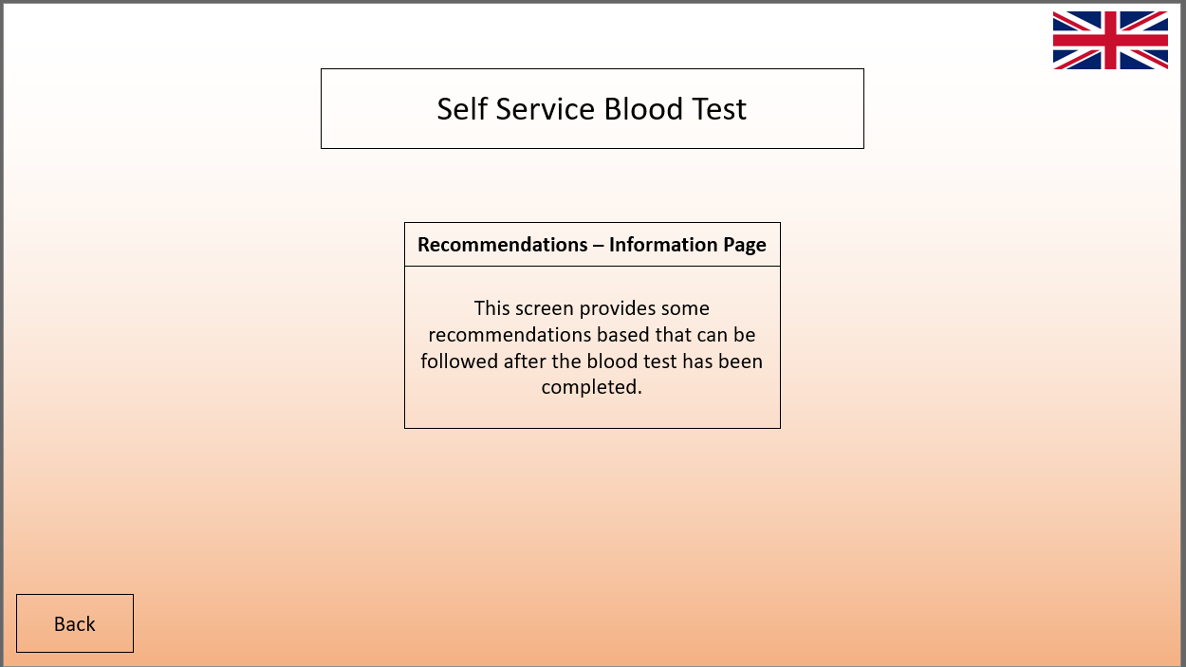
Error Screens (Payment Declined, Invalid Name Input)
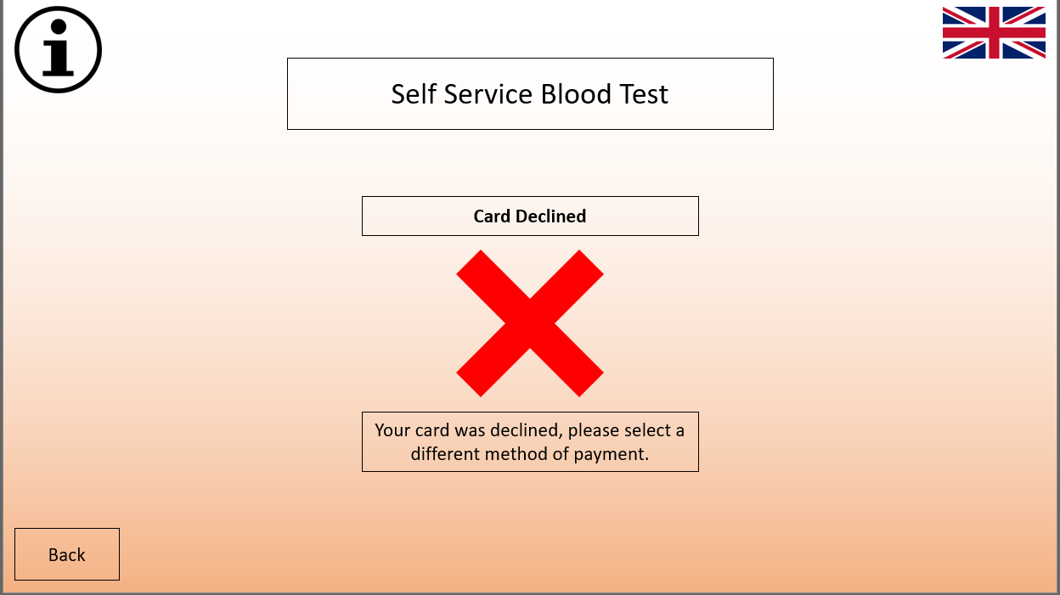
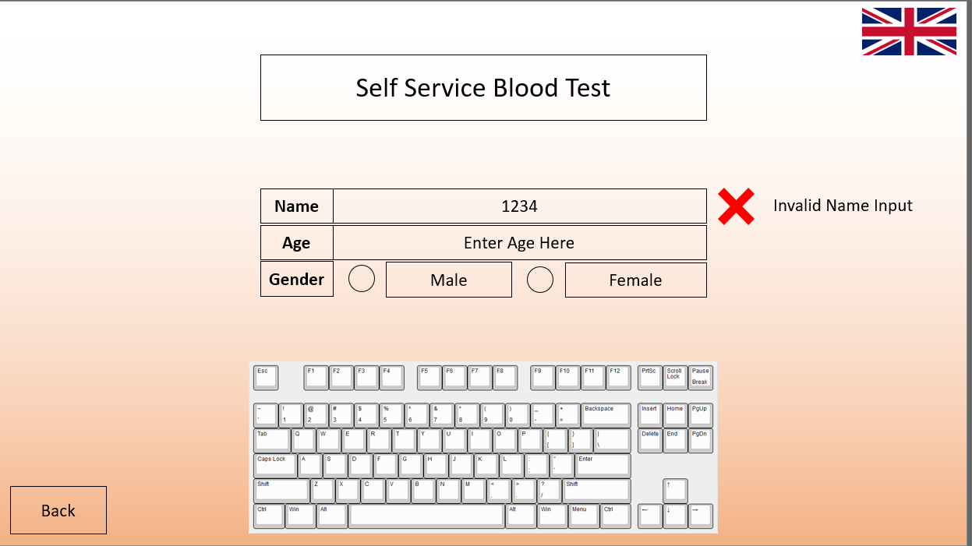
When designing interfaces for this blood test kiosk use of design principles from Shneiderman, Dix, Norman, and Nielsen were considered and implemented like using back buttons being a form of recoverability as users can return to previous screens. The screens use the same layout, so the learnability of the interface is simple. The system is predictable as it uses simple buttons and information to provide insight into what is needed or will happen. This system is synthesizable as it is clear when users have selected something like the gender buttons turning a different colour or test types having a thicker border when selected. The system utilises a small amount of customisability as it allows users to select English or Welsh as language options.
The system uses task migratability as users are not required to check all their inputs for specific errors like names containing numbers, this is shown by the system instead of users checking for errors. Task conformance is visible in this system as it allows users to complete all tasks identified in the task analysis completed prior. The system uses the responsiveness principle from Dix’s design heuristics as changes are made immediately unless they are processes that require waiting where an hourglass is shown with text instead.
The designs include images to display the state of the system like hourglasses to show the system is processing and users must wait, it makes use of ticks and crosses to identify successful or unsuccessful interactions. This is an example of visual perception as it uses images to show what is occurring. The designs use the memory human factor as images make users recognise the state of the system.

Walkthrough
Link for video of the walkthrough of my system: https://youtu.be/de8uoS5gtq8
From this walkthrough I discovered the designs I created were easy to use and flowed well, I discovered some minor flaws within the system based on the feedback provided, the user, in this case, stated they had no issues with how the system flowed and each screen was intuitive, the user stated the information screens included in the designs provided sufficient clear and concise help. When asked to rate the design on a scale from 1-5 they provided a 4 which was rated as “somewhat easy.” The feedback they provided for improvements stated use of back buttons would be beneficial in the case of a wrong test being selected, this feedback is useful however the design currently allows users to select tests and alternate between each type of test before selecting the continue button as well as back buttons on multiple screens so users can revert to previous screens, the area that the user stated this should be implemented is after the payment. The user-provided me with an issue they encountered which was the email option for results collection taking them to a printing screen instead of the email success screen, this is a simple issue to fix in future iterations of the system. Some additional features the user stated may be useful included having an option that allows users to have text read to them to provide some assistance to visually impaired users, this is a feature that should be implemented, however a suitable method of implementation needs to be found before doing so. The user stated a home button would be useful on each screen so users can return to the beginning if they so wish, a home button will be added as this will help with users that may want to cancel the test before payment. The answered questionnaire can be found in the Appendix.

User & Self Design Evaluation
Link for my walkthrough of someone’s design: https://youtu.be/F6ad4JYdHMs
After testing another blood test kiosk design from someone for a walkthrough it became apparent, I had missed some things which could have been beneficial to my designs. Their designs contained home buttons to return to the start something I had not even considered; this has led to me implementing home buttons in my software prototype which will be displayed in screenshots in the next section. After testing my designs I realised the feedback was provided to me was worth implementing excluding the back button for different tests as there was already a back button to change tests before payment, the reason for not implementing a back button after payment is because users would have to repay for tests as the system is unable to return to the testing period without repaying.

Software Prototype
Start Screen (Start Screen & Kiosk Info Page)
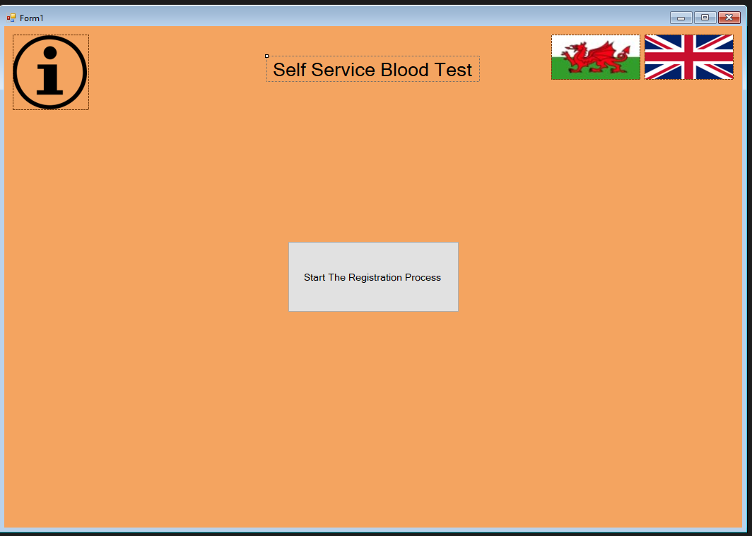
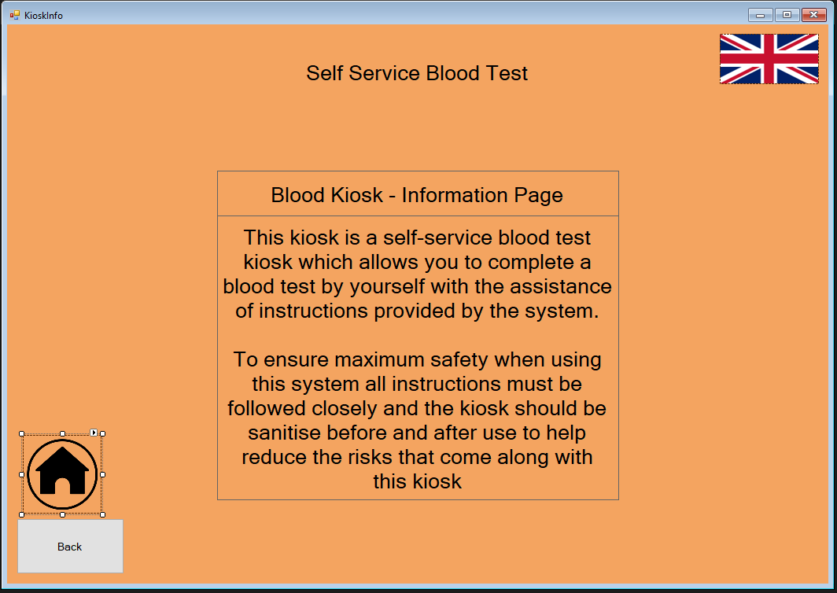

Registration Screen
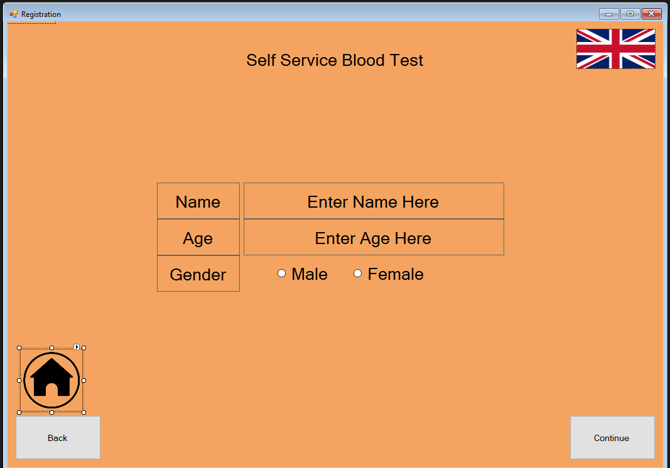
Test Selection Screens (Female & Male Test Screens, Test Info)
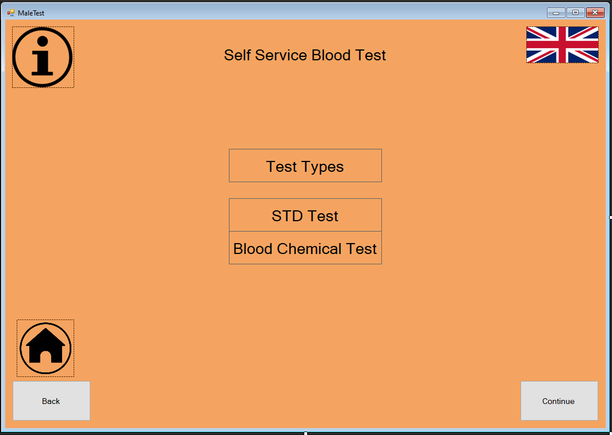
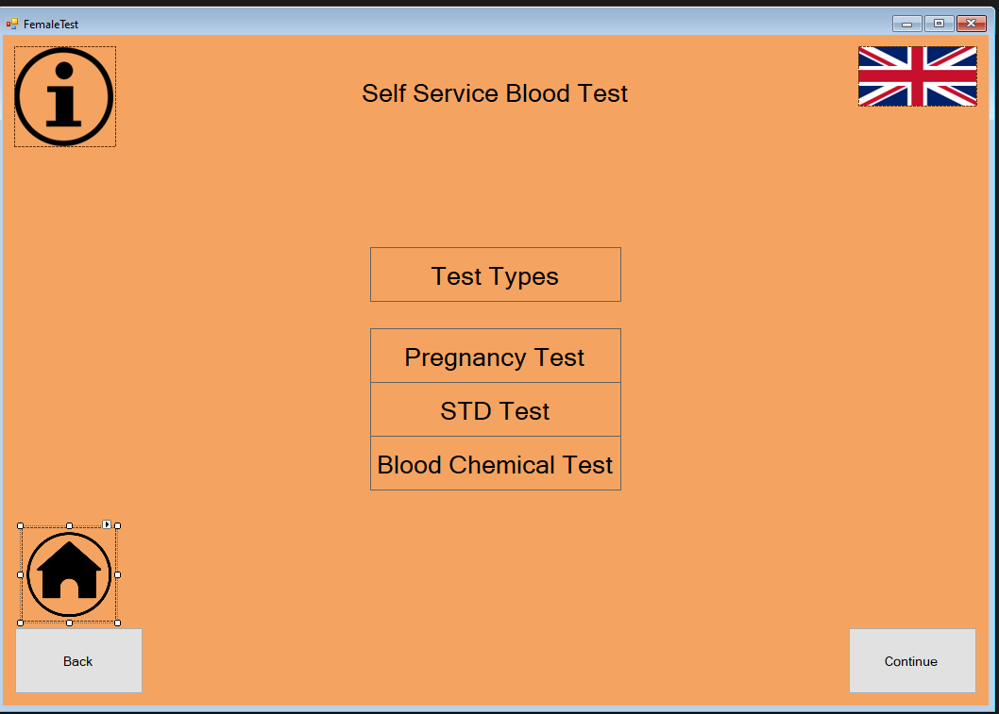
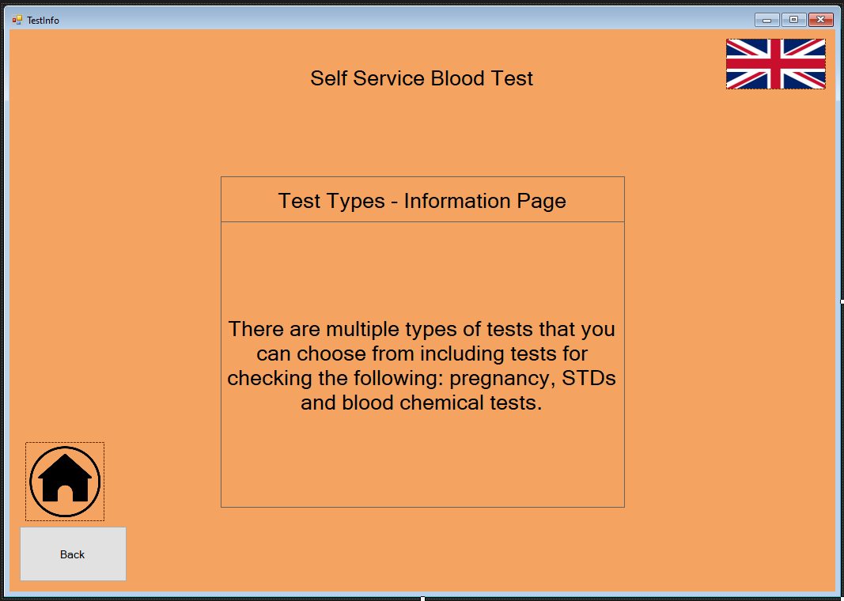

Payment Screens (Payment Selection, Card Payment, PIN Entry, Cash Payment, Payment Processing, Payment Processed, Card Declined, Payment Info, PIN Info, Card Declined Info)
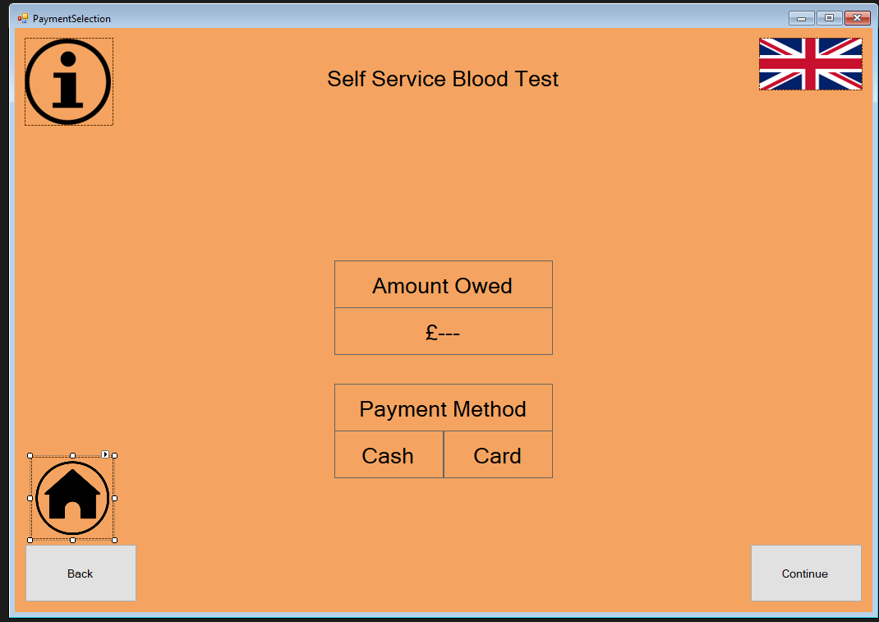
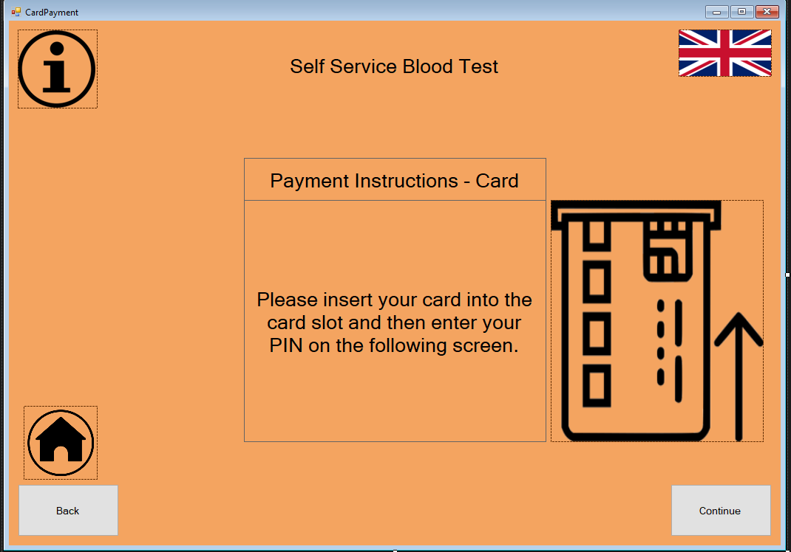
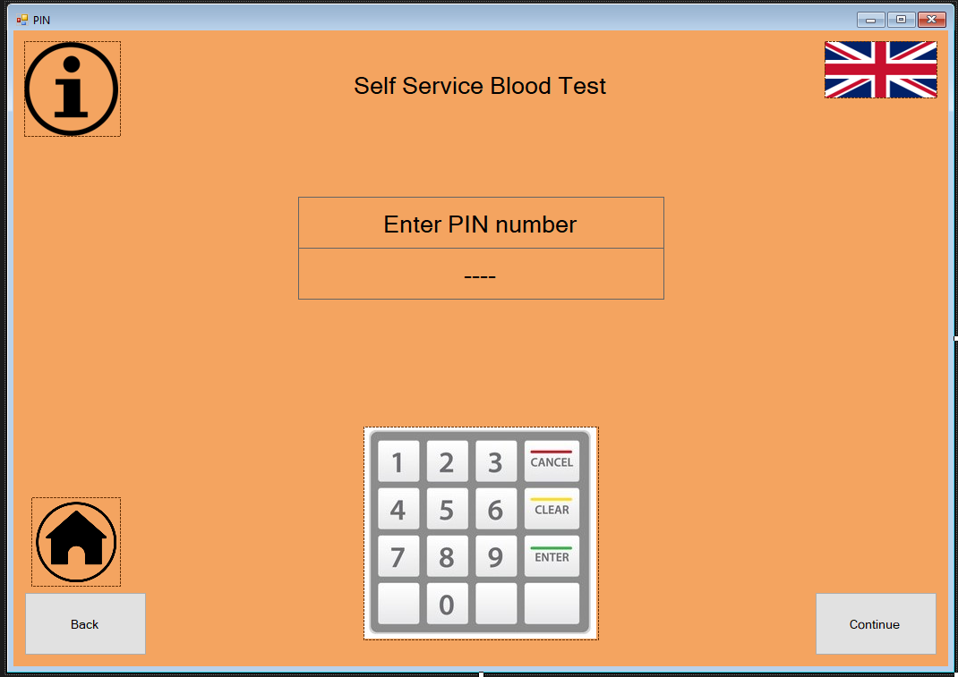
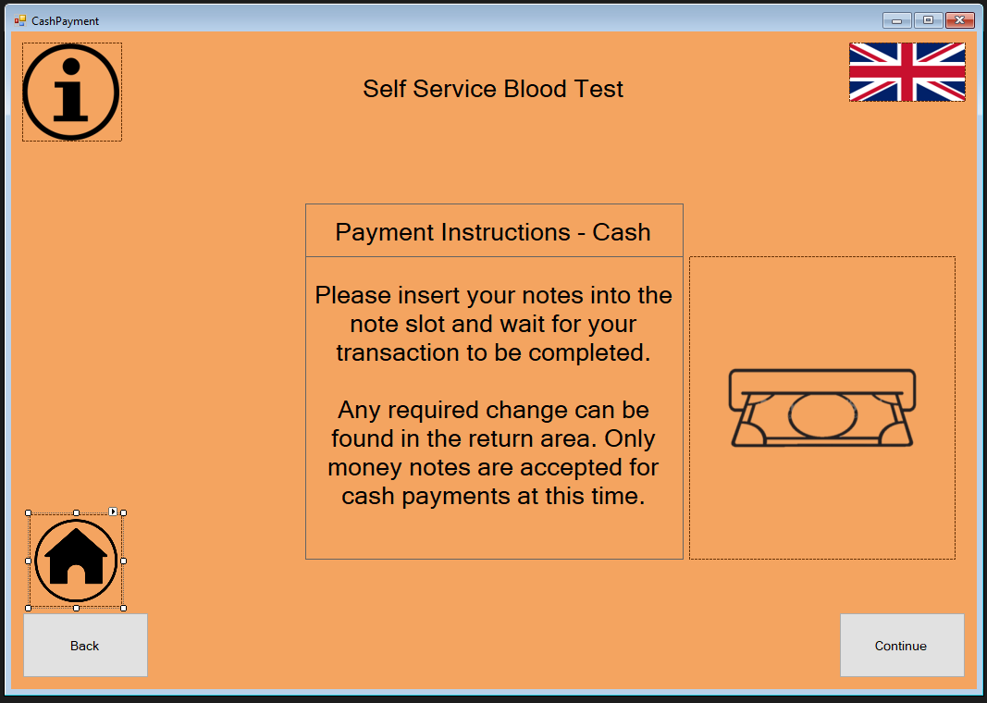
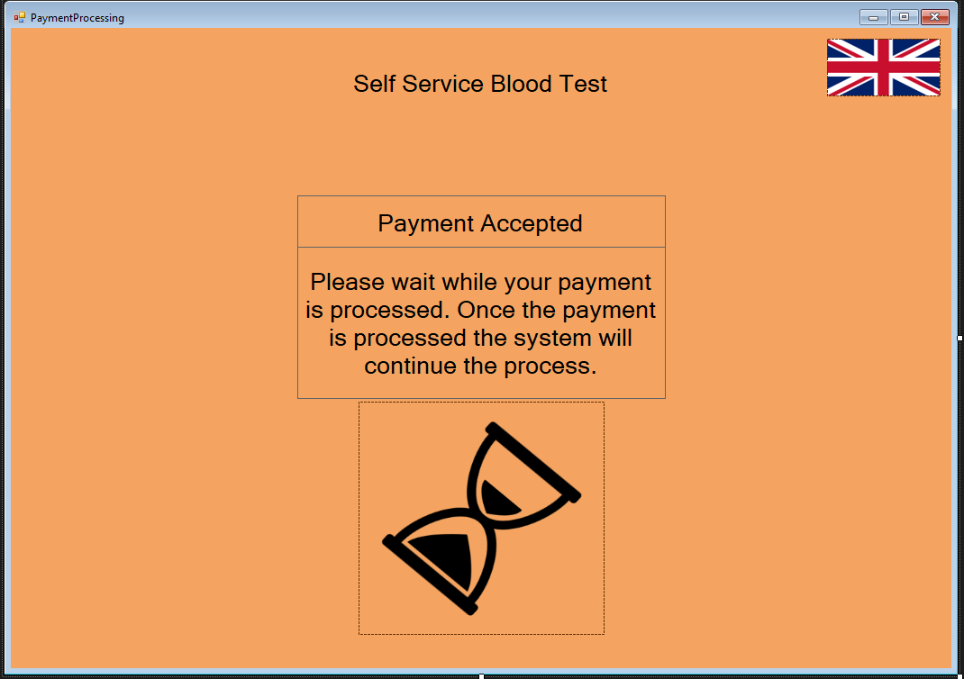
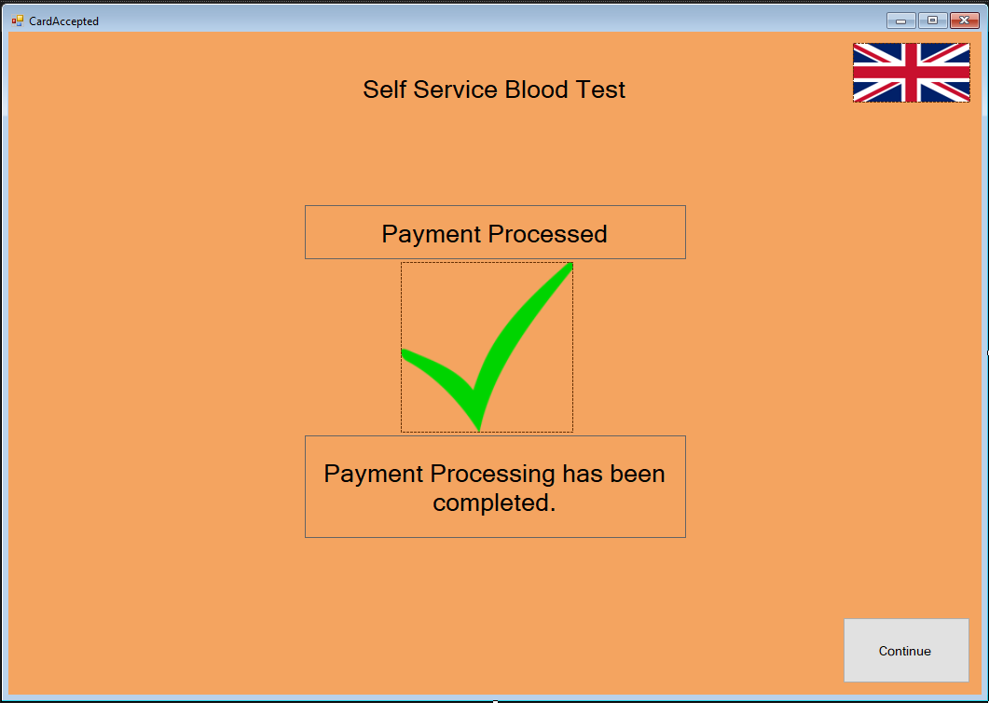
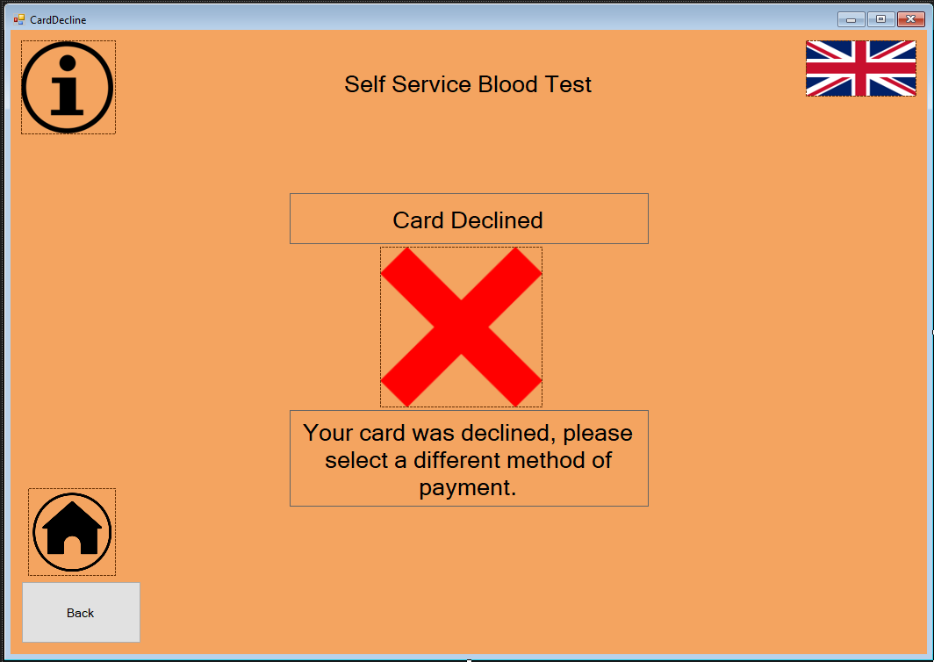
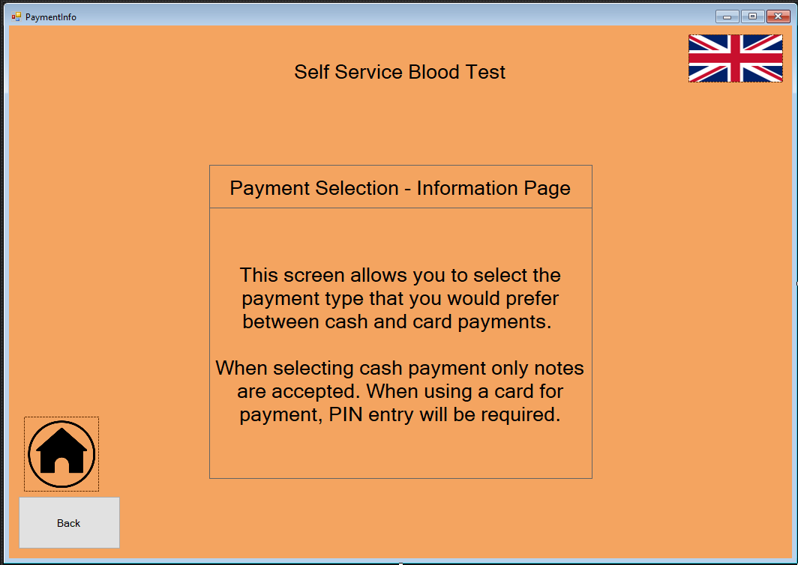
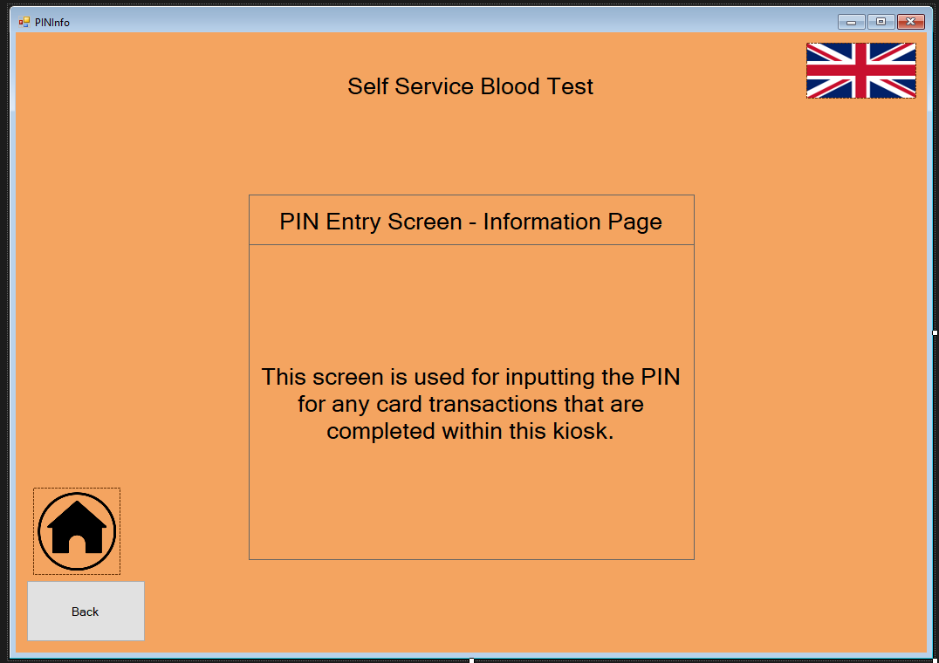
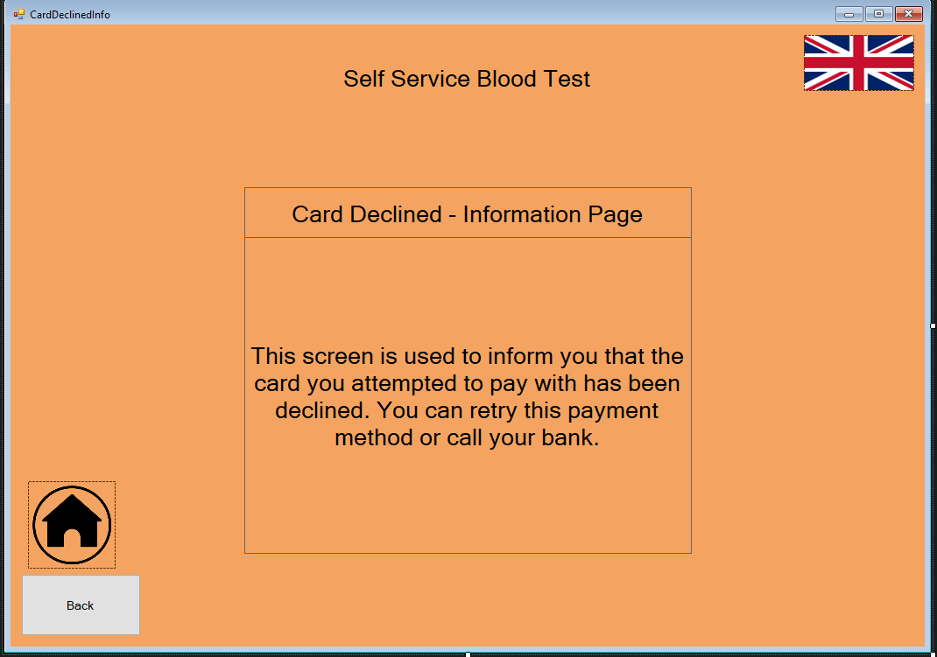

Test Screens (Instructions, Sanitisation, Insert Hand, Blood Extraction)
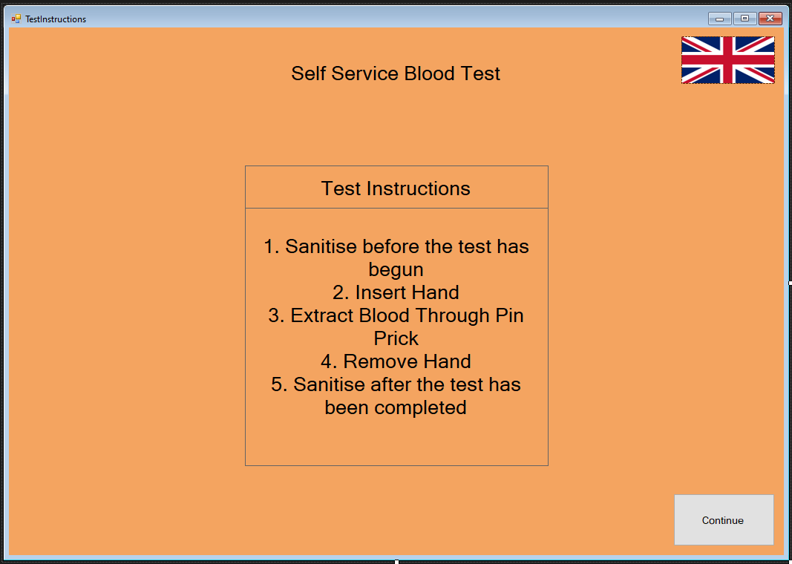
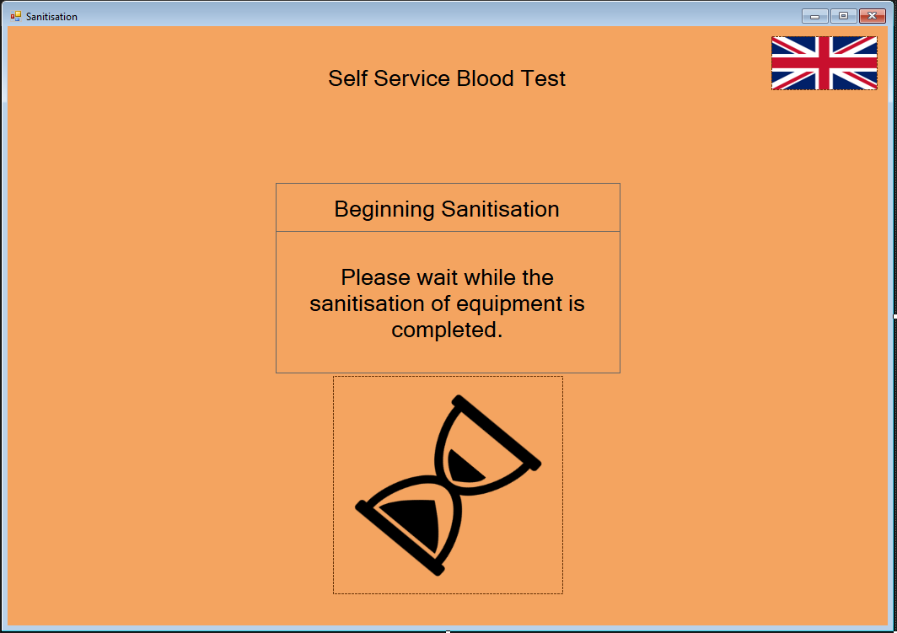
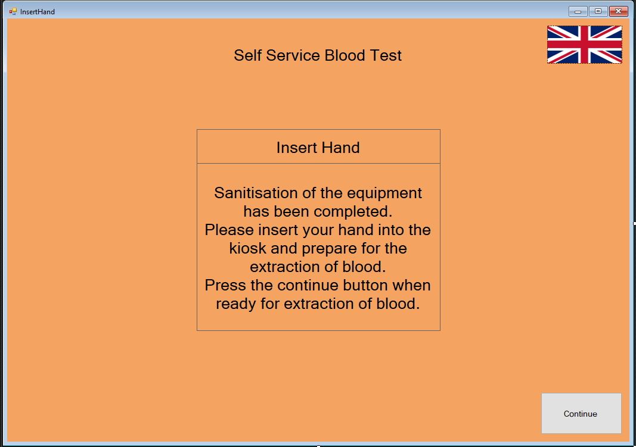
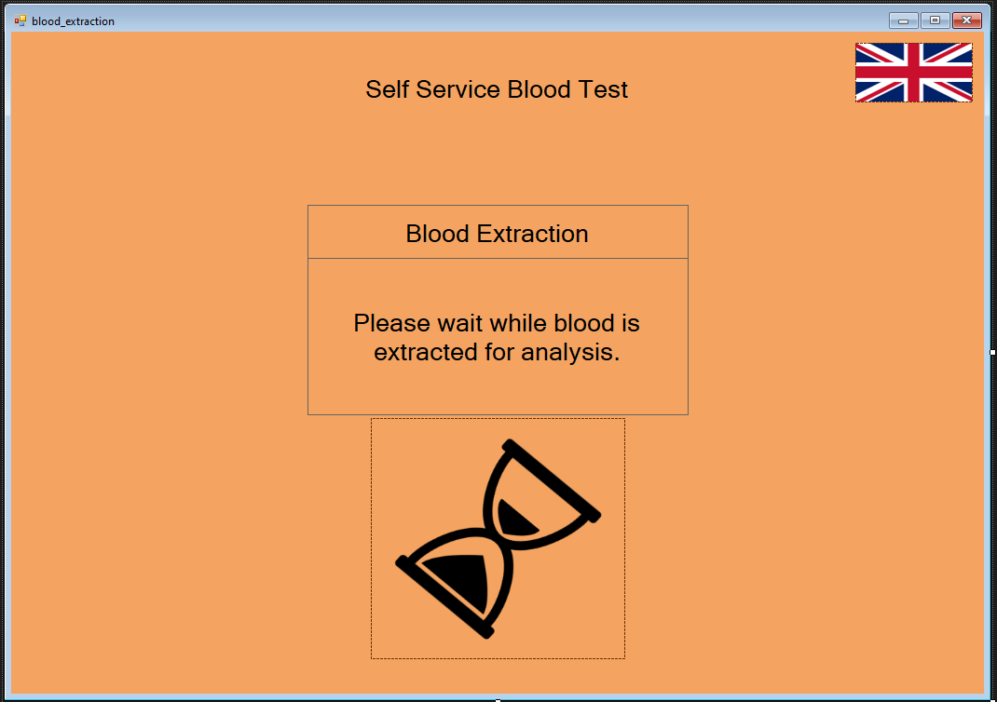
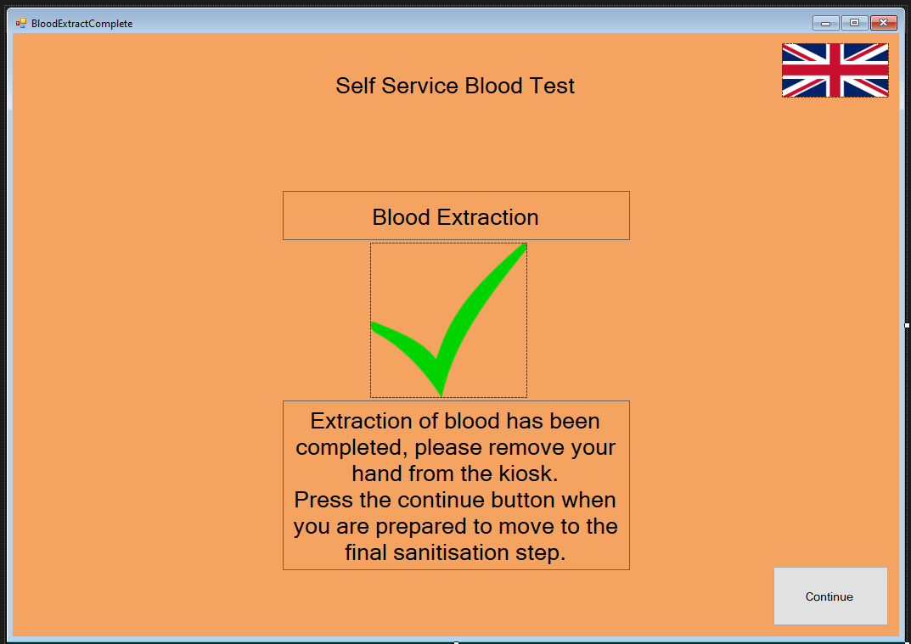
Blood Analysis Screens (Blood Analysis Outcome, Blood Analysis Info)
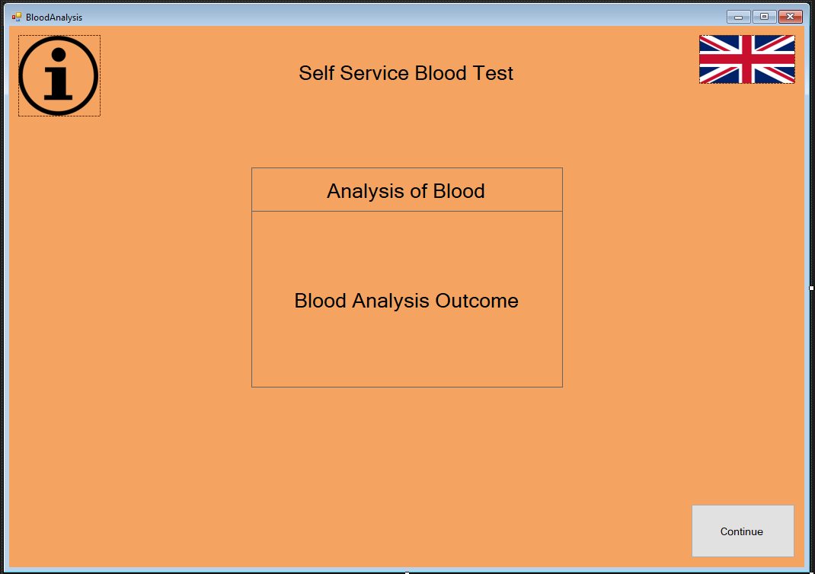
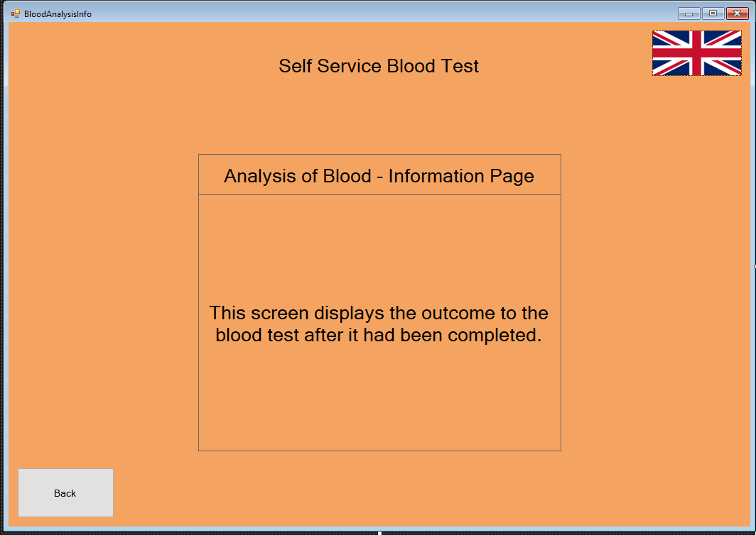
Results Screens (Results Collection, Results Collection Info, Email Results, Email Info, Printing, Printing Confirmed)
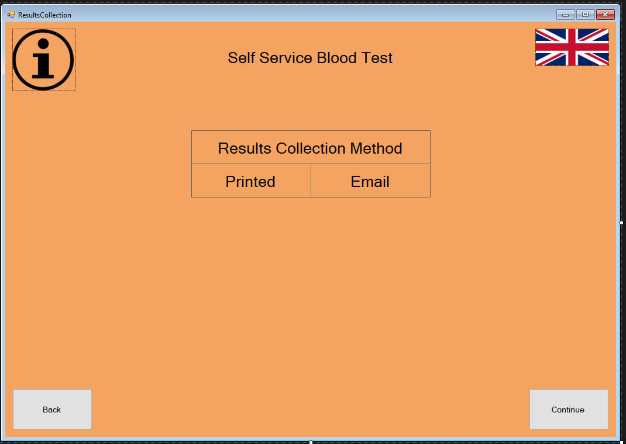
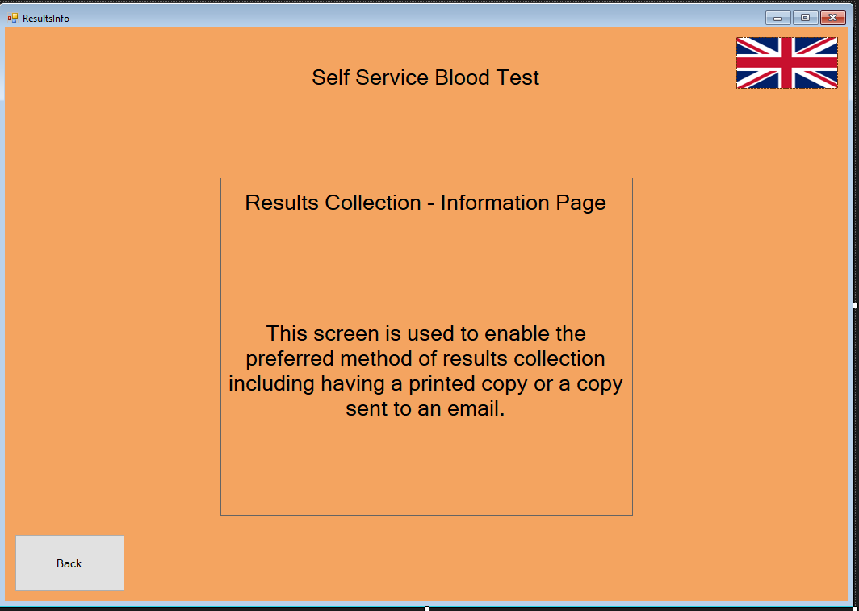
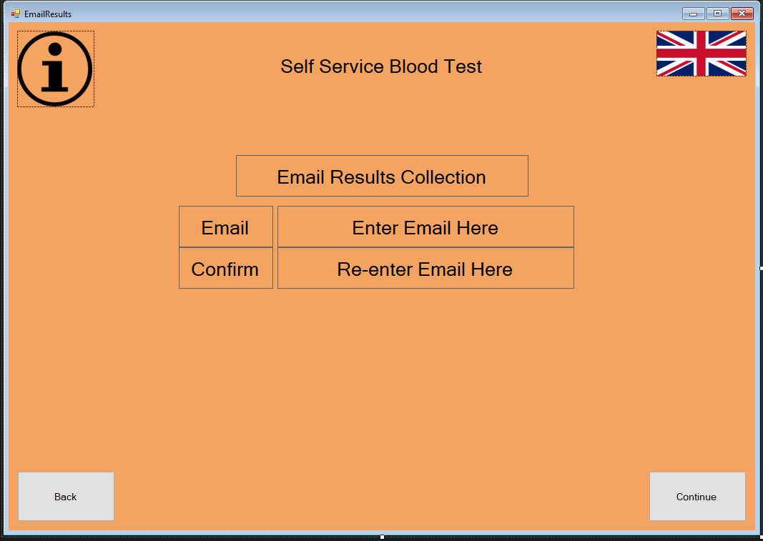
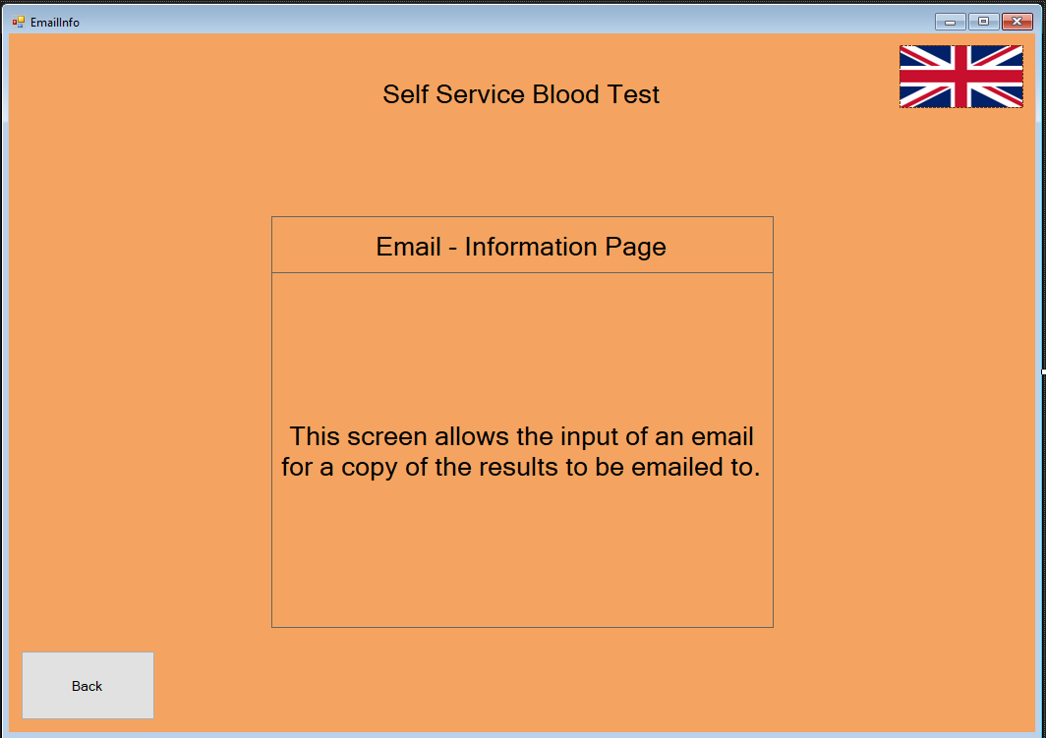
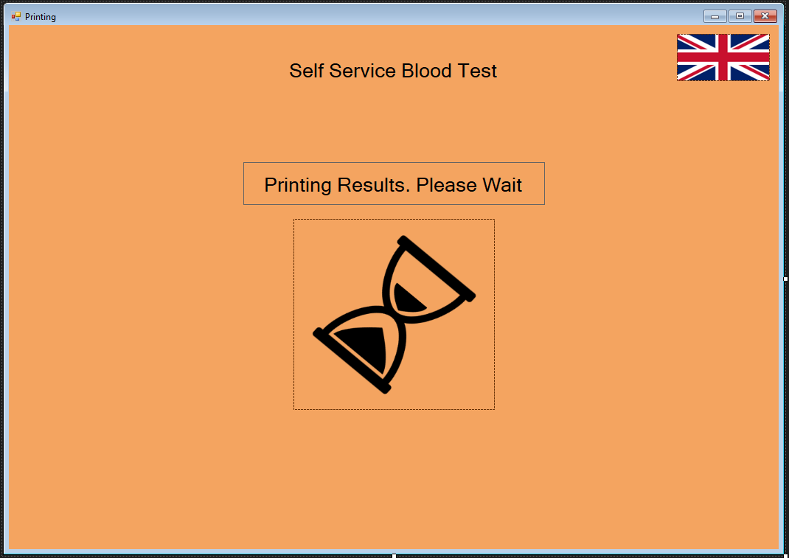
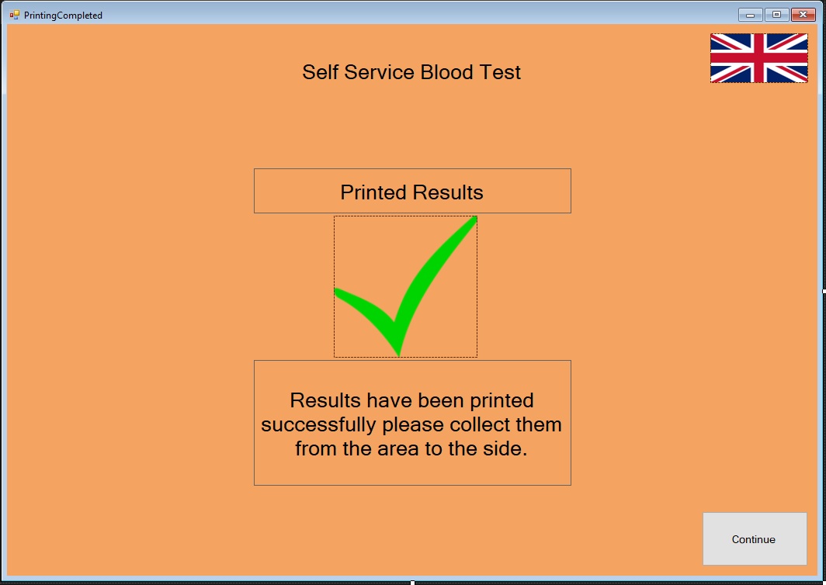
Recommendations Screen (Recommendations, Recommendations Info)
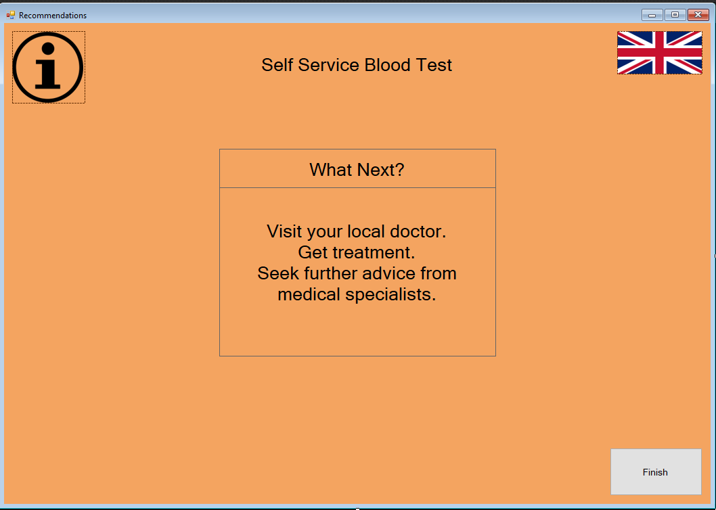
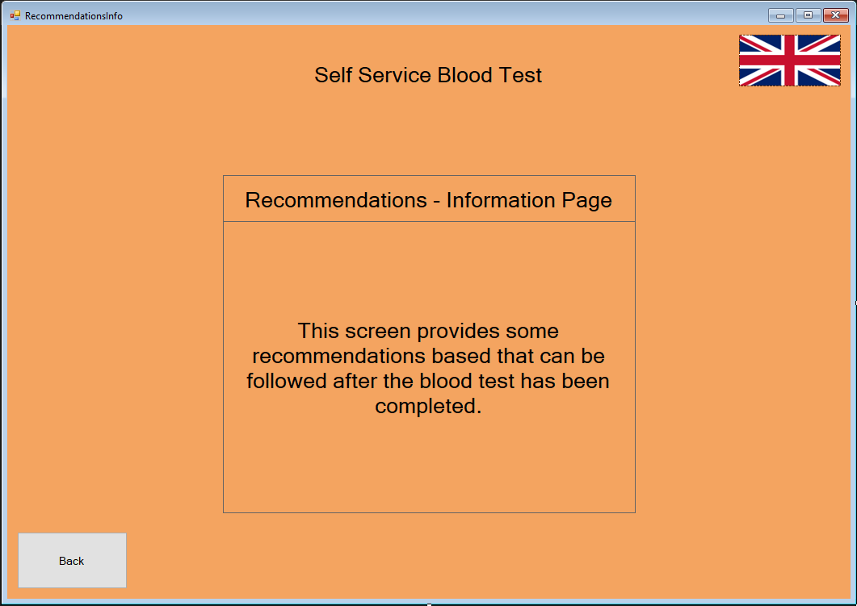
To create the software prototype visual studio was used because the creation of interfaces is simple, and many languages can be coded in this environment. When creating interfaces from the previous designs changes were made using feedback from the walkthroughs, home buttons were added on all screens before payment so that users can cancel the process before paying for a test, having a voice read out the information on screen for visually impaired users has not been added yet as it is difficult to find a suitable way to implement it. This is a feature that should be considered in designs and a suitable method of implementation needs to be found before it is added.

Overall Evaluation
After further analysis of this project and designs that had been created I learnt that there are several important aspects to interfaces to ensure the usability that I had not considered previously, this information came from research that was done into the various principles, the walkthroughs completed for myself and the walkthroughs that I completed for others as well as after completion of a task analysis. Originally I had only considered around half of the tasks that needed to be included within the system and completion of a task analysis made it much clearer as to the functionality needed within each task to make that task successful like having various screens and errors for any point that could be prone to failure.
Following the feedback that I received from users of my design, I realised that I had overlooked some important features which enabled users to have more control over their process like being able to return to the home screen as a form of cancelling the process or to restart. After seeing this feedback implementation of these features occurred where possible although not all feedback could be implemented because of the difficulty that it imposed like adding a feature for visually impaired people on an interface being rather difficult, or the implementation of a back button after payment being not useful as users would have to repay for their test.

From this experience it has become more clear to me the major importance of some principles within designs like having an interface that is easier to learn due to predictability, this is something I had not previously considered as when using an interface you don’t think of what a system is going to do and instead go based off of assumptions. The information I have gained on design principles will be beneficial to me and my future work.

Conclusion
To conclude, from this investigation and project I have been able to gain insights into various principles that make an interface flow and function well, I have gained an understanding of issues that can occur in interfaces making them significantly difficult to use compared to other designs when principles are not taken into account. After completing a walkthrough and having someone test my designs for a walkthrough, I realised that there were points that were beneficial that I had not considered in my designs these changes were implemented in a software prototype so that the usability of my interface was improved. Some feedback that I had been given was useful but I was unable to implement it properly and this is information that will be useful to me in the future as I will need to plan suitable methods for the implementation of features.

References
[1] What is Usability Engineering? [Internet]. The Interaction Design Foundation. [cited 26 March 2021]. Available from: https://www.interaction-design.org/literature/topics/usability-engineering
[2] Mayhew D. 3.2: The Usability Engineering Lifecycle | Engineering360 [Internet]. Globalspec.com. [cited 26 March 2021]. Available from: https://www.globalspec.com/reference/42281/203279/3-2-the-usability-engineering-lifecycle
[3] Usability Engineering Lifecycle [Internet]. Computing.surrey.ac.uk. [cited 26 March 2021]. Available from: http://www.computing.surrey.ac.uk/courses/cs285/CS285-UsabilityEngineering-Week2.pdf
[4] Butow E. User interface design for mere mortals® | Guide books [Internet]. Dl.acm.org. [cited 26 March 2021]. Available from: https://dl.acm.org/doi/book/10.5555/1407402
[5] The Usability Engineering Life Cycle | Making the Business Case for User Interface Design | InformIT [Internet]. Informit.com. [cited 26 March 2021]. Available from: https://www.informit.com/articles/article.aspx?p=726420&seqNum=6
[6] Dix A, Dix J, Finlay J, Abowd G, Beale R. Human-computer Interaction [Internet]. Google Books. [cited 26 March 2021]. Available from: https://books.google.co.uk/books?hl=en&lr=&id=IuQxui8GHDcC&oi=fnd&pg=PR14&dq=human+computer+interaction&ots=I52eyPFWZG&sig=nxcoE8f5OC_Bjp5uGP_7qhpNnrg#v=onepage&q=human%20computer%20interaction&f=false
[7] Nielsen J. Ten Usability Heuristics [Internet]. Pdfs.semanticscholar.org. [cited 26 March 2021]. Available from: https://pdfs.semanticscholar.org/5f03/b251093aee730ab9772db2e1a8a7eb8522cb.pdf
[8] Shneiderman B, Plaisant C, Cohen M, Jacobs S. Designing the User Interface: Strategies for Effective Human- Computer Interaction (6th Edition) by Ben Shneiderman, Catherine Plaisant, Maxine Cohen, Steven Jacobs [Internet]. Academia.edu. [cited 26 March 2021]. Available from: https://www.academia.edu/43687843/Designing_the_User_Interface_Strategies_for_Effective_Human_Computer_Interaction_6th_Edition_by_Ben_Shneiderman_Catherine_Plaisant_Maxine_Cohen_Steven_Jacobs
[9] Wong E. Shneiderman’s Eight Golden Rules Will Help You Design Better Interfaces [Internet]. The Interaction Design Foundation. [cited 26 March 2021]. Available from: https://www.interaction-design.org/literature/article/shneiderman-s-eight-golden-rules-will-help-you-design-better-interfaces
[10] Norman D. Design principles for human-computer interfaces | Proceedings of the SIGCHI Conference on Human Factors in Computing Systems [Internet]. Dl.acm.org. [cited 26 March 2021]. Available from: https://dl.acm.org/doi/abs/10.1145/800045.801571
[11] Norman D. The Design of Everyday Things [Internet]. Sunyoungkim.org. [cited 26 March 2021]. Available from: http://www.sunyoungkim.org/class/old/hci_f18/pdf/The-Design-of-Everyday-Things-Revised-and-Expanded-Edition.pdf
[12] Henkel L. Point-and-Shoot Memories: The Influence of Taking Photos on Memory for a Museum Tour [Internet]. ResearchGate. [cited 26 March 2021]. Available from: https://www.researchgate.net/publication/259207719_Point-and-Shoot_Memories_The_Influence_of_Taking_Photos_on_Memory_for_a_Museum_Tour
[13] Sharp H, Preece J, Rogers Y. Interaction Design - Beyond Human-Computer Interaction [Internet]. Arl.human.cornell.edu. [cited 26 March 2021]. Available from: https://arl.human.cornell.edu/879Readings/Interaction%20Design%20-%20Beyond%20Human-Computer%20Interaction.pdf

Appendix
Completed Questionnaire


