As the Department for Education and Skills (2012, p.2) states, entrepreneurship education is
having the drive to turn ideas and opportunities into reality, enabling young people to be positive, proactive and successful in their approach to life and work.
This portfolio will demonstrate an entrepreneurial education opportunity that enhances creativity and critical thinking skills in children. This document will discuss skills which will be developed during the opportunity and consider how it is relevant to education in the 21st century. The links that the opportunity has to the curriculum, the resources and content will also be demonstrated in this portfolio.
Rationale
The entrepreneurial opportunity “Plastic Enthusiastic” has been chosen because it addresses a modern issue and the idea is to help reduce the amount of plastic that is wasted. 500 million plastic straws and 500 billion plastic cups are used daily around the world (Earth Day Network, 2019).
This opportunity does link to different current entrepreneurial policy and strategies. Some examples of these are the Youth Entrepreneurship Strategy (YES plan), this strategy aims to develop young entrepreneurs who will successfully contribute to social and economic progress (Youth Entrepreneurship Strategy, 2010). The opportunity discussed in this assignment aims to provide children with the skills to give them the most success in their future. Linking in with the Youth Entrepreneurship Strategy is Big Ideas Wales, which helps people under 25 develop their skills in enterprise (Welsh Government, 2017). The Plastic Enthusiastic opportunity links in with this strategy because it encourages children to manage a business, creating and assessing their own ideas. As Valerio and Roseth (2014) states, even if you do not aspire to be an entrepreneur, all the skills are useful in 21st century learning, e.g. combining science and art by using enterprise skills such as networking and marketing or creativity and planning.
The opportunity that is discussed in this portfolio is relevant to 21st century learning because it equips children with the necessary tools to be successful. For example, there is more importance now on people in society to be prepared with entrepreneurial abilities (Lackeus, 2015). Also, children at a younger age are more engaged with the challenge of creating new ideas. Jůvová et al (2017) states that these enterprise skills can be taught to children, some easier than others but they all must be integrated in the curriculum. The Plastic Enthusiastic opportunity provides all abilities a chance to come up with an idea of how to change plastic into something re-usable, it can be carried out in a 21st century classroom and the implementation of technology in this opportunity can help with designing a product and advertising.
Target Group/Market Research
The age group that this opportunity will focus on is between ages 7 – 11 years old (key stage 2). This age group was chosen because the role that the educator can have at this age is fitting to the learning aims and objectives of this opportunity, this will be discussed below. As Neck and Corbett (2018) state, the educator is able to act as a guide through the experience, they can help the students to develop their skills and demonstrate the high standards, showing the connection between putting their entrepreneurial skills into a real-life context. However, for the role of the educator to be effective in this way they must be correctly trained in this area. A panellist in research by Neck and Corbett (2018) suggested that some educators do not want to invest their time into the training and all educators will have a different teaching style, therefore affecting how effective the opportunity will be.
The target group will consist of males and females in a primary school due to the age group that is being focused on. The opportunity will be available to males and females because it is important to encourage the development of skills that are appropriate to different people. Some of the characteristics that make successful entrepreneurs are shown in both men and women, however there can also be some distinctive differences between the two (Shmailan, 2016). The different goals that drive females to achieve could be different to those of males, however, there are individual differences between everyone not juts gender that need to be considered. Also, this opportunity recognises the importance of recycling for our economy and our future. As Hindley (2017) states, recycling has had a lot of attention in the media in recent years, with awareness improving but still not where we would like to be as a society. Recycling is still a key focus especially for the economy even if we continue in or outside of the European Union.
Brief of Plastic Enthusiastic opportunity
The focus of the opportunity is sustainability and the environment, where children create inventive products through upcycling. ‘Upcycling is a process in which used materials are converted into something of higher value and/or quality in their second life’ (Sung, 2015, p.28). The children will be using plastic collected from around the school and local community to be able to physically make and design their products. For example, some children may make recycling bins out of plastic, plant pots, piggy banks etc. After carrying out research around the topic of sustainability and recycling the children will learn how they can make a difference and how their business of selling the products they make can make a positive impact on this global issue.
For the opportunity to develop the enterprise skills and transferable skills that the children need, it is essential that they are fully involved with the project. Setting their goals, these may start small for example, coming up with a product and then get bigger when they eventually try selling the product and finding consumers. They will be able to manage their own resources and money, working on their customer service skills (the skills developed will be discussed in more detail below). It will give children the experience and ownership of a small enterprise that can replicate their characteristics while doing something that supports the environment (Seikkula‐Leino, 2011).
These elements are all involved in this opportunity because it recognises that entrepreneurship is something that should keep growing. As Ahmad and Seymour (2008) state, entrepreneurship is valuable to people in different ways, for example, in some countries it benefits the economy because it creates new businesses, it can create inclusion in a society and with regards the Plastic Enthusiastic opportunity, its assistance in solving environmental problems. Entrepreneurship is not just linked to small businesses because it joins characteristics and developments which contribute to the entrepreneurial process and this opportunity shows this on a small scale.

The Leaning Aims and Objectives
Aim:
- To develop entrepreneurial skills by creating a business idea that will help reduce the amount of plastic wasted in the local area.
Objectives:
- Can recognise the impact of plastic waste on the environment.
- Can identify the resources available to make a product out of plastic.
- Can give examples of different innovative product designs.
- Can formulate 2 methods of advertising.
- Can calculate cost and profit of plastic products.
The aim of this opportunity has been chosen because it provides the children with the goal of gaining or enhancing the different entrepreneurial competencies through a creative project that fits in with the 21st century curriculum. It allows the children to be creative, developing their critical thinking skills. Some children will naturally be more creative than others which is why this opportunity will help develop or learn creativity skills (McCorkle, et al, 2007). This is the idea that creativity can be learned and is not dependant on your biology. However, as Grimm and Brandert (2016) suggest, people can have a predilection for a certain way of thinking or ideas that control creativity. The opportunity will be flexible for the children to choose the roles they would like to play in the project to encourage the most creativity.
The objectives represent some of the steps that will be taken to achieve the aim of the opportunity. The children will research the topic of the opportunity to get an understanding of why their ideas are important. This initial research can open new questions to be answered, inspire them with ideas and identify what can be learned (Catling, 2003). These objectives have also been chosen because they allow the children to design and advertise in different ways. The children can use technology, draw or physically make their designs and advertising depending on their desired approach to the project. For example, as Truong (2016) suggests, some children prefer to learn through experimenting or readings while others get more understanding through pictures and diagrams. The aims and objectives allow for a variety of approaches to maximize creativity.
Links to the curriculum
This next section will look at the links to the curriculum with regards to the new curriculum Successful Futures (Donaldson, 2015). One of the key purposes of Successful Futures is that it wants to develop learners who are enterprising and creating contributors. The Plastic Enthusiastic opportunity links with this because it allows the children to take on a different role in the project, think creatively to solve problems and link their knowledge to create a product out of the plastic waste. Digital literacy is an important aspect of Successful futures and is shown in this opportunity because the children can use technology skills to create their product designs and advertising. For example, making posters to put around the community, creating a video to put on the school’s website showing the products and keeping track of costs using excel. As part of the opportunity it is required that the children have the resources to use their digital skills and are supported by the staff who are digitally trained (Estyn, 2018). There is also a link with other areas of learning in the document Successful Futures (2015) such as expressive arts. The children are working together to overcome challenges and get enjoyment from taking part in different areas of the creative arts, in this opportunity children will be using creative expression to create their ideas.
The Plastic Enthusiastic project also links with Education for Sustainable Development and Global Citizenship (ESDGC) (DCELLS, 2008). The project uses resources to recycle or upcycle and it improves the quality of the local environment. The children will be visiting the local area when collecting the plastic and they can comprehend what happens to the environment with regards to consumption and waste. The only problems with including the link with ESDGC are that this opportunity only focusses on recycling and not any other ESDGC themes and one of the aims of ESDGC is that the different themes are concentrated on the same, e.g. poverty, identity and culture. This opportunity only looks and consumption and waste.

The key skills that learners will develop
The Plastic Enthusiastic opportunity is principally based on the ACRO model which includes the entrepreneurial behaviours and embraces enterprise and entrepreneurship together. As the Youth Entrepreneurship Strategy (2010) states, the ACRO model contains 4 key areas which are easily linked to the opportunity. Firstly, there is attitude, children can show competitiveness and determination through their passion to help the environment and sell as many products as they can. They will acquire belief and self-confidence when they start to make money from a successful business. Creativity is shown when the children develop their product and ideas, problem solving when the product they make is not what they planned and spotting other opportunities, for example selling to the public. Relationships include skills such as working as part of a team, depending on the role they have in the project, presenting their findings from research or negotiating when selling the product. Lastly, organisation produces skills such as managing their resources, setting targets and making decisions based on research.
If children are capable of using some of these skills, they will be well equipped when the time of employment comes. Creative learning allows children to feel like they have more control instead of ‘being a consumer of education’ (Miles,2007, p. 282). This opportunity allows children to work in a creative mindset which creates transferable skills that provide children with an essential set of abilities and skills. Furthermore, as Moses and Baldwin (2005) suggest, this opportunity encourages critical thinking because the children have control over the actions they make and their thoughts in the project. The only problem with encouraging the children to think critically is that they may not have the confidence to challenge ideas, for example, if they do not agree with the decision of another team member, do they negotiate or let it go? (Heyman, 2008). The children need to be able to understand and have an interest in order for them to think critically.
The resources needed
In order for the opportunity to run there are some resources that are required. A minimum amount that would be spent on resources is shown below (See Figure 1). The plastic that will be used to turn into products to sell will be collected from inside the school and outside in the community, this will not cost any money because they are being recycled. The main cost of resources will be spent on the arts and crafts side of the project which is required for the children to be able to design their products, some of which the school may already be able to provide. This part of the opportunity provides the art experiences that can enhance the children’s physical development because they are using small motor skills, language and literacy through their ideas they are conveying in art and their social and emotional development through the growth of self-control and the ability to focus and make choices (NAEYC, 2018). The technological resources will already be provided by the school such as iPad, computers, design software, for example, Tinkercad which allows the children to create 3D models of their product.
Figure 1: Table displaying costs of resources
Resources | Cost (Approximately)
Plastic Materials | No Cost (donated and recycled)
Coloured pens x 2 | £8.98
Glitter Shakers | £4.99
Paints | £6.99
PVA Glue | £8.99
iPad | Provided by the School
Total Cost | £29.95

There are not a lot of costs that need to be covered and a lot of the resources are included in the school budget. However, there are ways of getting extra funding if the opportunity is to be carried out on a bigger scale (See Appendix A). Having additional funding will not place a reliance on the school budget allowing more money for better resources and up to date technology. The opportunity is non-profit, therefore will be donating their profits to Waste Aid (2016), a charity that also turns waste into useful products to protect the environment and improve health and wellbeing.

Content

The programme Plastic Enthusiastic will take part over 5 weeks with a session every Friday for two hours. There are various aims and objectives of the sessions with the children being assessed to make sure there is an understanding of what is expected of them (See Appendix B). Differentiation will be considered throughout in order to make sure the children’s learning styles are considered. Lethaby (2017) states that there is no research that learning styles has an improvement on learning and that there is no relationship between the two. However, if the children have a preferred way of learning the project can be carried out more efficiently with the children enjoying if they understand what they are doing. The resources have already been discussed above but some of the aids include using PowerPoint, creating mind-maps and worksheets. The assessment methods include peer-assessment of product ideas, using traffic lights (assessment for learning) and questioning, as formative assessment is one of the most influential ways of increasing students learning and achievement (Wiliam, 2013). The sessions also consider ESDGC, Essential Skills Wales and Welsh dimension (See Appendix B).
The lessons are only going to be 2 hours a week as stated above and will have aims and objectives for each session. The children will be taught towards the learning objectives and take part in activities that develop their enterprise skills but also provide feedback to the teacher (See Appendix C). The health and safety and contingency plan have been completed in the lesson plan to maximize the efficiency of the opportunity. It is important to have an outline of the goals that you want to achieve throughout a session and how you are going to achieve them. As Milkova (2016) states, preparing for a variety of different learning styles can help children be more engaged and you will be more prepared if there are problems in the sessions.

How will the learners recognise their progression?

The children will be able to see their progress throughout the opportunity through regular feedback. As Hattie and Timperley (2007) states, the feedback can be delivered by the teachers, peers or themselves. Feedback is most valuable when it gives information about progress or how the children are going to progress. For Example, self- evaluating a task after it is completed to see if the child has followed the criteria of the task, they would write down the things they did well and what they can improve on next time (Wiggins, 2012). There are some challenges with giving feedback to the children, it needs to be reliable. As Ertmer et al (2007) suggests, some children could give themselves more positive feedback or be more critical of their work and if their peers are evaluating their work, they could accept it to be worthless.
Some other ways that learners can see their progress and recognise what skills are developing are from different tasks. For example, taking a quiz after each session to show what they have learned or using a feedback sheet (See Appendix D). The feedback sheet can help the children recognise what the opportunity is providing them with the option to compare their feedback with other pupils. Verbal feedback will also be available from this opportunity, some sessions it will be one-to-one and then other times it will be in groups depending on the amount of time available in the session. It is important that quality feedback is presented to the students to see if they are working in line with the aims and objectives (Beaumont, O’Doherty and Shannon, 2011). The feedback will be specific to each child to be most effective. As Hardavella et al (2017) states, if the feedback is generalised the child will not understand it and will be uncertain of why they are taking part in the opportunity. This could then cause a lack of respect for the feedback they are receiving.

How will the project be assessed and evaluated?

The opportunity will be assessed and evaluated throughout to check that it is enhancing creativity and critical thinking skills. The assessment will include formative and summative assessment (some examples are shown below). There will also be a competition in groups for the children who make the most amount of profit on their designed upcycled plastic. An example of the summative assessments used in the project are the tests/ amount of profit made at the end of the opportunity to put a measure on what has been learned (Garrison and Ehringhaus, 2007). The summative assessments will be able to evaluate the success of the project. As Boston (2002) states, formative assessments include the questioning and discussion in class to improve their understanding on a topic (the environment in this case). An example of assessment used in this project would be to carry out a quick project inside of the bigger project, e.g. recording a video of themselves discussing how plastic is affecting the environment. This assessment shows the children’s ability to understand the task. Formative assessment includes self and peer assessment which can provide problems if the children do not understand the learning objectives and the teacher must ensure the goals of the project are specific and clear to the children.

Conclusion

In conclusion, this portfolio has considered the opportunity Plastic Enthusiastic in 21st century learning and how it enhances creativity in the different activities and critical thinking when the children are making decisions, taking part in assessment and evaluation. The learning aims and objectives are specific and link into the topic of the environment. The resources have been contemplated, including how the opportunity will be set out. This opportunity would provide children with the enterprise skills needed to be successful in further education, e.g. critical thinking, problem solving, or the skills for life, e.g. communication and creativity.

References
Ahmad, N., & Seymour, R. G. (2008) Defining Entrepreneurial Activity. http://www.oecd.org/std/business-stats/39651330.pdf (Accessed: 26th March 2019).
Beaumont, C., O'Doherty, M. and Shannon, L. (2011) ‘Reconceptualising assessment feedback: A key to improving student learning?’ Studies in Higher Education, 36(6), pp.671–687.
Boston, C. (2002) ‘The concept of formative assessment’, Practical Assessment, Research & Evaluation, 8(9, August), pp.1-4.
Catling, S. (2003) ‘Curriculum Contested: Primary Geography and Social Justice’, Geography, 88, pp. 164-210.
DCELLS (2008) Education for Sustainable Development and Global Citizenship. Cardiff: Welsh Assembly Government.
Department for Education and Skills (2012) Learning and progression in entrepreneurship education. Cardiff: Welsh Assembly Government.
Directions in Psychological Science, 17(5), pp. 344–347.
Donaldson, G. (2015) Successful Futures: Independent review of curriculum and assessment arrangements in Wales. Cardiff: Welsh Assembly Government.
Earth Day Network (2019) Fact Sheet: How Much Disposable Plastic We Use. https://www.earthday.org/2018/04/18/fact-sheet-how-much-disposable-plastic-we-use/ (Accessed: 25th March 2019).
Ertmer, P. A., Richardson, J. C., Belland, B., Camin, D., Connolly, P., Coulthard, G., et al. (2007) ‘Using peer feedback to enhance the quality of student online postings: an exploratory study’, Journal of Computer Mediated Communication, 12(2), pp. 412–433.
Estyn (2018) Schools need a clear vision for the new digital competence framework. https://www.estyn.gov.wales/news/schools-need-clear-vision-new-digital-competence-framework (Accessed:27th March 2019).
Garrison, C., & Ehringhaus, M. (2011) ‘Formative and Summative Assessments in the Classroom’, Paper presented at the NMSA Annual Conference and Exhibit. http://ccti.colfinder.org/sites/default/files/formative_and_summative_assessment_in_the_classroom.pdf (Accessed:31st March 2019).
Grimm, B. and Brandert, K. (2016) ‘HOW DOES AN INDIVIDUAL’S INNATE PREFERENCES IMPACT INNOVATION AND CREATIVITY?’, JOURNAL OF LEADERSHIP STUDIES, 10(1), pp. 34-36. CREATIVITY?
Hardavella, G., Aamli-Gaagnat, A., Saad, N., Rousalova, I. & Sreter, K.B. (2017) ‘How to give and receive feedback effectively’, Breathe, 13(4), pp. 327-333.
Hattie, J., and Timperley, H. (2007) ‘The power of feedback’, Review of Educational Research, 77(1), pp. 81–112.
Heyman, G. D. (2008) ‘Children’s critical thinking when learning from others’, Current
Hindley, R. (2017) ‘The recycling challenge’, Aluminium International Today, 29(1), pp. 49-50.
Jůvová, A., Čech, T., & Duda, O. (2017) ‘Education for Entrepreneurship–A Challenge for School Practice’, Acta Educationis Generalis, 7(3), pp. 63-75.
Lackeus, M. (2015) Entrepreneurship in Education What, Why, When, How. https://www.oecd.org/cfe/leed/BGP_Entrepreneurship-in-Education.pdf (Accessed: 25th March 2019).
Lethaby, C. (2017) Four reasons to avoid 'learning styles' – and one alternative. https://www.britishcouncil.org/voices-magazine/four-reasons-avoid-learning-styles-one-alternative (Accessed: 29th March 2019).
McCorkle, D., Payan, J., Reardon, J. and Kling, N. (2007) ‘Perceptions and Reality: Creativity in the Marketing Classroom’, Journal of Marketing Education, 29(3, December), pp. 254-261.
Miles, S. (2007) ‘Different journeys at different speeds: Young people, risk and the challenge of creative learning’, Journal of Youth Studies, 3, pp. 271–284.
Milkova, S. (2016) Strategies for effective lesson planning. Center for Research on Learning and Teaching. http://www.crlt.umich.edu/gsis/p2_5 (Accessed: 29th March 2019).
Moses, L.J., and Baldwin, D.A. (2005) ‘What can the study of cognitive development reveal about children’s ability to appreciate and cope with advertising?’, Journal of Public Policy and Marketing, 24, pp. 186–201.
NAEYC (2018) Supporting the Development of Creativity. https://www.naeyc.org/our-work/families/supporting-development-creativity (Accessed: 29th March 2019).
Neck, H. and Corbett, A. (2018) ‘The Scholarship of Teaching and Learning Entrepreneurship’, Entrepreneurship Education and Pedagogy, 1(1), pp.8-41.
Riley, S. (2016) A new twist on feedback. https://educationcloset.com/2016/12/30/new-twist-feedback-forms/ (Accessed: 31st March 2019).
Seikkula‐Leino, J. (2011) ‘The implementation of entrepreneurship education through curriculum reform in Finnish comprehensive schools’, Journal Of Curriculum Studies, 43(1), pp. 69-85.
Shmailan, A. (2016) ‘Compare the Characteristics of Male and Female Entrepreneurs as Explorative Study’, Journal of Entrepreneurship & Organization Management, 5(4), pp.1-7.
Sung, K. (2015) ‘A Review on Upcycling: Current Body of Literature, Knowledge Gaps and a Way Forward’, 17(4, April), pp. 28- 40.
The National Lottery Community Fund (2019) National Lottery Awards for All Wales. https://www.tnlcommunityfund.org.uk/funding/programmes/national-lottery-awards-for-all-wales#section-1 (Accessed:29th March 2019).
Truong, H. (2016) ‘Integrating learning styles and adaptive e-learning system: Current developments, problems and opportunities’, Computers In Human Behavior, 55, pp. 1185-1193.
Valerio, A. and Roseth, V. (2014) Can Entrepreneurship Be Learned? http://documents.worldbank.org/curated/en/237611468151500808/122290272_201510324105610/additional/875990PUB0978100Box382175B00PUBLIC0.pdf (Accessed: 25th March 2019).
Waste Aid (2016) WasteAid shares recycling skills around the world. https://wasteaid.org/ (Accessed: 29th March 2019).
Welsh Government (2017) About Big Ideas Wales. https://businesswales.gov.wales/bigideas/about-big-ideas-wales (Accessed: 25th March 2019).
Wiggins, G. (2012) ‘Seven Keys to Effective Feedback’, Feedback for Learning, 70(1), pp.10-16).
Wiliam, D. (2013) ‘Assessment: The bridge between teaching and learning’, Voices from the Middle, 21, pp. 5–20.
Youth Entrepreneurship Strategy (2010) Youth Entrepreneurship Strategy An Action Plan for Wales 2010-15. Cardiff: Big Ideas Wales.

Appendices
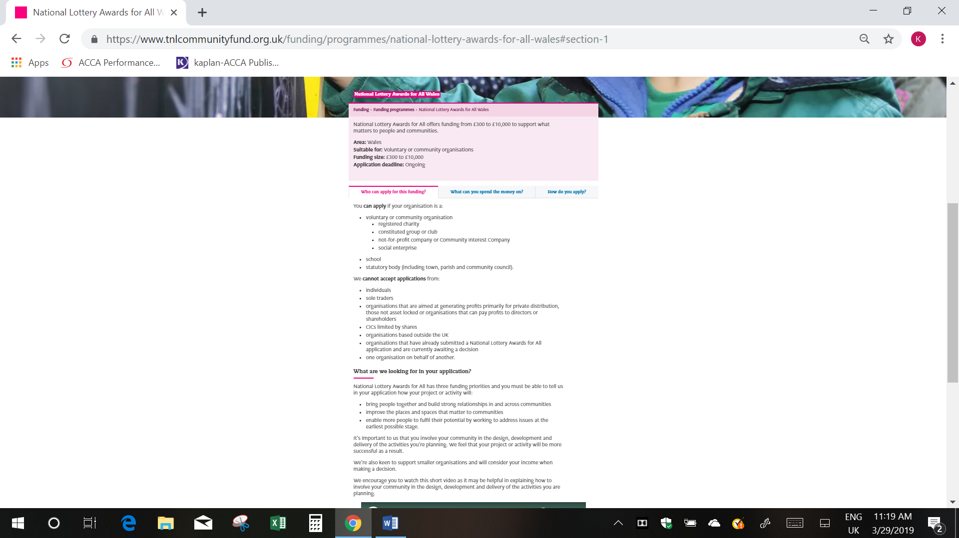
Appendix A – Funding

(The National Lottery Community Fund, 2019).

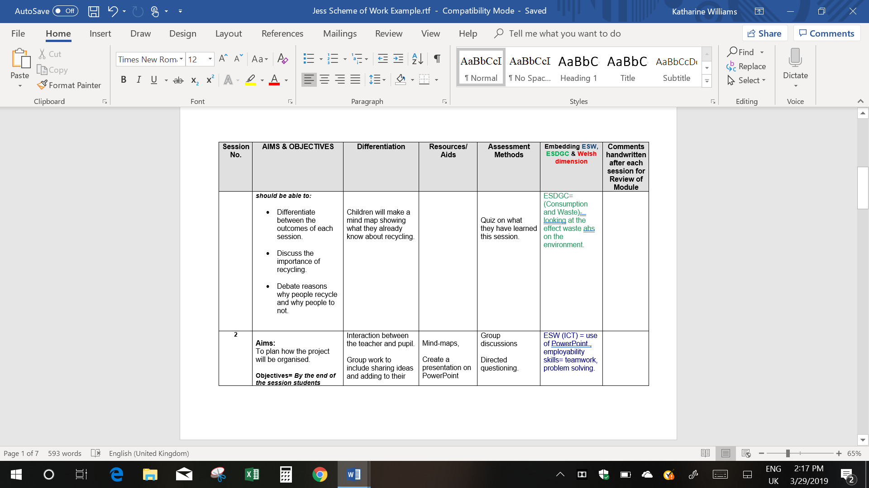
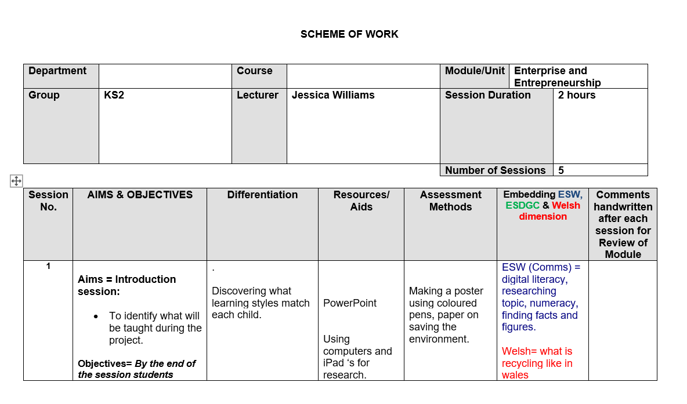
Appendix B – Scheme of Work

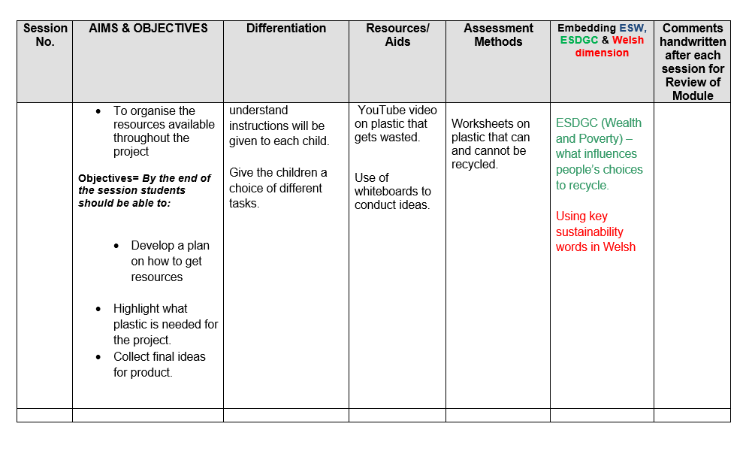
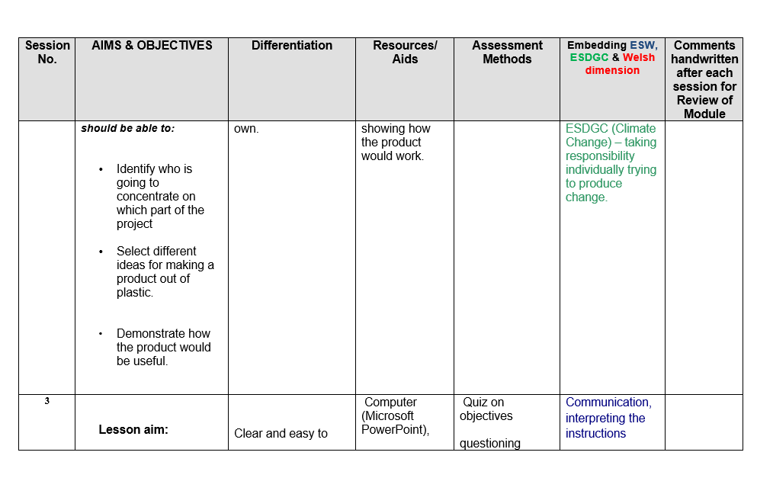

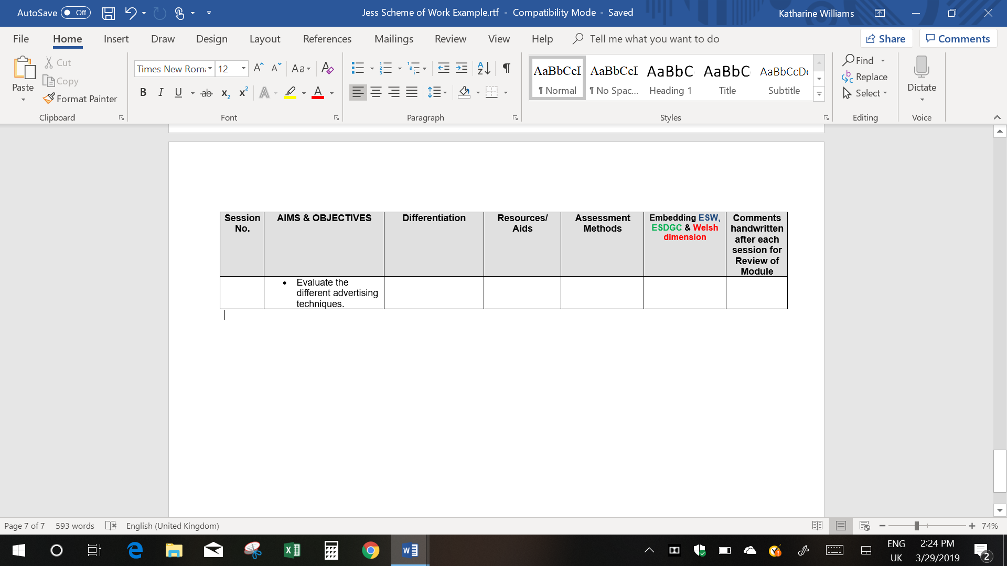
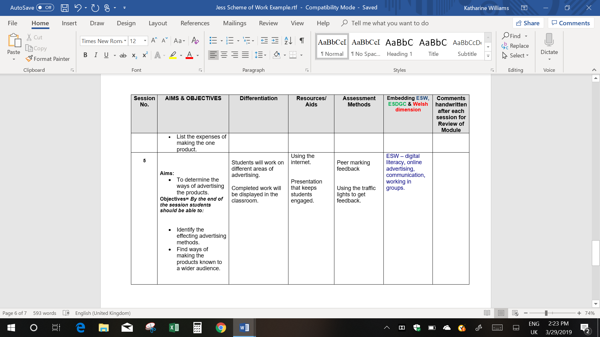
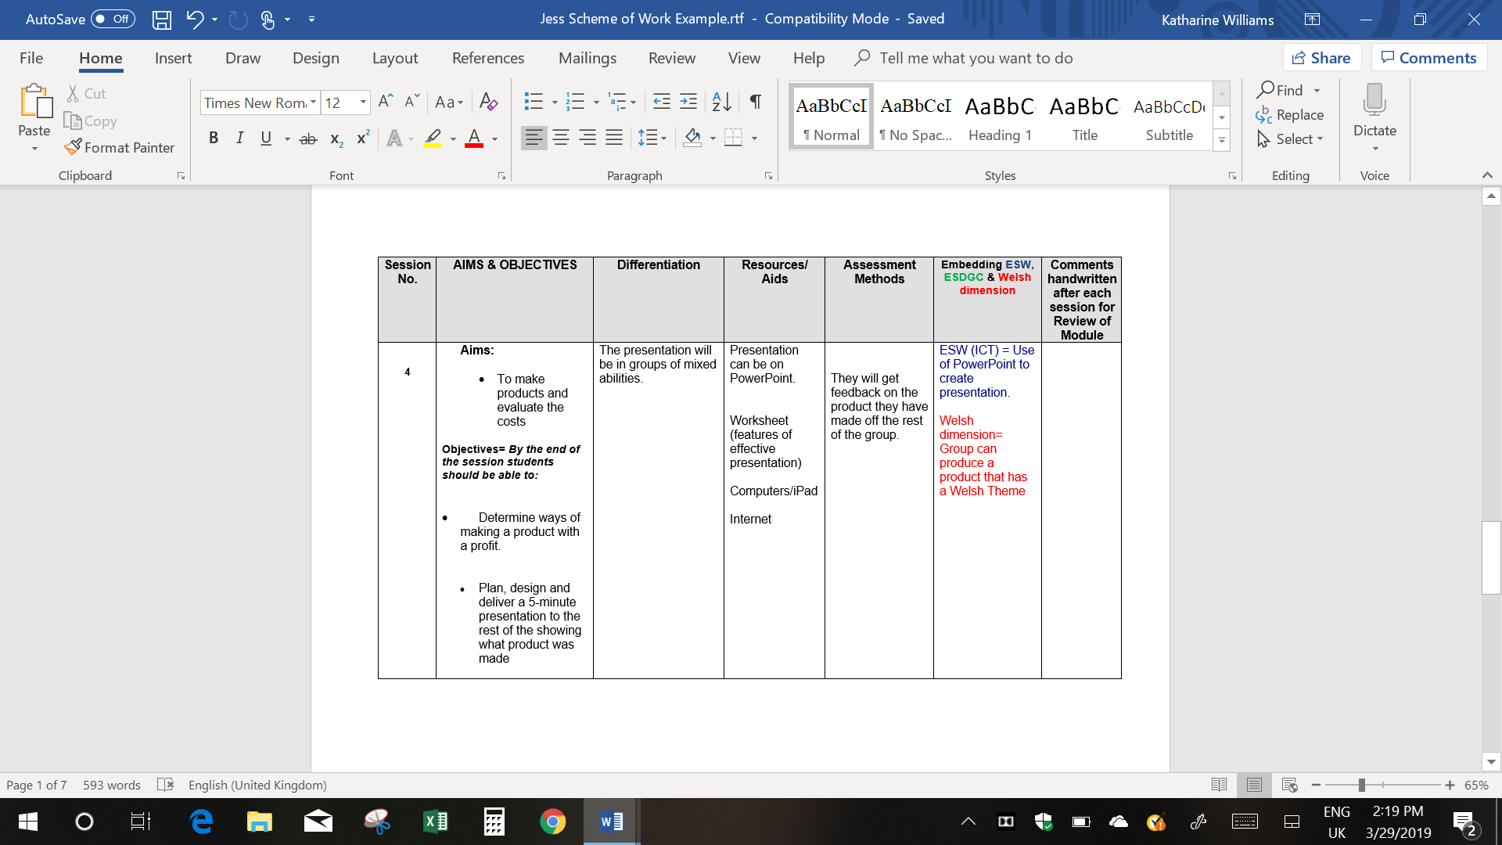
Appendix C- Lesson Plan
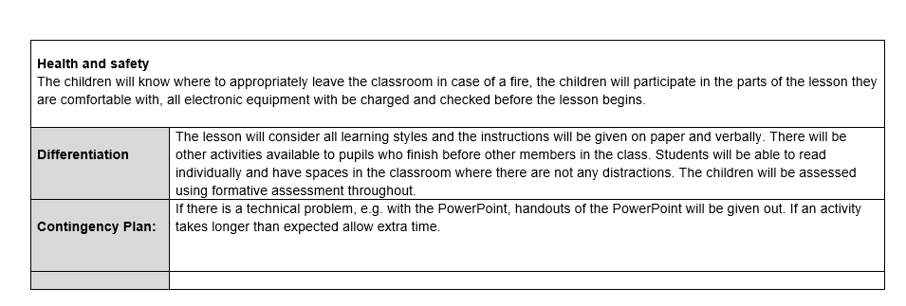
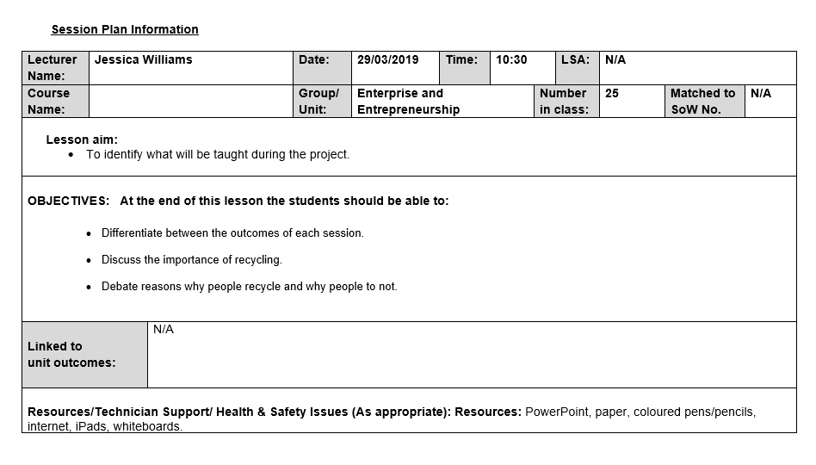

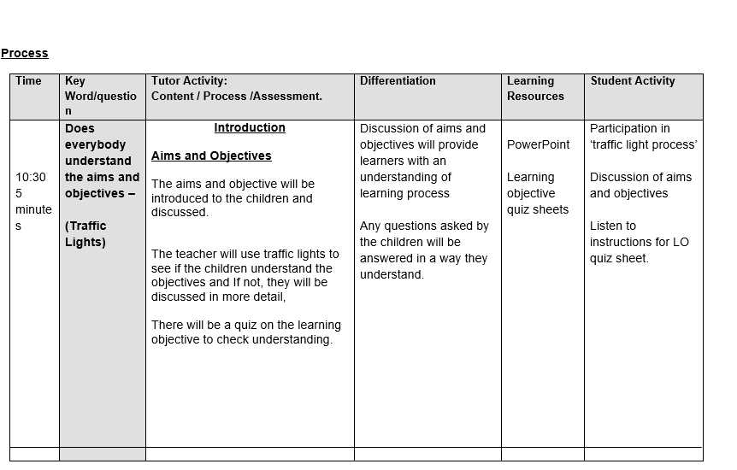
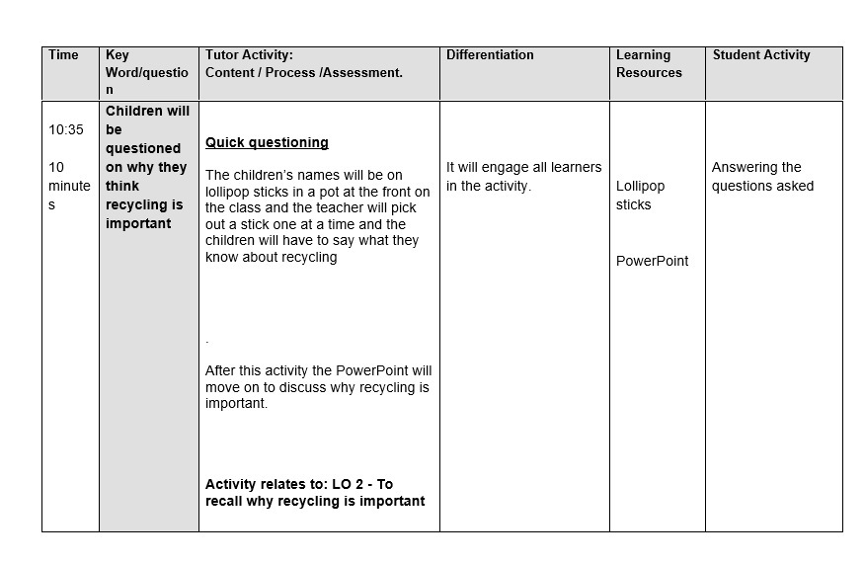

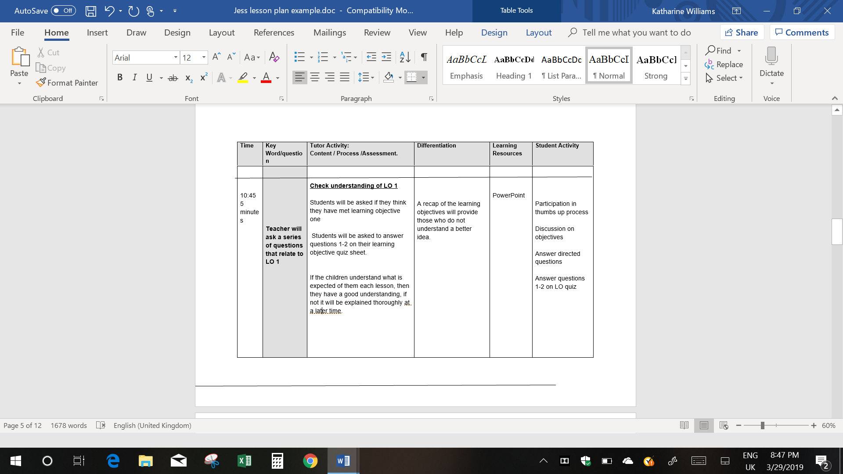

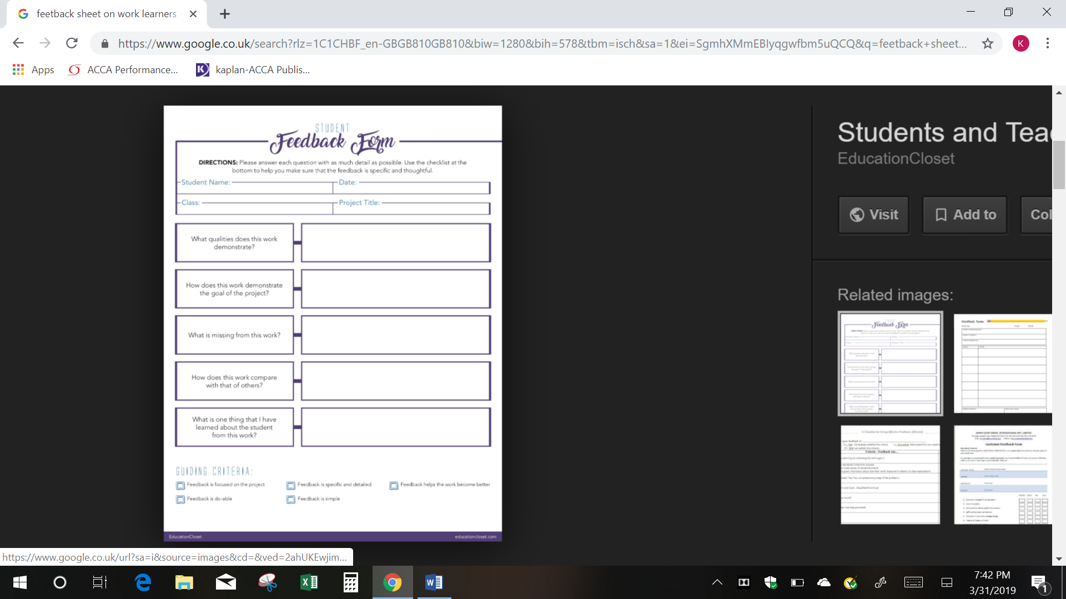
Appendix D- Feedback Form
(Riley, 2016)

