Creating a Technical Report Template

This document will show the steps taken during our lecture about creating a technical report template.
This document is not exhaustive, there is always more you can add and as you do more of them there may be things that you want to change to suit your personal preference.
Don’t forget to also look at the School of Engineering – Technical Report Guidelines document that will be on Teams and Moodle, it details the requirements for how your reports should be written.
Be aware that this document was made based on the Microsoft Word version that is available as part of your free Office 365 package, different versions of Word and Mac versions will have slightly different functions.

Before We Start
  - Have you installed MS Word? If not, go to https://www.uwtsd.ac.uk/it-exclusives/student-it- exclusives/ and you will find the download link to get your free version of Office 365.
  - You can use the online version of Word, but it does not have the same functionality as the installed version, so I recommend you download and install.


Once you open Word, in the top right there is a Sign In button. Sign in using your university account so that you can link to your OneDrive cloud storage easily.
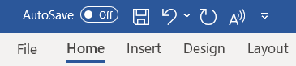

Once signed in, in the top left, turn on AutoSave, a popup box should appear asking if you want to save to OneDrive for your student email account. If you choose to save to this, then all your work will be automatically backed up to the cloud, and it generally saves changes as you write them. This is highly recommended as a way of ensuring that you always have a backup copy of your work just in case of any technology issues!

Creating a New Document and Title Page
  - Open MS Word
  - Choose Blank Document

Your title page will be the first page of your report document, so create that first and get it out the way.
Check your font is set to a clear and easy to read one. Calibri is a very popular font that is clear and
simple (that’s what this document is written in).

Text on your title page should be centralised (Ctrl + E) or click:
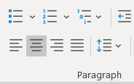

Have a look back at the Technical Report Writing presentation and check what the mandatory information is that your title page must contain. Write in this information, on separate lines. Try and space things out so that the title of the report is central in the page. Adjust your font size as appropriate. The information going on this page should be:
  - University name
  - Institute name
  - Title of report
  - Module name and code
  - Your name
  - Your student ID number
  - Date of report (mm/yyyy format will be fine)

For now, just put “Title of Report” etc where you don’t know what they will be. Maybe make those
line Italic so you know to change them each time!

You can add the university logo onto your title page if you want. Many people prefer to do this, it makes the title page look a little more appealing. If you chose to, make sure you are using the latest version of the logo, it has changed a few times over the years. Go to www.uwtsd.ac.uk to check if you have to!
Your title page should now look something like this:

University of Wales Trinity Saint David

Wales Institute of Science & Art



Title of Report Here
Module Name (Module Code)

Your Name
Your Student ID Number September 2020

Setting Line Spacing
Your document should use a 1.5 line spacing to make it easier to read. Since all the reports you will write at university will follow the same format, it makes sense to set this as your default on the template now.
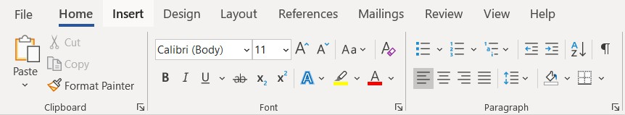
Make sure you have Normal selected under the Styles section in the Home tab. On the Home tab, look for the Paragraph section.

Click on the arrow icon in the bottom right of the paragraph section to open the full options box.
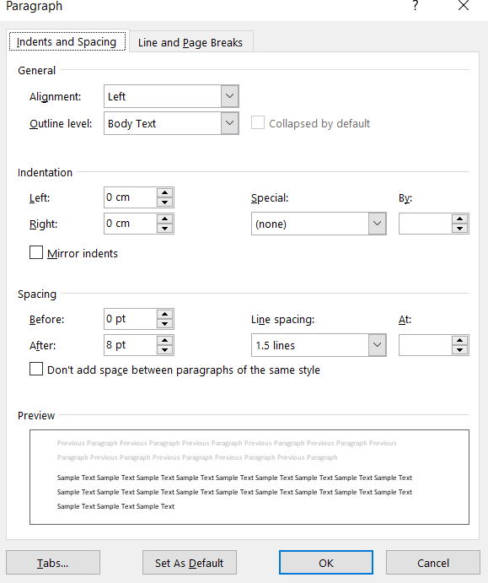

Set the Alignment to Left. Set the Line Spacing to 1.5 Lines. Press Set As Default and then OK. Repeat this step for Heading 1, Heading 2, Heading 3 and Heading 4 under the styles section.

Creating Chapter Titles
Your main chapters should always start on a new page. Instead of repeatedly hitting enter to move things to a new page, use Page Break under the Insert tab.
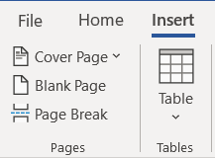

If you hit return/enter to move things down to the next page, Word only knows that you asked for a gap of that size, so it always keeps that many blank lines. This is a problem if you change something above the gap, then your spacing will all be wrong. Page break just moves your text down to the next page and it will always stay there.
After writing your last line of your title page, make sure the cursor is at the end of the text and press

Page Break.

Now you should be at the top of a blank page.

You want your section headings to stand out, so they should be larger, bolder, and even a different colour. You could do this manually, but Word has a built-in function for this to make it easier.

Press Heading 1 in the Styles pane. Now write Introduction and it will show in blue as a larger font size, because you have asked Word to make it a Heading.

However, your headings also need to be numbered. You can manually write in the numbering system, but that can become problematic if you want to add or remove a section, the numbering might not update correctly. Word again has a feature to do the numbering automatically for you.
Under the Paragraph section in the Home tab there is a button for Multilevel List.

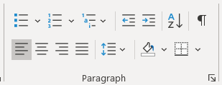

When you click on this, there is a List library of the different options, you will see one for headings on the right.
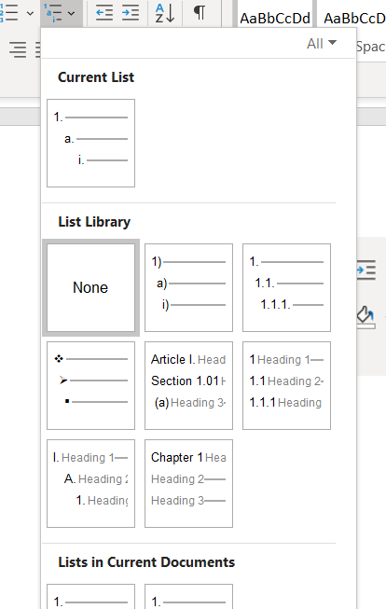

By selecting that, Word will then automatically number your headings for you, at all heading levels, so now you do not need to worry about doing it yourself.
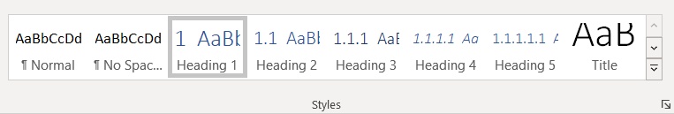

Now go through and create headings for all the mandatory sections (check last week’s presentation).
Remember to use Page Break to make sure they start on new pages!

Inserting Page Numbers
Your reports should ALWAYS have page number on them. It makes it much easier for the reader if they want to jump from the contents page to a specific section and it is more professional.
However, you do not want a page number on the title page, that should just be a title page and not numbered.
Go to the Insert tab, find the Header & Footer section. There is an option for Page Number.
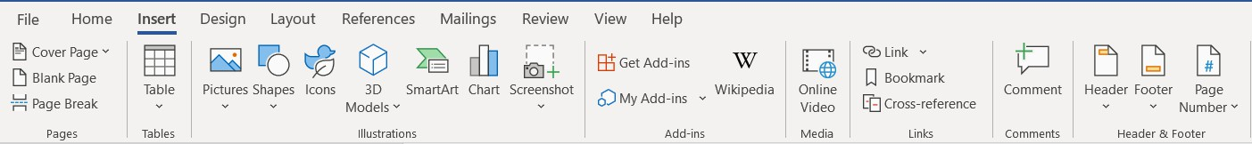

Put in page numbers in Bottom of Page. The style and position of the page numbers is up to you, but make sure it looks simple and professional, nothing too fancy.
Go back into the Page Number drop down and select Format Page Numbers. In the new window that opens, select Start at: and start the numbering from 0, press OK.
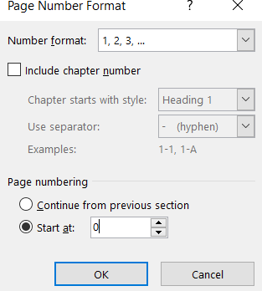

Now go to the bottom of the page and double click on the page number itself. This opens the
Header & Footer toolbar.
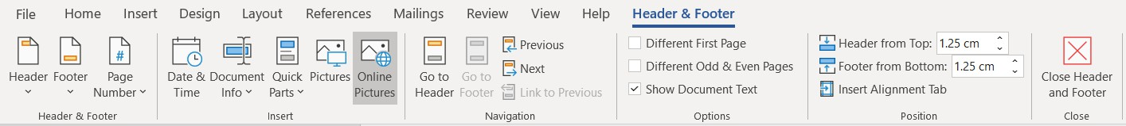

So that your title page doesn’t have a page number, tick the Different First Page option. Close the Header & Footer toolbar. Now your title page should not have a page number and the next page should be page 1.

Inserting a Contents Page
By using the automatically number headings system in Word, you can very easily create a contents page. Your report MUST have a contents page, but there is no point manually typing it out yourself, use the tools available.
First, go back to your title page. Click at the end of the page and insert another Page Break. Now you should have a blank page between your title page and your introduction page. This is where your contents page will go.
Under the References tab you will find the Table of Contents option.
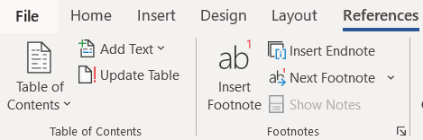

Select the style of contents page that you want from the drop down. There are no specific requirements here, but generally people will use Automatic Table 1 or Automatic Table 2 styles.
Once you have selected the type of table you want to use, you should end up with something that looks like this (with your heading titles obviously):

Contents
- Before We Start 1
- Creating a New Document and Title Page 2
- Setting Line Spacing 4
- Creating Chapter Titles 5
- Inserting Page Numbers 7
- Inserting a Contents Page 8

To update the table as you add more section, Right Click on the table of contents, select Update Field. In the box that opens select Update Entire Table.
You should always make sure your contents table is updated once you have finished writing!

- Inserting Captions to Figures & Tables
In your reports you will likely be using lots of table and figures to support your work. As we discussed before, these need to be numbered and have captions explaining what they show to the reader.
Click into your Results section.

Under the Insert tab, insert a Table, doesn’t matter about the size, just insert a table of some sort.

Click into one of the cells of the table. Go to the References tab and find the Insert Caption option.
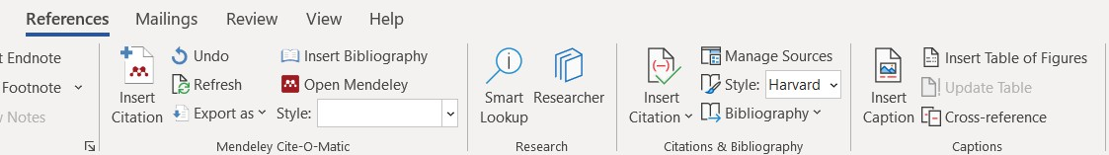

In the pop up box, make sure that the correct type is selected, in this case Table. You should see that Word has automatically numbered the table for you. Now add your description of what the table shows and click OK.
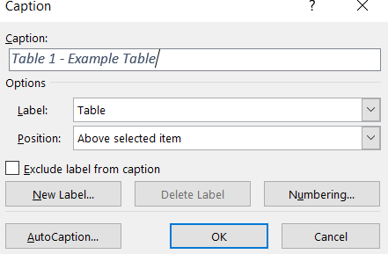

Now your table should have a caption added to it, and for a table that should be above the table like this:
Table 1 - Example Table

Like your contents, you also have to present a list of tables and figures at the start of the document. Again, Word can do this automatically for you.

Click back to you contents page, clicking on the blank space below the contents table. Under the References tab, in the Captions section, click Insert Table of Figures.
In the pop-up box, make sure you select the right type, be that Figure, Equation or Table. You should have a list of each of these if you have used that type.
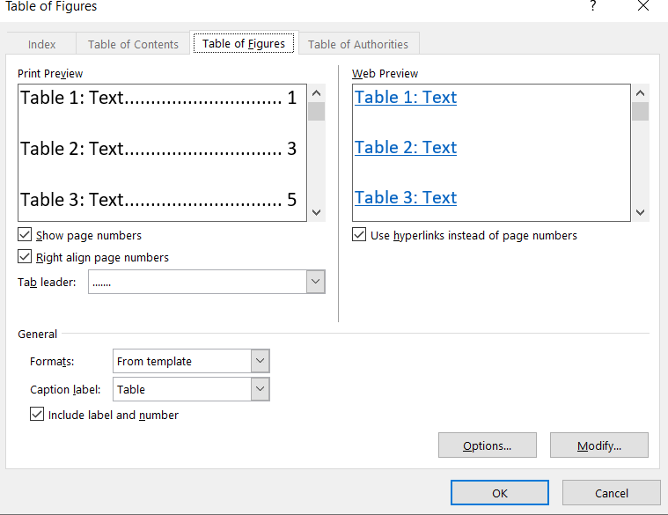

Click OK and Word will insert a list of tables something like this:
Table 1 - Example Table 9
Word does not automatically create a title for lists of Tables and Figures, you may wish to add a header yourself to make it more obvious.
Again to update these tables, Right Click on the list and select Update Field.

- Saving the Document as a Template
Click File

Click Save As

Change the file format from being Word Document to being Word Template

Press Save

The document and its format is now saved as a template that you can use for all the reports you write from this point on in university.
- Loading the Template
When opening Word, or from the Home section, in the main window near the top you should see an option for More Templates, press this.
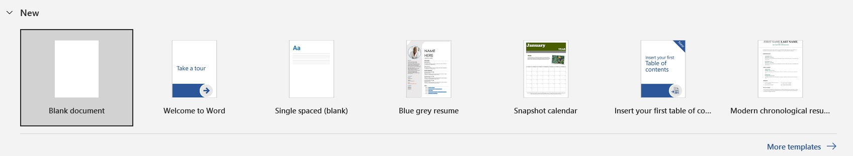

The next window will have two template types as an option, Office and Personal. Click on Personal.


You should now be able to see the template that you created and saved. Load this template and start writing your report!

