MongoDB Exercise using MongoSH

- Open MongoDBCompass on your computer.

- Connect to the Pagila database.

- Click on ‘Open MongoDB shell’ .
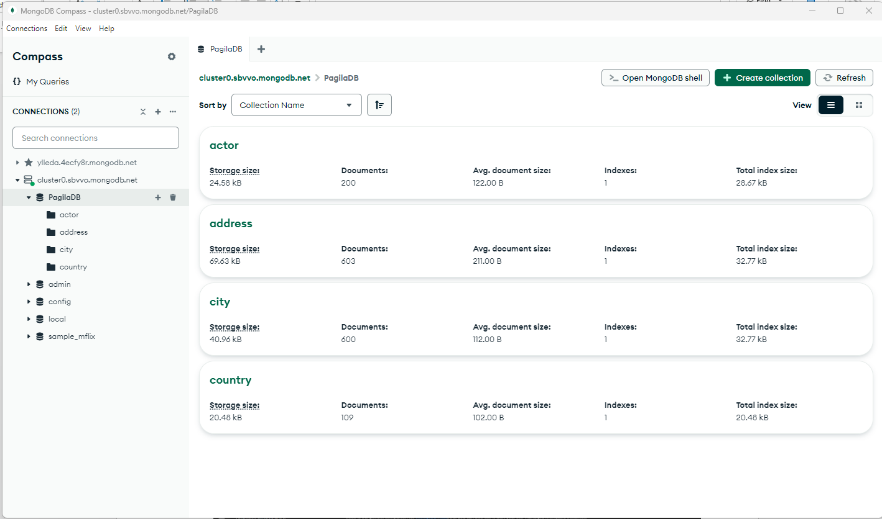

- Use this to write your shell queries.
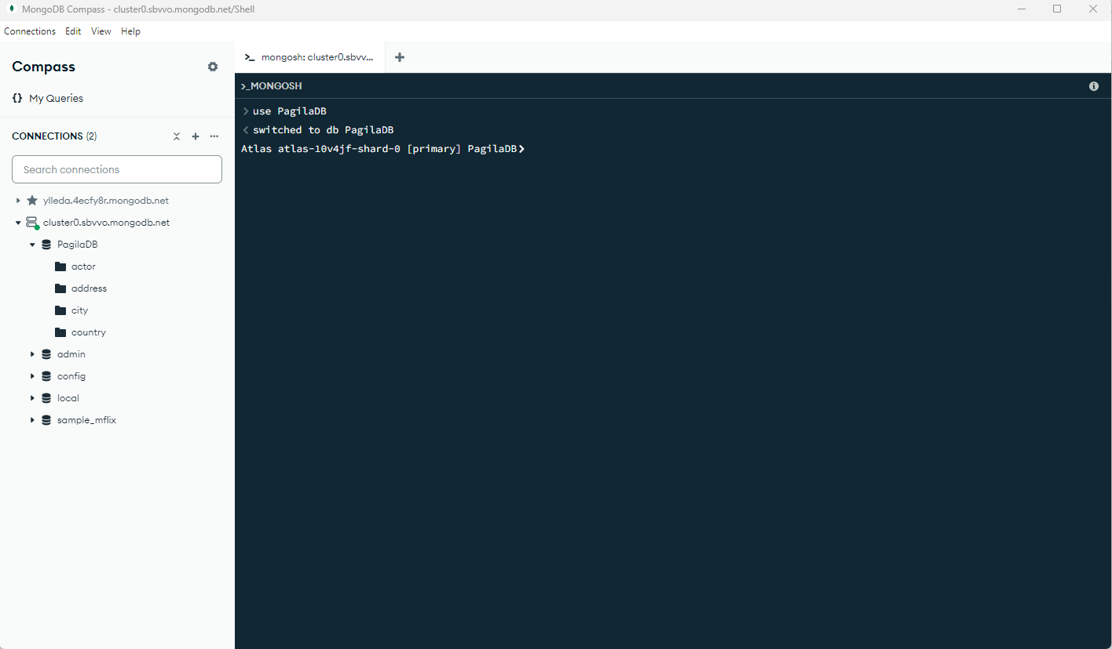

- The syntax will be ‘db.<collection>.find({})' This will bring up the whole collection. To choose specific attributes / values, use a comma, and the attributes to find inside curly braces.
- db.customer: Refers to the customer collection in the database.
- .find({}, { first_name: 1, last_name: 1 }): Executes a find query with two parts:
- {}: The first argument (empty curly braces {}) is the query filter. An empty filter {} means "select all documents" in the customer collection without any conditions.
- { first_name: 1, last_name: 1 }: The second argument is the projection, which specifies the fields to be included or excluded in the result. In this case:
  - first_name: 1 and last_name: 1 mean "include only the first_name and last_name fields in the output." A 1 signifies inclusion

i.e.
db.customer.find({}, { first_name: 1, last_name: 1 });

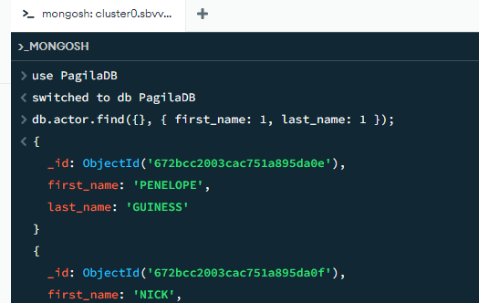

- Try all the questions in the same way we did with SQL:
  - Retrieve all customer names (first and last).

  - Get the email and address ID of customers who have provided an email.

  - Show customers who have an active status (activebool = true).

  - Retrieve all distinct store IDs from the customer collection.

Conditional Queries

  - List customers created after January 1st, 2020.

  - Get customers whose first name starts with 'A'.

  - Retrieve customers who are inactive (activebool = false).

  - Show customers whose last update was within the last month.

Aggregate Functions

  - Count how many customers are in the database.

  - Find the number of active customers.

  - Get the average customer active score.

  - Find the maximum customer_id in the customer collection.

  - Grouping and Filtering with Aggregation.

  - Count how many customers there are per store.

  - Get the number of customers per store where the count is greater than 50.

Lookups (Joins in MongoDB)

  - List all customers along with their address details.

  - Get all customer emails and the city they live in.

  - Show the store ID and the number of customers per store.

  - List all films rented by customers.

  - List all active customers and the date they last rented a film.

Subqueries with Aggregation and Filters

  - Find the customer with the highest number of rentals.

  - Get a list of customers who rented a specific film UNFORGIVEN ZOOLANDER.

  - Find customers who have not rented any films.

  - Get the name of the store with the most active customers.

  - Find customers whose last name appears more than once.

Complex Queries

  - Retrieve the total number of films rented by active customers.

  - List all customers who rented films from both store 1 and store 2.

  - Get the name of the film rented the most in 2023.

  - Find the store with the highest revenue from rentals.

  - Get the list of customers who have rented more than 5 films in the past month.

  - Find the names of customers who have rented every available film.

