Student name: Tawhid Ahmed Student number: 1715006 Lecturer names: Terry Walcott

big DATA (acua6001_lon)
January Assignment UNIVERSITY OF WALES TRINITY SAINT DAVID Academic Year 2020/2021

Table of Contents
Worksheet 1
1. Data Exploration
1.1 Yellow -small.data ………………………………………………………………………………………………………………………………p.3
1.2 Extending Yellow- small.data ………………………………………………………………………………………………………………p.7
1.3 Read adult.data…………………………………………………………………………………………………………………………………...p.9
2.1 Decision trees using wine.datap…………………………………………………………………………………………………………p.18
2.2 MLP using wine . data ……………………………………………………………………………………………………………………….p.22
2.3 Reading data “website 1.txt”……………………………………………………………………………………………………………..p.24
Worksheet 2
3. First Report Workflow
3.1 Evaluating Adult.data ………………………………………………………………………………………………………………………..p.27
3.2 Extending Evaluation of adult. data …………………………………………………………………………………………………..p.28
3.3 Evaluate soccer worldcup2006.txt …………………………………………………………………………………………………….p.29
4. First report
4.1 Building a report using Chap 3. expercise 1 data ……………………………………………………………………………….p.31
4.2 Extend ‘Private ‘ class ……………………………………………………………………………………………………………………….p.32
4.3 Extend chap.3 exercise 2 build report……………………………………………………………………………………………….p.32
4.4 Extend chap 3. exercise 3 build report ………………………………………………………………………………………………p.33
Worksheet 3
5. Database Operations
5.1 Creating an empty workflow …………………………………………………………………………………………………………….p.34
5.2 Connecting KBCBOOKs.sqlite ……………………………………………………………………………………………………………p.35
5.3 Database Looping Nodes …………………………………………………………………………………………………………………p.36
6. Accessing Information from the Web
6.1 Chemical database information retrieval ………………………………………………………………………………………….p.36
Worksheet 4
7. Date and Time
7.1 Adding Random Dates ………………………………………………………………………………………………………………………p.37
7.2 Importing date and time ……………………………………………………………………………………………………………………p.38
Worksheet 5
8. Flow Variables
8.1 Reading sales.csv ………………………………………………………………………………………………………………………………p.41
8.2 Using cars dataset ………………………………………………………………………………..…………………………………………..p.41
8.3 Maximum Engine Size ……………………………………………………………………………………………………………………….p.43
8.4 Building a Wrapped Metanode………………………………………………………………………………………………………….p.44
9. Loops
9.1 generating data row…………………………………………………………………………………………………………………………p.45
9.2 generating a full table………………………………………………………………………………………………………………………..p.48
9.3 deleting duplicate data rows ……………………………………………………………………………………………………………p.49
9.4 creating an original file ……………………………………………………………………………………………………………………p.94
10. Switches
10.1 IF switch node …………………………………………………………………………………………………………………………………p.51
10.2 Workflow control ……………………………………………………………………………………………………………………………p.51
11. Advanced Reporting
11.1 Projects.txt report building ……………………………………………………………………………………………………………p.52
11.2 sales.csv KCB ………………………………………………………………………………………………………………………………….p.52
11.3 reporting building extension…………………………………………………………………………………………………………..p.52
Worksheet 6
12. Developing Big Data Warehouse using Walmart Sales Data……………………………………………………………….p.53
Reference ……………………………………………………………………………………………………………………………………………….p.57

Worksheet 1
1. Data Exploration
1.1 Yellow -small.data
The task for this exercise is to read the file ‘yellow- small.data’.
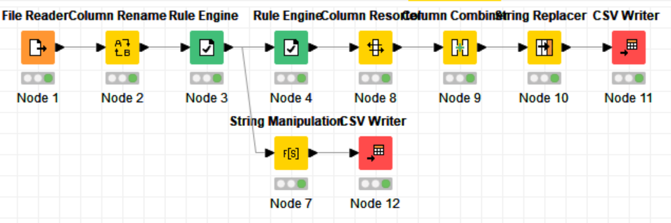 We can find the bellow table with the first node.
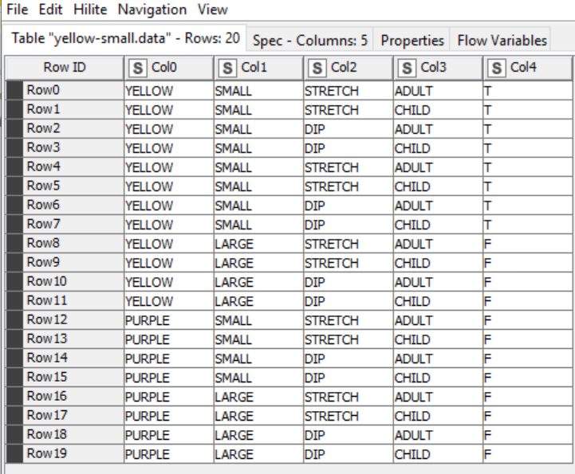
The second node change the column name, Col0 as Colour, Col1 as Size, Col2 as Act, Col3 as Age, Col4 as Inflated (True/False). All of them have String value.
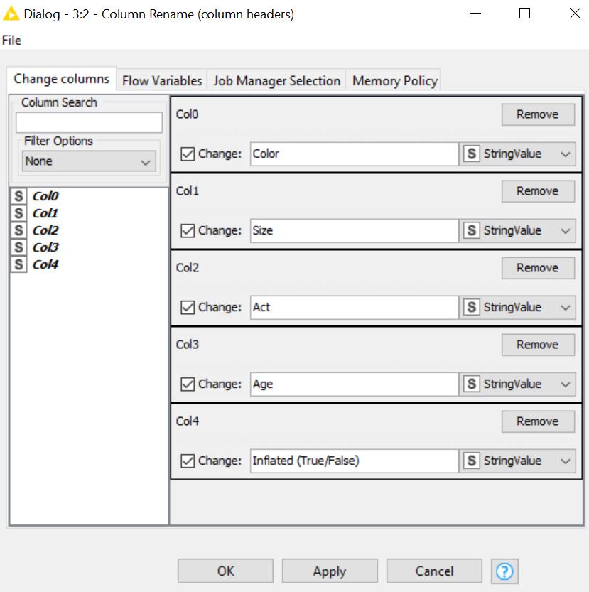
The third node is a rule engine node that add ‘class’ column and it put as value inflated if the colour is yellow and the size is small, for other case it assigns the value not inflated.
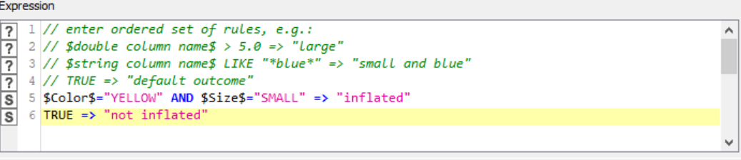
The fourth node is a rule engine node that add a column name ‘tmp’ and gives the value is for all the rows.
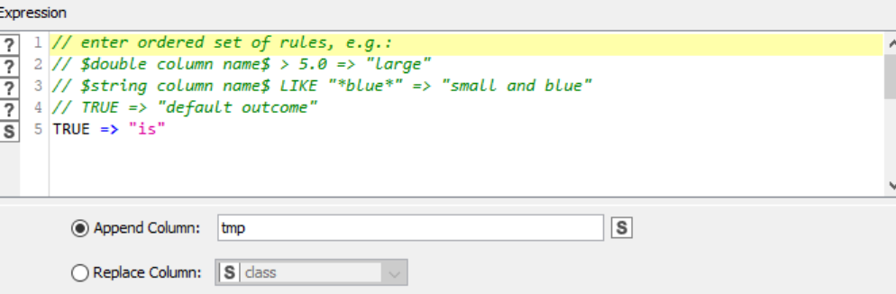
The fifth node it is a column resorter that re organize the other of the column in this order: colour, size, act, age, class, tmp, inflated. 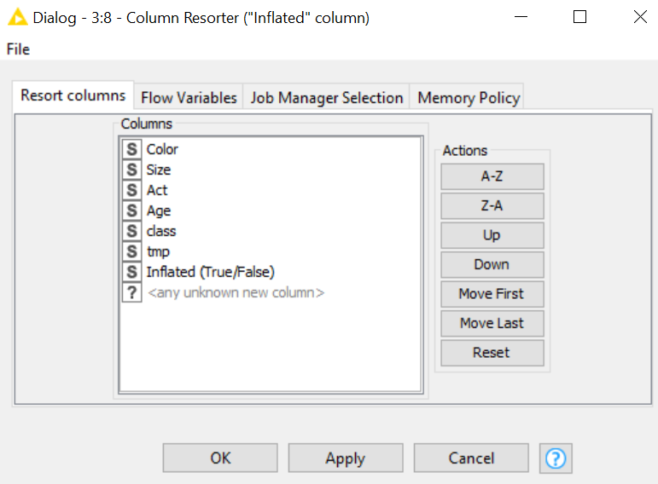
The sixth is a column combiner, that create a new column with name of ‘full sentence’ where it join the three column: class, tmp, inflated. 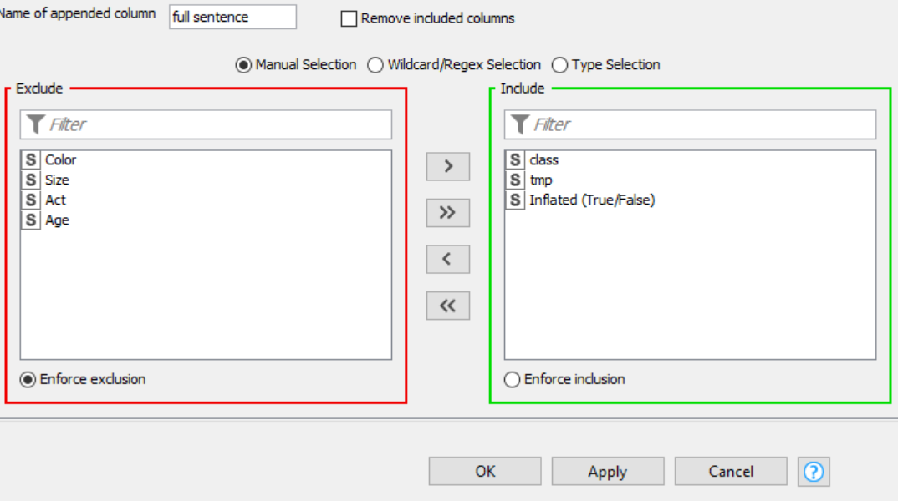

The seventh node is a string replacer, it changes the string from ‘not,’ to ‘not’ in the column full sentence.
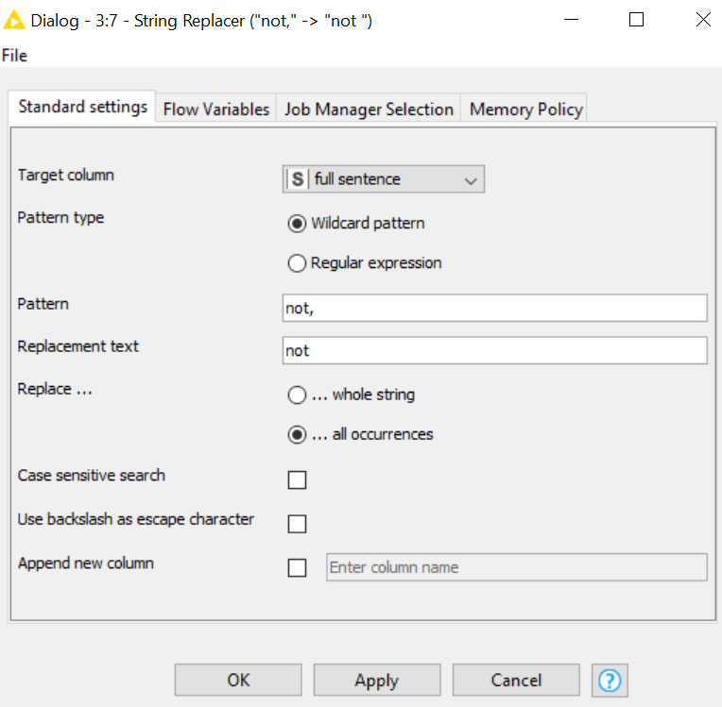

The eighth node is linked with third node and it is an alternative and has seme function of all node from forth to seventh.
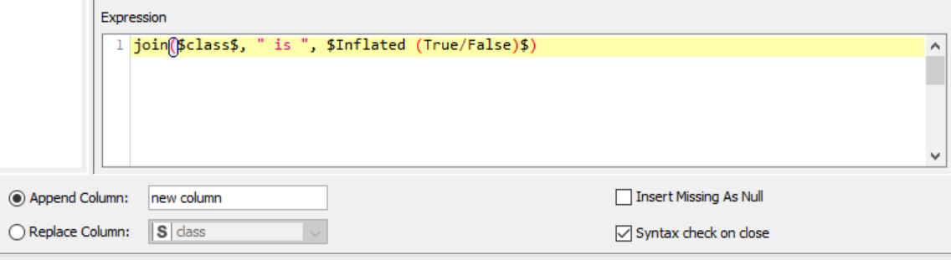

1.2 Extending Yellow- small.data
This workflow takes the first four node from previous exercise 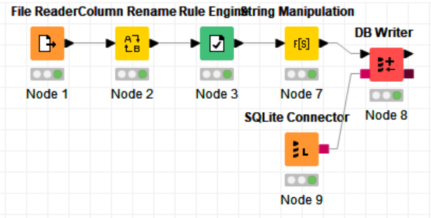
it adds an SQLite database where it writes the last data table in a database called ‘KBLBook.sqlite’.
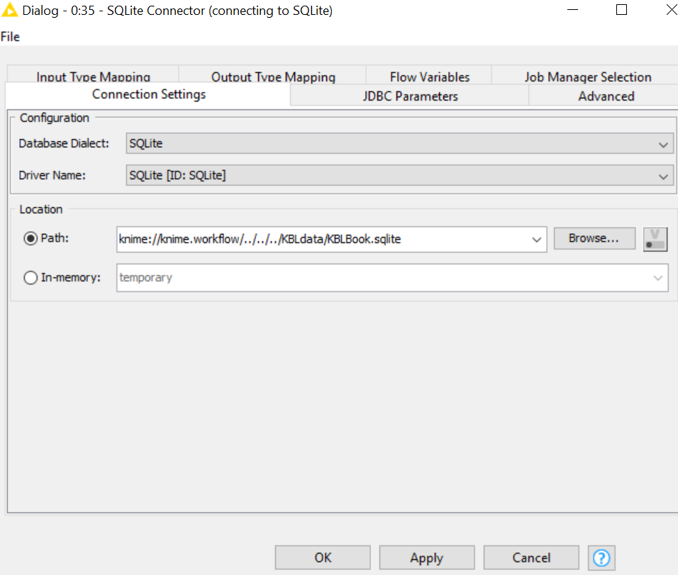

The last node is a database writer, it writes the data table in csv file called ‘Chapter3Exercise2’.
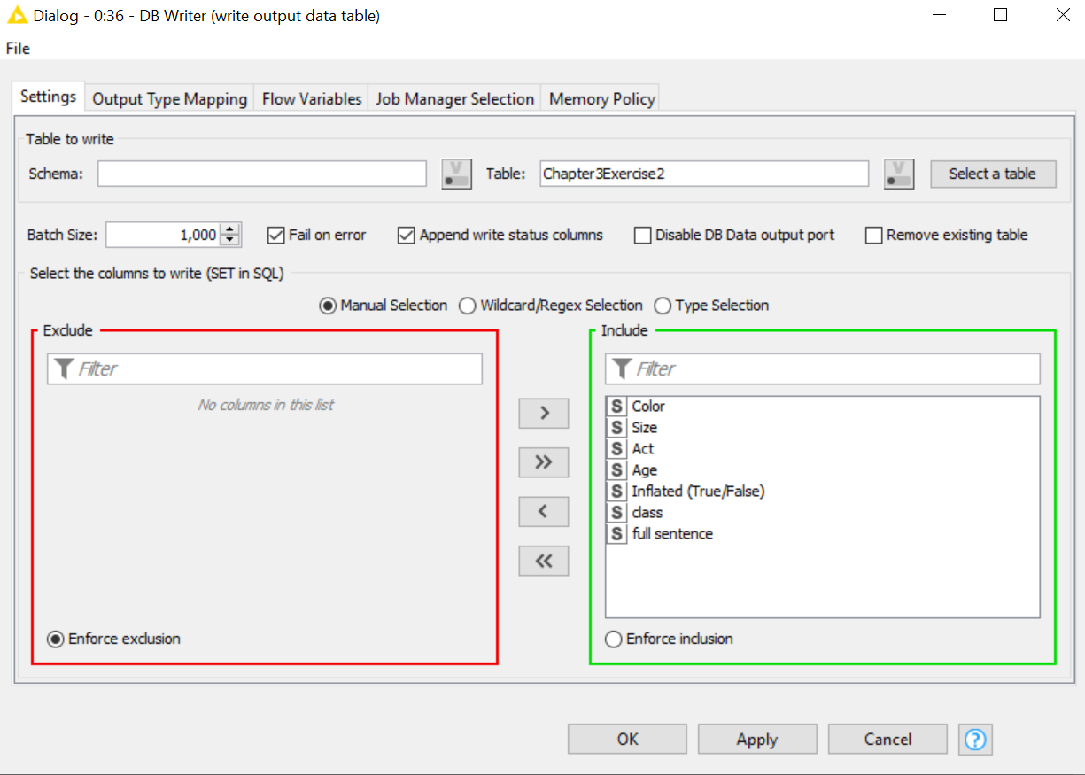

1.3 Read adult.data
In this workflow 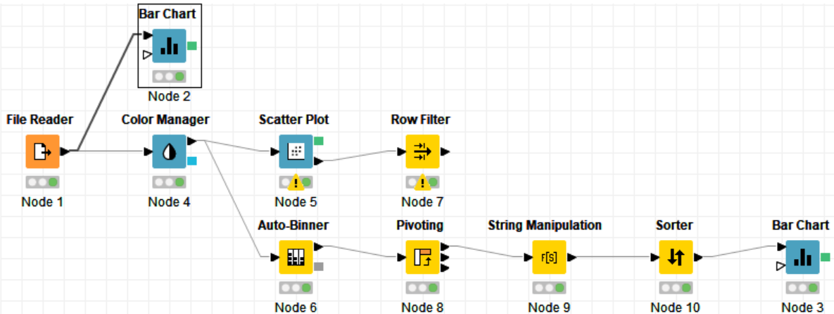first node is a file rider that read the adult.data file, then there is a node for bar char where there are some change from default, from option window and from general plot options. 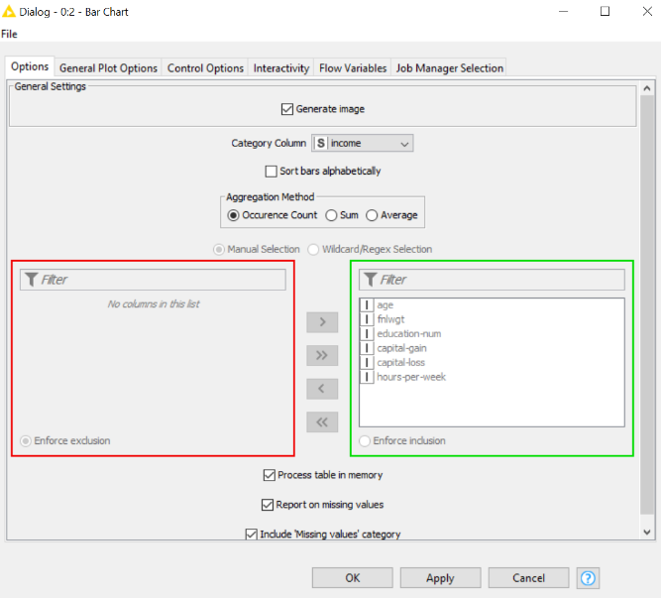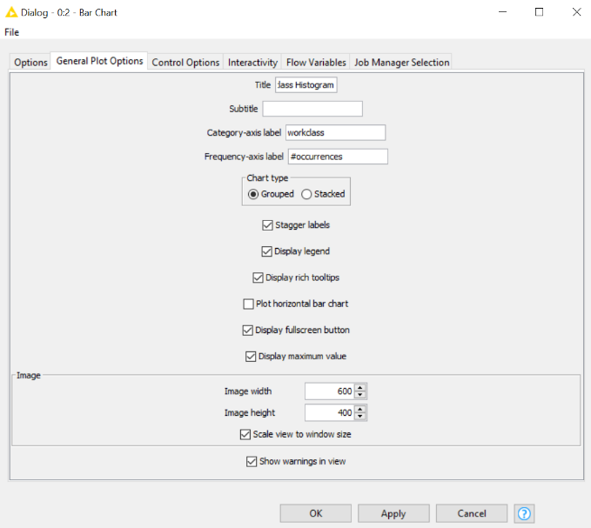

From colour manager node there are change in the colour settings window. 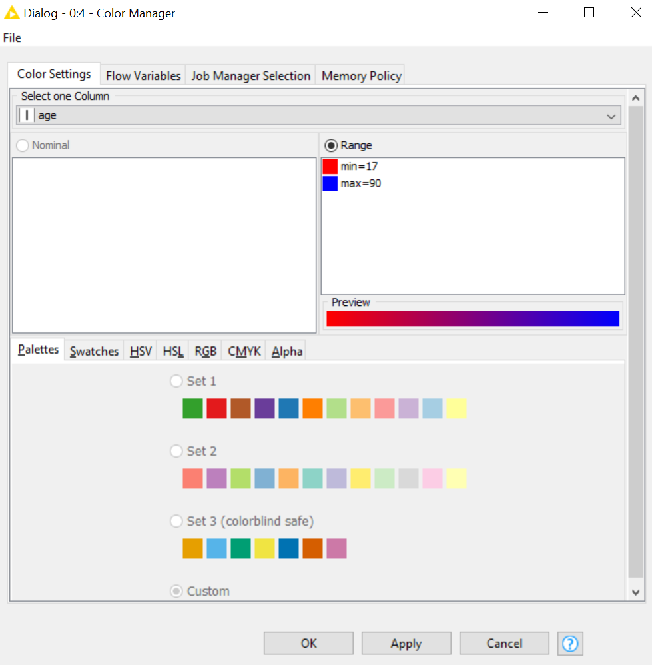
Sample of output of the node is below. It is possible to notice that young age is mor read and old age is bluer. 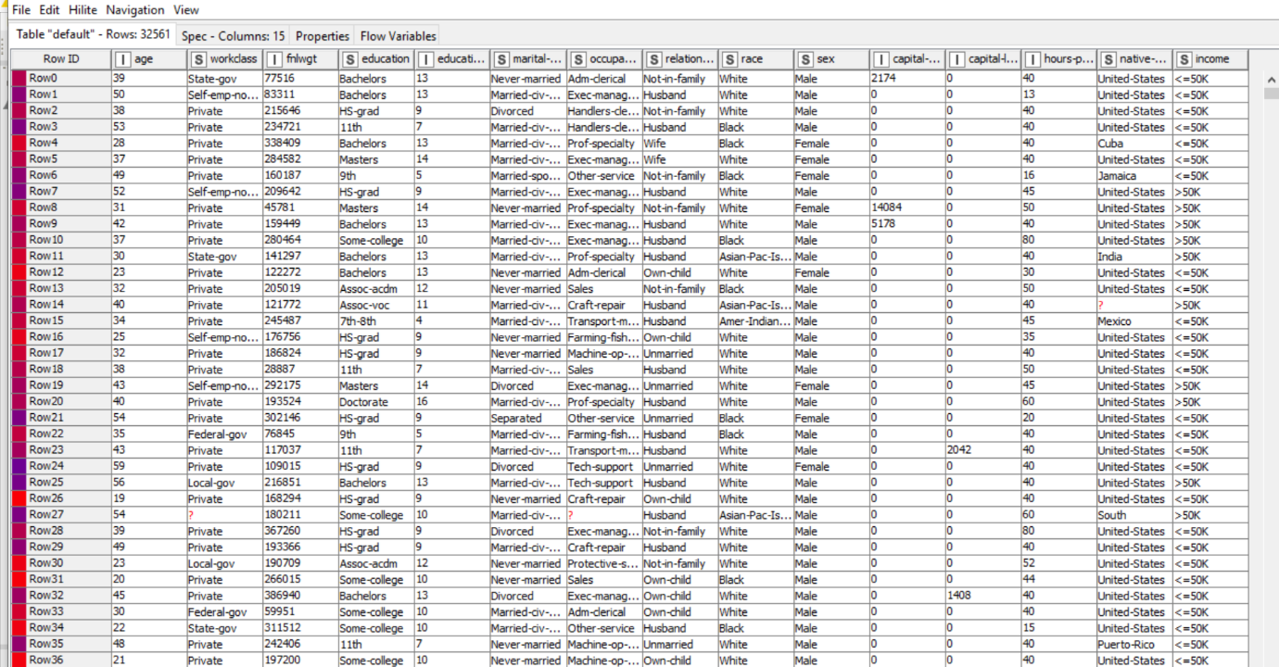
Following there is scatter plot node and from default there are some changes in option window and general plot option.
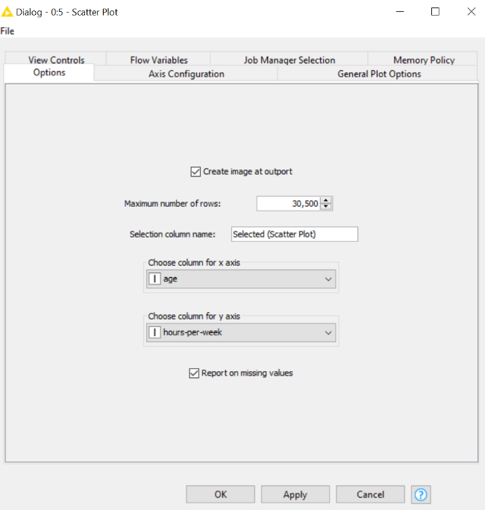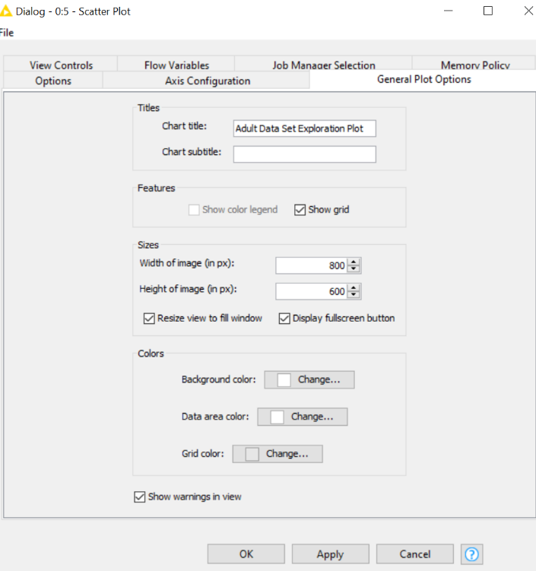
The output of the node is the graph bellow. 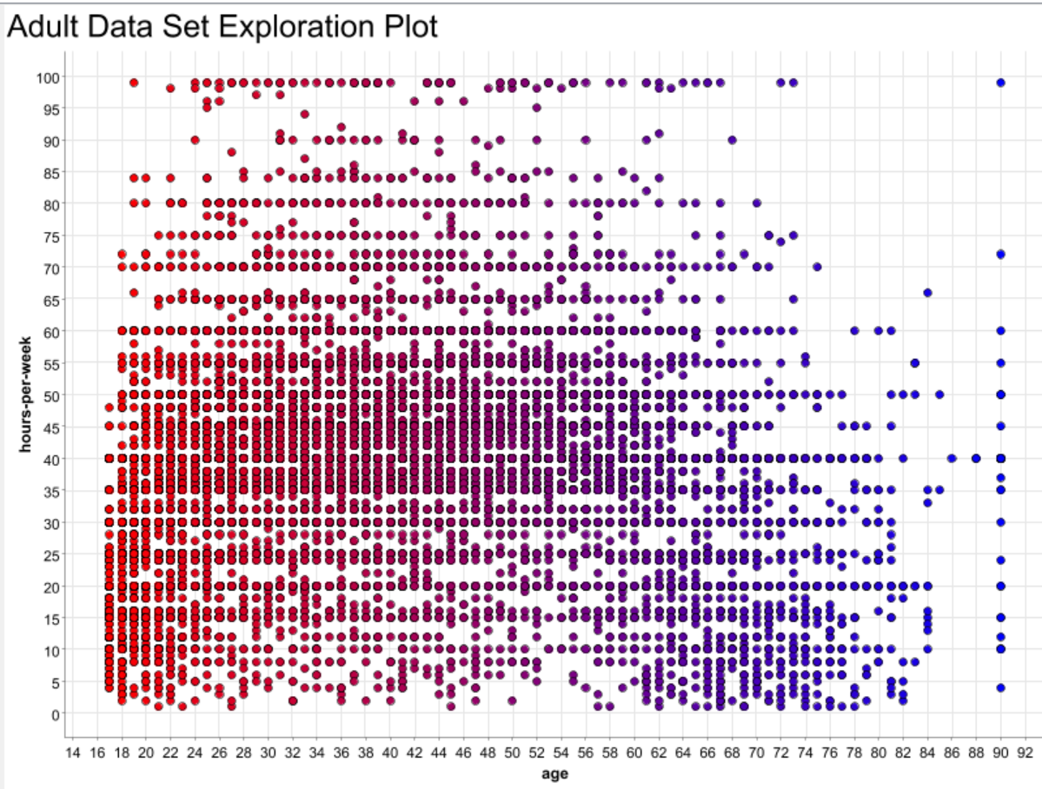

Nest to the scatter plot node there is Row Filter node with some change in filter criteria.
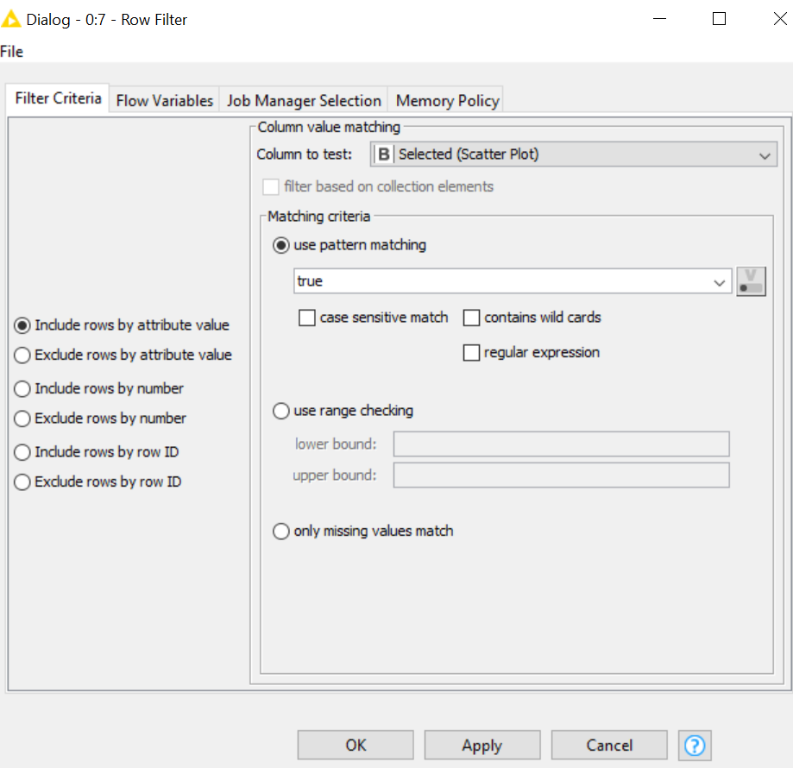

Whit colour manager node there is another node connected, an auto-binner is used, change are in Auto Binner Settings. 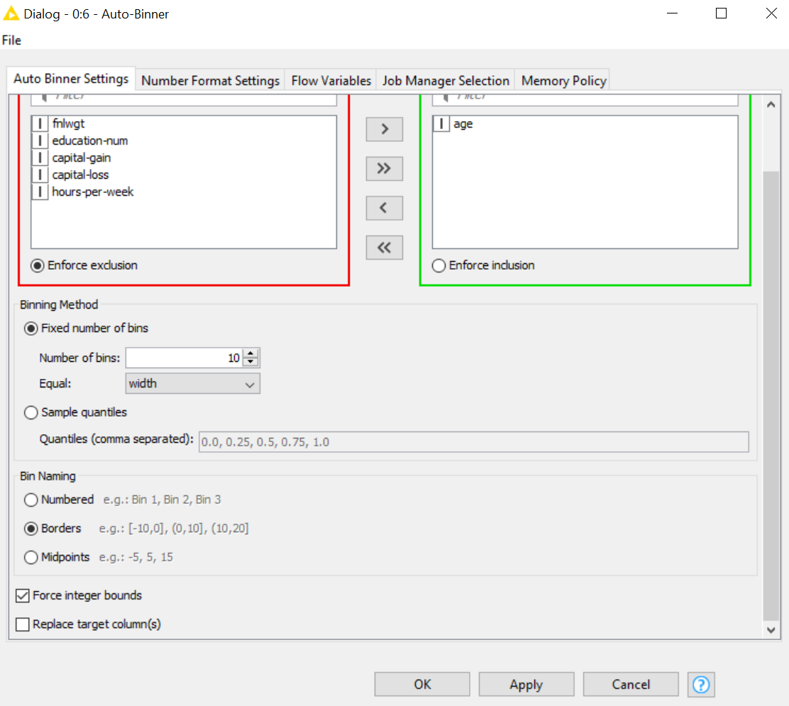

Then there is a pivoting node, changes are in settings. 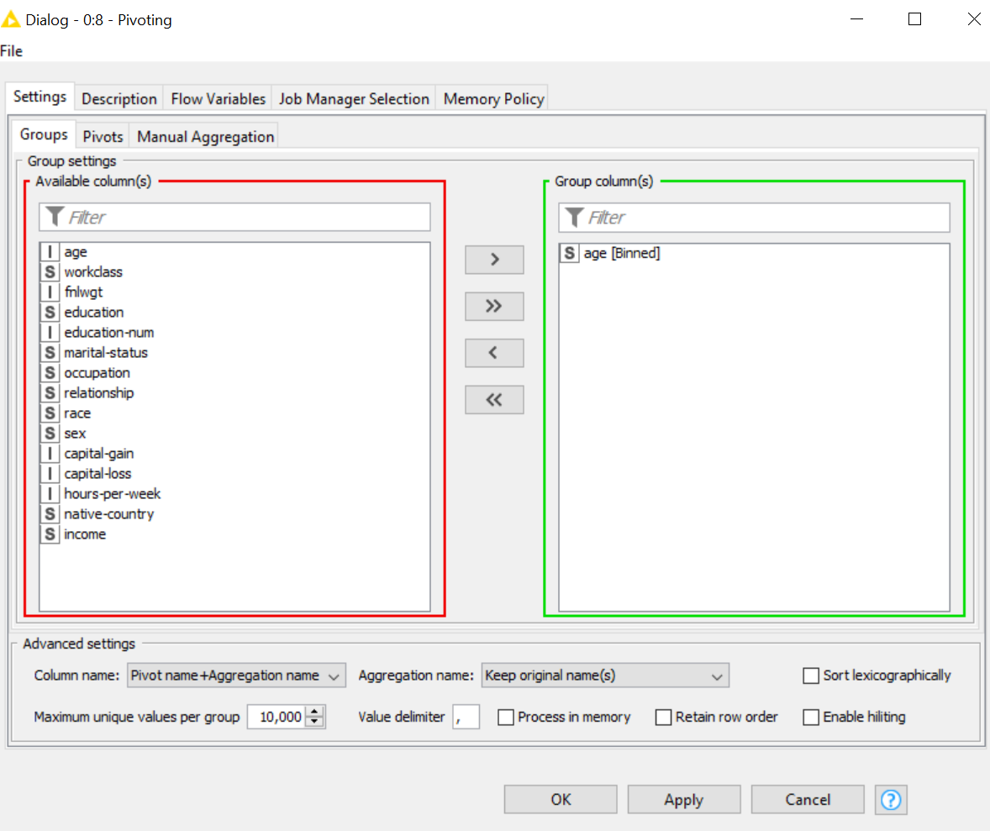
The pivoting table is below.
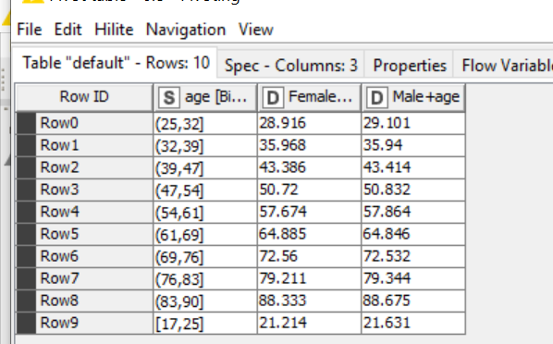

Following there is a String Manipulation node, and expression for the manipulation is in String manipulation window. 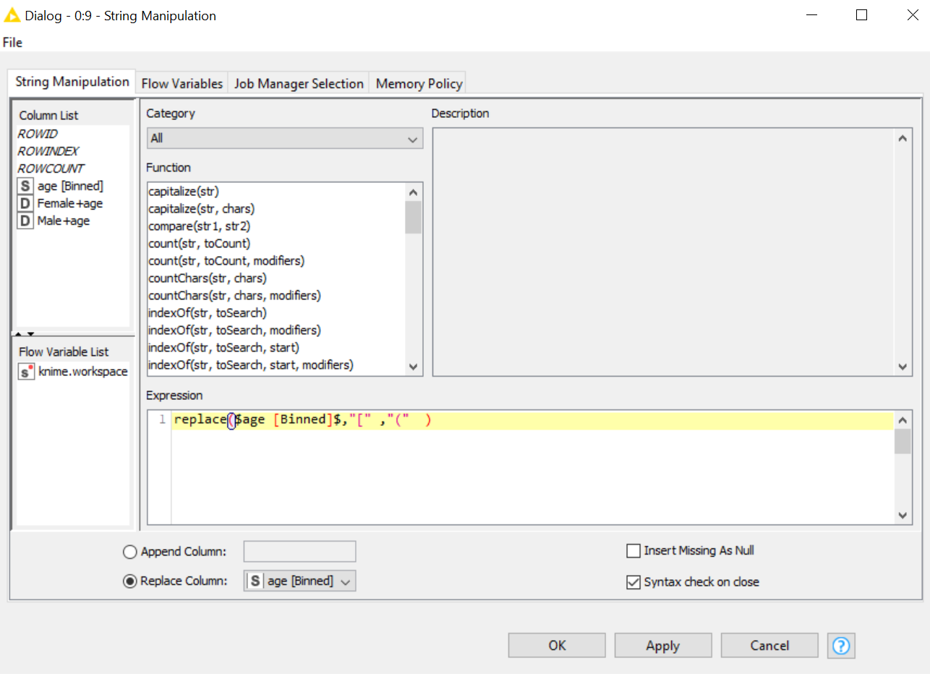
Then it is possible to notice the change in the table.
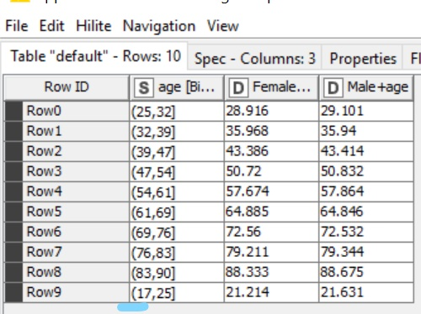
A sorter node sorts the table by Age in ascending order.
The last node is a Bar Chart node, change are in option window and General Plot Option.
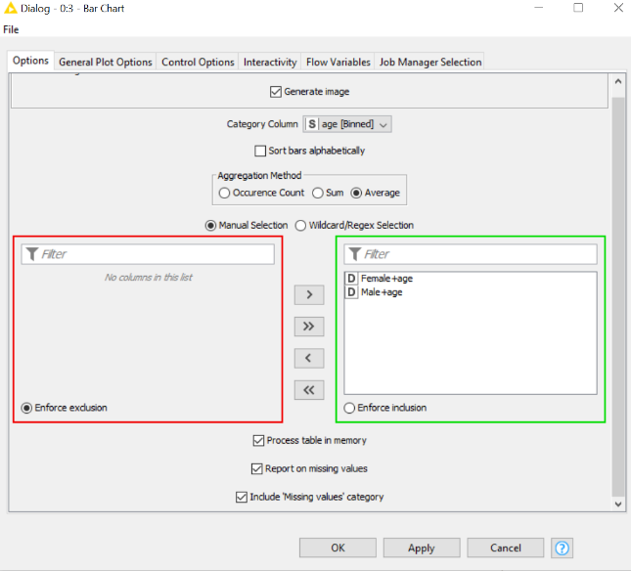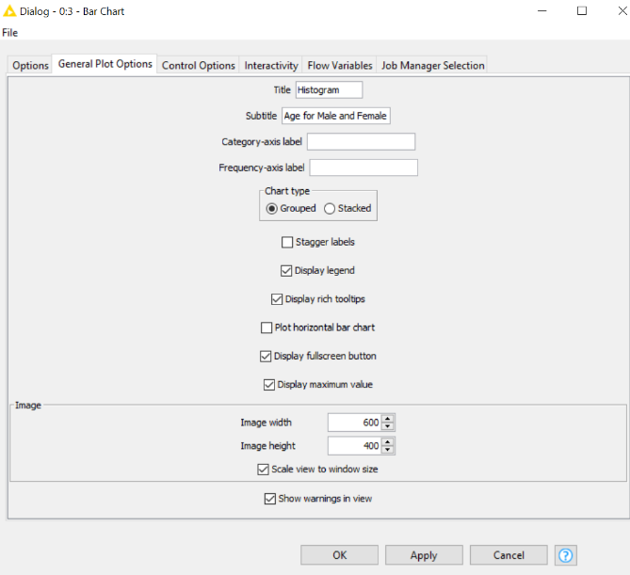
The final Chart is below.
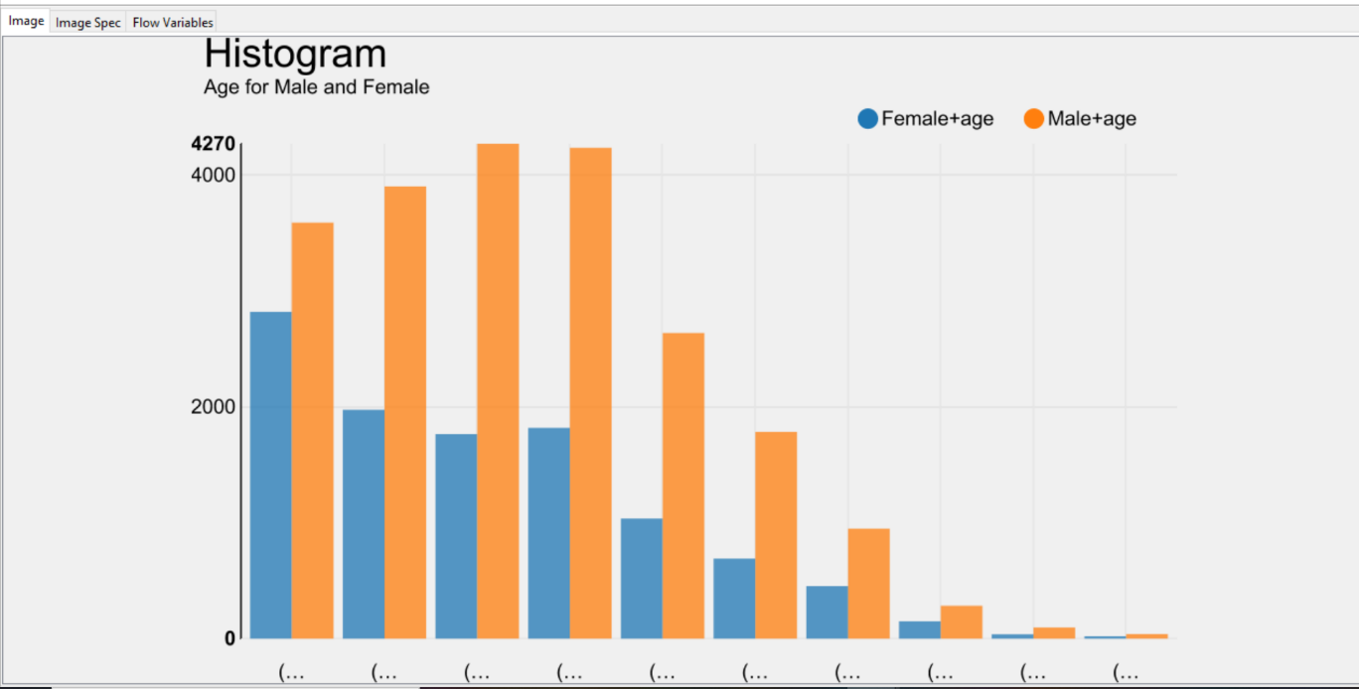

2. First Model creation
2.1 Decision trees using wine.data
In this workflow,
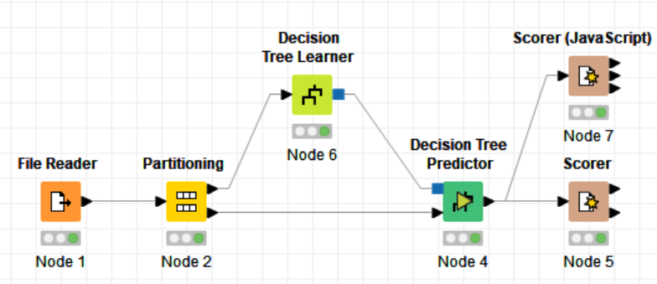
There is a file reader nod for wine.data, then a Partitioning node
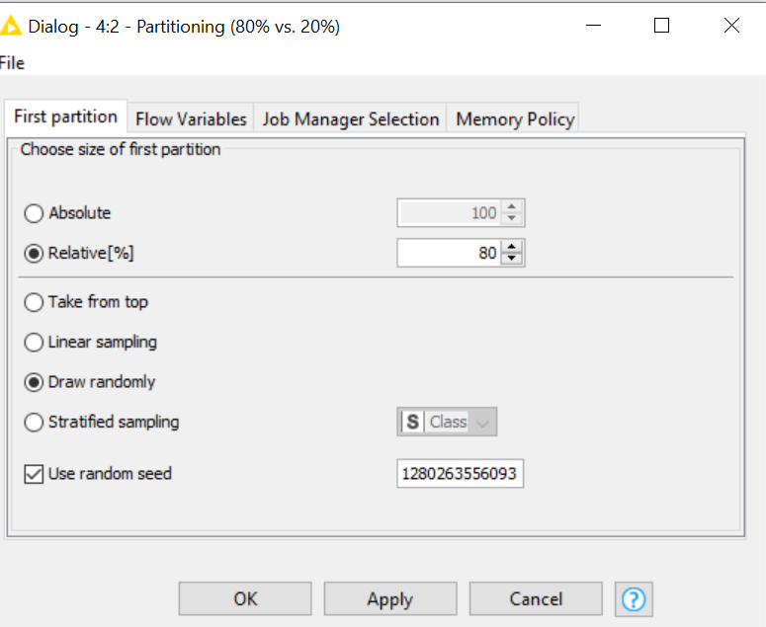
Inked to Partitioning node there is Decision Tree Learner node.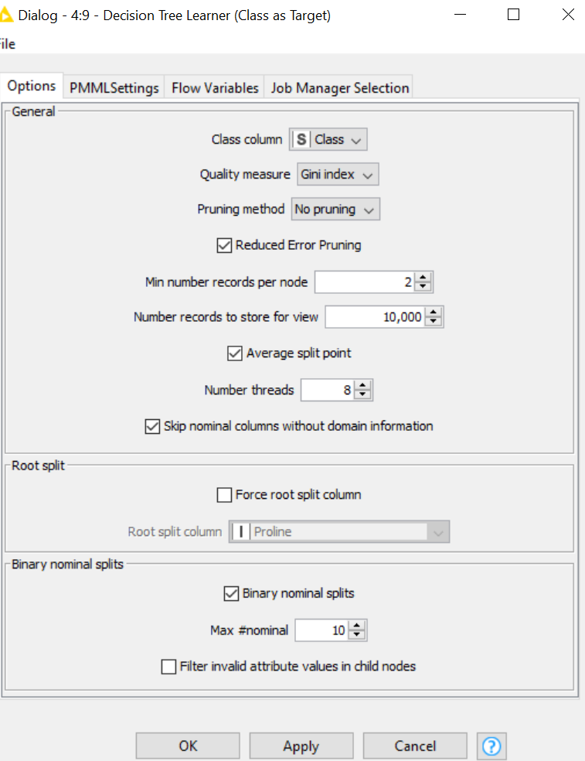
Then there is a decision tree predictor node linked with partitioning and decision tree learner, no changes are made from default node.
Last node is Scorer.
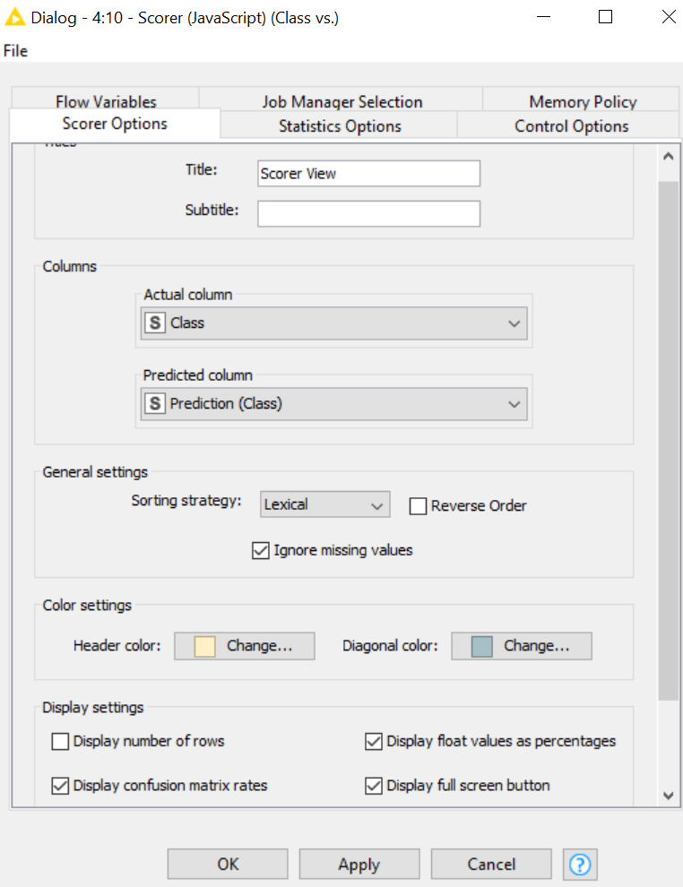

And class statistic out put table is the following.
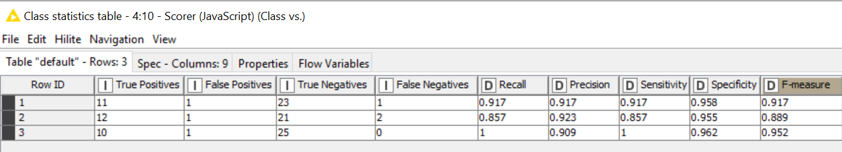

With sorer node it is possible to show how many False negative where in the table.
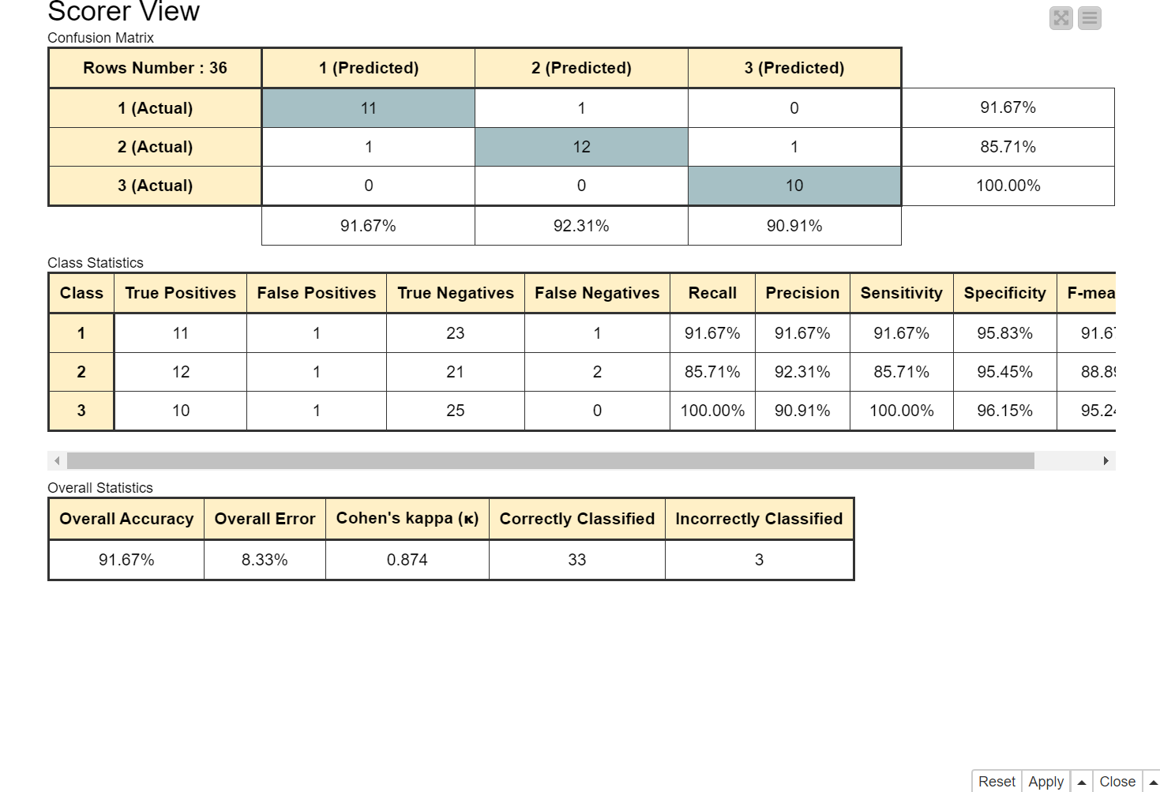

2.2 MLP using wine.data
In this workflow wine.date is in the file rider node,
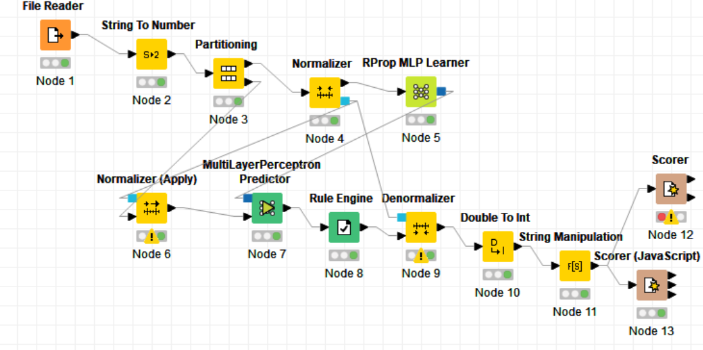
then a node to change from string to number is used to change ‘class’ column data type, then a partitioning node is used to set 80% and 20%.
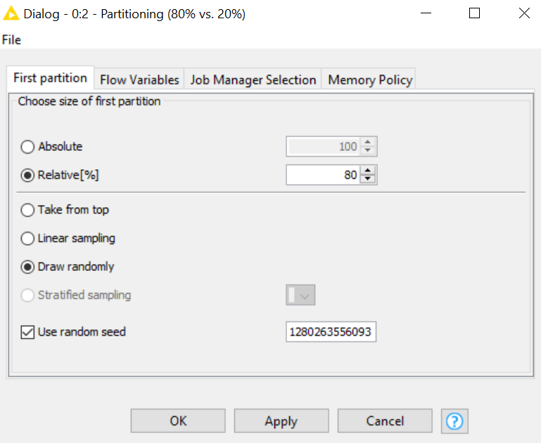

Then a couple of normalized nodes are used to scale 80% and 20% of the set, then an Rprop Mlp Learner is used, next step is to use a MultiLayerPreceptor Predictor node. The output table is the next.
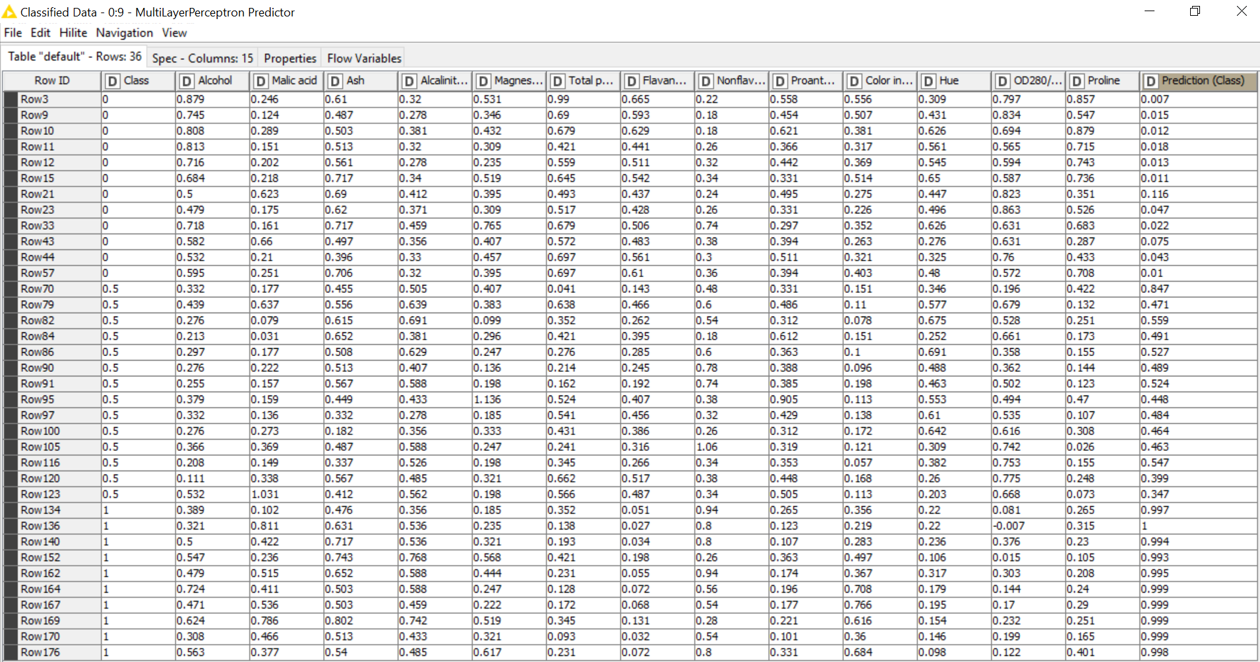

A Rule Engine node is used to process class data.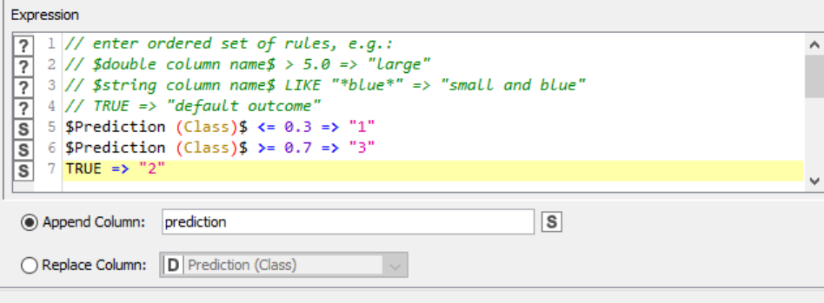

Next node is Denormalizer node, Double To Int node, String Manipulation node, this three are used to invert the beginning process, last node is a Scorer. The output of the node is the following. 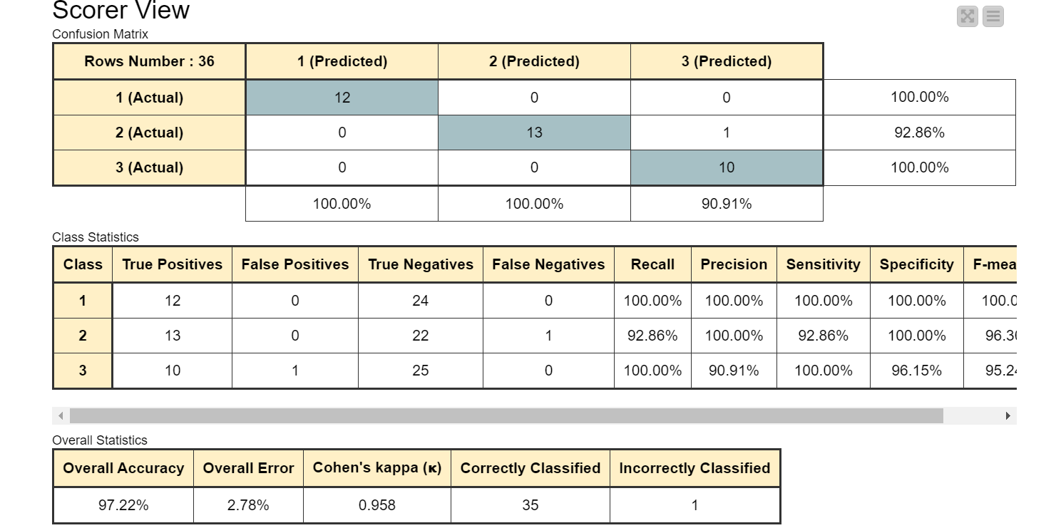

2.3 Reading data “website 1.txt”
In this workflow 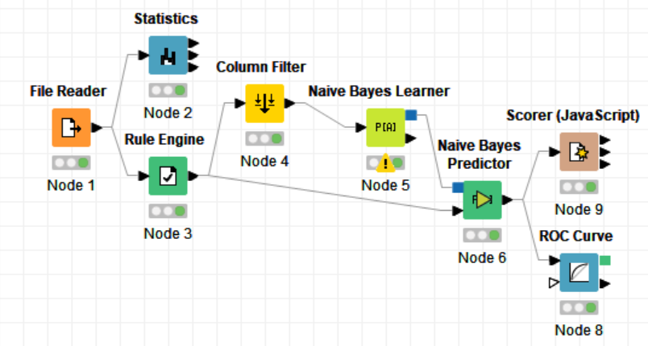
The first node is reading the txt file called ‘web site 1.txt’. Next on top there is a statistics node to find the basic statistic of visitors. 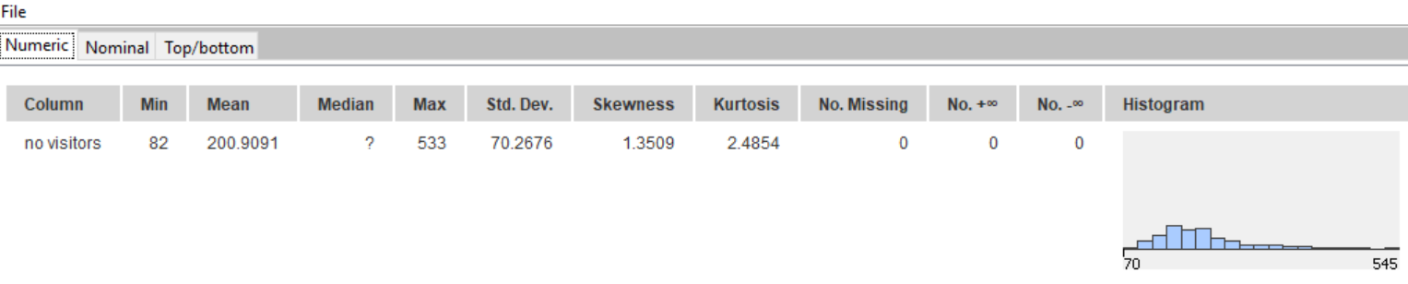
Next on the bottom there is a rule engine node used to create a column where is possible to have value like weekend or not weekend. 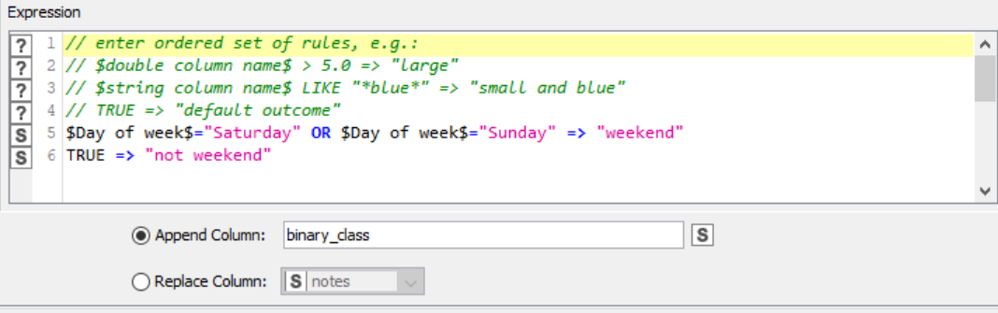
Following a column filter is used to filter ‘day of the week’, and a Naïve Bayes Learner used for classification,
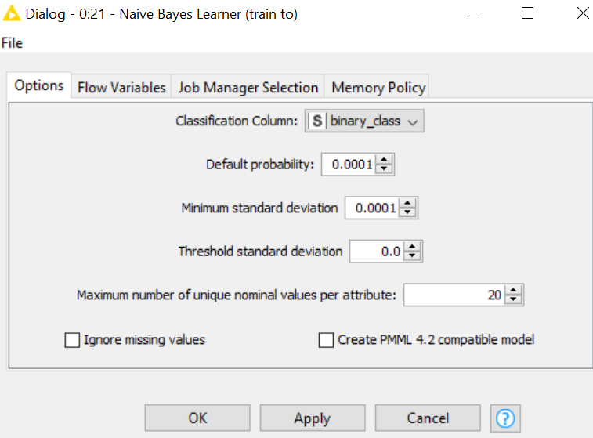
next is the Naïve bayers predictor used to train on ‘weekend’ and ‘not weekend’ before de creation of the ROC curve. 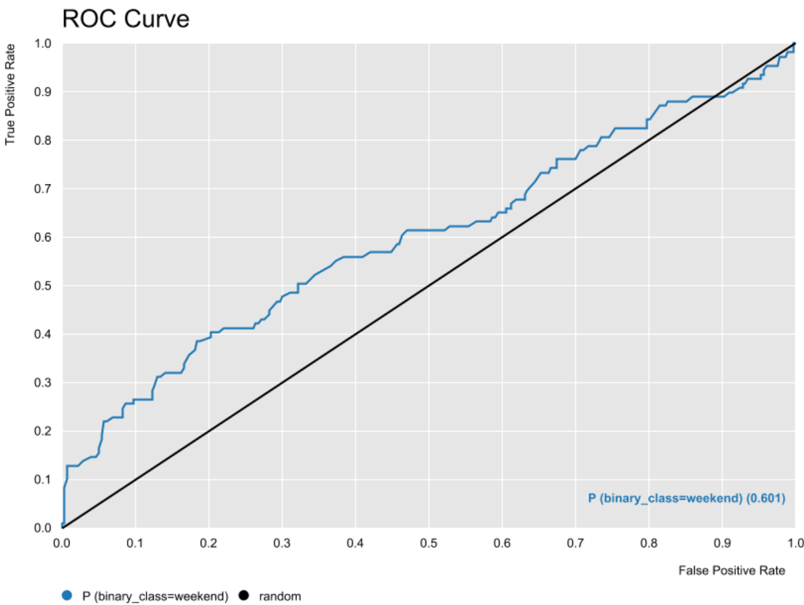

Worksheet 2
3. First Report Workflow
3.1 Evaluating Adult.data
This workflow read adult.data table.
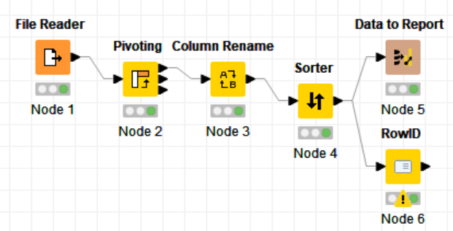
With the second node the workflow arranges people with salary more than 50K and the people with salary less than 50K.
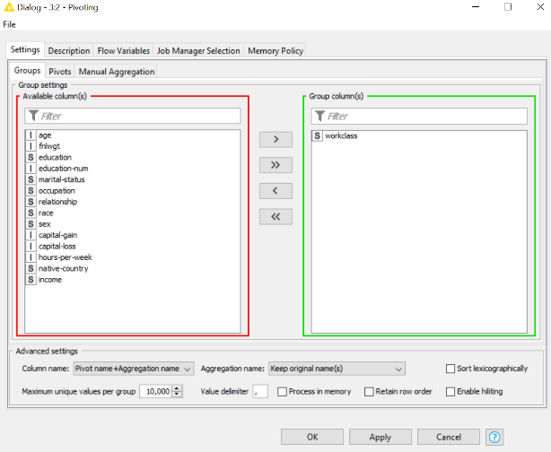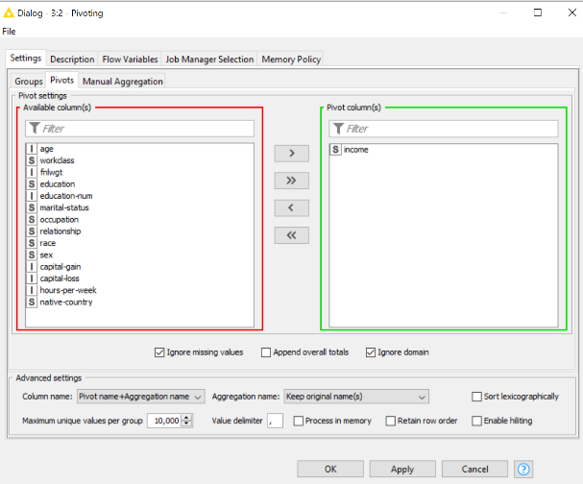

third node rename the column, following node order of the column and the last one make possible to export the data to a report.
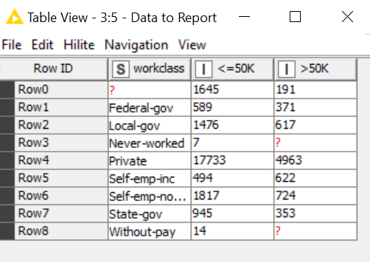

3.2 Extending Evaluation of adult. data
First two node of this exercise are the same of the previous one.
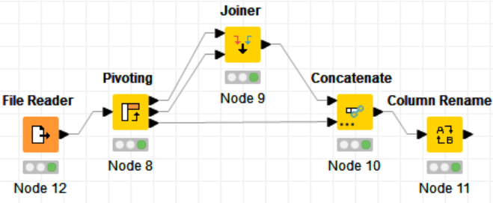
Then a joiner node is used to join total row whit workclass values.
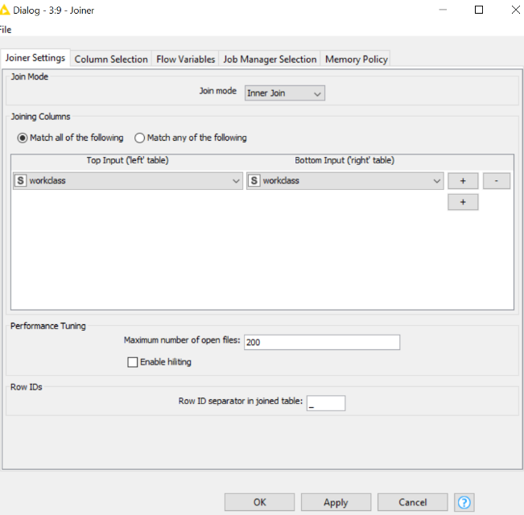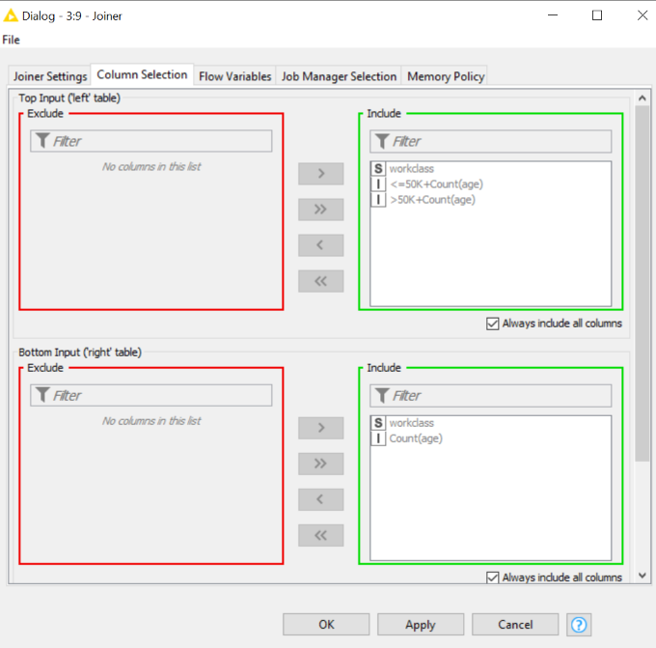

Then a concatenate node is needed to concatenate the finale table.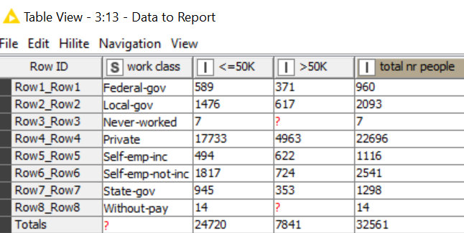

3.3 Evaluate soccer worldcup2006.txt
In this wark flow there are three meta node, two of them are similar and the data are taken from csv file SoccerWorldCup2006.txt. 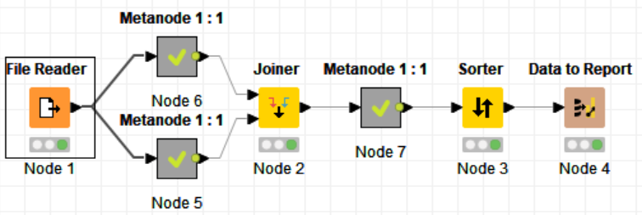
First two meta node are like:
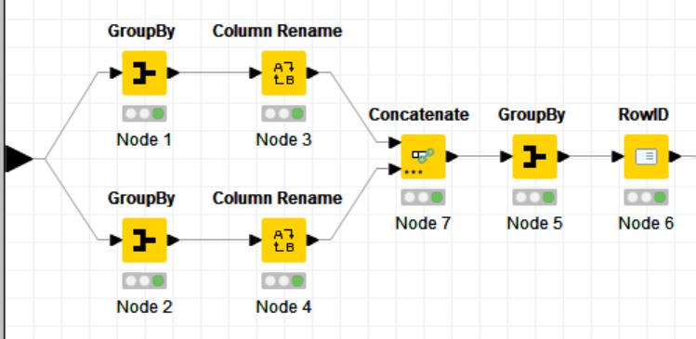

The third meta node is like:
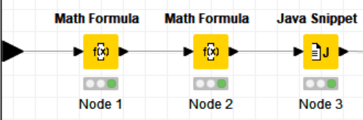
The first meta node calculate the total number of played game and scored goals. The second meta node calculate the total number of played game and the taken goals, after combining this two with joiner node it is possible to check the table.
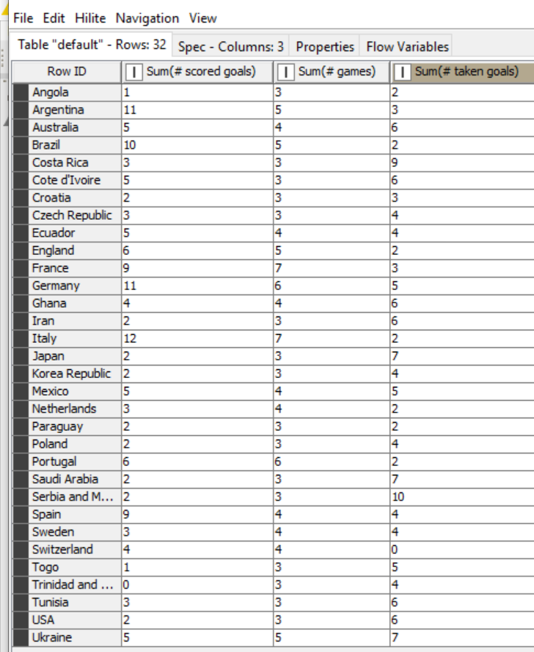
Last meta node calculate the average of scored goal and taken goal, then it makes a subtraction of this two and finally it makes a division with number of played games. The resulting table is the following:
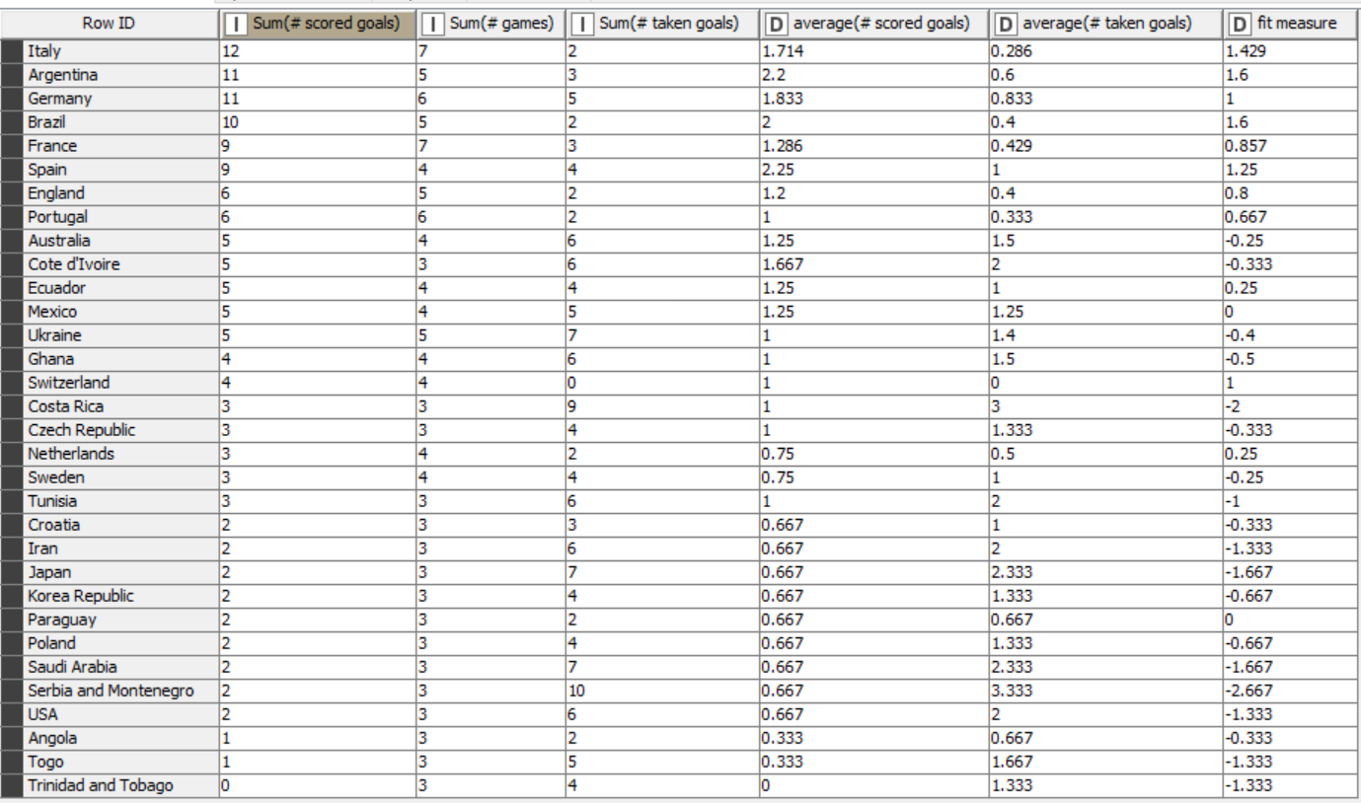
4. First report
4.1 Building a report using Chap 3. exercise 1 data
The workflow built a table and a bar chart based on exercise 3.1
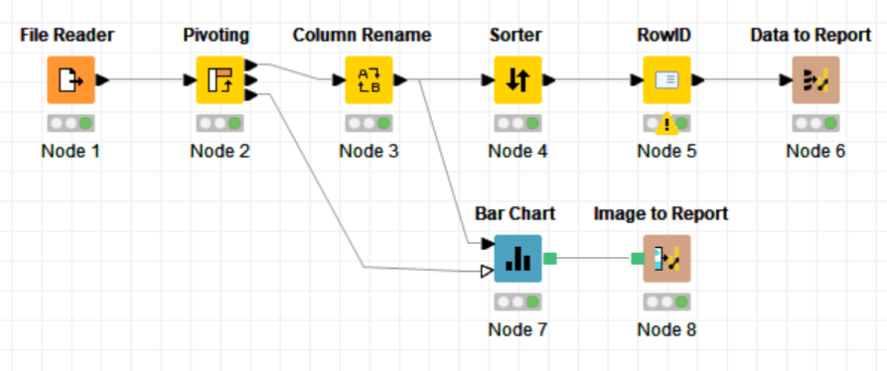
The output of the workflow is the following.
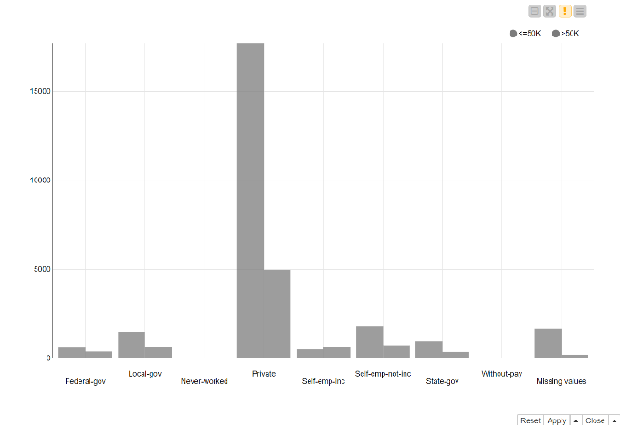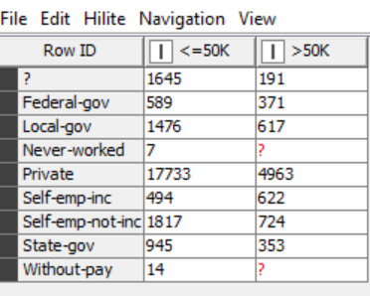
And the final report of the exercise is the next one.
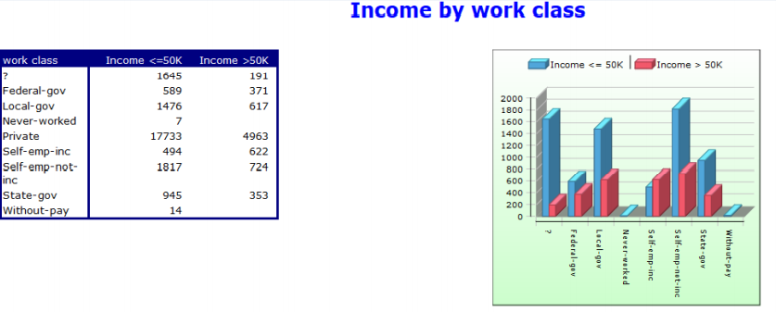

4.2 Extend ‘Private ‘ class
This workflow is based on previous one, the row of ‘private’ make the column to large in bar chart, it is possible to use the row filter node to exclude it. The final report il look same as the previous one.

4.3 Extend chap.3 exercise 2 build report
This exercise output is the fooling.
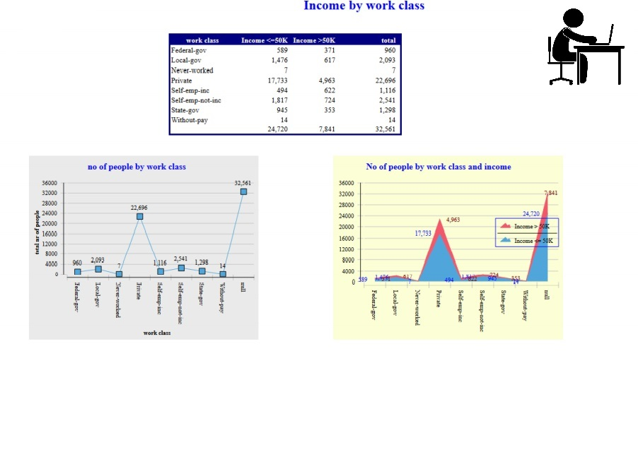

4.4 Extend chap 3. exercise 3 build report
The result of this exercise is the following.
Soccer World Cup 2006
Total number of taken goal and total number of scored goal
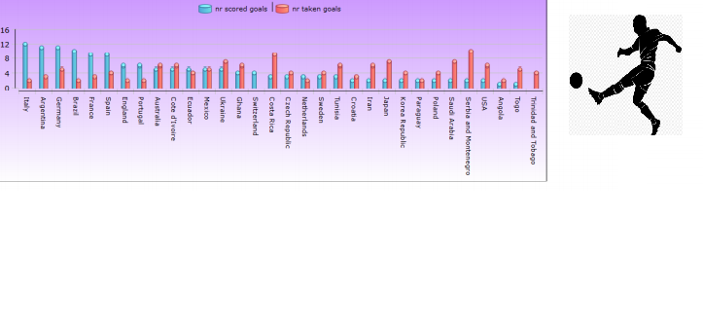
Average number of taken goal and average number of scored goal
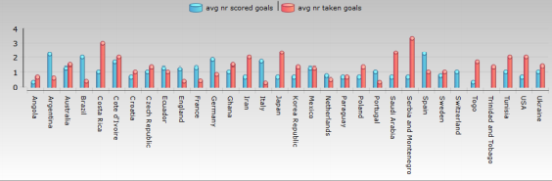
Average number of taken goal vs average number of scored goal
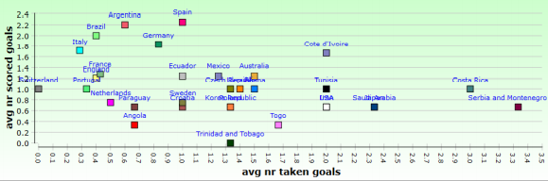
Table
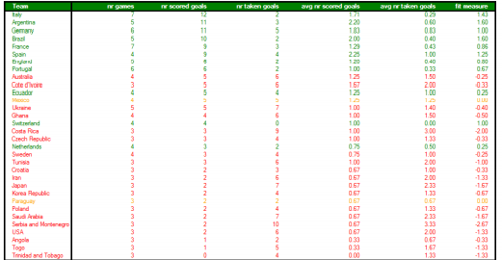
Worksheet 3
5. Database Operations
5.1 Creating an empty workflow
The workflow read the data from cars-85.csv.
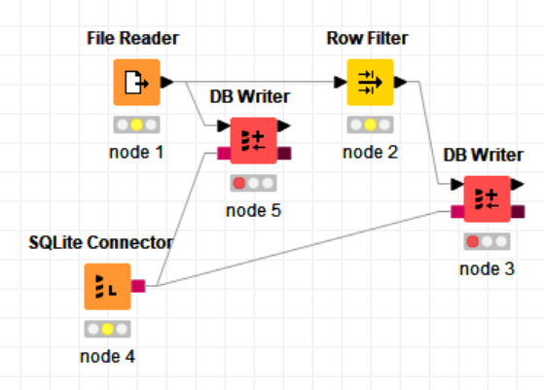
The node 5 write in the database KcBBook.sqlite the datatable named ‘cars85’, the node 2 and 3 filter the first 20 rows. Resulting table is the following.
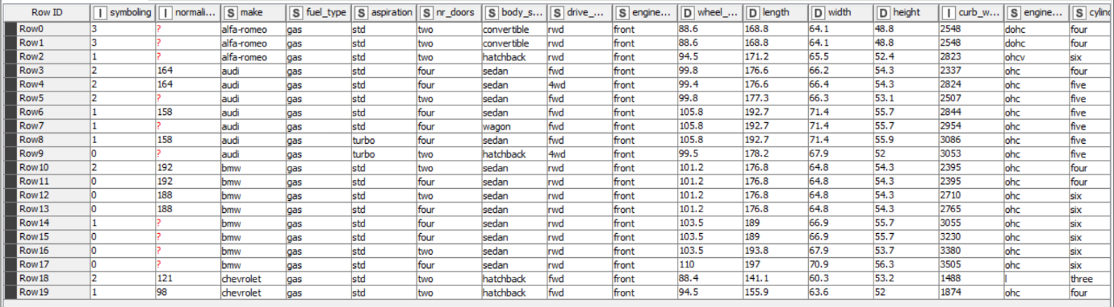

5.2 Connecting KBCBOOKs.sqlite
There are different way to do this exercise.
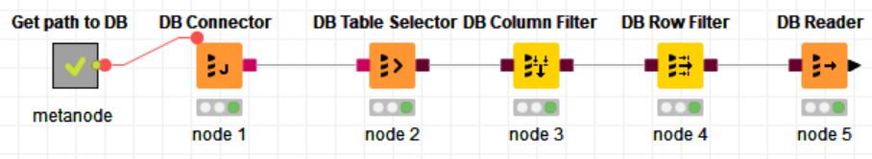
In this case there are a database connector as a node 1, following is a table selector that chose the table, next are column filter and row filter to pick specific data from table and the last is the data base reader that show the selected table.
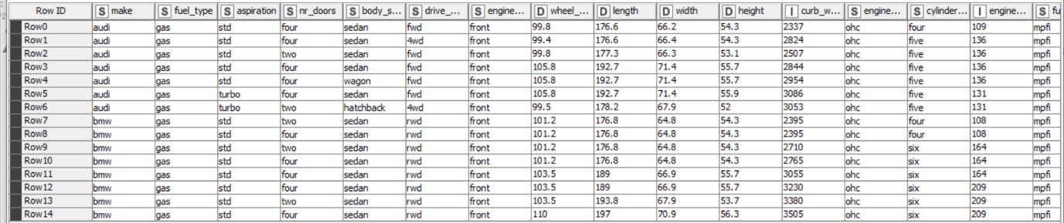

5.3 Database Looping Nodes
In this exercise use the database looping.
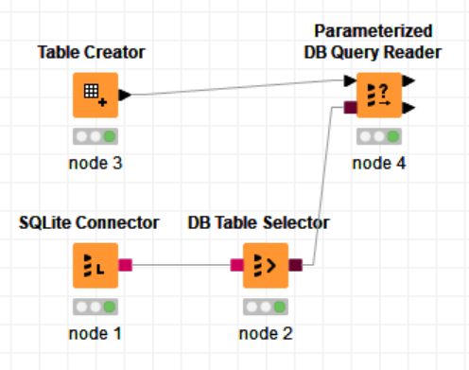

With node first 2 node we create the connection with database and select the table, the node number 3 create a list of make to include and last one loop over columns and store only BMW and Audi cars, with following statement. 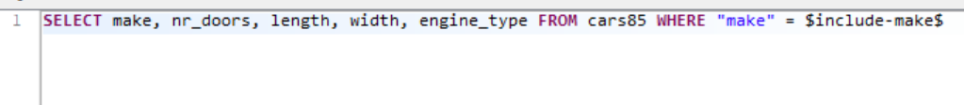
Next is the resulting table.
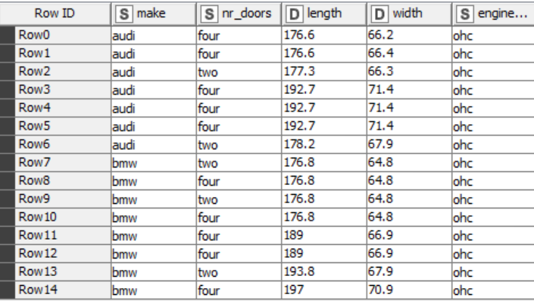

6. Accessing Information from the Web
6.1 Chemical database information retrieval
This workflow as first node use a google authentication.
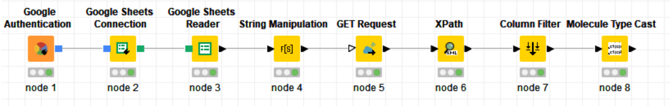
Then as core component of this workflow there is a node for google sheets connection with an API, the fifth one is a node that GET request from InChlKey to Mol then a node to extract a root, last node it is used to draw the structure.
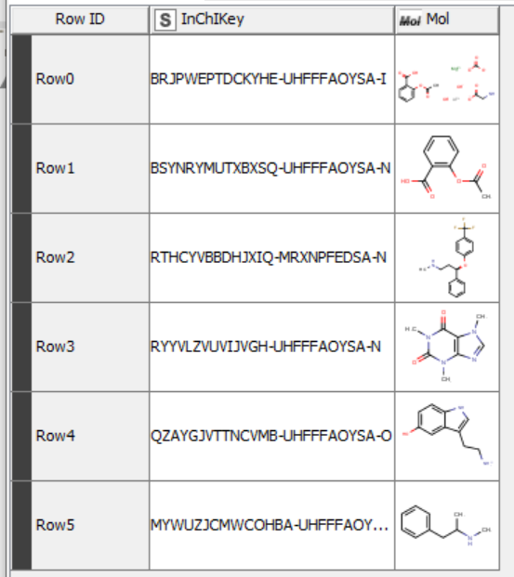
Worksheet 4
7. Date and Time Manipulation
7.1 Adding Random Dates
This workflow applies some node for date and time manipulation.
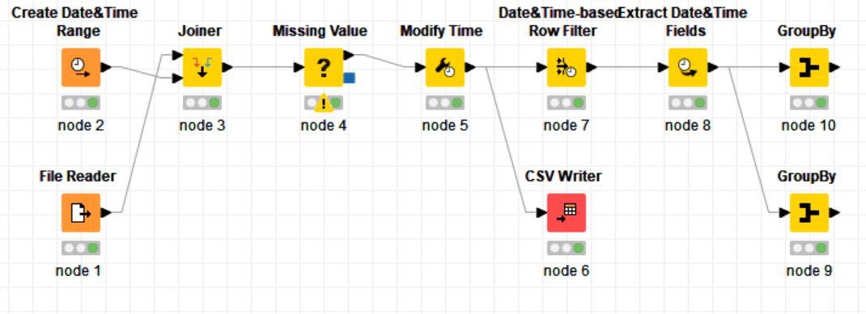
The first node read data from cars-85.csv file, the second node add random sale date from 30-06-08 to 30-06-11, the third node combine the previous two file, the fifth node remove the time, the six create a CSV file, after filtering some row an extracting day of the week, month and year, finally there are two node, one create a table for money made by month the other create table for money made by weekday.
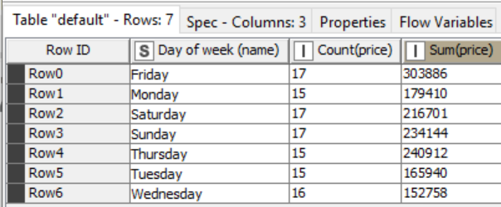
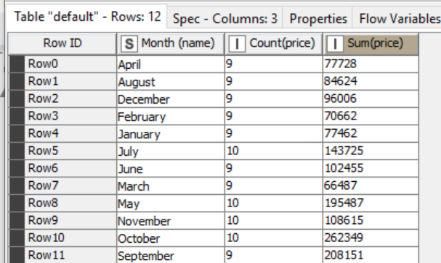

7.2 Importing date and time (ex2.csv)
The first node of this workflow read data from previous exercise.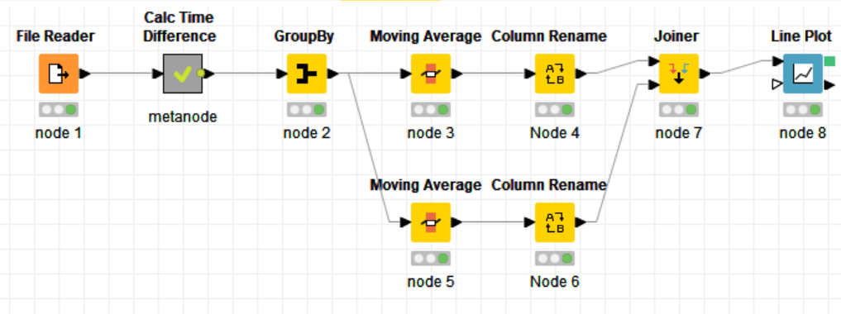
The meta node isolate the data sale greater than 12 months.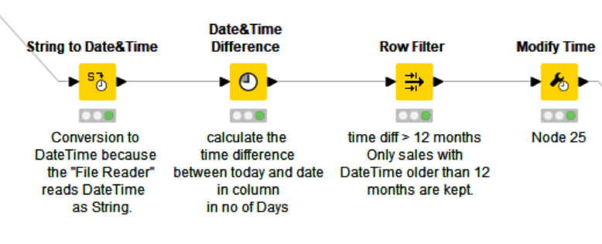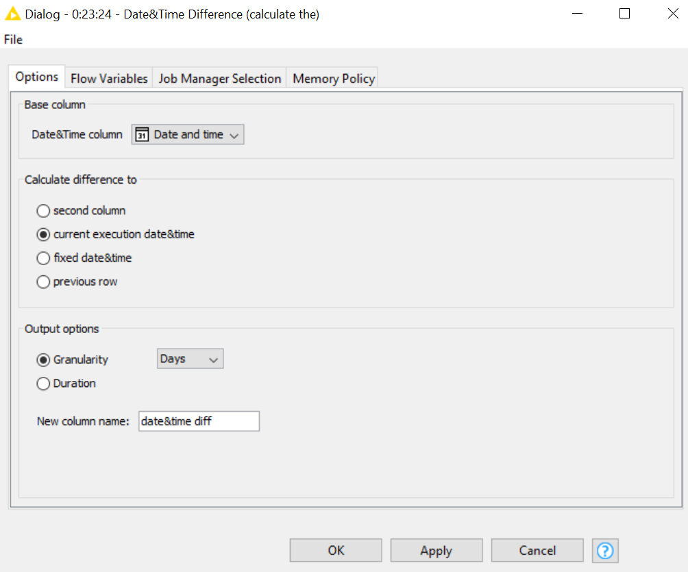

Then two moving average nodes with size 11 and 21 are used to observe the moving average from different time, combined. 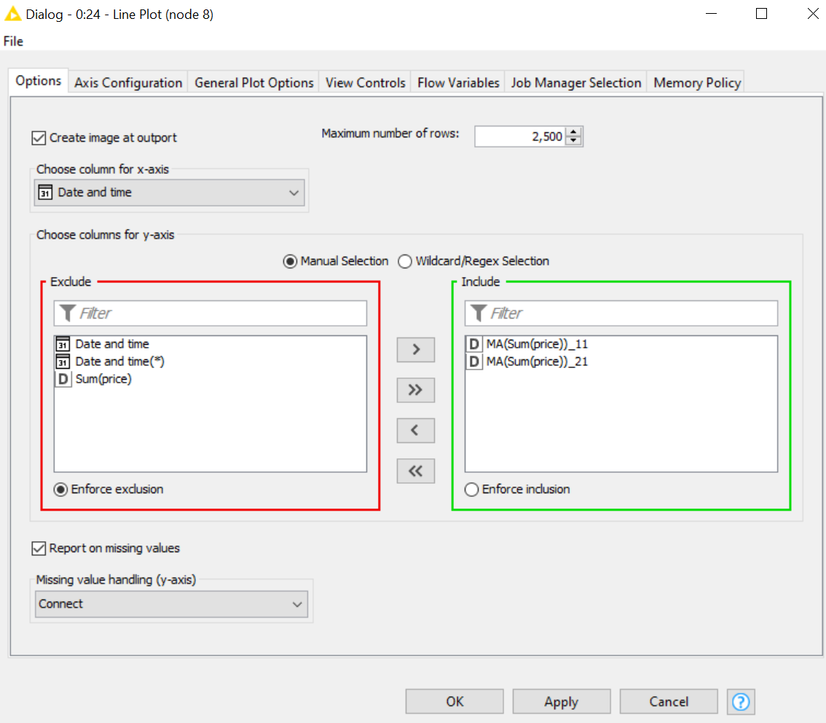
In the end a linear plot.
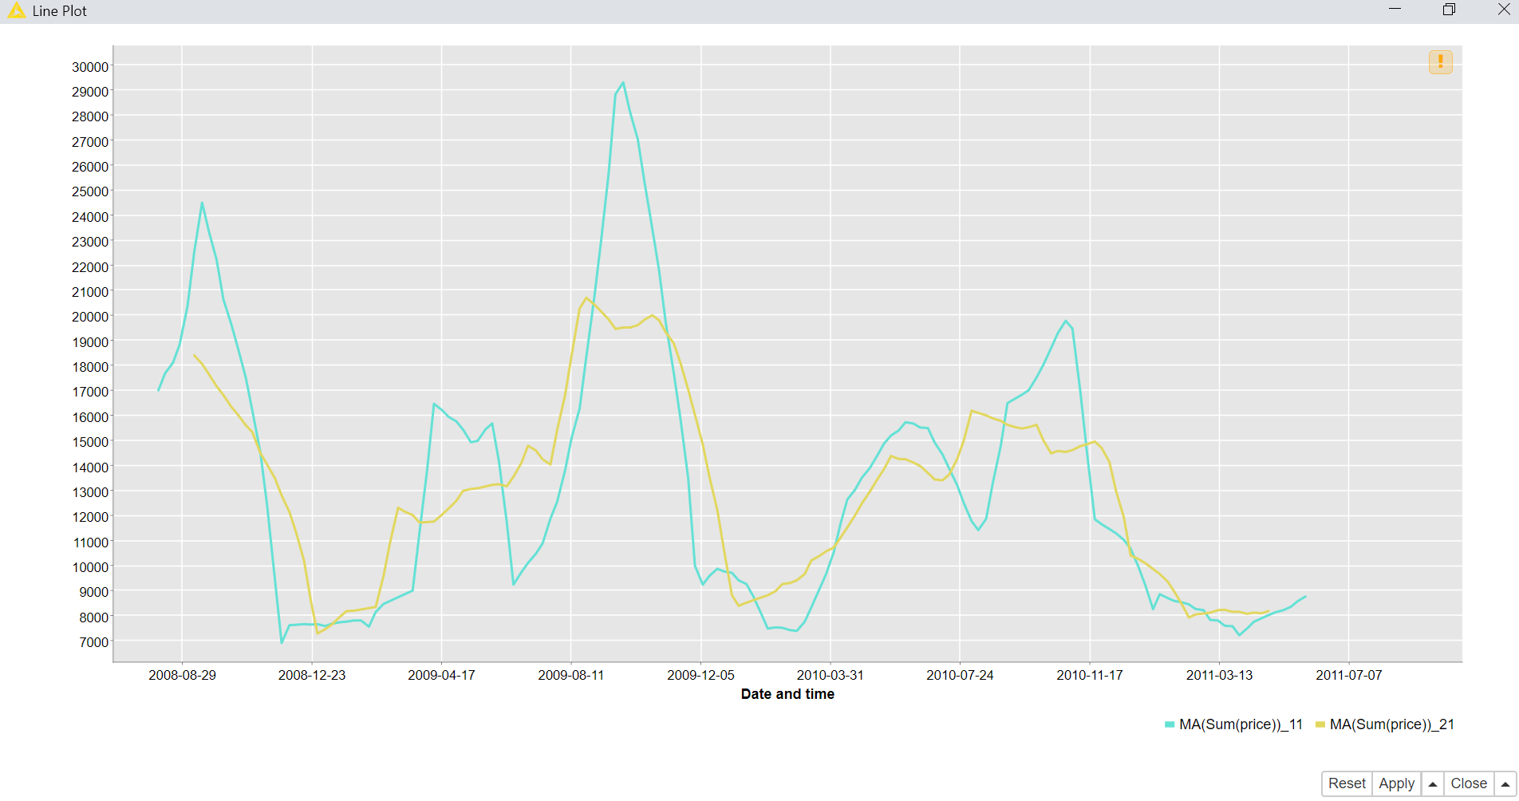
Worksheet 5
8. Flow Variables
8.1 Reading sales.csv
This exercise is for a selection of a specific month and year.
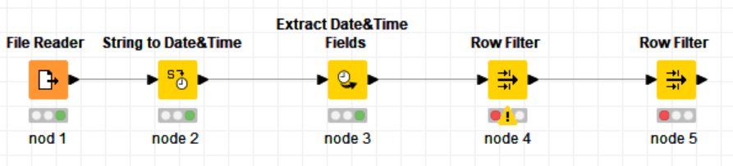
The first node read data from sales.csv, the third node extract from data the year and the month, node number 4 filter data with month March, following is the resulting table.
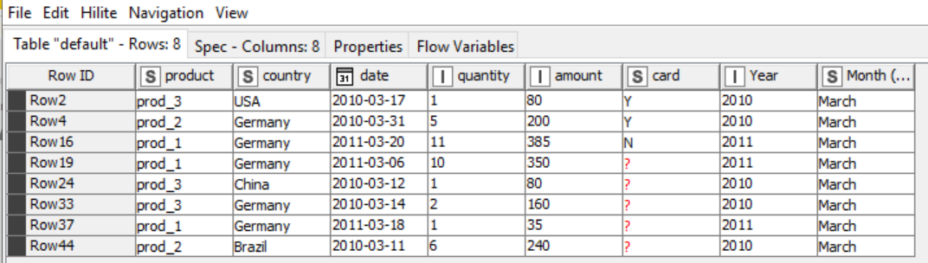
Last node filter data with year 2010 and the resulting table is the following.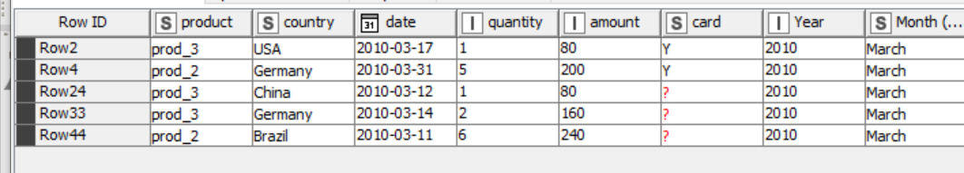
8.2 Using cars dataset
This workflow use data from Cars-85.csk file.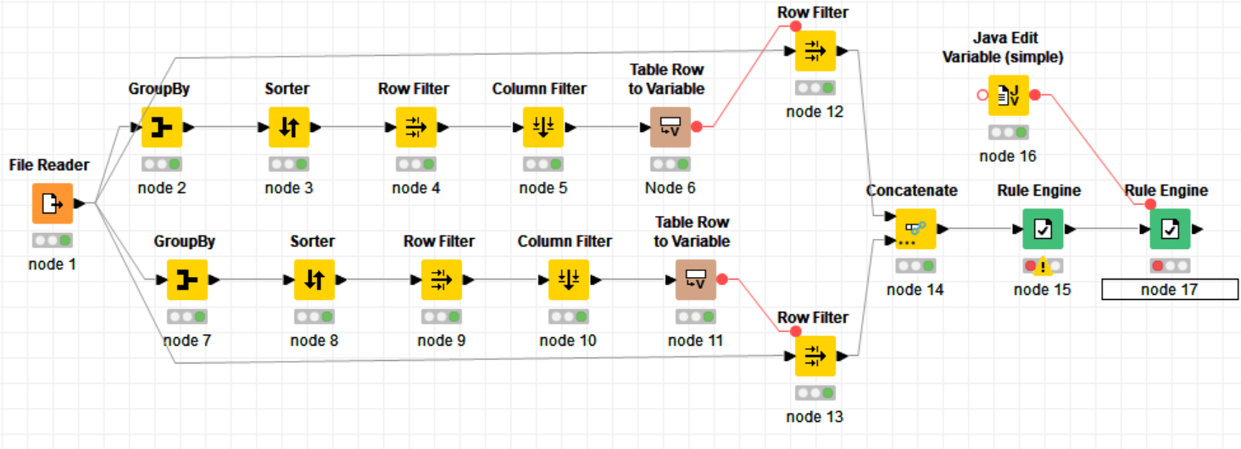
The node from 2 to 16 are used to find the most present car in the table, the output from node 12 is the following. 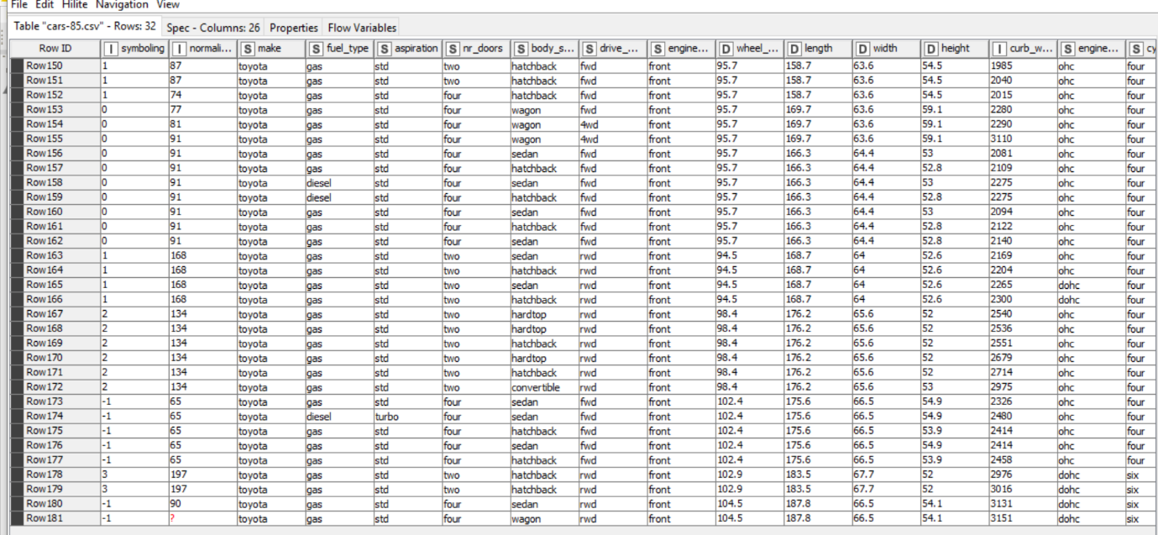
The node from 7 to 11 are used to fine the les present car in the table. The output table from node 13 is the following. 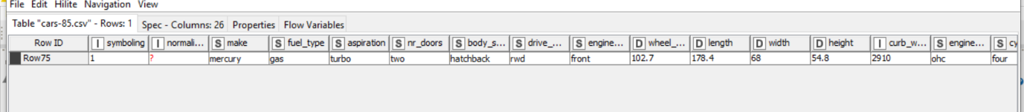
Node 15 and 17 are used to append in the final table the username and timestamp columns with the following statement. 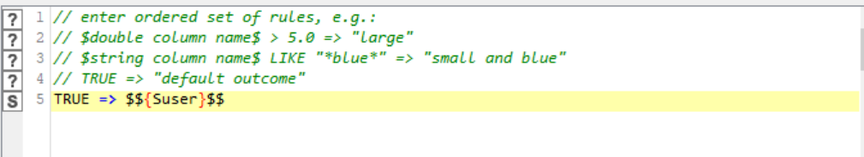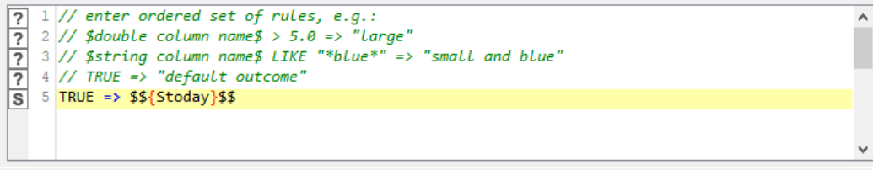
Next is the portion of final table.
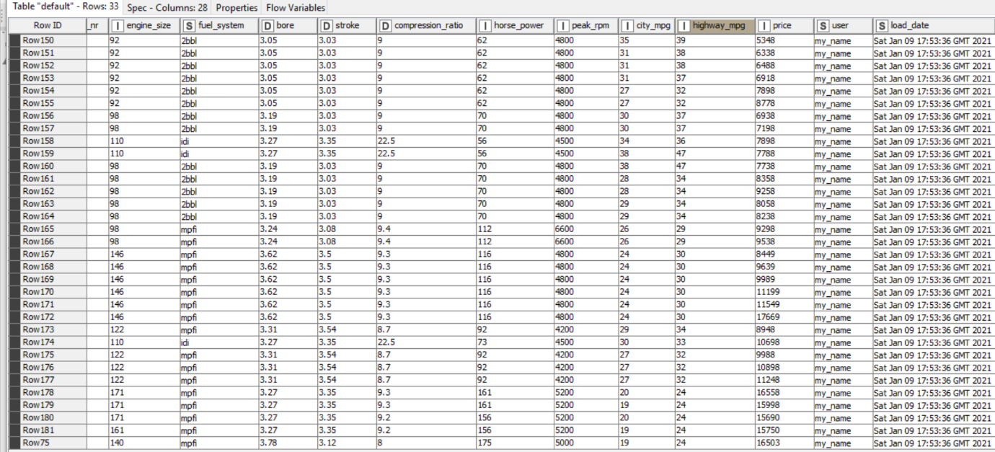

8.3 Maximum Engine Size
This workflow read data from file cars-85.
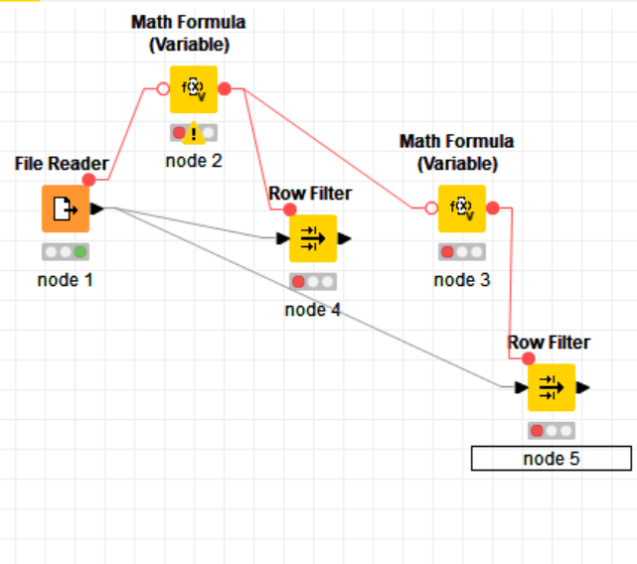
Node number 2 and number 3 use mat formula to find the engine size from half to maximum and to quarter to half with following formula. 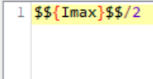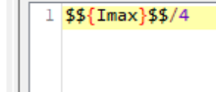
In the resulting table in node 4 and 5 is possible to find the range 300 to 150 and 150 to 75.
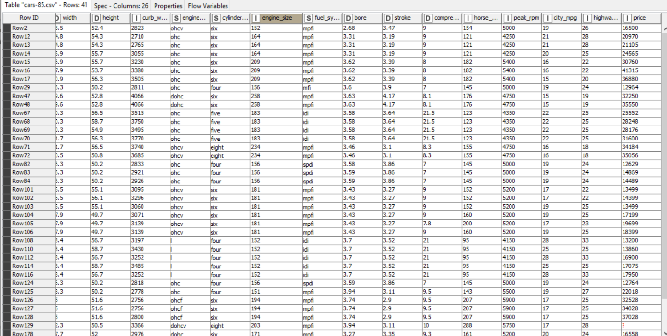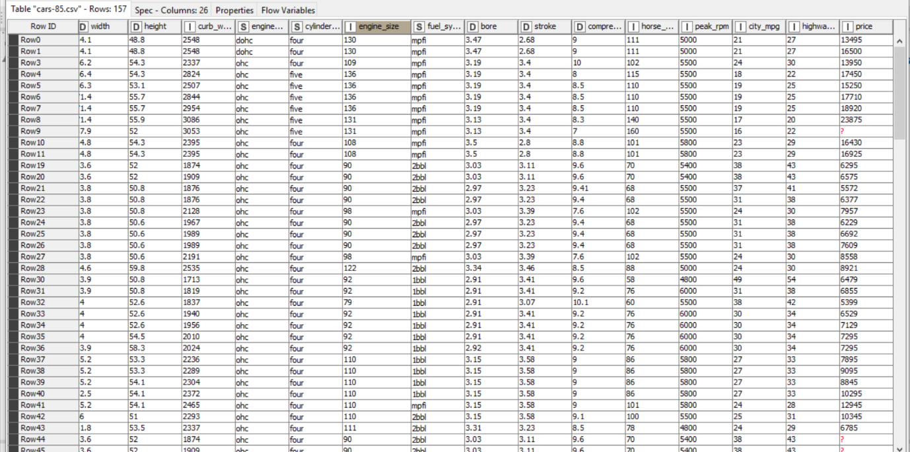

8.4 Building a Wrapped Metanode
This exercise replace data from one column to another, the data are taken from cars-85
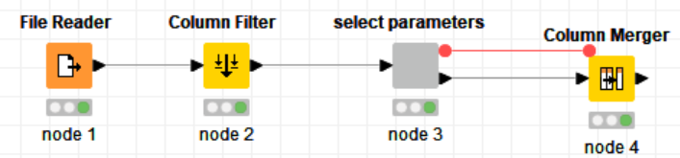
After selectin the parameters with node 3
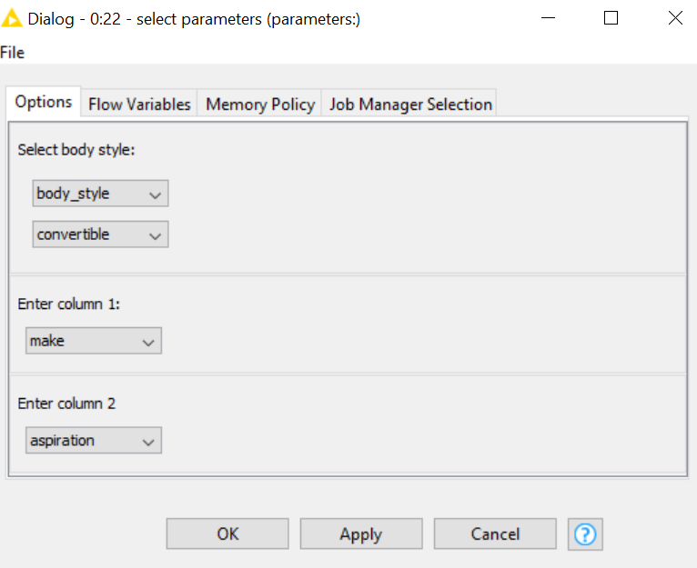
The last table replace column 2 with column 1, resulting table is the following.
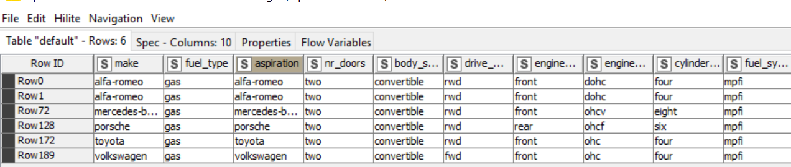
9. Loops
9.1 generating data row
In this workflow first node generate 6 group of clusters in two dimensions.
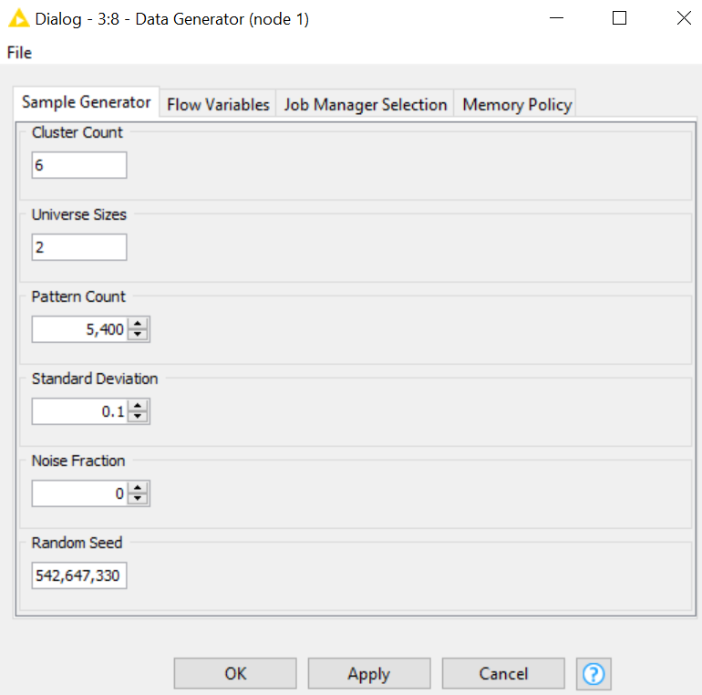
Node 3 crate a scatter plot.
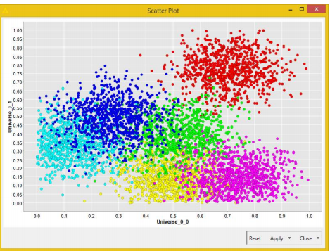
Node 5 use formula x=x+1.
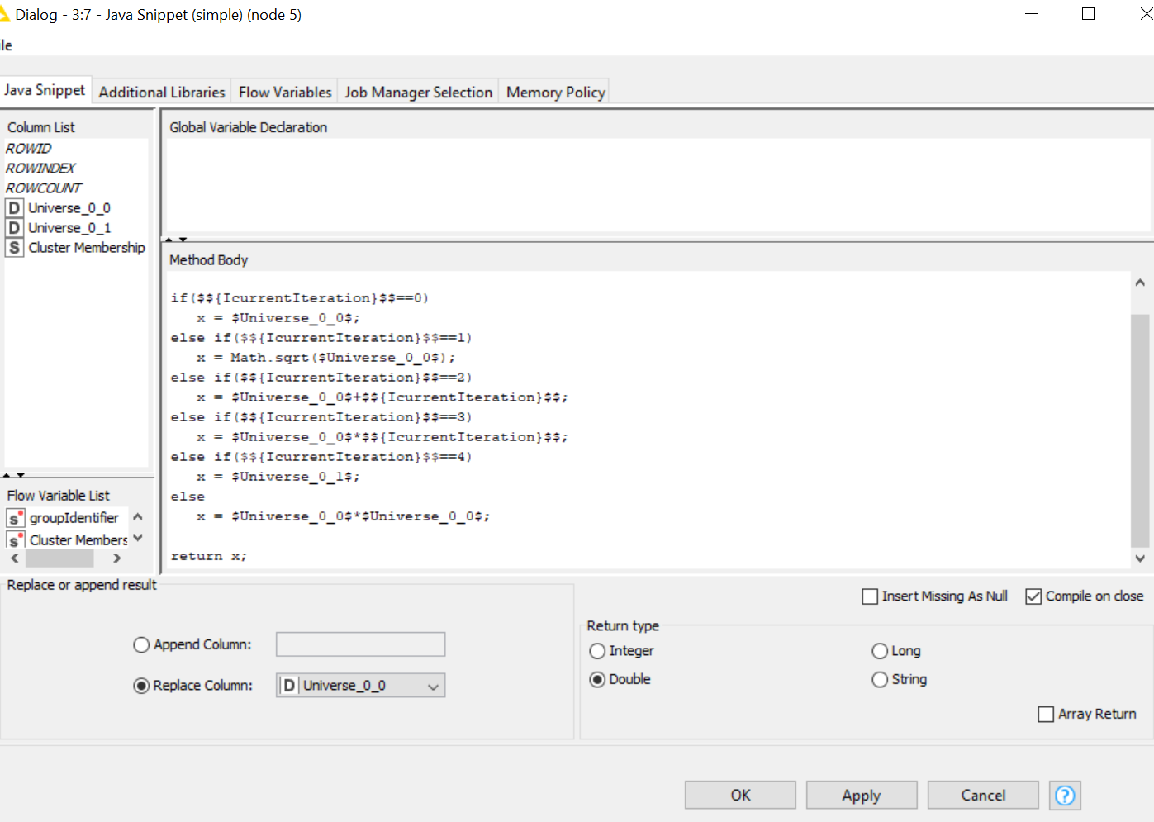
Final resulting scat plot.
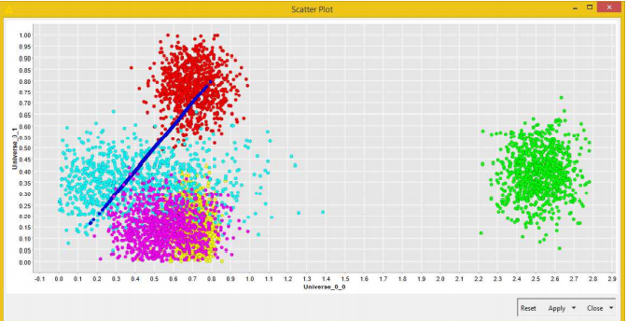

9.2 generating a full table
This exercise starts with a creation of a table from 15.01.2011.
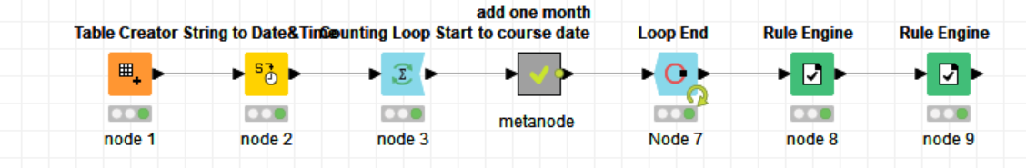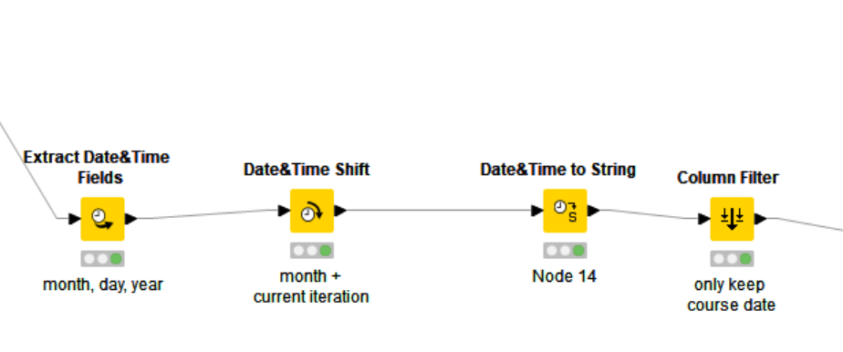
After using the loop start and end node to repeat 12 times, rule engine are used to add teacher and town. 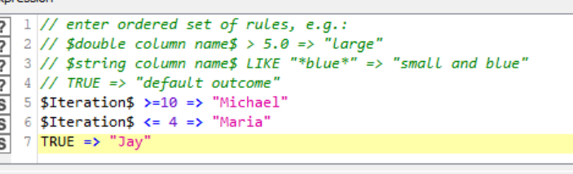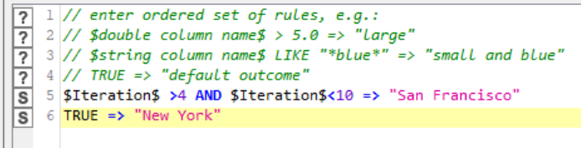
The final table is the following.
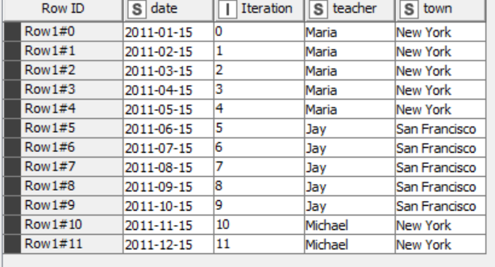

9.3 deleting duplicate data rows
This exercise use data from wrong sales.
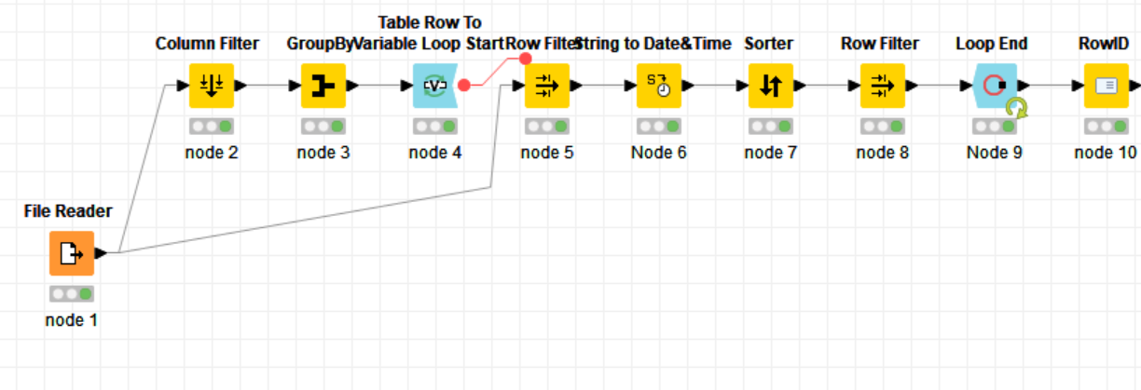
Node 2, 3 and 4 filter older record with missing data. Node 5 keep ’contract nr’ record of itinerary, after sorting the recent data, the loop close. We have resulting table.
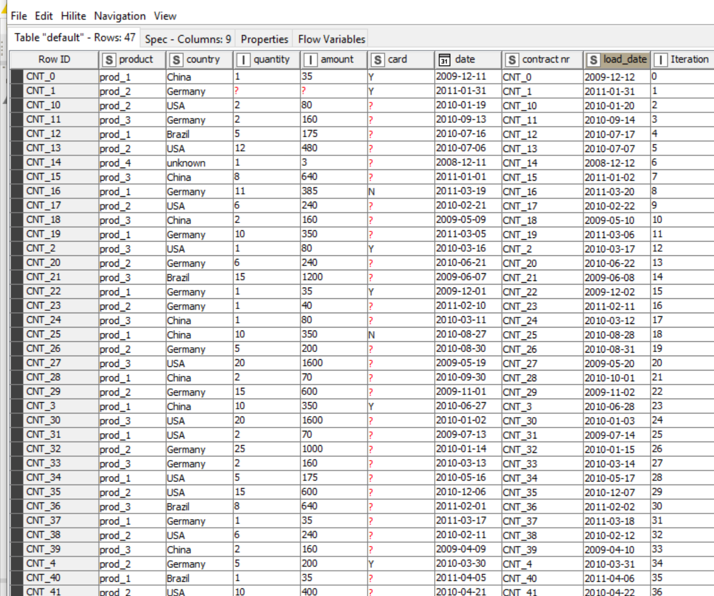

9.4 creating an original file
The workflow starts with a creation of a table.
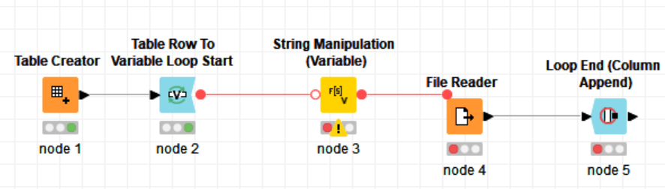
Then it takes file type one by one, next it creates file path file type.
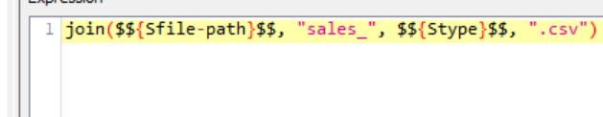
Final it read file in a single column.
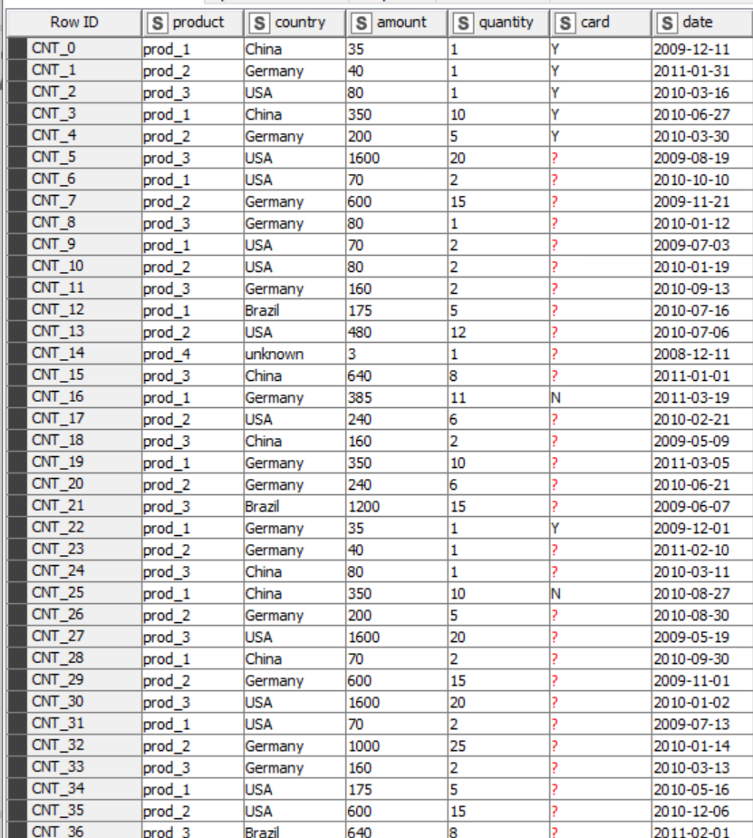

10. Switches
10.1 IF switch node
This workflow generate number from 1 to 10.
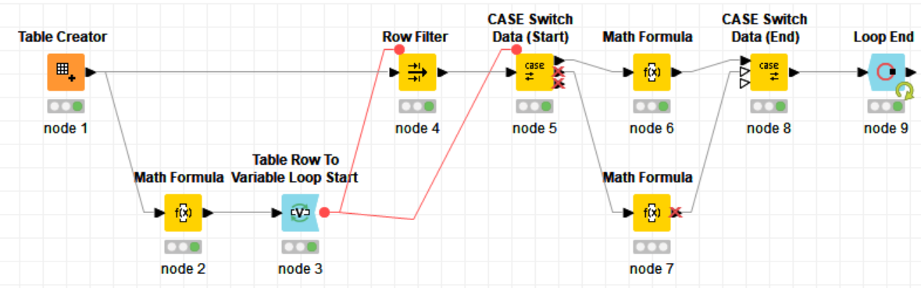
Then use mat formula to find even and odd number.
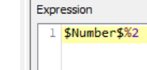
After looping the operation it create a switch case, if is an odd it multiply by 10 other case multiply by 3. 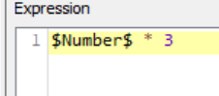
Final table is the following.
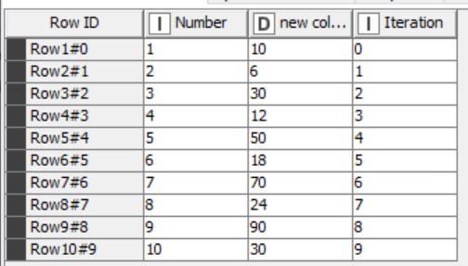
10.2 Workflow control
The exercise read cars-85 file.
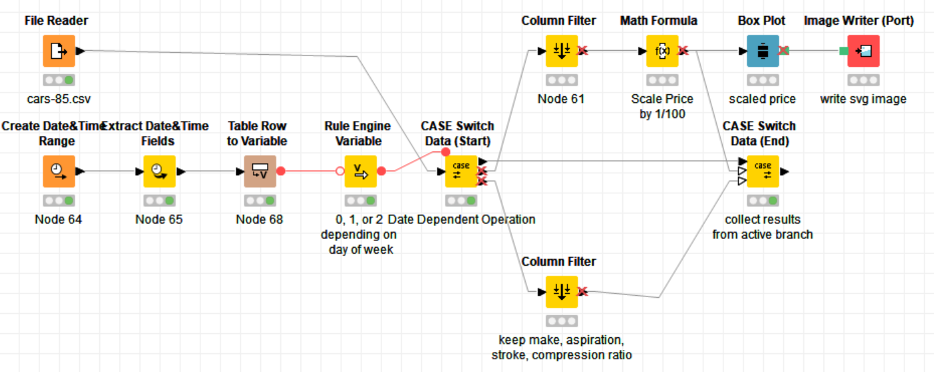
This exercise creates a switch case after creating date and time range. Rule engine assign the number 0 if is weekend, 1 if is Wednesday and 2 for other day, for Wednesday it create a table to collect result.
11. Advanced Reporting
11.1 Projects.txt report building
Picture of the report 1
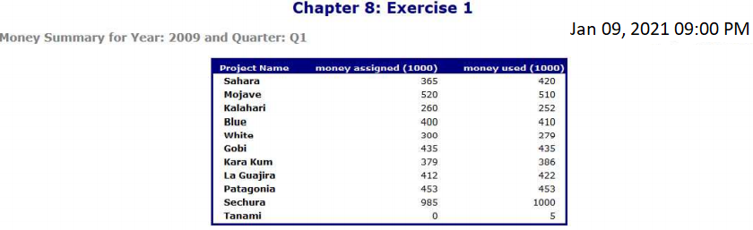
11.2 sales.csv KCB
Picture of the report 2
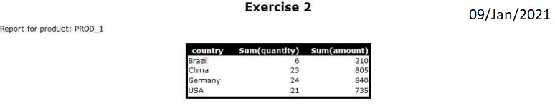

11.3 reporting building extension
Picture of the report 3
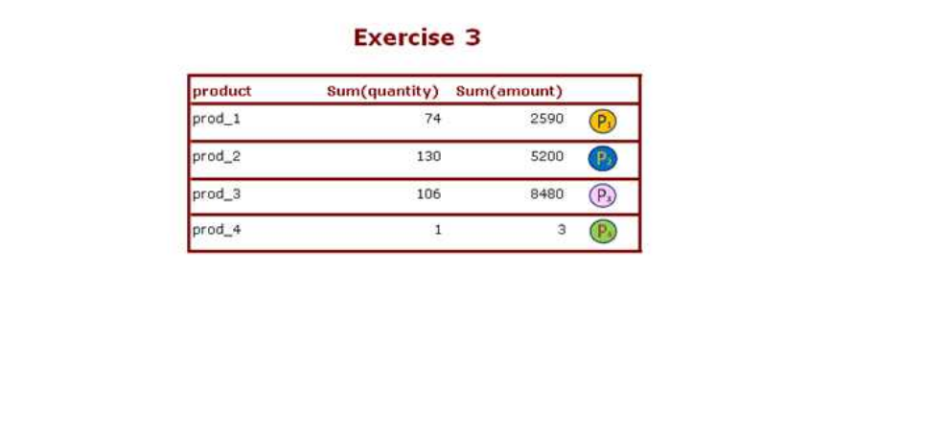

Worksheet 6
12. Developing Big Data Warehouse using Walmart Sales Data
For this exercise we have to use Snowflake, it is a SaaS data platform, it can be used with GDP, AWS, Azure or other cloud platform. By linking Snowflake and KNIME, it is possible to develop and populate an in-cloud data warehouse, Tableau will be the reporting tool.
First of all we need to create a Snowflake account with free trial, after receiving a confirmation email with a link, we will use it to create a warehouse and connect with KNIME as shown in following picture.
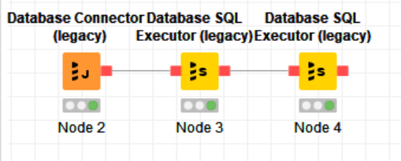
The first node of the workflow is used to connect whit data base.
The interface requires the jdbc driver installation, the link to connect with Snowflake, and the username and password for the account.

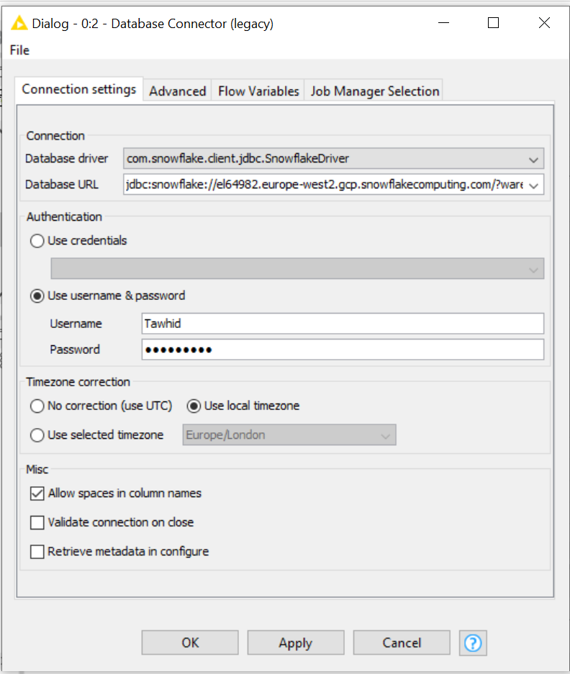

The second node is used to create a database with name walmartDB.
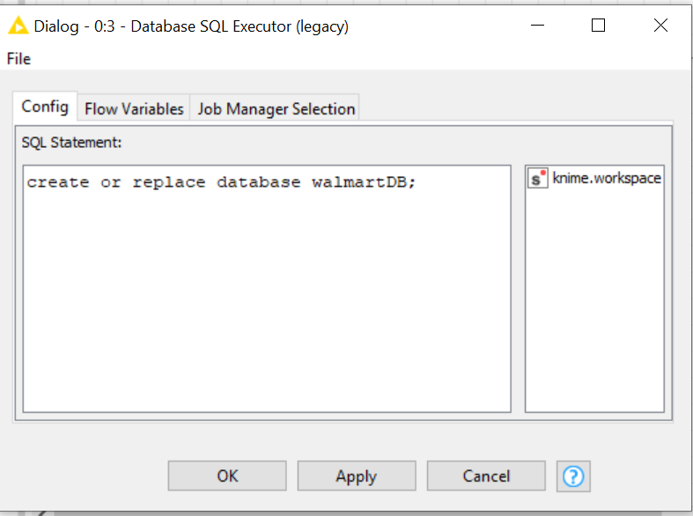

After executing the second node it is possible to see on Snowflake account that a data base is been created.
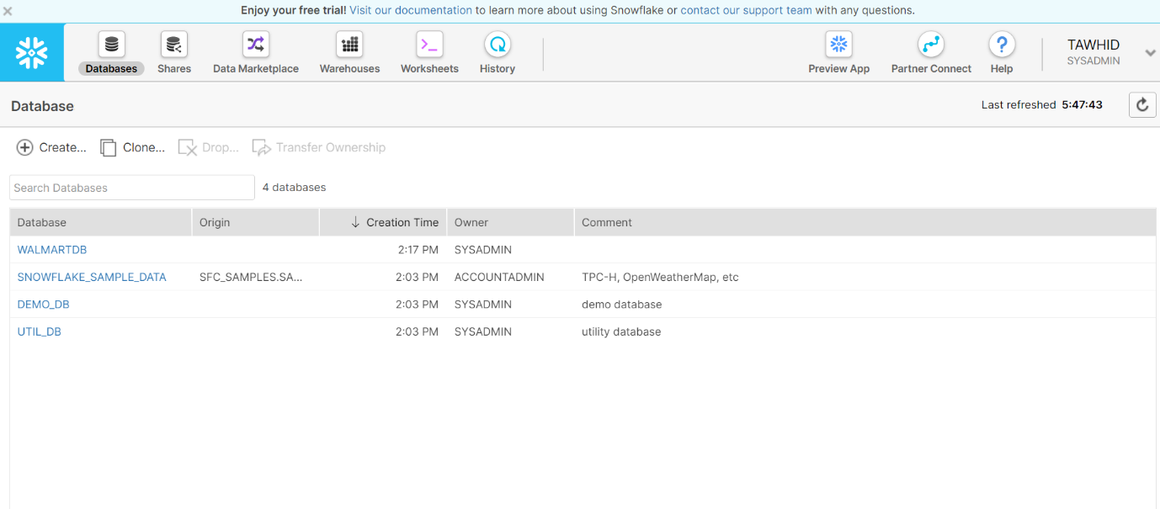
The last node use SQL statement to create or replace the database, then configure as a small database. And finally save the change and keep suspended at the beginning.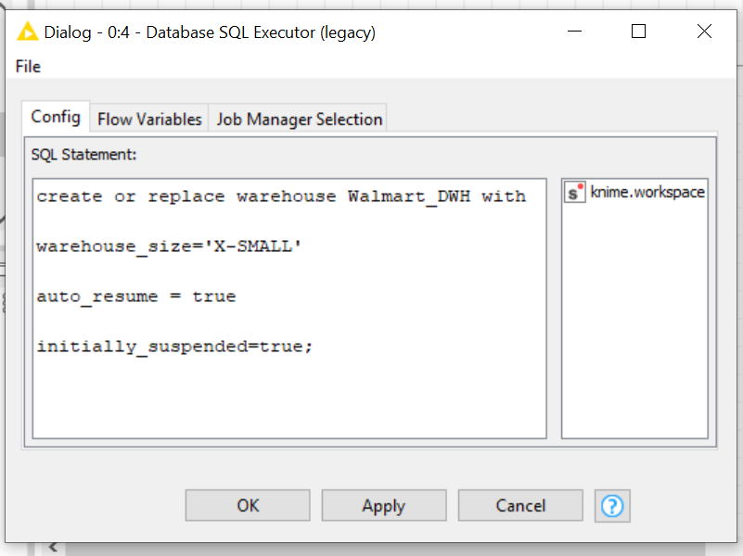
Next one is the workflow to create a warehouse with Walmart data.
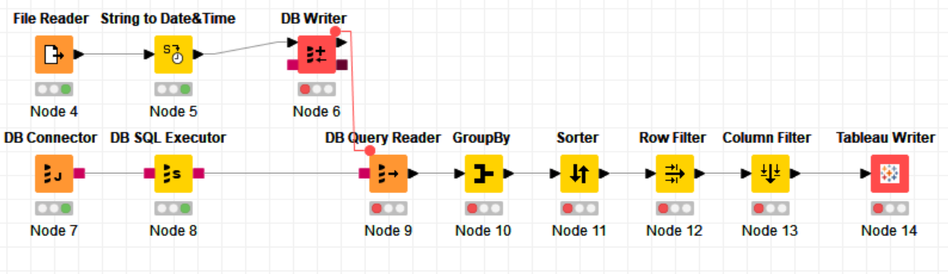
The node 4 of this workflow read data from Walmart sales file. The node 5 change from string to date and time the data in the ‘date’ column. The node 6 write the Database whit this new column. The node 7 create the connection whit the warehouse. Node 8 is used to select the database o replace it. The node 9 read SQL query and select the whole table of Walmart sales from Snowflake. Node 10 is used to group by store, 11 create an ascending order, 12 filter data and take last 20 store, 13 select only the column of weekly sale and store number. Final node is used to create a report in Tableau.

Reference
[1]"Snowflake meets Tableau. Data warehouse in an hour? | KNIME", KNIME, 2021. [Online]. Available: https://www.knime.com/blog/will_they_blend_snowflake_meets_tableau. [Accessed: 11- Jan- 2021].

