The ER Diagram below could be used to implement an invoice system to help out the extension of their business.

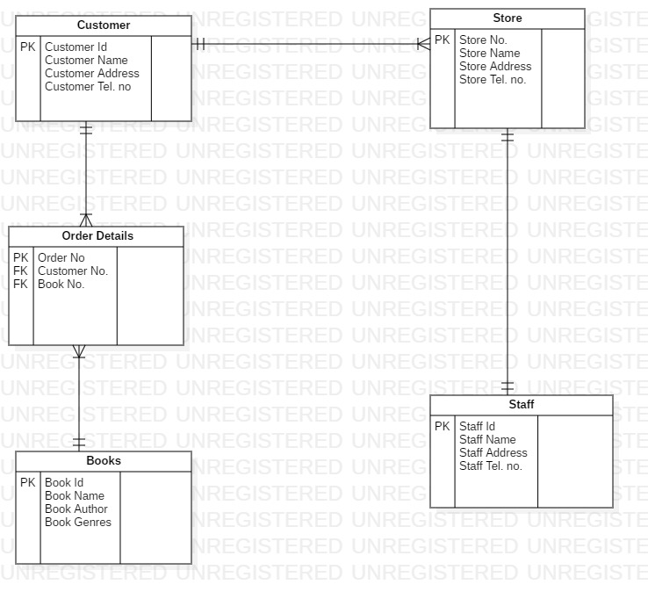

Below there is a Use Case Diagram which can be use in the development of an app for Book4U.

Actors
- Admin Staff
- Customer
Cases
- Login
- Browse Catalogue
- Feedback
- Invoice
- Place Order
- Updates
- Shop Cart
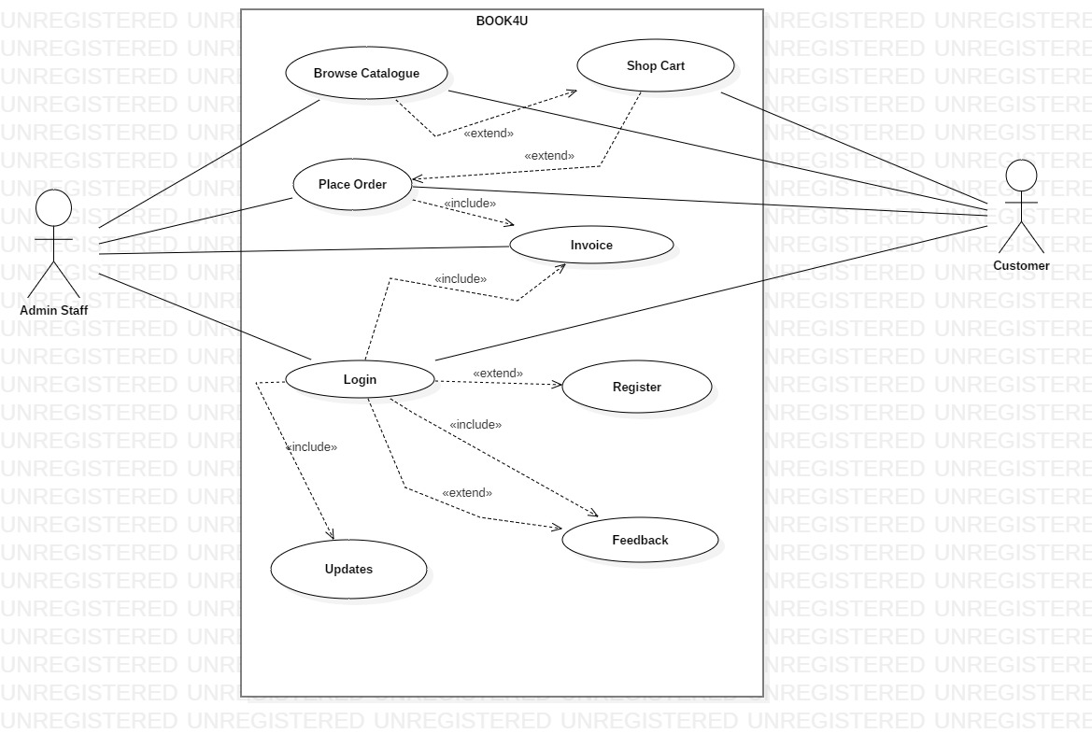
As you can see from the diagram Customer has access to Login then if he is not register he can do it.If he is logged in then he can view his invoices, feedbacks,updates etc.
As an Admin Staff you can see that has all the access to do whatever he needs.He can modify prices,invoices he can do updates to new arrivals etc.

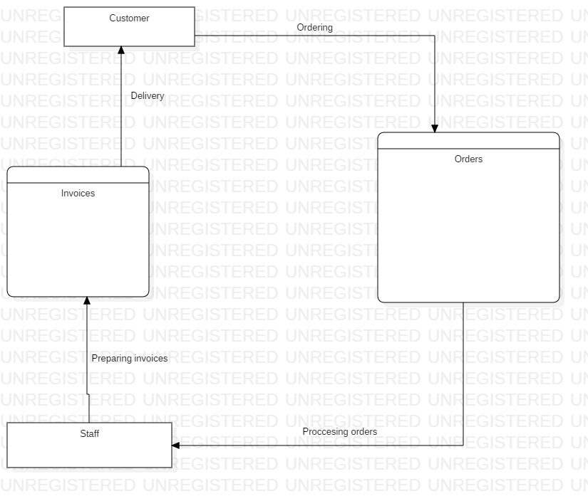

As you can see from the diagram the customer is making an order then goes to staff which is processing the order and prepares the invoice after the order and invoice is being delivered.

