1/12/2025
Assessment
Portfolio Report on Contemporary Software Applications for Business


Student Name: Shahana Nimmi Parvin
Student ID: 2509124

Module NaMe: Software solutions for business
Module Code: ACCA 4026
Lecturer: Koushik Modak
Trinity saint david University of Wales (London Campus)

Table of Contents
Introduction 2
Main Body 2
Task 1: e-Commerce Website builders/software solutions 2
Comparative Analysis of Contemporary E-Commerce Solutions 3
1. Shopify 3
2. WooCommerce 3
Task 2: Mind-map of Contemporary Software Applications 4
Contemporary Software Applications for Business Operations 5
Task 3: Office Applications for Creating, Storing, Presenting, and Analysing Data 6
Task 4: Communication and Collaboration applications 13
Practical Use of Communication and Collaboration Applications 15
Step 1: Sharing the Sheet with Co-authors 17
Step 3: Leaving a Contextual Comment 18
Conclusion 19
References 19

Introduction
The modern business landscape is defined by its reliance on sophisticated software applications to drive efficiency, facilitate digital commerce, and enable global collaboration. This report provides a comprehensive analysis of the critical digital infrastructure underpinning contemporary organizational operations. It is divided into four key sections: an exploration of the foundational e-commerce website builders that power digital transactions; a visual mind-map highlighting the diverse categories of software applications essential for daily business; a detailed review of core Microsoft Office applications used for data creation, storage, and analysis; and an assessment of communication and collaboration tools that sustain hybrid work environments. Through comparative analysis and practical demonstrations—including the use of the Excel IF function and the Word Mail Merge feature, as well as a demonstration of Google Meet and Google Sheets for real-time collaboration—this report aims to synthesize how these diverse technological solutions collectively contribute to business success and strategic decision-making.

Main Body

Task 1: e-Commerce Website builders/software solutions
E-commerce website builders and software solutions form the critical infrastructure that allows businesses to transact digitally. These platforms generally fall into two categories: hosted, all-in-one builders such as Shopify and Wix as well as self-hosted, open-source software such as WooCommerce [1], [2]. Modern solutions increasingly focus on providing powerful out-of-the-box features, strong scalability, and tools for multi-channel sales and artificial intelligence (AI) integration [1], [3]
E-Commerce Solutions
The market for e-commerce software is dominated by platforms that balance powerful capabilities with ease of use. The most popularly used e-commerce solutions, based on market share and adoption, include:
- Shopify: Best for ease of use and all-in-one, hosted growth [1].
- WooCommerce: The most popular open-source plugin, offering maximum control via WordPress [3].
- Wix: Highly rated for its intuitive, design-focused website builder and improving e-commerce features [2].
- BigCommerce: A robust hosted platform built for scaling businesses with large inventories and complex catalogs [4].
- Squarespace: Favoured by creative professionals for its stunning, design-led templates and integrated marketing tools [1].
- Square Online: An ideal solution for businesses integrating online sales with in-person Point of Sale (POS) transactions [3].

Comparative Analysis of Contemporary E-Commerce Solutions
A detailed comparison of Shopify and WooCommerce provides insight into the main technology choices facing contemporary e-commerce merchants: a fully managed hosted service versus a flexible, self-managed solution [5].

1. Shopify
Shopify is a leading subscription-based, fully hosted e-commerce platform that manages all technical infrastructure, security, and updates on behalf of the merchant [6].
Category | Features & Assessment
Major Features | Provides a secure, hosted infrastructure that ensures Payment Card Industry (PCI) compliance and built-in security. It excels at multi-channel selling, with native integrations for platforms like Facebook and TikTok. It leverages a massive App Store (over 8,000 options) for extended functionality and includes built-in AI tools (Shopify Magic) [5], [7].
Benefits | Offers the fastest launch time and is the easiest to use for beginners, requiring virtually no coding knowledge [6], [7]. Reliability & Scalability: The closed, proprietary nature of the platform ensures high uptime and stability, reliably handling high-volume traffic spikes without user intervention [5]. Support: Provides comprehensive 24/7 customer support through multiple channels [6].
Limitations | Imposes its own transaction fees (ranging from 0.6% to 2%) if the merchant opts to use any third-party payment gateway instead of its native Shopify Payments 7, [8]. Customization options are generally more limited compared to open-source platforms, with advanced features often requiring costly, paid apps that increase the total cost of ownership [5], [7].

2. WooCommerce
WooCommerce is an open-source plugin that adds e-commerce functionality to a self-hosted WordPress website, providing maximum control and flexibility [5].
Category | Features & Assessment
Major Features | The core software is free and provides total open-source control over the code, design, and data. It excels at content and commerce integration, seamlessly leveraging WordPress's powerful CMS. All functionality, from advanced SEO to shipping, is handled via a flexible, plugin-based ecosystem [7], [6].
Benefits | Offers unlimited customization and the ability to create highly unique, specialized features. It provides the most powerful control for advanced technical Search Engine Optimization (SEO) [6], [7]. While the software is free, costs are dictated by self-managed hosting and domain registration. It can be the cheapest option if the business requires minimal premium add-ons [5], [8]. Ownership: The merchant retains full ownership of the data and hosting environment [7].
Limitations | Requires the merchant to manage all technical aspects, including hosting performance, security, and updates, which necessitates more technical expertise than a hosted platform [7]. Dedicated, instant customer support is not included; reliance is placed on extensive community forums and hiring external developers [6]. Store performance is highly dependent on the quality of the chosen web hosting and proper technical configuration, leading to variable outcomes [5].

Task 2: Mind-map of Contemporary Software Applications
In this section of the report, I intend to discuss the concept of mind-mapping and its benefits in business. Mind mapping is a versatile visual tool used to organize information, generate ideas, and structure complex concepts around a single central topic [1], [2]. It presents information in a non-linear, graphical layout that mimics the brain's natural process of associative thinking [1]. The core concept is placed at the centre, with main themes radiating outwards as branches, and sub-topics branching further off, creating a hierarchical, yet interconnected, structure [2]. The use of colours, images, and short keywords is encouraged to enhance memory and clarity [1], [3].
Benefits of Mind Mapping in Business Operations
Mind mapping offers several significant advantages for day-to-day business and organizational operations such as:
- Enhanced Brainstorming and Creativity: Mind maps break down the artificial barriers of linear thinking, allowing ideas to flow freely and branch out organically from the central concept. This radial structure fosters richer ideation and can help teams uncover hidden connections and surprising insights during brainstorming sessions [1], [3].

- Improved Organization and Clarity: For complex projects or data-heavy situations, mind maps transform long, monotonous lists into highly organized, memorable diagrams [1], [3]. They provide a clear hierarchy of information while maintaining a view of the bigger picture, helping teams to break down complex topics into digestible segments [3]. This clarity aids in effective project outlining, knowledge management, and documentation [3], [4].
- Boosted Collaboration and Communication: Mind maps create a shared visual space for collaborative work, making it easier for team members with diverse perspectives to see how their ideas connect and complement each other [3]. They bridge communication gaps and facilitate consensus building around complex ideas [3].

- Streamlined Project and Task Management: Mind mapping is valuable for the planning and analysis stage of project management, as it aids in visually capturing the hierarchy of tasks, activities, and project requirements (often referred to as the Work Breakdown Structure) [4]. They help in setting goals, outlining strategies, and identifying priorities, ultimately leading to better focus and clarity on tasks and objectives [1], [4].

Mind Map of Contemporary Software Applications
The mind map below visually organizes key categories and examples of contemporary software applications that are essential for supporting daily business and organizational operations [5], [6].

Contemporary Software Applications for Business Operations
Collaboration & Communication
  - Microsoft Teams and Slack: Platforms for team messaging, calling and file sharing.
  - Zoom: A leading video conferencing application.
  - Google Workspace: A suite for email, document creation, and communication [5].

Project & Task Management
  - Jira and Asana: Tools for tracking projects, tasks, and workflows, especially in Agile environments [5].
  - Trello and Monday.com: Visual, flexible platforms for managing team tasks and projects.
Enterprise Resource Planning (ERP) & Finance
  - QuickBooks and Xero: Accounting software for managing finances, invoicing, and payroll [5].
  - SAP and Oracle NetSuite: Comprehensive ERP systems integrating all aspects of a business, from manufacturing to finance.
Customer Relationship Management (CRM) & Sales
  - Salesforce and HubSpot CRM: Systems for managing all of a company's relationships and interactions with customers and potential customers [5].
  - Zoho CRM: An integrated platform for sales, marketing, and customer support.
Marketing & Analytics
  - Google Analytics: Tool for tracking website traffic, user behaviour, and marketing campaign effectiveness [5].
  - Mailchimp: Platform for email marketing and marketing automation.
  - Hootsuite: Social media management tool for scheduling and analysing posts across platforms [5].
Human Resources & People Management (HRM)
  - BambooHR and Workday: Software for managing employee data, recruiting, payroll, and benefits [5].
  - ADP Workforce Now: Comprehensive solution for HR, payroll, time, and benefits.
File Storage & Productivity Suites
  - Microsoft 365 and Google Drive: Cloud-based services for secure file storage, sharing, and synchronous editing [5].
  - Dropbox and Box: Dedicated cloud storage and collaboration platforms.

Task 3: Office Applications for Creating, Storing, Presenting, and Analysing Data
The following section provides a detailed explanation of four core Microsoft Office applications (Part A) and a practical, step-by-step demonstration of two business-related functions (Part B). The Microsoft Office suite provides essential tools for documentation, data management, and communication across virtually all business sectors. The following sections detail four foundational applications; MS Word, MS PowerPoint, MS Excel and MS Access focusing on their features, benefits, and limitations in a business context.
Microsoft Word
Microsoft Word is the professional word processing application used for the creation, editing, and formatting of all types of text-based documents that require a clean, consistent, and structured appearance [1]. Its major features include a wide array of sophisticated formatting tools such as styles, themes, headers/footers, robust collaboration utilities like Track Changes and commenting for multi-user review, and the powerful Mail Merge function for generating mass personalized correspondence [2]. Word's primary benefit to a business is its ability to ensure uniformity and professionalism across all official documentation, such as legal contracts, policy manuals, and proposals. By utilizing templates and standardized styles, it guarantees brand consistency and streamlines the often-time-consuming processes of document review and approval. However, a significant limitation is that Word is not designed for dynamic data analysis or complex calculation. While it can display tables, any data within the document is static and cannot be used for calculation or modelling, necessitating manual updates or the transfer of data to a dedicated spreadsheet program [2].
Microsoft PowerPoint
Microsoft PowerPoint is the industry-standard presentation software designed to communicate information visually, persuasively, and effectively to groups of people. Its core features revolve around a slide-based structure that easily accommodates diverse multimedia elements, including text, high-resolution images, charts, and embedded video clips [3]. Advanced tools include dynamic slide transitions and animations, specialized Design Tools (like Designer) for rapid visual layout, and the crucial Presenter View, which allows the speaker to view their private notes and control the flow without audience visibility. The immense benefit of PowerPoint to business operations is its capacity for effective stakeholder engagement; it allows complex financial results, marketing strategies, or training content to be synthesized into clear, high-impact visuals. This visual clarity significantly enhances audience retention and is fundamental for successful sales pitches and internal reporting. A key limitation, however, is that its utility is constrained by the user's design choices. Poorly designed, text-heavy slides can lead to "Death by PowerPoint," detracting from, rather than amplifying, the core message [4]. Furthermore, the presentation is a static final product, lacking the interactive, exploratory nature of live data dashboards.
Microsoft Excel
Microsoft Excel is the globally dominant spreadsheet application utilized for the organization, calculation, analysis, and visualization of quantitative data. Its strength lies in an extensive library of built-in formulas and functions (e.g., mathematical, statistical, logical functions like IF and VLOOKUP) for performing mathematical, logical, and financial calculations. It includes powerful data manipulation tools such as PivotTables for summarization, sorting, filtering, and conditional formatting, along with robust charting capabilities for visualization [5]. The indispensable benefit of Excel is its role in financial modelling, budgeting, and forecasting. It empowers businesses to perform complex calculations quickly, simulate various "what-if" scenarios, and track operational Key Performance Indicators (KPIs), enabling data-driven decision-making across all functional areas [5]. Despite its power, the most critical limitation is the high risk of error propagation. Since cells are interconnected by formulas, a small, subtle mistake in data entry or a formula reference can cascade through an entire model, leading to significant inaccuracies that can affect major financial and strategic outcomes [6]. For very large, complex, and interrelated datasets, Excel also lacks the scalability and rigorous integrity checks of a relational database system.

Microsoft Access

Microsoft Access is a Relational Database Management System (RDBMS) specifically designed for small to medium-sized business environments to organize, store, and efficiently retrieve large volumes of structured information [7]. Its key features are the creation and management of four primary objects: Tables (to store data and enforce data integrity rules), Queries (for extracting, filtering, and manipulating specific subsets of data), user-friendly Forms (for guided data entry), and Reports (for summarizing and printing data) [8]. The chief benefit of Access is its ability to enforce data integrity and manage complex relationships between different entities (e.g., linking customer records to their associated order details), which is a crucial capability that a flat spreadsheet cannot reliably provide [9]. This makes it ideal for building custom applications like inventory trackers or departmental contact databases. However, Access is significantly limited by scalability and concurrent user access. It is generally not suited for large enterprise deployment or high-demand, web-based applications, as performance degrades rapidly with more than a dozen simultaneous users, often requiring migration to industrial-grade RDBMS solutions like SQL Server as the business grows [9].

Practical Use of Software Applications
This section provides a practical, step-by-step demonstration of two different business-related functions from two different software applications: the IF Function in MS Excel and the Mail Merge feature in MS Word. Screenshots are also documented to provide evidence of practical use.

MS Excel: The IF Function
The IF Function is a fundamental logical function in Excel that allows a business to automate decision-making based on whether a specified condition is met. This is commonly used for commission calculations, determining pass/fail status or automating performance ratings.
For this particular assignment, I intend to use apply a scenario where a company offers a performance Bonus of £500 to any employee whose sales performance is greater than or equal to £10,000.
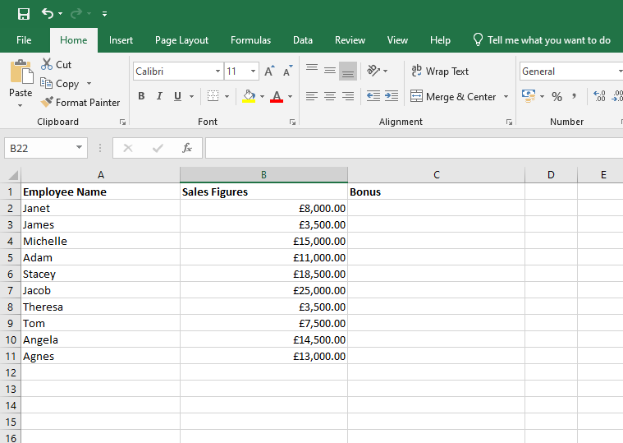
Step 1: Inputting data

We first begin by inputting the employee names in Column A and the sales figures in Column B. In order to automate and I will use the formula below:
= IF (B2>10000,500,0) to elaborate further, the IF function will look at figured in Column to determine if they are greater than 10000 if so, Column C will show each employee that qualifies for the £500 bonus and if not, the figure will appear as 0.
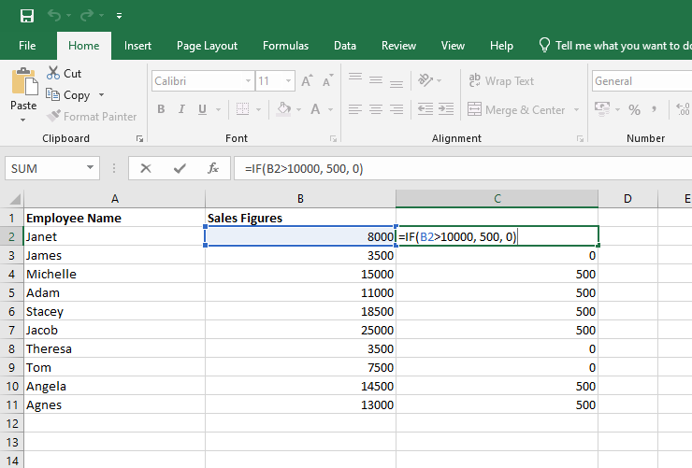
Step 2: Calculation

In this example, the formula used assumes that if the figures in Column B are greater than £10000, the employee is entitled a £500 bonus. Column C shows all the employees entitled to the £500 bonus and the employees who have achieved less than £10000 in sales. As shown in the image above, the formula has been merged with the dataset.
MS Word: Mail Merge
Mail Merge is a high-efficiency tool in MS Word used by businesses to create personalized documents (e.g., letters, invitations, invoices) for a large number of recipients by merging a single main document with an external data source (the Excel file from the previous example) [10].
For this exercise I intend to use the dataset from the sales performance to send out a personalised bonus notification letter to every employee listed in the Excel sheet that qualifies for the bonus.
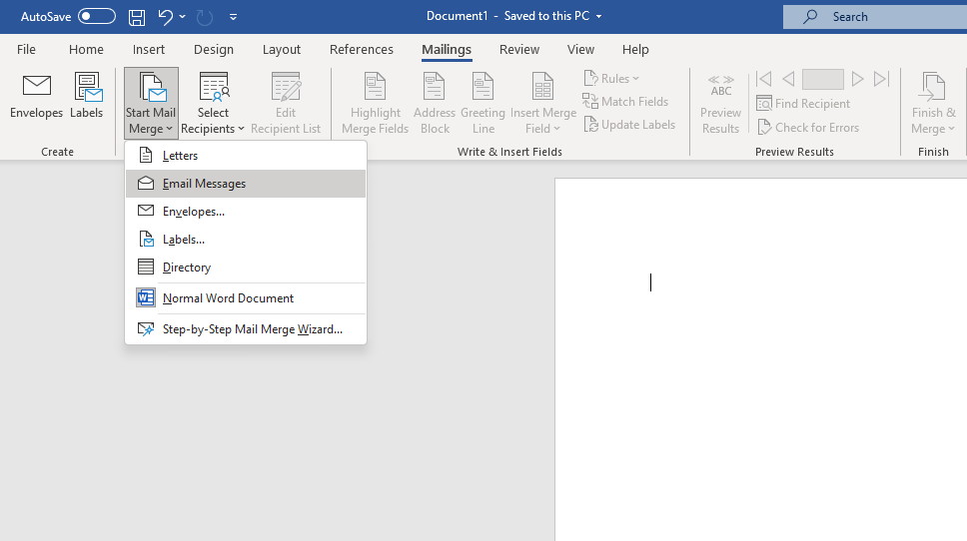
Using Microsoft Word, I will use mail merge function to prepare the email and connect the data of the recipients. In order to do this, I first select the Mailing option (as shown above) then from there, I will select ‘Start Mail Merge’. I will then have a number of options to choose from and in this particular case, I will select the ‘Email Messages’.

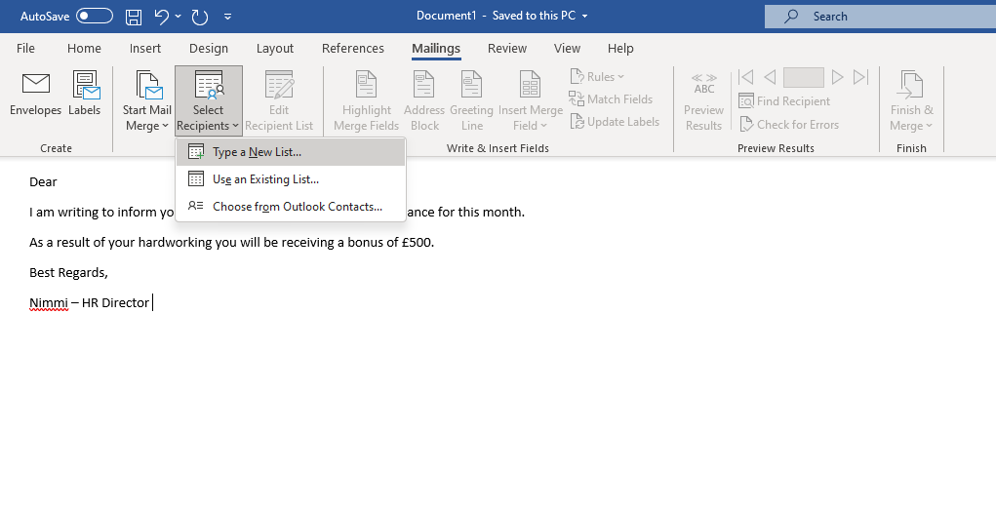
Once the email has been prepared (as shown above) we then need to select the recipients and this is where we connect to the excel spreadsheet. In order for this to work, we need to have email addresses of the recipients.

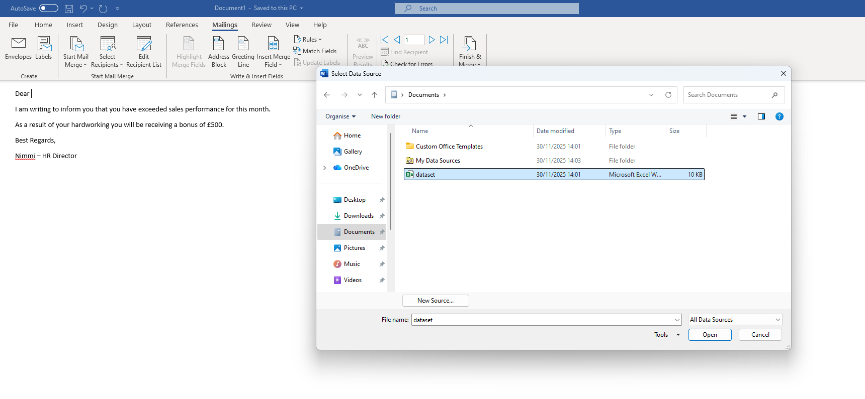
Once select recipient is selected, a pop up shows up (as shown above) in order to connect the data.
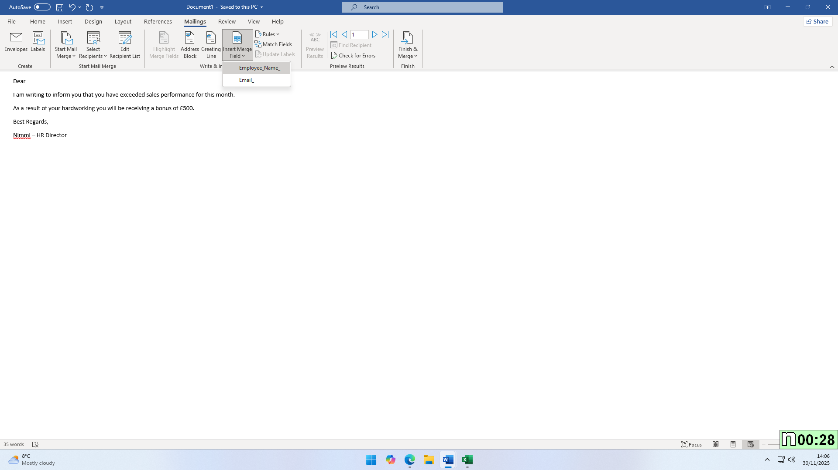
In order to personalise this email, we will then select ‘Insert Merge Field’ and in this case, we will ensure that the email reaches the recipient in their name rather than just generic email.

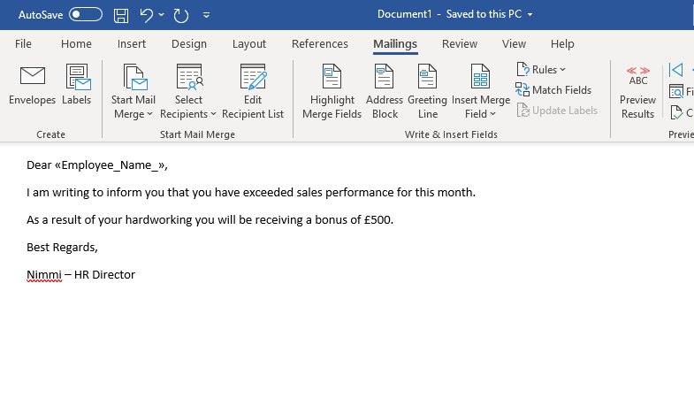
The image above shows our data successful connected to the actual email and merged.

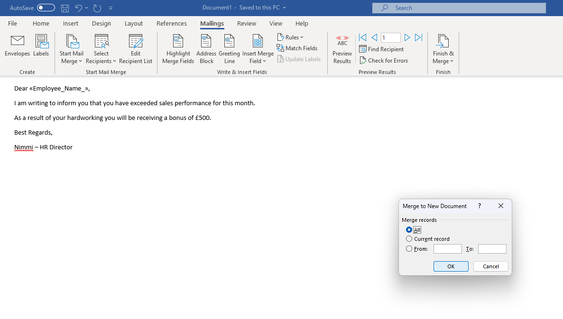
Once the data is integrated, we will then select the ‘Finish & Merge’ button to send out the email to all recipients. Word allows a user to either send to all parties or a select few as shown in the image above.

Task 4: Communication and Collaboration applications
The digital transformation of the modern workplace has made Communication and Collaboration applications indispensable for business success, driving alignment, innovation, and productivity across organizations [4.2], [4.4]. These tools facilitate seamless interaction between employees, regardless of geographical location, and are pivotal for the shift towards flexible and hybrid work models [1.1], [4.4].
Analysis of Contemporary Applications
Microsoft Teams is a cloud-based unified communication platform that centralizes chat, video meetings, calling, and file sharing in a single interface [1.1], [1.2]. As a foundational tool within the Microsoft 365 ecosystem, it is widely adopted for enhancing both internal and external communication in professional settings [1.5], [4.1]. Its key features include offering flexible communication options such as one-to-one chats, group chats, and team-based channels for topical, threaded conversations, which significantly reduces the need to rely on email for quick or project-specific discussions [1.2].
Teams strongly supports remote and hybrid work environments by offering HD video meetings complete with screen sharing, custom backgrounds, live captions, and recording capabilities [1.3]. A major feature is its native integration with other Microsoft applications (e.g., Word, Excel, PowerPoint, Outlook, and SharePoint), enabling real-time co-authoring on documents directly within the Teams interface [1.4], [3.1], and it also allows for secure collaboration with external users, such as clients or vendors [1.3].
The platform offers several significant benefits to organizations. By centralizing communication and tools, Teams effectively reduces task switching and promotes clearer project focus, allowing employees to work smarter and faster [1.2], [1.4]. The interactive elements like emojis, GIFs, and real-time chat create a more dynamic and engaging communication experience [1.4]. Furthermore, its accessibility across desktop, web, and mobile devices supports highly flexible and remote work arrangements [1.1]. Finally, the channel-based structure makes information significantly more transparent and easily searchable compared to scattered email threads [1.2].
However, Teams does have limitations. While it offers calling, its native telephony features may lack the intricacy of dedicated Voice over IP (VoIP) systems, such as advanced call flows or contact centre capabilities [1.1]. Additional licensing is often necessary for full Public Switched Telephone Network (PSTN) calling functionality [1.1]. Some users find the way Teams handles file structure, storing conversation uploads in the channel root folder, can be confusing compared to traditional folder hierarchies [1.2]. Lastly, the overlapping functionality between Teams, Outlook (for email/calendar), and SharePoint (for file storage) can sometimes complicate user adoption and management efforts [1.5].
Collaboration Application: Microsoft SharePoint
Microsoft SharePoint is a web-based document management and collaboration platform, frequently utilized for creating comprehensive company intranets and team sites [2.1], [2.4]. It serves as the secure, underlying storage and content management backbone for all file sharing across the entire Microsoft 365 suite, including both Teams and OneDrive [3.4]. SharePoint’s key features centre on robust content control; it provides a secure, centralized repository for documents, offering essential functions like version control (to track changes and restore versions), check-in/check-out, and powerful search capabilities [2.1], [2.3]. It allows organizations to establish internal websites, news feeds, and communication portals to efficiently share company-wide announcements, resources, and policies [2.1].
The platform facilitates business process management by allowing the creation of custom lists, libraries, and integration with Power Automate, which helps automate repetitive tasks like document approvals and HR processes [2.1], [2.3]. Furthermore, its use of metadata and taxonomy is critical for organizing content, significantly improving information discoverability and supporting robust knowledge management strategies [2.2].
SharePoint offers substantial benefits to organizations. It functions as a single, secure hub for all organizational documents, resources, and institutional knowledge, effectively reducing the need to search through fragmented emails or local drives [2.1]. Built with enterprise-grade security, it provides necessary features like data encryption, role-based permissions, and compliance tools (such as retention policies and auditing), which are vital for regulated industries [2.1], [2.3]. The cloud version, SharePoint Online, is designed to scale easily to meet the demands of large enterprises and provides deep customisation possibilities for unique business requirements [2.1], [2.4]. As the secure storage layer, it seamlessly enables real-time co-authoring and file sharing across Teams, OneDrive, and Office applications [3.4]. Despite these benefits, SharePoint has clear limitations. The initial setup, configuration, and proper governance (especially managing permissions) can be complex and frequently necessitates specialized IT expertise or reliance on external consultants [2.4], [2.5]. Due to the sheer number of features and complexity, user adoption can be low without comprehensive training, as some users initially find the platform "hard to use" [2.4], [2.2]. Finally, poorly configured, overly customized sites, or those with excessively large lists can sometimes result in noticeably slow performance [2.2].

Practical Use of Communication and Collaboration Applications
For the practical activity, I will use Google Meet as the freely available communication application and Google Sheets as the freely available collaboration application.
1. Communication Application: Google Meet
Google Meet is a video-conferencing platform widely used in the business world for scheduled and impromptu video meetings and presentations [3.2].
Practical Use: Remote Client Presentation and Feedback
I will demonstrate how a consultant uses Google Meet to present a proposal to a client and use the chat feature for quick, non-disruptive feedback.

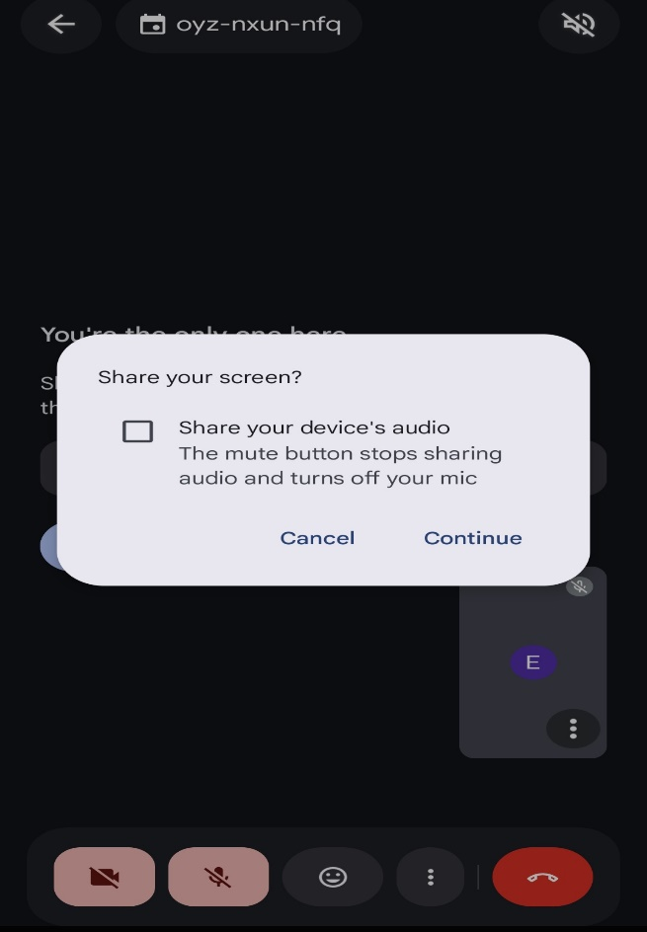
Step 1: Starting the Meeting and Sharing the Screen

As shown in the images above the consultant starts the meeting and uses the Screen Share feature to display the presentation slides to the client.
Once screen sharing is fully activated, the client will be able to see the screen of the consultant and the consultant can go ahead and display the presentation slides.

Step 2: Non-verbal communication via In-Call Chat
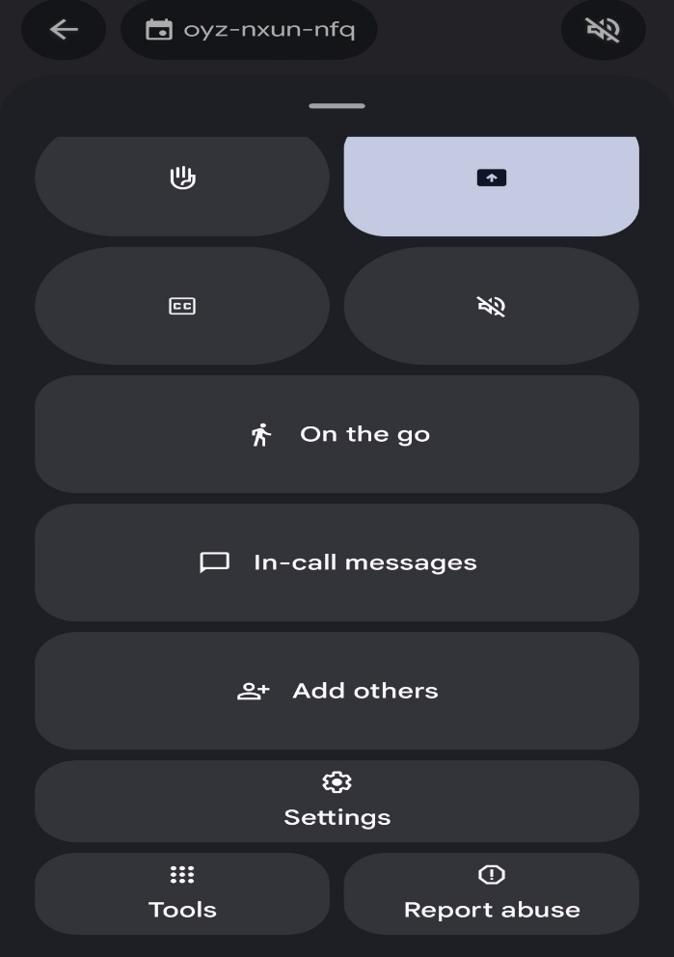
As shown above, we can use the ‘in-call messages’ feature during the meeting to ask specific questions or request further information without interrupting the presentation. As shown in the image above (right) the in-call message feature in use and everyone on the call is able to view the message and contribute where possible. The feature can be used throughout the presentation to share links and respond to the question or enquiry.

Collaboration Application: Google Sheets
Google Sheets is a cloud-based spreadsheet application providing real-time co-authoring. Its primary business use is to allow multiple users to work on financial or planning data simultaneously without version control issues [3.4].
Use Case: Collaborative Budget Tracking
This exercise will demonstrate a Finance Manager and a Project Manager simultaneously updating a shared project budget sheet to track real-time expenditures.

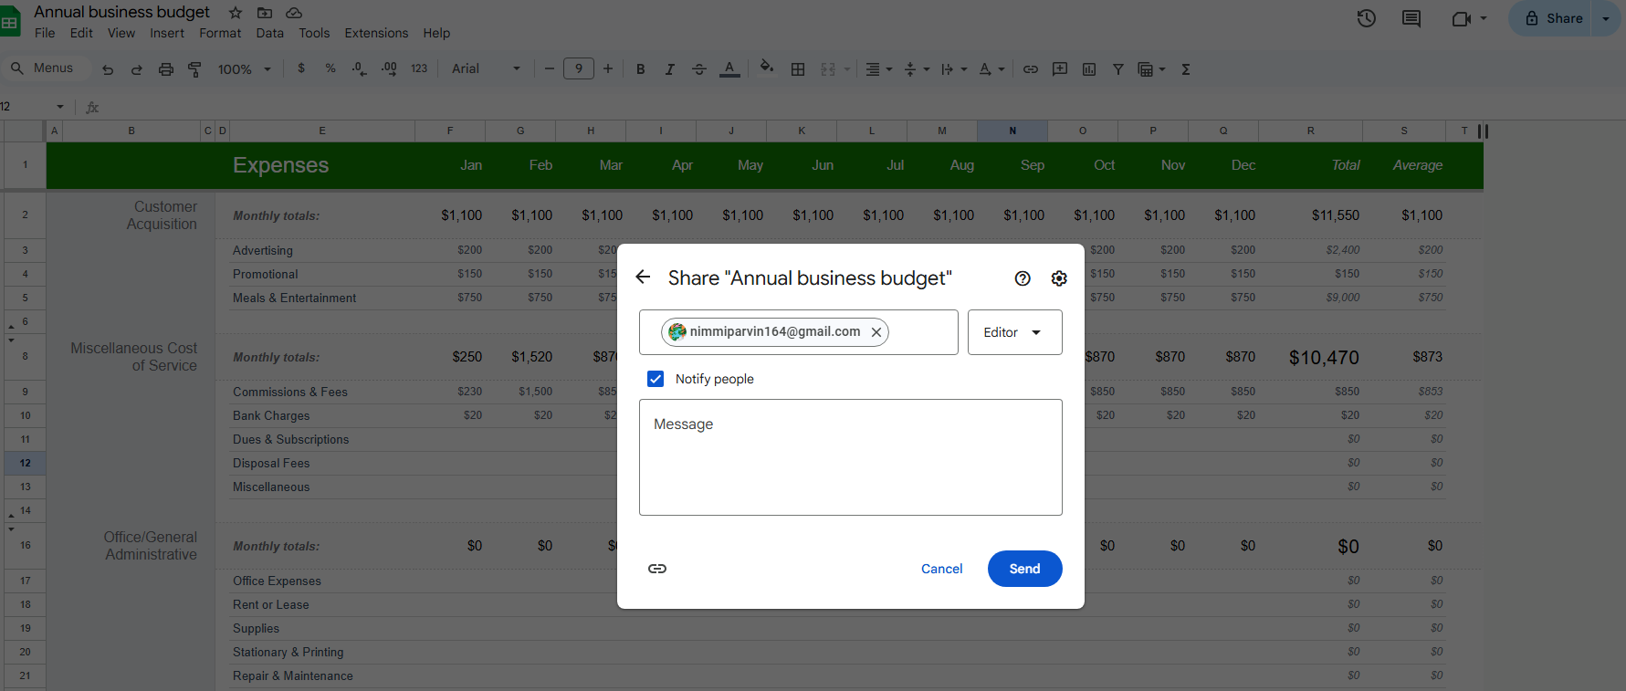
Step 1: Sharing the Sheet with Co-authors
In the image above is a demonstrate of the use of the 'Share' button to grant a colleague access to the sheet. This critical step ensures both parties can view, edit, and contribute to the same live document, eliminating the confusion of sending files back and forth.


Step 2: Simultaneous Real-Time Co-authoring

In the image above, it shows the collaboration between the colleagues. By looking at the version history, it will show the changes made to the sheet and the person responsible for making the updating making it easier for the team to collaborate and communicate.
Step 3: Leaving a Comment
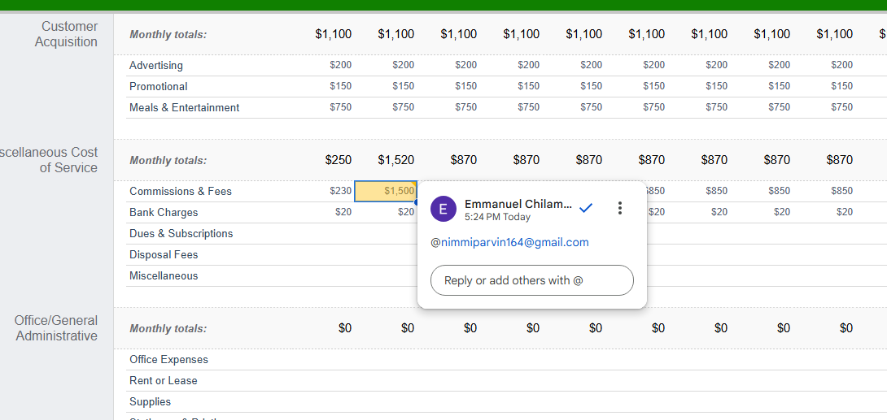
In this image, the Finance Manager highlights the cell containing a questionable cost and clicks the Comment icon. By using the @mention, it will notify the Project Manager who then receives an immediate alert and can resolve the query directly within the data's context.

Conclusion
This analysis underscores the indispensable role that contemporary software applications play in the modern business ecosystem. From the comparative examination of e-commerce platforms like Shopify (hosted) and WooCommerce (self-hosted), which represent fundamental strategic choices for digital sales, to the overview of various Enterprise Applications (CRM, ERP, Project Management) organized visually through the concept of a mind-map, it is clear that specialized tools drive every facet of operations. The report detailed the distinct strengths and limitations of the core Microsoft Office Suite—Word for professionalism, PowerPoint for stakeholder engagement, Excel for complex financial modelling, and Access for structured data management—while providing practical, step-by-step demonstrations of their utility. Finally, the review of Communication and Collaboration tools like Microsoft Teams and SharePoint confirmed their essential function in enabling hybrid work through centralized interaction, secure content management, and real-time co-authoring. Ultimately, strategic success in the digital age hinges on a business’s ability to select, integrate, and effectively utilize this diverse, interconnected portfolio of software solutions to achieve scalability, efficiency, and clarity in communication.

References
[1] "The 6 best ecommerce platforms for small businesses - Startups," Startups, Nov. 11, 2025.
[2] "The 11 best website builders in 2025 - TechRadar," TechRadar, Nov. 20, 2025.
[3] "10 Best E-Commerce Platforms Of 2025 - Forbes," Forbes, Nov. 7, 2025.
[4] "10 Best eCommerce Website Builders for Your Online Store (2025) - Armada Internet," Armada Internet, Jul. 28, 2025.
[5] "Shopify Alternatives in 2025, WooCommerce vs Shopify vs BigCommerce," CV3, Sept. 20, 2025.
[6] "Shopify vs BigCommerce vs WooCommerce in 2025," White Peak Digital, Mar. 29, 2025.
[7] "Best Ecommerce Platform 2025 | Shopify vs Woo vs BigCommerce," JetFuel.Agency, Aug. 29, 2025. [8] "Which is Better in 2025: BigCommerce vs Shopify vs WooCommerce," Waredock, Jul. 28, 2025.
[1] R. Salecl, “What Is A Mind Map? | MindMapping.com,” MindMapping.com, 2020. [Online]. Available: https://www.mindmapping.com/mind-map
[2] Mind Mapping - Improvement Service, Improvement Service. [Online]. Available: https://www.improvementservice.org.uk/business-analysis-framework/investigate-situation/mind-mapping
[3] “What Is a Mind Map? Learn Its Benefits and How to Create One | The Workstream - Atlassian,” Atlassian, 2025. [Online]. Available: https://www.atlassian.com/work-management/project-management/mind-mapping
[4] “6 Benefits & Uses for Mind Mapping Within Project Management - MindGenius,” MindGenius, 2025. [Online]. Available: https://www.mindgenius.com/6-benefits-uses-for-mind-mapping-within-project-management/
[5] “Contemporary Business Software Applications | MindMeister Mind map,” MindMeister, 2024. [Online]. Available: https://www.mindmeister.com/3556685967/contemporary-business-software-applications
[6] MindManager: Mind Mapping Software by MindManager, 2025. [Online]. Available: https://www.mindmanager.com/en/
[1] T. Chen, "The critical role of Microsoft Word in professional technical documentation," J. Tech. Writing Commun., vol. 54, no. 1, pp. 34–51, 2024.
[2] M. V. Mukhedkar, "Reference management using MS-Word software: A practical approach," Int. J. Res. Inf. Technol., vol. 9, no. 5, pp. 100–103, 2021.
[3] S. A. Smith, "Visual communication strategies using Microsoft PowerPoint in the corporate environment," Bus. Commun. Rev., vol. 18, no. 3, pp. 112–125, 2023.
[4] J. Garrett, "Presentation skills for the modern workplace: Avoiding design pitfalls," Business Communication Journal, vol. 18, no. 2, pp. 45–58, 2023.
[5] J. L. Hall, "Advanced Excel functions for financial modeling and forecasting," Financial Analysts Quarterly, vol. 35, no. 1, pp. 112–125, 2024.
[6] T. Chen, Financial Modeling and Risk Management Using Advanced Excel Functions. New York, NY, USA: Wiley, 2024, ch. 4.
[7] NetCom Learning, "What is Microsoft Access? - Uses, Features, & Benefits in 2026," NetCom Learning, 2025. [Online]. Available: https://www.netcomlearning.com/blog/what-is-microsoft-access-a-complete-guide
[8] A. Smith, "Fundamentals of small business database management using MS Access," J. Inf. Syst., vol. 10, no. 4, pp. 180–195, 2023.
[9] The Knowledge Academy, "Advantages and Disadvantages of Microsoft Access: Explore," The Knowledge Academy, 2025. [Online]. Available: https://www.theknowledgeacademy.com/blog/advantages-and-disadvantages-of-microsoft-access/
[10] Tech Skills Center. (2021). Step-by-step guide to mass personalization with Mail Merge. Digital Learning Resource.
[1] M. K. K. Lee, "The role of communication and collaboration in business management," ResearchGate, pp. 1-8, Aug. 2025.
[2] Gartner, "Market Guide for Unified Communications as a Service," Gartner Report, 2021.
[3] A. Zander and B. Chen, "Digital tools for the modern workplace: A path to productivity and resilience," World Journal of Advanced Research and Reviews, vol. 25, no. 02, pp. 524-533, 2025.
[4] J. Bughin, M. Chui, and J. Manyika, "How social technologies are expanding organizations," McKinsey Quarterly, 2010.

