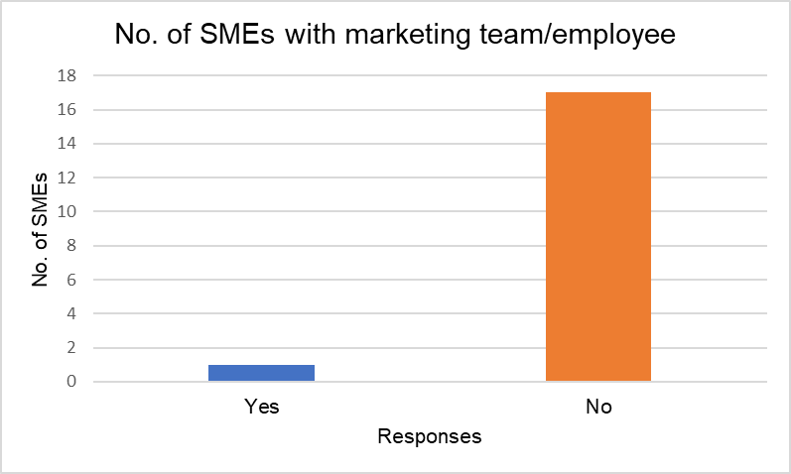

6. Social Media Pages Analysis
Social media pages of certain SMEs that responded to the survey were analysed for average number of posts per week over a month and engagement metrics e.g. likes and comments. Here are some examples from a florist.
The types of posts they posted were also analysed. 63% were sales which was expected from a product seller.

5. Survey Results
The survey respondents were all SMEs based in Swansea. As expected, only one of the SMEs had a marketing team/employee.

All but one of them also had a social media presence, and 67% of them found their social media strategy unsuccessful, so more research is needed to help SMEs have a successful social media strategy.

9. References
[1] Bonhill Group plc., “Top social media tips for small businesses,” 11 September 2018. [Online]. Available: https://smallbusiness.co.uk/top-social-media-tips-small-businesses-2540617/. [Accessed 10 November 2019].

8. Conclusions/Recommendations
Social media marketing should be treated as a completely different field to traditional marketing. Most SMEs find their social media strategy unsuccessful, so the guide can be useful for them to improve. The SME respondents could be contacted, and the guide can be tested on their social media to see whether it works. Research can be done in other localities to see how generalised the guide is and how useful it can be.

1. Introduction
Compared to traditional marketing, which works as a static, one-way line of communication, social media marketing allows for feedback and further outreach to a much bigger audience that can be targeted specifically.
Small Medium Enterprises (SMEs) can find it difficult to utilise social media marketing due to lack of a marketing team, time and budget [1]. Lack of research in this field brought the idea of this project.

upload schedule
4. Lay out social media metrics to see whether their social media marketing is successful
5. Build strong relationships with your audience

7. Social Media Marketing Guide for SMEs
Proposed steps for an SME to follow for a successful social media strategy are:
1. Consider what sector they are in and how social media marketing can help to reach their goals
2. Choose their target audience and what social media platforms to join
3. Decide what kind of posts to post and choose an

4. Research Methodology
A survey and analysis of social media pages were chosen as part of the research methodology. A survey can reach many people in a short timescale which is important because of the time constraints of the project. The analysis of social media pages can back up the results of the survey and see how SMEs are using social media.
It will be a phenomenological research design and inductive research approach. Data collection will be cross-sectional, again due to the limited timescale. Mixed methods research will also be used as both qualitative and quantitative data will be collected. This means both types of data can be compared for any contradictions.

2. Aim
The aim of this project is to produce a best practice guide of social media marketing for small and medium enterprises in Swansea.

3. Objectives
To achieve this aim, there are 5 objectives to complete:
- Research traditional and social media marketing

- Investigate social media strategies used by SMEs today

- Create a survey to see how SMEs use social media

- Analyse SME social media pages

- Write an up-to-date best practice guide on social media strategies for SMEs

Investigation implementation and evaluation of up-to-date Social Media strategies for SMEs
Runa Bibi (1702463)
Business Information Systems

