Assignment 1 Data Security and Compliance

Jacob Davies
2416227

Contents
Introduction 3
Task 1 4
Principles of Zero Trust Architecture 4
Technological Enablers of Zero Trust Architecture 6
Real World Case Studies and Critical Discussion 9
Conclusion 10
Task 2 11
Proposal and Implementation Plan for Establishing an Information Security Unit at Aegis FinTech Innovations Ltd 11
Work-Stream 1 – Organisational Design & Resourcing 12
Work-Stream 2 – Policy Framework Development 14
Work-Stream 3 – Regulatory Compliance Strategy 15
Work-Stream 4 – Technical Standards & Architecture 16
Work-Stream 5 – Strategic Risk Assessment 18
Work-Stream 6 – Incident Response & Business Continuity 19
Work-Stream 7 – Governance & Strategic Roadmap 20
Conclusion 23
References 24

Introduction

The rapid adoption of cloud computing, remote working, software-as-a-service (SaaS), and Internet of Things (IoT) technologies has transformed how organisations manage information systems. While these technologies provide greater flexibility and efficiency, they have also expanded the attack surface available to cybercriminals [3][5]. Modern threats, including ransomware, credential theft, supply chain attacks, and cloud misconfigurations, have demonstrated the limitations of traditional perimeter-based security approaches. [3][5]
Historically, organisations relied on a “castle-and-moat” security model, where users and devices inside the corporate network were considered trusted after authentication. However, this approach is increasingly ineffective due to the growth of hybrid cloud environments, remote access, and third-party services. Attackers who obtain valid credentials can bypass traditional defences and move through internal systems without detection. [5][9]
Zero Trust Architecture (ZTA) has emerged as a modern security approach designed to address these challenges. Based on the principle of “never trust, always verify,” Zero Trust removes implicit trust by requiring continuous authentication, authorisation, and monitoring of users, devices, and applications. Rather than focusing solely on protecting the network boundary, it applies security controls directly to identities, resources, and access decisions. [1][10][11]
This research critically examines the principles of Zero Trust Architecture and evaluates the technologies that enable its implementation, including Identity and Access Management (IAM), Zero Trust Network Access (ZTNA), Secure Access Service Edge (SASE), Security Information and Event Management (SIEM), and artificial intelligence-driven security analytics [2][6][7][11]. It also considers the challenges organisations face when adopting Zero Trust, including legacy infrastructure, implementation costs, and organisational change. [8][10][12]
Through analysis of industry evidence and real-world cyber incidents, this report evaluates the effectiveness of Zero Trust as a strategy for improving organisational resilience against modern cyber threats. [3][10][13]

Task 1

Principles of Zero Trust Architecture

Overview of Zero Trust Architecture

Zero Trust Architecture (ZTA) is a cybersecurity approach based on the principle that no user, device, application, or network connection should be automatically trusted, regardless of whether it exists inside or outside the organisation’s traditional network boundary[1][10]. The concept was formalised by the National Institute of Standards and Technology (NIST) through publication SP 800-207, which defines Zero Trust as a security model that assumes threats may exist both outside and inside an organisation’s environment. Instead of relying on a secure internal network perimeter, Zero Trust requires continuous verification of every access request before granting access to resources.[11]

Traditional security approaches commonly followed a “castle-and-moat” model, where organisations focused on protecting the network perimeter through firewalls and intrusion prevention systems. Once a user successfully entered the network, they were often trusted with broad access to internal systems. However, modern business environments have changed significantly due to cloud adoption, remote working, mobile devices, and third-party services. These changes have made network boundaries increasingly difficult to define and have created opportunities for attackers to exploit compromised accounts or vulnerable systems after gaining initial access.[3][5][10]

Zero Trust addresses these weaknesses by shifting security controls from the network perimeter towards identity, access policies, and continuous monitoring. The objective is not to prevent all attacks from occurring but to limit their impact by reducing unnecessary access and detecting suspicious activity as early as possible. [1][2][11][12]

Core Principles of Zero Trust

A fundamental principle of Zero Trust is “never trust, always verify.” Every access request must be authenticated, authorised, and evaluated using multiple factors, including user identity, device security status, location, behaviour, and the sensitivity of the requested resource [1][10][11]. This approach reduces the risk of attackers gaining access through stolen credentials, which remains one of the most common methods used in modern cyber-attacks. [3][5]

Another important principle is least-privilege access, where users and systems receive only the minimum level of access required to perform their tasks [1][11]. Limiting permissions reduces the potential damage caused by compromised accounts. For example, if an attacker gains access to a standard employee account, least-privilege controls can prevent them from accessing critical financial systems or sensitive customer information.[1][10]

Continuous authentication and monitoring are also central to Zero Trust. Unlike traditional models that authenticate users once at login, Zero Trust continuously evaluates whether access should remain permitted. Security systems analyse user behaviour, device health, and potential indicators of compromise to identify abnormal activity and automatically respond where necessary. [1][2][11][12]

Micro-segmentation further strengthens security by dividing networks and applications into smaller protected zones. This prevents attackers from moving laterally across an organisation’s environment after gaining access. This capability is particularly important for protecting hybrid cloud infrastructures, where workloads may be distributed across multiple platforms.[1][6][7][11]

Finally, Zero Trust operates on an assume breach philosophy. Organisations should design their security architecture with the expectation that attacks will eventually occur. This encourages proactive monitoring, rapid detection, and effective incident response rather than relying solely on preventative controls. [1][2][10][11]

Importance of Zero Trust for Modern Organisations

The adoption of Zero Trust has become increasingly important due to the growth of ransomware, cloud-based attacks, and identity-focused threats. Attackers increasingly target user credentials rather than attempting to bypass traditional network defences. By strengthening identity verification and restricting unnecessary access, Zero Trust reduces opportunities for attackers to escalate privileges and compromise critical systems. [1][3][5]

However, implementing Zero Trust is not without challenges. Organisations must overcome issues including legacy systems, complex cloud environments, user resistance, and the financial investment required for new security technologies. [10][11][12] Therefore, Zero Trust should not be viewed as a single security product but as a long-term security strategy that requires technological, organisational, and cultural changes. [1][10]

When implemented effectively, Zero Trust provides organisations with a stronger security foundation by improving visibility, reducing attack pathways, and supporting faster detection and response against increasingly sophisticated cyber threats.[1][2][9]

Technological Enablers of Zero Trust Architecture

The implementation of Zero Trust Architecture depends on the integration of several security technologies that enable continuous verification, controlled access, and improved threat detection. Zero Trust is not a single product but a security strategy supported by technologies that strengthen identity management, monitoring, and automated response capabilities. [1][2]

Identity and Access Management (IAM)

Identity and Access Management (IAM) is a fundamental component of Zero Trust because modern attacks increasingly target user accounts rather than network infrastructure. IAM solutions manage user identities, authentication, and permissions to ensure that individuals only receive access to the resources required for their role [1][11]. Multi-Factor Authentication (MFA) strengthens IAM by requiring additional verification beyond passwords. This reduces the risk of account compromise caused by stolen credentials, which remain a common method used by cybercriminals [3][5]. However, effective IAM requires accurate permission management, as excessive user privileges can undermine Zero Trust principles. [1][10]

Zero Trust Network Access (ZTNA)

Zero Trust Network Access (ZTNA) replaces traditional network-based access methods by providing users with access only to specific applications they are authorised to use. Unlike Virtual Private Networks (VPNs), which often provide broad network access after authentication, ZTNA applies identity-based controls and continuously evaluates access requests [1][10]. ZTNA is particularly valuable for organisations operating hybrid working models and cloud environments because it reduces the risk of attackers gaining access to wider systems after compromising a single account. [7][9]

Secure Access Service Edge (SASE)

Secure Access Service Edge (SASE) combines networking and security capabilities into a cloud-based architecture. It integrates technologies such as secure web gateways, cloud access security brokers, and ZTNA to provide consistent security controls regardless of user location [6][7][9]. SASE supports Zero Trust by extending security policies beyond the traditional corporate network. However, organisations must carefully assess cloud security providers because reliance on third-party services introduces additional supply chain risks. [6][7]

SIEM, XDR and AI-Driven Security Analytics

Continuous monitoring is essential to Zero Trust, and Security Information and Event Management (SIEM) platforms support this by collecting and analysing security events from multiple sources, including endpoints, applications, and cloud services [2][7]. Extended Detection and Response (XDR) expands these capabilities by correlating information across different security environments to identify complex attack patterns [3][9]. Artificial intelligence is increasingly used alongside SIEM and XDR solutions to detect unusual behaviour, identify potential threats, and improve response times. For example, AI systems can identify abnormal login behaviour and trigger additional verification steps [3][9]. However, AI-driven security tools should support human decision-making rather than replace security professionals, as inaccurate detection or biased algorithms can create additional risks. [2][9]

Critical Evaluation

Although these technologies significantly improve Zero Trust implementation, their effectiveness depends on correct configuration, governance, and integration. Organisations cannot achieve Zero Trust simply by purchasing security tools; they must also establish appropriate policies, processes, and security awareness. When combined effectively, these technologies provide greater visibility, reduce unnecessary access, and improve an organisation’s ability to detect and respond to modern cyber threats. [1][2]
Implementation Challenges of Zero Trust Architecture

Although Zero Trust Architecture provides a stronger security approach for modern organisations, implementing it successfully presents several technical, financial, and organisational challenges. Zero Trust should not be considered a simple technology deployment but rather a long-term transformation that requires changes to security processes, infrastructure, and organisational culture. Many organisations struggle to achieve full Zero Trust adoption because of existing limitations within their technology environments and the complexity of managing modern digital ecosystems. [1][10][11]

Legacy Infrastructure and System Compatibility

One of the largest barriers to Zero Trust implementation is the continued reliance on legacy systems. Many organisations operate applications and infrastructure that were designed under traditional perimeter-based security assumptions and may not support modern authentication methods, identity-based access controls, or continuous monitoring. [10][11][12]

Replacing legacy systems can be expensive and disruptive, particularly for organisations operating critical services where downtime is unacceptable. As a result, businesses often need to adopt a phased approach by introducing Zero Trust controls around existing systems while gradually modernising their infrastructure. However, this hybrid approach can temporarily increase complexity because security teams must manage both traditional and Zero Trust environments simultaneously. [10][11]

Financial Investment and Skills Requirements

Implementing Zero Trust requires significant investment in security technologies, including Identity and Access Management platforms, Security Information and Event Management (SIEM) solutions, endpoint protection, and cloud security tools [1][6][7]. Smaller organisations may find the cost of these technologies challenging, particularly when combined with the requirement for specialist cybersecurity expertise. The shortage of skilled cybersecurity professionals creates an additional challenge. Zero Trust requires employees with knowledge of identity management, cloud security, threat detection, and security architecture. Without sufficient expertise, organisations may incorrectly configure security controls, reducing the effectiveness of their Zero Trust strategy. [10][11]

User Adoption and Organisational Culture

A successful Zero Trust implementation depends heavily on user acceptance. Employees may perceive additional authentication requirements, access restrictions, and security monitoring as barriers to productivity. For example, increased use of multi-factor authentication may initially create frustration for users who are accustomed to simpler login processes. [10][11]

Organisations must therefore balance security requirements with usability. Effective communication, cybersecurity training, and strong leadership support are necessary to ensure employees understand why additional security measures are required [2][10]. Without appropriate cultural change, users may attempt to bypass security controls, creating new risks. [10][11]

Cloud Complexity and Third-Party Risk

The growth of cloud computing has increased the importance of Zero Trust but has also introduced additional challenges. Organisations increasingly depend on external providers for cloud infrastructure, SaaS applications, and managed services. While these services improve efficiency, they also introduce supply chain risks because security teams have less direct control over third-party environments. [6][7][9]

Cloud misconfiguration remains a significant concern, as incorrectly configured storage, permissions, or access policies can expose sensitive information. Therefore, Zero Trust implementation must include strong vendor risk management, continuous cloud monitoring, and clear security responsibilities between organisations and service providers. [6][7][2]

Evaluation

Despite these challenges, Zero Trust remains one of the most effective security approaches for addressing modern cyber threats. However, organisations should avoid viewing Zero Trust as a product that can be purchased and immediately deployed. Its success depends on strategic planning, strong governance, and continuous improvement. [1][2][10]

A major limitation of Zero Trust is that it cannot eliminate cyber threats completely. Attackers may still exploit vulnerabilities, compromise trusted users, or target poorly managed third-party services. Therefore, Zero Trust should operate alongside other cybersecurity practices, including incident response planning, employee awareness training, vulnerability management, and regulatory compliance frameworks. [2][5][13]

Overall, the challenges associated with Zero Trust demonstrate that implementation requires organisational commitment rather than only technical investment. When introduced correctly, Zero Trust provides a flexible security model capable of supporting modern cloud environments, remote working, and increasingly sophisticated cyber threats. [1][9][11]

Real World Case Studies and Critical Discussion

The increasing adoption of Zero Trust Architecture has been driven by several high-profile cyber incidents that exposed the limitations of traditional perimeter-based security [1][10]. One significant example is the Colonial Pipeline ransomware attack (2021), where attackers gained access using a compromised Virtual Private Network (VPN) account. The incident demonstrated how stolen credentials can bypass perimeter defences and disrupt critical infrastructure [13]. Stronger identity verification, multi-factor authentication (MFA), and least-privilege access, all key principles of Zero Trust, could have reduced the attacker's ability to move within the network. [1][13]

Another notable example is the SolarWinds supply chain attack (2020), which affected thousands of organisations through malicious software updates from a trusted vendor. This attack highlighted that organisations cannot rely solely on trusted internal networks or third-party suppliers. Instead, every user, device, and application should be continuously verified before access is granted, reinforcing the core principles of Zero Trust. [14][1][10]

Industry reports further support the adoption of Zero Trust. The IBM X-Force Threat Intelligence Report and the Verizon Data Breach Investigations Report (DBIR) consistently identify compromised credentials, phishing, and cloud misconfigurations as leading causes of security breaches [3][5]. These findings demonstrate that identity-based attacks continue to present a significant threat to organisations operating cloud and hybrid environments. [3][5][7]

Despite its advantages, Zero Trust is not a complete solution to modern cybersecurity challenges. Successful implementation requires continuous investment in identity management, monitoring technologies, employee training, and governance [1][2][10]. Organisations that fail to integrate these elements may still remain vulnerable to insider threats, configuration errors, or third-party risks [2][6][7]. However, compared with traditional perimeter security, Zero Trust provides a more resilient security model by assuming that breaches will occur and limiting their impact through continuous verification and least-privilege access. [1][10]

Conclusion

The evolving cyber threat landscape has demonstrated that traditional perimeter-based security models are no longer sufficient for protecting modern organisations. The growth of cloud computing, remote working, and increasingly sophisticated cyber-attacks has created a need for security strategies that continuously verify users, devices, and applications rather than relying on implicit trust. [1][9][10]

This report has shown that Zero Trust Architecture provides an effective framework for improving organisational security through principles such as continuous authentication, least-privilege access, micro-segmentation, and ongoing monitoring. Technologies including IAM, ZTNA, SASE, SIEM, and AI-driven security analytics play an important role in enabling these principles, although successful implementation requires appropriate governance, investment, and organisational commitment. [1][2][10]

Overall, Zero Trust should be viewed as a long-term cybersecurity strategy rather than a single technology solution [1][10]. By reducing unnecessary trust and strengthening the ability to detect and respond to threats, organisations can improve resilience against modern cyber-attacks while supporting regulatory compliance and secure digital transformation [2][9]. These findings provide the foundation for the strategic recommendations presented in Task 2 for establishing a secure Information Security Unit at Aegis FinTech Innovations Ltd.

Task 2

Proposal and Implementation Plan for Establishing an Information Security Unit at Aegis FinTech Innovations Ltd

Executive Summary

Aegis FinTech Innovations Ltd is preparing to expand into the European Union while developing its AI-powered financial analytics platform. As the company continues to grow, it will become a more attractive target for cybercriminals, particularly ransomware groups and attackers targeting financial organisations. At the same time, the business must ensure it complies with regulations such as the General Data Protection Regulation (GDPR) and the Digital Operational Resilience Act (DORA). The research completed in Task 1 found that traditional perimeter-based security is no longer sufficient to protect modern organisations. Instead, Zero Trust Architecture provides a stronger security approach by continuously verifying users, limiting access to sensitive systems, and improving threat detection. This proposal uses those findings to recommend the creation of a dedicated Information Security Unit that will protect company assets while supporting future business growth. The proposal covers the structure of the new security team, security policies, compliance planning, technical architecture, risk management, incident response procedures and a 12-month implementation roadmap. Together, these recommendations provide a practical approach to improving cyber resilience and supporting the company's expansion into the European market.

Work-Stream 1 – Organisational Design & Resourcing

The research completed in Task 1 demonstrated that Zero Trust relies on strong identity management, continuous monitoring and secure cloud services [1][2][7]. To support these requirements, it is recommended that Aegis FinTech establishes a dedicated Information Security Unit with clearly defined responsibilities. [2][10]

Proposed Security Organisation
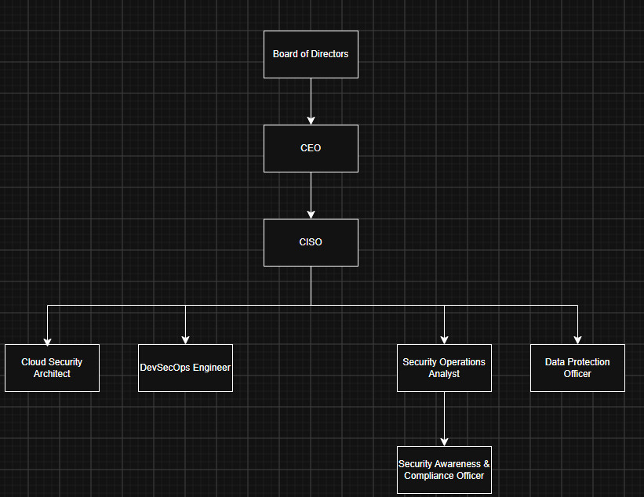
Figure 1

Role Justification

Chief Information Security Officer (CISO)
The CISO will oversee the company's cybersecurity strategy, ensure regulatory compliance and report security risks directly to the Board of Directors. [2]

Cloud Security Architect
This role will design and maintain secure cloud environments. As identified in Task 1, cloud security has become increasingly important due to the growth of hybrid working and cloud-based services.[6][7][9]

DevSecOps Engineer
The DevSecOps Engineer will integrate security into the software development process, ensuring vulnerabilities are identified before systems are deployed. [2][9]

Security Operations Analyst
This role will monitor security alerts, investigate suspicious activity and manage the company's SIEM platform. Continuous monitoring was identified in Task 1 as a key principle of Zero Trust.[1][2]

Data Protection Officer (DPO)
The DPO will ensure compliance with GDPR, manage data protection responsibilities and support the company's expansion into the European Union.[2]

Security Awareness & Compliance Officer
Many cyber-attacks begin through phishing or human error. This role will deliver staff awareness training, maintain security policies and support compliance activities across the business. [5][13]

By creating these specialist roles, Aegis FinTech will be better prepared to implement the Zero Trust principles identified in Task 1 while ensuring security becomes part of everyday business operations. [1][2][10]

Work-Stream 2 – Policy Framework Development

The research completed in Task 1 identified that organisations face increasing risks from cloud services, remote working and third-party suppliers [6][7][9]. To reduce these risks, Aegis FinTech should introduce clear security policies that establish consistent standards across the business. These policies will support the implementation of Zero Trust Architecture while helping the company meet GDPR and DORA compliance requirements.[1][2]

Acceptable Use Policy for AI & Cloud Services
The purpose of this policy is to ensure employees use artificial intelligence tools and cloud services securely and responsibly. Staff should only use AI platforms and cloud applications that have been approved by the IT and Security teams. Company information, financial records and customer data must never be uploaded to unauthorised AI tools or personal cloud storage accounts [2][6]. Access to cloud services should be protected using Multi-Factor Authentication (MFA) and role-based access controls to ensure employees only have access to the systems required for their role [1][7]. The policy should also require regular reviews of user permissions to prevent excessive access rights[1][10]. This recommendation supports the findings from Task 1, which identified identity management and controlled access as key principles of Zero Trust Architecture.[1]

Hybrid Work and Remote Access Security Policy

Hybrid working increases flexibility but also introduces additional security risks because employees regularly access company systems from different locations and devices [7][9]. This policy requires all remote connections to use Zero Trust Network Access (ZTNA) rather than traditional VPN access where possible [1][10]. Only company-managed devices that meet security requirements should be allowed to access business systems [1][7]. Devices must have up-to-date security patches, antivirus software and encrypted storage before access is granted [2][7]. Employees should also complete regular cybersecurity awareness training to help reduce phishing attacks and social engineering risks [2][5]. As discussed in Task 1, Zero Trust continuously verifies users and devices instead of automatically trusting users because they have successfully logged into the network [1].

Third-Party and Cloud Vendor Risk Management Policy

Aegis FinTech relies on cloud providers and external suppliers to support business operations. While these services provide flexibility and scalability, they also introduce additional security risks [6][7]. Before engaging with any third-party supplier, the company should complete a security assessment that reviews the supplier's security controls, compliance certifications and incident response capabilities [2][6]. Suppliers should also demonstrate compliance with GDPR and, where applicable, DORA requirements. Security reviews should continue throughout the contract rather than only during procurement. This includes regular risk assessments, audit rights and monitoring of supplier performance [2][6]. This policy directly supports the findings from Task 1, which identified cloud security and supply chain attacks as significant risks facing modern organisations [6][9][13]. By regularly assessing suppliers, Aegis FinTech can reduce the likelihood of third-party security incidents affecting the business. [2][13]

Work-Stream 3 – Regulatory Compliance Strategy

As Aegis FinTech prepares to expand its services into the European Union, compliance with the General Data Protection Regulation (GDPR) and the Digital Operational Resilience Act (DORA) will become a key business requirement [2]. Failure to comply with these regulations could result in financial penalties, reputational damage and delays to the company's expansion plans [2]. Based on the findings from Task 1, compliance should be treated as an ongoing business process rather than a one-time exercise. To do this, the company should implement a phased compliance roadmap over a 12-month period [1][2].

GDPR and DORA Compliance Roadmap

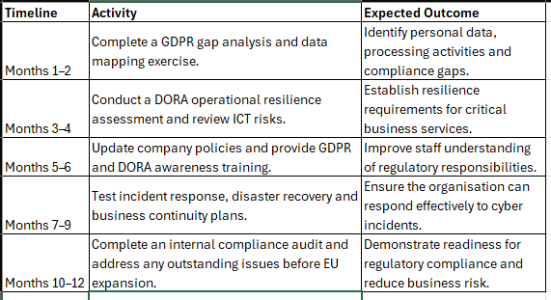
Figure 2

Implementing this roadmap will help Aegis FinTech establish strong governance while supporting its expansion into the European market [2]. The roadmap also reflects the findings from Task 1, which identified governance, continuous monitoring and incident response as essential components of an effective cybersecurity strategy [1][2]. By completing these activities before expansion, the organisation will be better positioned to protect customer data, maintain operational resilience and demonstrate compliance with both GDPR and DORA. [2][13]

Work-Stream 4 – Technical Standards & Architecture

To establish a secure and resilient Information Security Unit, Aegis FinTech should adopt the NIST Cybersecurity Framework (CSF) 2.0 as its primary security framework [2]. The research completed in Task 1 identified that Zero Trust Architecture provides an effective approach to protecting modern organisations against identity-based attacks, cloud security threats and ransomware [1][3][5]. NIST CSF 2.0 complements these findings by providing a structured framework that helps organisations identify risks, protect critical assets, detect threats, respond to incidents and recover from cyber-attacks [2]. NIST CSF 2.0 has been selected instead of ISO 27001 because it provides a practical, risk-based approach that is well suited to a growing fintech company. As Aegis FinTech prepares for EU expansion and future growth, the framework offers flexibility while supporting continuous improvement [2][9]. It also aligns with the company's proposed Zero Trust strategy by promoting continuous monitoring, risk management and governance across the organisation. [1][2]

The technical architecture should follow Zero Trust principles by ensuring every user, device and application is continuously verified before access is granted [1]. Rather than trusting users because they are connected to the company network, access decisions should be based on identity, device health, location and user behaviour [1][10]. This approach reduces the likelihood of attackers moving laterally through the network if a user account becomes compromised. [1][5]

The proposed architecture integrates Identity and Access Management (IAM) with Multi-Factor Authentication (MFA) to verify users before they access company resources[1][7]. Zero Trust Network Access (ZTNA) provides secure application access for employees working both remotely and within the office. Security Information and Event Management (SIEM) and Extended Detection and Response (XDR) continuously monitor activity across endpoints, cloud services and applications to identify suspicious behaviour[2][3]. Cloud Security Posture Management (CSPM) is used to monitor cloud environments for configuration weaknesses, while immutable backups ensure business systems can be recovered quickly following a ransomware attack. [6][7][13]

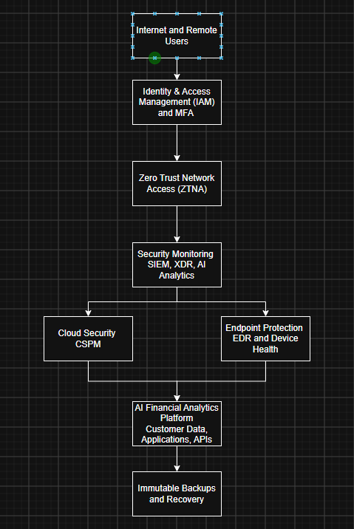
Figure 3

This design directly reflects the research findings presented in Task 1, where Zero Trust was identified as the most suitable security model for protecting cloud-based organisations against modern cyber threats. By combining Zero Trust principles with the NIST Cybersecurity Framework, Aegis FinTech will improve its ability to prevent, detect and respond to cyber incidents while supporting regulatory compliance and future business growth.

Work-Stream 5 – Strategic Risk Assessment

The research completed in Task 1 identified that modern organisations face increasing risks from cloud environments, third-party suppliers and emerging artificial intelligence technologies [3][6][9]. As Aegis FinTech develops its AI-powered financial analytics platform and expands into the European Union, it is important that these risks are identified and managed proactively.[2]
The following risk register identifies the three most significant threats facing the organisation and outlines recommended mitigation strategies.

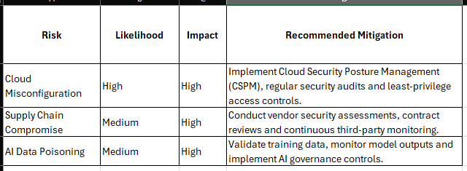
Figure 4
Cloud misconfiguration remains one of the most common causes of data exposure within cloud environments. As discussed in Task 1, organisations increasingly rely on cloud infrastructure, making configuration management and continuous monitoring essential. [6][7]
Supply chain attacks continue to present significant risks, particularly for organisations that depend on third-party software providers and cloud services [3][9]. The SolarWinds incident discussed in Task 1 demonstrated how trusted suppliers can become attack vectors if adequate controls are not implemented. [13]
AI data poisoning represents an emerging threat for Aegis FinTech due to its reliance on artificial intelligence technologies. Attackers may attempt to manipulate training data or influence model outputs, potentially affecting the accuracy of financial analysis and business decision-making [9]. Establishing strong AI governance controls will help reduce this risk. [2]
By regularly reviewing and updating the risk register, Aegis FinTech will be better positioned to identify new threats and prioritise security investments effectively. [2]

Work-Stream 6 – Incident Response & Business Continuity

As identified in Task 1, ransomware continues to be one of the most significant cybersecurity threats affecting organisations, particularly within the financial sector [3][4][5]. A successful ransomware attack could result in the loss of sensitive customer data, disruption to business operations and financial losses [4][13]. To reduce these risks, Aegis FinTech should implement a clear ransomware response playbook that enables the organisation to respond quickly and recover critical systems with minimal disruption. [2][13]

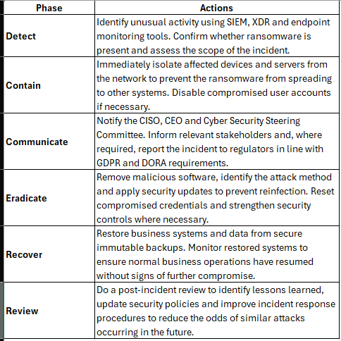
Figure 5

The proposed playbook follows the findings from Task 1, which highlighted the importance of early detection, continuous monitoring and rapid response when dealing with modern cyber threats [1][2]. Using SIEM and XDR technologies allows suspicious activity to be detected more quickly, while immutable backups provide a reliable method of recovering business-critical systems without paying ransom demands. [3][6]

Regular incident response exercises should also be carried out to ensure employees understand their responsibilities during a cyber incident [2]. Testing the playbook through simulated ransomware scenarios will improve the organisation's preparedness and support business continuity as Aegis FinTech continues to expand into the European market. [2][13]

Work-Stream 7 – Governance & Strategic Roadmap

To ensure cybersecurity remains a business priority, Aegis FinTech should establish a Cyber Security Steering Committee. The committee will provide strategic direction, monitor security performance and ensure cybersecurity supports the company's business objectives [2]. Regular meetings will allow senior management to review risks, monitor compliance and make informed decisions regarding future security investments. [2]

Proposed Cyber Security Steering Committee

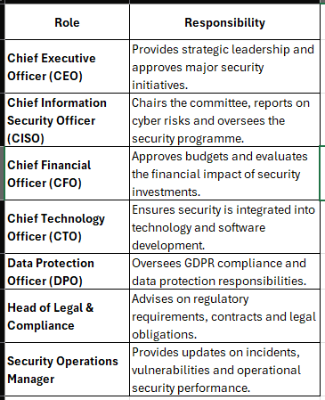
Figure 6

The committee should meet monthly to review cyber risks, monitor project progress and ensure security remains aligned with business objectives [2]. Additional meetings should be held following any significant cybersecurity incident. [2][13]

12 month Strategic Roadmap

The following roadmap outlines the proposed implementation plan for establishing the new Information Security Unit. I used online Gantt Chart to create the below chart

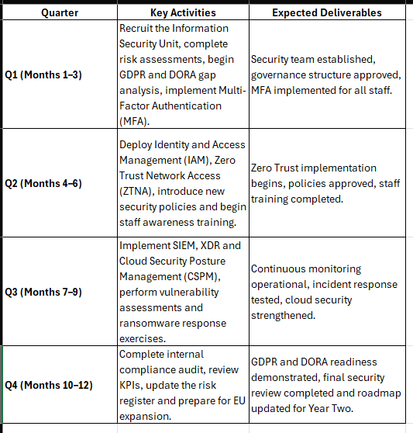
Figure 7

Figure 8

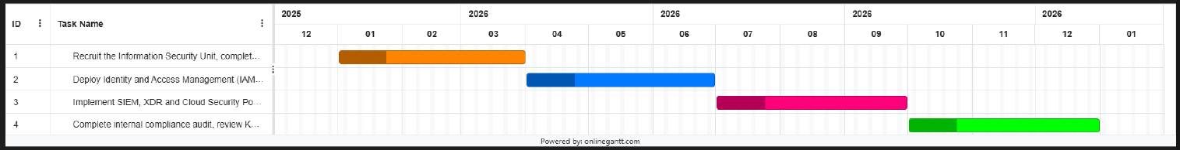
Figure 9

Key Performance Indicators (KPIs)

The success of the Information Security Unit should be measured using clear and achievable Key Performance Indicators (KPIs). These measures will allow senior management to monitor progress and identify areas requiring further improvement. 2[]

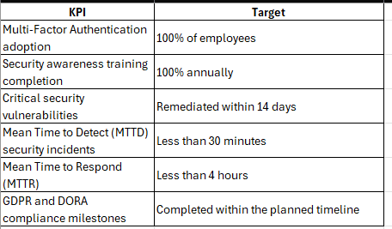
Figure 10

The priorities within this roadmap are based directly on the findings from Task 1. Zero Trust Architecture was identified as the most effective approach for protecting modern organisations against evolving cyber threats [1][10]. Therefore, the first phase of implementation focuses on strengthening identity management, governance and access controls before introducing advanced monitoring technologies and completing regulatory compliance activities [1][2]. This phased approach reduces implementation risk while providing a clear pathway towards a resilient and secure operating environment. [10][11]

Conclusion

The proposed Information Security Unit provides Aegis FinTech with a practical and structured approach to strengthening its cybersecurity capabilities while supporting future business growth. By adopting the recommendations outlined in this proposal, the organisation will improve its ability to prevent, detect and respond to cyber threats while meeting the regulatory requirements associated with expansion into the European Union. [2]
The proposal has been developed using the research findings from Task 1, where Zero Trust Architecture was identified as the most effective approach for protecting modern cloud-based organisations [1][10]. The recommended organisational structure, policies, technical architecture and implementation roadmap all support the principles of continuous verification, least-privilege access and proactive risk management [1][2]. Overall, implementing these recommendations will help Aegis FinTech build a resilient Information Security Unit capable of protecting business operations, maintaining customer trust and supporting long-term organisational success. [2][13]

References

[1] National Institute of Standards and Technology (NIST), Zero Trust Architecture (SP 800-207), Gaithersburg, MD, USA, 2020.
https://csrc.nist.gov/pubs/sp/800/207/final

[2] National Institute of Standards and Technology (NIST), Cybersecurity Framework (CSF) 2.0, 2024.
https://www.nist.gov/cyberframework

[3] IBM, X-Force Threat Intelligence Index 2024.
https://www.ibm.com/reports/threat-intelligence

[4] IBM, Cost of a Data Breach Report 2024.
https://www.ibm.com/reports/data-breach

[5] Verizon, 2024 Data Breach Investigations Report (DBIR).
https://www.verizon.com/business/resources/reports/dbir/

[6] Amazon Web Services, AWS Well-Architected Framework – Security Pillar.
https://docs.aws.amazon.com/wellarchitected/latest/security-pillar/welcome.html

[7] Microsoft, Azure Security Documentation.
https://learn.microsoft.com/en-gb/azure/security/

[8] Alshamrani, A., Myneni, S., Chowdhary, A. and Huang, D., "A Survey on Advanced Persistent Threats: Techniques, Solutions, Challenges and Research Opportunities,"

[9] Gartner, “Gartner Identifies the Top Cybersecurity Trends for 2024. February 22nd 2024

[10] C. Buck, C. Olenberger, A. Schweizer, F. Völter and T. Eymann, "Never Trust, Always Verify: A Multivocal Literature Review on Current Knowledge and Research Gaps of Zero-Trust," Computers & Security, vol. 110. DOI: 10.1016/j.cose.2021.102436

[11] N. Syed, S. Shah, A. Shaghaghi, A. Anwar, Z. Baig, R. Doss. DOAJ. “Zero Trust Architecture (ZTA): A Comprehensive Survey. January 2022. Vol. 10. DOI: 10.1109/access.2022.3174679

[12] N. Ngema, B. Nleya, R. Maswanganyi “A Review of Zero Trust Architecture: Principles, Applications, and Implementation Challenges in Communication, Navigation, and Surveillance (CNS) Systems” published June 15th 2026. DOI: 10.3390/s26123813

[13] J. Easterly - Cybersecurity and Infrastructure Security Agency (CISA) “The Attack on Colonial Pipeline : What We’ve Learned & What We’ve Done Over the Past Two Years” May 7th 2023
https://www.cisa.gov/news-events/news/attack-colonial-pipeline-what-weve-learned-what-weve-done-over-past-two-years

[14] National Cyber Security Centre. SolarWinds November 17th 2021
https://www.ncsc.gov.uk/collection/ncsc-annual-review-2021/the-threat/solarwinds

