

Module code: LCMB7024
Module: Marketing Management
Assignment Title: Assessment Component 2: Marketing Strategies Portfolio

Lecturer’s Name: Dr Laila Maazouz

Student Name: Sadrakar Om Prakashbhai

Student ID: 2526083

Table of Contents
Element 1 3
Element 2 4
Element 3 6
Element 4 9
References 11

Element 1
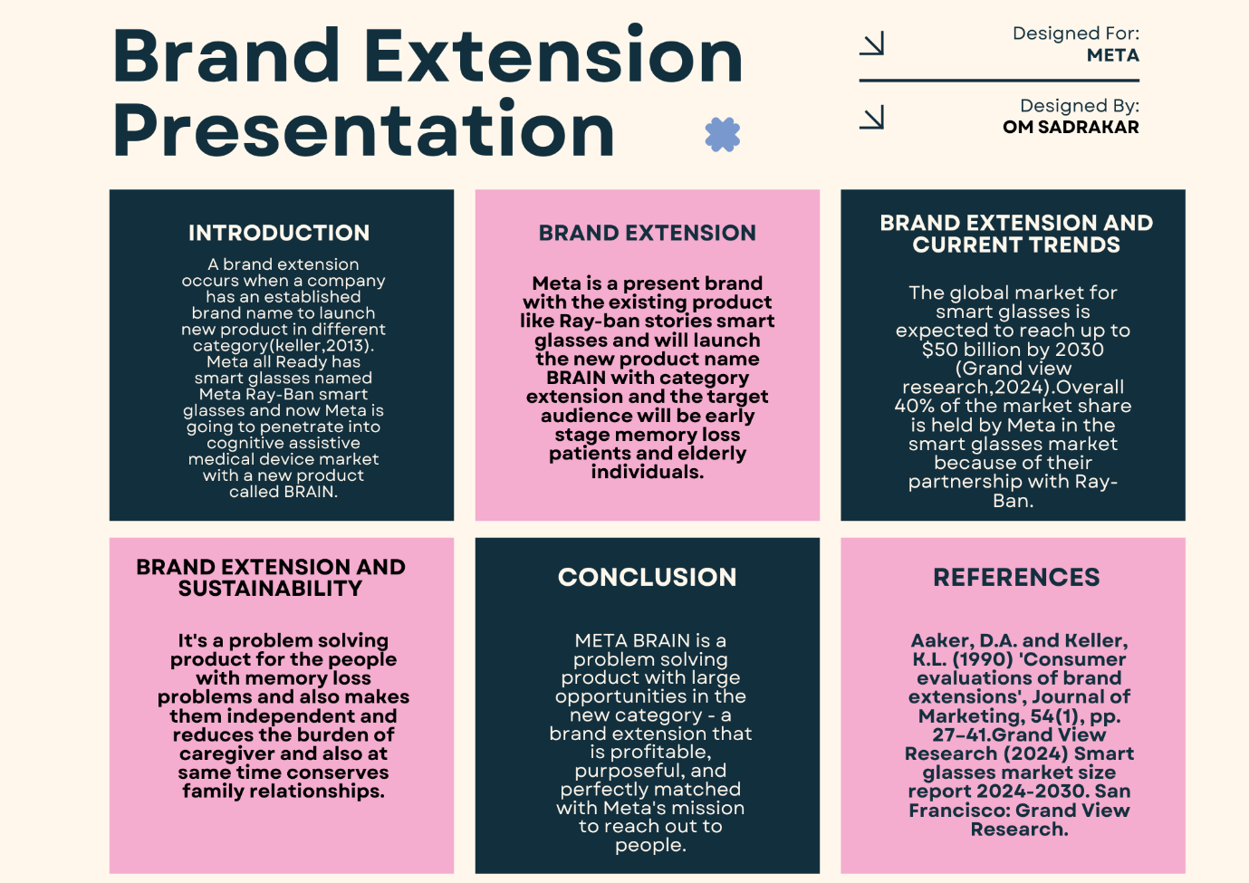

Element 2
Segmentation, Targeting, Differentiation, and Positioning (STDP) Analysis
(Brand Extension: Beyond Meat Ready-to-Cook Plant-Based Meal Kits)
1. Segmentation
It needs a properly planned segmentation approach to be in line with the changing demand of consumers in the plant-based food market. According to a framework presented by Philip Kotler, the segmentation is analysed in terms of geographic, demographic, psychographic, and behavioural variables (Marcelo et al. 2024). Urban and semi-urban markets in developed and emerging economies like the UK, the US, and metropolitan India are a priority of geographic segmentation. These areas are more conscious of sustainability and more exposed to the modern retail and digital environment. Time constraints and the growing demand for convenient meal solutions can also be observed among urban consumers. This, however, narrows down coverage in the rural areas where price sensitivity is a major constraint. The millennials and Gen Z demographics (ages 20-40) are targeted by demographic segmentation, especially middle- and high-income employees. This segment has more disposable income and is more open to paying for premium and ethical food decisions (Matnin, 2025). However, a narrow focus on this group of consumers can be detrimental to considering more senior consumers who are moving towards increased consumption of plant-based foods because of health considerations.
Psychographic segmentation is essential as it is aimed at individuals who are environmentally conscious, health-motivated, and ethically motivated. There is a strong fit between these consumers and the sustainability-focused identity of Beyond Meat. Nevertheless, the psychographic characters may be dynamic and immeasurable, and in such a case, long-term segmentation will be less foreseeable. Behavioural segmentation focuses on flexitarian consumers who still cut meat, but do not completely give up on meat (Verain et al. 2022). There is convenience, taste parity, and perceived health benefits that propel their choices.
2. Targeting
A differentiated targeting approach would be the most appropriate, with most attention paid to urban flexitarian professionals in their 30s and 40s (millennials) and Gen Z workers. Ideal targeting must have corresponding strengths of the brands and targets, as pointed out by Kevin Lane Keller. The following target audience can be described through the following characteristics: it is active in its life, has a moderate to high income, is digital, and has a growing interest in sustainability and health (Thomas and George, 2021). They are best suited to this type of ready-to-cook meal kit due to their preference for convenient, but high-quality, food solutions. Furthermore, flexitarians are a larger and more expandable market than the targeted vegan segments. Nevertheless, this method has its drawbacks. High-end pricing might lock out cost-sensitive customers, especially within emerging markets. Also, an overemphasis on urban consumers might limit expansion to broader mass markets. To overcome this, the plan ought to be progressive to similar segments, like the health-conscious family, which guarantees expansion without constituting brand dilution (Qin et al. 2021).
3. Differentiation
Separating itself is essential to a competitive advantage in a mature plant-based market. By relying on Michael Porter, Beyond Meat will have to compete in terms of unique value instead of cost effectiveness.
The differentiation of the brand extension is based on four aspects:
Product innovation: While the competitors propose standalone products only, Beyond Meat meal kits are composed of ingredients, recipes, and convenience, thereby improving the user experience and decreasing the effort required to prepare their products (Agustian et al. 2025).
Sustainability leadership: Eco-friendly packaging and ethical sourcing help the brand solidify its environmental presence, enhancing emotional consumer relationships.
Taste and quality: The technological ability of Beyond Meat to recreate the flavour and feel of meat is a solution to one of the primary adoption obstacles, which will be a massive benefit.
Brand equity: Since it is a pioneer in the market, Beyond Meat has good credibility and trust that can be distinguished from itself and new entrants or major corporations that are viewed as less authentic. Although high differentiation makes production costs high, this can affect price competitiveness (Hengyu et al. 2026). Striking a balance between innovation and affordability is thus needed to ensure success in the long term.
4. Positioning
Positioning indicates the perception of the brand extension against competitors. Clarity and consistency are two crucial elements in effective positioning, as expressed by Al Ries.
The suggested positioning statement is:
“Beyond Meat Meal Kits: convenient, sustainable, and premium plant-based meals for modern lifestyles.”
The first two emphasise convenience in time-starved consumers, environmental friendliness and sustainability, and high quality in providing a high-quality experience. It is an evident distinction of the brand from the standard of meal kits with no plant emphasis, low-priced ones, and the huge competitors in the market, with the primary emphasis on prices (Qin et al. 2021). However, there are risk factors associated with premium positioning, such as poor accessibility and exposure to price wars.

Element 3
Marketing Mix (4Ps) – Beyond Meat Ready-to-Cook Meal Kits
The marketing mix is a series of manageable tactical instruments that organisations apply to impact the consumer response and attain strategic goals (Niazi et al. 2021). The success of the marketing mix is the integration of the other aspects of the marketing mix, where the benefits of a particular element support the total value creation (Karim et al. 2021). In the case of Beyond Meat's extension of its brand, which is a line of ready-to-cook plant-based meal kits, the 4Ps have to collectively underscore a high price, sustainable, and convenience-driven positioning.
1. Product Strategy
The focus of delivering differentiation and value lies in the product element. The meal kits at Beyond Meat expand the services of the company, offering new options in a standalone form of plant-based products but wholesome meals, combining ingredients, recipes, and convenience. This is in line with the concept of an augmented product envisaged by Levitt, whereby the value of the product is not solely the product itself but encompasses other aspects of the product, like ease of use and experience. The meal kits are meant to curb major pain points of the consumers, namely time limitations, lack of cooking skills, and the willingness to have healthier options. The product makes cognitive and physical exertions less by providing pre-measured ingredients and recipes, thus improving perceived value (Arshad et al. 2025).
More importantly, the product strategy utilises the brand extension theory that can be used to help Beyond Meat leverage its existing equity as it gets into an adjacent category. This will present risk as well; in case the meal kits cannot live up to the expectations, then this would dilute the reputation of the parent brand. Also, alternative products like meal kit companies and plant brands can copy the products, eroding differentiation in the long run.
2. Pricing Strategy
Pricing is strategically important in the signalling value and positioning (Ali and Anwar, 2021). Beyond Meat has a premium positioning as a brand, and the meal kits are likely to be priced on the basis of value, with prices dependent on the perceived value, and not the cost of production. According to Putra et al. (2021), this is compliant with a differentiation strategy where the firms fetch a higher price with distinctive value. The high price of meal kits is explained by several considerations: convenience, sustainability, quality of ingredients, and brand name. The target market, being urban and health-conscious professionals are not as price-sensitive; they will be prepared to pay more for ethical and convenient solutions.
However, there are difficult challenges that are involved in this approach. The prices are too high, and this can decrease penetration within the market, especially in the emerging economies, where affordability excludes a major aspect. Moreover, big players like Nestle will have an advantage of lowering costs through economies of scale to provide lower-priced options, aiding in increasing price competition. In that regard, Beyond Meat can implement a system of pricing by tiers, differentiating its users into various price categories through different product variations. Promotions, discounts, and packages can also increase what is perceived, without damaging the image of the premium (Jabbour Al Maalouf et al. 2026). Finally, pricing has to be on the middle ground of profits and affordability to make it grow in the long-term.
3. Place (Distribution) Strategy
A place is where the product is distributed to the consumers. In the case of Beyond Meat meal kits, a multi-channel distribution approach is essential to reach the greatest number of people at the highest convenience. This involves the use of direct-to-consumer (DTC) online, online partnerships with e-commerce stores, and a selective presence in supermarkets (McKee et al. 2023). The DTC model enables Beyond Meat to have more control over the customer experience, gather important data about the consumers, and establish better relationships. The integration of e-commerce fits the online behaviour of the target population, thus allowing hassle-free ordering and delivery (Dam and Dam, 2021).
Strategically, this means that it has a significance of channel integration, making it consistent in its touchpoints. Nevertheless, operating several channels may result in channel complexity and channel conflict. As an example, differences in prices between online and retail stores can result in consumer dissatisfaction. In addition, logistical issues, like preserving the product and delivering it effectively, are important in the meal kit sector. Limitations in distribution may have a direct effect on brand perception and customer satisfaction (McKee et al. 2023). So, Beyond Meat needs to invest in the incorporation of efficient supply chain management and alliances to make sure it can be reliable and scaled.
4. Promotion Strategy
Promotion involves the communication plans addressing information, persuasion, and involvement of the consumers (Czinkota et al. 2021). In the case of Beyond Meat, its activities should be promoted as a high-quality, environmentally friendly, and innovative brand. Building customer-based brand equity requires very strong brand communication, as highlighted by Kevin Lane Keller. This is why the idea of a digital-first promotion strategy, in particular, through such promotion instruments as social media, influencer marketing, and content marketing, is applicable. Partnerships with health, fitness, and sustainability influencers can boost credibility and reach. But promotion strategies should not be overly dependent on sustainability messages. Sustainability might no longer be a business-strong differentiator as the market becomes saturated. Rather, a mix of taste, convenience, and lifestyle benefits should be the focus of communication (Kehinde et al. 2024). Moreover, excessive use of promotions can affect the profitability when the product is in the initial lifecycle. Thus, Beyond Meat will need to implement a more strategic and targeted approach, emphasising high-impact channels and outcomes.
Conclusion
The 4P of the marketing mix of Beyond Meat meal kit is highly related and aligned with the marketing mix, which helps in achieving its brand extension strategy. Convenience and innovation are fulfilled through the product, premium positioning is strengthened through pricing, accessibility and efficiency can be achieved through distribution, and awareness and emotional engagement through promotion. But the success of such a strategy lies in finding the balance between these aspects: differentiation and affordability, innovation and consistency, reach and control.

Element 4
Reflection
1. Reflection on Developing the Brand Extension
When designing the Beyond Meat meal kit extension, I came to realise that the process of translating the marketing theory to the real world is much more complicated than it seems in the textbooks. At the beginning, I tackled the task in a systematic manner, applying frameworks and models, such as STDP and the marketing mix. Nevertheless, later on, I realised that every choice was invariably related, and I had to assess it critically. As an illustration, the decision to market the product as high quality corresponded with the brand, yet it also brought about the question of affordability and market accessibility. I also realised that branding consistency is important. Dupraz et al. (2025) state that a successful brand extension should coincide with the existing brand equity but develop a new relevance. This concept made me make sure that the extension was true to my Beyond Meat sustainability-focused positioning.
2. Reflection on Poster Preparation and Presentation
Creating and presenting the poster presentation has been an illustrious but demanding experience. It was also hard to fit the comprehensive analysis into a well-reduced format that should be not only concise but also visually pleasing. This made me focus on the most important points and express them effectively, and not lose the richness of my arguments. Through it, I came to understand that good communication does not only depend on what one says, but also on how they present it.
I realised more about the significance of being confident and clear during the presentation. The process of explaining my ideas to people made me have to really comprehend my work and provide acceptable reasons. I was also required to improvise when answering questions, and this served to enhance my flexibility. In this experience, it was made clear that effective communication abilities are crucial in the workplace, particularly when making strategic proposals. I also got to know the value of visual communication. The information has been made easier to comprehend and more appealing through a well-constructed poster. According to Edward Tufte, a good visual design must promote clarity and minimise complexity. This added further weight to the value of simplicity and organisation in the presentations. This experience, in general, reinforced my presentation and communication skills.
3. Skills, Learning, and Future Improvements
The project has greatly helped me to develop analytical and critical thinking skills. I went further than explaining marketing theories and assessing their usefulness and restrictions in the actual world. My perception of consumer behaviour, competition strategy, and positioning of a brand also improved. The lessons learned are very applicable in my future profession, especially in the field of marketing and business strategy. Another learning area was time management. Although I managed to work on the project successfully, it occurred to me that I was a bit late in beginning the project, which could have been nurtured with more time on the revision. In the future, I will focus more on developing deeper research, including more real-world information and industry knowledge.

References
Agustian, A.M., Bakhri, S. and Faozi, M.M., 2025. STP Analysis (Segmenting, Targeting, Positioning) and SWOT Analysis in Digital Marketing Strategies Infacing Business Competition at BT Batik Trusmi Cirebon. Journal on Islamic Economics, Finance & Banking [Z-CONOMICS], 1(2).
Ali, B.J. and Anwar, G., 2021. Marketing Strategy: Pricing strategies and its influence on consumer purchasing decision. Ali, BJ, & Anwar, G.(2021). Marketing Strategy: Pricing strategies and its influence on consumer purchasing decision. International journal of Rural Development, Environment and Health Research, 5(2), pp.26-39.
Arshad, M.T., Maqsood, S., Ikram, A. and Abdullahi, M.A., 2025. Functional, nutraceutical, and health‐endorsing perspectives of ashwagandha. eFood, 6(3), p.e70061.
Czinkota, M.R., Kotabe, M., Vrontis, D. and Shams, S.R., 2021. Designing effective promotion and advertising strategies. In Marketing Management: Past, Present and Future (pp. 553-606). Cham: Springer International Publishing.
Dam, S.M. and Dam, T.C., 2021. Relationships between service quality, brand image, customer satisfaction, and customer loyalty. The Journal of Asian Finance, Economics and Business, 8(3), pp.585-593.
Dupraz, S., Nakamura, E. and Steinsson, J., 2025. A plucking model of business cycles. Journal of Monetary Economics, 152, p.103766.
Hengyu, L., Jiahe, M., Tana, G. and Junwu, C., 2026. Is entering the low-end market better? The implication of managing out-of-season product with pricing strategies. Journal of Retailing and Consumer Services, 90, p.104650.
Jabbour Al Maalouf, N., Freiha, S., Hanna, J., Sfeir, L. and Sawaya, C., 2026. From discounts to decisions: the mediating role of brand image in price promotions during turbulent times. Cogent Business & Management, 13(1), p.2644549.
Karim, R., Latip, N.A., Marzuki, A., Haider, S., Nelofar, M. and Muhammad, F., 2021. The impact of 4ps marketing mix in tourism development in the mountain areas: A case study. International Journal of Economics and Business Administration, 9(2), pp.231-245.
Kehinde, S., Bankole, O., Moses, C., Borishade, T., Kehinde, O., Simon-Ilogho, B. and Kehinde, K., 2024. Effective sales promotion: A necessary catalyst for elongating the product life cycle in a developing economy. International Journal of Advances in Social Sciences and Humanities, 3(1), pp.1-7.
Marcelo, J., Maliwat, M.C. and Salacata, I.D.S., 2024. Kotler’s decision-making model as a predictor of the consumer buying behavior of young professionals in the Philippines. International Journal of Marketing and Digital Creativity, 2(1), pp.59-70.
Matnin, M., 2025. Integrated Implementation of Marketing Mix, Market Segmentation, and Trust in Third-Party Funds Mobilization Strategy at KSPPS NURI Pegantenan. Dinamika: Jurnal Studi Kepesantrenan dan Keislaman, 3(02), pp.86-96.
McDougal, E.R., Syrdal, H.A., Gravois, R., and Kemp, A., 2025. Telling the tale: Applying a strategic brand storytelling process for STP planning. In Strategic Brand Storytelling (pp. 105-125). Routledge.
McKee, S., Sands, S., Pallant, J.I. and Cohen, J., 2023. The evolving direct‐to‐consumer retail model: A review and research agenda. International Journal of Consumer Studies, 47(6), pp.2816-2842.
Niazi, N., Rashid, M. and Shamugia, Z., 2021. Role of marketing mix (4Ps) in building brand equity: case study of shell petrol, UK. International Journal of Applied Business and Management Studies, 6(1), p.2021.
Putra, F.R., Abdillah, R. and Putri, K.T., 2021. Understanding Strategic Initiatives Contributing to The Implementation of Cost Leadership and Differentiation Strategy to Achieve Competitiveness: A Case Study of Indonesia’s Cement Industry. In Proceedings of the 4th European International Conference on Industrial Engineering and Operations Management (pp. 2-5).
Qin, T., Hong, X., Chen, R., Zha, J. and Shen, J., 2021. Evaluating environmental impact of STP effluents on receiving water in Beijing by the joint use of chemical analysis and biomonitoring. Science of The Total Environment, 752, p.141942.
Thomas, M.R. and George, G., 2021. Segmenting, Targeting, and Positioning (STP) of GenerationalCohorts Y, Z and Alpha. IIMS Journal of Management Science, 12(2), pp.115-129.
Verain, M.C., Dagevos, H. and Jaspers, P., 2022. Flexitarianism in the Netherlands in the 2010s: Shifts, consumer segments, and motives. Food Quality and Preference, 96, p.104445.

