Title：Can Graphic Design Save Your Life?

Explore the association of well-being and personal growth in design. In your discussion focus on a maximum of three specific areas.

Student Number：2405595 Ai Zhang
BA course title：Graphic design
Word count：2518
Lecturer's name: Donna

For this assessment, I confirm that I have NOT used Generative AI to support me in structuring my submission, including creating a draft argument structure, identifying parts and headings.
I confirm that I have not used Generative AI to create text for my submission. I confirm that I have not used Generative AI for creative materials, such as images
Table of Contents
List of Illustrations .................................................................................. pg. 4
List of Supporting Illustrations............................................................ pg. 4-5
thesis statement .......................................................................................pg. 5
Introduction............................................................................................pg. 5-7
1.Semiotics, Color, and Emotional Meaning...........................................pg. 7
1.1 Color as a Signifier.........................................................................pg. 7-10
1.2 Spatial Narrative and Bodily Experience......................................pg. 10-13
2.Well-being: From Individual to Community..................................pg. 13-15
3.Graphic Design: Emotional Support & Cultural Meaning.................pg. 15
3.1 Emotional Impact of Public Installations.......................................pg. 15-17
3.2 Comparative Cases: Visual Language of Positive Emotion...............pg. 17
4. Personal Growth through Design Participation...............................pg. 17
4.1 Reconsidering the Role of the Designer............................................pg. 18
4.2 Ethical Considerations Behind Joy...............................................pg. 18-19
Conclusion.............................................................................................pg. 19
References........................................................................................pg. 20-21
Bibliography.......................................................................................pg. 22-23
Supporting imagery...........................................................................pg. 24-27

List of Illustrations：
Figure 1. Alegra, installation view by Morag Myerscough, 2022.
Figure 2. Temple of Agape, installation view by Morag Myerscough, 2014.
Figure 3. Joy Garden, installation view by Morag Myerscough, 2021.
List of Supporting Illustrations：
Figure 4. Heads Together campaign posters and promotional materials (British Royal Family, n.d.). [Online]. Available at: https://www.headstogether.org.uk (Accessed: 30 November 2025).
Figure 5. You Are Enough, poster by Lisa Condon (n.d.). [Online]. Available at: https://lisacongdon.com/products/you-belong-here-art-print?utm_source=chatgpt.com (Accessed: 30 November 2025).
Figure 6. Airbnb – Belong Anywhere, visual identity (Airbnb, n.d.). [Online]. Available at: https://design.studio/work/airbnb (Accessed: 30 November 2025).
Figure 7. The Refugee Nation Flag, designed for the Refugee Olympic Team (Yara Said, 2016). [Online]. Available at: https://yara-said.com/The-Refugee-Nation-Flag?utm_source=chatgpt.com (Accessed: 30 November 2025).
Figure 8. Love Has No Labels Campaign (Ad Council, 2015–). [Online]. Available at: https://lovehasnolabels.com (Accessed: 30 November 2025).
Figure 9. The Noun Project, global icon library (Ongoing since 2010). [Online]. Available at: https://thenounproject.com (Accessed: 30 November 2025).
Figure 10. We Belong to Something Beautiful, Sephora campaign (2019). [Online]. Available at: https://www.prnewswire.com/apac/news-releases/sephora-adopts-a-global-brand-signature--we-belong-to-something-beautiful--302080996.html?utm_source=chatgpt.com (Accessed: 30 November 2025).
thesis statement
This essay examines how the public installations created by Morag Myerscough demonstrate the potential for graphic design to support emotional well-being and encourage personal growth. Drawing on concepts from emotional design and selected ideas from semiotic theory, the essay argues that Myerscough’s use of colour, spatial composition，and participatory making transforms graphic design into a powerful form of emotional care. Her works not only offer a moment of visual pleasure within the city，but also construct alternative ways of understanding everyday environments by reshaping the cultural meanings attached to colour, form and shared space. Ultimately, this essay suggests that Myerscough’s practice strengthens the emotional connection between individuals and their surroundings and that this sense of connection has the capacity to cultivate a deeper feeling of belonging within contemporary communities.
Introduction

In contemporary visual culture, graphic design has long surpassed its ordinary decorative function and has gradually become an essential means of shaping how we perceive the world. It is not merely a tool for commercial communication; through its unique visual language, color, form, and spatial composition engages in deep emotional dialogue with us. As Hall (1997) noted, systems of meaning organize our behaviors and influence how we understand ourselves and our environment. From this perspective, graphic design effectively creates a visualized emotional map, guiding our feelings, evoking resonance, and subtly redefining our relationship with our surroundings.

This study explores whether graphic design can “save lives.” This is not meant in the literal biomedical sense, but rather in terms of emotional stabilization, psychological resilience, and social belonging. To examine this question, this paper takes the works of British designer Morag Myerscough as a case study. She is internationally renowned for her large-scale, brightly colored public installations, which transform urban environments into spaces filled with collective joy, empathy, and participation. Her works are particularly suitable for this study because they operate aesthetically, emotionally, and intellectually: they provide sensory pleasure, stimulate community interaction, and transform monotonous urban landscapes.

This paper employs semiotic theory, design research, and design psychology to analyze how Myerscough uses color, form, and spatial composition to construct a positive symbolic language. Her installations are not merely visual artworks but are considered catalysts for guiding viewers’ internal identification processes. Through an analysis of Myerscough’s works, supplemented by cases such as The Happy Newspaper, this study aims to illustrate an emerging trend in design: graphic design is increasingly acting as a resource for positive emotion and cultural engagement in contemporary society. Ultimately, this paper argues that such designs not only enhance individual well-being but fundamentally reshape the way we perceive the world, providing significant potential for creating a public life that is more resonant and emotionally rich.

- Semiotics, Color, and Emotional Meaning

  - Color as a Signifier

Semiotics provides a highly instructive framework for analyzing Myerscough’s work, especially her use of color. Color itself does not carry fixed emotional codes; its power lies in the resonance accumulated through collective memory and cultural narratives over time. When a particular hue is repeatedly used in celebrations, nature, or specific cultural contexts, it gradually acquires deep meanings beyond the purely visual, leaving a lasting impression on people.
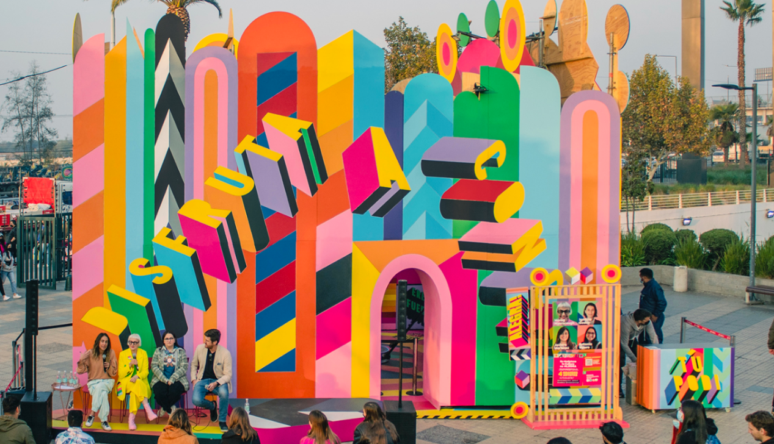
Figure 1. Alegra, installation view by Morag Myerscough, 2022.

Morag Myerscough is a master of harnessing this language of color. Her signature combination of highly saturated neon colors and bold geometric patterns ( Figure 1) constitutes a vibrant visual declaration. This combination goes beyond mere aesthetic choice; it is a direct form of emotional expression, conveying unrestrained joy, exuberant vitality, and an open invitation for social interaction.

More importantly, Myerscough’s practice of color carries clear cultural intent. By systematically introducing these intensely celebratory colors—often associated with specific contexts—into everyday public spaces, she performs a cultural act in itself. This disrupts the conventional expectation that public environments must remain neutral or serious, establishing joy as a significant and legitimate urban value. Consequently, her works do more than beautify spaces; they create a new spatial meaning in which positive emotions are allowed to flourish, and shared pleasure becomes an invisible bond connecting people with each other and with their surroundings.

This aligns with Barthes’ concept of myth (Barthes, 1972, p. 39), in which everyday signs are transformed into carriers of ideological meaning. Myerscough’s installations convert color into a “myth of joy,” emphasizing that the enhancement of emotion is not marginal to city life but an indispensable element. This not only significantly elevates people’s positivity toward life but also contributes to society in a meaningful way. Her work challenges the mainstream ideology that public spaces should be defined by seriousness and order. Instead, she introduces a system of signs in which exuberance is normalized and shared joy becomes a civic necessity.

Analyzing this visual language deepens our understanding of color as a tool rather than a mere decorative element. Myerscough’s works demonstrate how color can serve as a “map of meaning,” as Hall (1997, p. 21) describes—a system that guides interpretation and constructs experience. This perspective encourages a reevaluation of my own creative practice, prompting reflection on how color choices can influence the emotional lives of audiences and how one’s own work might similarly serve as a tool for shaping feelings.

  - Spatial Narrative and Bodily Experience
Morag Myerscough’s works redefine the interaction between graphic design and viewers through a unique approach to spatial narrative. Her creations break the two-dimensional confines of traditional graphic design, liberating visual elements from static surfaces to construct vibrant three-dimensional experiential spaces. This shift in design philosophy not only expands the expressive possibilities of graphic design but also transforms the way people perceive and engage with art.
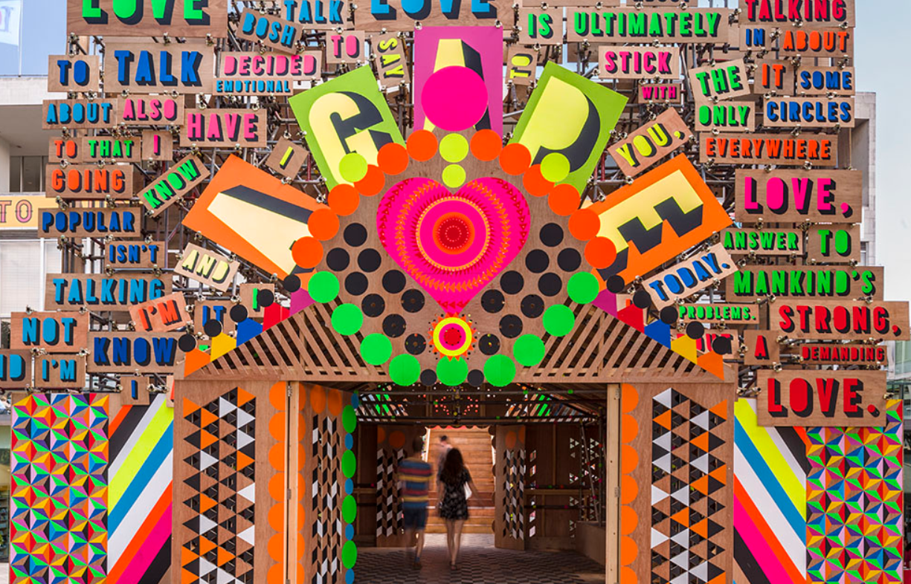Figure 2. Temple of Agape, installation view by Morag Myerscough, 2014.
In Temple of Agape ( Figure 2), Myerscough cleverly distributes color, text, and geometric forms across different spatial dimensions. Viewers must physically enter the vibrant structure, moving, turning, and looking upward to gradually uncover entirely distinct layers of visual information. This strategy creates a unique spatiotemporal experience: as viewers change positions within the space, visual elements continuously reorganize, forming a dynamic visual rhythm. The meaning of the work is no longer pre-assigned; it is actively constructed and discovered through the viewer’s exploration.
The sophistication of this approach lies in shifting the focus of design from visual presentation to experiential design. By controlling the sequence and spatial arrangement of visual elements, Myerscough skillfully guides the emotional rhythm of viewers. Sudden appearances of vivid color blocks around a corner, or floating text revealed upon looking up, become crucial narrative nodes, generating surprise, anticipation, and discovery. This approach resonates with phenomenological theory, emphasizing the centrality of the body in the cognitive process (Merleau-Ponty, Phenomenology of Perception, 1962).
Further analysis shows that this spatial design strategy embodies the concept of “embodied cognition” in environmental psychology (Ingold, The Perception of the Environment, 2011). As viewers move through the installation, their bodily actions continuously interact with the spatial environment, intertwining visual information with physical perception to create a unique spatial experience.
From a semiotic perspective, Myerscough’s spatial design expands the representational capacity of visual signs (Chandler, Semiotics: The Basics, 2017). In her works, elements such as color and shape carry not only traditional symbolic meanings but also acquire new dimensions through spatial positioning. For example, a red circle appearing in different parts of a space may signify warning, welcome, or emphasis, and its specific meaning must be interpreted through the viewer’s exploration of the environment.
This innovative design philosophy transforms graphic design from a passive visual communication tool into an active creator of spatial experience. The designer’s role evolves from an information arranger to a curator of experiences. In this process, viewers are no longer passive recipients; they become co-creators of meaning, completing the work through their own actions and engagement.
Myerscough’s approach to spatial narrative offers a highly instructive paradigm for contemporary design. It reminds us that excellent design is not solely about visual aesthetics but also about creating immersive experiences. In this sense, design becomes a creative dialogue between designer and user, generating continuous meaning and emotional resonance through carefully orchestrated spaces. This shift signifies that graphic design is moving from mere visual decoration toward a more inclusive and interactive field of experiential design.

- Well-being: From Individual to Community

Myerscough’s works, with their distinctive public character, clearly demonstrate how design can systematically articulate urban well-being: first by guiding and shaping individual positive spatial experiences, and then by fostering emotional connections and social belonging at the community level. Her often-quoted phrase, “Make the people around you happy, and those far away will naturally come” (Myerscough, 2018), is far more than a casual slogan. It embodies the core of her design philosophy, elevating “joy” from a transient emotional response to a conscious value choice and ethical principle in design.

At the individual level, her design acts as a sensory emotional navigator. Through high-saturation color matrices and visually rhythmic symbols, Myerscough directly and powerfully stimulates the viewer’s sensory system, instantly evoking pleasure and excitement. Moreover, through asymmetrical, walk-through, and exploratory spatial structures, she transforms static observation into dynamic “parading.” This tangible interaction ensures that positive emotions arise not merely from visual reception but from bodily exploration and discovery within the space. As design theorist Donald Norman (2004) emphasizes in Emotional Design, behavioral-level design can generate feelings of achievement and control. Myerscough’s works achieve this by guiding viewers’ physical actions, allowing them to become co-creators of meaning during the exploration process.

However, the true depth of Myerscough’s design lies in its transcendence of personal emotional impact, moving toward the collective construction of community well-being.

At the communal level, the resulting sense of happiness largely stems from the process of “co-creation” itself. In Temple of Agape and many of her community projects, local residents—including children and the elderly—are invited to paint portions of the color blocks or components themselves. This transforms the work from a pristine visual object, intended only for observation, into a collective artwork bearing the memories and labor of a social group. This practice aligns with the core principles of participatory design (Schuler & Namioka, 1993), which emphasize transforming users from passive recipients into active collaborators.

This approach has deep implications. Excellent public design is never merely a unilateral expression of the designer’s talent; it is a social practice that stimulates interaction and facilitates dialogue. When participants invest their time, labor, and emotions in a public project, their relationship with both the work and the surrounding space fundamentally changes—from detached observers to intimate co-creators. They do not merely consume the final, pleasurable visual experience; they cultivate social bonds and psychological belonging through shared creative activity.

Thus, the “joy” advocated by Myerscough extends far beyond the superficial decorative purpose often associated with commercial design. It embodies a profound idea: on a micro level, it is a deliberate intervention to respond to and reshape the emotional states of urban individuals, providing essential emotional buffering and energy replenishment; on a macro level, it actively promotes social connection and counters emotional neglect in society. This reconceptualization allows us to view “joy” in contemporary design not as an optional embellishment but as a powerful, irreplaceable force—a positive medium that effectively links isolated individuals with a broader community.

3. Graphic Design: Emotional Support & Cultural Meaning
3.1 Emotional Impact of Public Installations
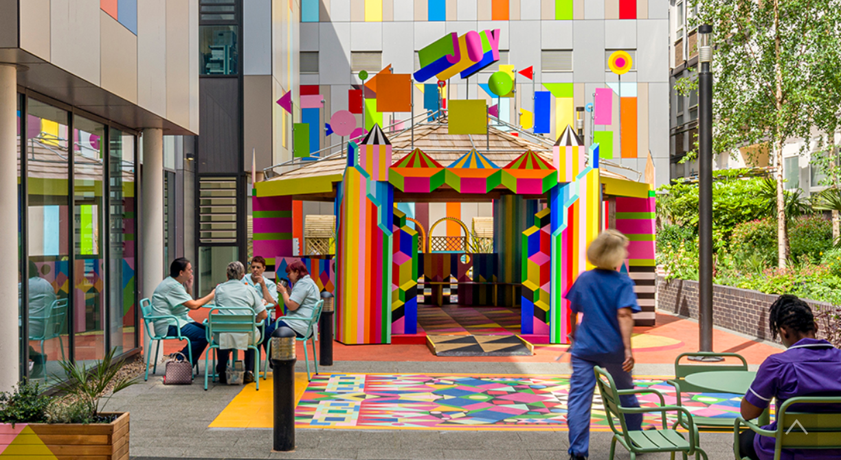Figure 3. Joy Garden, installation view by Morag Myerscough, 2021.
Public installations are unique in that they exist in spaces that people pass through or occupy daily. Therefore, when Myerscough creates works such as Joy Garden ( Figure 3) with bright colors and bold patterns, their impact extends beyond mere “visual appeal”; they alter people’s emotional perception of everyday environments.
As Chapman (2005, p. 18) notes, design can generate “emotionally memorable experiences.” The presence of Joy Garden transforms what might have been a plain, functional space into a lighter, more welcoming environment, making it easier for passersby to experience moments of joy. Even brief encounters can produce genuine, though transient, psychological relief.
This observation highlights an important point: design can influence daily emotional life without requiring complex interventions. Simple changes—such as shifts in color, typographic prompts, or small graphical elements—can make a space more inviting and enjoyable.
3.2 Comparative Cases: Visual Language of Positive Emotion
To gain a broader understanding of Myerscough’s approach, two related examples are also considered.
The Happy Newspaper by Emily Coxhead uses soft tones, rounded fonts, and positive narratives to create a warm reading experience (Coxhead, n.d.). Although smaller in scale than public installations, it similarly demonstrates that design can serve as emotional support.
Another example is Nadina Ali, whose works employ bold lettering and bright colors to convey encouragement, support, and empowerment (Ali, n.d.). These works reach audiences’ emotions directly, turning design into an intuitive source of positive feedback.
These cases illustrate a growing trend in contemporary design: creating “feel-good” experiences is no longer an ancillary feature but increasingly recognized as an essential design objective.
4. Personal Growth through Design Participation
4.1 Reconsidering the Role of the Designer
Studying these works has led me to realize that design is not only an aesthetic or functional concern but also shapes how people feel about their lives. I now actively ask myself: “What kind of feeling do I want my design to evoke?” rather than merely, “Does it look good?” This shift has deepened my understanding of the purpose of design, emphasizing its capacity to influence emotional experience.
4.2 Ethical Considerations Behind Joy
Previously, I had never considered “joy” as a serious design concern. Myerscough’s practice has shown me that her work embodies the social responsibility advocated by design theorist Victor Papanek (Design for the Real World, 1971). In a society marked by high pressure and widespread anxiety, providing a relaxed, positive space is itself an active response to societal emotional needs. This perspective redefines the designer’s role: no longer merely a creator of visual content, the designer becomes an active shaper of the emotional atmosphere in public life.
Consequently, visual design is more than aesthetic expression; it is an ethical practice that directly engages with social reality and cares for public psychological well-being. Designers are challenged to consider not only what their work looks like but also how it affects the emotional and social environment.
Conclusion
Through the study of Myerscough’s works, I have come to understand how graphic design can provide support on emotional, communal, and cultural levels. It can make people feel accepted and connected, and it can alter the way individuals perceive everyday environments. Supplementary cases, such as The Happy Newspaper and Nadina Ali’s works, further demonstrate that promoting positive emotion is a legitimate and increasingly recognized design direction.
Ultimately, I have realized that design is more than a visual presentation; it is a form of care that constructs fundamental aspects of human reality. By intervening subtly yet authentically, design weaves networks of emotion and social meaning between people and the world. For this reason, graphic design uniquely addresses the fundamental question of how to live with greater belonging. In doing so, it profoundly participates in the “saving” of everyday life, not in a literal biological sense but by fostering emotional stability, personal growth, and social connectedness.

References:
Ali, N. (n.d.). Nadina Ali - Design & Illustration. [Online]. Available at: https://www.nadinaali.com/ (Accessed: 24 November 2025).
Barthes, R. (1972). Mythologies. Translated by A. Lavers. New York: Hill and Wang.
Chapman, J. (2005). Emotionally Durable Design: Objects, Experiences and Empathy. London: Earthscan.
Chandler, D. (2017). Semiotics: The Basics (3rd ed.). London: Routledge.
Coxhead, E. (n.d.). The Happy Newspaper. [Online]. Available at: https://thehappynewspaper.com/ (Accessed: 24 November 2025).
Hall, S. (Ed.) (1997). Representation: Cultural Representations and Signifying Practices. London: SAGE Publications.
Ingold, T. (2011). Being Alive: Essays on Movement, Knowledge and Description. London: Routledge.
Merleau-Ponty, M. (1962). Phenomenology of Perception (C. Smith, Trans.). London: Routledge & Kegan Paul.
Myerscough, M. (2018). Morag Myerscough: Where Do Ideas Come From? [Video]. TEDx Talks. Available at: https://www.ted.com/talks/morag_myerscough_where_do_ideas_come_from (Accessed: 24 November 2025).
Norman, D. A. (2004). Emotional Design: Why We Love (or Hate) Everyday Things. New York: Basic Books.
Papanek, V. (1971). Design for the Real World: Human Ecology and Social Change. London: Thames & Hudson.
Schuler, D. and Namioka, A. (Eds.) (1993). Participatory Design: Principles and Practices. Hillsdale, NJ: Lawrence Erlbaum Associates.

Bibliography:
Ali, N. (n.d.). Nadina Ali - Design & Illustration. [Online]. Available at: https://www.nadinaali.com/ (Accessed: 24 November 2025).
Barthes, R. (1972). Mythologies. Translated by A. Lavers. New York: Hill and Wang.
Chapman, J. (2005). Emotionally Durable Design: Objects, Experiences and Empathy. London: Earthscan.
Chandler, D. (2017). Semiotics: The Basics (3rd ed.). London: Routledge.
Coxhead, E. (n.d.). The Happy Newspaper. [Online]. Available at: https://thehappynewspaper.com/ (Accessed: 24 November 2025).
Garland, S. (2018). ‘The Joyful World of Morag Myerscough’, Creative Review, 38(5), pp. 56–63.
Hall, S. (Ed.) (1997). Representation: Cultural Representations and Signifying Practices. London: SAGE Publications.
Ingold, T. (2011). Being Alive: Essays on Movement, Knowledge and Description. London: Routledge.
Merleau-Ponty, M. (1962). Phenomenology of Perception (C. Smith, Trans.). London: Routledge & Kegan Paul.
Myerscough, M. (2018). Morag Myerscough: Where Do Ideas Come From? [Video]. TEDx Talks. Available at: https://www.ted.com/talks/morag_myerscough_where_do_ideas_come_from (Accessed: 24 November 2025).
Myerscough, M. (n.d.). Studio Myerscough. [Online]. Available at: https://www.studiomyerscough.com/ (Accessed: 24 November 2025).
Norman, D. A. (2004). Emotional Design: Why We Love (or Hate) Everyday Things. New York: Basic Books.
Papanek, V. (1971). Design for the Real World: Human Ecology and Social Change. London: Thames & Hudson.
Schuler, D. and Namioka, A. (Eds.) (1993). Participatory Design: Principles and Practices. Hillsdale, NJ: Lawrence Erlbaum Associates.
The Happy Newspaper. (n.d.). About. [Online]. Available at: https://thehappynewspaper.com/ (Accessed: 24 November 2025).

Supporting imagery:
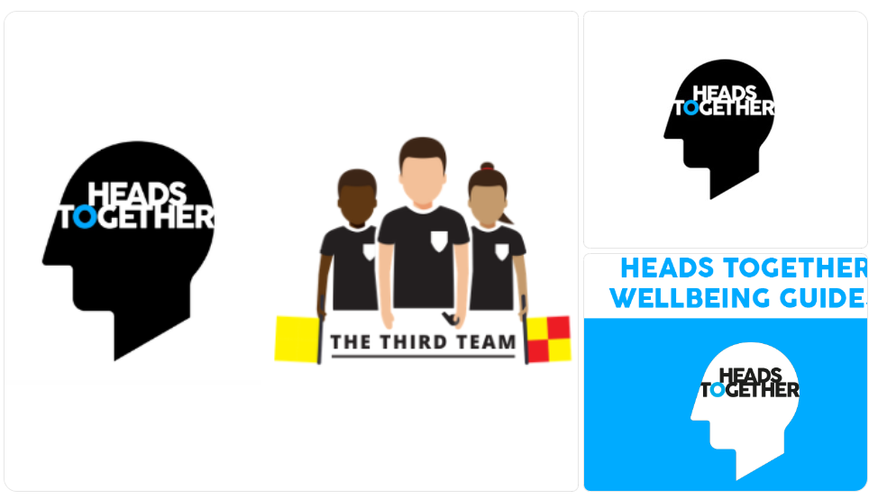
Figure 4. Heads Together campaign posters and promotional materials (British Royal Family, n.d.). [Online]. Available at: https://www.headstogether.org.uk (Accessed: 30 November 2025).

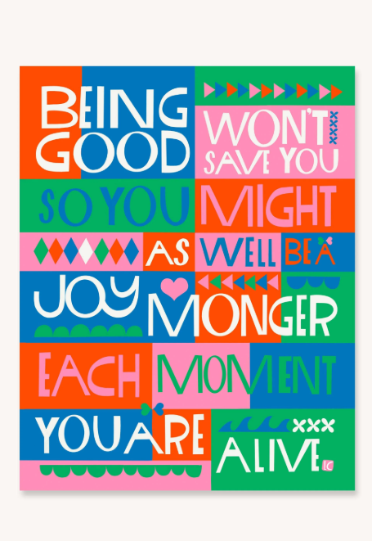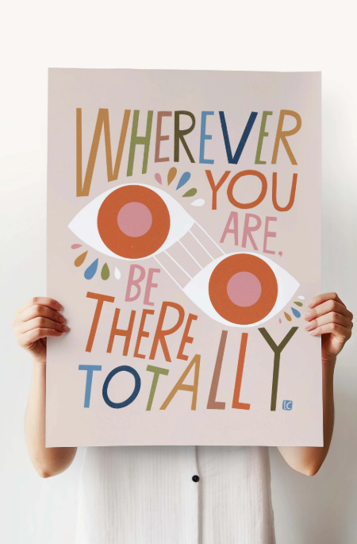
Figure 5. You Are Enough, poster by Lisa Condon (n.d.). [Online]. Available at: https://lisacongdon.com/products/you-belong-here-art-print?utm_source=chatgpt.com (Accessed: 30 November 2025).

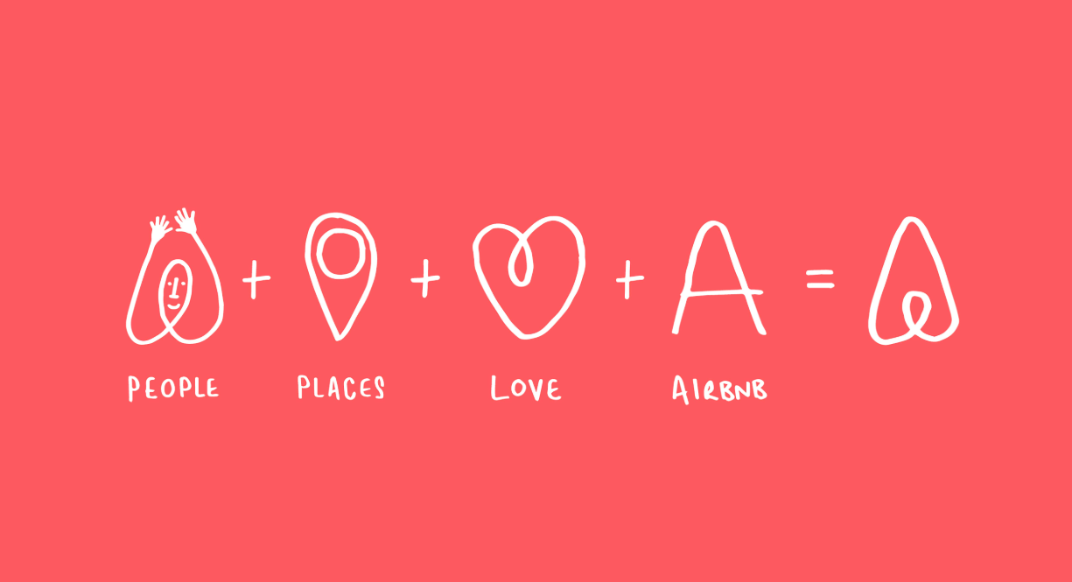

Figure 6. Airbnb – Belong Anywhere, visual identity (Airbnb, n.d.). [Online]. Available at: https://design.studio/work/airbnb (Accessed: 30 November 2025).
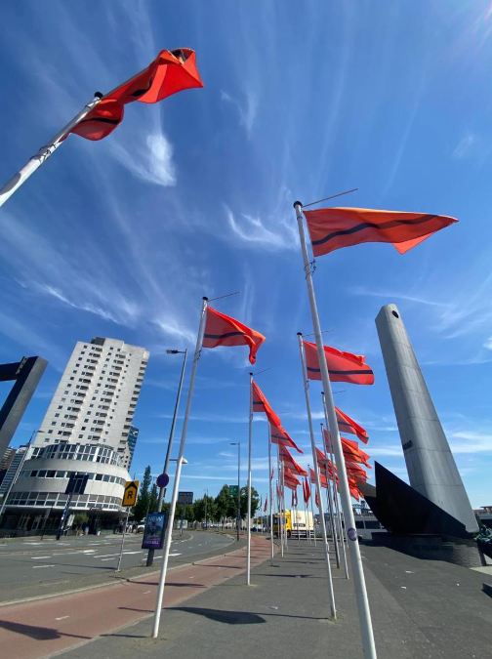
Figure 7. The Refugee Nation Flag, designed for the Refugee Olympic Team (Yara Said, 2016). [Online]. Available at: https://yara-said.com/The-Refugee-Nation-Flag?utm_source=chatgpt.com (Accessed: 30 November 2025).
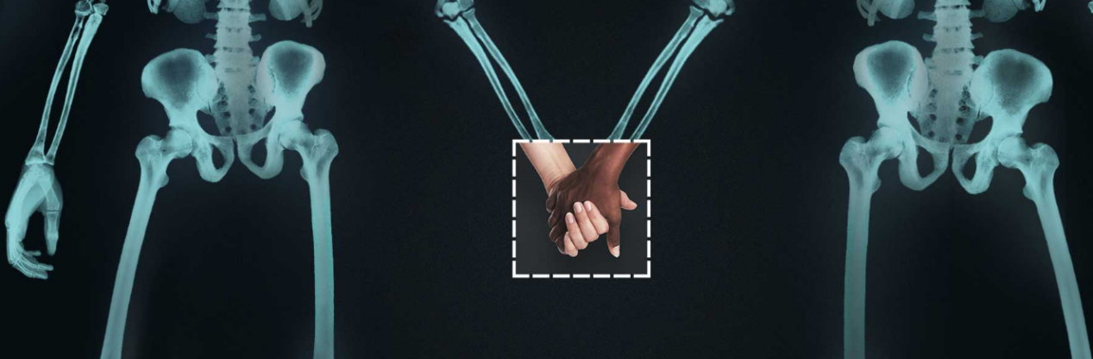
Figure 8. Love Has No Labels Campaign (Ad Council, 2015–). [Online]. Available at: https://lovehasnolabels.com (Accessed: 30 November 2025).

Figure 9. The Noun Project, global icon library (Ongoing since 2010). [Online]. Available at: https://thenounproject.com (Accessed: 30 November 2025).
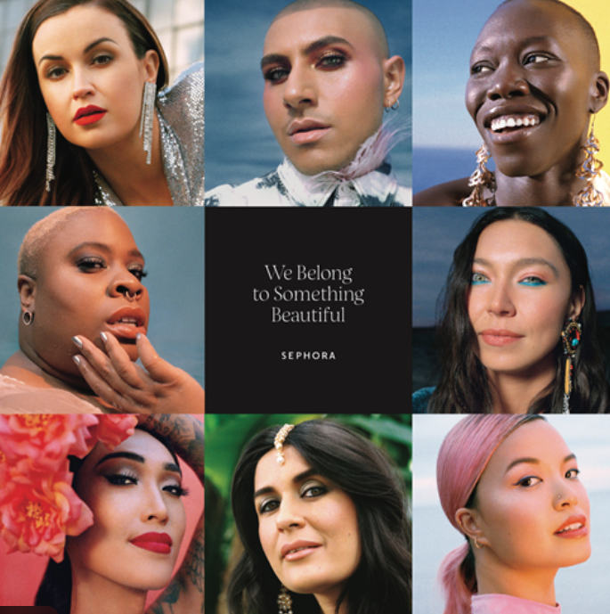
Figure 10. We Belong to Something Beautiful, Sephora campaign (2019). [Online]. Available at: https://www.prnewswire.com/apac/news-releases/sephora-adopts-a-global-brand-signature--we-belong-to-something-beautiful--302080996.html?utm_source=chatgpt.com (Accessed: 30 November 2025).

