

Managing Enterprise
Module Name BMSW4011
Module Lead: Mel Squire
Student name: Mohammed Sumon Ali
Student number: 1813647
Deadline: 19th June

Business Plan
1. Product/Service Description
Doner Kings is a fast-food restaurant based in Cardiff specializing in premium doner kebabs, wraps, loaded fries, burgers, soft drinks, and takeaway meals. The business will offer high-quality ingredients, fast service, affordable prices, and delivery through online platforms.

2. Company Name
Doner Kings
The name reflects quality and expertise in the doner kebab market while being memorable and appealing to customers.
3. My Story
I decided to establish Doner Kings after noticing the high demand for quality takeaway food in Cardiff. Many local customers seek affordable, convenient meals, but there is an opportunity to provide better quality ingredients and customer service. My goal is to create a modern takeaway brand that delivers excellent food and value while becoming a recognised name in Cardiff. I have previous experience in this type of environment which inspired me to open my very own business.

4. Legal Status (Sole Trader)
Advantages
Easy and inexpensive to set up.
Full control over business decisions.
Keeps all profits.
Disadvantages
Unlimited personal liability for business debts.
Harder to raise finance.
Greater personal financial risk.
Doner Kings will initially operate as a sole trader due to its simplicity and low setup costs.

5. Mission Statement, Aims, SMART Objectives and USP
Mission Statement
"To provide Cardiff customers with high-quality, affordable doner meals delivered with exceptional service. I intend on providing all of Cardiff with new flavours which have never been tasted before which come from my personal home recipes which date back many years."
Aims
Build a strong local reputation.
Achieve profitability within the first year.
Expand customer loyalty through excellent service.
Being able to give back when possible.
Providing Cardiff with new flavours
SMART Objectives
Achieve £100,000 sales revenue within the first 12 months.
Gain 500 social media followers within 6 months.
Achieve an average customer review rating of 4.5/5 within the first year.
Being able to provide high quality food to a wide range of people for a reasonable price
USP (Unique Selling Proposition)
Fresh ingredients, generous portions, affordable prices, and fast service specifically tailored to Cardiff customers. Having televisions set up for when big sports events are live which may attract more customers. Producing different flavours to the people of cardiff as my food will be unique compared to other food places near me

6. Location
Doner Kings will be located on Tudor street Cardiff
Google Maps:
Google Maps – Cardiff City Centre
Advantages:
High customer traffic.
High footfall
Student population
Office workers
Nightlife customers
Strong demand for takeaway food.
Good public transport links.

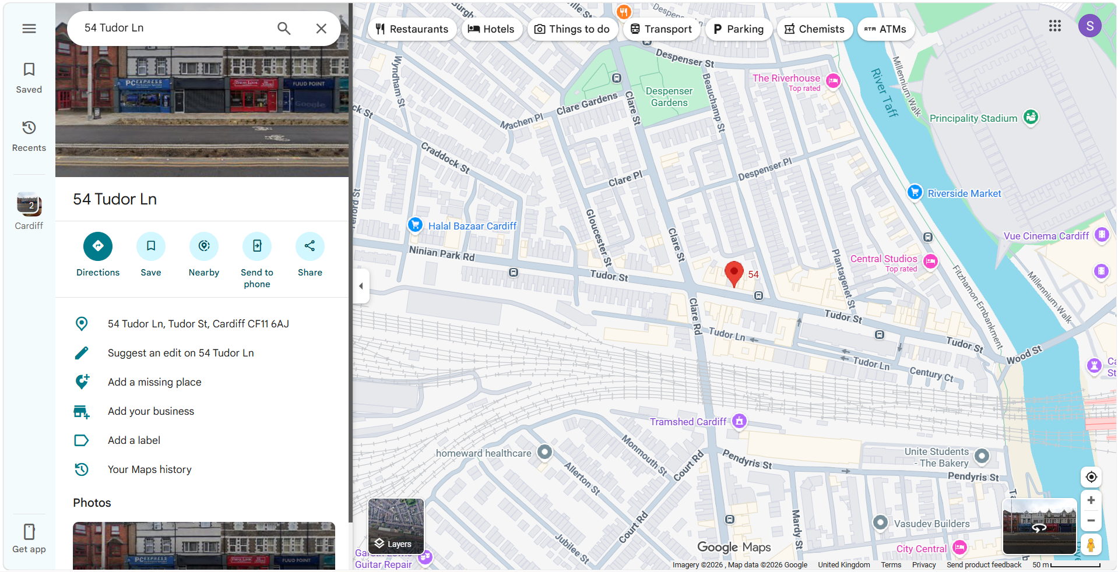

7. Human Resources
Initially the business will employ:
Owner/Manager
2 Kitchen Staff
1 Counter Assistant
1 Delivery Driver
Organisation Chart
Owner/Manager
Kitchen Staff (2)
Counter Assistant
Delivery Driver
Staff will receive food hygiene and customer service training to maintain high standards.

8. Marketing Activities
Instagram and TikTok promotion.
Local Facebook advertising.
Grand opening discounts.
Loyalty card scheme.
Online ordering through delivery apps.
Encouraging customer reviews.
These activities will increase awareness, attract new customers, and encourage repeat business.

9. Market Research
Research shows strong demand for fast-food and takeaway services in Cardiff, particularly among students and young professionals. Online reviews indicate customers value food quality, speed, portion size, and price.
Primary research could include:
Customer surveys.
Social media polls.
Taste-testing events.
Secondary research:
Industry reports.
Competitor websites.
Local demographic data.

10. Financial Resources and Cash Flow Forecast
Start-Up Costs
Item |  |  | Cost (£)
Equipment |  |  | 12,000
Initial Stock |  |  | 3,000
Licences & Insurance |  |  | 1,500
Marketing |  |  | 2,000
Rent Deposit |  |  | 6,000
Total |  |  | 24,500
Month | Sales Revenue (£) | Rent (£) |  | Wages (£) |  | Stock (£) | Utilities (£) | Marketing (£) | Other Costs (£) | Total Expenses (£) | Net Cash Flow (£)
Jan | 8,000 | 2,000 |  | 4,000 |  | 2,500 | 500 | 500 | 500 | 10,000 | -2,000
Feb | 10,000 | 2,000 |  | 4,000 |  | 2,000 | 500 | 500 | 500 | 9,500 | 500
Mar | 12,000 | 2,000 |  | 4,000 |  | 2,000 | 500 | 500 | 500 | 9,500 | 2,500
Apr | 13,000 | 2,000 |  | 4,500 |  | 2,000 | 500 | 500 | 500 | 10,000 | 3,000
May | 14,000 | 2,000 |  | 4,500 |  | 2,500 | 500 | 500 | 500 | 10,500 | 3,500
Jun | 15,000 | 2,000 |  | 4,500 |  | 2,500 | 500 | 500 | 500 | 10,500 | 4,500
Jul | 16,000 | 2,000 |  | 5,000 |  | 2,500 | 500 | 500 | 500 | 11,000 | 5,000
Aug | 16,500 | 2,000 |  | 5,000 |  | 2,500 | 500 | 500 | 500 | 11,000 | 5,500
Sep | 17,000 | 2,000 |  | 5,000 |  | 3,000 | 500 | 500 | 500 | 11,500 | 5,500
Oct | 18,000 | 2,000 |  | 5,500 |  | 3,000 | 500 | 500 | 500 | 12,000 | 6,000
Nov | 19,000 | 2,000 |  | 6,000 |  | 3,000 | 500 | 500 | 500 | 12,500 | 6,500
Dec | 22,000 | 2,000 |  | 7,000 |  | 3,500 | 500 | 500 | 500 | 14,000 | 8,000
Total Annual Income: £180,500
Total Annual Expenses: £132,000
Projected Annual Net Cash Flow: £48,500

11. Competitor Analysis
The takeaway and fast-food market in Cardiff is highly competitive, especially in kebabs, burgers, and late-night food. Doner Kings will compete with a mix of independent shops and large chains.
Main Competitors
1. Local kebab shops (independent takeaways)
Strong local customer base and repeat business
Often located in high-footfall areas
Weaknesses: inconsistent food quality, limited branding, poor online presence
2. Large fast-food chains (e.g. McDonald’s, KFC)
Strong branding and high trust
Efficient service and delivery systems
Weaknesses: less authentic food, less customisation, higher prices for value meals
3. Other burger/kebab independents in Cardiff
Similar pricing and target market
Some offer delivery and late-night service
Weaknesses: weak social media marketing, lack of unique identity, variable customer service

Competitive Advantage of Doner Kings
Consistent high-quality doner meat and fresh ingredients
Strong brand identity (“premium kebab” positioning)
Active social media marketing (TikTok/Instagram food content)
Fast service and strong delivery focus
Loyalty rewards to increase repeat customers

Conclusion
While Cardiff has a saturated takeaway market, most competitors rely on tradition or brand size rather than innovation. Doner Kings will stand out by combining quality, branding, and modern digital marketing.

12. Critical Appraisal
Doner Kings has strong potential due to Cardiff's large takeaway market and growing demand for convenient dining options. Key strengths include a clear target market, affordable pricing, and strong branding. Risks include competition, rising food costs, and economic uncertainty. These risks will be managed through careful budgeting, quality control, and effective marketing. Overall, Doner Kings is a viable business opportunity with potential for long-term growth and profitability.
Reference list
BBC Bitesize. (n.d.). GCSE Business. [online] Available at: https://www.bbc.co.uk/bitesize/subjects/zpsvr82.
‌Tutor2u.net. (2026). Teaching Business. [online] Available at: https://www.tutor2u.net/teaching/business.
‌Trading (2018). Trading. [online] Investopedia. Available at: https://www.investopedia.com/business-4427765 [Accessed 18 Jun. 2026].
‌Statista. (2020). Statista - The Statistics Portal. [online] Available at: https://www.statista.com/markets/418/topic/467/food-service/ [Accessed 18 Jun. 2026].
‌Food Standards Agency. (n.d.). Business guidance. [online] Available at: https://www.food.gov.uk/business-guidance.
‌HubSpot (2019). HubSpot Blogs | Marketing. [online] Hubspot.com. Available at: https://blog.hubspot.com/marketing.
‌Hootsuite.com. (2026). Welcome To Zscaler Directory Authentication. [online] Available at: https://www.hootsuite.com/resources/social-media-marketing.
‌Shopify (2024). How To Add Some Flavor To Your Restaurant Marketing Strategy - Shopify. [online] Shopify. Available at: https://www.shopify.com/blog/restaurant-marketing [Accessed 18 Jun. 2026].
‌Hayes, A. (2025). Cash Flow: What It Is, How It Works, and How to Analyze It. [online] Investopedia. Available at: https://www.investopedia.com/terms/c/cashflow.asp.
‌Business. (2019). Forbes. [online] Available at: https://www.forbes.com/business/.
‌BusinessBalls (2020). Leadership & Management Training - BusinessBalls.com. [online] Businessballs.com. Available at: https://www.businessballs.com/.
‌TripAdvisor (2023). TripAdvisor: Read Reviews, Compare Prices & Book. [online] TripAdvisor. Available at: https://www.tripadvisor.co.uk/.
‌Small Business. (n.d.). Advice and ideas for UK small businesses. [online] Available at: https://www.smallbusiness.co.uk.
‌Ons.gov.uk. (2019). Business, industry and trade - Office for National Statistics. [online] Available at: https://www.ons.gov.uk/businessindustryandtrade.
‌Entrepreneur (2019). Entrepreneur - Start, Run and Grow Your business. [online] Entrepreneur. Available at: https://www.entrepreneur.com/.

Reflection – Doner Kings Business Plan
Doing this business plan for Doner Kings has helped me understand what is needed to start and run a real business. Before this task, I mostly thought about the food and the brand name. Now I understand that a successful business needs a lot of planning in different areas like money, marketing, staff, and competitors.
One of the most important things I learned was about money and costs. Making the cash flow forecast showed me that running a restaurant costs a lot. There are many expenses like rent, wages, food stock, electricity, and advertising. I also learned that in the first few months, a business might not make much profit and could even lose money. This showed me that new businesses need savings or starting money to survive at the beginning.
The competitor analysis helped me understand how competitive the food industry in Cardiff is. There are many kebab shops and also big fast-food chains like McDonald’s and KFC. This means Doner Kings would need something special to stand out. I learned that having a unique selling point is very important. Without it, customers may just go to other well-known places.
Marketing was another important part of this project. I used to think marketing was just posters or adverts, but now I understand that social media is very important. Apps like Instagram and TikTok can help attract customers by showing food pictures and videos. I also learned that having a Google Business Profile is important because many people search online before choosing a place to eat. Good reviews can bring in more customers.
Planning the business also helped me understand how different parts of a business work together. For example, if wages go up, the business might need to raise prices or reduce costs somewhere else. Everything is connected, so decisions need to be carefully thought out.
If I could improve this project, I would do more real research by asking people in Cardiff what kind of food they like and how much they would pay. I would also visit competitor restaurants to see what they do well and what they could improve.
Overall, this task helped me understand how hard it is to start a real business. It is not just about having a good idea, but also about planning carefully, managing money, and attracting customers. I now see Doner Kings as a more realistic business idea with both opportunities and challenges.

Marketing was another key area where I gained new understanding. I used to think advertising mainly meant posters or word of mouth, but I now see how important digital marketing is, especially social media platforms like Instagram and TikTok. These platforms allow businesses to reach large audiences quickly and cheaply. I also learned how important Google Business Profile is for local visibility, especially for takeaway businesses where customers often search online before choosing where to eat.
The process of structuring the business plan also improved my organisational skills. Breaking the plan into sections such as finance, marketing, and human resources helped me understand how different parts of a business connect. For example, staffing decisions affect costs, which then affect pricing and profitability. Everything in a business is linked, and decisions in one area impact others.
If I were to improve this project, I would include more detailed primary market research, such as surveys or interviews with potential customers in Cardiff. This would make the plan more realistic and based on real customer opinions rather than assumptions. I would also research competitors more deeply by visiting them or analysing their menus and pricing in more detail.
Overall, this task has given me a much clearer understanding of how a real business is planned and managed. It has shown me that success in business requires careful planning, awareness of competition, strong financial control, and effective marketing. Doner Kings now feels like a more realistic and structured business idea rather than just a concept.

