E-Portfolio

Arafat Akhtar
University of wales
Rhiannon
CertHe law
10.03.2023

Question 1
Preparing for higher education is a crucial step for any student who aspires to excel academically and professionally. It necessitates thorough preparation, commitment, and a solid work ethic. Starting early is one of the most crucial pieces of advice for getting ready for higher education. Students should begin considering their academic objectives and long-term professional aspirations early in their careers. Also, they want to emphasize mastering time management and effective study practices. This will support students in maintaining their planning and schedule throughout their academic careers.
Research your interests as you get ready for higher study. To discover a subject of study that is important and interesting to them, students should investigate their interests and passions. They can do this by enrolling in classes, giving back to the community, or attending events that interest them (Tinmaz, 2022). They will be able to choose a major they are passionate about and have a deeper grasp of their interests. Researching colleges and universities is crucial to be ready for higher education.
Students should look into the schools and institutions that provide courses in their desired subject area. When selecting a college or university, they should consider location, size, cost, and academic reputation. This will assist them in locating the college or university that best suits their requirements. Most schools and universities require applicants to maintain a GPA of at least 3.0. Maintaining a good GPA and enrolling in rigorous classes that will prepare them for college-level work are two things that students should do. They will be able to showcase their academic skills and stand out during the college admissions process.
Planning carefully, committing, and working hard are necessary while preparing for higher education. Students should begin their studies early, identify their interests, research schools and universities, keep their grades, develop a strong resume, prepare for standardized examinations, and submit applications for financial aid and scholarships. Students can successfully prepare for higher education and accomplish their academic and professional goals with the correct mentality and resources.

Question 2
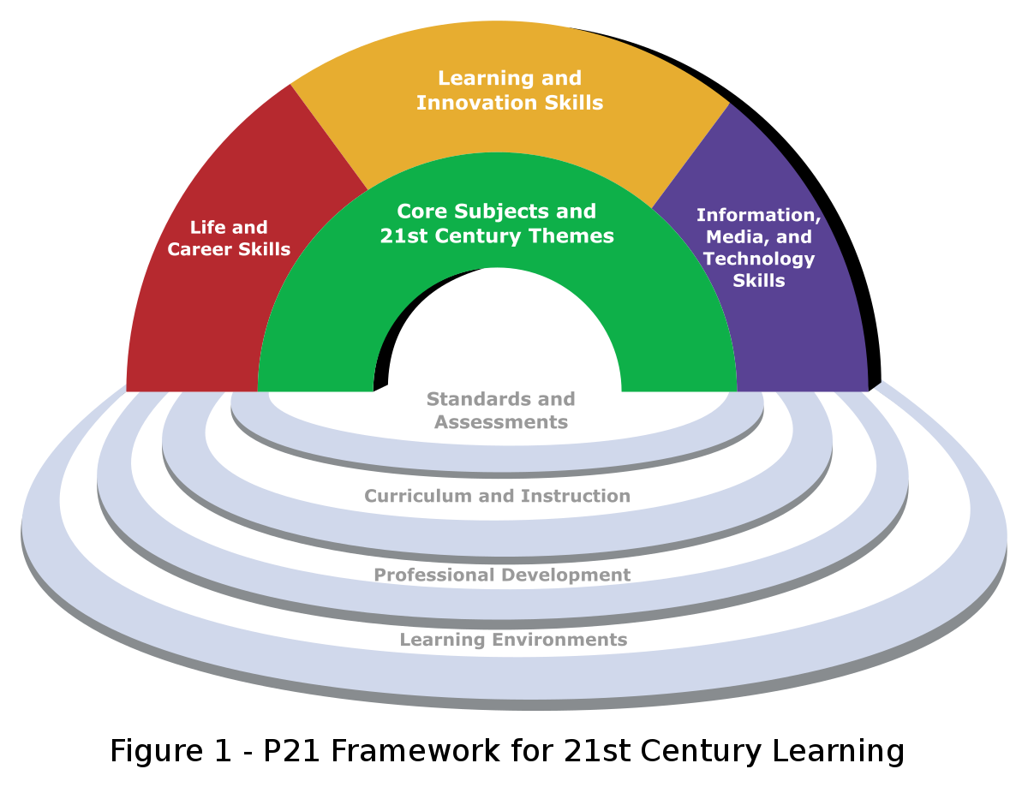
Several interconnected themes are highlighted in "Being a Digital Learner" and can help people prepare for business management careers. These themes include flexibility, teamwork, critical thinking, and digital literacy.
Being a Digital Learner covers the significance of mastering digital tools and technology to flourish in the modern world. One key issue that is stressed in the essay is digital literacy. Digital literacy is crucial in the context of company management for navigating the digital environment of contemporary firms, from managing social media accounts to utilizing digital tools for data analysis. Individuals can improve their productivity and effectiveness by developing digital literacy skills, which is crucial in the fast-paced corporate sector.
The article's focus on collaboration comes from its discussion of the value of teamwork in achieving shared objectives. Collaboration is crucial for cooperation and developing successful connections with coworkers, clients, and stakeholders in business management (Tinmaz, 2022). Those who collaborate well with others can create strategies, find solutions to issues, and accomplish corporate objectives.
Another significant issue underlined in the article is adaptability, as it highlights how crucial it is to be flexible and adaptable in a rapidly changing world. Being able to adjust to changes in the market, the economy, and technology is crucial in the context of business management. Those who can adapt to change can help their organization flourish in the long run by keeping it competitive.
Another significant subject that is emphasized in the article is critical thinking. Analyzing information and making judgments based on facts and logic require critical thinking (Sousa, 2019). Critical thinking is crucial for decision-making, problem-solving, and innovation in business management. Critical thinkers can analyze information, spot issues, and come up with solutions that will benefit their business.
When considered collectively, these themes aid in preparing people for careers in business management by fostering the development of crucial abilities like digital literacy, critical thinking, cooperation, and adaptability. Success in the modern corporate world, where technology and change continuously reshape the landscape, depends on having these talents. Through navigating the digital environment, coming to wise decisions, working with others, and being adaptable to change, people who acquire these abilities can help their businesses prosper.
Question 3

Question 4
Beginning studies at university can be both an exciting and difficult experience, especially when adjusting to online learning and resources and completing your first assignments. Reflecting on my personal experiences, I can pinpoint several important lessons I've gained. I learned much about time management, resource use, and feedback-seeking through my experiences beginning university, adjusting to online learning and resources, and completing my first assignments. I'm confident that if I use these lessons in my future coursework and professional endeavors, I'll be able to keep improving my abilities and find success in my chosen industry.
What?
The information explains how the concepts in "Being a Digital Learner" are connected and help people prepare for business management careers. Digital literacy, critical thinking, cooperation, and flexibility are among the topics covered.
So what?
The data emphasize these concepts' importance in acquiring the abilities necessary for success in the contemporary corporate environment. Critical thinking is required for decision-making, problem-solving, and innovation, whereas digital literacy is essential for navigating the digital environment of modern enterprises (Martzoukou, 2021). While adaptability is necessary to respond to shifts in the market, economy, and technology, collaboration is crucial for teamwork and developing strong connections with coworkers, clients, and stakeholders.
What's next?
The data emphasizes how crucial it is to have these abilities to succeed in business management. Digital literacy, critical thinking, cooperation, and adaptability are skills that people may gain to help their businesses prosper in the long run. People can take classes or workshops, seek coaching or mentoring, or actively look for opportunities to practice and apply these abilities in their jobs to develop these skills. To pinpoint areas for development and establish objectives for ongoing growth and development, they might also think back on their experiences.

References
Martzoukou, K., 2021. Academic libraries in COVID-19: a renewed mission for digital literacy. Library management, 42(4/5), pp.266-276.
Sousa, M.J. and Rocha, Á., 2019. Digital learning: Developing skills for digital transformation of organizations. Future Generation Computer Systems, 91, pp.327-334.
Tinmaz, H., Lee, Y.T., Fanea-Ivanovici, M. and Baber, H., 2022. A systematic review on digital literacy. Smart Learning Environments, 9(1), pp.1-18.

