
My e-Portfolio
By Imran Ahmed
2232680
Digital Skills
UWTSD
e-Portfolio Link: https://sites.google.com/view/myeportfolio786/home

Task 1
Access to e-portfolio : https://sites.google.com/view/myeportfolio786/home
"E-commerce" is a shortened term for "electronic commerce," which refers to the exchange of goods and services using telecommunication methods like the internet. It encompasses various forms of online interactions between businesses, individuals, and authorities, such as online marketplaces, storefronts, and B2B transactions. (Lisa Sims (2018) Building Your Online Store with WordPress and WooCommerce, pp. 17-18, Apress publishing). Numerous e-commerce website software solutions are available today, with some of the most popular options including Shopify, WooCommerce, and BigCommerce. See their descriptions below.
Shopify is a leading e-commerce platform that offers a user-friendly interface, 24/7 customer support, and a vast app store. It's a fully hosted platform that takes care of all technical aspects of running a web-based business, including upgrades, encryption, and hosting. With its extensive selection of templates, building a professional-looking online store is a breeze.
WooCommerce is a WordPress extension that is the largest and most widely used content management system (CMS). Because it is free software, it provides a great deal of flexibility, allowing developers to tailor it to their own needs. WooCommerce is also extremely scalable, making it appropriate for organizations of all sizes. (Lisa Sims (2018) Building Your Online Store with WordPress and WooCommerce, pp. 42 - 44, Apress publishing).
BigCommerce is a virtualized e-commerce platform that provides several features, such as integrated SEO, mobile optimization, a choice of payment methods, and several customization options, making it simple to construct a website that looks professional.
To conclude, when it comes to choosing e-commerce website software solutions, there are numerous options available with distinct features and benefits. To select the right one for your business, it's crucial to assess your needs and requirements carefully.

Reference: -
- Lisa Sims (2018) Building Your Online Store with WordPress and WooCommerce, pp. 17-18, Apress publishing
- Lisa Sims (2018) Building Your Online Store with WordPress and WooCommerce, pp. 42 - 44, Apress publishing

Task 2
Mind Mapp of contemporary Software Application for a business company
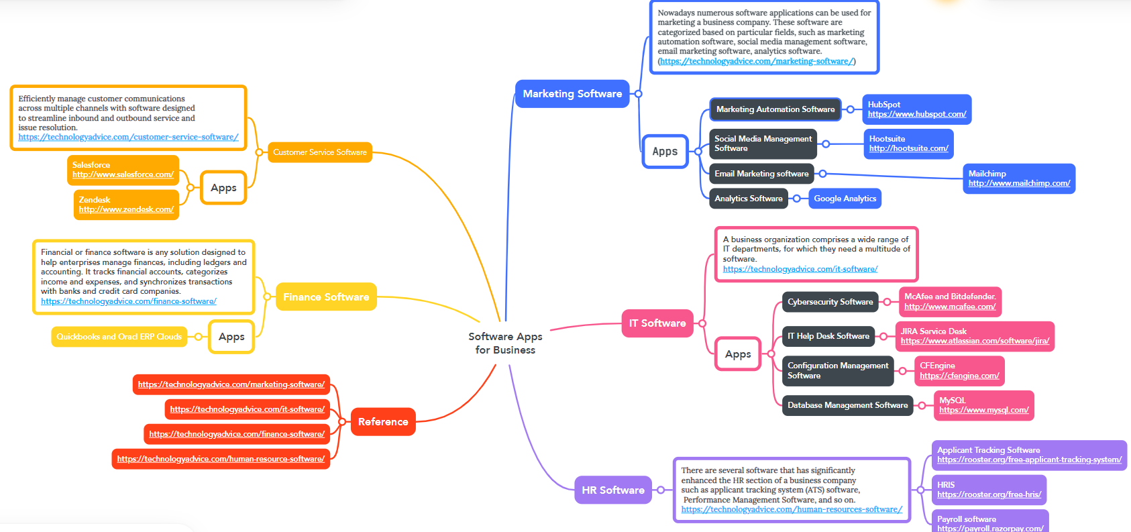

Task 3
Efficiency is paramount for any successful business. Streamlining the processes of creation, collaboration, and communication enhances productivity and agility, key factors for a competitive edge. Microsoft's Office 365 productivity suite offers a suite of essential tools, including Word, Exchange, Excel, SharePoint, Teams, and more. Below are some features of the significant office applications used in business companies: -
Microsoft Word:
- Word processing software used for creating and editing documents.
- Features include font styles and formatting options, spellcheck and grammar check, track changes, and the ability to add images and tables.
- Offers templates for various types of documents, such as resumes, letters, and reports.
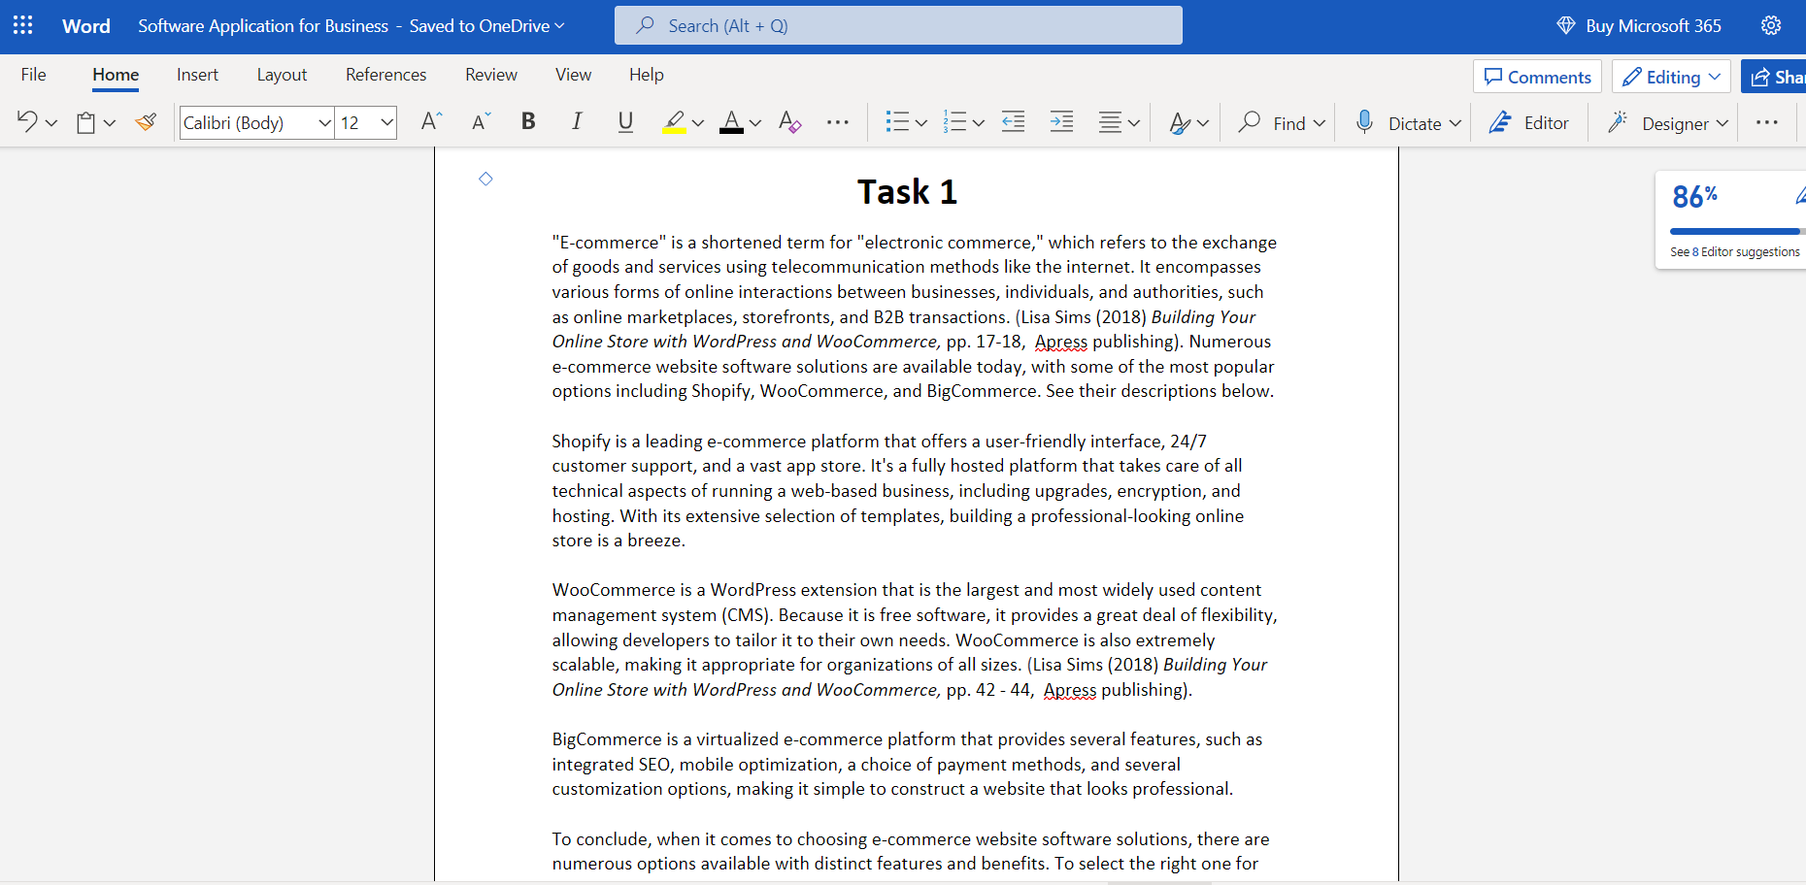
Microsoft Excel:
- Spreadsheet software used for organizing and analysing data.
- Features include a range of mathematical and statistical functions, chart creation and formatting options, and the ability to create macros.
- Allows for the import and export of data from other sources, such as databases or web pages.
Microsoft PowerPoint:
- Presentation software used for creating and presenting slideshows.
- Features include a variety of slide layouts, design themes, and animation options.
- Allows for the insertion of multimedia elements, such as images, videos, and audio files.
Microsoft Outlook:
- Email and personal information management software
- Features include email organization and filtering options, calendar and task management, and contact management.
- Allows for the integration of other email accounts and the ability to sync with mobile devices.

One Drive
- OneDrive is a cloud storage service by Microsoft that offers up to 5TB of secure file storage, real-time collaboration, and seamless syncing across devices. It's integrated with Microsoft Office, includes security features like two-factor authentication and encryption, and is built with privacy in mind.
References: -
- https://www.core.co.uk/blog/blog/the-7-undeniable-benefits-of-using-office-365-for-business
- https://www.business.com/articles/5-random-things-you-can-create-in-a-microsoft-word-document/
- https://www.investopedia.com/articles/personal-finance/032415/importance-excel-business.asp/

Task 4
Digital dashboards are data visualization tools that provide real-time insights and analytics to help organizations make informed decisions. (Steve Wexler, Jeffrey Shaffer, and andy Cotgreave (2017) The Big Book of Dashboards Visualizing Your Data Using Real-World Business Scenarios pp-16. New Jersey, John Wiley & Sons, Inc. Publishing).
Key features of a digital dashboard are as follows: -
- Digital dashboards display real-time performance metrics in a customizable format.
- They integrate data from multiple sources and offer drill-down functionality for deeper insights.
- Best digital dashboards are user-friendly and offer real-time data updates with mobile compatibility.
- They provide robust security and privacy measures for sensitive data.
- These features enable organizations to make data-driven decisions for improved performance and competitiveness.
(https://www.toptal.com/designers/data-visualization/dashboard-design-best-practices)
Key feature of a data analytics software is: -
- Data analytics software offers real-time data analysis and reporting.
- It integrates data from multiple sources and allows users to customize visualizations.
- It provides advanced analytics tools, such as predictive modelling and data mining.
- It offers drill-down functionality for deeper insights and allows users to identify trends and patterns.
- It is scalable and can handle large volumes of data.
- It offers collaboration features to enable teams to work together on data analysis projects.

Task 5
Project management software helps teams work collaboratively to achieve project goals efficiently, by providing features such as task distribution, time tracking, budgeting, resource planning, team collaboration, and more. It is also referred to as Task Management Software, Project Manager Software, or Project Portfolio Management (PPM).
Here are summaries of some contemporary communication, collaboration, and project management applications:
- Microsoft Teams Microsoft Teams is a communication and collaboration platform that enables teams to chat, collaborate on documents, and hold virtual meetings. Key features include:
- Chat and Messaging: Teams allows for group chats and direct messaging, as well as the ability to share files and collaborate on documents.
- Video and Audio Conferencing: Teams offers video and audio-conferencing capabilities, including the ability to share screens and record meetings.
- Integration with Microsoft Office: Teams integrates with Microsoft Office, allowing users to access and collaborate on Word, Excel, and PowerPoint documents directly within the app.
- Customizable Channels: Teams allows users to create customized channels for different projects or teams, making it easy to organize conversations and collaborate with specific groups of people.
- Asana Asana is a project management tool that helps teams track and manage their work. Key features include:
- Task Management: Asana allows users to create and assign tasks, set due dates, and track progress.
- Project Views: Asana offers multiple project views, including lists, boards, and calendars, making it easy to visualize progress and deadlines.
- Collaboration: Asana enables team collaboration by allowing users to comment on tasks and projects, and by providing a centralized location for all project-related information.
- Integrations: Asana integrates with a variety of other tools, such as Slack, Google Drive, and Zoom, to provide a seamless workflow.
- Slack Slack is a messaging and collaboration platform that enables teams to communicate and share information. Key features include:
- Channels and Direct Messaging: Slack allows users to create channels for different projects or teams, as well as direct messaging for one-on-one conversations.
- Integration with Other Tools: Slack integrates with a variety of other tools, such as Google Drive and Trello, allowing users to access and collaborate on files and projects directly within the app.
- Customizable Notifications: Slack allows users to customize their notification settings, ensuring that they receive important information without being overwhelmed by too many notifications.
- Search Functionality: Slack's search functionality makes it easy to find specific messages or files, even in large conversations or channels.
Overall, these applications offer a range of features that support communication, collaboration, and project management. By leveraging these tools, teams can improve their workflows and work together more effectively.

