DATE: 29/04/19
STUDENT NAME: Pecos Dingu
Student ID: 1605452

BMSK5006
Knowledge and Information Management Skills for the Workplace

Executive summary

The whole report discusses about the management of knowedge as well as business related dataof Sainsbury’s to make the organization profitble. Many organizations face difficulties to collect necessay and important data from its storage of data and can not succeed in getting any profit. Compettors are putting pressure in erverywhere so the data management is necessary and there are dfferent sources of data an there are diffrnt models as well to make the data organized. The managers shoud have the skill to find out ho he knowledges should be gathered and how they will be used to attain competitive edge. Employee cusomr relationship depends a lot in manging data.

Contents
Executive summary 1
Introduction 3
PART A 4
a. The Relationship between Data Information and Knowledge 4
b. The Relationship between Individual Knowledge and Organizational Knowledge 5
c. The Application of Analysis and Modeling Techniques to identify knowledge assets 7
d. The Evaluation of Actual and Potential Knowledge Assets 9
PART B 10
a. The Requirement of Creating, Storing, Applying and Integrating Knowledge 10
b. The Importance of Intellectual Property Rights 12
PART C 13
a. The Contribution of Knowledge Assets have on an Organization 13
PART D 14
b. The evaluation of Knowledge Requirements for the Organization 14
c. The Evaluation of Organizations’ Framework for Enabling Knowledge Sharing 16
d. The Recommendation of Improving the Current Framework 18
Conclusion 19
Bibliography and references 20

Introduction

Knowledge management is a very essential task which controls and uses information flow around an organization and help the information to ensure the company to flourish. There are various sources of information or knowledge within an organization and the companies can gather knowledge from its employees, its tradition, managers etc. This knowledge helps an organization to more effective and competitive and become sharper. Here an organization called Sainsbury’s has been selected and its knowledge management technique is discussed.
Sainsbury’s is one of the most renowned and largest supermarket series in the world and It was unveiled in 1869 by opening a store at DruryLane in London and it was launched by John James Sainsbury and his loving wife Mary Ann (Collison, C. and Parcell, G. 2007).
In that time, Sainsbury’s became very popular and flourished very quickly because it offered high quality and affordable goods to the customer. Due to its increasing demand, they had to open a new store within and outside of London (Herschel, R. and Jones, N. 2005). Now the company has around six hundred supermarkets and around eight hundred convenience store worldwide and these offer a wide range of products to cater customer with continual upgrading.
Their long term goal is to cater customer by keeping their need in mind and giving first priority. They make their vision possible through the use of proper knowledge and information and that help them to become a market leader (Herschel, R. and Jones, N. 2005). Here how the company is managing its valuable information and using to prosper its business will be analysed.

PART A

The Relationship between Data Information and Knowledge
I was very fortunate that I got the opportunity to work as a volunteer in a store of Sainsbury’s in Manchester.I am also a loyal customer of Sainsbury’s and have an enthusiasm for knowing their progression of handling customer in the era of information technology.
It is important to know the relationship between data, information, and knowledge in any organization settings like Sainsbury’s (Quintas, et al. 2007). It is very challenging for the Sainsbury’s to keep up-to-date of their range of products and service which make their customer more contented and this only possible only because of their distinctive way of collecting data, make evocative information from those raw symbols and signs and finally harvesting this information to decide what they are doing, where is there ultimate position and how ultimately they will go that position (Herschel, R. and Jones, N. 2005).
The relationship of data, information, and knowledge can be exemplified by giving the scenario of Sainsbury’s launching idea of the self-service supermarket. Once a customer ordered his food from reception and it was packaged by their staff. After a while, the customer was annoyed because he wanted to choose his product on his own and threw a basket of food at the founder. And this simply incident gave the idea of an opening first self-service superstore in the UK. Here it can be seen the strong relationship of data, information, and knowledge (Herschel, R. and Jones, N. 2005). Here, observation of the customer behaviour can be defined as data and what actually makes the customer annoyed can be referred as information and the ultimate idea of opening a self-service store where customers can purchase their products without the assistance of staff can be described as knowledge which ultimately helps to take action.
To sum up, knowledge helps to create a valuable decision by processing data which are raw and from more precious information to more worthless information. A string of data help to produce meaningful information and the collection of information helps to enrich one’s level of knowledge which is follow an incremental process. By understanding this relationship between data, information, and knowledge, Sainsbury’s can use this sequence in their market strategy (Herschel, R. and Jones, N. 2005).

The Relationship between Individual Knowledge and Organizational Knowledge
Individual knowledge is a belief of information about a point of interest which is justified by any pieces of evidence and follow a learning process which is cognitive. Individual knowledge results in individual capital through the practicing of information gathering by explicit and implicit ways (Ichijo, K. and Nonaka, I. 2007). An individual knowledge depends on how capable he or she is to do a particular work, how much skilled about a particular job, how much putting effort to learn something new, and by which way it is communicated, other people (Herschel, R. and Jones, N. 2005). In this era of the internet, an individual can enrich his or her knowledge by browsing the internet without memorizing a single word. Individual knowledge influences the culture of work and organization and also use as a motivating tool to make skilled the staffs.
The assortment of knowledge and capabilities which are infatuated by the people who are the part of an organization can be referred to as organizational knowledge. This knowledge is distinctive from one organization to another organization and basically, it develops based on the history of an organization (Ichijo, K. and Nonaka, I. 2007). It also connects the member of an organization to achieve a common goal and objective. It can be learned from various internal sources such as achievement and let-down history, the property of intellectual and from external sources such as feedback and knowledge of the satisfied and dissatisfied customer, information and knowledge from the supplier (Ichijo, K. and Nonaka, I. 2007). Organizational knowledge represents the culture of an organization and is mainly articulated in written documents.
It can be seen that there has a relation between individual knowledge and organizational knowledge. Knowledge which owns by an individual through experience and learning can be transferred in an organization for giving a solution to a problem and help in managerial decision making (Quintas, et al. 2007). Ultimately the organization uses this individual knowledge and repackages it for service offering. On the other hand, individuals have to combine their knowledge with the knowledge of the organization. For becoming successful in the current market, Sainsbury’s has maintained and managed the relationship between individual knowledge and organizational knowledge (Ichijo, K. and Nonaka, I. 2007). The company has a belief that they will earn a profit by selling fewer goods but that will give the customers a healthy life. To maintain the relationship between individual knowledge and organizational knowledge, the company provides various packages of training and maintain a database of knowledge which helps to achieve the company mission and vision.
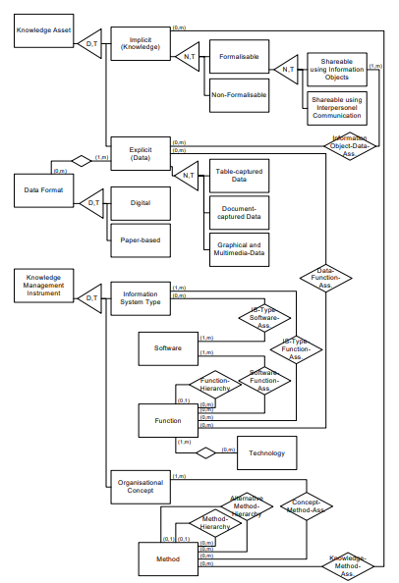

Fig- A model known as CF-KM (conceptual framework for knowledge management)

The Application of Analysis and Modelling Techniques to identify knowledge assets
The term knowledge management is an organized approach of managing an organization’s individual knowledge and organization knowledge which are intellectual for the intention of making a tie and adding value between organizational goal and strategy. Knowledge management is very important for any organization setting just like Sainsbury’s (Ichijo, K. and Nonaka, I. 2007). It provides the appropriate gear, persons, understanding, procedures, and work culture to boost the process of learning. Sainsbury and their employees fight back to perform their actions easily and constantly and somewhat straightforward way
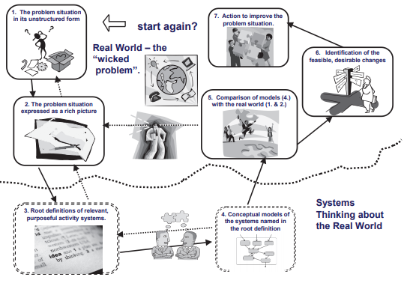
Figure- SSM approach as a seven-stage process (Collison, C. and Parcell, G. 2007)

For identifying the knowledge assets Sainsbury’s follow the Soft System Technology (SSM) (Quintas, et al. 2007). In this knowledge assets gathering process, at first the company identified an unstructured problem or situation that is problematic and in this stage transfer of knowledge is very poor.
At the second phase, all the participants are given an opportunity to express their tacit knowledge what they think about the situation and they can graphically represent the situation and identifying knowledge assets through taking the interview of the participants (Quintas, et al. 2007).
At the third phase, the participants incorporate their point of view about the situation and depict a root definition which gives a meaning to take consideration of all the point of view and willingness (Collison, C. and Parcell, G. 2007).
The fourth step considered as an activity stage because in this stage management must decide what must be done to achieve the process of knowledge transformation and uses the available techniques for identifying knowledge assets.
At the phase of five, there makes a comparison between the participant's idea and the ideal knowledge. For this management must decide what question they will address, which assumption need to be check, and which action needs to be eliminated (Lilley, et al. 2004). At this stage, management rethink and re-analyse their situation to identify a creative and satisfactory outcome
At the seventh-phase managements take the decision of implementing the idea and knowledge and make a recommendation. For this, management can take the decision of changing their existing strategy, procedure, and culture (Quintas, et al. 2007).
The final phase is the action stage in which actual knowledge assets use to solve the problematic situation and continue this process from the beginning to identify the knowledge assets constantly from the new and existing workers (Lilley, et al. 2004). By following this soft system technology, an organization can easily identify their knowledge assets like Sainsbury’s.

The Evaluation of Actual and Potential Knowledge Assets
Actual knowledge assets is slightly different from potential knowledge assets and physical assets. Physical assets can measure and represent trough documents for which it can easily be evaluated by any organization (Lilley, et al. 2004). But this evaluation is not so easy in the case of actual and potential knowledge assets and in some cases, many organization fails to identify their potential knowledge assets which leads them to lose their profit margin.
In the case of Sainsbury’s, it seems difficult to measure what is the tangible value of actual and potential knowledge assets (Lilley, et al. 2004). The company has altered its business procedure based on the actual and potential knowledge assets because it helps to prolong its competitive advantage in the sphere of trading. But sometimes the company has failed to identify their actual and potential knowledge assets which have various distinctive characteristics. As a result, the company has lost its valuable knowledge assets as well as its output and inventiveness that consume the company’s valuable time and money when it tries to regain it (Malhotra, Y. 2001). But after being aware of this loses the company has started to maintain databases of actual and potential knowledge assets which allows Sainsbury’s to create and a wide range of new products and services and helps to sustain its market position (Lilley, et al. 2004).
The nature of actual and potential knowledge assets is very complex and intangible. A company will be innovative or not it relies upon how systematic way it follows to identify its different kinds of knowledge assets. It is affordable for large organizations to invest in expensive and giant knowledge management program but it is impossible for many small organizations to bear those expenses (Gold, et al. 2001). It is high time to think about knowledge management techniques which will be affordable for any organization setting and small organization can easily identify their actual and potential knowledge assets, can compare those assets for better understanding and analyse those assets for taking the full advantage of their potential of originality (Sanchez, R. 2003).

PART B

The Requirement of Creating, Storing, Applying and Integrating Knowledge
Knowledge management follows a process which is very systematic and effective to use in any organization for managing their knowledge assets (Lilley, et al. 2004). The requirement of creating, storing, applying and integrating knowledge can be described as a process of knowledge management. This process is applied by many companies just like Sainsbury’s.
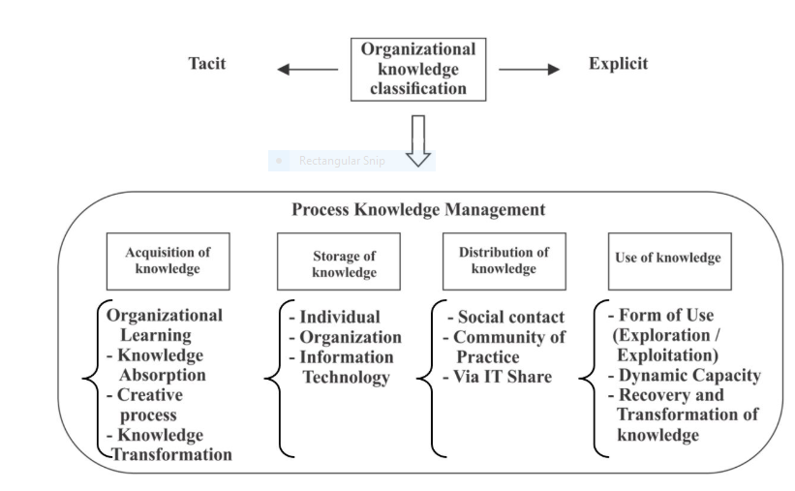
Figure: (Collison, C. and Parcell, G. 2007)

The requirements of knowledge creation
In this stage, Sainsbury’s identify its knowledge sources which are external and internal. It can be seen that for acquiring knowledge at first the company focuses on a process of learning which is responsible for company’s routine performance, the function of the firm and ability of the company to improve a dynamic environment (Collison, C. and Parcell, G. 2007). Sainsbury’s is able to recognize its valuable knowledge assets and capable to know how to incorporate it and apply it in a creative way (Malhotra, Y. 2001). This process of knowledge accumulation makes the Sainsbury’s ability to transform this knowledge in a specialized area.
The requirements of knowledge storage
Sainsbury’s stores its knowledge through the use of a variety of process. At first, it keeps their data of online and another self-service customer in the physical stuff such as databases of the customer (Lyles, M. and Easterby-Smith, M. 2003). The company also stores its knowledge in the form of an individual’s expertise, skill, experience, and specialization. The company has also reputation, values, belief, work ethics, work culture, and the overall process of making the customer satisfied and these all work as storage of knowledge in the form of the positioning of the organization (Gold, et al. 2001).
The requirements of knowledge application
For applying this stored knowledge, Sainsbury’s assimilates this knowledge from their higher level of management to lower level of management (Lilley, et al. 2004). Then for informing the customer, this knowledge shares in the social media use the word of mouth communication and direct contact with the community through the use of information technology (Davenport, T. and Prusak, L. 2000).
The requirements of knowledge integration
After applying the knowledge using various ways and means, now it must be integrated and collaborate with various digital medium and platform such as technology that is web-based, interactive and social media, and an organized website (Lilley, et al. 2004). For this integration process making smooth, an organization must be known about various new technology and adopt new strategies. This integration and transformation of knowledge have been accomplished by the Sainsbury’s by following the requirements of integration (Gold, et al. 2001). The company started to offer service in the online system and opened a self-service store and maintained an organized website and make their customer up-to-date about their new and existing products range.

The Importance of Intellectual Property Rights
The rights of property and properties were given to an individual or an organization on the basis of their unique creation can be defined as intellectual property rights (Lilley, et al. 2004). This right has been given by an authorized company for a certain period of time. An organization can use intellectual property rights to protect their individual knowledge and organizational knowledge being imitated by the third party (Tsoukas, H. and Mylonopoulos, N. 2004).
This intellectual property can be categorized from various perspectives such as rights related to industrial property and rights related to creative and artistic works that can be referred to as copyright (Tsoukas, H. and Mylonopoulos, N. 2004). The intellectual properties of Sainsbury’s are distinctive and unique signs, symbols and logos, products packaging, the physical layout of their store and dress-code of their employees, unique designs of its products, secrets of its selling proposition, innovative knowledge, and skill of its employees (Davenport, T. and Prusak, L. 2000). These rights of intellectual properties achieved for an over a period of time and facilities to broaden the company’s area of the market in the worldwide and don’t need to spend in products familiarization process.
An organization which efficiently manage and protect their intellectual property rights leads to the growth of an economy and contributes to a nation. The importance of intellectual property rights is very significant to an organization just like Sainsbury’s (Gold, et al. 2001). The intellectual property rights give the customers of Sainsbury’s a sense of protection and guarantee that they are purchasing a right and quality product. By using the intellectual property rights, the company can easily take the benefit of using their unique trade systems and invention of new products and services and can invest more and more time in research and development projects (Gold, et al. 2001). The company can easily compensate for imitating their process, procedure and stealing their innovative ideas (Lyles, M. and Easterby-Smith, M. 2003). It also gives courage to Sainsbury’s to take the risk of new and high volume investments. As a result, the company can improve its productivity and can easily minimize their production cost and ultimately offer a superior to the customer and facilitates its licensing process easier.

PART C

The Contribution of Knowledge Assets have on an Organization
This can be seen that there has a valuable contribution to the knowledge assets of an organization to become a leader in the market. For this reason, an organization must identify its various types of knowledge assets (Sanchez, R. 2003). In any organization setting, individual and artistic mind related knowledge assets are given very important than any organizational knowledge assets such as managerial process and procedure and assets related to information technology and techniques (Davenport, T. and Prusak, L. 2000). A very important knowledge asset of a company which gives the way of becoming successful has no value to other organization. If the knowledge assets of a company are rare, difficult to duplicate and have no substitution then it can easily capture consumer and able to retain competitive advantage.
In the case of Sainsbury’s, there have huge amounts of assets which can be defined as knowledge assets of Sainsbury’s. These include firm secret trading skills, capabilities, and competencies of workers and how they are actually using these to create quality output, unique idea of producing products, rights of intellectual property, databases of customer and employees, employees’ skills, experience, creativeness and expertise, success and failure history (Davenport, T. and Prusak, L. 2000). These all knowledge assets leverage the company competitive advantage, empower the employees to take a decision and participate in the decision making process, increase the employees and firms production performance, stimulate company’s employees to enhance their skills consistently and inspire them to make the customer satisfied with their very well and excellent performance.
Sainsbury’s can sustain its contribution of knowledge assets in the way of competitive advantage through the use of information technology, unique strategies such as strategy of minimizing cost, the strategy of distinct and differentiated products, the strategy of creativeness and innovation (Malhotra, Y. 2001). Ultimately these knowledge assets which are physical and human-related help to the development of workers, increase customer loyalty and contentment, develop a culture of communication and collaboration in the company (Davenport, T. and Prusak, L. 2000). So it is important for any organization to identify its knowledge assets and its contribution and properly apply knowledge management techniques to take the benefit of physical and indefinable knowledge assets.

PART D

The evaluation of Knowledge Requirements for the Organization
An organization uses its knowledge in various areas such as to sense and understand the changing environment, to take decisions, to innovate distinctive and new products. It is important to identify the area of knowledge requirements in any organization like Sainsbury’s. The areas in which Sainsbury’s use of its knowledge are the following
The process of decision making: In the case of decision making, Sainsbury’s pulls the knowledge of all employees from top to bottom (Lips, M. 2014). Normally it gives value the knowledge of lower level employee and empowers them if required to make an instant decision.
The process of Problem solving: to solve any arising problem, the first requirement is able to identify the reason of the problem that only possible by the knowledgeable workforce (Lips, M. 2014). An organization requires a bunch of knowledgeable employees who can use their tacit and implicit knowledge at every stage of solving in the case of an emergency situation like as Sainsbury’s.
Stages of Product innovation and development: Sainsbury’s spends a huge amount of money in hiring market specialist and research and development projects so that they can innovate a product which can arise need and demand in the customer mind and continuously improve the existing products.
The process of Customer contentment: To make the customer satisfied, Sainsbury’s use the trained, skilled and experienced service provider and workers who use their expertise and knowledge to reach the products quickly to the customers and increase their sense of loyalty (Lyles, M. and Easterby-Smith, M. 2003).
The process of Cost reduction and Performance improvement: the management of Sainsbury’s continuously use their knowledge and knowledge assets how to reduce their production and promotion cost and improve and enhance performance through the training on the job, seminar, and briefing (Davenport, T. and Prusak, L. 2000).
The process of Crisis management: If any customer becomes discontent and annoyed being late in service providing, the well-bred worker of Sainsbury’s can pacify them easily with their sweet and decent behaviour and give a follow-up message (Gold, et al. 2001). And they can also use any incident as a way of innovation and creation.

So if any organization wants to be successful, it will require to identify the area where actually need knowledge and analyse how can use this knowledge.

The Evaluation of Organizations’ Framework for Enabling Knowledge Sharing
The transfer of knowledge, expertise, skill, and experience from one person to another in an organization can be considered as knowledge sharing. It is not sufficient for any organization to an emphasis on systems of hiring and training that only focused on hiring based on skills, capabilities, and competencies (Davenport, T. and Prusak, L. 2000). An organization can exploit its resources based on knowledge through the sharing of knowledge among workers and inside and outside of the organization.
It is important for any organization to establish a framework by which an organization can facilitate its knowledge sharing among its stakeholders. For making this knowledge sharing easier and smooth, Sainsbury’s organizations’ framework is described and evaluated in the following
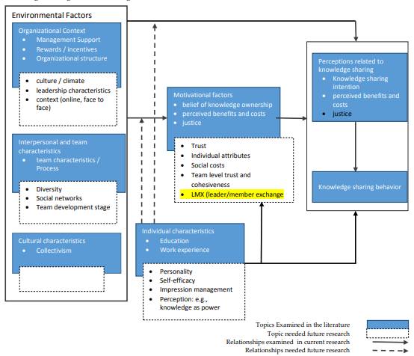

Figure- A Framework for knowledge sharing (Burton-Jones, A. 2001).
The figure can be used as the framework of Sainsbury’s on which it takes the decision of the whole knowledge sharing process. For making the knowledge sharing fruitful, the company has considered its socio-cultural factors, environmental factors, technological factors and motivational factors and culture of the organization (Gold, et al. 2001).
The company has focused on its value creation and credibility which enhance knowledge sharing among the member of groups. The employees exploit the perception of a customer when sharing knowledge and try to seek their attention when they are sharing knowledge because if a customer pays attention then it will motivate the employees further sharing of knowledge (Tsoukas, H. and Mylonopoulos, N. 2004).
While sharing knowledge, it should be kept in mind that the organizational culture and diversity of the various market group. Based on this, it makes their promotional and knowledge sharing message. It also focuses on the individual’s individuality, self-efficacy, and knowledge as a power because based on these qualities what actually will be shared that can be assumed (Lilley, et al. 2004).
The company also takes the help of social networks while sharing knowledge. It helps to maintain its collaboration with customers and employees face to face and online. It also monitors how enthusiastic an employee when it shares knowledge and how much involved while conversation and evaluate knowledge sharing behaviour (Davenport, T. and Prusak, L. 2000).
To sum up, a company can enhance and elaborate its knowledge sharing process through a structured organizations’ framework.

The Recommendation of Improving the Current Framework
The current organizations’ framework is structured and organized but not sufficient for knowledge sharing from bottom to up level. To facilitate knowledge sharing Sainsbury’s have to follow some recommendations and apply in the organization.
An organization fails to share its knowledge within and outside of its boundary because it doesn’t pay attention to the characteristics of individual and doesn’t take account to the context organization and the context of an interpersonal relationship. Sainsbury’s has to maintain its interpersonal relationship among its worker through the organization intranet (Tiwana, A. and Williams, M. 2000). It also has to make diversified a group while sharing knowledge. As a result, if a worker fails to share knowledge properly due to his or her unwillingness then this can be shared by another worker or workers.
A company can boost its worker willingness to share knowledge by giving reward and incentive. It can be given by arranging various competition based on performance and unique way of knowledge sharing (Tiwana, A. and Williams, M. 2000). Sainsbury can use this strategy to enhance their knowledge sharing and can arrange a motivational program for boosting the enthusiasm of workers.
One of the best ways of boosting knowledge sharing is to participate in corporate social responsibility. If an organization participate in any program that main purpose is to help deprived people rather than earning a profit then it is very easy to capture the attention of customers and can emotionally trigger them and very easy to retain the coverage of media (Gold, et al. 2001). It can also organize various awareness programs such as environmental protection and food safety-related awareness. This strategy can be followed by the Sainsbury’s to share its knowledge and make the customer loyal and sustain their relationship. To make the expertise available throughout the organization, Sainsbury can apply the peer-to-peer communication.

Conclusion

Sainsbury is very effective in managing knowledge and the company is successful in using its full capability and knowledge power to attract the customers. They have collected feedback from the customers and used this knowledge to resolve the mistakes and as a result the store patronage increased and the past knowledge and data is used to reduce risk and forecast future needs of the consumers (Tiwana, A. and Williams, M. 2000). The company used different kinds of models and tried to assess the customers to the fullest. For this the company has become a mode in managing knowledge and its management team has to be given the full credit.

Bibliography and references

Burton-Jones, A., 2001. Knowledge capitalism: Business, work, and learning in the new economy. OUP Catalogue.
Collison, C. and Parcell, G., 2007. Learning to fly: practical knowledge management from leading and learning organizations (with CD). John Wiley & Sons.
Davenport, T.H. and Prusak, L., 2000. Working knowledge: How organizations manage what they know. Harvard Business Press.
Gold, A.H., Malhotra, A. and Segars, A.H., 2001. Knowledge management: An organizational capabilities perspective. Journal of management information systems.
Herschel, R.T. and Jones, N.E., 2005. Knowledge management and business intelligence: the importance of integration. Journal of knowledge management.
Ichijo, K. and Nonaka, I., 2007. Knowledge creation and management: New challenges for managers. Oxford university press.
Lilley, S., Lightfoot, G., Amaral, P. and Amaral, P., 2004. Representing organization: Knowledge, management, and the information age. Oxford University Press.
Lips, M., 2014. Transforming government—by default. Society and the Internet: How Networks of Information and Communication Are Changing Our Lives.
Lyles, M. and Easterby-Smith, M.P., 2003. The Blackwell handbook of organizational learning and knowledge management. Blackwell.
Malhotra, Y. ed., 2001. Knowledge management and business model innovation. IGI Global.
Quintas, P., Lefrere, P. and Jones, G., 2007. Knowledge management: a strategic agenda. Long range planning.
Sanchez, R., 2003. Knowledge management and organizational competence. Oxford University Press, Inc.
Tiwana, A. and Williams, M., 2000. The Essential Guide to Knowledge Management: E-Business and Crm Applications. Prentice Hall PTR.
Tsoukas, H. and Mylonopoulos, N., 2004. Organizations as knowledge systems. Palgrave Macmillan, a division of Macmillan Publishers Limited.

