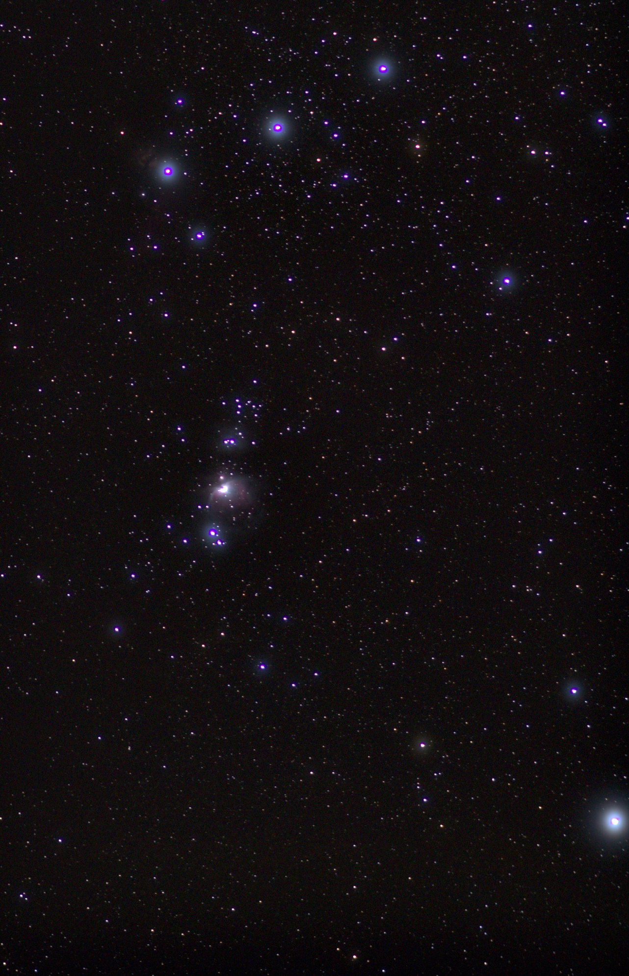
“Inspired by the Heaven Above”
My final printed image was a crop of the image above. I didn’t have the foresight to save that crop before printing so I can’t exactly replicate it and don’t want to make an incorrect attempt here. The reason I did so was to put more focus onto the busier portions of the image, namely the three stars of Orion’s Belt and the Orion nebula. I felt fine in cropping out parts of the image because of the working philosophy I’ve had for the later parts of the project, being that it’s not necessarily about which stars are captured but rather the sheer beauty of the starscape, which allowed me to feel more comfortable omitting parts of the image in favour of changing its focus points. In addition to this, the curation team ended up mounting the image upside-down on the wall thanks to my lack of foresight, not labelling the correct orientation of the image and not realising that it’s not immediately obvious to most people. I noticed it immediately, as would anyone with any real interest in the subject, but nothing about this mounting was actually incorrect. If anything, it opened my mind a little.
The inverted nature of the constellation visible gives thought to the southern hemisphere, where looking up at the stars presents you with an orientation inverse to our own in the northern hemisphere. Presenting them in this way sort of inlaid a bit of hidden political commentary on the northern-centric nature of global societies. Up here in the north we rarely give pause for thought of anything in the south. None of this is at all relevant to my aims with the imagery, but it still remains interesting.
I did look into potential other methods of presenting the image in-gallery, including with a sheet of writing detailing what’s visible in the image and making links to various things like Orion’s links to Greek mythology. In the end I decided to not try and complicate it, and just let the image speak for itself. Not least assisted by the curatorial decision to give the image its own wall (a totally unexpected choice, but one I very much appreciate.) I feel that presenting the image alone helped enforce the idea I was following when formulating the idea, as mentioned in the initial responses to the short story. Speaking of which, I chose not to include my submission for that task in with the body of work here despite it being topically suitable, as I believe I have improved in the imaging process and do not feel that this image reflects the quality standards I aimed for when imaging.
Taking on a project like this was perhaps not the smartest move, venturing into a field of photography in which I’d never really done more than marvel at and having to learn a lot of new processes and techniques resulted in a lot of trial and error, resulting in about a 60% failure rate thanks to odd white balance caused by light spilling in from the city behind me, among other things. Every night that there was maybe even an hour-long gap in the clouds you can bet your bottom dollar I was out trying to make something. The unpredictable weather conditions of late haven’t been very helpful, however I would make arguments on the merit of each image given the difficulty of obtaining the many tens or even hundreds of exposures needed to compose each final image. For a lot of these images I feel like I’ve made some rather good work in the face of these unavoidable hardships.

