

Student ID:2027887

Digital Skills and Research Methods
Module code: BMSW4003

Assignment 2 Research Report

HOW TECHNOLOGY IS TRANSFORMING IN OUR GP SURGERY AND WORKPLACE

CONTENTS

- Introduction……………………………………………………………………….3

- Research report on the impact of technology in our general practitioner surgery’s workplace………………………………………………………………….4,5,6,7

- Methodology……………………………………………………………………………8

- Conclusion……………………………………………………………………………….9

- Reference…………………………………………………………………………….10

INTRODUCTION

Digital technology is transforming our NHS healthcare system and local general practitioner are now better equipped. Also, it is easier for GPs to access and collect patient medical information on a daily base, with the software data and different device.

The advanced digital technology has carried about a significant modification to the health care industry, as patients now have access to some best diagnostic tools and cutting edged equipment for many treatments and can operate on the smallest procedures resulting in less pain and quicker healing and recovery.

Today’s general practitioner surgery is not always managed or controlled by NHS, as some surgeries are run privately or sometimes a small group of companies, or in partnership with the GP or other times can be a larger organisation. GP surgery has progressed from paper pens and files to new digital technologies. All patient records are now stored on computer device and GP’s can deliver online video consultation. GP surgeries are always diverse and always delivering care to patients. However, some surgeries are still very traditional and still use the old blood presser wrap and still doing checks on paper, and with some surgeries they have the new and advanced technology, with live video chats.

There are a few challenges the healthcare is facing in the world, healthcare industry has one of the biggest challenges that is the cost of running the healthcare system, government are concerned if they can continues providing full care to patients with medical needs in the community, they are aware of keeping people healthy will mean less cost for the government, also keeping in mind the ageing community,

TECHNOLOGY IN GP SURGERY

Although some digital technologies and new tools are in operation theatres, even some basic smartphone technology can help with information and have a positive impact on patients before and after operations. Already we have NHS app that allows people to book general appointments online. Phone app can activate many services through a system which incorporates with ambulance service, it can be very useful when doctors need to dispatch any nearby trained healthcare professionals while an ambulance is on way to patent, doctors now are able to heal wounds and monitor patients’ wounds by using video calls live chat after their surgeries. A simple smart watch can monitor pulse and collect data on their heart rate, patients can monitor their calorie and watch what they are eating and checking the body temperature. source Kerr, R., (2020)

Communication and collaborating with digital technologies is very successful and easy to implement now, the healthcare industry functions better with the advanced tools which enables to communicate better doctors with patients and with their care workers through the advanced technology’s, with modern technology medical specialists have now have access to many research studies as well as helping the diverse population groups ,this offer new insight into diseases and other medical needs, and this way GP can achieve better care outcomes for the patients. Medical Care workers can compare patient data with other patients, GPs can assess and suggest preventive treatments using this new technology. This technology has given a huge improvement to medical tourism who can travel any part of the world and making it possible for patients to get in touch with specialists practically any part of the world for consultations and second or third opinion regardless of where they themselves are located anywhere around the globe technology has made this possible, all doctors can follow on remote communications such as video conferences, patients can then travel to another country to receive better treatment or highly advanced surgery if they wish. Source Jones, M., (2018)

According to Burney, A et al (2010) Advance technology in information and communication technologies development has raised way for delivering cost efficient services to the people around the globe. The blend of such wireless technologies with e-health is known as m-health. In general terms, m- health can be defined as mobile computing, or medical device, and communication technologies for healthcare. The applications involve the use of phone and other interaction devices to save health data, or transfer of healthcare information to medical doctors, researchers, and patients. It also includes actual and direct provision of health services. It can help improve clinical outcomes and contribute to better public health monitoring and future learning. This scheme will be very handy in locations where there is a lack of healthcare services and organisation. ICT establishment can be used to get medical advice from health professionals at distant location done with the support technology.

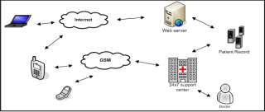
Picture (1) Source Burney, A et al (2010)
Concept of M-Health system

There is suggestion that for patients with continuing conditions, have improved use of virtual meetings has meant that patients seem more involved in aspects of self-care and that improved use of telephone and video triage models has contributed to concentrated presences at any NHS services, additional evidence is required to know whether this is the case or not. It is also not clear how far patients use of digital alternatives will continue once the NHS resumes more routine care. Society may have acknowledged during Covid that remote care was the right and single option, but this doesn’t essentially mean that they choose retrieving services remotely.
Recent Covid-19 pandemic has showed that most country in the globe have adjusted to new healthcare services to manage with the covid -19 crises, hospitals had to increase bed for the increasing demand, healthcare services had to cancel GP and hospital appointments, more online consultation was getting book with the doctors. Source Hutching, R., (2021)

SAFETY AND SECURITY IN THE GP SURGERIES AND HEALTHCARE WORKPLACE

The basic law and safety in the United Kingdom are the legal system, the health and safety at work act 1974, all employers and employee must follow the guidelines, the second law is the management of health and safety at work regulations 1999, the main duties of employers are to assess Risk Assessment instructions, to make suitable and sufficient assessment of the hazards to employees and others arising from their work activities. Making sure to Put in place adequate control measures to eliminate or minimise the risk. Record significant findings when necessary.

Another main duty of the manager in the healthcare workplace is to appoint adequate number of competent people to assist the employer to comply with his health and social arrangement, the manager needs to employ competent person. Manager needs to provide information and suitable training. The staff needs to understand fire and emergency plans, all staff needs to consider their own health and safety and health and safety of others, staff must cooperate with their employer and colleagues, staff must maintain the management of health and safety, employees must carry out the work given to them, employees must understand the hazard in workplace and go through the risk assessments,

The new wireless medical sensors are put in to monitor data for doctors and patients, this network covers a range of medical applications, sensor services is put there to help with patient care all data of medical and important information can be easily collected for the patient and can be shared with other doctors if necessary, as with all technology there are certain advantages and also disadvantages, this applications can provide a wider support for patient and there family , but some disadvantages is that some hackers can use patient data and some private matters can be leaked out or used for the wrong reasons, this is why strict laws are put in place, some case the healthcare providers can be subjected to criminal penalties or sometimes put in prison, this is why it is very important to follow strict laws and follow all instruction’s that the law has implemented. Source Kumar, P., (2012)

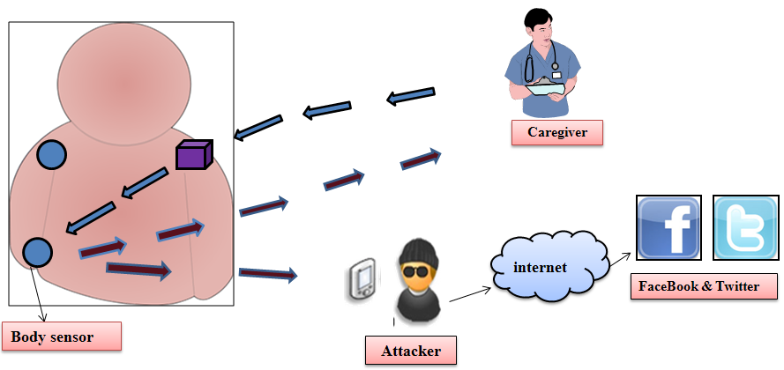
Risks to patient privacy
Picture (2) Source Kumar, P., (2012)

security and confidentiality matter in healthcare industry requests using medical sensor networks. It has been revealed that planned security device must be considered for the successful distribution of such a wireless application. we have found various important challenges in applying a secure healthcare monitoring system using medical sensors, which reflects the fact that if a technology is safe, then people will trust it, or its use will not be useful, and could even endanger the patient life. Eventually could cause countless security and privacy issues in healthcare applications using wireless medical sensor networks still need to be searched. Source Kumar, P., (2012)

Methodology

In terms of research methodology I used case study from various articles and different website to explain further on the recent changes in GP surgeries ,as digital technology is changing every day there are new tools introduced ,if we compare to twenty years ago, GP surgeries were run on paper and pen with all the filing systems in place for patient, and GP had to write patient report on paper files even write prescription for patients medicine, the recent information show that new technology are being used and is making work easier and quicker we save time and work is done more efficiently.

Research has showed that the risk and security issue that comes along with the new technologies are also there. The study shows with the picture (1) case study showing the medical system, and picture (2) case study of patient risk and security with the healthcare

CONCLUSION

The advanced digital technologies are better used and effectively running the healthcare industry like the GP surgeries in some parts of the world than others one of the reason the research show the developing countries are not fully equipped with the advanced tools yet. But more developing countries like America and United kingdom have advance connection to technology and have rather more efficiently and improvement in patient care however some developing countries are still catching up gradually, Healthcare workers who have not yet embraced digital tools and technology, recent study shows digital technology can lower costs and increase efficiency and most importantly digital tools can help to improve quality of patient care, the security and privacy issues in healthcare industry has been shown that a planned security in placed can be successful in the placement , several researchers have discovered important information to work well the healthcare needs there are important challenges is crucial in implementing a secure healthcare monitoring system using medical sensors for the workplace which can work better and reflects that if a technology is running safely or not, this can help to keep trust in people. furthermore, it cannot be useful and will not be applied to use and could then patient life at risk and the confidentiality, many security and privacy issues in healthcare applications using wireless medical sensor network services and still need to be tested and this can motivate the future researchers to come up with more strong security appliances for healthcare services as digital technology is continuously improving and as we can see we are still it is improving and new technology are evolving .

Safeguarding patients details and information is very important the trust between all healthcare employers and employees needs to be there , healthcare workplace need to be extra careful and work together to deliver more effective services and can work productively, there are rules and regulations that need to be followed, workplaces have law put in place, simple and easy rules so staff must follow clear instructions at the healthcare workplace this is for their own safety and other staff members.

REFERENCE:

Burney, A., 2021. [online] Available at: <https://www.semanticscholar.org/paper/Information-and-Communication-Technology-in-for-Burney-Mahmood/70ae1fa4630c93e996a81faeccdd4b9b9fd38a31> [Accessed 21 August 2021].

Hutchings, R., 2021. The impact of Covid-19 on the use of digital technology in the NHS.
[online] The Nuffield Trust. Available at: <https://www.nuffieldtrust.org.uk/research/the-impact-of-covid-19-on-the-use-of-digital-technology-in-the-nhs> [Accessed 30 August 2021].

Jones, M., 2021. HealthCare: How Technology Impacts the Healthcare Industry. [online] Medium. Available at: <https://healthcareinamerica.us/healthcare-how-technology-impacts-the-healthcare-industry-b2ba6271c4b4> [Accessed 31 August 2021].

Kerr, R., 2021. [online] Rcpjournals.org. Available at: <https://www.rcpjournals.org/content/futurehosp/7/1/46.full.pdf?download=true> [Accessed 1 September 2021].

