BMSK 4004
Problem Solving and Decision Making
Name of the Student:
Syed Hossein
Student ID
1705778
Lecturer
Ze Zook
Name University
University of Wales Trinity Saint David
Course
Certificate of Higher Education in Skills for the Workplace
Semester: June 2018
Submission: August 2018

Contents
Introduction 4
Case study 5
Defining the complex problem in the workplace including its scope and impact 6
Scope of the problem 6
Impact of the problem 6
Defining the problem 6
Analysing information on the identified problem, to help inform the decision making process 8
Fish bone diagram 8
Forces Field analysis 9
Proposing a range of alternative solutions to the problem 10
Reducing license fee 11
No license fee 11
Digital technology 11
Employee motivation 11
Efficient utilization of the resources 12
Competitions from another channel 12
Evaluating the possible solutions to identify the most appropriate option 13
No license fee 13
The threat of these features 13
The possibility of this solution 14
Developing a plan for implementing the solution 15
Communicating the plan to stakeholders 16
Assessing appropriate monitoring and review techniques to ensure successful implementation of the solution. 16
Clarify the Expectations 16
Setting regular monitoring intervals 17
Choose a way to collect data 17
Conclusion 19
References 20

Introduction
Companies are always concern about the profit maximization. They most of the time use several techniques to ensure keep it right. But there are some problem arises that they can’t avoid. Solving that problem becomes their headache. There are tons of framework theories are there but not all of them is useful. To dig dipper most of the time some problem solving sessions are taken in big companies to give them the clear idea about the plan. In this part most of the managers try to involve employees form all the part or departments. This enables the manager to get a clear understanding of the problem. This is important because not all problems we consider are the problem or issue. Some problems are symptoms. Symptoms most help the problem to happen.

Case study
John Brit joined as a deputy director general of BBC in 1987. At that time British Broadcasting Channel (BBC) has the best position in the industry. As the industry was changing rapidly a critical changing wave was going on. And BBC had to cope with that.
The revenue model of BBC is mostly dependent on the broadcasting fee from radio and channels. But at that time the British government freeze their license fees. So they started making no profit from the core business (Hickson and Khemka, 2013). But the company had to satisfy a good number of high overhead costs. That situation started a questionable situation in the company at that time.

Defining the complex problem in the workplace including its scope and impact

Scope of the problem
The case study shows that BBC is facing a number of problems regarding its revenue model. The revenue model of BBC defines the sources of the value, which sources to pursue, which service to offer and what will be the price. As BBC is currently dealing with problems of its revenue model, the company is to deal with all of the aspects of the revenue model. The company should identify the best sources of values to pursue, then which of the services will be offered and what will be the offering price.

Impact of the problem
As the problem is related with the revenue model of BBC, the impact of the problem can be hazardous. As the main objective of each business institution is to earn profit, problems in the revenue model of the business can lead to the failure of the main objective of the business. Moreover, BBC is not willing to introduce a new model or technique. As a result, the problem can become a bottleneck for the company in the upcoming days.

Defining the problem
In the case of BBC, the revenue model gives them a headache for like decade. Most of the managers were unwilling to change the whole formation. Most importantly they were not interested in introducing a new technique; rather they start thinking this may cost them more money. To understand the problem in the deeper scene. A popular technique will be used and that is:
SWOT analysis
Strengths
- Reputation: a reputation for honest reporting is an important plus point for a company like BBC. Telecast range of the company is increasing day by day. The reporting quality is also acclaimed in the whole world. BBC has some poplar shows like EastEnders or casualty.
- The market leader: for the strong broadcasting channel BBC was the market leader in the telecom industry. They streamed round the globe (Saaty, 2015). The CNN has the same sort of competence but the reach still to be acquired.
- Ample resources to cover any major event: the company has the capability to arrange any type of big events any time they want. They most of the time arrange the Royal programs of their own. No other company has the right of doing the same. They had two most sophisticated cameras which are not common in this industry.
Weaknesses
- Resources wastage: Highly bureaucratic procedures most of the time lead to inefficiency. This inefficiency mostly happens with the resources and the rate is 25 to 50 % of all the resources.
- Distribution: Regionally unwarranted authority mostly hampers the distribution channel of the company. This also cost more money.
Lack of planning: Lack of business process knowledge also a threat to the portfolio planning. This also allows avoiding solid planning of the company (Baumberger-Henry, 2017).
Opportunities
- Cost optimization: the cost of broadcasting can easily be optimized through the optimum planning of the available resources. Introducing some modern tools may help.
- New business markets and models: different business model are now available to reshape the whole business. Only a suitable transformation can help.
- International Expansion: right now the company only covered 60% of the whole there is almost 40% market still in an untapped condition which can be penetrated.
Threats
1. Government policies: as the new policies are not allowing the company to earn through the silence. The cost of operation is now increasing.
2. Unbalanced financial records: there is a deficit of £100m in 1992. This is a threat for the company in upcoming years.
3. Digital technology: a good competition is coming up from the side of digital transformation from companies like BskyB (Baumberger-Henry, 2017).

Analysing information on the identified problem, to help inform the decision making process
Now we need to understand the problem from different angels of a company. There are several issues that may cost the company a lot. But not all the problems we need to address in this part. And most of the time there is a core problem that is fueled by some symptoms. A problem identifying model will be used:

Fish bone diagram
In the fish bone diagram, there could be more than one reason for making the issue but the main problem will be one. And the other issues will be considered as the symptom. And those symptoms will be fueling the main issue or the problem (Callaway and Esser, 2014). In the case study of BBC one problem that caused a headache to the management. And that is the lower revenue. This is the main problem and another issue that is fueling this issue is the symptom.
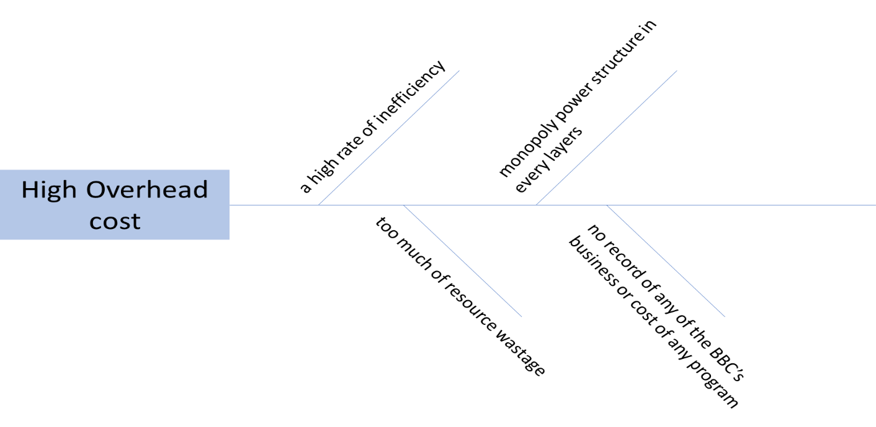
Figure 1: Fish bone diagram of BBC’s ‘Birt’s Wave of Change’ (source: Deber et al, 2016).
The high rate of inefficiency: all the employees are not well aware of the costing of the production. Some of them most of the time utilize more money than they are assigned of. Some of the programs are not that much profit making. Due to the political and other pressures, those programs telecasted. The average TRP was less than 2.5 of those programs.
Too much of resource wastage: As the loss projects like Soap Opera, the Borgias (1981) etc. were helping the company with losing money rather than making any. But the management was not thinking about those projects at all (Peterson at. el, 2016). These programs were also hampering the production house of popular shows, as the resources were used by the unpopular shows. The resources are limited so it is impossible to use all the resources in every production at a time.
Monopoly power structure in each layer: this thing happen because in all the head of the structure is monopolized by a person who is old and a bit arrogant. This mostly happens with the lack of the motivation in the whole workplace (Rasmussen, 2014). All the team needs to be worked as a team rather just one will be leading it from the front.
Keeping no record of any of the BBC’s business or cost of any program: this one symptom contributing 40% of the main problem. The bookkeeping practice is a worldwide accepted one. This helps the companies to track all their costing and track down the revenue consuming portion of their whole business model. At that time this practice was missing. And this at the end of the day cost the company a lot.

Forces Field analysis
This is a process where an assessor gets the opportunity of responding to the different environmental change and a strategy to cope with the market needs (Flanagan, 2013). In this technique, we have seen the company has the same issue that we faced earlier. Here all the challenged is placed with the help of our previous models. These models help the assessors to understand the problems in dipper way and a possible solution can be placed.
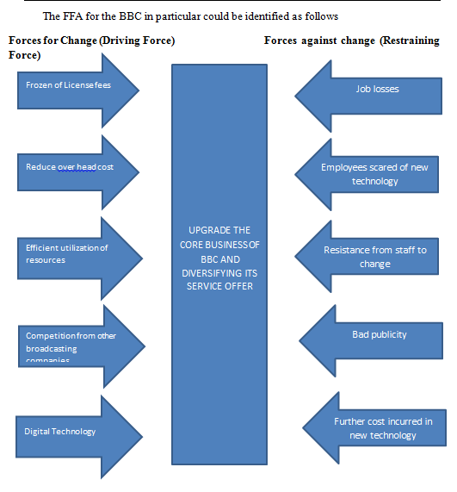
Figure 2: FFA model (source: Deber et al, 2016).

Proposing a range of alternative solutions to the problem
From the very beginning of BBC considered as a well diverse organization. There are 28,000 employees are working in around 600 offices in the world. So the change strategy for a company like BBC is not that easy. But the fact is that if this change didn’t take place in time this may more detrimental for the company. The core problem is solely identified in the previous portion. A model for possible solution and threat for that solution will be placed in this portion. When Brit joined BBC it faced a deficit of £100M (Baumberger-Henry, 2017). A fast reformation was needed for the company. At the same time, the company faced high competition for the technological advancement and new market opportunity. At that time the company underutilized their resources and there are some severe drawbacks to the model of operation.
There are several possible solutions, we have for this problem:

Reducing license fee
Possible changes: The license fee that the company right now earning need to be reduced. The yearly or bi-yearly model needs to be introduced.
Threats to the change: if this thing implemented the one this happen and that is job cut in all the 600 offices. Which may be hurt the reputation of the company (Flanagan, 2013). Thought this process will reduce the costing but the quality of the news may go down lack of manpower.

No license fee
Possible changes: If the government doesn’t allow the company to collect further license fees that would be a problem. Then the company needs to broadcast without money. This is always a tough call. But this problem can be solved by introducing two different features (Flores at el., 2016). One is free and another one is premium. In the free mode, viewers will be allowed to watch the channel free of cost but will have to watch advertisement instead. In the premium, no ad will run. Viewers will watch it ad-free. This will allow the company to earn more money.
Threats to the change: this may cost our viewers times. If they need to watch TVC, then that may cost good some of the time. So viewers will be reluctant of watching our channel. The number of viewers will reduce. This would be a bad sign for the company.

Digital technology
Possible changes: by introducing new technology is the best way of reducing costs and ensuring the best quality programs for the people (McFadzean, 2017).This new way also allows the company to be in the head to head to the competition of the competitors. Broadcasting to all around the world would be easier.
Threats to the change: the cost of this transformation is not lees. This will cost the company a lot. Now the company already in a deficit of 100 million euro. And this new project may require another 100 million at least. The cost of training of the employees is also very high.

Employee motivation
Possible changes: this will allow the company to ensure a better workforce for the company. People will not only find the motivation in the money rather the satisfaction in the job will be a good player for them.
Threats to the change: before motivation, most of the companies fail to identify the need of the people or the employees (Flores at el., 2016). This process allows the employees to be more frustrated about the things surrounded by them.

Efficient utilization of the resources
Possible changes: not all the program runs all the yearlong. So a schedule needs to be prepared when the resources are required and how much that should be (Kirkwood, 2016). And the resources would be outsourced or self-owned. By the schedule, the costing can be reduced. A planning will be implemented for the whole process.
Threats to the change: in the season of the cinema making the rescores price most of the time goes up. This is always a threat for the company. So to reduce this outsourcing can be costly options for the company.

Competitions from another channel
Possible changes: this threat was always available in this industry. In recent, the competition is too much for the technological advantage (McFadzean, 2017). Unique program and different channels for different shows may help to be up in the competition. Sports channel for all sorts of sports, other series will be under the different channel.
Threats to the change: to be head to head with the competitors this will cost more money. But pushing the limit always a plus point any company in the world.

Evaluating the possible solutions to identify the most appropriate option
From all the problems the core problem that we found from the frameworks is the funding or the costing issue. This is not a problem that arises all the day long but this most of the time allows the company to cut its profit. In this part, the best two suitable options will be taken from all the options available.

No license fee
To decrease the costing problem this is the best option available. Because of the government order, the company will not be allowed of collecting any fee from the viewers. These wills lead the company to fire employees (Thornton & Dumke, 2014). Layoff most of the time fall the company in severe crisis. In some cases, some most important employees go off the track and when a new employee needs to be recruited a huge training is required. This also cost a good sum of money. There would be 2 plans available for the viewers. One would be a free one and another one would be the premium one. The premium one would charge some pound.
Free of cost subscription: this would be the free version of the BBC broadcasting. A pilot project will go on the basis of the people’s demand. This free will cost the time of the viewers. The free version will air TVC with the entire program. Some programs may be requiring more TVC if that cost more money to produce that (Marsiske and Margrett, 2016). This plan is the suitable one in the 2nd and 3rd world countries. The reason is they mostly reluctant to pay a pound for any sort of program. This free version will allow the channel in overseas.
Premium subscription: this would be a costlier version of the BBC broadcast. But this can be targeted to the upper-class people. Those people have less time watching any sort’s unnecessary things. So they will look for some prime subscription package. Premium portion will also allow viewers of some special shows. The pricing of the subscription needs to be low. This will allow avoiding under subscription.

The threat of these features
For proving the free services the new advertising unit needs to be introduced. As the channel will be broadcasted all around the world the cost of advertising on our channel will be higher. So there is always a possibility that sometimes the channel has to broadcast shows without any slot (Kirkwood, 2016). The premium on is not the suitable one for the 3rd world countries or the lower class people. So this need to keep in mind.

The possibility of this solution
This solution will help the company with more revenue. And this will allow the company to come up from the deficit. The company can easily avoid the layoff problem.
- Digitalization
To ensure that the company is in the competition this is an important tool. Without digitalizing the whole platform a company can’t be at the top of the industry. BBC started facing competition from BskyB (Reese and Rodeheaver, 2015). This digitalization may cost lost of money so this can only be possible if the company allow the 1st project of No License Fee. This solution is not helping the company with reducing the overhead cost rather it is helping the company with a good prospect in the future and be a leader in the industry.

Developing a plan for implementing the solution
Pilot survey: to let people know more about the product and services that BBC will be provided within a few days a survey need to be conducted. This will help the team to understand that how the people will be reacting to this. This will take good some of the time to enter every single country at once a proper plan of the whole launching needs to be ensured. Only 70% acceptance rate will be accepted. The survey sheet needs to be well informed. As this will be the determinant of taking the project or rejecting it.
Defining the target market: after the survey a clear understanding will be ensured. Which package will be suitable for what region? According to that a marketing plan need to be introduced (Lindblom, 2016). Most of the time 70% of the project fails because of not fulfilling the expectation of the time or the completion of the time.
Marketing plan: some new feature will be introduced so a solid marketing plan is important. Otherwise, this entire project will be in vain. A product launch ceremony for the company is the best option available. For the subscription package services newspaper or a big event, sponsorship is enough. Celebrity endorsement is also a good option for the company like BBC. The digitalization will take place only after the success of the subscription model.
Timeline: this is the most important part of a plan. All the time will be placed I in accordance with the project. Most of the employees will not well aware of this but proper notification is important (Peterson at. el, 2016). For the 1st project the time will be 2 years and after accumulating enough money from the 1st project the 2nd one will be introduced and that is the digitalization project. This 2nd project will take around 1 to 3 years to go on live. So the proper use of it is important. For monitoring the time line a person will be assigned with all the amenities. The projects time is calculated considering all the information and all the possibilities like, survey, marketing for a certain time.
Alternative plan: If the 1st plan fails only the free version will be introduced to ensure the best option of the company (Rasmussen, 2014). This will at least ensure profit and help the company not to sink. This will also ensure the employees that there would be no layoffs. The motivation will be also keep in the right track.

Communicating the plan to stakeholders
The stakeholders of a business company are the people who are somehow related with the operations of the business. Whenever a company devise or change and implement a plan or a project, it is crucial to communicate the plan with the stakeholders as the stakeholders are the parties who will implement the project. As different stakeholders have different expectations from the plans of the business, the most effective way to meet these expectations is to meet the stakeholders on a regular basis and keep them updated regarding the progress of the plan (Smith et al., 2014). Besides, a proper communication with the stakeholders allows the business to keep the visibility of the plan intake.
In the case of BBC, the company is planning to make some changes in its revenue model by introducing free subscription and premium subscription. In premium subscription, the viewers will have the access to some popular shows which the free subscribers won’t have. The company should communicate this plans properly to the stakeholders to avoid confusion among the stakeholders. Besides, the shareholders of the company should also be notified of the changes. As the revenue model is directly related with the revenue as well as profit or loss of the institution, the shareholders have direct interest in the revenue model. So, changing the revenue model lead to the emerging of adverse attitudes of the shareholders towards the company.

Assessing appropriate monitoring and review techniques to ensure successful implementation of the solution.
There will be a monitoring team which will ensure that all the time is met. People of all around the world will be watching the shows at a time so the synchronization of the show schedule is important for the channel (Reese and Rodeheaver, 2015). Sometimes company miss that the plan is set no need to be monitored. But this is a wrong idea. Because without monitoring the goal of the whole project will go vain. So a total plan for monitoring is important.

Clarify the Expectations
The goal of the monitoring or the project needs to be well defined. A plan needs to introduce to the people. This will help them with the achieving the end result. a master plan need to be developed (Reheem, 2015). The target market services will be offered need to be well defined. The time line needs to be set with proper explanation and task.
A proper justification of all the solutions needs to check. As all the information need to be passed by the company executive board. All the survey result needs to be checked whether all the information is used to they need more information (Saaty, 2015). A marketing agency needs to be hired to ensure that people know about the product or services we will be offering. The plan B or the alternate plan for the company need to be set all the time to ensure if an6y discrepancy happen, what the team will do.

Setting regular monitoring intervals
Discovering a great equalization between screening excessively soon or excessively may be regularly. A challenge, particularly though one’s new to venture administration. Though one is continually checking to with one r group alternately expecting them with a report card with one each day, it camwood feel like one’s micromanaging Furthermore one don't trust one r group (Simon at. el, 2012). Assuming that one try excessively yearn between check-ins, one might figure out a really late that those project will be behind planned alternately hit a major obstacle.
Planned weekly following meets expectations great to a large number of undertakings. A few ventures might worth of effort best with bi-weekly alternately month to month check-ins. Others might have checked more habitually if that turn-around time may be short alternately the timeline can't move a great part. Settle on an interim that fits one r needs and the project timeline, also impart the individuals reporting weight desires to one r less group.

Choose a way to collect data
The initial part about gathering information will be comprehending how you're setting off should get that majority of the data from your cooperation. You might ask venture members to self-report, however, you might use additional time reminding individuals to weigh in for you alternately following down points on task advancement. A simple best approach will assistance Everybody recall What's more guarantee you get that illumination you need may be will have a standing gathering In the decided interim (Smidts at.el, 2017). That could mean you have a fast weekly meeting the place everybody reports Advance. This reason the gatherings also provide for you an opportunity should address issues that emerge. Keep those reason the gatherings short Also to the point with aggravate them concerning illustration effective similarly as conceivable.
Alternate and only gathering information may be choosing how you're setting off on track it. Spreadsheets the table versant capacities on keep track about tasks, prioritize responsibilities, relegate obligations Furthermore handle different observing assignments. The spreadsheet configuration considers the color coding Furthermore simple association of the data. You might likewise utilization venture administration product to keeping All that straight (Thornton & Dumke, 2014). When you decide a method, use it reliably something like that it’s a dependable asset to keeping all that ahead track. Whether different kin enters information or aggravate progressions of the spreadsheet, situated rules Also principles for the individual's progressions to guarantee consistency.

Conclusion
Authoritative of any company change will be no more a detached figure which is foreseen best throughout a certain time to time. At a society which needs with a chance to be inserted of the association with receive Furthermore keep up of the regularly evolving earth for that practicality. Also the development of the association. Those human assets are recognized. A magic and only this transform administration that will assistant encourage those desires of the transform system. Henceforth the right methodology must be utilized toward the tight the long run Comprehension the necessity of the association in this worldwide setting. Hence recognizing the sum over Realities FFA Might make acknowledged as the best system to BBC. Not all the system is perfect rather sometimes it requires the attention of the employees and the managers how to solve the issue of an everyday life. There can be lots of options available but the fact is that only the best options need to be taken. That doesn’t matter would that cost more money or not the satisfaction of the employees and betterment of the company need outmost priority.

References
- Baumberger-Henry, M., (2017). Cooperative learning and case study: does the combination improve students’ perception of problem-solving and decision making skills? Nurse education today, 25(3), pp.238-246.
- Callaway, M.R. and Esser, J.K., (2014). Groupthink: Effects of cohesiveness and problem-solving procedures on group decision making. Social Behavior and Personality: an international journal, 12(2), pp.157-164.
- Deber, R.B., Kraetschmer, N. and Irvine, J., (2016). What role do patients wish to play in treatment decision making?. Archives of internal medicine, 156(13), pp.1414-1420.
- Flanagan, R. (2013). Problem Solving in the Therapeutic Process: Strategic Decision Making in Cognitive Behavioral Therapy. PsycCRITIQUES, 5858(5151).
- Flores, L.Y., Ojeda, L., Huang, Y.P., Gee, D. and Lee, S., (2016). The relation of acculturation, problem-solving appraisal, and career decision-making self-efficacy to Mexican American high school students' educational goals. Journal of counseling psychology, 53(2), p.260.
- Hickson, L. and Khemka, I., (2013). Problem solving and decision making. The Oxford handbook of positive psychology and disability, pp.198-225.
- Kirkwood, C.W., (2016). Strategic decision making: multi-objective decision analysis with spreadsheets (Vol. 59). Belmont, CA: Duxbury Press.
- Lindblom, C.E., (2016). The intelligence of democracy: Decision making through mutual adjustment. Free Pr.
- Marsiske, M. and Margrett, J.A., (2016). Everyday problem solving and decision making. In Handbook of the Psychology of Aging (Sixth Edition) (pp. 315-342).
- McFadzean, E. (2017). Developing and supporting creative problem‐solving teams: part 1 – a conceptual model. Management Decision, 40(5), pp.463-475.
- Peterson, G.W., Sampson Jr, J.P., Lenz, J.G. and Reardon, R.C., (2016). A cognitive information processing approach to career problem solving and decision making. Career choice and development, 4, pp.312-369.
- Rasmussen, J., (2014). The role of hierarchical knowledge representation in decisionmaking and system management. IEEE Transactions on Systems, Man, & Cybernetics.
- Reese, H.W. and Rodeheaver, D., (2015). Problem solving and complex decision making.
- Reheem, M.A.A., (2015). Problem solving and decision making. Pathways to Higher Education.
- Saaty, T.L., (2015). Creative thinking, problem solving and decision making. Rws Publications.
- Simon, H.A., Dantzig, G.B., Hogarth, R., Plott, C.R., Raiffa, H., Schelling, T.C., Shepsle, K.A., Thaler, R., Tversky, A. and Winter, S., (2012). Decision making and problem solving. Decision making: Alternatives to rational choice models, pp.32-53.
- Smidts, C., Shen, S.H. and Mosleh, A., (2017). The IDA cognitive model for the analysis of nuclear power plant operator response under accident conditions. Part I: problem solving and decision making model. Reliability Engineering & System Safety, 55(1), pp.51-71.
- Smith, R., King, D., Sidhu, R. and Skelsey, D. (2014). The effective change manager's handbook. London: Kogan Page.
- Thornton, W.J. and Dumke, H.A., (2014). Age differences in everyday problem-solving and decision-making effectiveness: A meta-analytic review. Psychology and aging, 20(1), p.85.

