University of Wales Trinity Saint David


Component 2- Individual report- Information Systems Improvements
Name:
Samia Kousar
ID:
2211601
Module:
LCLM5004 Managing Business Information
Date:
March 14, 2026
Word count:
2146

Kalori Ltd. – Overcoming Operational Challenges through Information System
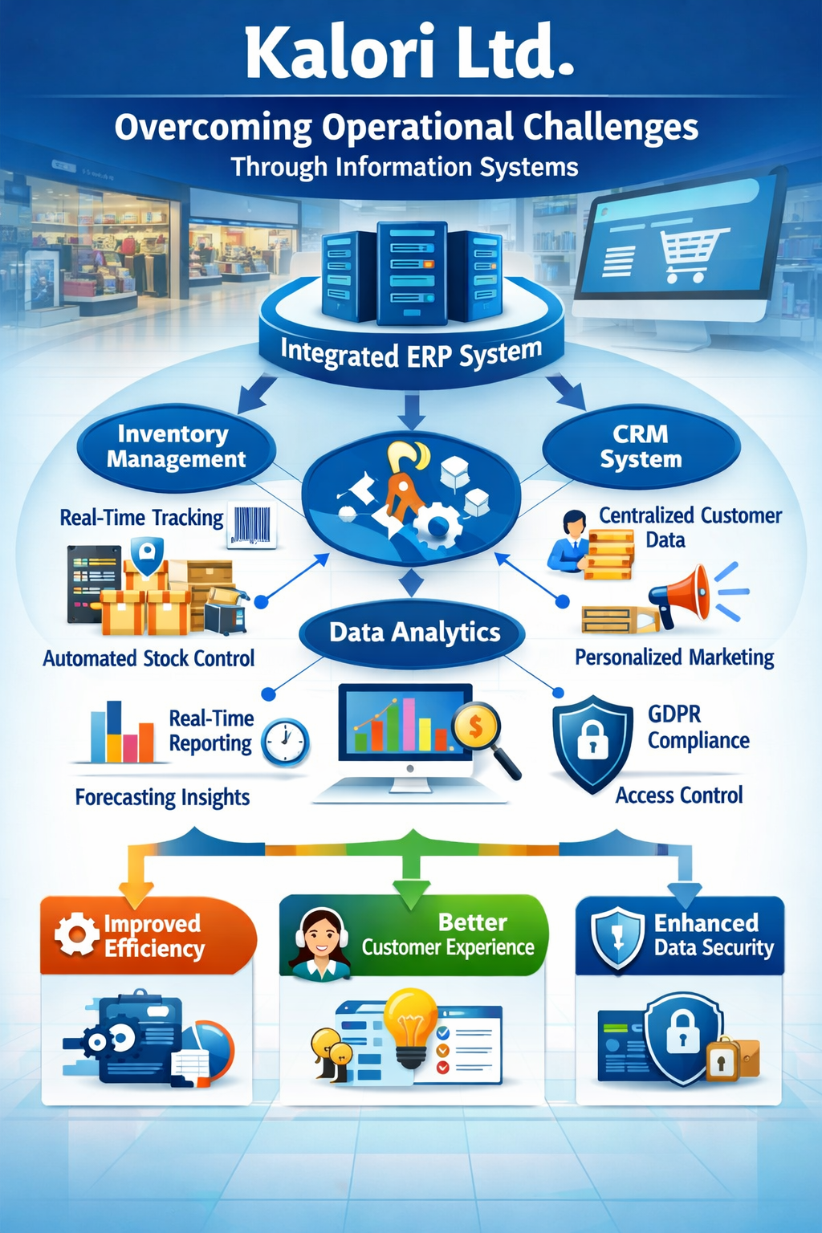
Contents
Introduction 4
2. Evaluation of Existing Systems 4
2.1 Current Information System Environment 4
2.2 Inventory Management Inefficiencies 4
2.3 Customer Relationship Management Limitations 5
2.4 Slow and Inefficient Decision-Making 6
2.5 Data Security and Compliance Risks 7
2.6 Lack of System Integration 8
3. Recommended Solution 8
3.1 Implementation of an Integrated ERP System 8
3.2 Automated Inventory Management Technologies 9
3.3 Centralized Customer Relationship Management System 9
3.4 Advanced Data Analytics and Decision Support 9
3.5 Enhanced Data Security and Compliance 10
4. Implementation Plan 10
4.1 System Requirements Analysis 10
4.2 Vendor Selection 10
4.3 System Integration and Data Migration 10
4.4 Employee Training 11
4.5 Pilot Testing and Deployment 11
5. Conclusion 11
References 12

List of figures
Figure 1 Inventory Management issues 5
Figure 2 Customer Relationship Management 6
Figure 3 Data Security and Compliance Risks 7
Figure 4 System Integration 8

Introduction
High rate of business growth often brings shortcomings in the legacy information systems that were initially designed to support smaller business operations (Kang and Gershwin, 2004). Kalori Ltd. is a fast-growing electronics retailer that has operational challenges that are based on old-fashioned inventory management systems, ineffective customer data management, and slow decision-making systems that hinder its efficiency, customer satisfaction, and compliance with the regulators (Inventory Information Systems in Water Companies, 2021).

2. Evaluation of Existing Systems

2.1 Current Information System Environment
Kalori ltd. is currently relying on a set of disjointed and outmoded information systems which cannot accommodate the growing complexity of its growing retail business (IJSAT, 2025). Companies that use dis-aggregational legacy systems are normally characterised by inefficiencies, since the flow of information through the departments and operational platforms cannot be smooth (IJRPR, 2025). The lack of integrated information systems significantly reduces the visibility of operations and will not allow managers to access real-time business data (Davenport and Harris, 2017). In the fast-growing retail organisations, old systems are often transformed into bottlenecks that limit their scalability and operational flexibility (WJAETS, 2025).

2.2 Inventory Management Inefficiencies
The most pressing operational issue that Kalori limited has is the use of manual inventory tracking mechanisms, which are highly vulnerable to human mistakes and data contradictions (Inventory Information Systems in Water Companies, 2021). Manual inventory control always creates differences in synchronisation between the physical store inventories and digital e-commerce (Inventory Information Systems in Water Companies, 2021). It leads to the fact that customers order the products online that are no longer being sold in shops (The Impacts of Inventory Record Inaccuracy and Cycle Counting on Distribution Centre Performance, 2023). The problems of inaccurate inventory are generally considered a leading contributor to the distribution centre performance and supply chain efficiency (The Impacts of Inventory Record Inaccuracy and Cycle Counting on Distribution Centre Performance, 2023). Studies have shown that the inaccuracies experienced in the inventory records may reduce the efficiency of the operations by provoking stockouts, over stocks, and delays in fulfilments (Kang and Gershwin, 2004).
The impact of these inefficiencies on customer satisfaction is rather straightforward since any delay in the order fulfilment process and order cancellations create a negative customer experience (Christopher, 2016). Lack of automated inventory systems like barcode reading or RFID also increases the likelihood of inaccurate inventory documentation (Kang and Gershwin, 2004). Companies that do not use automated inventory technologies tend to have a hard time ensuring that they have real time visibility of the stock in various retail channels (IJSAT, 2025).
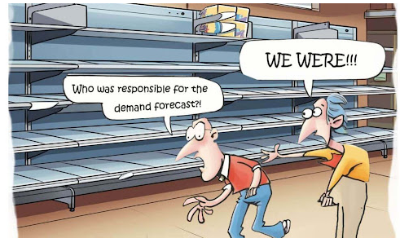
Figure 1 Inventory Management issues

2.3 Customer Relationship Management Limitations
A second significant weakness of the information system infrastructure of Kalori Ltd. is the absence of a centralised customer relationship management system (The Lack of Sharing of Customer Data in Large Software Organisations, 2016). Currently, customer data is maintained in several and disconnected systems that lack efficient information sharing (The Lack of Sharing of Customer Data in Large Software Organisations, 2016). Fragility of customer data prevents the organisations to build a holistic view of customer buying behaviour and preferences (Buttle and Maklan, 2019). Lack of unified CRM systems in the organisations limits the marketing teams to adopt specific marketing campaigns or customised promotional plans (The Lack of Sharing of Customer Data in Large Software Organisations, 2016). In the same way, customer care departments face challenges when trying to respond to complaints, as no purchase history can be easily obtained (Buttle and Maklan, 2019). Lack of access to full customer information decreases the efficiency of customer support services and damages the relationships with customers in the long term (Payne and Frow, 2017). The growing use of integrated CRM systems by modern retail organisations is becoming fundamental in the improvement of customer engagement and loyalty (IJSAT, 2025).
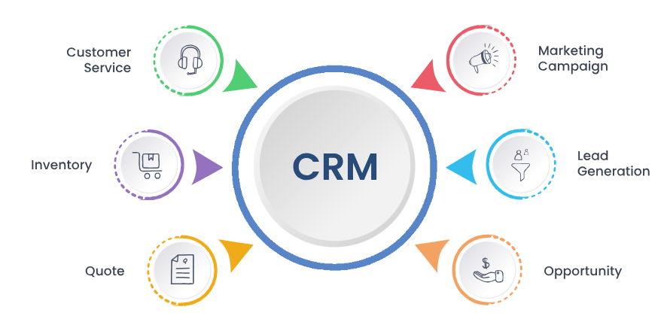
Figure 2 Customer Relationship Management

2.4 Slow and Inefficient Decision-Making
The problem of slow and inefficient decision-making processes also concerns Kalori Ltd. because it has to resort to manual spreadsheets as a form of reporting (Optimising Decision Latency in Big Data Analytics through Intelligent Model Selection and Learning Algorithms, 2025). The risk of inaccurate business report creation and delays is eminent because manual data processing is associated with a high chance of making mistakes and requiring much time to process the data (Optimising Decision Latency in Big Data Analytics through Intelligent Model selection and Learning Algorithms, 2025). Decision latency is associated with organisations that spend too much time processing data and developing insights needed to support strategic decisions (Optimising Decision Latency in Big Data Analytics Through Intelligent Model Selection and Learning Algorithms, 2025). Retail businesses also exist in very dynamic worlds that require real-time data, which can be easily accessed in a response to changing consumer demand (Davenport and Harris, 2017). Time delays in a decision-making system may result in inaccurate forecasting and unfavourable inventory control (Effects of Data Time Lag in a Decision-Making System using Machine Learning to predict Pork Prices, 2023). Late data analysis does not make managers able to detect the new sales trends or react properly to the market changes (Effects of Data Time Lag in a Decision-Making System Using Machine Learning to Predict Pork Price, 2023). As a result, organisations that have sluggish decision-making tend to lose competitiveness in the competitive retail markets (Porter and Heppelmann, 2015).

2.5 Data Security and Compliance Risks
Another significant concern for Kalori Ltd. is poor data governance and security measures in its current information systems (Surveillance and Society, 2011). Data protection laws like the General Data Protection Regulation (GDPR) mandate organisations to come up with stringent access control and data protection systems (Surveillance and Society, 2011). Disjointed systems of data storage augment threat of unauthorised access to delicate consumer data (Surveillance and Society, 2011). Companies that do not adhere to the rules of data protection can be fined a significant amount of money and have their reputation ruined (Greenleaf, 2018). The lack of proper cybersecurity infrastructure increases the susceptibility to cyberattacks and data breaches as well (WJAETS, 2025).
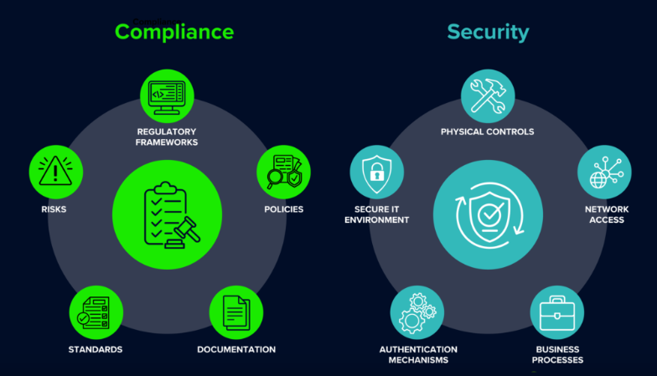
Figure 3 Data Security and Compliance Risks

2.6 Lack of System Integration
Another significant bottleneck in operations at Kalori Ltd. is the absence of integration of the sales, finances, and inventory systems (IJSAT, 2025). This means that employees now need to move data between various systems manually since the systems are not in a position to automatically communicate (IJSAT, 2025). Such data transfers by humans enhance the likelihood of errors and inconsistency of data existing in organisational databases (IJRPR, 2025). Unlinked information systems lower organisational performance because the employees spend a lot of time in coming up with data discrepancies (Davenport and Harris, 2017). Enterprise systems are also necessary to guarantee the smooth flow of information within the departments and the accuracy of the data (Laudon and Laudon, 2022).
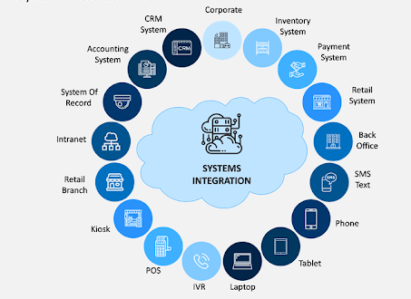
Figure 4 System Integration

3. Recommended Solution

3.1 Implementation of an Integrated ERP System
The operational issues that have been revealed in the evaluation phase can be resolved by proposing the introduction of an integrated Enterprise Resource Planning (ERP) system to the Kalori Ltd. (IJSAT, 2025). ERP systems include various organisational activities into one centralised system and therefore allow a smooth flow of information across departments (Laudon and Laudon, 2022). This type of integration promotes effectiveness in operations by removing the unnecessary data entry in the system and offering uniformity to the organisational processes (IJRPR, 2025). Moreover, ERP systems offer the real-time tracking of inventory, financial flows, and sales operations within the organisation (IJSAT, 2025).

3.2 Automated Inventory Management Technologies
The suggested ERP system will have automated inventory management features that offer real-time stock level of physical stores and e-commerce sites ( Inventory Information Systems in Water Companies, 2021). The technologies used in automated inventory systems are usually barcodes and RFID tags with the help of which the movements of the products can be tracked (Kang and Gershwin, 2004). The RFID is one technology that has been noted to significantly enhance accuracy in inventory by allowing automatic identification and tracking of the products during the supply chain (Kang and Gershwin, 2004). It has been empirically proven that organisations using automated inventory technologies enjoy greater stock accuracy and lower operational expenses ( The Impacts of Inventory Record Inaccuracy and Cycle Counting on Distribution Centre Performance, 2023). Inventory visibility (real-time) also allows optimised replenishment, which reduces stock shortages (Christopher, 2016).

3.3 Centralized Customer Relationship Management System
In addition to the ERP implementation, Kalori Ltd. needs to implement a centralised CRM system, which would help consolidate the customer information across all sales channels (The Lack of Sharing of Customer Data in Large Software Organisations, 2016). With such a system, it is possible to establish customer profiles including purchase history, preferences, and interaction history (Buttle and Maklan, 2019). Availability of consolidated customer information also helps the marketing departments to create profile promotional programmes that can draw more customers (Payne and Frow, 2017). The customer-service teams also have access and use of CRM systems, which enable quick access to the purchase records of customers, making it easier to resolve their complaints (Buttle and Maklan, 2019).

3.4 Advanced Data Analytics and Decision Support
Kalori Ltd. is recommended to incorporate the latest analytics features of its ERP system to enable the use of data in decision-making (Optimising Decision Latency in Big Data Analytics Through Intelligent Model Selection and Learning Algorithms, 2025). The process of large amounts of transactional data processing and the discovery of new sales trends become feasible with the use of big data analytics platforms (Davenport and Harris, 2017). The machine-learning algorithms also increase the accuracy of the forecasts since they analyse the past sales patterns and forecast the demand (Effects of Data Time Lag in a Decision-Making System Using Machine Learning to Predict Pork Prices, 2023). Real-time analytics dashboards enable managers to track key performance indicators and address market shifts in a fast manner (Laudon and Laudon, 2022).

3.5 Enhanced Data Security and Compliance
The current ERP systems have integrated inbuilt data security controls like role-based access control, data encryption and audit trails (Surveillance and Society, 2011). Such mechanisms will make sure that confidential customer information is only available to the authorised staff (Surveillance and Society, 2011). Strong data governance systems also contribute to the meeting of regulatory obligations, including GDPR (Greenleaf, 2018). As a result, secure information systems implementation minimises the legal risks and improves customer trust (WJAETS, 2025).

4. Implementation Plan

4.1 System Requirements Analysis
The initial aspect of the proposed solution is the detailed system requirements analysis that will reveal the functional and technical requirements of Kalori Ltd. (IJSAT, 2025). The employees in the various departments should also be consulted as stakeholders to make sure that the new system can support all the processes related to its operation (IJRPR, 2025).

4.2 Vendor Selection
The second one is to choose an appropriate vendor of ERP that will provide scalable solutions that can sustain the further development of the company (WJAETS, 2025). Scalable system enables organisations to scale operations without the need of making major alterations to the prevailing technology infrastructure (Laudon and Laudon, 2022).

4.3 System Integration and Data Migration
After choosing the vendor, the implementation team must start connecting the ERP system to other systems including the e-commerce site and software used in financial management (Inventory Information Systems in Water Companies, 2021). Migration of data should be handled carefully to make sure that past business information is moved to the new system correctly (The Lack of Sharing of Customer Data in Large Software Organisations, 2016).

4.4 Employee Training
The success of information system implementation is dependent on employee training since users should know how to use the new system successfully (IJSAT, 2025). The training programmes must be designed to meet the requirements of different groups of users, such as store managers, marketing employees, and top managers (WJAETS, 2025).

4.5 Pilot Testing and Deployment
Before the full implementation, the organisation must pilot test the new system in selected stores to uncover possible technical problems (IJRPR, 2025). The pilot testing allows assessing the functioning of a system under actual operational conditions and modify the parameters of the system (Laudon and Laudon, 2022). With a positive test, the system can be implemented in all the departments and retail outlets (WJAETS, 2025).

5. Conclusion
Kalori Ltd. is facing major operations difficulties brought about by old information systems which are disjointed making it difficult to maintain efficiency, accuracy of data, and decision making. These problems would be solved through the introduction of an integrated ERP system with a centralised CRM and advanced analytics tools, which would automatise the inventory management process, consolidate the customer information, speed up decision-making process and enhance the security of the data. The effective adoption of the new system will be supported by a structured implementation plan that includes the requirements analysis, vendor selection, training of the employees, and pilot testing. Finally, the given solution is likely to increase the effectiveness of operations, raise customer satisfaction, and contribute to the sustainable development of business in an increasingly competitive retail sector.

References
- Buttle, F. and Maklan, S. (2019) Customer Relationship Management: Concepts and Technologies. Routledge.
- Christopher, M. (2016) Logistics and Supply Chain Management. Pearson.
- Davenport, T. and Harris, J. (2017) Competing on Analytics. Harvard Business School Press.
- Effects of data time lag in a decision-making system using machine learning for pork price prediction (2023) Available at: https://www.researchgate.net/publication/370656284
- Greenleaf, G. (2018) ‘Global data privacy laws’, Privacy Laws & Business International Report.
- Inventory Information Systems in Water Companies (2021) Available at: https://www.researchgate.net/publication/350337039
- IJSAT (2025) Available at: https://www.ijsat.org/papers/2025/1/2365.pdf
- IJRPR (2025) Available at: https://ijrpr.com/uploads/V6ISSUE5/IJRPR45884.pdf
- Kang, Y. and Gershwin, S. (2004) Available at: https://web.mit.edu/manuf-sys/www/oldcell1/papers/kang-gershwin-autoid04.pdf
- Laudon, K. and Laudon, J. (2022) Management Information Systems. Pearson.
- Optimizing Decision Latency in Big Data Analytics (2025) Available at: https://www.researchgate.net/publication/400478563
- Payne, A. and Frow, P. (2017) ‘Strategic CRM’, Journal of Marketing.
- The Impacts of Inventory Record Inaccuracy (2023) Available at: https://www.researchgate.net/publication/370036063
- The Lack of Sharing of Customer Data in Large Software Organizations (2016) Available at: https://www.researchgate.net/publication/303084828
- WJAETS (2025) Available at: https://wjaets.com/sites/default/files/fulltext_pdf/WJAETS-2025-0673.pdf
- Zaman, S. (2024) – A Systematic Review of ERP and CRM Integration for Sustainable Business and Data Management in Logistics and Supply Chain Industry. Journal: Frontiers in Applied Engineering and Technology. Available at https://journal.aimintlllc.com/index.php/FAET/article/view/36
- Purwasih, R. & Candana, D. (2024) – Development of Inventory Management Information System in a Retail Company, Jurnal Sains Informatika Terapan
https://rcf-indonesia.org/jurnal/index.php/jsit/article/view/341

