MSc Digital Skills for the Health and Care Professions 2022/23
Module: Digital Technology in Health and Social Care
Module Code: BMDS7006
Assignment title: System Improvement Programme
Student number: 2211949

Total word count: 4738
Date of submission: 16th December 2022

List of contents
Page number | Content
1 | Front page
2 | List of contents
3 | Introduction, Organisational structure
4 | Introduction continued, Business problem
5 | Root cause analysis, Justification
6 | Justification continued & Aims
7 | Objectives, change introduced
8 | Future improvements & Method
9 | Literature review & Search strategy
10 | Search strategy continued
11 | Discussion
12 | Discussion continued & Conclusion
13 | Conclusion continued
14 | Appendix A & B
15 | Reference list

Length of Sickness Absence related to Musculoskeletal (MSK) Injury and digital self-referral to physiotherapy services: System Improvement Programme
Introduction
Welsh Ambulance Service NHS Trust (WAST) provides unplanned clinical care for over 3 million people across Wales every year, and the organisation employs over 3500 staff both clinical and non-clinical.
WAST provides emergency medical care, a 111 service and Clinical Contact Centres for non-emergency advice and a non-emergency patient transport service. With over ninety ambulance stations, three Clinical Contact Centres, Non-Emergency Patient Transport, educational services for schools and members of the public, and much more, covering 20,640 kilometres. WAST and its many staff benefit from the support of a fully functioning Occupational Health and Wellbeing Service, which is one of its biggest assets.
“For the NHS to consistently deliver the highest quality care to patients, employees must be supported at work by programmes that protect and promote the highest levels of health and wellbeing.” (Nicholson Paul J, BMJ (online) 2013,vol.346 (apr 08) ⁽¹⁾
Organisational Structure

Stakeholders

External
Internal
This group will consist of the Project team, OH&W team and WAST management.

This group will consist of any external organisations and people who will be affected by the project outcomes.

- Chief Executive
- Chair of the Trust
- Members of the Board
- Senior Management
- Welsh Ambulance Service Staff
- Welsh Government
- Trade Unions
- Local Health Boards
- NHS patients
- Public Health Wales
- Health Courier Services
- NWSSP

WAST Occupational Health Service provides a comprehensive immunisation programme, pre-employment medical checks, sickness absence, plus a wealth of support and guidance for all employees and managers. The Wellbeing Service provides first line provision for wellbeing support of staff and volunteers. Using a number of tools such as signposting, drop-in sessions, workshops and apps, the team provide much needed support and information. The role of the Occupational Health and Wellbeing Service within WAST is to promote a healthy workforce but to also support employees during the times they are unable to work due to ill-health or injury. The service is there to provide support and resources to assist employees to remain in work or to return quickly and effectively following sickness absence. Due to the nature of the work carried out by front line (emergency) staff such as paramedics, sickness absence levels due to muscular skeletal injury are particularly high.
An important public health burden on the government, employees, employers and public resources is sickness absence (SA). This is a result of decreased productivity, more effort of other employees, and costs incurred to cover absences and recover from illness. SA statistics are more frequently employed as a gauge of poor health. Governments and employers are establishing policies to support employees in improving health, reducing SA rates, and improving return to work (RTW) timelines.
Business problem
As a department, OH have identified that musculoskeletal (MSK) injury is one of the highest causes of sickness absence (SA). It costs the service lost hours due to staff shortages, and high expenditure covering sickness absence to ensure the service is not impacted too heavily. At present, sickness absence due to musculoskeletal injury is not currently recorded in the form of data by the OH&W service and there is currently no data to assess the length of sickness absence following injury related to time waited for treatment. As Demou, Smith, Bhaskar A et al (BMJ Open 2018, page 1)⁽²⁾ summarises MSK conditions/injuries attribute to a high percentage of SA and lost days in healthcare. It is important that WAST OH&W service develop digital opportunities and invest in system improvement programmes in order to support and educate their staff.
Root Cause Analysis

PROJECT: Digital referral system to physiotherapy services linked to OH referral for MSK injuries to reduce SA duration

CAUSE – Team
CAUSE - Equipment
Lack of training
Software - limitations of current system
not available or inadequate
Motivation of staff to accept change
Maintenance
Cost of new software or hardware
Demographics of teams
PROBLEM – no automatic referral system currently in place

Current process prolongs referral time
Current process not cost effective
Current process long winded
Limitations to record data accurately
Instructions for current process unclear
CAUSE - Process
CAUSE – Method

Justification
These changes are important because a digital information system for self-referral to physiotherapy services could potentially reduce the length of sickness absence and therefore reduce cost to WAST, strain on an already stretched team and improve the outlook for the staff member. The current process for managing sickness absence due to MSK injury begins with the staff member reporting sick following injuries received possibly whilst carrying out their duties. The line manager will refer their staff member to the Occupational Health and Wellbeing Service via a management information system (COHORT), and in this referral will request an assessment and possible treatment with a physiotherapy provider. The staff member will be contacted by OH&W and offered a telephonic appointment with the team to discuss options, and following this appointment they will be referred for physiotherapy treatment via an external provider. The wait incurred by this process prolongs any assessment or treatment by weeks possibly months and during this time the staff member remains off work and untreated. The alternative route to physiotherapy services is via a DATIX (a risk management information system used for notification of adverse events). On completion of a DATIX, OH&W are notified of an MSK injury, an email is then sent to the staff member inviting them to contact OH&W in order for a referral to be completed. Again, this process is time consuming and delays treatment, it also relies heavily on the individual to contact OH&W.
By implementing a digital information system that would allow a staff member to self-refer to physiotherapy services, this could reduce the length of absence, speed up treatment/recovery and potentially their return to work could be accelerated, thereby reducing the cost and pressure on WAST. With a new digital information system in place, the Line Manager would still complete the mandatory sickness absence process on ESR (if the employee is absent from work), but would have the opportunity to input a specific SA code that would generate a notification to OH&W, this would allow OH&W to track any self-referral to physiotherapy services. Once the referral has been submitted OH&W would provide a telephonic appointment following the outcome of the initial physiotherapy assessment. This appointment would be used as an opportunity to assess fitness to return to work, and recommend any required adjustments needed for the staff member to perform their duties safely, a possible RTW timeline could also be predicted. It would not hinder a RTW but would be used as a mechanism to support a safe RTW. If a self-referral is not submitted by the employee an appointment would still be offered by OH&W in order for fitness for work or any other concerns to be discussed.
By recording data for sickness absence related to MSK injury, job roles could be monitored to identify possible staff training requirements, the possible need for improved or alternative equipment to assist with roles, and any potential opportunities to avoid unnecessary risk. Data could also identify any trends such as types of injuries being sustained at certain times of the year, e.g., ice equals more falls/mechanical injuries.
These changes are crucial as high levels of sickness absence are draining on the finances of the service and the morale of staff having to fill in the gaps and take on extra workload. Sickness absence also has an impact on the way in which a service is able to function and perform. A self-referral system gives the opportunity to empower employees to take care of their own health and wellbeing.
Doing nothing could result in a service that has increased costs and more pressure being exerted on an already stretched workforce. The current system is not sustainable as it stands. Employee welfare is paramount and alternative solutions should always be sought in order to improve services and promote a healthier workforce.
Aims
WAST Occupational Health Service aim to implement a digital information system that would allow self-referral triggered via a digital link. The link would be available via the organisation intranet and various social media platforms, the link would also be sent to the staff member by email upon notification of SA via WAST Electronic Staff Record (ESR). This process would allow staff to refer directly to physiotherapy services as soon as an injury occurs. This system improvement programme would enable access to a physiotherapy assessment and treatment more quickly in order to facilitate a faster return to work, and therefore reduce costs and unnecessary strain on the service. The digital referral system should have the capability to be integrated with our current Electronic Staff Record (ESR) and be accessible and useable by all staff members employed by WAST. If this is not possible all options for a suitable alternative IS should be explored.
Objectives
The following objectives will be achieved within 12 months:
- An exploratory study will be carried out to identify the effectiveness of introducing a digital self-referral system that will aim to reduce the length of sickness absence, and in turn reduce the cost and pressure on WAST as an organisation.
Using Leavitt’s Diamond Model (as shown below) the project group will aim to:
- Reduce timeframe of referral & return to work.
- Develop a working digital solution to budget which will allow for self-referral to physiotherapy services for assessment/treatment upon reporting of MSK injury.
- Develop and roll out a training programme and competency framework to all managers and staff within WAST.
- Develop and implement Information Governance policies and procedures.
- Collate and monitor data monthly to identify trends and to establish feasibility and any realised benefits of the project.
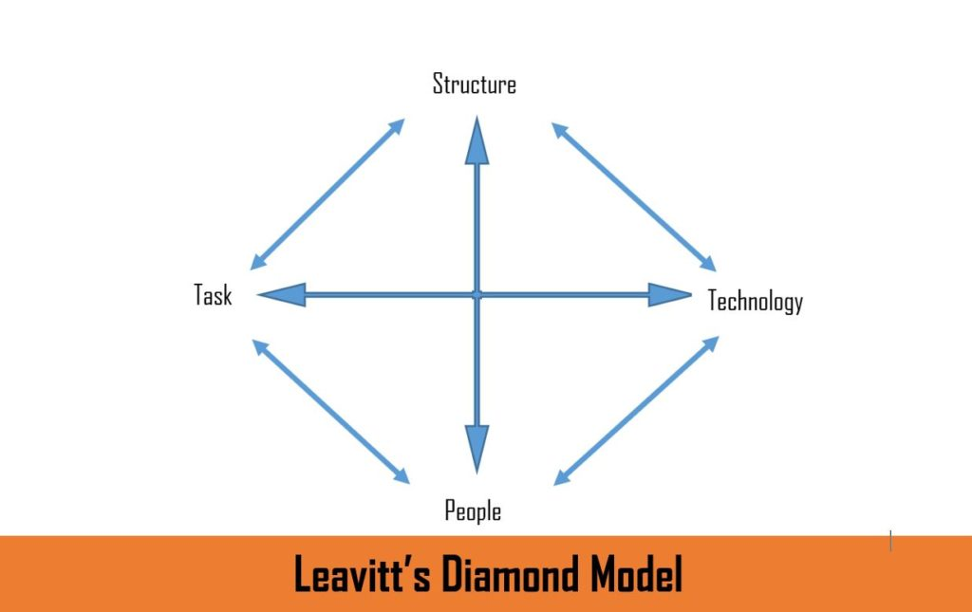
A model explaining organisational transformation was developed by an American Professor named Harlod J Leavitt in the early 1960’s. There are four main components within the transformational concept and each component depends on one another.
The four components are:
Structure – The basis of any organisation is its structure. It includes numerous things, people, departments and levels of hierarchy and how they all relate to one another. The structure needs to be able to adapt to change.
People – Employees within the organisation, the backbone of the organisation. Chosen depending on their knowledge, skills and expertise.
Task – The tasks that need to be performed in order for the organisational change to happen.
Technology – The software and hardware required to perform the change. Technology is required to provide faster, more up to date systems.
Change Introduced
Electronic links will be available to staff members via WAST intranet and social media platforms which will allow staff members to self-refer to physiotherapy services following MSK injury. Whilst completing a sickness absence notification on the staff member’s electronic staff record (ESR), managers would also be able to select MSK injury code as the reason for absence and a notification to OH&W would be generated. Staff member would then be assessed by physiotherapy within one week of referral and would receive an appointment from OH&W in line with the results of the assessment, to ensure return to work is supported and that any adjustments required are in place prior to the return to work. This new process will replace the current process whereby a staff member reports sick with an MSK injury, their line manager submits a referral to OH&W services via the management information system (Cohort). The staff member is then offered a telephonic assessment appointment and will then be referred to the physiotherapy provider. The new process will, in theory, reduce sickness absence duration by allowing for quicker assessment and treatment.
Future improvements
Following the implementation of the digital system for self-referral following MSK injury the service could possibly use this model to trial implementing the same system for other SA reasons e.g., Mental health disorders, chronic conditions and referral to relevant services.
Method
There are a number of Project Management methodologies that could be followed for this project. Having compared the pros and cons of Waterfall and Prince2 Project Management methodologies it was decided that this project would follow the Prince2 project management methodology. Prince2 is one of the most well-known and widely used methodologies, this is because Prince2 uses experiences from previous projects and as it is generic it can be applied to any project. Prince2 always has a Project Manager who is responsible for overseeing teams and ensuring each phase of a project is completed within tolerance. The project phases are all completed sequentially which allows for structure and clear objectives. Whilst the methodology is set and structured there is allowance for tailoring, however this can sometimes become the downfall of any project – too much tailoring could blur the objectives. Using the Prince2 methodology ensures the project always remains viable and on schedule as much as possible. The Waterfall methodology is a fairly straight forward method. Advantages of the waterfall methodology are the clear stages and low risk presented by the method. However, as the project relies on teams working on each stage at once there is the risk of delays to progression and therefore cost implications or possible failure.
This project will be based on the Prince2 Project Management methodology as this allows for tailoring if required but ensures strict processes and principles are in place and that the project runs as smoothly as possible and always remains viable. It also ensures that each stage of the project is continually assessed to ensure the project will be completed on time, within tolerance and any benefits realised. If for any reason the project becomes unviable it can be closed early, thereby reducing any unnecessary costs being incurred or time wasted.
Following the Prince2 Project Management methodology this project will complete the phases outlined in the diagram below. The project will produce a business case in order to establish mechanisms to ensure the project always remains desirable, achievable and viable. The business case will be used as a means to support decision making. For each stage there will be set tolerances and should these tolerances be breached the Project Manager will be responsible for communicating this to the Executive and all stakeholders to ensure the project remains viable. The project will not move on until each stage has been completed therefore it is imperative that each stage is completed to the timeframe agreed at the start of each stage. Using the Prince2 methodology encourages accountability by defining roles and responsibilities. Prince2 focuses on the output but is broken down into stages which makes it more manageable but also allows for a project to be adapted if necessary. All stakeholders are encouraged to be involved in each decision which reduces the risk of producing something that isn’t required or requested. The project manager will be provided with and share reports/updates with senior management which reduces the requirement for progress meetings.
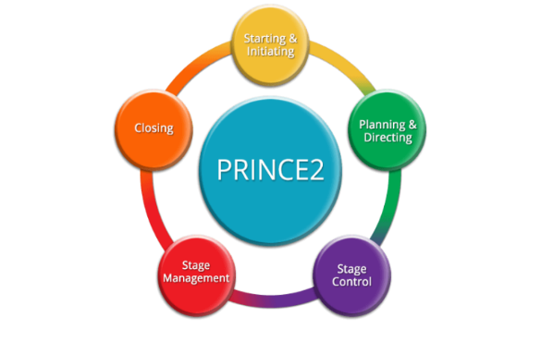(Niekerk, 2022)

Work breakdown structure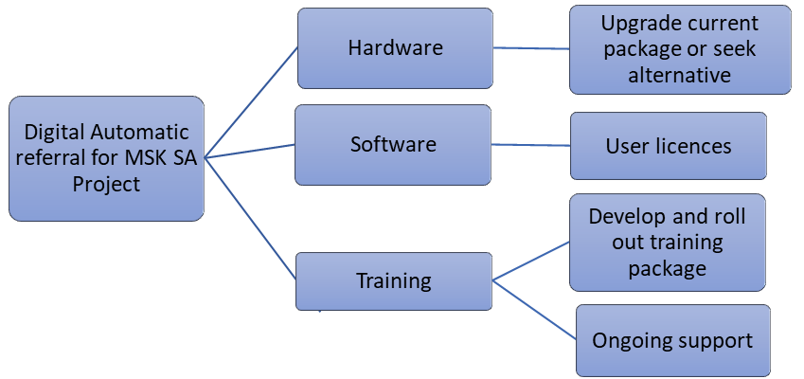
Literature review
The purpose of this literature review is to provide a summary of literature based on self-referrals to physiotherapy services following MSK injury and its impact (or lack of), on duration of sickness absence. Included in this review is research from UK. Papers and articles prior to 2000 were discounted as more up to date research was required for the purposes of this review. Literature from outside the UK was not included. Literature containing research for paper based self-referral for was discounted as this was not deemed pertinent to this current review. The review also looks at the use of digital information systems when referring to physiotherapy services for MSK injury/disorders and whether or not this has any impact on duration of sickness absence. Does a digital referral pathway contribute to the impact (or lack of), timely referrals to physiotherapy services compared to a non-digital pathway?
Search strategy
Using the PICO framework, a question was formed in order to help formulate a search strategy. The PICO framework is used to help define a question prior to starting any research. PICO is a mnemonic used to describe the four elements of the question which are Population/Patient, Intervention, Control/Comparison and Outcome (Appendix A). For the purposes of this literature review the question ‘Does self-referral to physiotherapy services via a digital information system (I) decrease duration of sickness absence (O) amongst healthcare workers (P) compared to OH&W referral to physiotherapy services (C)?’ was formulated.
As a starting point for this review a scoping search was initially conducted using Ovid and from this search 8095 results were found. This number was reduced using a PRISMA flow diagram (Appendix B) defining more clearly the parameters of the search. PRISMA is a set of evidence-based guidelines used for reporting systematic reviews and meta-analyses. Its main focus is on reports evaluating interventions but it can also be used for reviews that evaluate interventions that have objectives.
The Boolean operators And and Or were also used to further narrow the results for this search. Boolean operators are used to connect pieces of information and help to find more precise information which enables the search to be narrowed or broadened depending on how much information is available on a given topic.
Search results using Boolean Operators
Using the database HMIC Health Management Information Consortium <1979 to September 2022>
Search number | Search term used | Number of papers found
1 | "self refer*". ti,ab. | 203
2 | "eRefer*”.ti,ab. | 1
3 | “online refer”.ti,ab. | 6
4 | “electronic refer*”.ti,ab | 31
5 | “digital refer*”.ti,ab. | 2
6 | 1 or 2 or 3 or 4 or 5 | 240
7 | “healthcare staff”.ti,ab. | 379
8 | “NHS staff”.ti,ab. | 1161
9 | “health care staff”.ti,ab | 249
10 | 7 or 8 or 9 | 1759
11 | “physiotherapy*”.ti,ab | 1353
12 | “Exp Physiotherapy” | 910
13 | 11 or 12 | 1833
14 | 6 and 10 and 13 | 0

Search terms for the same concept were OR’d together OR’d sets for the same concept were combined with AND to create a set of papers that include all concepts. Total number of papers found using the above search terms was 8095. Relevant papers were selected by reading abstracts and those that did not fit the criteria or relate to the business problem were discounted. The eventual number of papers used for the purposes of this literature review was four.
Using the same search strategy an additional search to include sickness absence due to MSK injury and the impact of early physiotherapy interventions was also run which only yielded two results of any relevance. From this search only one of the papers was selected as parts of their research due to it being most applicable to the project.
Discussion
Musculoskeletal health refers to the performance of the locomotor system, comprising intact muscles, bones, joints and connective tissue. ⁽⁵⁾ Due to the nature of the role paramedics and frontline staff are a high-risk group for MSK injuries. It is important to address MSK injuries/disorders early in order for outcomes to be most positive.
There is very little relevant literature available based on self-referrals to physiotherapy services by NHS employees or healthcare workers and its impact on sickness absence. Therefore, this literature review is based on literature describing the positives and negatives of self-referral to physiotherapy services by members of the public/patients. There is also limited evidence regarding the impact of early physiotherapy intervention and a quicker return to work.
In 2015 North Bristol NHS Trust set up a fast-track physiotherapy service following recommendations from the Boorman review (2009). Dr Boorman conducted a review of NHS staff health and Wellbeing and from this review he predicted that productivity improvements of up to £555 million could be realised. Following the review North Bristol NHS Trust implemented their fast-track physiotherapy service for a period of six months (funded by the 2015 NHS CQUIN (Commissioning for Quality and Innovation). The new service was a telephone self-referral service that replaced the former paper-based self-referral service with the aim of reducing sickness absence due to MSK. Data from OH was analysed to establish the numbers of staff accessing physiotherapy services. An anonymised survey was sent out to staff electronically over a five-month period to demonstrate levels of satisfaction and efficacy of the service. This data was then analysed. The results were positive with staff numbers accessing the service remaining consistent. “Over 75% of staff were extremely likely or likely to recommend the Physio Direct service and would rate the service as excellent.” ⁽⁶⁾ The project concluded that after six months the service proved beneficial in helping to reduce sickness absence and further improvements were being explored.
In 2007 a national trial was completed by The Scottish Physiotherapy Self-Referral Study Group to identify he views and attitudes to access physiotherapy and ‘patient-autonomous health-seeking behaviours’ ⁽⁷⁾ This trial found that there was a marked lack of knowledge about the profession, thus highlighting the need to raise awareness and knowledge in order to change perception and behaviours towards self-referral schemes. Within the National Health Service patient satisfaction is regarded as a reliable indicator of quality and is routinely used to obtain consumer perspective. At the time of this trial there was very little evidence to confirm that self-referral to physiotherapy was feasible, appropriate and cost effective. Two small studies were conducted but both reported high levels of satisfaction with self-referral but didn’t explore views or attitudes any further. Whilst surveys are useful, they are also limited and may not be a true reflection of attitudes as satisfaction surveys tend to elicit positive responses. As part of the WAST Health and Wellbeing Strategy 2020 – 2024 a review was carried out following recommendations from the Boorman review (2009). One of the strategic goals of the People and Culture Strategy is the aim for everyone to enjoy a long, happy and healthy (working) life. This strategy reflects the core ethos of A Healthier Wales – emphasising the importance of preventing illness and supporting people to manage their own health and wellbeing.
A follow-on study ‘what are the costs to NHS Scotland of self-referral to physiotherapy?’ was undertaken. The purpose of the study was to establish the cost of different access routes to physiotherapy in NHS Scotland. Twenty-six GP practices throughout Scotland with a total number of 3010 patients were included in the trial. Self-referral was introduced alongside GP referral and the costs to NHS Scotland associated with each route were collated over a full year. The trial concluded that there were notable positive indications associated with self-referral which represented added benefit to not just NHS Scotland but the wider NHS.
A multi-centred trial was conducted between 2003 and 2005 (Holdsworth, Webster and McFadyen, 2007)in order to establish the efficacy and feasibility of self-referral. The findings suggested that the offering of self-referral was viable. According to the results of the trial, self-referral did not appear to effect overall referral rate, it was also noted that historically, rates for referral to physiotherapy in urban, semi-rural and rural areas varied. People who self-referred presented with similar complaints as those who were referred via the GP (general practitioner) pathway. Offering patients a self-referral system didn’t provide immediate access to physiotherapy, but it did break down some of the barriers and remove obstacles which in turn sped up access and treatment. The results of the pilot did suggest a positive impact on the workload of GP’s, however, there was no suggestion that this attributed to NHS costs.
In 2021 The Centre for Sports and Exercise medicine set up a usability study (funded by Optima Health) ⁽⁷⁾⁽⁸⁾ to develop an MSK Digital Assessment Routing Tool (DART) to allow for self-assessment and signposting to relevant care/services. MSK conditions negatively affect millions of people every year and this places a huge demand on healthcare. The aim of this study was to use digital technology to improve outcomes and to empower patients. In the UK the cost of musculoskeletal disorders costs over £4billion annually, the average waiting time for patients to be assessed by outpatient physiotherapy services currently exceeds six weeks. Long wait times have a detrimental effect on each patient and can cause further health problems. When the user uploads information into DART they will be provided with recommendations of interventions that may be suitable based on the information they have supplied. DART is to be integrated with existing management information systems which allows for direct sharing of assessments and recommendations. A link would be available via the provider’s website and can be accessed on all technological devices. The conclusions from the study were that it was user-friendly and has the potential to be used as an alternative to primary care or physiotherapy led triage. In terms of this project some of the theories and information could be adapted.
Conclusion
Whilst digital self-referral to physiotherapy is not a new concept it is also not one that has been utilised by WAST or many organisations for numerous reasons. In order to evaluate the impact of the project sickness absence data will be reviewed six months post implementation of the new process and compared to data from six months prior. Feedback questionnaires will also be sent to employees who have accessed physiotherapy via the new process and those who have been referred via the old pathway. Continuation of the project’s objectives will only occur if the change has positive results and if RTW timescales are proven to have reduced since the introduction of the new process. Whilst it is extremely important to provide quick access to treatment it is also important to remember that each case is individual and what works for one person may not work for all. Therefore, a quicker RTW may not be possible even with earlier interventions. As the evidence is limited it is important to ensure the project is viable, necessary and the information system would be beneficial. The literature reviewed for this study has shown that there is still lots to be learnt and organisations need to be open to change and innovation in order to utilise digital information systems to improve service access to staff members. Self-referral to physiotherapy is strongly supported by healthcare professionals and bodies. The fact that there is very little evidence to support the hypothesis does not necessarily mean it will fail. Provided the project is managed correctly, that user feedback is gathered and data is analysed and presented regularly to prove worth and viability then the project should remain worthwhile. It is important that the project evaluate feedback but use it wisely, negative feedback is as valuable as positive and should be used to ensure any issues are dealt with promptly. Any benefits will not be realised in the first few months of the trial and the focus should therefore not be solely on costs or financial savings. In order for the project to work there needs to be transparency and patience. Education is fundamental. If digital self-referral is to work then WAST staff, managers and the OH&W service need to be aware of the role of the physiotherapy service. Links to the digital referral form need to be readily available and all platforms need to be able to communicate. The DART study could be utilised in order to implement integrated systems and digital links for direct access to physiotherapy. All of the studies or trials relevant to this project have the same focus – patient empowerment and improved access to services that improve their quality of life. The aim of each trial/study was to establish whether a self-referral process would reduce financial burden on the healthcare system, reduce workload and empower patients to take control of their own health and wellbeing.
The opportunities for wider system improvements such as WAST employees having the ability to self-refer to counselling services, pain management services and other health improvement interventions could be implemented following the same process as outlined by this project. This could then further reduce SA and improve outcomes for a faster and more successful RTW and reduce costs to the service. This intervention could be the way forward for other NHS staff who are already facing long waits for physiotherapy and other services as their OH departments struggle to keep up with demand. This intervention could be used as a model for other organisations wanting to implement digital improvement programmes. WAST also work closely with Public Health Wales (PHW) and Health Courier Services (HCS) regularly sharing best practice approaches. As part of the WAST wellbeing strategy 2020 – 2024, which also mentions The Boorman review, although published over 10 years ago, the findings are still relevant and important as the findings reiterate that the health and wellbeing of staff should be paramount. A healthy workforce is a successful workforce.
The project will be evaluated using user feedback questionnaires – these will be anonymous and submitted via an electronic link which should encourage users to be honest in their answers. Whilst recording sickness absence on the employee’s ESR managers will be able to select codes related to MSK injury as reason for absence. This code will then generate a notification to the OH&W management information system. OH&W would run weekly reports via this system and cross reference with any notifications from the referral links to analyse numbers of staff accessing physiotherapy services. The duration of sickness absence will also be monitored using ESR – all sickness is logged on the employee’s electronic record, working with the ESR team, OH&W will be given access to the data trends and will be able to compare to previous months statistics in order to establish whether or not self-referral and faster access to physiotherapy does indeed reduce SA. If the statistics and feedback suggest otherwise following the 12-month duration of the project then the project will assess the feasibility of continuing.
Whilst there is limited evidence for this project to base its model on that does not suggest the project will fail. It also doesn’t mean a similar idea or model isn’t being followed elsewhere, it could just be that other projects have not been documented or the information is not readily available.

Appendix A
PICO
Population | Healthcare workers
Intervention | Self-referral to physiotherapy services
Control | Non-referral to physiotherapy services
Outcome | Decrease duration of sickness absence

Appendix B
PRISMA 2020 flow diagram for new systematic reviews which included searches of databases and registers only
Identification of studies via databases and registers
Identification of studies via other methods

Records identified from:
Websites (n =1)
Organisations (n = 0)
Citation searching (n =0)
etc.
Records removed before screening:
Duplicate records removed (n = 150)
Records marked as ineligible by automation tools (n = 0)
Records removed for other reasons (n = 7850) )
Records identified from*:
Databases (n = 8095)

Identification

Records excluded**
(n = 180)
Records screened
(n = 195)

Reports sought for retrieval
(n = 2)
Reports not retrieved
(n = 10)
Reports sought for retrieval
(n = 15)
Reports not retrieved
(n = )

Screening

Reports assessed for eligibility
(n = 1)
Reports excluded:
Reason 1 (n = 4)

Reports assessed for eligibility
(n = 10)
Reports excluded:
Reason 1 (n = )
Reason 2 (n = )
Reason 3 (n = )
etc.

Studies included in review
(n = 4)
Reports of included studies
(n = 1)
Included

(Prisma, n.d.)

Reference list
- Nicholson Paul J, BMJ (online) 2013,vol.346 (apr 08)
- (Demou et al., 2018)
- Anon, (n.d.). The 6 Most Effective Project Management Methodologies. [online] Available at: https://processnews.blogspot.com/2017/12/the-6-most-effective-project-management.html.
- Prisma (n.d.). PRISMA. [online] www.prisma-statement.org. Available at: https://www.prisma-statement.org/PRISMAStatement/PRISMAStatement.
- WHO (2021). Musculoskeletal conditions. [online] Who.int. Available at: https://www.who.int/news-room/fact-sheets/detail/musculoskeletal-conditions.
- (Clevely, 2018)
- (Webster et al., 2008)
- (Holdsworth, Webster and McFadyen, 2007)
- (Lowe et al., 2021, 2022)

