Network Operating Systems and Services (ACCA5023)

Build, and deploy, a Type 2 Hypervisor Platform Based Virtualised Network

Stephen Protheroe-Hewitt – 2112883

Data and Information Systems

Contents

List of Figures/Tables 3
Abstract 4
Introduction 5
Hypervisor Research 6
Hypervisor Decision 10
Downloading the Hypervisor, Server and Client Operating Systems 11
Creating the Network 16
IP Addressing Research 18
Configuring the IP Addresses of the Network 22
Network Testing and Troubleshooting Research 24
Testing the Network 26
Conclusion 29
References 30

List of Figures/Tables

Fig. 1 Hypervisor Architectures 6
Fig. 2 Oracle VirtualBox Hypervisor Installed 11
Fig. 3 Swansea (SW) and London (LD) Domain Settings 12
Fig. 4 SW Windows Server 2019 Username and Password 12
Fig. 5 LD Domain Username and Password 13
Fig. 6 SW and LD Client PC Settings (RAM) 14
Fig. 7 SW and LD Client PC Settings (Storage) 14
Fig. 8 Completed Download and Installation of Server Domains and Clients 15
Fig. 9 “NOSS” Topology 16
Fig. 10 SW and LD Domain Network Setup 17
Fig. 11 SW and LD PC Network Setup 17
Fig. 12 IP Address Example via Text Messaging 18
Fig. 13 IPv4 Address Structure Format 19
Fig. 14 IPv6 Address Structure Format 21
Fig. 15 SW and LD Domain IPv4 Address Manual Creation 22
Fig. 16 SW and LD Client IPv4 Address Manual Creation 22
Fig. 17 SW Domain and PC ‘Echo Request – ICMPv4-In’ Ruling Enabled 26
Fig. 18 LD Domain and PC ‘Echo Request – ICMPv4-In’ Ruling Enabled 26
Fig. 19 SW Network Ipconfig and Successful Pings 27
Fig. 20 LD Network Ipconfig 27
Fig. 21 LD Domain to LD PC Successful Ping 28
Fig. 22 LD PC to LD Domain Successful Ping 28

Abstract

Virtual networks are networks performed by software and wireless technologies for different devices, servers, and data centres, performing communications and processes regardless of location. There are advantages to virtual networking like streamlining hardware functions to reduce maintenance, centralising controls to software technologies to reduce costs, using software features to improve security, and improving productivity and flexibility via automation.

This report focuses on a virtual network creation and installation for “NOSS”, including hypervisor research to analyse and evaluate available options, allowing for informed decisions on the most cost-effective option for “NOSS” for network implementation, investigating and configuring IP addresses on the “NOSS” network appropriately, and investigating network connectivity testing and troubleshooting techniques, applying them to the network. The report concludes with any recommendations and future research ideas for continuous improvement of the network.

Introduction

Virtual networks are networks where connected servers, virtual machines, etc. perform and complete communications and processes via software worldwide, rather than physical infrastructures in a set location [1], [2], [3]. This has developed further with Virtual Network Functions (VNF) adoption, where dedicated hardware performs firewalls, load balancing, etc. in a Network Function Virtualisation (NFV), improving efficiency and reducing the cost of maintenance [4].

There are advantages and benefits to virtual networking.

- Streamlining hardware functions like switches to software, reducing hardware monitoring and maintenance [2], [3]
- Reducing hardware and maintenance to centralisation processes and controls, reducing costs [2], [3]
- Using software features like tunnelling encryption to improve security [2], [3]
- Increased productivity and improved flexibility via virtual upgrades, quicker configurations, and automation [2], [3]

This report focuses on a virtual network creation and installation based on a topology from “NOSS” for two domains. This includes hypervisor research to analyse and evaluate available options for informed decisions on the most cost-effective option for “NOSS” for network implementation, investigating and configuring IP addresses and their structures on the network appropriately, and investigating network connectivity testing and troubleshooting techniques, applying them to the network. The report concludes with any recommendations and future research ideas for continuous improvement of the network. While virtual networks have benefits, it is important to create them as expected for improved efficiency over physical infrastructures to ensure the benefits realisation are fully achieved.

Hypervisor Research

Hypervisors within virtualisation allow operating systems (OS) to perform along one another to share the same physical hardware resources, create and use virtual machines (VM) which hypervisors separate, and allow each VM to have security, its own computing memory and storage to avoid conflictions with each other [5], [6].

Two types of hypervisors are available.

- Type 1 Hypervisors – ‘Bare metal’ hypervisors are installed on physical hardware to access and control, of which Cloud providers prefer this hypervisor type [7] and allow various forms of virtualisation implementation with VMs from one physical server.

- Type 2 Hypervisors – ‘Hosted’ hypervisors are installed on the host OS of physical hardware and assist the CPU and other resources for VMs via the physical hardware’s OS [7], allowing VMs to be created from an individual’s desktop or laptop.

The architecture for both types is similar, though the OS on type 2 hypervisors is between the hardware and hypervisor on the host system, which type 1 hypervisors do not have [8].

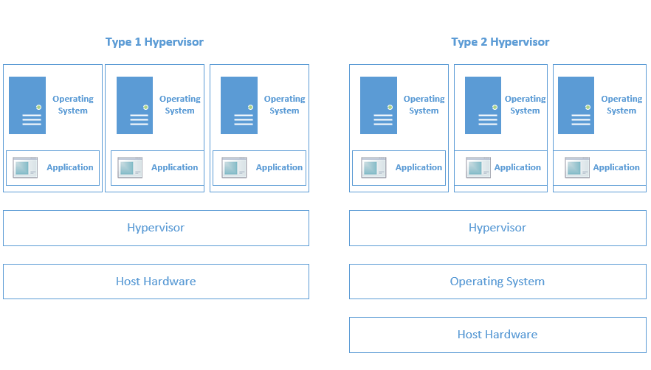
Fig. 1 Hypervisor Architectures [8]
The hypervisor architectures allow for one or more VMs to run independently from each other on the hardware, meaning that if one VM experiences any issues, others are not affected [9].

There are many features of hypervisors.

- Partitioning – Allows multiple processes to be performed via efficient usage of the same hardware, to which the OS partitions them [10]. Partitioning also assists the security aspect [11].
- Resource Distribution – Allocates and distributes resources like memory and storage on different VMs to best utilise resources, improving efficiency and network performance [10], [11].
- Functionality – Improves functionality of systems and apps as different OSs can be used on the same host [11].

The chosen hypervisor determines the hardware requirements. For example, the minimum requirements to run hypervisor KVM or VMware ESXi on VMware SD-WAN 5.4 [12] are as follows.

- CPU - Intel XEON (10 cores minimum) with 2.0 GHz minimum clock speed.
- RAM – 4GB, with one Gateway VM requiring 16GB.
- Disk Space – 150GB.
- Network Interface Ports – 1 x 10Ge.

Citrix Hypervisor 8.2 [13] requires the following:

- CPU – One or more 64-bit x86 CPUs with 1.5Ghz minimum clock speed.
- RAM – 2GB.
- Disk Space – 46GB.
- Network – 100Mbit/s or faster.

This confirms that KVM or VMware ESXi hypervisors will be more powerful but require more resources and storage.

There are many advantages of hypervisors.

- Increased hardware efficiency – More physical resources of the host are utilised due to multiple OSs running together, improving capability and efficiency [14], [15].
- Portability – Allows for allocation of extra resources and migration of VMs for load balancing and failovers [14], [15].
- Improved security – Any attacks that occur will only affect one VM and not any of the others as they are separated [14].

Hypervisors can be scaled to maximise resources on physical hardware to run workloads and processes across multiple VMs, resulting in cheaper hardware costs. Bratterud and Haugerud [16] investigated how much the OpenStack hypervisor could sustain when performing scalability within VMs, to which 10,000 VMs used just above 2% of the CPU, allowing VMs to perform more efficiently.

Hypervisors have improved security, with Aalam, Kumar, and Gour [7] highlighting three specific security features.

- Abstracting physical resources – Hypervisors abstract hardware details and restrict access, with a guest machine having no details about the host OS or hardware, making attacks difficult to succeed.
- Pre-attack State Restore – VMs take backups of virtual disks regularly, allowing for restoration from files to remove issues, and maintaining integrity.
- Isolation – Partitions are created to make isolated areas for VMs to perform on their own. Because of this, any attacks on one VM do not affect any others.

Microsoft Azure has further mitigations within the hypervisor like virtualisation-based security to maintain integrity and exploit mitigations like data execution and corruption prevention, which were made to make any attempts to exploit any vulnerabilities across VMs very difficult [17].

Hypervisors allow for different compatibilities with Microsoft, Oracle, Citrix, etc. For example, Microsoft allows many guest OSs for Hyper-V on Windows Server like Windows Server 2016 and 2019, as well as client guest OSs like Windows 10 [18], with the secure boot security feature compatible with Linux Ubuntu and CentOS [19]. VMware provides a compatibility guide to search different systems and servers (for example, guest OSs) based on release version (for example, EXSi 8.0) for users to choose the best options as required [20].

There are many use cases for hypervisors.

- Optimised resources – Multiple VMs can be used on one server, improving productivity by using idle resources [11].
- Reduced power consumption – One server for many VMs reduces power consumption and costs [11].
- Continuity of Legacy Systems – Older systems can be used, improving integration with new software and hardware [11].
- Disaster Recovery – Hypervisors move all VMs to a physical data centre if a failure occurs, reducing data loss risk and maintaining availability [11].

There are various hypervisor solutions available to users and organisations.

- Microsoft Hyper-V – A type-1 hypervisor allowing VMs to run on virtual hardware, as well as virtual switches and other virtual devices within the hypervisor [21], [22].
- Oracle Virtual Box – A free, open-source type-2 hypervisor allowing businesses and home use in virtualisation [23].
- VMware ESXi – A type-1 hypervisor as part of vSphere solutions, providing unified platforms for more effective management and improved AI innovation [24].
- Xen Project Hypervisor – An open-source type-1 hypervisor that forms the basis of other business and open-source applications to create automated processes [25].
- Kernel-Based Virtual Machine (KVM) – An open-source type-1 hypervisor that runs on x86 hardware using Linux [26].

Hypervisor Decision

The chosen hypervisor for “NOSS” is Oracle VirtualBox, as it provides a free professional hypervisor that can be used by individuals and organisations, while allowing many guest OSs to be installed on VirtualBox, including Windows, Linux, and Solaris [23].

This runs as an application rather than from hardware, allowing users to run multiple OSs between different VMs and providing access to guest OSs that users can use for improved productivity [5]. However, as it accesses CPU and other resources via the host OS, performance issues could occur due to latency, with security issues occurring if the host OS is compromised as attackers can access any guest OS [5].

Bonuccelli [27] compared Microsoft’s Hyper-V (type-1 hypervisor) to Oracle’s VirtualBox (type-2 hypervisor) and concluded that VirtualBox is more user-friendly and easier to set up, has a ‘Shared Folders’ feature for transferring files between the host OS and VMs, seamless transition between a PC and VM (which Hyper-V does not have), supports more OSs and has more virtual disk format options.

Other hypervisors were considered but not used for the following reasons.

- KVM – While an open-source software, this would not be the most suitable to be used as a host OS as it is Linux-focused, especially as VirtualBox can run Linux as a guest OS on VMs [26].
- VMware ESXi – While there are free versions of ESXi and trial versions of vSphere, the cost for each workstation could become costly depending on the number of workstations requiring the software. It would cost $199 each in America for the pro version that connects to the ESXi server [28].

Downloading the Hypervisor, Server, and Client Operating Systems

Oracle VirtualBox was installed.

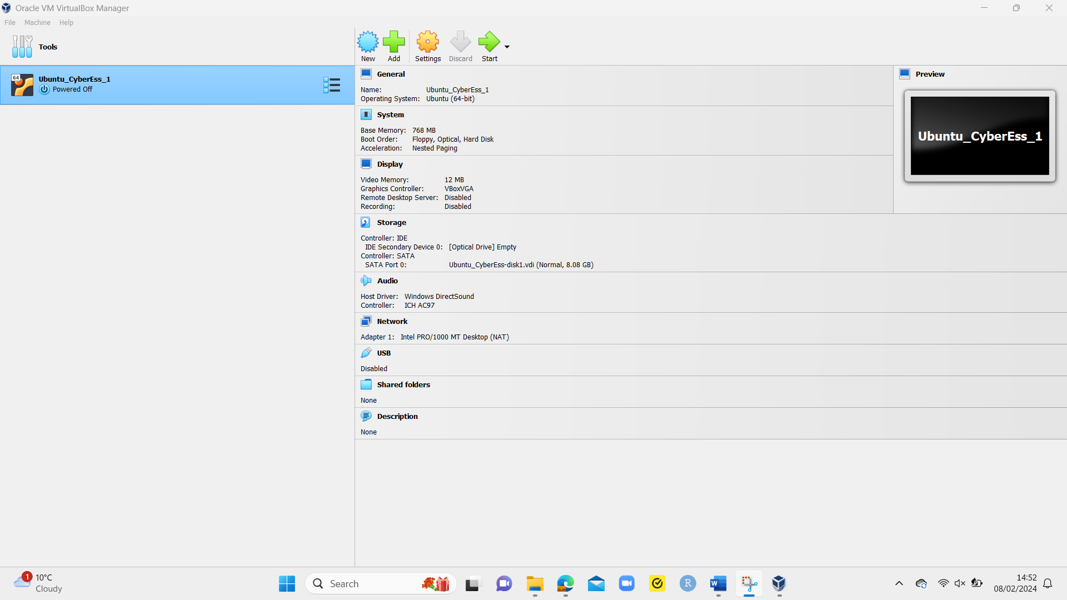
Fig. 2 Oracle VirtualBox Hypervisor Installed

Windows Server 2019 was downloaded as while Windows Server 2022 is newer, it is cheaper (Windows Server 2022 Standard costs $1069 in America [29]) and, according to a Microsoft community post, a free upgrade to Windows Server 2022 can be performed for those purchasing Windows Server 2019 [30].

The setup for the Swansea and London (cloned from Swansea) domains was as follows.

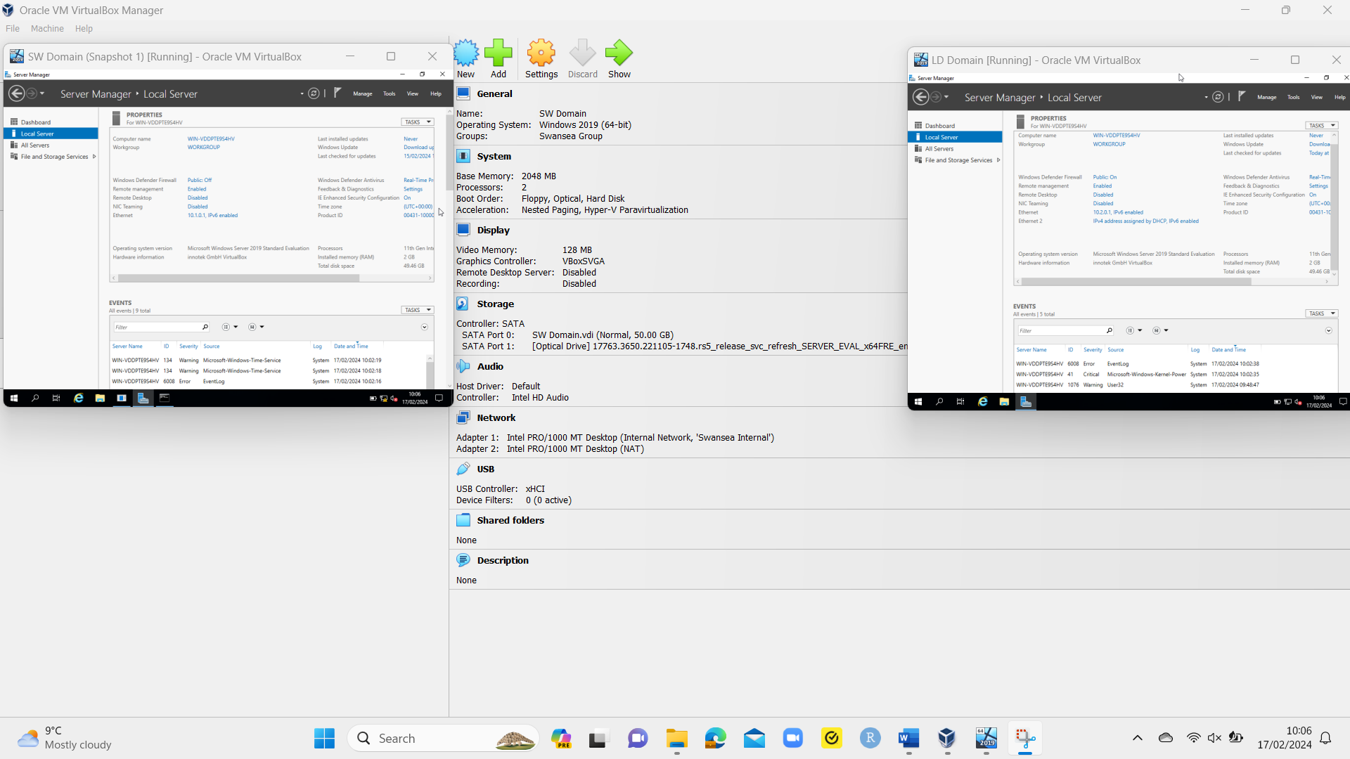
Fig. 3 Swansea (SW) and London (LD) Domain Settings

Both domains were created with the username and passwords as per “NOSS” requirements.

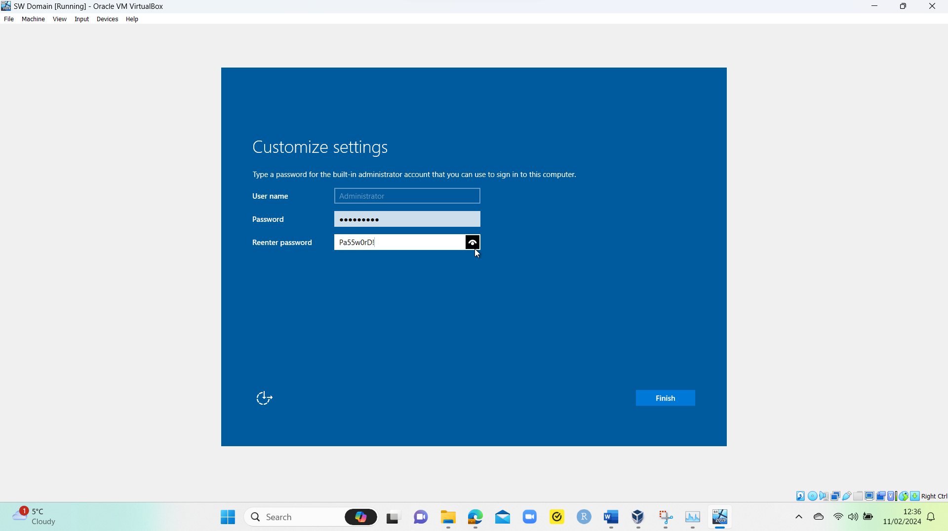
Fig. 4 SW Windows Server 2019 Username and Password

The LD domain had the same username and password.

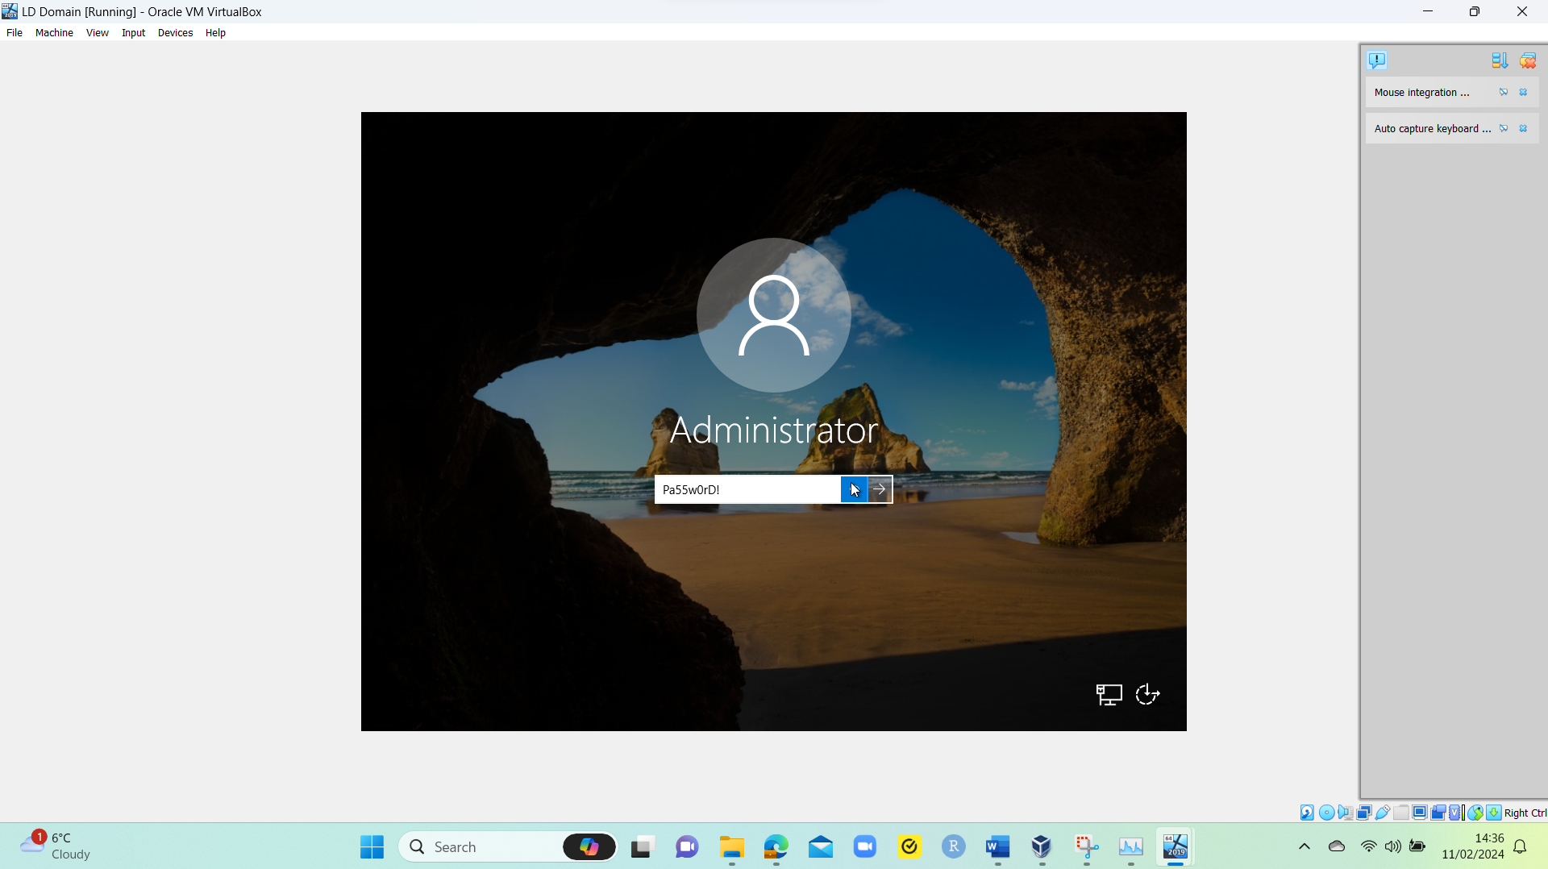
Fig. 5 LD Domain Username and Password

Windows 10 was downloaded for clients as while Windows 11 is newer, it is cheaper to purchase and run, and Windows 11 can be installed as part of an upgrade.

The setup for the Swansea and London (cloned from Swansea) client PC was the same as the domains.

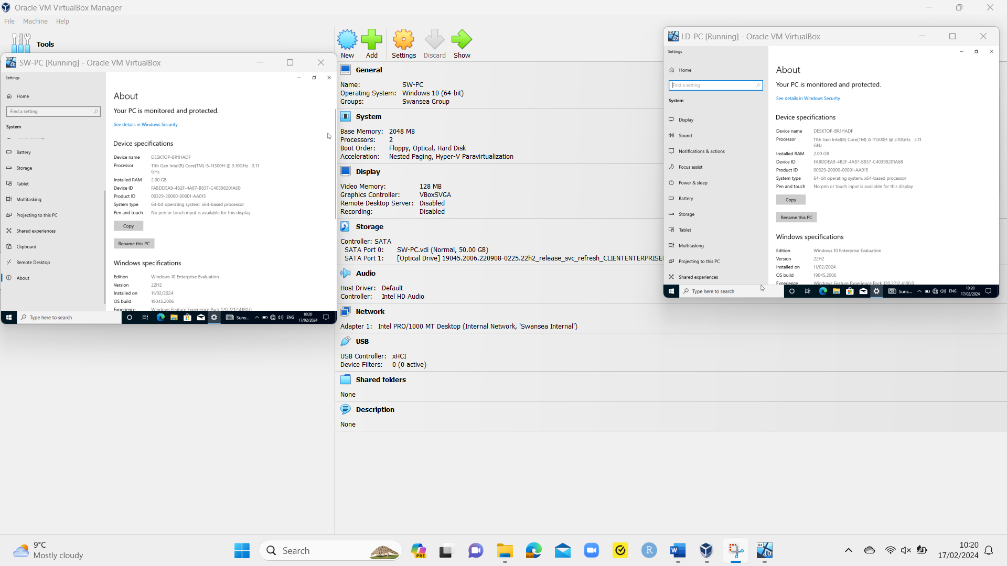
Fig. 6 SW and LD Client PC Settings (RAM)

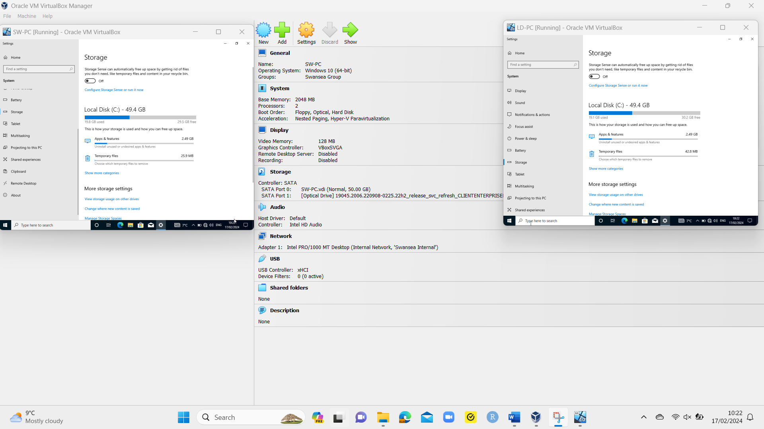
Fig. 7 SW and LD Client PC Settings (Storage)

The complete hypervisor, server, and client OSs were downloaded and installed as follows.

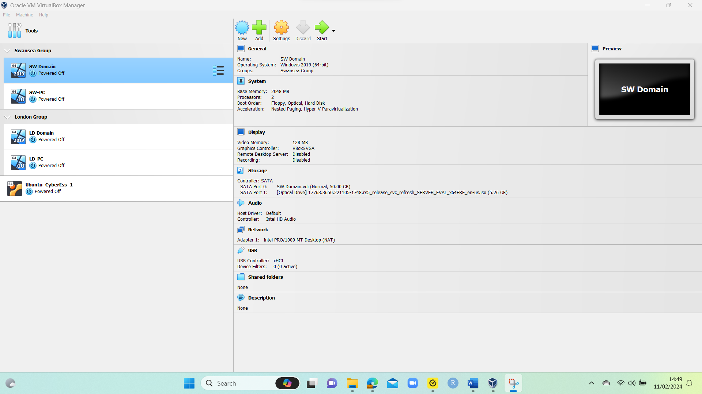
Fig. 8 Completed Download and Installation of Server Domains and Clients

Creating the Network

The required topology for “NOSS” is as follows.

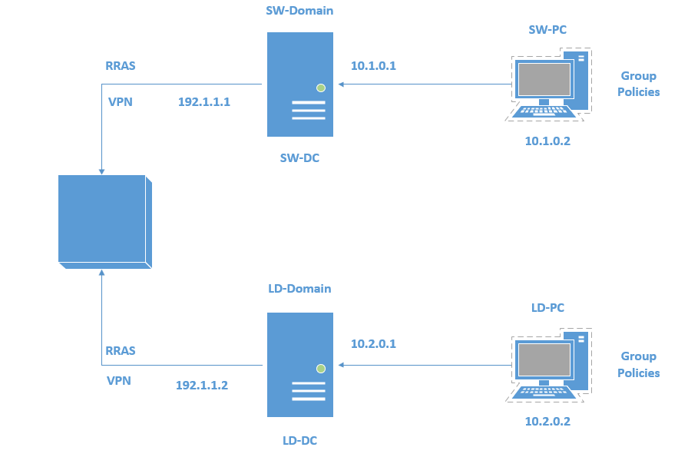
Fig. 9 “NOSS” Topology [31]

The Swansea networks were configured to show as ‘Internal Network’ for ‘Swansea’ and ‘Network Address Translation’ (NAT), though NAT could create performance and compatibility issues, as well as troubleshooting issues and increased memory usage [32]. This creates two ethernet ports within both domains and one ethernet within the client PC.

All VMs were given 2GB RAM with 2 processors and 50GB of virtual hard disk, based on minimum requirements for Windows Server 2019 [33] and Windows 10 [34].

The network setup for the Swansea and London domains was as follows.

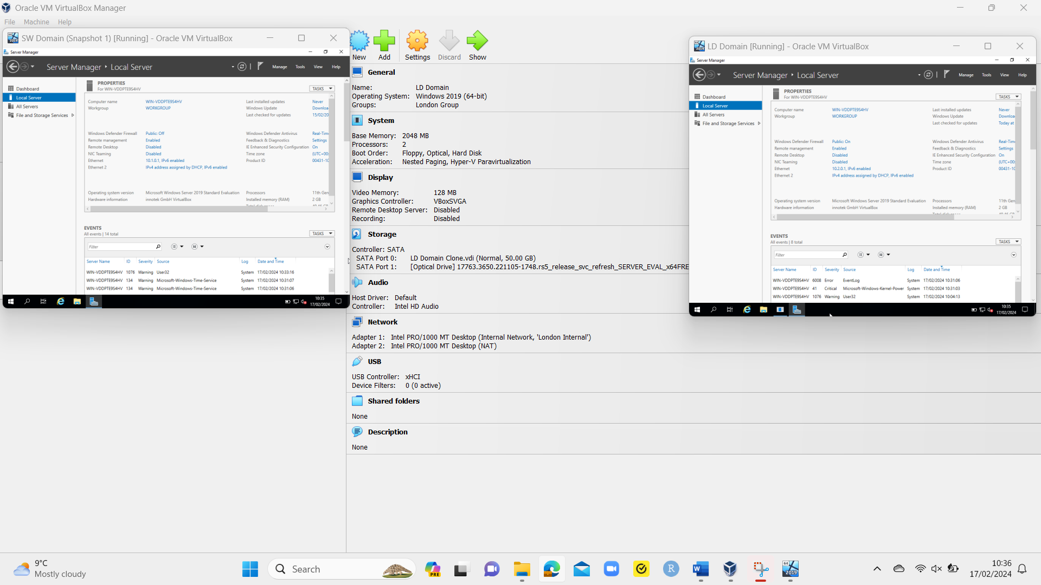
Fig. 10 SW and LD Domain Network Setup

The internal network setup for Swansea and London clients was as follows.

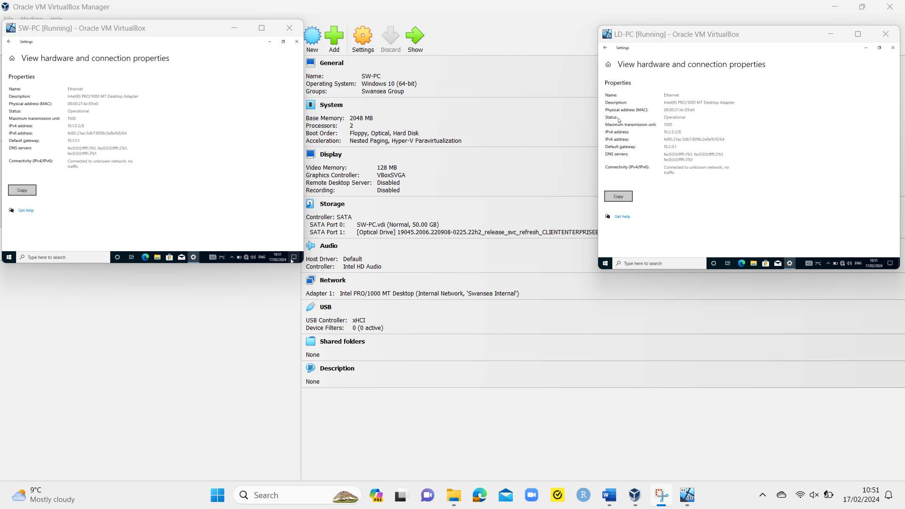
Fig. 11 SW and LD PC Network Setup

IP Addressing Research

Data communicates between computers via internet protocols (IP) and networking, creating communication rulings between any devices and applications connected to the internet [35]. This is performed via IP addresses, which are logical addresses assigned to different devices communicating within networks and the internet, identifying that device to send and receive data [36]. For example, when sending and receiving a text message from a mobile phone, the sender creates the message and sends this from their mobile number to the receiver via a mobile signal. The mobile network(s) sends the message to the recipient and the receiver receives the message from the sender, showing the sent message and the mobile number it originated from.

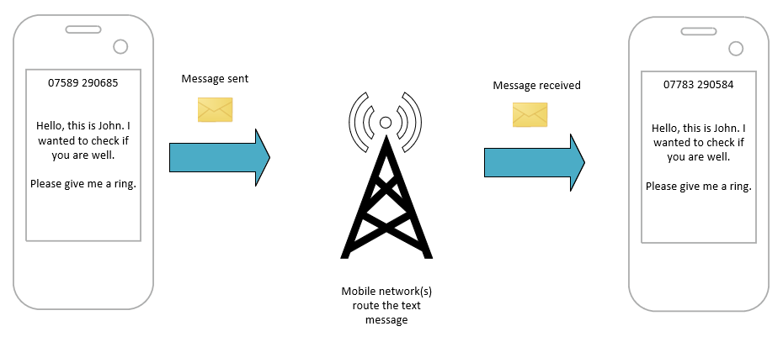
Fig. 12 IP Address Example via Text Messaging

This is like how computers communicate, whereby messages are sent detailing the source (the sender) and destination (the receiver) IP addresses via data packets (information transmitted and exchanged within networks and the internet [37]) containing details of the message. This is sent to the internet via routers (a device used to make connections, provide routing information, and forward decisions based on IP addresses [38]), to which routers send the message to the correct destination, find the recipient, and deliver the message.

There are two IP address types.

- IPv4 addresses - 32-bit addresses created using binary and octal systems, identifying hosts within networks and have ‘two to the power of 32’ addresses available, though have no blocks left [39]
- IPv6 addresses – 128-bit addresses created using hexadecimal systems which can be assigned to every device without worrying about running out of IPv6 addresses [39]

IPv4 addresses have private (communicates to other devices in the same network only [40]) and public (communicates outside the network and over the internet, usually assigned by an internet service provider (ISP) [40]) addresses, with each address created via dotted decimal notations (unique IP addresses containing four numbers less than or equal to 255 and separated by dots [41]). IPv4 addresses are created via subnetting (the creation of subnetworks in a network for devices to communicate directly [42]).

4 bytes = 32-bits
1 Byte = 8-bits | 1 Byte = 8-bits | 1 Byte = 8-bits | 1 Byte = 8-bits
1 1 0 0 0 0 0 0 | 0 1 1 0 1 0 0 0 | 0 0 0 0 0 1 1 1 | 1 0 0 1 0 0 0 1
128 + 64 = 192 | 64 + 32 + 8 = 104 | 4 + 2 + 1 = 7 | 128 + 16 + 1 = 145
IPv4 Address = 192.104.7.145

Fig. 13 IPv4 Address Structure Format [43]

The structure for IPv4 addressing is a prefix length consisting of decimals in 8-bit fields [44]. This helps identify the subnet mask addresses by counting the number of bits within a subnet mask and appending it with a slash at the end (for example, if a subnet mask shows as 255.0.0.0, as there are 8 bits used at the beginning, the prefix length would be ‘/8’ and the full IP address would be ‘255.0.0.0/8’).

There are three different classes for IPv4 addresses.

- Class A – Default subnet mask of 255.0.0.0 and range between 0.0.0.0 to 127.0.0.0 [45], supporting huge networks.
- Class B – Default subnet mask of 255.255.0.0 and range between 128.0.0.0 to 191.255.0.0 [45], supporting medium to large networks.
- Class C – Default subnet mask of 255.255.255.0 and range between 192.0.0.0 to 223.255.255.0 [45], supporting small networks.

IPv4 addresses can be assigned to establish communications on networks, or the internet as follows.

- Static IPv4 addresses
- Dynamic IPv4 addresses

Static IPv4 addresses are used for host devices like servers or printers that keep a permanent address for devices to establish and maintain constant connections while being more secure than public IPv4 addresses as they are in private networks [40]. However, manual assignment can lead to user errors when being created and cause connection issues. Static IPv4 address lists must be created and maintained for accuracy and to minimise unnecessary disruption.

Dynamic IPv4 addresses allow for automatic IPv4 address assignment via dynamic host configuration protocols (DHCP, a client/server protocol automatically providing IP addresses [46]). They are preferred in larger networks as IP addresses can be automatically assigned to many devices, while IP addresses can be reallocated from one device to another when available as they continuously change [40].

IPv6 addresses function like IPv4 addresses but use the format ‘x:x:x:x:x:x:x:x’, with each ‘x’ consisting of four hexadecimal values [47]. An example IPv6 address is ‘25B0:2FA8:00C6:0000:0000:0000:0534:0006’, which is truncated as leading zeros in each quartet can be omitted, while one quartet per address with all zeroes can be replaced with a double colon. The IPv6 address can be shortened to show as ‘25B0:2FA8:C6::534:1’ [47].

IPv6 Address Structure Breakdown
24D5 | 3D64 | 0035 | 0F4D | 0000 | 467E | 01A4 | 79FE
24D5 | 3D64 | 35 | F4D | :: | 467E | 1A4 | 79FE
Routing/Site Prefix |  |  | Subnet ID | Interface ID

Fig. 14 IPv6 Address Structure Format [48], [49]

IPv4 and IPv6 addresses can be defined into distinct categories.

- Global unicast – Allows one-to-one communication with routable IPv6 addresses on the internet [50]
- Multicast – Always beginning with ‘FF,’ allows other PCs wanting to receive information to join the group via an IPv6 address [50]
- Link-Local – Always beginning with ‘FE,’ communicates with another device in the same network area [50]
- Loopback Address – Tests if interfaces are available and functioning [50]

Routers make connections with networks, routing both information and forwarding decisions via IP addresses, adding all directly connected routers to a routing table to connect to other networks [38]. Routers connect to the internet which, if it does not know the specific network, sends information out via a default route within its network, though if there is more than one destination IP, the router will select the most specific route based on the most bits in a subnet mask [38].

Switches connect all devices in a network via MAC addresses and device ports, to MAC address tables are built and maintained to make forwarding decisions based on the source and destination MAC address [51]. As a switch’s MAC address table is empty to begin and using an example, when a PC sends information to a printer in a network, the switch adds the source MAC address and the port it came from to its MAC address table, while understanding the destination MAC address and port number of the printer, to which the switch will only send information out from the source to its destination via the recorded route in its MAC address table [51].

Configuring the IP Addresses of the Network

The IPv4 address was manually assigned on the Swansea and London domains as follows.

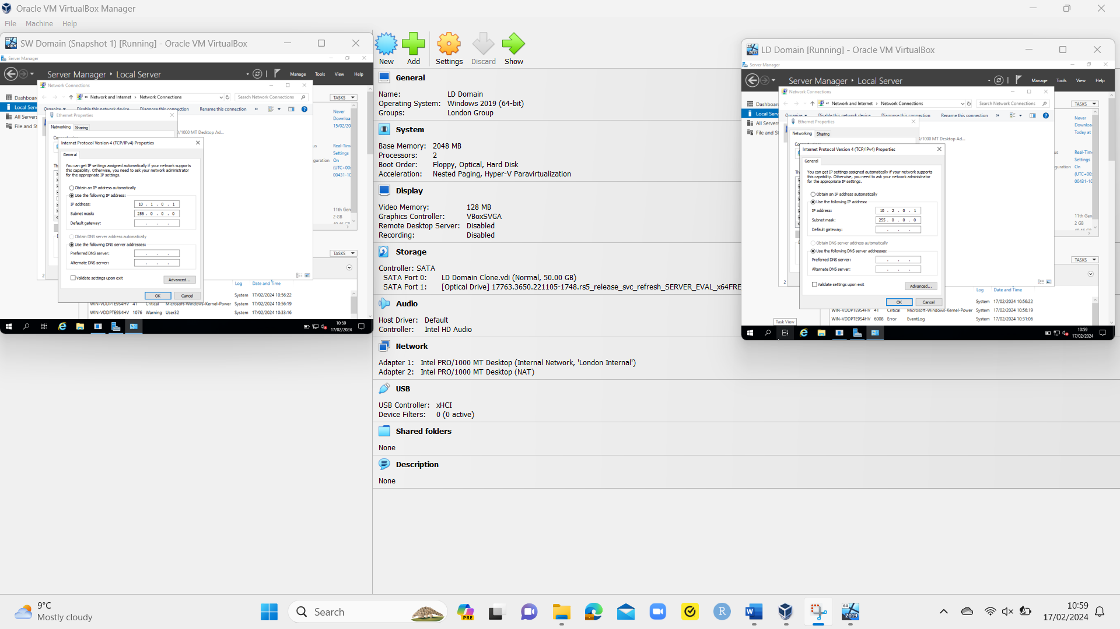
Fig. 15 SW and LD Domain IPv4 Address Manual Creation

The IPv4 address was also manually assigned on the Swansea and London clients as follows.

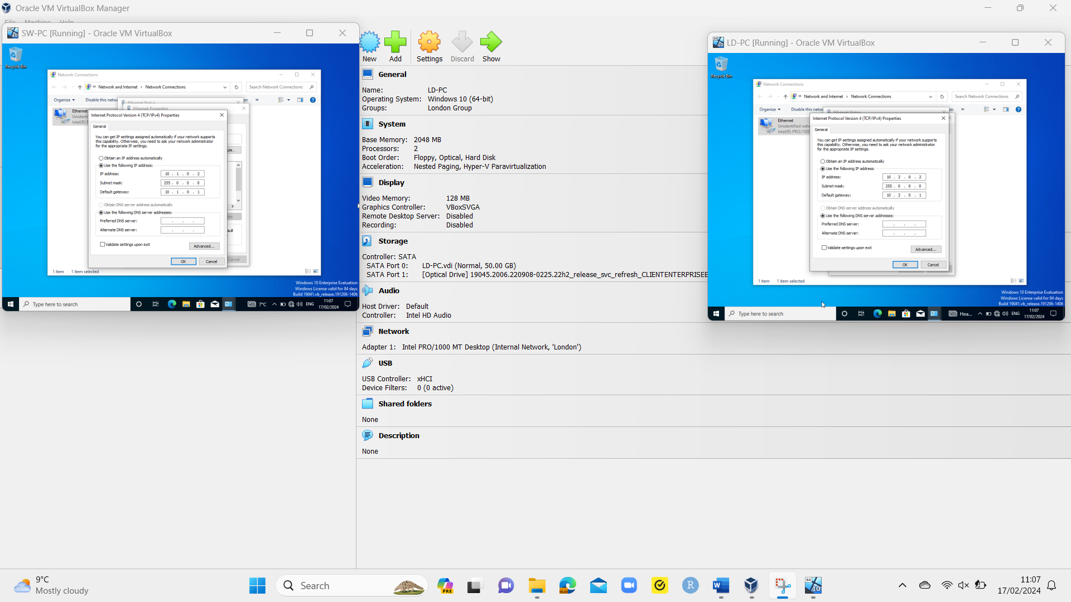
Fig. 16 SW and LD Client IPv4 Address Manual Creation
However, when performing a ping test from the SW domain to the SW client, a ‘request timed out’ occurred as it could not reach the SW PC, resulting in the packets being lost. This is the same when pinging the SW domain from the SW client. The London domain and client also failed to ping each other with the same ‘request timed out’ message.

Troubleshooting is required to ensure network and IP configurations are correct and ensure the servers and clients in their locations can successfully ping each other, confirming the network has been configured fully and each domain and client can communicate successfully.

Network Testing and Troubleshooting Research

When a network is created and configured, network testing must be performed, with any issues troubleshot to ensure issues are minimised and underlying causes are eliminated to minimise reoccurrence. If issues are not troubleshooted, underlying issues may become more complex and cause networks to perform poorly or cease functioning.

Part of network testing is around connectivity testing as follows.

- Bandwidth testing – Tests how efficient networks perform and if there are any bottlenecks. For example, one bandwidth test involves flooding a network with huge volumes of packets for a bottleneck to become overwhelmed with test data rather than actual data [52].
- Packet loss testing – Tests if there are communication issues in networks by detecting if packets are being lost and resulting in performance issues like slow load times and degraded system performance. Two options to test packet losses can be online websites that check a network connection for packet losses, with another option being ping tests via command prompts to an IP address, to which a computer will receive a response, confirming the connection has been made [53].
- Security testing – Proactively tests for potential threats to networks from attackers, including vulnerability tests (checks for vulnerabilities in networks, like a missing security update which could be exploited via SQL injection) performed via vulnerability scanning and penetration testing to try and exploit weaknesses within a network and if exploited, to secure that vulnerability and ensure threats are minimised [54].

There can be many connectivity issues as follows.

- IP Address conflicts – Two IP addresses are the same in two different devices and communications for both devices are continuously disrupted and re-established, to which there is difficulty determining an IP address conflict and no implemented processes to detect this [55]. This is resolved by changing any static IP addresses to DHCP for an IP address to be automatically assigned or excluding any static IP addresses from a DHCP server [56]. TCP/IP has an IP addressing scheme for users and applications to communicate on networks and consists of broadcast addresses (TCP/IP sending data to all hosts) and loopback addresses (a special network address of 127.0.0.1) [57].
- DNS resolutions – Translates IP addresses to domain names (for example, 8.8.8.8 translates to www.google.com), to which a DNS resolver provides website information to a PC if stored in its cache, but if the information is not available, it performs various queries to find the correct information and if it cannot find the requested information, it returns an error to the PC (for example, if a website is misspelled and no website exists with that name) [58].
- Firewall configurations – Detects any malicious packages coming through networks to PCs and domains, like web application firewalls (WAF) monitoring and blocking suspicious packages, and analysing traffic based on rules from a web application [59]. However, firewall rulings configured incorrectly can disrupt networks by blocking legitimate traffic if settings are too restrictive and certain rules are disabled. For example, ping tests may not work if the ‘File and Printer Sharing (Echo Request - ICMPv4-In)’ rule is disabled in a firewall on Windows. If switched on, this should allow servers and PCs to establish communications.

Testing the Network

The firewall settings were checked and after checking the inbound rules, the ‘File and Printer Sharing (Echo Request – ICMPv4-In)’ on both domains and PCs were disabled, meaning that no responses could be made. These were enabled on both domains and client PCs.

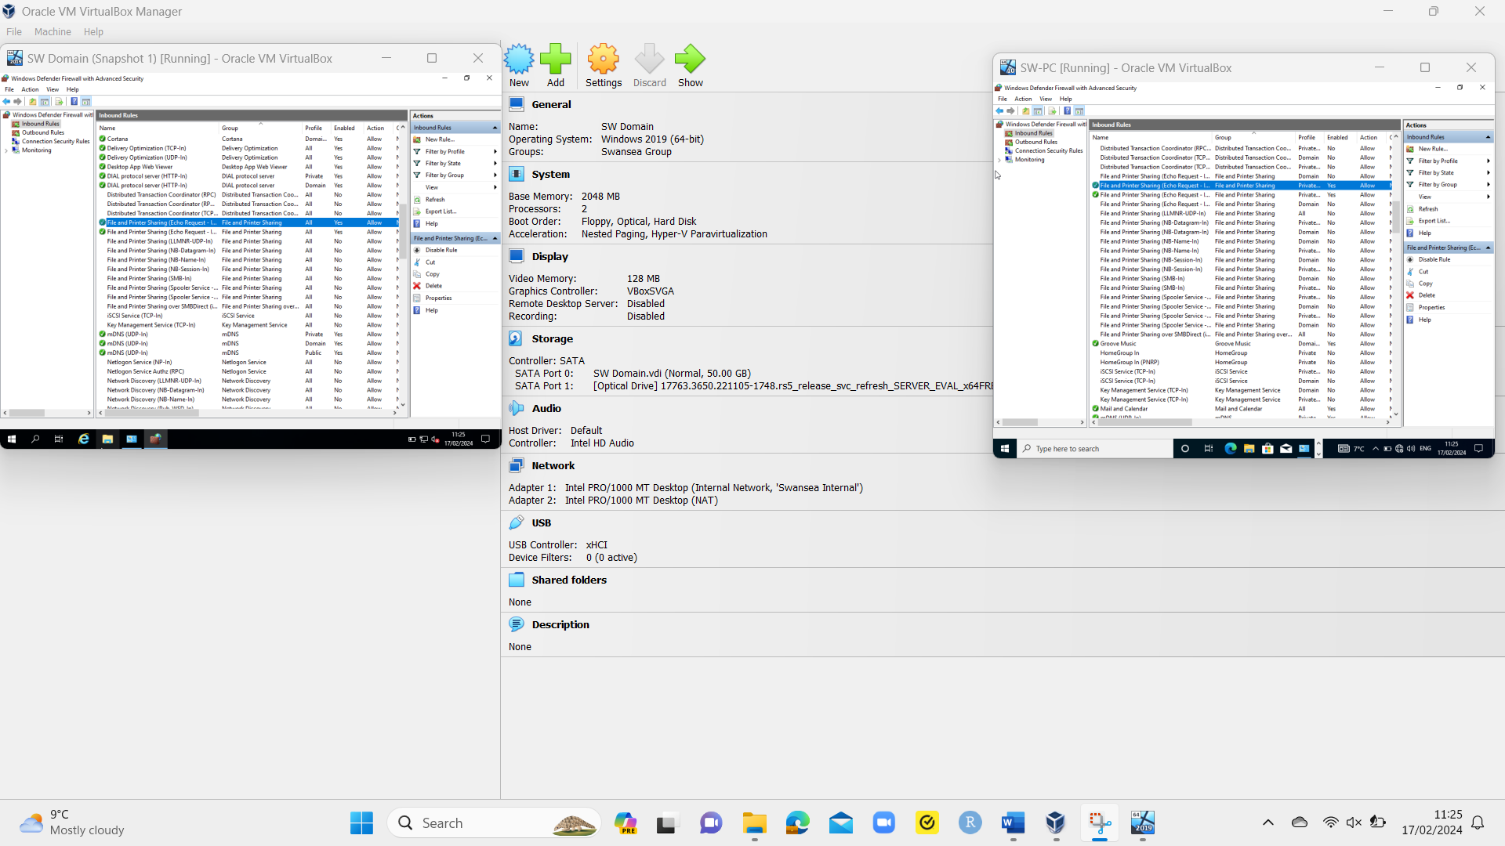
Fig. 17 SW Domain and PC ‘Echo Request – ICMPv4-In’ Ruling Enabled

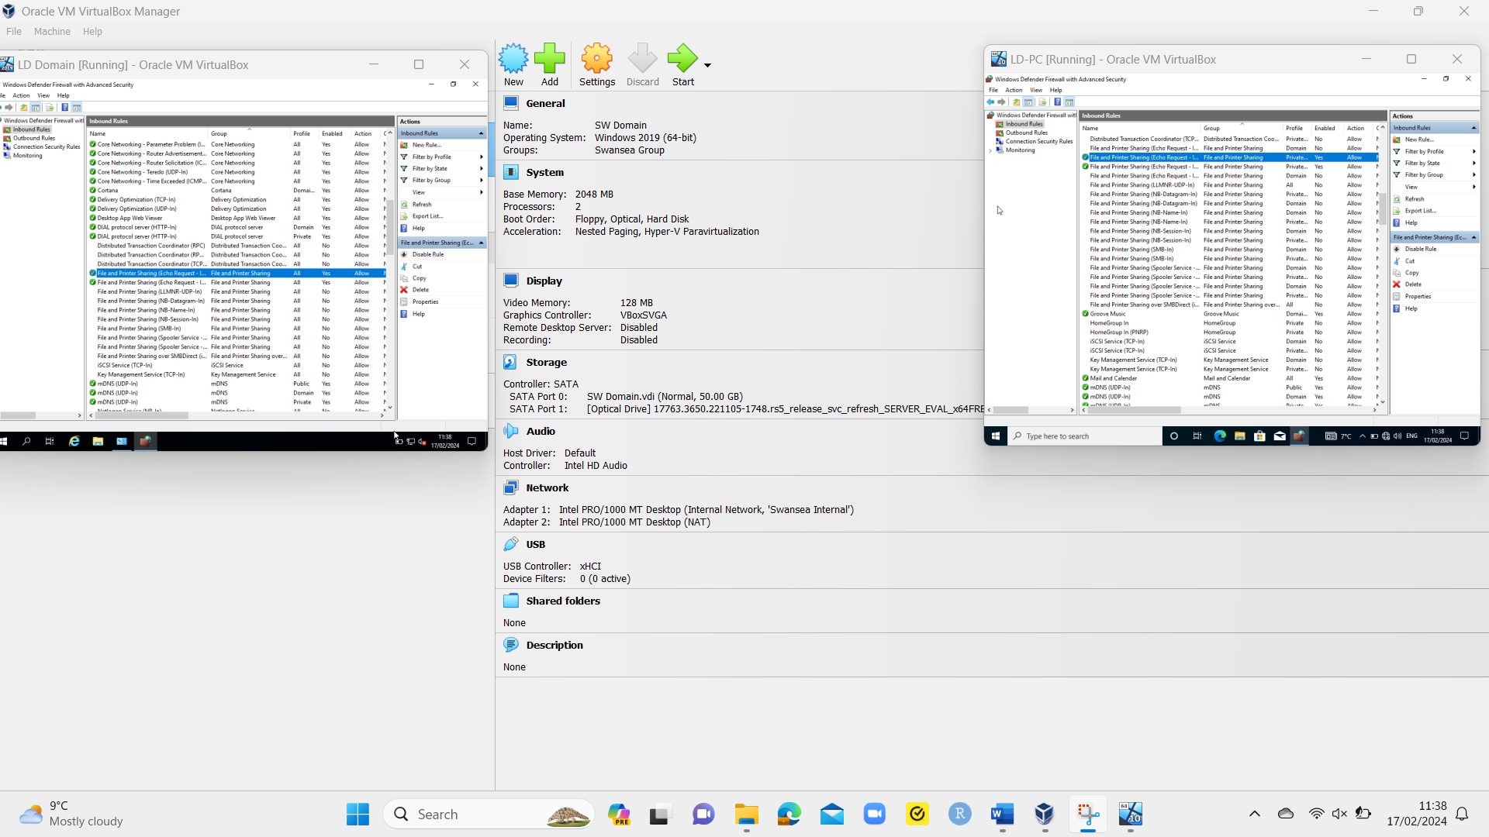
Fig. 18 LD Domain and PC ‘Echo Request – ICMPv4-In’ Ruling Enabled
The ‘ipconfig’ tests were performed showing the manually entered IPv4 address and subnet mask of the ethernet ports of the SW and LD domains and PCs. When performing the ping tests, both SW and LD domains and client PCs communicated with each other.

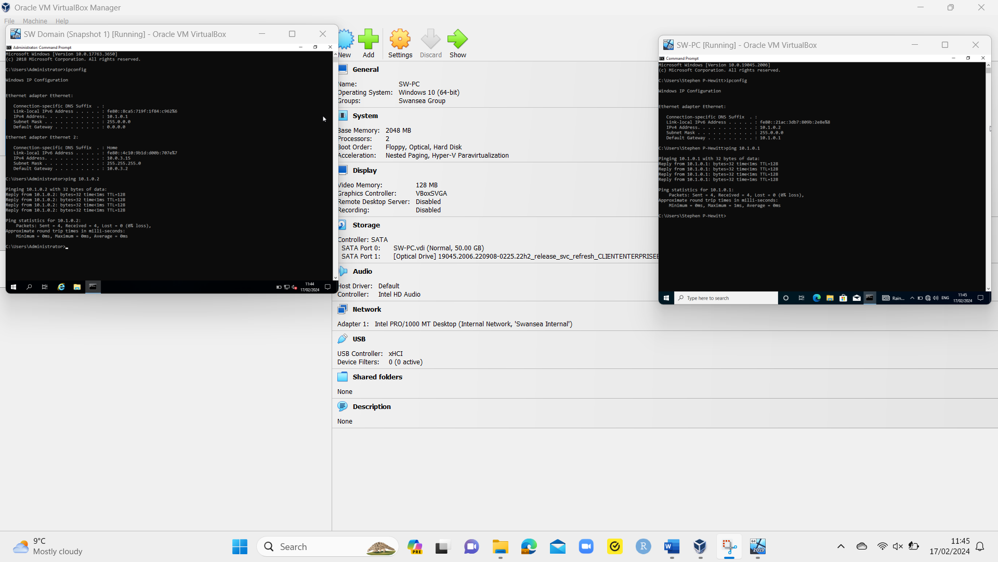
Fig. 19 SW Network Ipconfig and Successful Pings

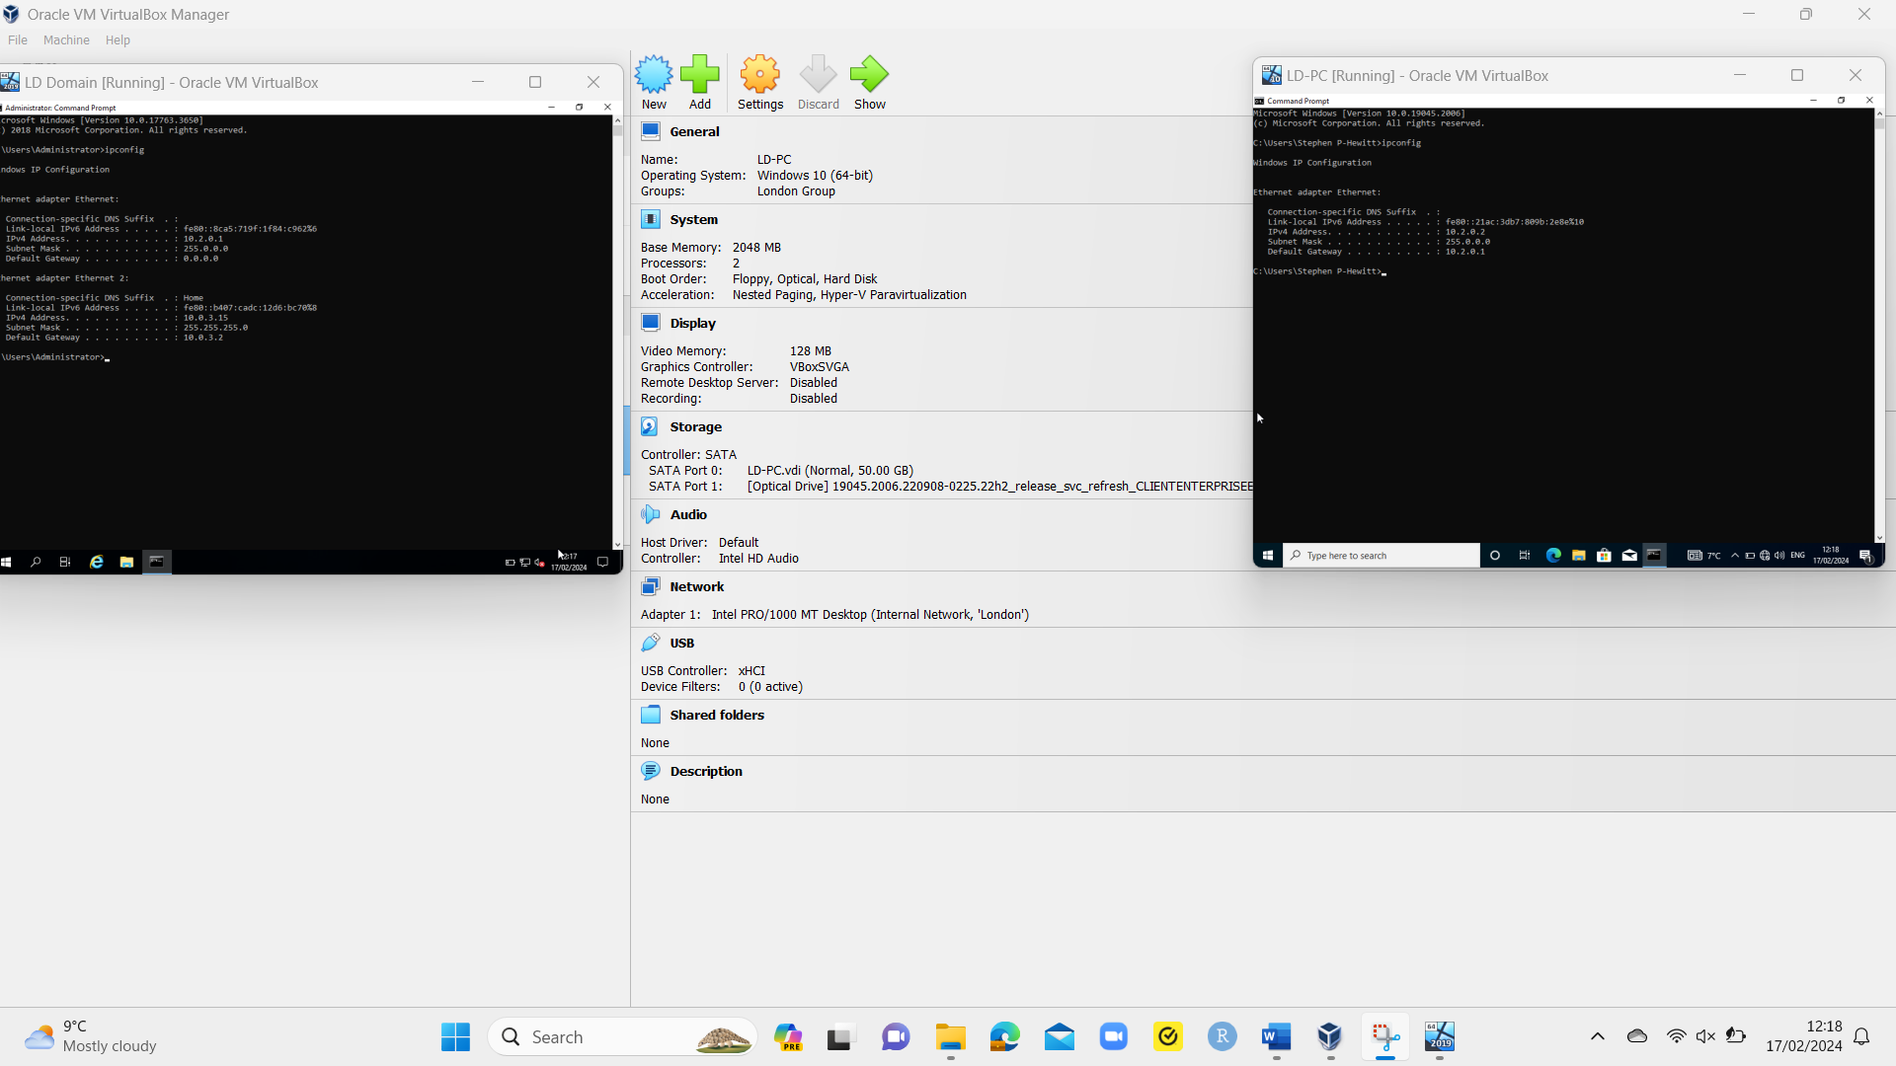
Fig. 20 LD Network Ipconfig

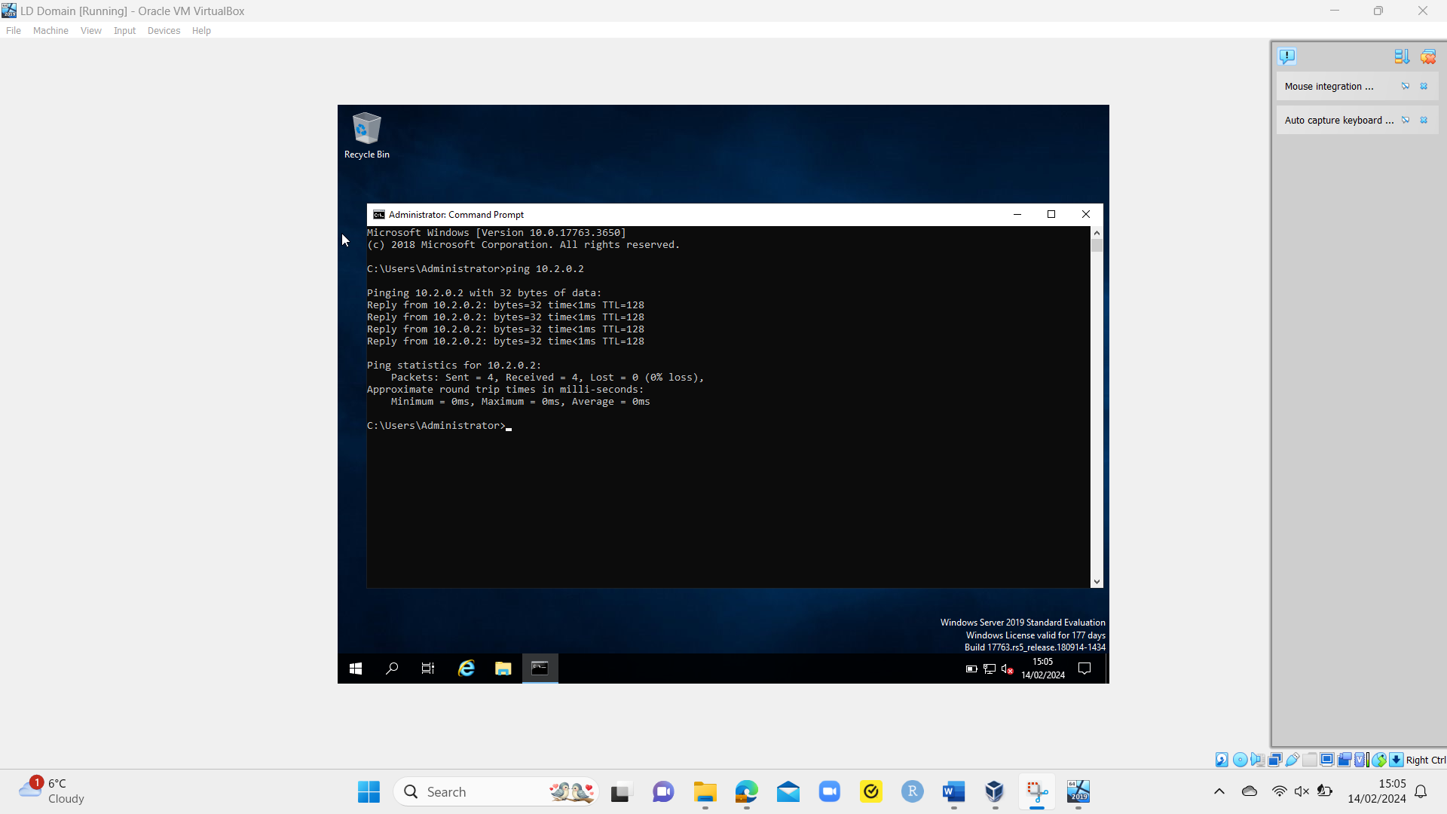
Fig. 21 LD Domain to LD PC Successful Ping

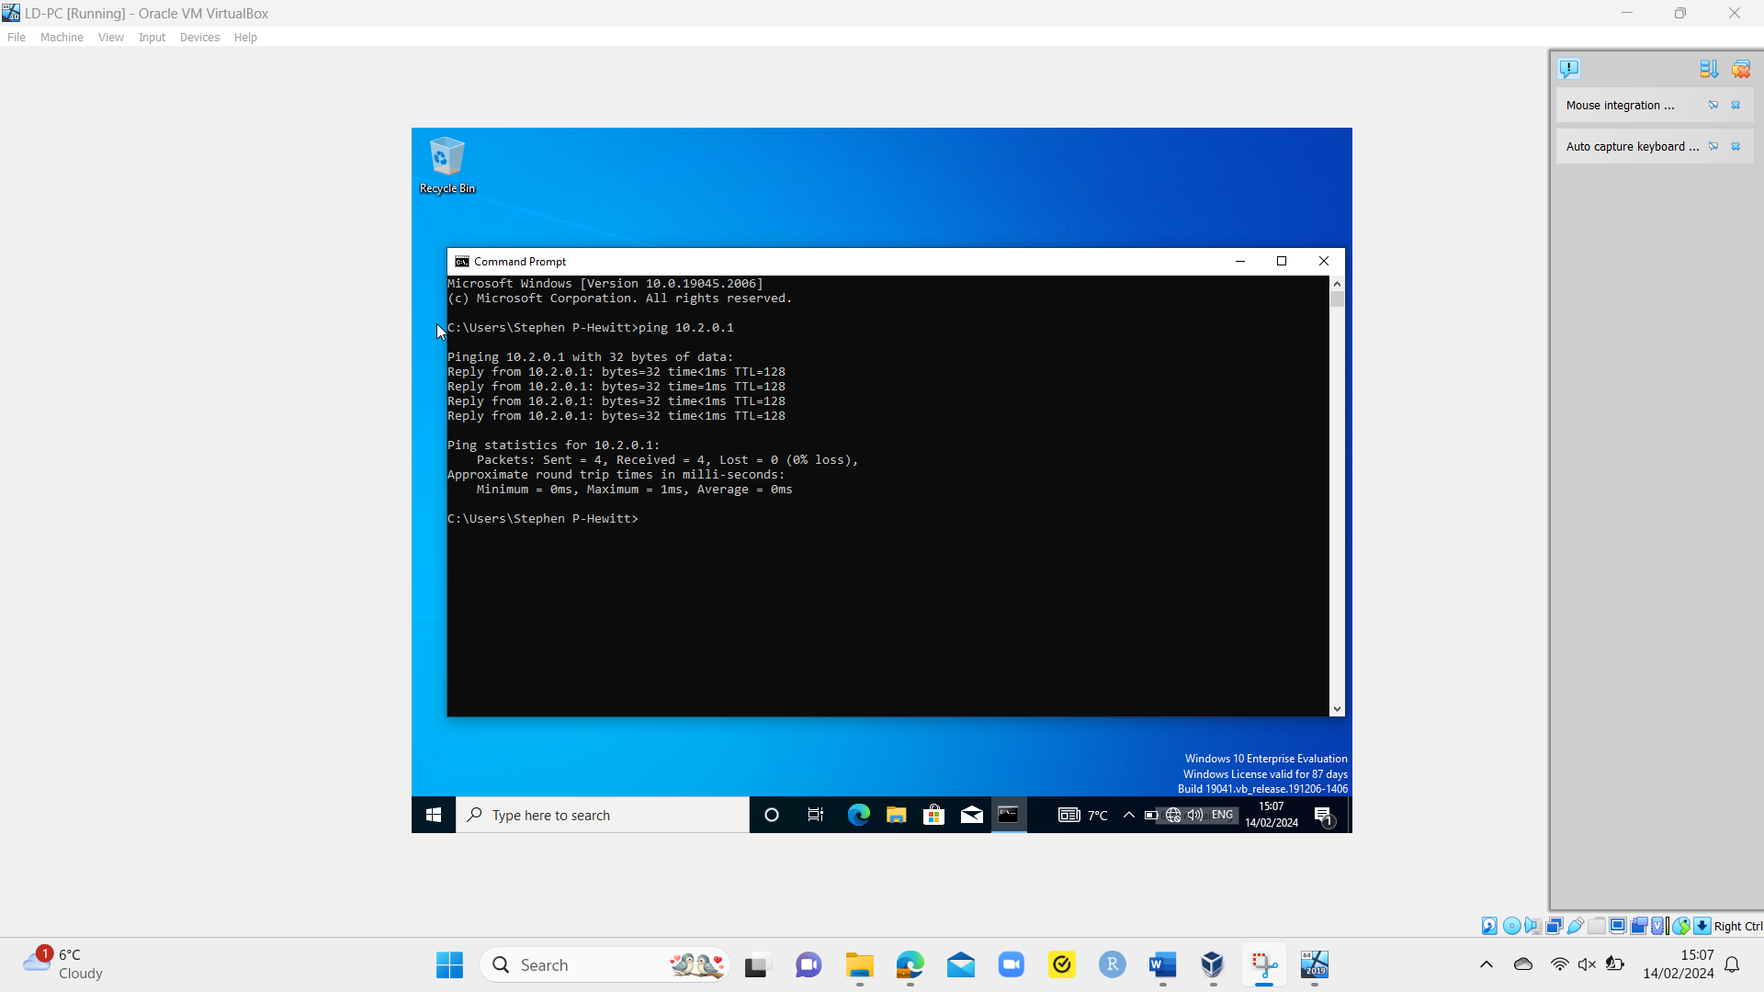
Fig. 22 LD PC to LD Domain Successful Ping

Conclusion

The most effective network virtualisation must be chosen to ensure that it meets organisational needs. If the incorrect virtualisation options are made (for example, the wrong hypervisor for what is required), it could create inconsistencies between each VM, cause compatibility issues and potentially increase the volume of resources required.

A recommendation would be to use IPv6 addresses and manually assign them as part of networking setup and configuration, due to the increased prevalence of IPv6 addresses and no blocks available for further IPv4 addresses. With many IPv6 addresses available to use, this will become the main communication method between servers, and devices within networks.

Another recommendation could be the creation of standardised procedures for firewall rulings. This allows organisations to create firewall rulings for networks using generalised processes across organisations based on best practices. While differences may occur depending on the firewall requirements, it allows for consistency across organisations, standardising inbound and outbound rulings for improved troubleshooting of firewall-related issues and documenting any changes made to ensure network security staff are aware.

Future research would involve the practical setup of static IPv6 addresses within networks and testing connectivity like with IPv4 addresses to ensure networks can communicate and perform as expected using IPv6 addresses only. This would be connected without IPv4 addresses and ensure networks can connect.

References

[1] | J. Fruhlinger, “What is a virtual network: Virtual networks are vital for cloud computing, and virtual LANs can transform networks,” Network World (Online), Feb. 2023 [Online] Available: https://www.proquest.com/trade-journals/what-is-virtual-network/docview/2771991693/se-2 [Accessed February 5, 2024].
[2] | S. Watts, “What is a Virtual Network?”, BMC, Jun. 16, 2020 [Online]. Available: https://www.bmc.com/blogs/virtual-network/ [Accessed Feb. 5, 2024].
[3] | VMWare, “What is Virtual Networking?”, VMWare [Online] Available: https://www.vmware.com/topics/glossary/content/virtual-networking.html [Accessed Feb. 5, 2024].
[4] | T.-M. Nguyen, A. Girard, C. Rosenberg and S. Fdida, “Routing via Functions in Virtual Networks: The Curse of Choices”, IEEE/ACM transactions on networking, vol. 27, no. 3, pp. 1192-1205, Jun. 2019 [Online] Available: 10.1109/TNET.2019.2912717 [Accessed February 5, 2024].
[5] | IBM, “What are hypervisors?”, IBM [Online]. Available: https://www.ibm.com/topics/hypervisors [Accessed Feb. 7, 2024].
[6] | V. Aggarwal and B. Thangaraju, “Performance Analysis of Virtualisation Technologies in NFV and Edge Deployments” in 2020 IEEE International Conference on Electronics, Computing and Communication Technologies (CONECCT), Bangalore, 2020 [Online] Available: 10.1109/CONECCT50063.2020.9198367 [Accessed Feb. 7, 2024].
[7] | Z. Aalam, V. Kumar and S. Gour, “A review paper on hypervisor and virtual machine security”, Journal of physics. Conference series, vol. 1950, no. 1, August 2021 [Online] Available: 10.1088/1742-6596/1950/1/012027 [Accessed Feb. 7, 2024].
[8] | B. P. Tholeti, “Learn about hypervisors, system virtualization, and how it works in a cloud environment”, IBM, Sept. 23, 2011 [Online] Available: https://developer.ibm.com/articles/cl-hypervisorcompare/ [Accessed Feb. 8, 2024].
[9] | R. C. Bhushan and D. K. Yadav, “Verification of Virtual Machine Architecture in a Hypervisor through Model Checking”, Procedia computer science, vol. 167, pp. 67-74, 2020 [Online] Available: 10.1016/j.procs.2020.03.183 [Accessed Feb. 8, 2024].
[10] | V. Yfantis, “What Is a Hypervisor and What Are Its Benefits? | Parallels Explains” Parallels, Apr. 30, 2020 [Online] Available: https://www.parallels.com/blogs/ras/hypervisor/ [Accessed Feb. 8, 2024].
[11] | RedSwitches, “What is a Hypervisor in Cloud Computing? Everything You Need To Know”, RedSwitches, May 23, 2023 [Online] Available: https://www.redswitches.com/blog/hypervisor-in-cloud-computing/#Importance-of-a-Hypervisor [Accessed Feb. 9, 2024].
[12] | VMware, “Minimum Hypervisor Hardware Requirements”, VMware, Jun. 8, 2023 [Online] Available: https://docs.vmware.com/en/VMware-SD-WAN/5.4/vmware-sd-wan-partner-guide/GUID-17432A7A-693D-477E-8D7F-1D74673072AA.html [Accessed Feb. 9, 2024].
[13] | Xen Server, “System requirements”, Xen Server, Aug. 31, 2023 [Online] Available: https://docs.xenserver.com/en-us/citrix-hypervisor/system-requirements.html [Accessed Feb. 9, 2024].
[14] | XenServer, “What is a hypervisor?”, XenServer [Online] Available: https://www.xenserver.com/what-is-a-hypervisor [Accessed Feb. 9, 2024].
[15] | VMware, “What is a hypervisor?”, VMware [Online]. Available: https://www.vmware.com/topics/glossary/content/hypervisor.html?resource=cat-1208275909 [Accessed Feb. 9, 2024].
[16] | A. Bratterud and H. Haugerud, “Maximizing hypervisor scalability using minimal virtual machines”, IEEE International Conference on Cloud Computing Technology and Science, vol. 1, pp. 218-223, 2013 [Online] Available: https://hdl.handle.net/10642/2009 [Accessed Feb. 9, 2024].
[17] | Microsoft, “Hypervisor security on the Azure fleet”, Microsoft, Nov. 11, 2022 [Online] Available: https://learn.microsoft.com/en-us/azure/security/fundamentals/hypervisor [Accessed Feb. 9, 2024].
[18] | Microsoft, “Supported Windows guest operating systems for Hyper-V on Windows Server” Microsoft, Sept. 26, 2023 [Online] Available: https://learn.microsoft.com/en-us/windows-server/virtualization/hyper-v/supported-windows-guest-operating-systems-for-hyper-v-on-windows [Accessed Feb. 9, 2024].
[19] | Microsoft, “Hyper-V feature compatibility by generation and guest”, Microsoft, Jul. 29, 2021 [Online] Available: https://learn.microsoft.com/en-us/windows-server/virtualization/hyper-v/hyper-v-feature-compatibility-by-generation-and-guest [Accessed Feb. 9, 2024].
[20] | VMware, “VMware Compatibility Guide”, VMware [Online]. Available: https://www.vmware.com/resources/compatibility/search.php [Accessed Feb. 9, 2024].
[21] | Microsoft, “Hyper-V architecture”, Microsoft, May 5, 2023 [Online] Available: https://learn.microsoft.com/en-us/windows-server/administration/performance-tuning/role/hyper-v-server/architecture [Accessed Feb. 10, 2024].
[22] | Microsoft, “Introduction to Hyper-V on Windows 10”, Microsoft, Apr. 26, 2022 [Online] Available: https://learn.microsoft.com/en-us/virtualization/hyper-v-on-windows/about/ [Accessed Feb. 10, 2024].
[23] | Oracle, “Welcome to VirtualBox.org!” Oracle [Online] Available: https://www.virtualbox.org/ [Accessed Feb. 10, 2024].
[24] | VMware, “vSphere”, VMware [Online] Available: https://www.vmware.com/products/vsphere.html [Accessed Feb. 10, 2024].
[25] | Xen Project, “VIRTUALIZATION”, Xen Project [Online] Available: https://xenproject.org/users/virtualization/ [Accessed Feb. 10, 2024].
[26] | KVM, “Main Page,” KVM [Online] Available: https://www.linux-kvm.org/page/Main_Page [Accessed Feb. 10, 2024].
[27] | G. Bonucelli, “Hyper V vs VirtualBox: Understanding Their Differences”, Paralells, Jun. 8, 2022 [Online] Available: https://www.parallels.com/blogs/ras/hyperv-vs-virtualbox/ [Accessed Feb. 10, 2024].
[28] | VMware Store, “The Most Powerful Virtualization for Windows and Linux”, VMware, [Online] Available: https://store-us.vmware.com/workstation_buy_dual#buy_dual_compare [Accessed Feb. 10, 2024].
[29] | Microsoft, “Pricing and licensing for Windows Server 2022”, Microsoft [Online] Available: https://www.microsoft.com/en-us/windows-server/pricing [Accessed Feb. 11, 2024].
[30] | Microsoft, “Windows server free upgrade costs from Windows server 2019 to 2022”, Microsoft, Nov. 27, 2023 [Online] Available: https://answers.microsoft.com/en-us/windowserver/forum/all/windows-server-free-upgrade-costs-from-windows/9c06469c-1c22-42f8-8297-806a96c34399 [Accessed Feb. 11, 2024].
[31] | N. M. Kaliyamurthy, Build, and deploy, a Type 2 Hypervisor platform based Virtualised network, University of Wales Trinity St. Davids, 2024.
[32] | Geeks for Geeks, “Advantages and Disadvantages of NAT”, Geeks for Geeks, Oct. 18, 2021 [Online] Available: https://www.geeksforgeeks.org/advantages-and-disadvantages-of-nat/ [Accessed Feb. 12, 2024].
[33] | Microsoft, “Hardware requirements for Windows Server”, Microsoft, Dec. 23, 2021 [Online] Available: https://learn.microsoft.com/en-us/windows-server/get-started/hardware-requirements [Accessed Feb. 12, 2024].
[34] | Microsoft, “How to Find Windows 10 Computer Specifications & Systems Requirements” Microsoft [Online] Available: https://www.microsoft.com/en-us/windows/windows-10-specifications [Accessed Feb. 12, 2024].
[35] | T. Rooney and M. Dooley, “Introduction,” in IP Address Management, Hoboken, New Jersey: Wiley-IEEE Press, 2021, pp. 1-29 [E-book].
[36] | K. Wallace, “Networking Foundations: Networking Basics”, Linkedin Learning, Carpenteria, 2020 [Online] Available: https://www.linkedin.com/learning/networking-foundations-networking-basics/ip-version-4-addresses?resume=false&u=77966930 [Accessed Feb. 1, 2024].
[37] | M. Gao, J. Hu, D. Chen and C. Jia, “Resilient state estimation for time-varying uncertain dynamical networks with data packet dropouts and switching topology: an event-triggered method,” IET control theory & applications, vol. 14, no. 3, pp. 367-377, Feb. 1, 2020 [Online] Available: 10.1049/iet-cta.2019.0721 [Accessed Feb. 4, 2024].
[38] | K. Wallace, “Networking Foundations: Networking Basics”, Linkedin Learning, Carpenteria, 2020 [Online] Available: https://www.linkedin.com/learning/networking-foundations-networking-basics/routers?resume=false&u=77966930 [Accessed Feb. 1, 2024].
[39] | K. Wallace, “Learning IP Addressing”, Linkedin Learning, Carpenteria, 2019 [Online] Available: https://www.linkedin.com/learning/learning-ip-addressing-2019/the-role-of-ip-addresses?resume=false&u=77966930 [Accessed Feb. 4, 2024].
[40] | Geeks for Geeks, “Difference between Private and Public IP addresses”, Geeks for Geeks, Sept. 20, 2023 [Online] Available: https://www.geeksforgeeks.org/difference-between-private-and-public-ip-addresses/ [Accessed Feb. 4, 2024].
[41] | Oxford University Press, A Dictionary of the Internet, 4th ed., Oxford: Oxford University Press, 2019 [E-book].
[42] | Solarwinds, “Subnetting: What Is a Subnet? How It Works” Solarwinds [Online] Available: https://www.solarwinds.com/resources/it-glossary/subnetting [Accessed Feb. 1, 2024].
[43] | M. Pramatarov, “What is IPv4? Everything you need to know”, ClouDNS, Mar. 24, 2023 [Online] Available: https://www.cloudns.net/blog/what-is-ipv4-everything-you-need-to-know/#IPv4_meaning [Accessed Feb. 6, 2024].
[44] | Oracle, “Parts of the IPv4 Address”, Oracle, 2010 [Online] Available: https://docs.oracle.com/cd/E19455-01/806-0916/6ja85399u/index.html [Accessed Feb. 4, 2024].
[45] | Microsoft, “Understand TCP/IP addressing and subnetting basics”, Microsoft, Dec. 27, 2022 [Online] Available: https://learn.microsoft.com/en-us/troubleshoot/windows-client/networking/tcpip-addressing-and-subnetting#ip-addresses-networks-and-hosts [Accessed Feb. 4, 2024].
[46] | Microsoft, “Dynamic Host Configuration Protocol (DHCP)”, Microsoft, Jul. 29 2021 [Online] Available: https://learn.microsoft.com/en-us/windows-server/networking/technologies/dhcp/dhcp-top [Accessed Feb. 4, 2024].
[47] | K. Wallace, “Learning IP Addressing”, Linkedin Learning, Carpenteria, 2019 [Online] Available: https://www.linkedin.com/learning/learning-ip-addressing-2019/ipv6-address-structure?resume=false&u=77966930# [Accessed Feb. 1, 2024].
[48] | A. S. Gillis, “IPv6 address”, Tech Target, Sept. 2020 [Online] Available: https://www.techtarget.com/iotagenda/definition/IPv6-address [Accessed Feb. 6, 2024].
[49] | Oracle, “IPv6 Addressing Overview”, Oracle [Online] Available: https://docs.oracle.com/cd/E18752_01/html/816-4554/ipv6-overview-10.html [Accessed Feb. 6, 2024].
[50] | K. Wallace, “Learning IP Addressing”, Linkedin Learning, Carpenteria, 2019 [Online] Available: https://www.linkedin.com/learning/learning-ip-addressing-2019/ipv6-address-categories?resume=false&u=77966930 [Accessed Feb. 1, 2024].
[51] | K. Wallace, “Networking Foundations: Networking Basics”, Linkedin Learning, Carpenteria, 2020 [Online] Available: https://www.linkedin.com/learning/networking-foundations-networking-basics/switches?resume=false&u=77966930 [Accessed Feb. 1, 2024].
[52] | Z. Li, X. Li, X. Yang, X. Wang, F. Qian and Y. Liu, “Fast Uplink Bandwidth Testing for Internet Users”, IEEE/ACM transactions on networking, vol. 31, no. 4, pp. 1886-1901, Aug. 2023 [Online] Available: 10.1109/TNET.2023.3234265 [Accessed Feb. 16, 2024].
[53] | CloudTalk, “Packet Loss Test: How to do a Packet Loss Test”, YouTube, Jul. 20, 2022 [Online] Available: https://www.youtube.com/watch?v=cKtQQXexkrs [Accessed Feb. 16, 2024].
[54] | J. Brennen, “Security Testing Essential Training”, Linkedin Learning, Carpenteria, 2022 [Online] Available: https://www.linkedin.com/learning/security-testing-essential-training-19750160/the-importance-of-security-testing?resume=false&u=77966930 [Accessed Feb. 16, 2024].
[55] | R. W. Daoud and W. S. Hassan, “Neural Network Based of a New User IP Address Determination and Address Conflict Elimination”, DIYALA JOURNAL OF ENGINEERING SCIENCES, vol. 12, no. 3, pp. 15-21, Sept. 2019 [Online] Available: 10.24237/djes.2019.12303 [Accessed Feb. 16, 2024].
[56] | Microsoft, “Fix duplicate IP address conflicts on a DHCP network”, Microsoft [Online] Available: https://support.microsoft.com/en-us/topic/fix-duplicate-ip-address-conflicts-on-a-dhcp-network-d68499da-69a3-da3b-4630-d17e502adf50 [Accessed Feb. 16, 2024].
[57] | IBM, “TCP/IP addressing”, IBM, Mar. 24, 2023 [Online] Available: https://www.ibm.com/docs/en/aix/7.3?topic=protocol-tcpip-addressing [Accessed Feb. 16, 2024].
[58] | J. Rivera, “Learning DNS”, Linkedin Learning, Carpenteria, 2023 [Online] Available: https://www.linkedin.com/learning/learning-dns/dns-name-resolution?resume=false&u=77966930 [Accessed Feb. 16, 2024].
[59] | M. Sepczuk, “Dynamic Web Application Firewall detection supported by Cyber Mimic Defense approach”, Journal of network and computer applications, vol. 213, p. 103596, Apr. 2023 [Online] Available: 10.1016/j.jnca.2023.103596 [Accessed Feb. 16, 2024].

