

Student name: SOUHIB ALHASSAN
Student ID: 2438046

Module name: Introduction To Health and social Care
Module code: LCHS4003
Lecturer name: Dr Inye Abel-Tariah
Poster of AMBULANCE SERVICE
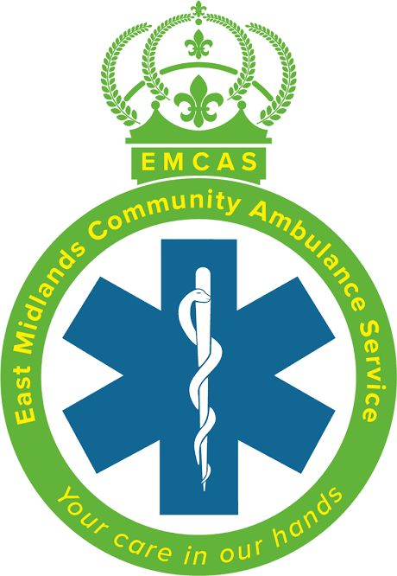

References:Aggarwal, R. (2023). Winter planning: tackle workforce strain in urgent and emergency care. BMJ, pp.p2186–p2186. doi:https://doi.org/10.1136/bmj.p2186.
England, N. (2023). NHS England» Search Results» ambulance services. [online] England.nhs.uk. Available at: https://www.england.nhs.uk/?s=ambulance+services [Accessed 14 Nov. 2025].
Service.gov.uk. (2019). Ambulance care assistant | Explore careers. [online] Available at: https://nationalcareers.service.gov.uk/job-profiles/ambulance-care-assistant [Accessed 12 Nov. 2025].
The King's Fund (2024). Activity in the NHS. [online] The King’s Fund. Available at: https://www.kingsfund.org.uk/insight-and-analysis/data-and-charts/NHS-activity-nutshell [Accessed 14 Nov. 2025].

Conclusion :
The public relies on the ambulance service a lot, as shown by the fact that more than ten million emergency calls are addressed in England every year. A steady focus is meeting reaction goals, especially for the most important cases. The objective is to arrive at patients in around seven minutes for Category 1 emergencies, such cardiac arrests, and in eighteen minutes for Category 2 emergencies, like strokes. There are over thirty thousand paramedics working for NHS trusts throughout the nation, and they need to be devoted to reaching these goals. These medical professionals are trained to provide quick, expert treatment as soon as they get there, and they frequently must make important choices in a matter of seconds. The service has also been changing to meet environmental issues in the last several years. More people are adopting electric ambulances, which help cut down on emissions. Air ambulances are also being increasingly utilized to get to hard-to-reach or crowded places more quickly. These changes highlight how the ambulance service is always changing to suit the needs of emergency treatment and to serve bigger aims like contemporary healthcare and sustainability.

Challenges Facing Ambulance Services:
Two Major Problems the Service Faces
The first challenge is that there is more demand and longer wait times for services. This is because of more emergency calls, an aging population, and more complicated medical needs. Responding to Category 2 calls (important but not life-threatening) takes longer than the NHS wants it to. Delays in hospital handovers make it even harder to get a vehicle. Working conditions and stress can also hurt health and effectiveness. Challenge Service.gov.uk. (2019). 2: Funding and Allocating Resources: The NHS pays for ambulance services, but budgets have not kept up with rising costs and demand. The costs of maintaining fleets, improving equipment, and hiring skilled workers are very high. Costs are higher, and answers are slower in rural areas and over long distances. Data ambulances, general care, and hospitals that need to be linked to digital systems are another problem. What ambulance services do in (Aggarwal, 2023) today's healthcare Ambulance services are now part of the system for urgent and emergency care. They fund community care, emergency rooms, and services that aren't open during normal business hours. Patients are handled at home by paramedics increasingly, which is also known as "see and treat" care. (Aggarwal, 2023) This method lowers the number of people who need to go to the emergency room and makes sure that each patient gets the support they need.

Introduction:
Description of the Healthcare Service Selected
Ambulance services deliver emergency and urgent medical assistance to individuals who are critically ailing or injured. They frequently serve as the initial point of contact in critical situations. They examine patients, provide pre-hospital care, respond to 999 (UK) emergency calls, and transport patients safely to hospitals. They are staffed by paramedics, emergency medical technicians (EMTs), and dispatchers in the control center. Ambulance services are available around the clock and are part of the National Health Service (NHS) as a whole. To make sure the correct help gets to the right patient at the right time, they also support community care, mental health crises, and major incident responses in addition to providing non-emergency patient transport. (England, 2023) 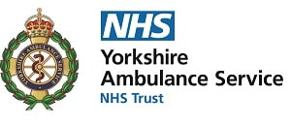
Concise Historical Overview of the Service
Ambulance services have its roots in the 19th century, when wounded troops were brought from battlegrounds in horse-drawn carriages. Civilian ambulance services commenced in major cities circa the early 1900s. The service became part of the National Health Service (NHS) in the UK in 1948. This made sure that emergency transport and care were paid for by the government. In the 1970s and 1980s, the incorporation of professional paramedics revolutionized ambulance teams from mere patient transports to proficient emergency clinicians. Today, ambulance services use computer-aided dispatch systems, GPS tracking, and modern life support technology to give faster, more accurate care. (England, 2023)
Functions of Ambulance Service
Present Operation of the Service
The NHS Trusts in each region work together to coordinate ambulance services. For example, the London Ambulance Service NHS Trust and the Northwest Ambulance Service NHS Trust. When an individual dials 999: 1. The control center utilizes triage tools to figure out how urgent something. (Service.gov.uk, 2019) 2. The system sends the closest vehicle that can help, such as an ambulance, a paramedic car, an air ambulance, or a community responder. 3. Rescuers check out the patients, fix them, and decide if they need to be taken to the hospital. 4. (Service.gov.uk, 2019) A hospital's emergency rooms get data and handover reports online. Roles of the staff: Paramedics oversee making clinical decisions and providing advanced life support. - Emergency Medical Technicians (EMTs): help with driving.


ELEMENT OF NATIONAL HEALTH SERVICE

Introduction:

The National Health Service (NHS) is one of the most significant and renowned institutions in the United Kingdom. It was established in the post-Second World War to provide universal healthcare, irrespective of individuals' financial status. The main thought behind the NHS was that everyone should be able to receive health care, no matter how much money they have.
Prior to the establishment of the NHS in 1948, healthcare in Britain was markedly inequitable. Many individuals were required to pay for medical consultations or hospital visits, and numerous working families could not afford these expenses. Charity hospitals and little insurance systems existed; however, they were adequate to assist all individuals. During the war, the government organized national medical services for soldiers and civilians. After the war was over, people wanted this system to stay in place because it worked so well. UK Parliament (2023)
In 1942, Sir William Beveridge authored a document known as the Beveridge Report. He stated that Britain must combat five "monstrous afflictions": poverty, illness, illiteracy, filth, and laziness. His thoughts significantly influenced the government and the people. Subsequent to the war, the Labour Party secured victory in the 1945 election and pledged to implement significant social reforms. Aneurin Bevan, the Minister of Health, was instrumental in establishing the National Health Service. The National Health Service Act of 1946 enacted the plans, and the NHS commenced on 5th July 1948. UK Parliament (2023)

The NHS was established around three fundamental concepts. Initially, it must fulfill all individuals' requirements. Secondly, it ought to be complimentary when individuals require it. Third, it needs to be predicated on medical necessity rather than financial considerations. These principles indicated that anyone might visit a physician or medical facility without incurring costs. The NHS was financed by taxation, integrating all hospitals, nurses, doctors, and dentists into a singular national system.(Clement, 2023)

Initially, there was difficulty in universally embracing this idea. Certain physicians expressed concerns regarding the potential loss of autonomy and employment under government authority. Bevan was compelled to negotiate agreements with them to secure their participation in the new system. Despite these challenges, the NHS rapidly gained popularity. It emerged as an emblem of justice, compassion, and equality for all individuals in Britain. UK Parliament (2023)

Currently, the NHS is one of the largest healthcare systems globally. It offers hospital care, general practitioners, community health, and mental health care. The majority of care remains complimentary for patients, primarily funded by taxes. The National Health Service in England oversees the health care system there, although Scotland, Wales, and Northern Ireland manage their respective systems independently. Local Integrated Care Boards now facilitate the planning of healthcare for their respective regions.

The NHS possesses numerous commendable attributes. It provides universal access to health care, not limited to the affluent. It has contributed to prolonging life and enhancing health. It additionally facilitates research and novel medical therapies. However, the NHS also faces other challenges. As the population ages, the prevalence of chronic conditions like diabetes and cardiovascular disease rises. There is a deficiency of physicians and nurses, resulting in prolonged waiting times for treatment. Numerous hospitals lack sufficient funding and require improved infrastructure and equipment. (BBC Bitesize, 2021)

Although the NHS holds on to its foundational principles, maintaining them has become increasingly challenging. The expenses associated with healthcare continue to escalate, resulting in prolonged wait times for assistance for certain individuals. Health and social care often lack effective collaboration, exacerbating conditions for patients. The NHS is influenced by political factors and frequently undergoes reorganization, leading to uncertainty and stress among workers. (Royal College of Nursing, 2023)
In conclusion, the NHS was established post-war to provide healthcare to all individuals, regardless of socioeconomic status. It transformed Britain and remains a source of significant national pride. Despite its challenges, the NHS continues to strive for fair treatment for all individuals. With increased support, personnel, and funding, it can continue helping individuals for numerous years ahead.
References

•UK Parliament (2023) 1942 Beveridge Report. Available at: 1942 Beveridge Report - UK Parliament (Accessed: June 2023).
BBC Bitesize (2021). Aneurin Bevan and the setting up of the NHS - Developments in patient care – WJEC - GCSE History Revision - WJEC. BBC Bitesize. Available at: https://www.bbc.co.uk/bitesize/guides/z27nqhv/revision/5 [Accessed 12 Nov. 2025].
Clement, M. (2023). The founding of the NHS: 75 years on - History of government. history.blog.gov.uk. Available at: https://history.blog.gov.uk/2023/07/13/the-founding-of-the-nhs-75-years-on/ [Accessed 10 Nov. 2025].
Royal College of Nursing (2023). NHS 75: the history of our National Health Service | RCN Magazine | Royal College of Nursing. The Royal College of Nursing. Available at: https://www.rcn.org.uk/magazines/History/2023/July/NHS-75-anniversary-history-of-the-National-Health-Service [Accessed 13 Nov. 2025].

