MANAGING ENTERPRISE IN THE 21ST CENTURY

TERM 2

STUDENT: ROXANA ZARNESCU
STUDENT ID:1906075

LECTURER: MRS MALANI GUNARATNAM

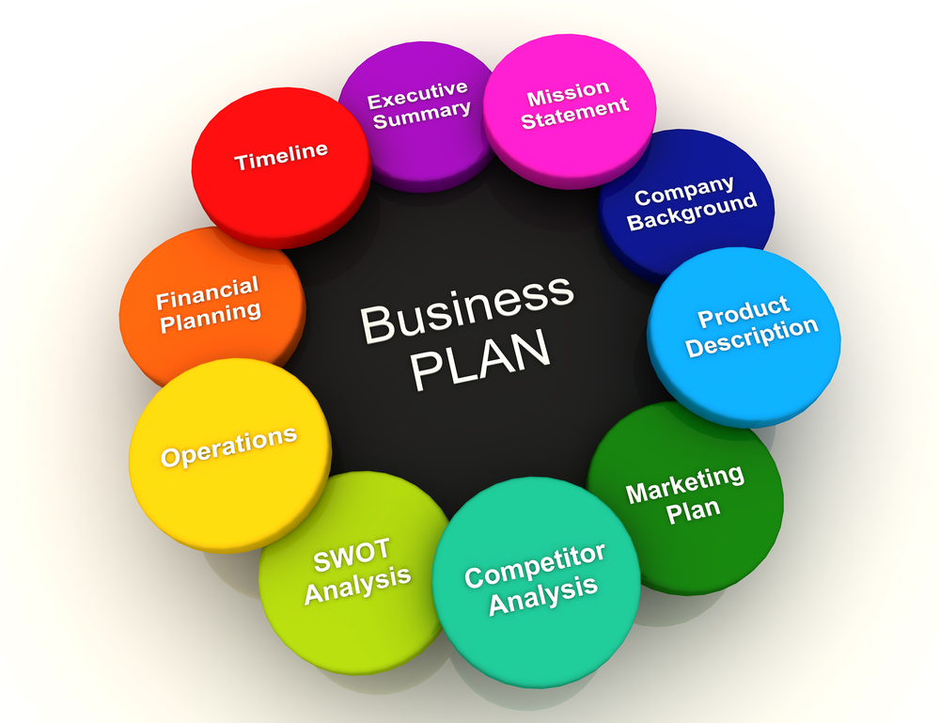

My name is Roxana Zarnescu and that I am the CEO of the corporate. I used to be born in Romania and finish my high school there. I might describe myself as someone who is honest, caring, intelligent, hardworking, and impressive. I even have an excellent sense of humour. I am a simple going person and do not get easily disturbed by down’s in my life. After high school I went to the psychology faculty in the city but unfortunately after the first year I went abroad, and I gave up. Also, in Romania I took the course ECDL (European computer driving license). Here in the UK I am currently in my first year of college and I hope that everything will be fine to be able to continue my studies.

OPERATIONS
We choose 2 of the biggest UK suppliers for chemicals, uniforms and machinery to work with.

Supplier / Relationship 1
Organisation  TOP CLEANING SUPPLIES | Relationship Status  Suppliers
Service provided  CLEANING PRODUCTS SUPPLIERS | Key terms of relationship

1.Top Cleaning Supplies are a web organisation based in Croydon, South East London. They distribute cleansing products inside the UK.
Their huge desire of low cost cleaning products & janitorial substances makes them a one-stop-shop for expert cleaners & commercial venues like schools, churches, gyms, fitness care establishments, hotels, pubs & restaurants to buy particularly effective, expert grade cleansing components.
Top Cleaning Supplies offer a quick delivery provider additionally as a Collect future preference to make buying online for the duration of to receiving your order a brief & fuss-free experience.
Top Cleaning Supplies have 100’s of cleaning products to be had to be used altogether
kinds of professional cleaning industries which includes carpet cleaning, specialist ground care, window cleaning & janitorial products.
Top Cleaning Supplies distribute cleaning merchandise from manufacturers like Prochem, who manufacture an vast range of carpet cleaning chemical compounds, Clover Chemicals, who manufacture cleaning chemical substances for both regular floor & surface cleaning at some point of two graffiti removal, floor paints & laundry detergents, and SYR, who're manufactures of a terrific variety of cleansing tools, like buckets, safety signs, bins & dispensers.

Supplier / Relationship 2
Organisation  HARVEYS | Relationship Status  SUPPLIERS
Service provided  UNIFORMS SUPPLIERS | Key terms of relationship

2.Harveys:
Established over sixty years, Harveys are one in all the up 's leading makers and suppliers of uniforms and protecting work wear among the united kingdom.
We offer associate degree thorough vary of labour wear covering the care sector, welcome, health & beauty and business.
Unlike most, if not all our competitors, we have a tendency to still operate a thriving UK mill. This ensures we will offer the sole doable service and avoid the prolonged delays which may occur by just commerce merchandise. This conjointly means that we'll manufacture work wear to your own specific style and colour, for cheap quantities.
We conjointly provide terribly competitive costs with absolutely the very best quality standards.
Harveys even have a totally equipped embroidery suite, guaranteeing your logo's are typically applied quickly and with no minimum order amount. All we'd like is your style, brand or letter paper, or if it's a bran-new project - your ideas that we'll do the remainder .
Our aim is to repeatedly update our vary, continually considering client feedback, while at an equivalent time provide the sole quality, service and worth doable.
Now we've 15 people which are working for us. they are all professional cleaners, well trained to carry out all our customer’s needs.
ECO HERO CLEANING has assembled a team of the only and brightest minds within the business.
We have 3 Exceptional team leaders and 12 amazing cleaners.
Our business is functioning from inside the house of Roxana Zarnescu. Roxana and Team will oversee schedules, forecasts, training, inventory, ordering, payroll and customer service. the form of business company is getting to be 5 proprietorships, with 15 workers within the primary 12 months.

LAWS OR REGULATION FOR A CLEANING COMPANY:

Our ECO cleaning company is following all the regulations and law imposed by the government.
COSHH: hazardous to Health needs (or COSHH) may be a GB law that needs all employers to manage risk from harmful substances. as a result of the owner of the improvement business is your responsibility to form positive that the chemicals you employ are treated, hold on and used safely so they are doing not hurt you, your staff and your customers.
All improvement chemicals are dangerous substances and will be treated with care.
People who use them should be trained and perceive a way to scale back risk. If used improperly then improvement chemicals will cause all types of health issues, equivalent to respiratory disorder, skin irritation or probably poisoning. they will have burnable or explosive surfaces if they are not treated and hold on within the right manner.

Legal Considerations
Register your business
Pay the National Minimum Wage
To follow the guidelines, you must first do a risk assessment.
This means looking at your cleaning chemicals and then the areas you will be working on and identifying what can be harmful to health. Read the warning labels of your cleaning products (dangerous signs are red, white and black) to check for potential hazards. See if you will work with them for a long time. you will be using this information to find out how to keep people safe.

INSURANCE:



There are two types of insurance that are important for all cleaning and type 3 businesses when hiring employees. These are:
• Social insurance - this protects you from avoiding a third party in cases of personal injury or property damage, including accidents. It means you will be covered in case you accidentally break someone else's heirloom container!
• Professional credit insurance - this protects you from claims from unhappy employees or customers. It means that you are covered if the customer refuses to pay the invoice or if you would like to fix the error.
• Employer insurance - if you have a staff number this will protect you from claims from employees, should they be injured or sick while working for you.

What is Corporate Social Responsibility?

We joined a Green Business Centre campaign that went on the road very ambitious. No one had to make any extra effort to join them, but only to choose the most appropriate path for him, be it blogger, volunteer, driver, environmental responsibility or just a person who cares about the environment. As an eco-cleaning company, we decided to offer this campaign 1% of our investment by giving us in return the advertising we need at the beginning of our journey.

Corporate Social Responsibility (CSR) refers to the efforts created by a community support organization and contributes to property development. conjointly brought up as company conscience or corporate citizenship, CSR describes business processes to live and take responsibility for many problems starting from human rights to the setting.
Corporate structure commitment will be a kind of automatic business, with programs that focus on achieving economic, social and environmental advantages for all key stakeholders (employees, consumers, investors and alternative groups).
The purpose of CSR is to encourage businesses to conduct their firms ethically and work to form a positive impact on society by guaranteeing continued growth.
Stability is often mentioned in CSR and is commonly involving environmental property. However, property may apply to a number of alternative aspects of the business together with procurance, economics, dealing and coaching as an example.
Corporate social responsibility usually refers to the length of your time taken by entities that are implemented by law and standards of conduct as determined by regulators and environmental organizations.

CSR can often result in short-term costs that may result in immediate economic gains, however, instead it supports and prioritises social and environmental priorities.
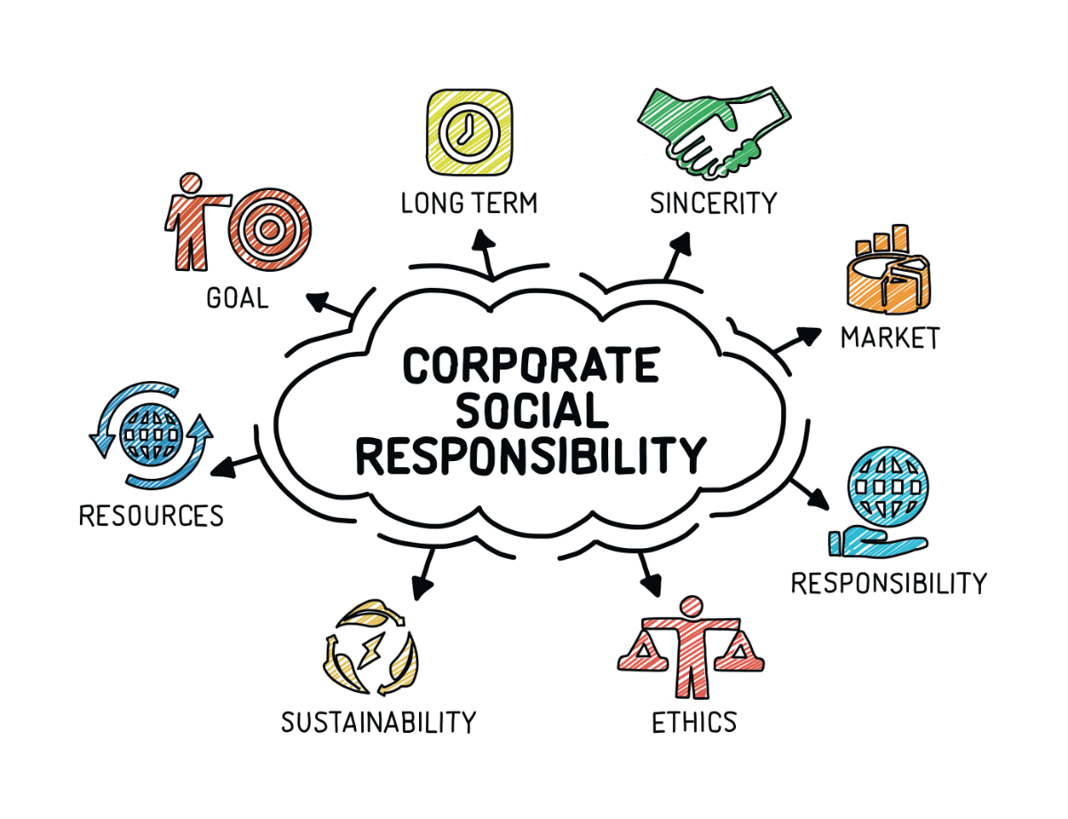

One of the foremost common sorts of corporate social responsibility, several companies focus their CSR efforts towards reducing their impact on the environment.
Environmental Corporate Social Responsibility
We are using only eco-friendly chemicals to guard our customers and therefore the environment.
Ethical Corporate Social Responsibility
Qualitative structure commitment programs think about that everybody who participates within the course of business receives acceptable management, from staff to customers.
Ethical responsibilities are the items that firms do once they believe it's price making an attempt rather than being accountable. Businesses are gazing however participants can suffer through their work and work to create the foremost impact.
Philanthropic Corporate Social Responsibility
Responsibilities for human well-being labour under the maximum amount work as doable associate degreed contribute to an economical society. this kind of social commitment is usually relating to donating to charitable organizations, with several businesses funding organizations that support their business effectively.
However, philanthropic CSR does not solely invite charitable donations. different common responsibilities to contribute embody investment within the community or collaborating in native comes. The goal is to support the community in this that goes on the far side merely hiring.

The Importance of Corporate Social Responsibility

Social commitment is probably going to be a very important manner for firms to replicate their temperament whereas doing their half in society, the atmosphere and their stakeholders.
Our world, the folks and organizations in it are getting more and more interconnected and CSR may be appreciative for with success managing those connections to create a profit for the corporate and as those individuals, organizations and communities you're connected with what you sell, rent, obtain from then on.
With the property development of the core of CSR, it is sensible for businesses to use CSR methods in their business plans not solely globally, however additionally business success.

Benefits of CSR for companies:

Better organization picture and client steadfastness

Distinguishing territories for development

Expanded representative commitment and fulfilment

Pulls in ability and financial specialists

Cost Effective Ways We Intend to Advertise/ Promote Our Cleaning Services without Using the Internet
• Pro Bono Resources
• Place advertisements on national television stations, Radio Stations and newspapers / magazines
• Appropriate community support program
• Participate in street shows from time to time
• Distribute our filters and suggestions to target areas from time to time
• Send out letters of appreciation to affiliated organizations and households in our marketplace.
• To ensure that our employees always wear our branded shirts during work hours and, we will make sure that we seal our lines, trucks and cars et al.

ABOUT ECO CLEANING INDUSTRY


In recent decades, the green cleaning industry has gone from specialty to standard. What can be the reason for this move? There are numerous explanations behind the development of the green cleaning industry, the most significant of which is that individuals are being educated. Educated about what synthetic compounds are in the cleaning items which are utilized in their homes and at their work environment. They are additionally being educated regarding the potential perils a portion of those synthetic compounds can cause. Obviously, the extraordinary lion's share of individuals needs what is best for their family, the earth, and themselves.
With respect to the development of green cleaning organizations, this can be credited to two or three components. For one, numerous families have different guardians who have all day employments, and in this way don't have the opportunity to keep up a spotless home without the help of a cleaning administration. Numerous guardians are likewise mindful of the harm synthetic compounds from cleaning items can cause, particularly to youngsters. Along these lines, when considering recruiting a cleaning administration, the kind of cleaning items utilized are turning out to be increasingly significant. Another contributing element is that numerous organizations and places of business are presently going to green cleaning administrations also. As per Go Green, ongoing investigations have indicated that places of business which have "practiced environmental awareness", "have quantifiable monetary profits because of worker wellbeing, profitability, and maintenance just as lower working expenses and certain administration motivating forces

