
Individual business model canvas with entrepreneurial reflection using appropriate academic models. “Avenue café”



Module Title: Entrepreneurship BMIH5001

Student Name: Ada Roman
Student ID: 2207421
Module Tutor: Charlotte Joyner
Submission date: 5/02/2024
Wordcount: 2041

Part 1: Essay
An entrepreneur venture refers to a business project that is accompanied by innovation. Avenue Cafe is a Birmingham-based restaurant that offers its customers with food served fresh. The value proposition that Avenue Cafe offers is its unique business model. The restaurant understands the importance of limiting its negative impacts on the environment. It has taken initiatives to limit its negative impacts on the environment from its operations. The restaurant has adopted green methods which include using eco-friendly straws made out of recycled paper, and cups produced from recycled paper. This has made the restaurant future-ready as it has already adopted the methods that will be required by all restaurants as the UK is planning to go net zero.

For the restaurant, the suppliers will be the local farmers who will be supplying fresh vegetables and food to the restaurant. The company that has been partnered with is George Perry Limited. George Perry Limited is a local fruit and vegetable wholesaler that supplies fresh vegetables and fruit at a low rate. The local fish shops will also be partnered to get a supply of fresh fish and meat. The company that has been partnered to get the fish supply is Kingfisher Midlands. It is also a local company that supplies a range of fish such as seafood, fatty fish, and so on (Kingfishermidlands, 2022). The motivation for both the suppliers and the business here is to work towards creating a sustainable practice that promotes the well-being of the customers and also supports the economic value of the company (Balatsky et al., 2020). The other motivation here is to work with the local community to boost the local economy as supporting local communities and businesses helps the local businesses grow (Sharma et al., 20210). The farmers for George Perry and the fishermen for Kingfisher Midlands are all locals who understand the taste and the preferences of the local consumers.
The Key activities will have to be done to run the operations smoothly. The restaurant will be getting the cutlery supplies from its plant. It will source recycled paper daily and produce the items to save costs (Foteinis, 2020). It will also engage in daily activities such as interacting with customers. The restaurant will be preparing its food and not be buying processed food from outside sources.
The value proposition Avenue Cafe will be offering will allow it to attract a larger section of customers. Avenue Cafe will be offering 3 main values to the customers. The first value that will be provided is that the food will be prepared from locally sourced fresh food supplies. The restaurant will not be using frozen items or frozen meat to prepare the dishes. Frozen and processed food is considered unhealthy hence, customers will get to eat healthy food (News, 2022). George Perry Limited and Kingfisher Midlands will supply fresh raw food that will be prepared at the restaurant by the chefs. The dishes will be prepared keeping in mind the preferences of the local customers.
The second value proposition for customers here is the elimination of plastic usage within the restaurant. Most restaurants in the location use plastics for packaging and cutlery. The Avenue Cafe will not be using a single plastic product inside the premises. By eliminating plastic, Avenue Cafe can ensure that customers of Birmingham are not consuming any harmful chemicals. Much research evidence has shown recently that plastic particles enter the human body via the food they consume (Guardian, 2020). Plastic particles are considered to be dangerous for the human body and are linked with several fatal health conditions including cancer.
The other value Avenue Cafe will be offering is the convenience of payment and a table book. The restaurant will launch an App “Avenue Cafe” that will provide ample benefits to the customers. The customers will also be able to use the app to learn about new offerings and dishes.
To improve customer relationships, The Avenue online app will be useful in delivering tailored services to customers. The Avenue Online will be essential in ensuring that customers can access payment tools without reaching the cashier table. The app will also allow the customers to book tables before reaching the restaurant. They will be beneficial for the customers when they are in a hurry.
The customers segment targeted by Avenue Cafe are young family members who worry about the well-being of their members and also the environment. The segment is well-educated and well-informed about the latest news happening around the world. Young adults use online payments as their preferred mode of payment hence, the business model will be designed keeping this in mind.
The Key resources of Avenue Cafe will be fresh food supplies from the local companies. Serving food made out of fresh raw foods will be a USP for the restaurant (Souza and Louzada, 2020). Avenue Cafe will be buying food supplies from local farmers and local growers. The other resources such as meat and fish will also be obtained from the local suppliers. There will be a legal contract that will ensure the restaurant gets daily supplies regularly and there is no supply crunch. The cups and cutlery that will be used will be made in-house.
To make plastic-free operations possible, the restaurant will manufacture its cups and cutlery at a nearby facility. The facility will also be owned by the restaurant. It will contact the local waste management companies to source the recycled paper. It will then manufacture the items according to the demand at the restaurant. One benefit it will provide is the proximity to the restaurant which will help it move the items from the manufacturing plant to the restaurant in a short time (Fischbach et al., 2022).
The channels that Avenue Cafe will be using are online social media websites such as Facebook and Instagram. The target customers are young adults with families who regularly visit online social media apps and sites to check regular updates (Gallarza-Granizo et al., 2020). The online channel has been chosen as this provides a great opportunity to reach the target market by using personalized ads. Facebook has a unique feature “Personalised ads” that allows companies to segment an audience and target that specific audience. The companies push ads to the exact target market. Instagram will allow Avenue Cafe to create an interest among the customers (Peters and Remaud, 2020). Online media such as Facebook and Instagram will also provide the opportunity to reach customers at a convenient cost as they are cheaper than traditional promotional methods (Darma and Noviana, 2020). The online media will allow the restaurant to make appealing adverts by using images and videos that will attract a lot of customers (Singh et al., 2022). Digital technologies will also allow the food to the customers as well (Alt, 2021). The online app of the company Avenue Online will be launched to serve customers within a 10km radius. This will allow the company to increase its revenue and earn additional income (Christ-Brendemühl, 2022).
The cost structure for the venture has been planned according to the expenditure associated with marketing and manufacturing. The costs that are needed to be covered are the initial costs to set up plants. The restaurant expects to break even within the first year as it expects solid demand and revenue (Anukiruthika et al., 2020). A total budget of 40,000 pounds will be required. The marketing team will be provided with a budget of 6,000 pounds to carry out the activities that will create awareness of the un uniqueness of the restaurant. The separate manufacturing unit that will be producing the green cutlery items will be allocated a budget of 25,000 pounds. A separate 5,000 will be kept for running the daily operations that will include buying the items from the farmers, paying wages, electricity bills, and so on.
The primary revenue stream of Avenue Cafe will be coming from selling food at the restaurant. The product that Avenue Cafe will be selling is food hence, this will be the primary source of its revenue stream. The margin will be higher as the restaurant has the power to charge a premium for its services (Mohd Yusof et al., 2021). The other revenue stream comes from the online food service. The company will be saving a large portion (Keeble et al., 2020). It will adopt a new payment method at the restaurant. It will be using contactless payment where customers can self-produce a bill and check out easily. This will provide a smart experience to the customers. The other payment channel that will be used is online payments. Online payments for online food orders are very effective as they can allow the opportunity to offer discounts (Prasetyo et al., 2021). Discounts are very essential in retaining customers.

The above business report has proposed a new business plan. The report has discussed the plan using the Business Model Canvas to better explain the steps in the plan. It has discussed the value proposition that will be offered to the customers. It was discussed that a plastic-free environment, freshly made food and the use of digital platforms will be offered as value to the customers. The steps and the plans were also discussed in the BMC. The details of the suppliers and the customer segmentation were also done in the Business Model Canvas.

Part 2 Reflection
This reflective essay explores my motives and entrepreneurial traits, utilizing theories and models of entrepreneurship to support my 63% managerial test score. I hope to learn more about my development and pinpoint areas that still require improvement by delving into my journey as an entrepreneur.
Description: My first experience with my managerial test result set me in motion for a thoughtful period. This is the first phase in the reflective cycle, according to Gibbs. The 63% score indicated areas that needed work, especially in strategic planning and decision-making. This insight paved the way for a more thorough examination of my managerial skills.
Feelings: Before starting the task, I was excited as I expected to learn new things and gather more knowledge about business. While working on the task I had to use my creativity skills to propose a new business idea. I felt happy as I was able to come up with a solid business idea. I needed to research to learn whether the idea was feasible. The knowledge that I gathered while doing the research made me feel satisfied and happy.
Evaluation: The good thing was that I was able to link my proposal with the current issues in the UK and the world (Fiedler et al., 2021). I was able to learn a lot of new information that would help me in my entrepreneurial journey in the future. I developed a solid business model that would help me in the future in similar works. The bad thing was my knowledge of the subject, I chose a business model that was new to me. Hence, I had to do a lot of research to gain more information which wasted my time (Kenny and Fluck, 2022).
Analysis: The reason why things went well was because the idea fit well with the future needs of the world. After all, climate change has taken a lot of attention from consumers (Fawzy et al., 2020). I was able to produce a plan that can help in solving the problems associated with complaints of customers. They are becoming more aware of the negative impacts of their actions on the environment. They are becoming more concerned about the health of their loved ones. Providing a solution that addresses both issues will be appreciated. Other than that, my creativity skills were useful in producing the idea that contributed to making things go well. However, the reason things went bad was because of my lack of knowledge in the sector. I have weaker research skills which was a barrier to gathering information. My time management skills were also a barrier.
Conclusion: From the project, I learned that I have solid creativity skills that are essential for a business management person. However, I was also made aware of my weaknesses such as weaker research skills and time management skills that need to be improved to eliminate barriers in my journey.
Action plan

Skills | Activities | Resources | Time frame
Research skills | I will engage myself in more activities that require research. This will be useful in enhancing my research skills. | Google Scholar, Internet applications, Journals. Books. | 6 Months
Time management skills | I will learn the skill to divide a large work into small tasks and allocate my time accordingly. I will also read books that will educate me on how to improve my time management skills. | Stopwatches, countdown timers, Books. | 3 months
Table no: 02 Action Plan
(Source: Created by the learner)

Appendix
Business Model Canvas
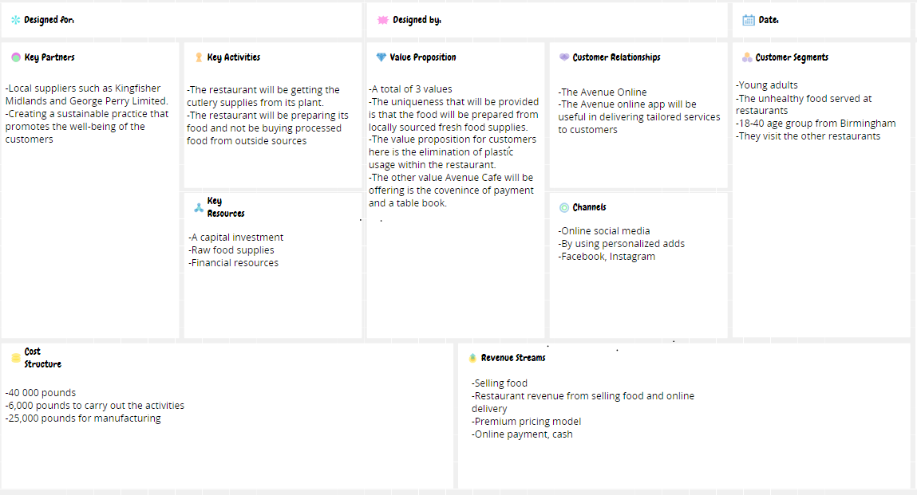
Conceptboard(2024)

References
Alt, R., (2021). Digital transformation in the restaurant industry: Current developments and implications. Journal of smart tourism, 1(1), pp.69-74.
Anukiruthika, T., Sethupathy, P., Wilson, A., Kashampur, K., Moses, J.A. and Anandharamakrishnan, C., (2020). Multilayer packaging: Advances in preparation techniques and emerging food applications. Comprehensive Reviews in Food Science and Food Safety, 19(3), pp.1156-1186.
Balatsky, E.V. and Natal'ya, A.E., (2020). Modern ways to boost economic growth in regions.
Conceptboard (2004) Individual Business Model Canvas. Available at: https://conceptboard.com/blog/business-model-canvas-free-conceptboard/ (Accessed: 27 February 2024).
Ekonomicheskie i Sotsialnye Peremeny, 13(3), pp.74-92.
Christ-Brendemühl, S., (2022). Bridging the gap: An interview study on frontline employee responses to restaurant technology. International Journal of Hospitality Management, 102, p.103183.
Darma, G.S. and Noviana, I.P.T., (2020). Exploring digital marketing strategies during the new normal era in enhancing the use of digital payment. Jurnal Mantik, 4(3), pp.2257-2262.
Fawzy, S., Osman, A.I., Doran, J. and Rooney, D.W., (2020). Strategies for mitigation of climate change: a review. Environmental Chemistry Letters, 18, pp.2069-2094.
Fiedler, T., Pitman, A.J., Mackenzie, K., Wood, N., Jakob, C. and Perkins-Kirkpatrick, S.E., (2021). Business risk and the emergence of climate analytics. Nature Climate Change, 11(2), pp.87-94.
Fischbach, E., Sparks, E., Hudson, K., Lio, S. and Englebretson, E., (2022). Consumer Concern and Willingness to Pay for Plastic Alternatives in Food Service. Sustainability, 14(10), p.5992.
Foteinis, S., (2020). How small daily choices play a huge role in climate change: The disposable paper cup environmental bane. Journal of Cleaner Production, 255, p.120294.
Gallarza-Granizo, M.G., Ruiz-Molina, M.E. and Schlosser, C., (2020). Customer value in Quick-Service Restaurants: A cross-cultural study. International Journal of Hospitality Management, 85, p.102351.
Guardian, T. (2020) Are plastic containers safe for our food? The Guardian. Available at: https://www.theguardian.com/us-news/2020/feb/18/are-plastic-containers-safe-to-use-food-experts (Accessed: 25 January 2024).
Keeble, M., Adams, J., Sacks, G., Vanderlee, L., White, C.M., Hammond, D. and Burgoine, T., (2020). Use of online food delivery services to order food prepared away-from-home and associated sociodemographic characteristics: a cross-sectional, multi-country analysis. International journal of environmental research and public health, 17(14), p.5190.
Kenny, J. and Fluck, A.E., (2022). Emerging principles for the allocation of academic work in universities. Higher Education, 83(6), pp.1371-1388.
Mohd Yusof, Y.L., Wan Jusoh, W.J. and Maulan, S., (2021). Perceived quality association as a determinant to re-patronize Shariah-compliant brand restaurants. Journal of Islamic Marketing, 12(2), pp.302-315.
News, F. (2022) These are the worst frozen foods for your health, experts say, New York Post. Available at: https://nypost.com/2022/03/05/these-are-the-worst-frozen-foods-for-your-health-experts-say/ (Accessed: 25 January 2024).
Peters, K. and Remaud, P.H., (2020). Factors influencing consumer menu-item selection in a restaurant context. Food Quality and Preference, 82, p.103887.
Prasetyo, Y.T., Tanto, H., Mariyanto, M., Hanjaya, C., Young, M.N., Persada, S.F., Miraja, B.A. and Redi, A.A.N.P., (2021). Factors affecting customer satisfaction and loyalty in online food delivery service during the COVID-19 pandemic: Its relation with open innovation. Journal of Open Innovation: Technology, Market, and Complexity, 7(1), p.76.
Sharma, G.D., Thomas, A. and Paul, J., (2021). Reviving tourism industry post-COVID-19: A resilience-based framework. Tourism management perspectives, 37, p.100786.
Singh, S., Singh, G. and Dhir, S., (2022). Impact of digital marketing on the competitiveness of the restaurant industry. Journal of Foodservice Business Research, pp.1-29.
Souza, T.N. and Louzada, M.L., (2020). The association between types of restaurants and the consumption of ultra-processed food. European Journal of Public Health, 30(Supplement_5), pp.ckaa166-254.
Kingfishermidlands, K. (2022) Seafood suppliers: Midlands fishmonger, Kingfisher Midlands. Available at: https://www.kingfishermidlands.co.uk/#discover (Accessed: 31 January 2024).

