MODEL CODE: M5X01924

COURSE TITLE: Management and Organisational Behaviour

NAME: BISWAJIT MUKHERJEE

NUMBER:1815040

LECTURER: DALE CLARKE

WRITTEN ASSIGNMENT 1



Introduction ……………………………………………………………….pg3

Organizational Structure………………………………………………….pg4

Organizational leadership……………………………………………….pg5-pg6

Organizational culture…………………………………………………….pg6-pg7

Impacts of organizational key areas……………………………………..pg7-pg8

Comparison …………………………………………………………………..pg9

Conclusion …………………………………………………………………. Pg9-pg10

References …………………………………………………………………..pg9-pg10


This research based on article of organizational behavior structure, culture and leadership upon company’s performance. Organizational behavior is a contradiction. It is not analysis of individual comportment, but rather the analysis of distinctive comportment in an companies setting. This is including the research of how distinctive behave alone, as well as how distinctive behave in groups.
The object of company’s behavior is to accumulation a greater apprehension of those matters that eminence distinctive and group dynamics in an company’s setting so that individuals and the batches effective in an company’s setup so that distinctive and the batches and administrative to which they belongs may become more systematized and adequate. The field also includes the research of companies factor that strength of individual and group dynamics is an administrative settings so that persons and the group energetic in an organizational background so that individuals and the groups and companies to which they associate it can become more associate and helpful.
Before discuss organizational behavior need to analysis about organization .organization has many meanings. Individuals and groups can get obstruction to manage their job.
Organizational or company’s behavior is relatively new, collaborative field of study. Eventually it draws most heavily from psychological ,sociologic sciences. There is another reason for associative in advance because the field of organizational behavior to take into consideration multiple stages of research, which are required to understand behavior within organizations, the reason is behind people do not perform in seclusion. That is employees influence their situation and are also manipulated by their environment. The research found that organizational behavior is ultimately focus on support human resource management executive with the knowledge and tool they need to select, train and retain workers in a fashion that brings high level of privilege for the specific worker as well as for the organization.
However this analysis based on organization and its involves such as culture , structure ,inter organizational cooperation and conflict , change ,technology and the external environment, Forces.
Report is producing an example of famous company and their structure, culture, and leadership step by step.



Organizational structure established not only big business its captures small business also. Its very important that if company’s structure is not appropriate or concept is not clear consequences for business, then for different kind of reason it can be wrong then company’s organizational structure become unclear. Here below this diagram is explaining that about usage of organizational structure of the business. This diagram is explaining that both directors have people with direct authority, about information, company’ send to manager which don’t have direct control .other side it is authentic of the managers association with terms.
By board of directors 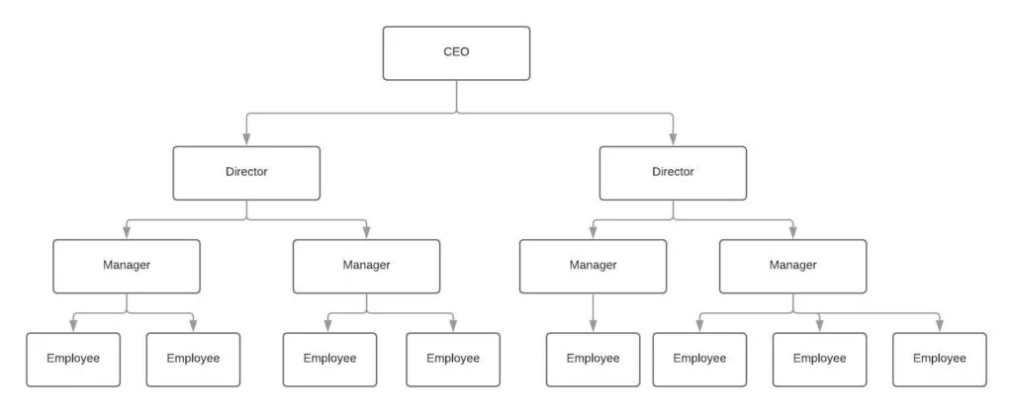
Different type of structure found in organization by research. Such as line organizational structure, functional organizational structure, line and staff organizational structure, project based structure, matrix structure . each organizational structure has its pros and cons. The thing is it has to find a form of organizational structure in which company gained most privilege from pros and which company will struggle least from the cons. This analysis found Bellow one of the example.
Starbucks known as a global coffee empire on the basis of quality reasonable drinks. In February 2009 the Seattle based company declared that 300 stores will be close and around 6000 staffs will be out of the job and the results is 700 layoffs. Starbucks have started that they will continue to increase its company in Europe and employee who are in jobless company will give scope of substitute jobs in their store.
At this moment Starbucks are represented in more than 15000 location worldwide.
In according to ‘’farfan,2012 the goal statement of Starbucks has been defined as their mission to motivate and characteristic the human spirit-one person, one cup and one neighborhood at a time.’’

Starbucks organizational structure has inconsistent groups of workers are taking care of different concern . The human resource department , sales department ,marketing department and so on . this structure is followed at the top hierarchy of the firm. Starbucks organizational structure is matched to most big group of the size. This company is controlled by the board of director can run from the group hq based in Seattle, Washington. A store manager responds as the local boss for control the employee ,at the selective store location. The organization does not useable as a franchise system, its does license store fronts. These are purchased and utilized by the Starbucks corporation under puritanical quality control guidelines. The whole Starbucks team work as partners and are adjusted towards quality customer service and consumer satisfaction. Starbucks identifies a policy of introduction between its entire employee and its doesn’t matter they fit in the scale, the firm makes every effort to distinguish separate resolution. As per schreiner 2012 report most of the
consumers who are admires of Starbucks will support the level of solidity found across the Starbucks locations weather it is in new York or London. The company has been extremely successful in this regard.

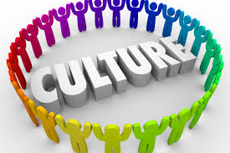

Organizational culture is one of the system of common expectation ,standards and principals , which commands how people behave in associations. This common values have a very powerful domination on the people in the company and demand about dress knowledge ,act, and perform their job. One of the factors can be effect on organizational culture ,which is individual working in company.
According to “Robert Quinn and Kim S. Cameron at the University of Michigan at Ann Arbor, there are four types of organizational culture: clean, adhocracy, market, and hierarchy.”
This research is also explain best culture in workplace . Best culture presuming everyone with the possibilities to establish change and to increase on an administrative and personal atmosphere. Corporate cultural also called organizational culture. Organizational culture includes an organizations assumptions experiences. Philosophy , as well as the virtues that attendant staff attitude and is communicated in staff self-image , internal workings, communication with the outside world and future prediction. Here bellow trying to explain about organization culture.

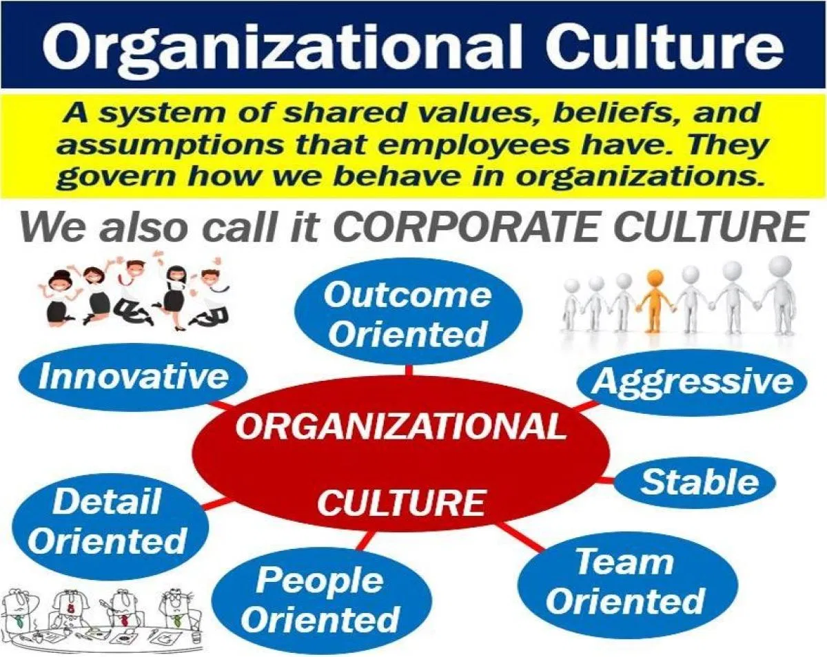
Previously this research discussed about Starbucks organizational structure. Now this research will discuss about Starbucks organizational culture.
Starbucks coffee’s company culture of effects addition assortment. The alloy of the organization’s key culture characteristic is exceptional and precise and specific to the temperament of its coffeehouse chain business.
Starbucks has gone through remarkable innovation in its corporate or organizational culture. These changes are based on topics and problems principal like Howard Schultz and Howard Behar recognize, especially in the early years of the distinguishing feature coffee house chain business. As a way of decorative business production , Starbucks instituted renovate in its corporate culture. At present Starbucks company’s corporate culture is a noticeable distinguishing that create ambitious convenience and elevate a consumer inhabitants of faithful Starbucks followers from which the company develop stable economic performance. Starbucks also has anti-discrimination policy that shapes its organizational culture. This procedure restrain any form of unfairness based on gender ,race, ethnicity ,sexual, orientation, religion, age, culture, backgrounds , life experiences, thought ideas. Organizational culture enabling supports worker motivation and helps minimize turnover.

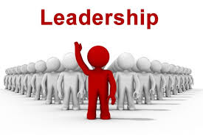
Organizational or corporate leadership is a approach which superior help set tactical goals for the company while motivating individual within the organization to successfully carry out assignment in service to those goals.
According to the Jessica Dihn and her co-authors in 2013,article for the management quarterly, “the role of the leader is to structure the way that the inputs of others are combined to generate companies outputs”. In according to Dr. Linda Ellington “The most important point is organization leaders integrate business distinguishing with their roles as future forecasters and forward thinkers who lead extensive dynamism using principal and morality.” Company’s leadership there is a administration approach in which leaders support to set strategic plans for the company’s while dynamic individuals within the group to successfully fulfill project in commitment to those goals.
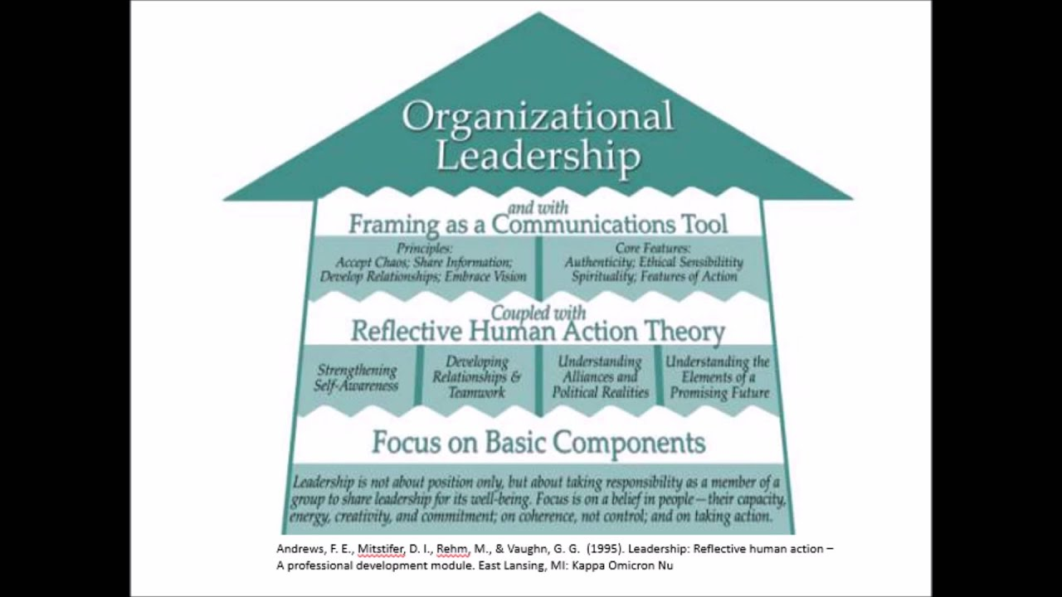

The organization development in the business is allocated to Schultz’s leadership style. According to the leadership theory established in 1978 ,transactional and transformational .the person behind one of the world most decent organization, Starbucks. Starbucks leadership style is transformational. In current years escalating business inexpensiveness and the necessity for the most effective use of human resources are needed. The transformational leadership’s view essences on perfect
Importance ,inspirational motivation ,intellectual stimulation and individual consideration. In according to Bass “transformational leaders stimulates representatives to do more than to do above their expectation. In this organizational leadership need to remember 7 principal, which is :
- Recruit the appropriate person
- Reliable in delivering products and service
- Take proper care of stuffs.
- Acknowledgement culture and stimulate diversity
- Need to focus mission and vision
- Importance of partnership
- Good knowledge about employees and customer.

The research found that organizational impacts can come from may ways. So that’s why every company take their strategy to make pestle. This very important for organization. Its called as well as pest analysis also. Normally pestle stands for 6 factors which affects the business. The factors are:
- Political
- Economic
- Social
- Technological
- Legal
- Environmental

1. Political
Here political factors is mainly raw materials
This accumulated a lot of consideration from politicians and from source countries.
It is inclined to follow the sourcing plans and it gives significance to fair trade 2.Economic
Economic recession is the prime outermost economic driver for Starbucks
This element concave the productivity of Starbucks.
Buyers can influenced to transfer to cheaper alternatives.
As buyer did not give up purchase coffee , Starbucks should seek an opportunity here .
3.Social
Starbucks is offering cheaper products which is may be sacrifice the quality.
It is one of the social challenge for new business.
It will increase shopper base to include the customers from the lower and middle income tiers.
Need to modified family pattern in Europe.
4.Technological
Starbucks is in a good place to enjoy privileges of the developing mobile wave.
They did collaboration with apple to cultivate app rebate coupons is helping it ride the mobile wave easily.
Business launched Wi-Fi
In its outlets already, because internet much needed for customers . its overall call consumer experience.
5.Legal
Company must certify that it does not contaminate any laws and regulations in the home market and countries where they purchase raw materials.
They need to follow also health authorities instruction about caffeine production and consumption. 6.Environmental
Many Starbucks business
Traditions deal with activists and international advocacy groups. Customers have expressed issues. So company responsibilities to take these into account to continue holding customer’s trust

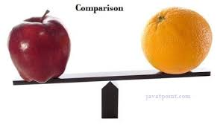
Comparison between Starbucks vs costa café
Costa cafe | Starbucks
- Costa café will take over by Coca-Cola and it would be British coffee shop chain for$5.1 billion.  - Costa café has 3882 stores for 32 countries and uk’s they have shops in 2467 locations which is based on independently.  - They locate in train station, inside retail shop, gas stations and many more places.  - As per research costa café is one of the major chain in uk and they have 2400 stores.  - As per record in 2018 total revenue of costa café was $1.7 billion in revenue | - Starbucks has currently majority in china with 2800 locations, but they are trying to increase up to 6000 stores in next 5 years  - As per record by 2018 they have 17000 stores in total. Worldwide  28000+ stores they have now.  - 2017 their revenue was $22.4 billion in total.  - Starbucks brings for their customers mix of hot and old breakfast.

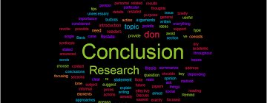

Through after various research , it is possible to understand what makes one company more attractive than another industry.
In conclusion, Starbucks is dominating the market because of their leading global presence and products distinction as different to Dunkin’ donuts’ cost leadership strategy. In according to ‘Hanaysha, J. (2016). Testing the Effects of Employee Engagement, Work Environment, and Organizational Learning on Organizational Commitment. Procedia - Social and Behavioral Sciences, 229, pp.289-297’.
In according to ‘Harter, J., Schmidt, F. and Hayes, T. (2002). Business-unit-level relationship between employee satisfaction, employee engagement, and business outcomes: A meta-analysis. Journal of Applied Psychology, 87(2), pp.268-279’.
Customer experience at a Starbucks area is potentially different than any other coffee shop and its cause of their familiar environment. Approachable atmosphere, and best services. Based on performance analysis this report shows that Starbucks is financially out performing. It is also presumed that Starbucks has a stronger market position and financial base.
It is also need to focus that as per current situation Starbucks need to amplify the product value creation. They must decrease their expenditure exposure risk associated to advertisement and promotion and the reason in 2000, 2006, 2008 and the expenditure was $103.5 million, $107.5 million, and $129.0 million.

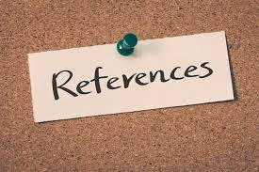

Al-Qutaib, G.E. (2007). “Personal factors and Managers‟ Job Satisfaction: The Case of
Omani Petroleum Sector” Journal of management, Sultan Kabous University 1(2):
33-45 (in Arabic)

Analoui, F. (2007). Strategic Human Resource Management. Thomson Learning, UK. pp.
1-300.

Baron, R. and Greenberg, J. (1990). Behavior in Organizations: Understanding and
Managing the Human Side of Work. Allyn and Bacon

BusinessDictionary.com. (n.d.) Organizational behaviour. Retrieved April 17, 2010 from http://www.businessdictionary.com/definition/organizational-behavior.html.

Chance, P.L., & Chance, E.W. (2002). Introduction to educational leadership and organizational behaviour: Theory into practice. Larchmont, NY: Eye on Education.

Porter, L.W., Bigley, G.A., & Steers, R.M. (2003). Motivation and work behavior (7th ed.). New York, NY: McGraw-Hill/Irwin.

Staw, B.M. (2003). Organizational psychology and the pursuit of the happy/productive worker. In L.W. Porter, G.A. Bigley, & R.M. Steers, R.M. (Eds.), Motivation and work behavior (pp. 144-155). New York, NY: McGraw-Hill/Irwin.

