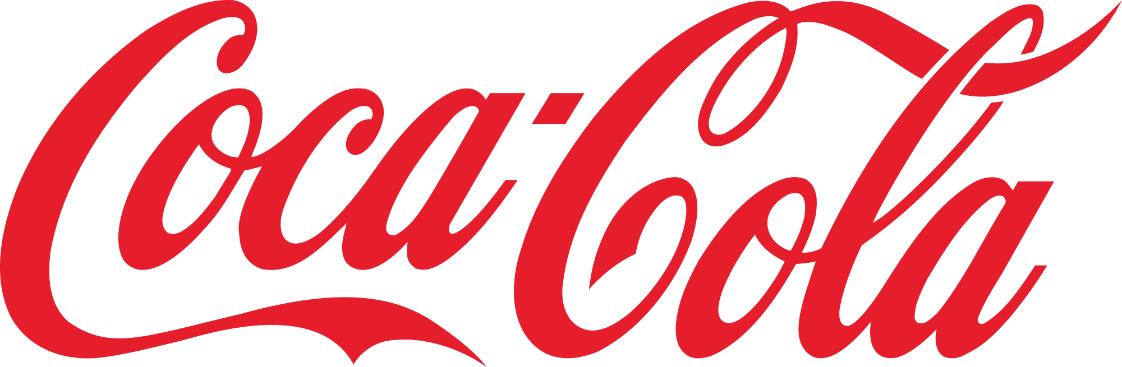
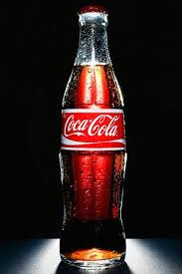
BLOG

Tutor’s name: Tushara Balendran
Module: Marketing Fundamentals
Module No: LCBB4004
Task 1A
The Team:

G.Leader Elena Hristozova
ID N0:1811990
Elena Petrova ID N0:1812410
Miglena Krasteva ID N0:1814710
Maria Taleva ID N0:1812411
Viliana Stoyanova ID N0:1814718

Table of Contents
Who we are – The coca cola Company Elena Hristozova 2
Our products – Tailored to whatever you desire! Miglena Krasteva 4
Carbonated drinks 4
Water 4
Fruit Juices 5
Organic products 6
Tea and coffee 6
The price of coca-cola products. Viliana Stoyanova 8
Where can you find our products? PLace and distribution Maria Taleva 10
The coca cola Promotion Elena Petrova 13
References 16

Who we are – The coca cola Company Elena Hristozova
W
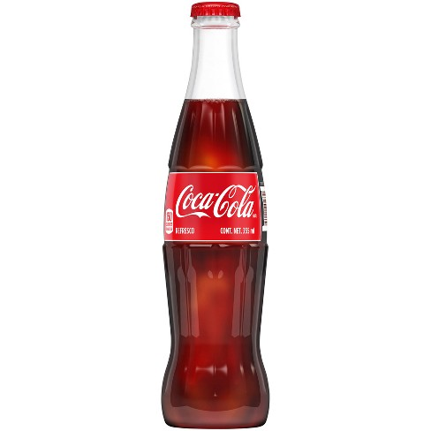
e, the most known brand to you, the Coca Cola company have a home back in the United States (Banutu-Gomez & Rohrer, 2012; Coca Cola Company, 2016a; Wölfle, 2013). We know you remember us due to our flagship product Coca Cola, which was developed by a pharmacist back in 1886 (Figure 1).
Figure 1: Flagship product of the Coca Cola Company
O
ur brand and recipe was purchased by Asa Griggs Candler in 1889, who incorporated the company. Since our inception, the business of the Coca Cola company is based on the franchising model, i.e. the company developed franchises in various locations and licenses have been provided to the franchises for the manufacturing, marketing as well as the sales of the company’s products (Kant, Jacks, & Aantjes, 2008; Louis & Lombart, 2010). The franchises typically get the syrups with the secret recipe from the company, which is used in the later process of manufacturing. The business operations initially started from America; however, over the period of time, the company made rapid expansion into other countries. Currently, we are operating around the globe and this is one of our competitive strengths.
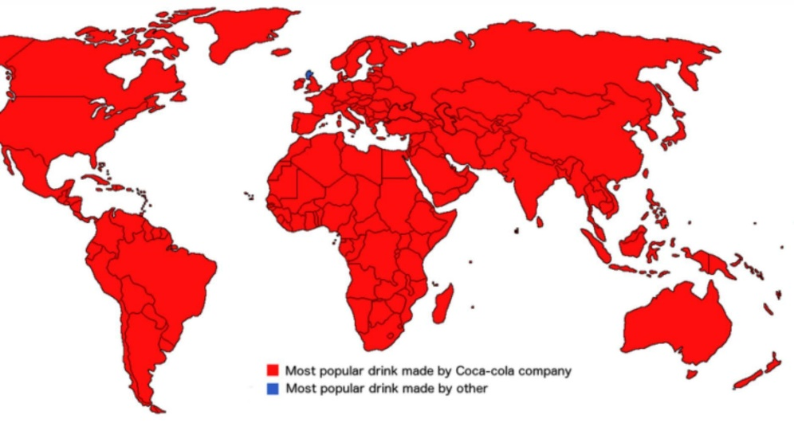
Figure 2: The world of Coca Cola
I
n addition to the business operations, the product line was also small initially and it only started with a carbonated black drink, which is still a flagship product by the company. However, due to the market changes observed over time, the company also expanded its product line (Cedillo Torres, Garcia-French, Hordijk, Nguyen, & Olup, 2012; Marketline, 2014; Yadav, Stapleton, & Wassenhove, 2013). For instance, carbonated drinks with different flavours such as Sprite and Fanta have been introduced. Other than this, we also acquired various other businesses. For instance, the company acquired an American juice maker, Minute Maid in 1982 (Figure 3) and in 2009, a Chinese juice maker have also been acquired by the company.
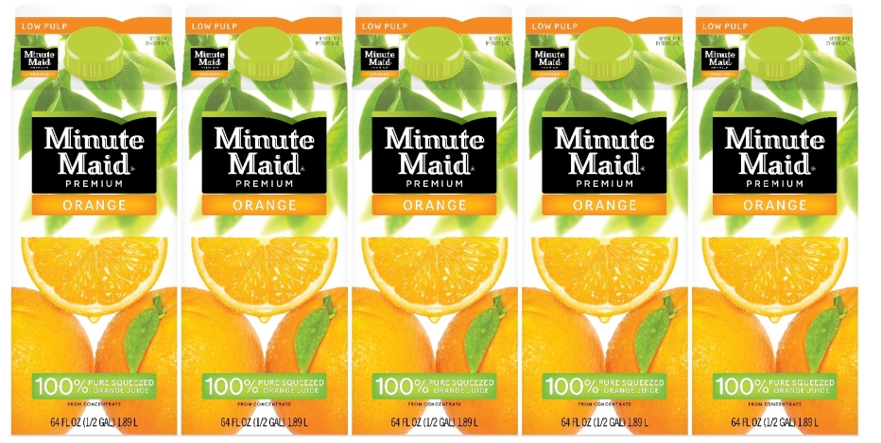
Figure 3: Minute Maid acquired by the Coca Cola Company in 1982
T
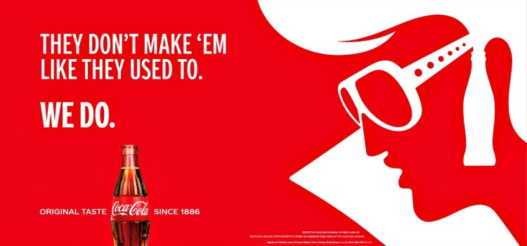
he markets in which we are operating has observed several changes over the period of time and this is one of the key reasons behind acquisition and extension of the product line. In most of the countries around the globe, Coca Cola is the best-selling carbonated drink and in 2010, we also received an award of global brand. Within the United Kingdom, in 2010, we were the first brand to top the sales of 1 billion GBP in grocery. Nonetheless, increasing health concerns and consciousness of the customers led to the decline of sales in the carbonated drinks. For our carbonated drinks, an 11 percent decline has been observed in 2017, which led to a higher focus on the alternative products such as Coke diet, fruit juices and other products (Madhavan, 2012; Varman & Belk, 2009). As far as the marketing aspect of the product is considered, we approach our customers through different channels and several state-of-the-art strategies are used in order to attract and engage the targeted market. This is one of the key reasons behind our success irrespective of a tough competition in the market. Above all, we maintain a consistency of taste to keep the legacy of great taste unlike other brands.

Our products – Tailored to whatever you desire! Miglena Krasteva
W
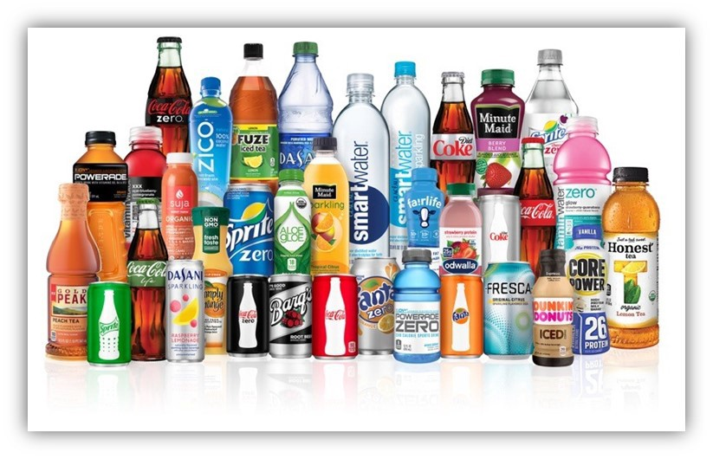
e maintains a diverse range of products in order to give our customers an option to choose from whatever they desire. You like a carbonated drink or you are a health conscious to have some juice or water with great taste? You are all covered with our product portfolio!

Carbonated drinks
O
ur range of products within the UK mainly include the brands Coca Cola original taste, Coca Cola zero sugar, Diet Coke, Sprite and Fanta. Initially, the company mainly relied on Coca Cola original taste; however, the product range over the period of time observed changes to meet your needs. For instance, to cater the customer who were demanding different tastes, Sprite and Fanta have been launched by us. Later on, for the health conscious customers, products such as Coca Cola zero sugar and Diet Coke have been introduced (Speers, Harris, & Schwartz, 2011; Xu, 2018).
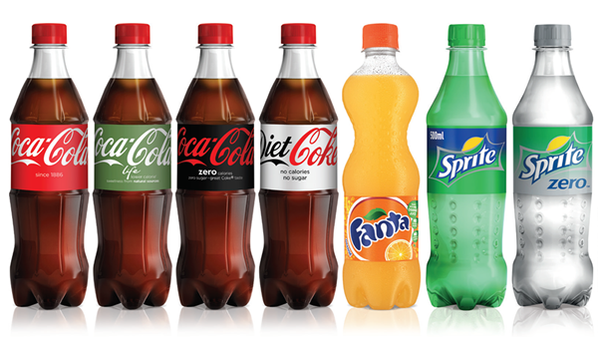
Figure 4: Carbonated drinks offered by the Coca Cola Company

Water
W
e listen to the needs of our customers and based that the Coca Cola Company also entered into the market of bottled water. In this particular category, the company is mainly operating with two bands within the UK. This includes GlaceAU smart water and GlaceAU Vitamenwater. GlaceAU smartwater includes a range of distilled bottled water in natural flavour as well as in different fruit flavours to cater the diversity of the targeted market (Coca-Cola, 2017). Similarly, the vitamin water also comes in different flavours. An overview of the products in this category are shown in the figure below (Figure 4):
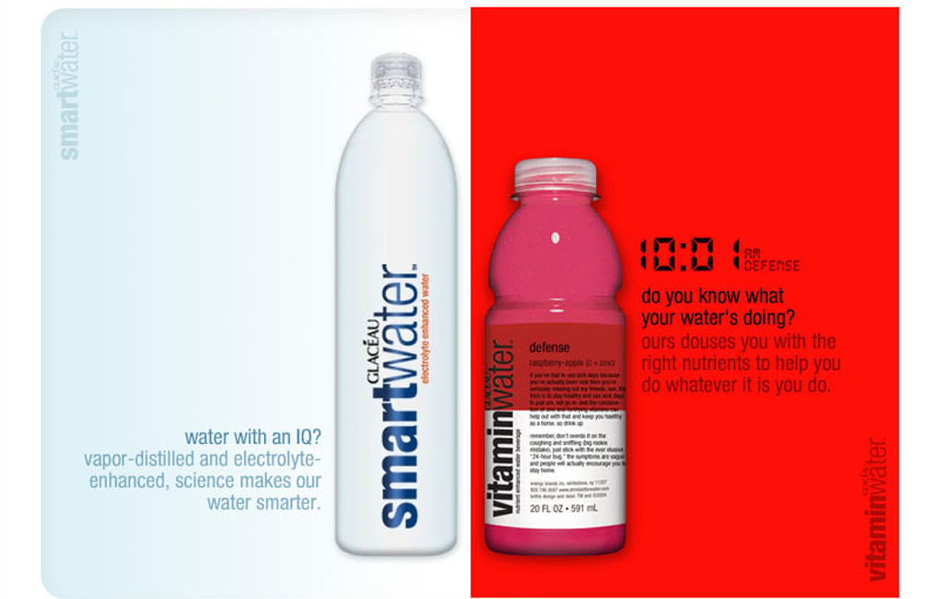
Figure 5: Bottled water brands by the Coca Cola Company

Fruit Juices
I
n order to cater the needs of the our health conscious customers due to the adverse health impacts of carbonated drinks, we started to focus on developing the brands of fruit juices back in 1960s. In this regard, two juice making companies have been acquired. Currently, within the UK, we offer fruit juices under the brand of Minute Maid (“Market Place,” 2019; Ram, 2007; Sereshti & Samadi, 2014). Various flavours and alternatives of juices are offered under this brand as represented briefly in the figure below (Figure 5):
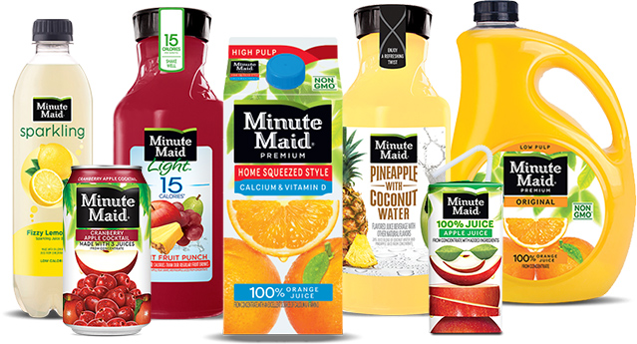
Figure 6: Fruit juices under the brand of Minute Maid

Organic products
W
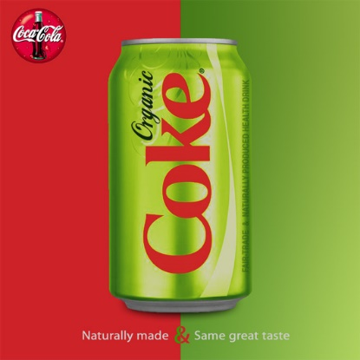
e know you are very much health conscious and is interested in organic products; this is why we have something very special and very organic for you. Within the UK, we operate with a brand of Honest Organic, which include different juices made out of the organic ingredients. The purpose of entering in to this particular market was to go with the recent trend of organic products, i.e. the products made out of the organic ingredients that do not use any pesticides to grow (Coca Cola Company, 2016b; Kumar, Teichman, & Timpernagel, 2012). With this product line, our target market are the consumers which are health and diet conscious and prefer to use the organic products.
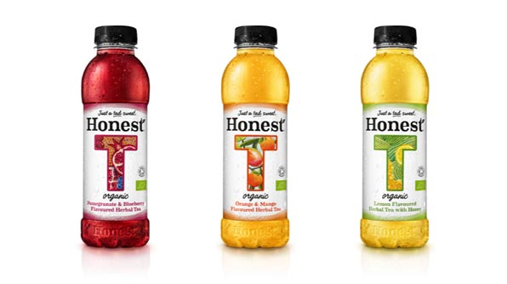
Figure 7: Honest Organic - Organic product by the Coca Cola company

Tea and coffee
T
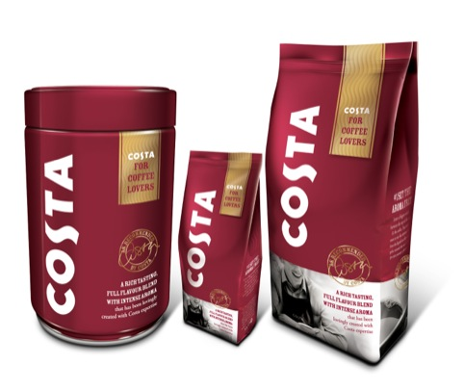
o cover our values customers including tea and coffee lovers within the UK, we have also offered the products including canned tea and coffee under the brands of Fuze Tea and Costa Coffee (Serôdio, McKee, & Stuckler, 2018). Both products come with different flavours; however, popularity of this product is still low.

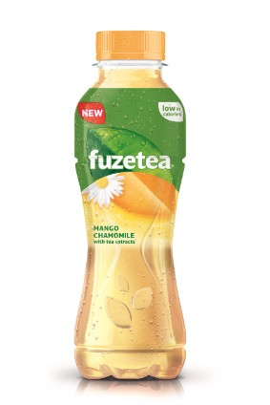
Figure 8: Fuze Tea by the Coca Cola Company

The price of coca-cola products. Viliana Stoyanova
W
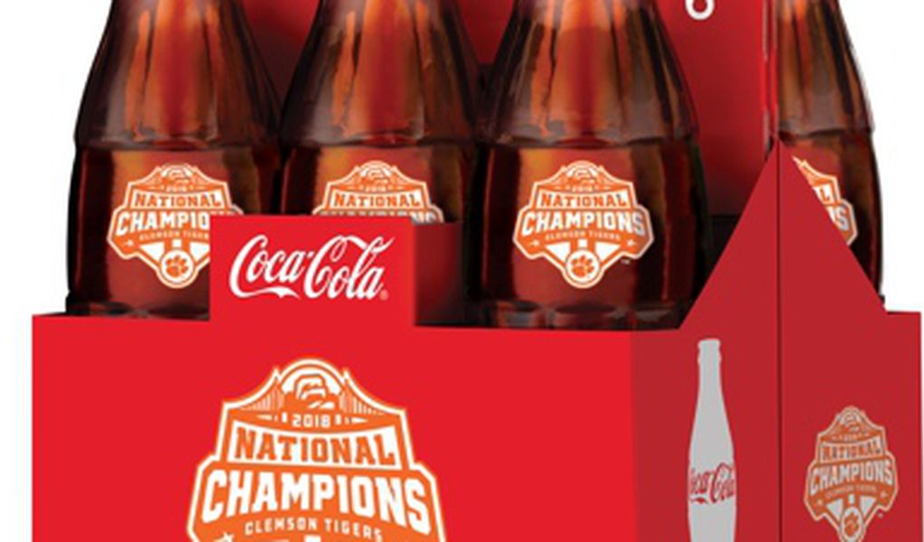
e know price is an important factor as holds a particular importance in assuring the success of a product in the targeted market. The pricing strategy for a product or a service is typically dependent on the overall outlook of the market and various micro and macro environmental factors. First and foremost is the nature of the targeted market that has been selected for the product. If an organisation is targeting and economically superior market, the price would be certainly higher as compared to the products of normal range or commodity products. However, if a product is supposed to be delivered in an economically deprived market and the individual economic conditions of the consumers is not so well, the price should be lower (Kolb, 2014; Yeu et al., 2012). Similarly, the competition in a market also affect the pricing strategy. In case the competition is high and a number of other players are also operating in the market with more of less similar products, the pricing can be set as low in order to develop a cost-based competitive advantage. One the other hand, in case of monopoly or oligopoly, the price can be in set as a moderate level in accordance with the prices of the competitors to avoid any negative market forces due to the prices (Nazari-Shirkouhi, Keramati, & Rezaie, 2013). Other than this, government regulations and the nature of the products, i.e. the product cost and supply chain also play a critical role in deciding the pricing strategy of a product.
O
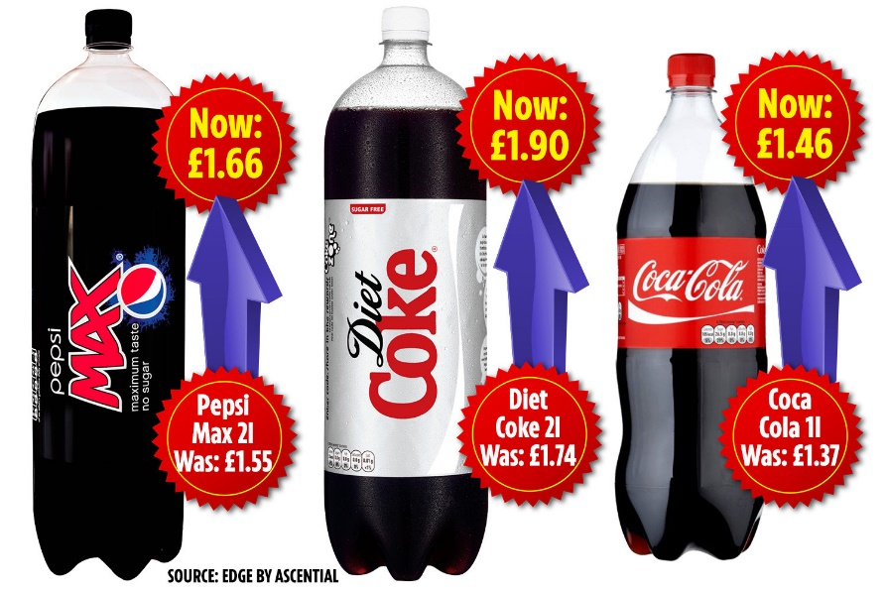
ur pricing strategy is based on a second degree discrimination, i.e. we decide the price of our products based on the nature of segments for which the products are to be offered. For instance, in case of the carbonated drinks, the market of the UK has an oligopoly, i.e. the company has a major competition with Pepsi only and there is not a large list of competitors in this segment. Thus, the prices for this product line are similar to Pepsi.
F
or our other product line, such as water and juices, the prices are also set based on the prices of other competitors. For instance, the water and juices from Minute Maid are more or less similarly priced as of other juice making companies within the UK (Kent & Ignatius, 2011; Sicilia & Palazón, 2008). However, for the products such as those under the brand umbrella of Honest Organic, the company charge premium products. One of the factors behind high prices of products in this category is its production costs. The organic components of this products have a different supply chain and as the supply is relatively limited in this category, the prices are high. In other words, the bargaining power of the suppliers is relatively high in this segment leading to the higher prices (Serôdio et al., 2018). For the products including tea and coffee, the same strategy of second degree differentiation has been followed keeping the prices a little high over its competition.
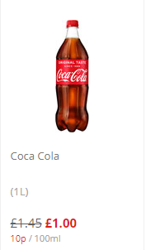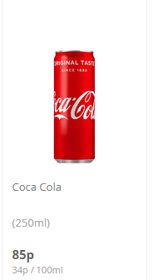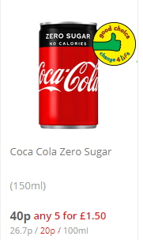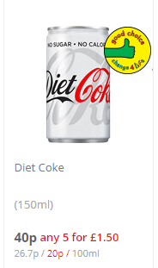
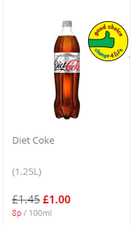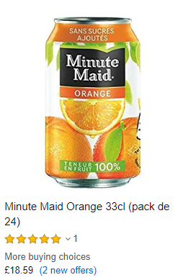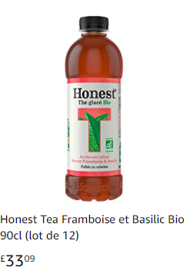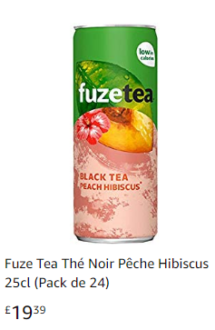

Where can you find our products? PLace and distribution Maria Taleva
W
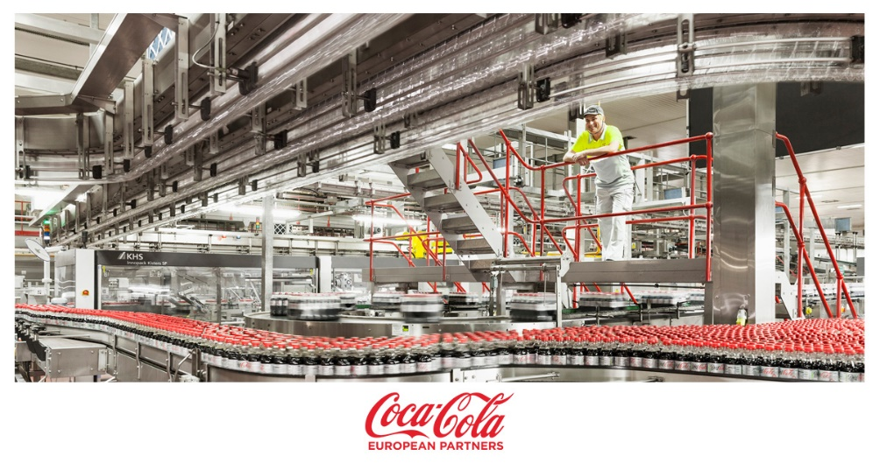
e is operating in the market from past 130 years and with an extensive experience in manufacturing as well as distribution, the company operates in around 200 countries around the globe. The distribution network of our company is very strong and assure the timely availability of the products to all of its target markets. The ‘place’ factor of marketing mix is very crucial for the companies as it assess the potential of a company in order to reach to its target market. The development of the distribution strategy is typically dependent on the nature of the market as well as the type of the product (Kumar et al., 2012). For instance, the shelf life of the products would hold particular importance in deciding the distribution strategy of the company and this would also affect the design of the supply chain network to be chosen by the company. Similarly, the nature of the market and business would also affect the decision of the company in this regard.
W
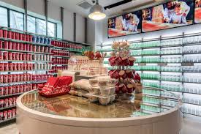
e understands that in case of B2B businesses, the distribution strategy would be something else, while for the B2C businesses, a different distribution strategy would be used in which a company would either supply in the market directly or through a network of distributors. Each has its own advantages and disadvantages. For the case under consideration, the Coca Cola Company supply to the market through a network of distributors (Sereshti & Samadi, 2014). This network is continuously engaged and provided trainings with various tools in order to improve their sales and provide effective forecasts. Based on the demand received from the distributors, the manufacturing units across the country provide the products, which are then sold to the consumers.
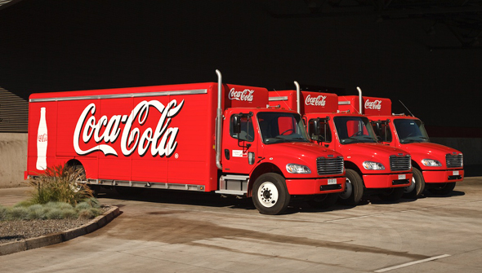
Figure 9: Coca Cola Distribution
I
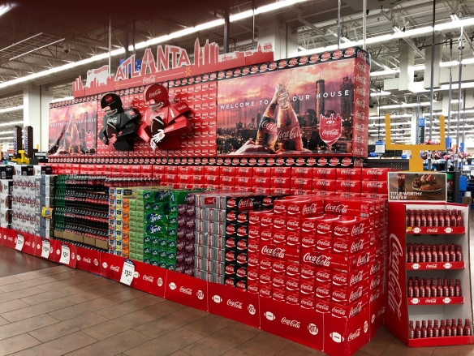
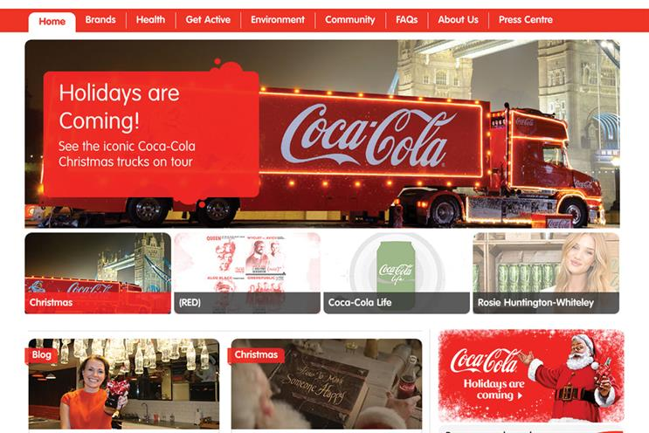
n comparison to our competitor, the distribution strategy of Coca Cola is particularly tailored to meet the needs of the market and at the same time, we assure a compliance with the quality standards adopted by the company. Unlike our competitors that mainly deliver the products to the distribution networks through contractors, the Coca Cola Company, in most of the cases, maintains its own transportation network in order to assure the products are being delivered to the distributors in good condition and at a timely manner (Coca-Cola, 2017). Although this involves certain cost, it assures the product quality and timely delivery to you with a unique connection of emotions.
O
ur distribution strategy is valuable for our customers in several ways. Firstly, distribution to a network of distributors helps the company to quickly enhance its sales by developing the distributors across the county as it does not require the company to develop physical offices at every location. Secondly, through a network of distributors, maximum market coverage can be attained, i.e. an increase in the network of distributors would increase the overall market spread of the company. Nonetheless, it may have certain disadvantages as well and the biggest of all is the quality problems (Kumar et al., 2012). The distributors and retailers represents the face of the company while supplying the products and any negative comment must be resolved appropriately by the retailers in order to assure a high degree of satisfaction for you.

The coca cola Promotion Elena Petrova
O
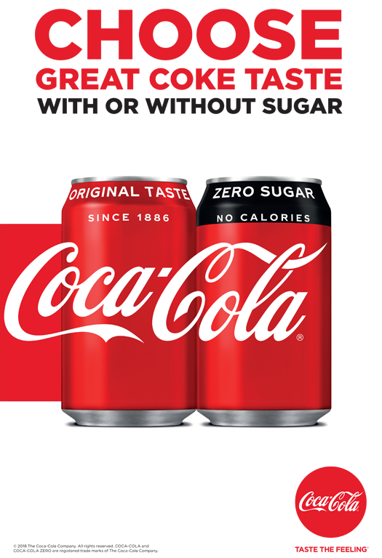
ur promotion strategy in the marketing mix helps to identify the channel were we can talk to you, i.e. the way a business would communicate with the targeted market in order to penetrate in it. It is important to distinguish marketing and promotion. Typically, marketing is a broader concept and it includes a process of studying the market in order to develop a broader strategy that will be used in order to enter in the market. On the other hand, promotion is a niche concept and is part of the market process (Nazari-Shirkouhi et al., 2013). The promotion strategy of an organisation specifically defines the process that would be adopted to communicate to the targeted market, i.e. how the company would be advertising for its products. There are several methods to advertise the business, i.e. it could include direct marketing, television, electronic media, online, social media and various other channels as well. The selection of the advertisement strategy for an organisation is also dependent on its products, market norms and the level of competition in the market. In a highly competitive market, it is inevitable for a company to develop a competitive advantage and it must be effectively communicated to the targeted market in order to assure that the company is receiving an effective response on this.
W
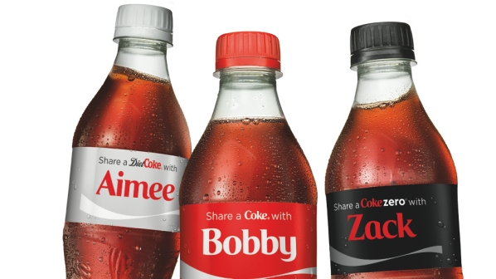

e uses a diverse range of channels in order to communicate to our targeted market. When it comes to marketing, the Coca Cola Company sets a benchmark in the market where it is operating (Sereshti & Samadi, 2014). The company target the consumers through ads using television, sign boards, social media, and online advertisement as well. In addition, we also develop partnerships with other brands in order to influence the sales. Moreover, the sports events are also effectively utilised in order to better advertise the products as this is advantageous to communicate to a broader audience at a relatively lesser cost. Other than the expenditures through these communication channels for marketing, we also involve the retailers and distributors in the advertisement strategy of the company (Xu, 2018). The retailers are specially offered with the benefits of having refrigerators and other equipment free of cost in return of the product promotions.

We set a benchmark through its marketing and advertisement strategy and the competitors are often required to follow the footsteps of the company in order to communicate to the targeted market. For instance, one of its major competitors, Pepsi, in the UK also utilises the same approach in order to communicate to the targeted market. However, there exists a touch of innovation and traditions to the advertisements by the Coca Cola Company. The primary objectives of these advertisements is to engage the audience and develop an emotional contact with the product, which will enhance their loyalty with the brand (Kumar et al., 2012). As far as the advertisement material is considered, as the company operates around the globe, the following advertisement can be used to highlight this through an ad:
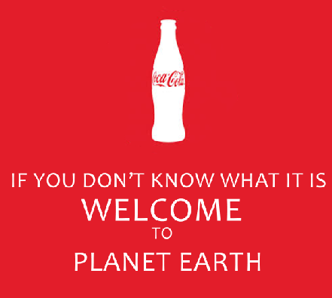
Figure 10: Advertisement by the Coca Cola Company

References
Banutu-Gomez, M. B., & Rohrer, W. G. (2012). COCA-COLA: International Business Strategy for Globalization. International Trade & Academic Research Conference The Business & Management Review.
Cedillo Torres, C. A., Garcia-French, M., Hordijk, R., Nguyen, K., & Olup, L. (2012). Four case studies on corporate social responsibility: Do conflicts affect a company’s corporate social responsibility policy? Utrecht Law Review. https://doi.org/10.18352/ulr.205
Coca-Cola. (2017). Coca-Cola History │ World of Coca-Cola.
Coca Cola Company. (2016a). Coca-Cola Leaders: The Coca-Cola Company.
Coca Cola Company. (2016b). Who We Are - The Coca-Cola Company: The Coca-Cola Company.
Kant, G., Jacks, M., & Aantjes, C. (2008). Coca-Cola Enterprises optimizes vehicle routes for efficient product delivery. Interfaces, 38(1), 40–50. https://doi.org/10.1287/inte.1070.0331
Kent, M., & Ignatius, A. (2011). Shaking Things Up at Coca-Cola. Harvard Business Review, 89(10), 94–99.
Kolb, B. (2014). Introduction to Marketing Research. In Marketing Research. https://doi.org/10.4135/9780857028013.n1
Kumar, S., Teichman, S., & Timpernagel, T. (2012). A green supply chain is a requirement for profitability. International Journal of Production Research. https://doi.org/10.1080/00207543.2011.571924
Louis, D., & Lombart, C. (2010). Impact of brand personality on three major relational consequences (trust, attachment, and commitment to the brand). Journal of Product and Brand Management. https://doi.org/10.1108/10610421011033467
Madhavan, A. (2012). CSR at Coca-Cola. Vikalpa: The Journal for Decision Makers, 37, 94–98.
Market Place. (2019). Plastics Engineering. https://doi.org/10.1002/peng.20129
Marketline. (2014). The Coca-Cola Company. Coca-Cola Company MarketLine Company Profile. https://doi.org/37CB5616-D04E-49EE-9F5C-FFE75047D6FF
Nazari-Shirkouhi, S., Keramati, A., & Rezaie, K. (2013). Improvement of customers’ satisfaction with new product design using an adaptive neuro-fuzzy inference systems approach. Neural Computing and Applications. https://doi.org/10.1007/s00521-013-1431-x
Ram, U. (2007). Liquid identities: Mecca Cola versus Coca-Cola. European Journal of Cultural Studies, 10(4), 465–484. https://doi.org/10.1177/1367549407081952
Sereshti, H., & Samadi, S. (2014). A rapid and simple determination of caffeine in teas, coffees and eight beverages. Food Chemistry. https://doi.org/10.1016/j.foodchem.2014.02.095
Serôdio, P. M., McKee, M., & Stuckler, D. (2018). Coca-Cola - A model of transparency in research partnerships? A network analysis of Coca - Cola’s research funding (2008-2016). Public Health Nutrition. https://doi.org/10.1017/S136898001700307X
Sicilia, M., & Palazón, M. (2008). Brand communities on the internet: A case study of Coca-Cola’s Spanish virtual community. Corporate Communications. https://doi.org/10.1108/13563280810893643
Speers, S. E., Harris, J. L., & Schwartz, M. B. (2011). Child and adolescent exposure to food and beverage brand appearances during prime-time television programming. American Journal of Preventive Medicine. https://doi.org/10.1016/j.amepre.2011.04.018
Varman, R., & Belk, R. W. (2009). Nationalism and Ideology in an Anticonsumption Movement. Journal of Consumer Research. https://doi.org/10.1086/600486
Wölfle, R. (2013). Coca-Cola. In Fulfillment im E-Business. https://doi.org/10.3139/9783446221987.003
Xu, S. (2018). Essay. Spectrochimica Acta - Part A: Molecular and Biomolecular Spectroscopy. https://doi.org/10.1016/j.saa.2018.02.055
Yadav, P., Stapleton, O., & Wassenhove, L. Van. (2013). Learning from Coca-Cola. Stanford Social Innovation Review, 51–55.
Yeu, C. S., Leong, K. C., Tong, L. C., Hang, S., Bashawir, A., & Subhan, M. (2012). A Comparative Study on International Marketing Mix in. Procedia -Social and Behavioral Sciences International Congress on Interdisciplinary Business and Social Science. https://doi.org/10.1016/j.sbspro.2012.11.370

