Lucia piñar
St number : 2308620.

Addressing the Impact of the Welsh Urban-Rural Divide on Health.

Rural Wales is home to vibrant communities, but its geography presents unique challenges for healthcare delivery. Long travel distances, limited transport links, and scattered populations mean that accessing timely medical care is often more difficult than in urban centres. These challenges are most visible in the performance of emergency services. Ambulance delays have become a pressing issue, with rural residentes waiting longer for urgent care due to stretched resources, difficult terrain, and workforce shortages.
These delays are not just statistics; they are moments of fear for families waiting for urgent help, and they are risks that can turn treatable conditions into tragedies. Carers and health workers in rural Wales do extraordinary work, but they are stretched thin, covering vast areas with limited resources
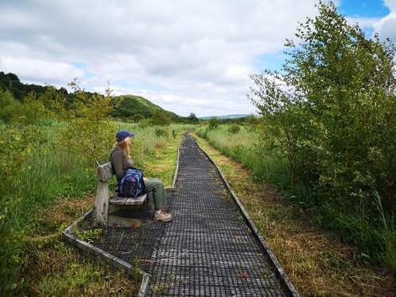

Charlie coleman from UK parliament said in 2033: There are several challenges facing the delivery of health care in rural areas, including generally older populations, long distances to cover, and poor connectivity (of both transport and telecommunications). The government has said it is addressing these issues through its levelling up agenda and has introduced policies such as the community pharmacist consultation service to support community pharmacies in rural areas.

Factors contributing to these urban-rural health disparities ares multifaceted.

L,W said in 2021: For examplee, individuals in rural communities may face obstacles such as transportation difficultyes, which limit access to healthcare services (Liverpool & Williams, 2021).

Additionally, socio-economic determinants including income, employment opportunities, and education can significantly affect health outcomes, leading to a cycle of poor health in disadvantaged populations (Barker, 2018).

-Impact of Health and Inequalities:
The repercussions of health inequalities extend beyond individual suffering; they impose broader economic and social burdens.

Children’s growing up in low-income families in rural areas can experience poorer health outcomes and educational disadvantages, perpetuating cycles of poverty (Health Foundation, 2019).
These disparities also result in increased morbidity and mortality rates in rural areas, lowering overall community health and productivity.
The economic strain on the healthcare system due to untreated preventable diseases translates into significant costs for the Welsh government (Marmot, 2020).
).



Factors contributing to these urban-rural health disparities areass multifaceted.
For examplee, individuals in rural communities may face obstacles such as transportation difficulties, which limit access to healthcare services (Liverpool & Williams, 2021).

Additionally, socio-economic determinants including income, employment opportunities, and education can significantly affect health outcomes, leading to a cycle of poor health in disadvantaged populations (Barker, 2018).

-Impact of Health Inequalities :
The repercussions of health inequalities extend beyond individual suffering; they impose broader economic and social burdens.

Children growing up in low-income families in rural areas can experience poorer health outcomes and educational disadvantages, perpetuating cycles of poverty (Health Foundation, 2019).
These disparities also result in increased morbidity and mortality rates in rural areas, lowering overall community health and productivity.
The economic strain on the healthcare system due to untreated preventable diseases translates into significant costs for the Welsh government (Marmot, 2020).

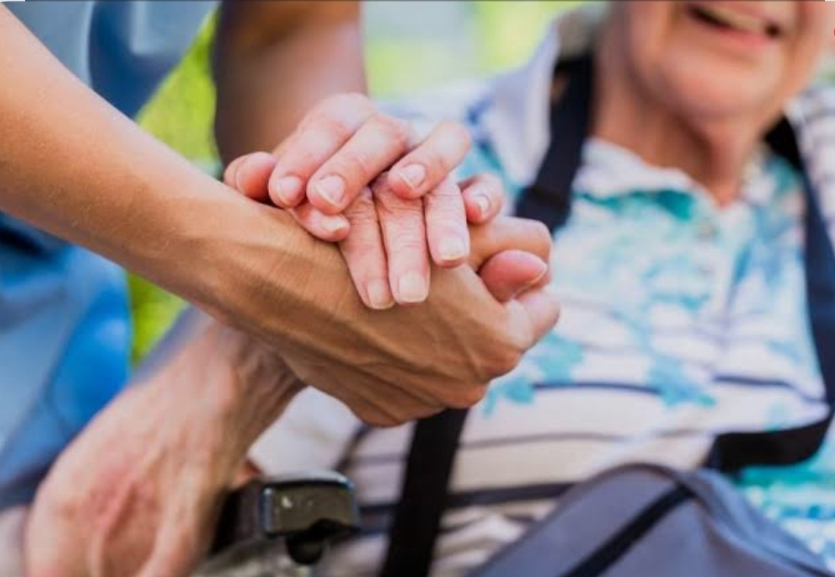

A recent report by the Commission for Rural Communities (2006) covered rural disadvantage in England, generating renewed interest in the subject. This Wales Centre for Health report aims to investigate inequalities in Wales between rural and urban areas in health outcomes and factors thought to influence health outcomes. The two approaches used are by geographically mapping data by LSOA for individual indicators to show patterns and areas of particular concern, and by comparing data for the aggregated urban, sparsely populated rural areas and less sparsely populated rural areas to show any differences.
It is not intended to single out individual areas or communities by name, but to investigate broader patterns and differences between classes and types of area.
(Andrea Gartner, Rhys Gibbon, Neil Riley,2007)

Research has underscored the importance of addressing these disparities not only for ethical reasons but also for enhancing the overall efficiency of the healthcare system.
By promoting health equity, Wales can potentially reduce healthcare expenditures, improve workforce productivity, and foster a healthier, more resilient and population (NHS Wales, 2021).

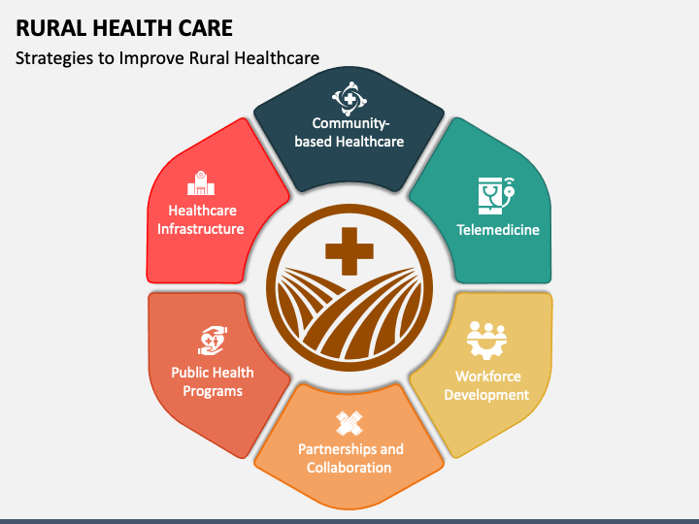

-Policy Context:
Wales has implemented several policies aimed at reducing health inequalities, including the Well-being of Future Generations Act (Welsh Government, 2019).
This framework emphasizes intergenerational well-being and holistic approaches to health. However, despite these efforts, there remains a significant need for targeted interventions that address rural health challenges specifically.
Current policies may not sufficiently focus on the unique health needs and barriers faced by rural populations, resulting in a gap that requires immediate attention to sort out what is go in on with the people.Living along , or they need café assistant, or they are on palliative care (Roberts & Zubair, 2020).

A comprehensive review of existing policies suggests that health determinants must encompass both access to healthcare and broader socio-economic conditions.
Policies should prioritize the root causes of health disparities rather than only addressing their symptoms (Friedli, 2015).

Research Evidence and Case Studies
Evidence from various initiatives globally indicates that targeted approaches can effectively mitigate health inequalities.
For instance, community-based health programs that enhance access to healthcare and provide tailored health education in rural areas have demonstrated success (Public Health England, 2021).

Evaluating cases if studies from Scotland, where community health initiatives have succeeded in bridging gaps in rural healthcare access, can offer valuable insights for policy adaptations in Wales (Nuffield Trust, 2019).

It is essential to recognising that effective policy changes often result from strong partnerships across multiple sectors.
Collaboration between healthcare providers, local authorities, and community organizations is critical to implement comprehensive interventions that directly address local health needs (Stirling, 2020).

Proposed Policy Changed:
This brief advocates for the establishment of a "Wales Rural Health Equity Task Force," aimed at identifying and addressing health disparities experienced by rural populations throughout Wales. This task force would include goverinment agencies, healthcare providers, non-profit organizations, and community stakeholders, specifically focusing on areas of highest need.

Key initiatives of the task force would encompass:
- Increasing funding for mobile health clinics to ensure adequate healthcare access in rural communities.
- Expanding telehealth services to provide mental health support and medical consultations to isolated populations.
- Implementing health education programs that target lifestyle-related issues prevalent in rural areas, such as obesity and substance abuse.

By focusing on targeted resource allocation and collaborative approaches, this proposed policy change seeks to create a more equitable healthcare landscape in Wales.

Implementation Strategy needed:
To implement the proposed task force, several steps should be undertaken:

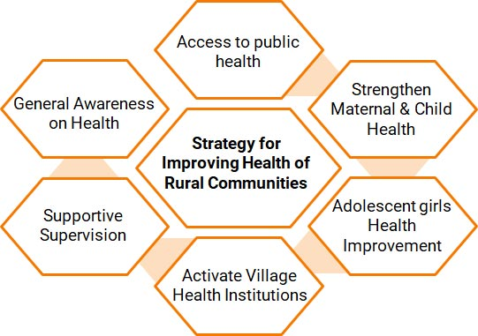

1. Engagement process for have actions about how to planing we need:
Involve community members, healthcare professionals, and organizations in the planning process to ensure the initiatives align with their needs.
2. Resource Allocation :
Secure adequate funding from both public and private sectors to support task force initiatives.
3. Training needed :
Provide training for healthcare providers focused on cultural and rural areas competence and the specific health challenges faced by rural populations.
4. The outreach Efforts: Develop strategies that educate communities on available healthcare resources and promote preventive health behaviors.

What is being done to address the social determinants of health for rural residents?
Rural communities face unique health challenges, and efforts to address social determinants of health (SDOH) focus on improving access to services, infrastructure, and economic opportunities. Key initiatives include expanding healthcare access, tackling poverty and housing issues, improving transportation and broadband, and strengthening local governance and community support.
Healthcare Access
- Expanding rural clinics, telehealth services, and mobile health units to overcome geographic barriers.
- Training and incentivizing healthcare professionals to work in rural areas
Economic Development
- Economic Development Districts (EDDs) are working to integrate health priorities into local economic planning, addressing employment, income stability, and workforce development.
- Programs focus on reducing rural poverty, which disproportionately affects these communities
Community & Social Support

Strengthening local councils, parish organizations, and community groups to provide social support and reduce isolation

- Evaluation and Metrics

Establishing measurable outcomes is essential for evaluating the effectiveness of the proposed policy change. Metrics could include:
- Reductions in health disparities as measured by improvements in life expectancy and the prevalence of chronic conditions .
Of the total variance in the mental health index, 1.47% occurred at regional level (95% CI 0.56–2.38). Adjustment for individual characteristics did not explain the between-region variation. A higher area deprivation score was associated with a higher score on the mental health index. ( Cambridge University press 02-january-2018)

- Increased the access to healthcare services in previously undeserved of the rural areas.

- Enhanced health literacy and healthy outcomes in targeted communities : (Welsh Government, 2020).

Regular data collection and analysis will be vital for assessing the impact of the task force initiatives, allowingins for necessarys adjustmhents to optimize effectiveness.

- the final Conclusion about what need to be adress:
Addressing health inequalities resulting from the urban-rural divide in Wales is an urgentt and critical challenge.
By advocating for the establishment of the Wales Rural Health Equity Task Force and implementing targeted initiatives, pathways can be created to improve health outcomes for all, particularly in rural areas. Ensuring that every individual has equitable access to healthcare is not merely a policy consideration but a moral obligation essential to fostering a healthier and fairer society.

Health in our rural communities is not a luxury, it is a right. Yet too often, geography becomes a barrier to care. If we are serious about equity, then we must act decisively.

We need ambulances that arrive swiftly, carers who are valued and supported, and doctors and nurses who see rural Wales not as a hardship post but as a place to build a career. We must invest in transport links and digital connectivity so that distance never dictates the quality of care.

But health is more than hospitals. It is safe housing, secure jobs, strong schools, and resilient communities. By tackling these social determinants head-on, we can ensure that rural residents enjoy the same dignity and opportunity as those in our cities.

The government of Wales must lead with vision and commitment. Let us build a health strong system that reaches every valley, every farm, every village is so important that points—so that no matter where you live, you can count on care when you need it most.
That is the promise of a fair and healthy Wales.”

Reference list

1. Public Health Wales, 2021.
Health Inequalities in Wales: Analysis Report. https://phw.nhs.wales/ https://phw.nhs.wales/

2. Welsh Government, 2019. Well-being of Future Generations (Wales) Act 2015: The Essentials.

https://gov.wales/future-generations-act-2015.

3. Marmot, M., 2020.
The Health Gap: The Challenge of an Unequal World.

https://www.thelancet.com/journals/lancet/article/PIIS0140-6736(15)00150-6/abstract?_tmc=cEI-Kdo5nGB9ku0pvbjTAClH-Uks7pd3i8OCOLhCfwU

4. NHS Wales, 2021. Annual Report on Health Inequality in Wales.

https://www.wales.nhs.uk/ Accessed 20 October 2023

5.
5. Nuffield Trust, 2019.
Addressing Health Inequalities in Wales: What Should Be Done?

https://www.nuffieldtrust.org.uk/research

6. Roberts, H. and Zubair, M., 2020.

The Role of Public Health in Addressing Health Inequalities in Wales. Journal of Public Health, 42(2), pp. 245-252. doi:10.1093/pubmed/fdz104.

7. Welsh Government, 2020. Healthy Weight: Healthy Wales.

https://gov.wales/healthy-weight-healthy-wales.

8. Barker, G., 2018. Social Determinants of Health in Wales: Understanding the Impact of Local Contexts.
Health and Social Care in the Community, 26(3), pp. 357-365. doi:10.1111/hsc.12650.

9. Friedli, L., 2015.

Mental Health and Well-Being: A Sense of Belonging: The Role of Community and Health Inequalities. The King's Fund. https://www.kingsfund.org.uk

10. Welsh Government, 2021. National Strategy for Mental Health Services.

https://gov.wales/mental-health-services .

11. Stirling, A., 2020. Urban-Rural Health Disparities in Wales: A Review of the Evidence.

Journal of Rural Health, 36(2), pp. 140-149.

12. Health Foundation, 2019. Understanding Health Inequalities in the UK: A Focus on Wales.

https://www.health.org.uk/publications .

13. Liverpool, S. and Williams, L., 2021. Disparities in Access to Healthcare in Wales: A Rural Perspective.
International Journal for Equity in Health, 20, p. 71.

14. Public Health England, 2021. Health Matters: Health Inequalities.
https://www.gov.uk/government/publications/health-matters-health-inequalities

15.Cambridge University Press: 02 January 2018

https://www.cambridge.org/core/journals/the-british-journal-of-psychiatry/article/mental-health-inequalities-in-wales-uk-multilevel-investigation-of-the-effect-of-area-deprivation/69CD20154EDDAEDAA651ECC76FEFD6EC

16. UK parliament,Charlie coleman ,(17 February 2023)
https://lordslibrary.parliament.uk/health-care-in-rural-areas/

17. Andrea Gartner, Rhys Gibbon, Neil Riley,(2007)
https://phw.nhs

