3/15/2023
Work

Computer architecture and operating systems
ACCA4022

Table of Contents
Introduction 2
Key functions for operating systems 2
Resource Management 2
Task Manager 2
Security 2
file solution 2
User interface 2
CLI commands in a Windows 2
IPConfig 2
netstat 2
group policy update 3
CLI commands in a Linux OS 3
Batch scripts in a Windows 3
Batch code 3
Bash scripts in a Linux OS 3
Bash code 3
Bibliography 10

Introduction

Key functions for operating systems
Typically the storage of an operating system is on either an SSD or HDD however, a modder managed to run tiny11 off a graphics card [1]. The key functions for operating systems differ in terms of layout and included features for example windows includes an anti-virus whereas Linux does not, this is due to the structure of linux if the user does contract a virus it will be very unlikely to do any long term harm.

Resource Management
One of the main functions for an operating system is the ways in which it controls resources, and the monitoring of which can be done through the logs created in the resource monitor. For new users, for an example look for figure 1 of the resource monitor

Task Manager
the task manager allows users to end processes, see the resource impact for specific processes, and a way to turn off applications from starting on boot. however, some important features are hidden such as the efficiency mode for specific applications, see figure 2 for an image of the task manager.

Security
windows gives a few methods of security such as an antivirus within the operating system and a firewall, these are both enabled by default however, can both be configured by the user to allow or deny specific applications/traffic. whereas Linux/Ubuntu has no firewall or antivirus enabled at startup, to enable a lightweight firewall the user must do a command in the terminal ubuntu discusses the role of the firewall here [2]. They do not carry an inbuilt Antivirus as the programs are run as a user not as a root user, Ubuntu has more examples here [3]. see figure 3 for the firewall settings

file solution
The file solution on windows is pretty simple to understand, however the basis of their operating system is ran off this, once the user ends the process on task manager, when this happens the start menu and task bar are unusable, however no permanent damage is done with this, as a simple launch of explorer exe using the run executable will add these back [4]. windows gives the user a display for giving user the option to change user permissions whereas ubuntu the user has to go through the terminal to change that permission. see figure 4 for the file management.

CLI commands in Windows
Ipconfig
the Ip configuration command provides the ipv4 address this command has different parameters a full list can be found here [5]. see figure 5 for the image.

netstat
This command monitors the ports which are taken by applications, the user can interpret this command and block the ports which may be malicious. see figure 6

group policy update
the group policy update happens automatically every 90 minutes, however the gpupdate command is to force it to happen, this command updates the user group policy, which ensures that the correct user has the correct permissions to read/write or execute programs and files [6]. see figure 7 for an example of this command

CLI commands in a Linux OS
the CLI commands for Ubuntu are very different from windows, these commands are executed from the terminal.

DF
the df command checks how much space a hard drive has left and a detailed report [7] for an example see figure 8.

LS
the LS command has many different options the -l displays information about each file in a directory [8] see figure 9 for an example.

Batch scripts in a Windows
the batch script I did was based around opening settings, I find myself a number of times forgetting the areas so I thought it would be a good idea to create an application with a number of ways to access the specific settings such as display, firewall, general and explorer, this list can be added onto in the future by simply using “start ms-settings:’AREA’”. when creating this script the explorer.exe would not launch in future I would swap the explorer.exe for another setting such as NVIDIA control panel.

Batch code
@echo off
:menu
cls
echo.
echo 1. Goto Firewall settings
echo 2. Open settings
echo 3. Display settings
echo 4. Disk storage
echo 5. Exit
echo.

REM the if statements to load the correct setting
set /p choice=Enter your choice:
if "%choice%"=="1" goto activateFirewall
if "%choice%"=="2" goto Settings
if "%choice%"=="3" goto DisplaySettings
if "%choice%"=="4" exit DiskStorage
if "%choice%"=="5" exit
goto menu

REM the if statements for the correct settings
:activateFirewall
start control firewall.cpl
goto menu

:Settings
start ms-settings:
goto menu

:DisplaySettings
start ms-settings:display
goto menu

:DiskStorage
start explorer
goto menu

Bash scripts in a Linux OS
The bash scripting involved for linux was a menu system to enable the firewall as previously discussed it is not enabled on default startup, the future could be upgraded to include more if statements for other areas such as display. when the bash scripts The gnome control centre, takes the user to the settings page on linux. a number of differences with this type of coding is the wildcard usage, compared to c# and python, bash and batch files use a lot more Wild cards and sometimes can be confusing.

Bash code
while true; do
echo "1. Turn on firewall"
echo "2. Go to settings"
echo "3. Exit"
read -p "Enter your choice: " choice
case $choice in
1)
sudo ufw enable;;
2)
gnome-control-center &;;
3)
break;;
*)
echo "Invalid choice";;
esac
done

Appendix
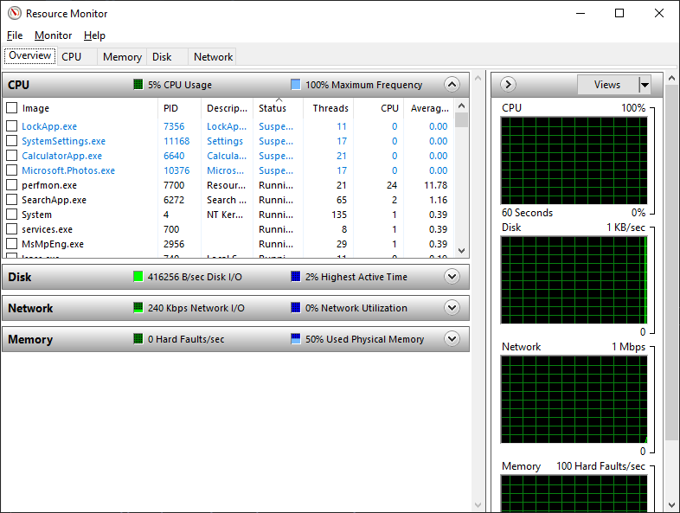figure 1 resource monitor
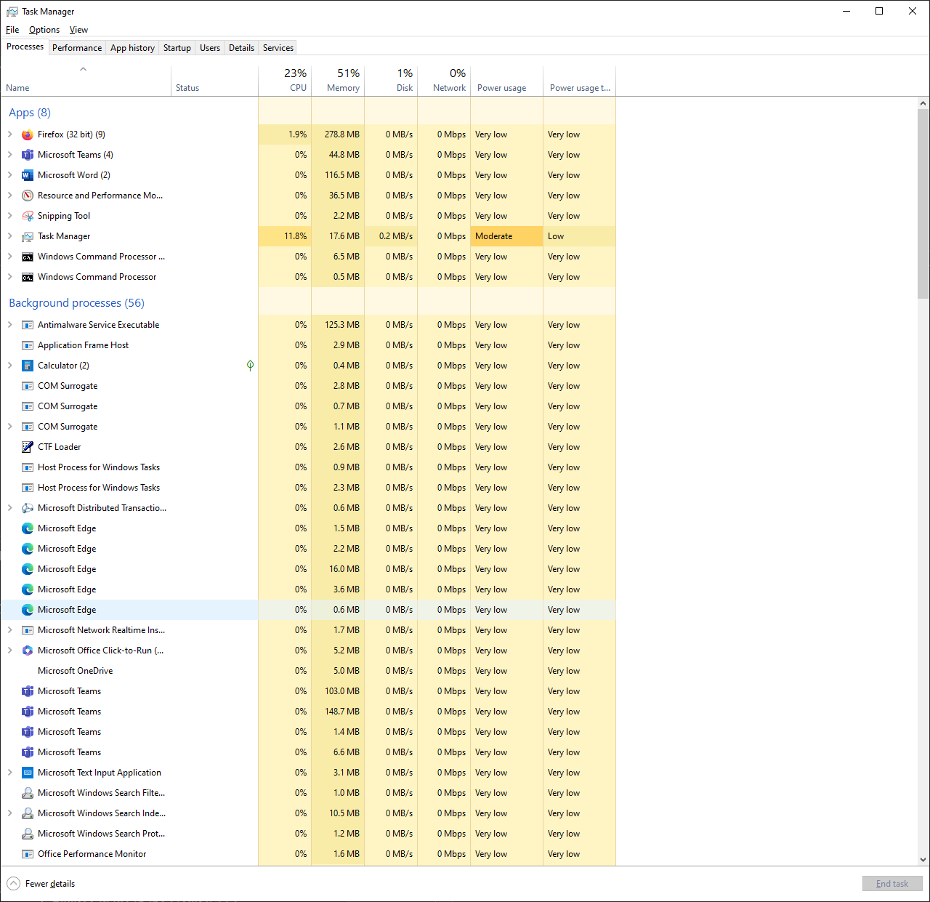
figure 2 Task manager
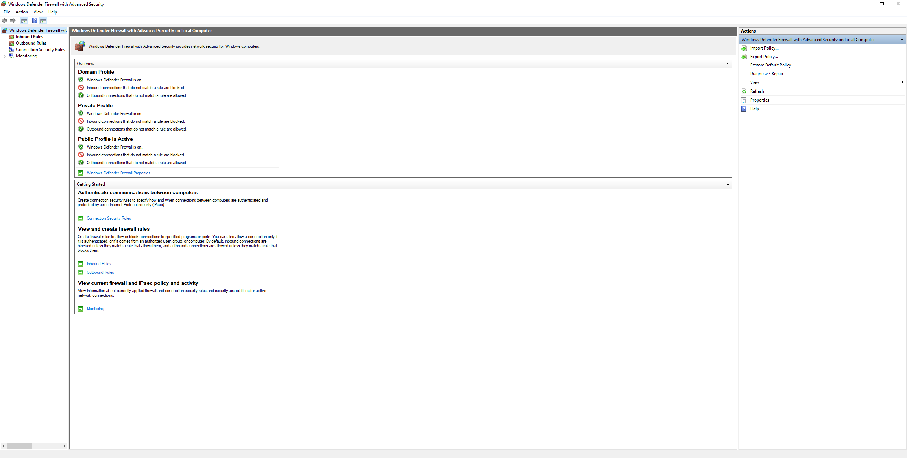figure 3
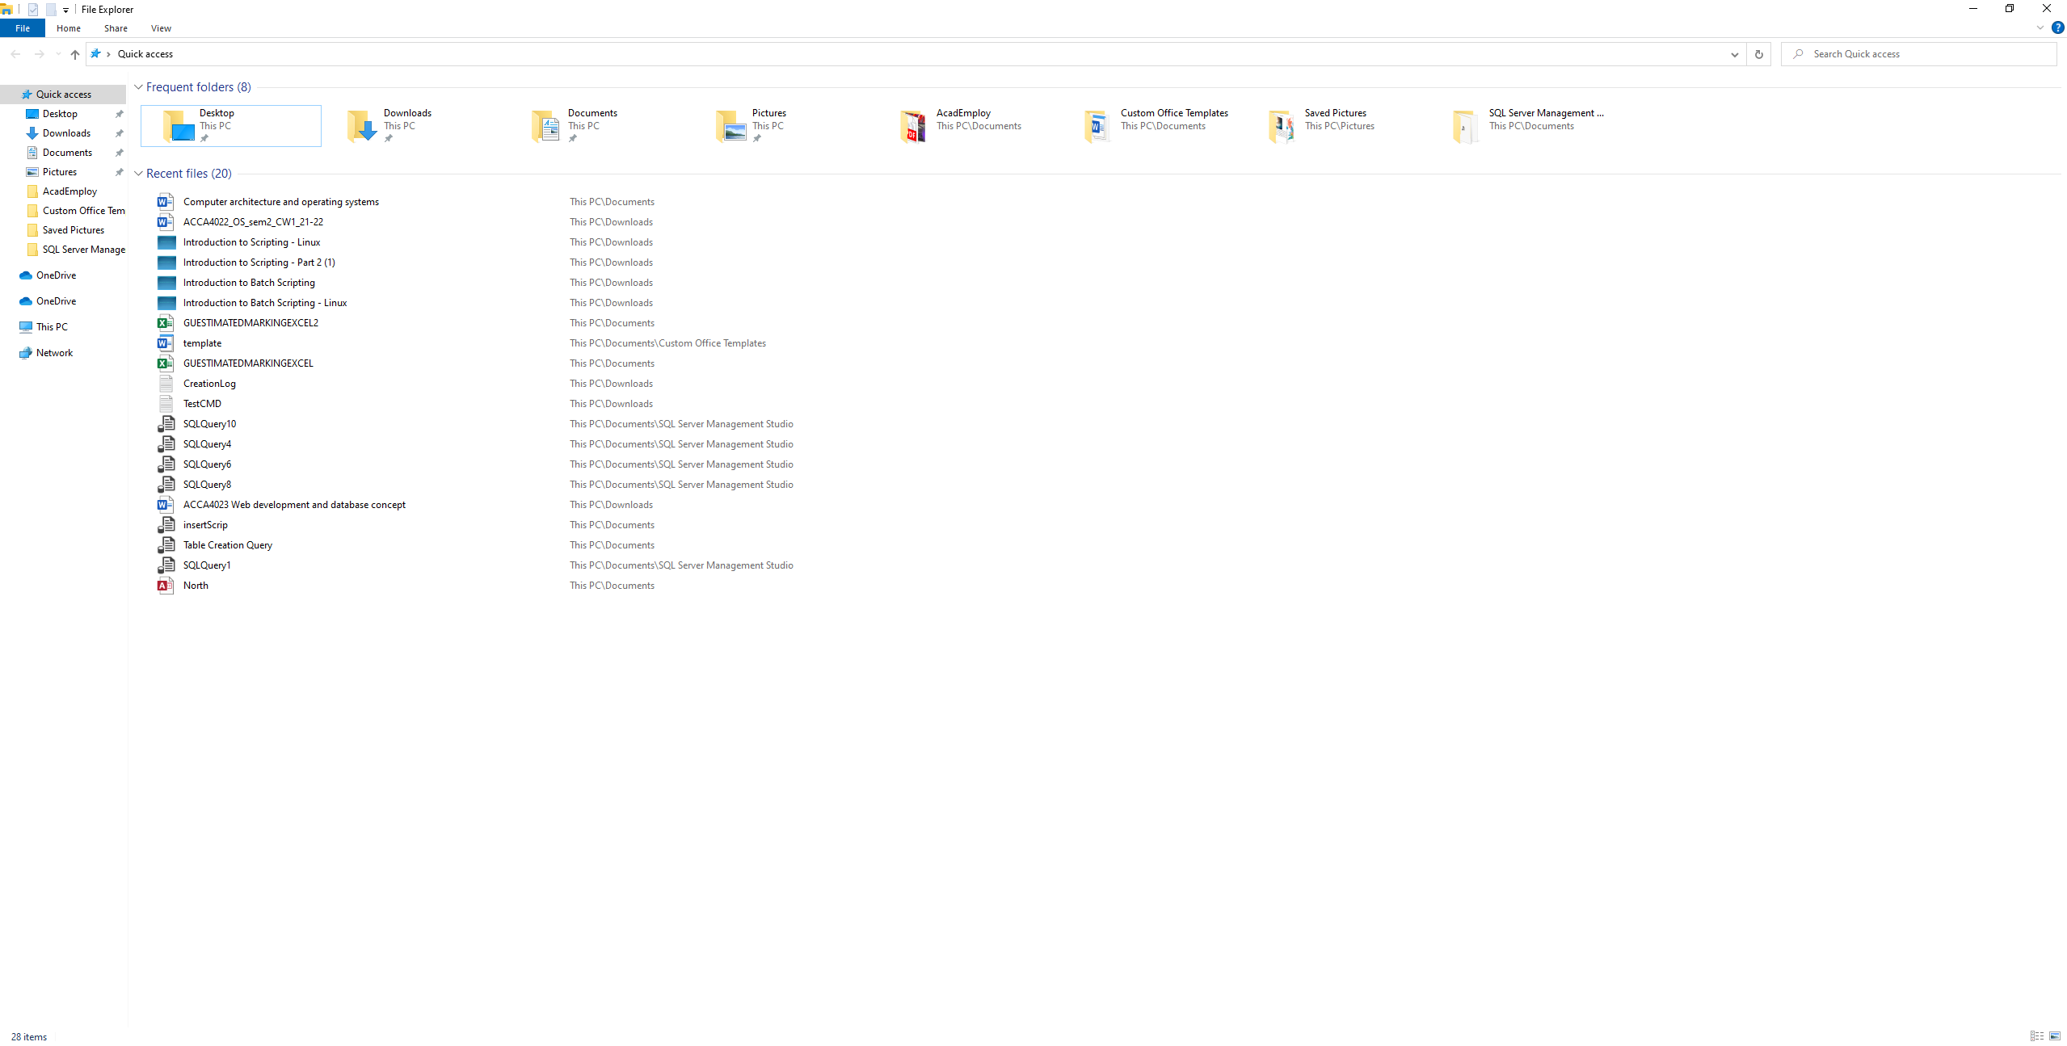figure 4 file management system

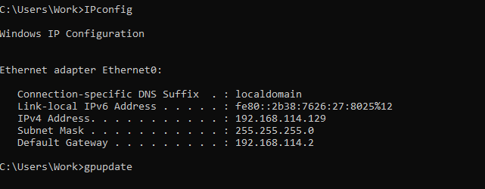figure 5 IP config
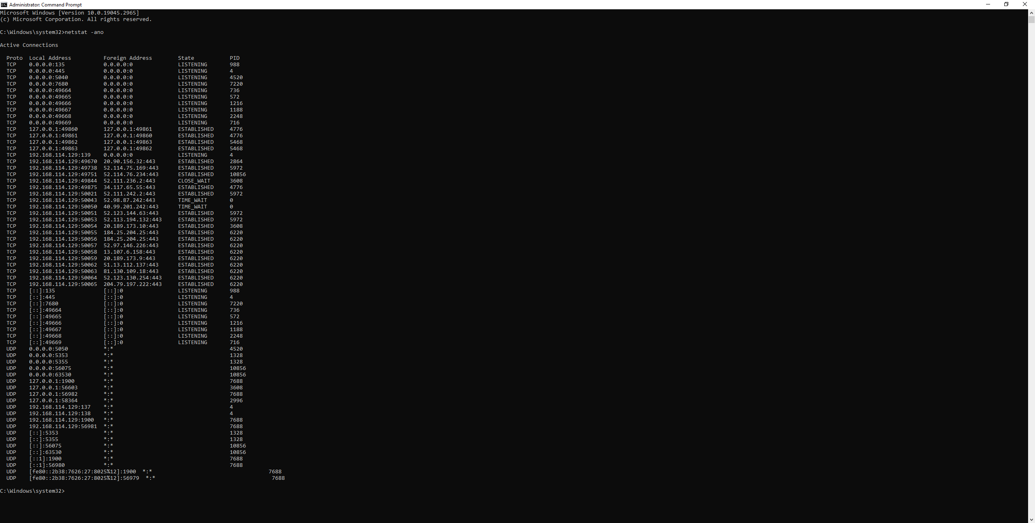
figure 5 netstat
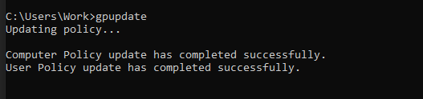
figure 6 group policy update

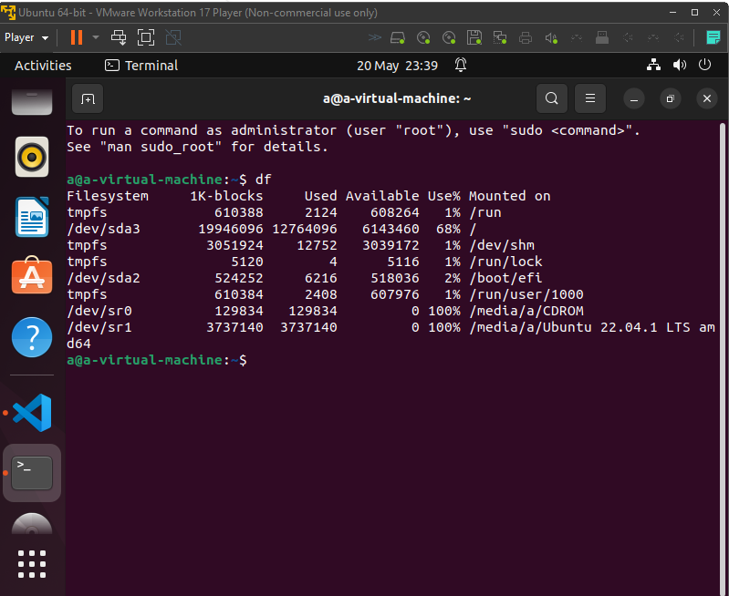
figure 7 df file command

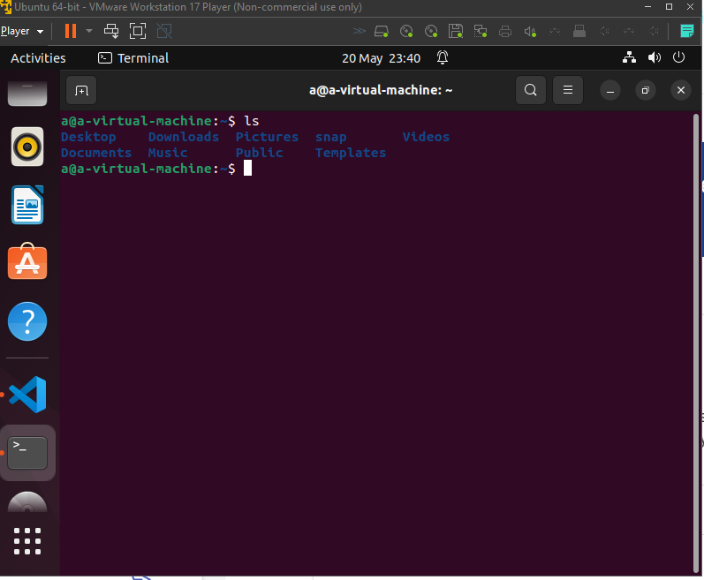
figure 7 LS script
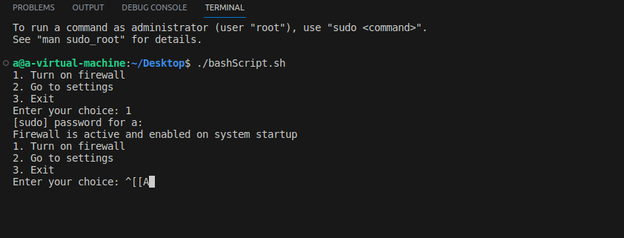
figure 8 is the output for the application

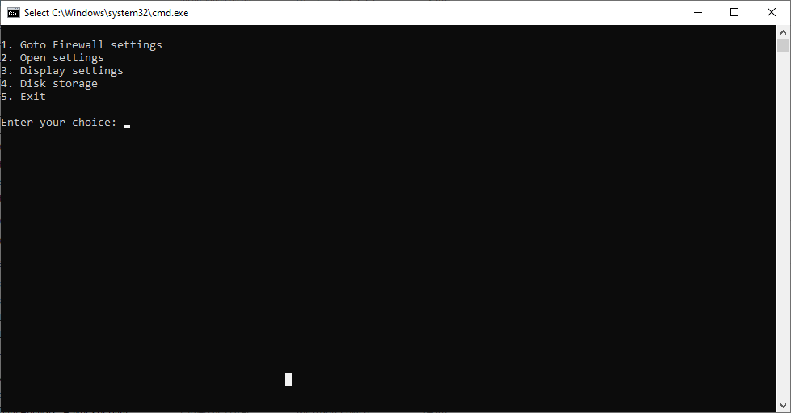
figure 9 the output to console windows

Bibliography

[1] | H. Hagedoom, “Modder NTDev Presents Windows 11 Running on Graphics card VRAM with Tiny11 Project,” tomshardware, 08 05 2023. [Online]. Available: https://www.guru3d.com/news-story/modder-ntdev-presents-windows-11-running-on-graphics-card-vram-with-tiny11-project.html#:~:text=Modder%20and%20software%20developer%20NTDev%20has%20showcased%20a,a%20laptop%20GPU%20memory%2C%20specifically%20the%20VGA%20m. [Accessed 20 05 2023].
[2] | Ubuntu, “Security-Firewall,” Ubuntu, 1 03 2023. [Online]. Available: https://ubuntu.com/server/docs/security-firewall. [Accessed 18 05 2023].
[3] | ubuntu, “Antivirus,” Ubuntu, 28 08 2019. [Online]. Available: https://help.ubuntu.com/community/Antivirus. [Accessed 20 05 2023].
[4] | B. Stegner, “7 Windows task manager processes you should never kill,” 23 09 2021. [Online]. Available: https://www.makeuseof.com/tag/vital-windows-task-manager-processes/. [Accessed 20 05 2023].
[5] | Microsoft, “ipconfig,” Microsoft, 02 03 2023. [Online]. Available: https://learn.microsoft.com/en-us/windows-server/administration/windows-commands/ipconfig. [Accessed 20 05 2023].
[6] | Microsoft, “Group policy overview,” Microsoft, 31 08 2016. [Online]. Available: https://learn.microsoft.com/en-us/previous-versions/windows/it-pro/windows-server-2012-r2-and-2012/hh831791%28v=ws.11%29. [Accessed 20 05 2023].
[7] | linuxize, “Df command in linux,” 11 04 2020. [Online]. Available: https://linuxize.com/post/how-to-check-disk-space-in-linux-using-the-df-command/. [Accessed 20 05 2023].
[8] | linuxize, “ls command in linux,” 7 11 2020. [Online]. Available: https://linuxize.com/post/how-to-list-files-in-linux-using-the-ls-command/. [Accessed 20 05 2023].

